




2025 Central Nebraska Community Action Partnership, Inc.
Community Needs Assessment

Executive Summary
Key Overall Findings

Within the 21 county CNCAP service area, there are 179,828 people. Of those, 91,725 are male and 88,103 are female. The largest age range within the service area is 18-64 with a total population of 99,015. There are 12,335 children under the age of four in our service area and 34,376 between the ages of 5-17. The second largest age range within our service area is the population above 65 years, with a total of 34,102.

The county with the highest median age in the service area is Wheeler county with a median age of 59.9. The county with the youngest median age is Colfax county at 35. Hall county has the second youngest age at 36. Followed by Platte at 38.2. These three counties are the most densely populated within the service area and they have the most youth. This is typically because of the availability of certain opportunities such as higher paying jobs, daycare, housing, and other opportunities. Of the working age people within the service area, the largest number of adults are in the 55-64 age range. This age group is made up of people who are either leaving or have already left the workforce. The smallest age group is the 18-24 with a population that has decreased in the last year to 8,973. This age range is the range of people who are available to replace the older generation when they retire and there is a significant gap in numbers there. This is the direct result of people moving to bigger cities in order to improve their quality of life and their families. In the last 10 years within our service area, only five counties have increased in population, while the rest have decreased. Many people are moving out of the CNCAP area into Nebraska’s more urban areas like Lincoln and Omaha. It is important that we find ways to help these rural communities flourish, as when people move out, businesses close, daycare shortages pull even more from the workforce, mental health decreases and people are forced to leave in search of more opportunity.

For another year, housing remains the number one challenge within the CNCAP service area. In fact, it is still the number one concern across the entire state. Housing shortages have continued to wreak havoc on the state of Nebraska. Compared to just five years ago, the pains Nebraskans now endure to acquire an affordable house or apartment are much worse. Especially for those below the median household income. Affordable housing challenges for low-income workers only appear to be increasing. More than a third of Nebraska households earn less than $50,000. As the cost of building a house surged in recent years, fewer houses were constructed, which only further inflated the cost of the remaining supply. In many Nebraska counties, the available housing stock is decades older than the national average and suffers from serious housing problems like a lack of complete kitchen or plumbing facilities. Workers earning a median wage in Nebraska are often unable to obtain a proper housing unit, especially with the recent values. Many Nebraskans near (and above) the median income are not eligible for housing subsidies and assistance, yet still have difficulty obtaining and affording a house that truly meets their needs. When most Nebraska jobs have lower wages than most of the United States, this creates a serious problem. The severe housing shortage that Nebraska is facing is driving people out of the state, causing people to deny jobs and move out of rural areas.

Childcare continues to hold its spot at the top as a major challenge within the CNCAP service area. The lack of affordable, quality care is yet another driving factor of people being forced to leave the workforce or more to bigger cities. Childcare shortages have consistently been a major challenge that parents face daily within the CNCAP service area, as well as the entire state. As of 2024, childcare officially surpassed college tuition at $11,068. Many small-town communities feared that their towns would not survive unless they gained better access to childcare. Even before the daycare shortage, the expense of childcare strained budgets. It is not just simply affecting family finances, but causing parents to leave the workforce entirely. In fact, the number of employees missing work due to lack of childcare has doubled since 2014. Keya Paha and Blaine counties within the service are do not have a single childcare facility. The average rate of center-based care for an infant now absorbs 10% of the median income of a married couple and 33% of the median income of a single mother. Having two young children in need of care becomes especially costly at 19% of a married couple’s income and 61% of a single mother’s income. Almost 90% of Nebraskans believe that ensuring affordable day care for working families is an important priority. Only 11% of Nebraskan’s said that it is not an important priority for Nebraska. 79% of Nebraskans believe that lack of quality childcare is affecting thousands of working families in Nebraska and requires bigger solutions.

Poverty remains a serious challenge year after year. There are 7,939 males living in poverty within the service area and 9,703 females. There are 5,405 children are living in poverty within our 21 counties. The federal poverty level in Nebraska is the same as last year at $15,060.00 for an individual and $31,000.00 for a family of four. The rising costs over the last three years has continued to put strain on families across the state of Nebraska. It requires more income to live comfortably in 2024 than the past several years. Nebraska incomes are not increasing at the rate of a family’s daily expenses.

The unemployment rate of the CNCAP service area is 2.8% as of December 2024. Within the service area there were 98,127 people in the labor force within the service area. Of those, 95,154 are employed and 2,032 are unemployed. This number has increased by 0.3% since December of 2023. Nebraska faces critical workforce shortages, despite having low unemployment. In 2021, 46% of the state’s nursing jobs went unfilled. 88% of teaching jobs. 73% of technology jobs. 91% OF HVAC and appliance jobs. It is believed one of the reasons for the worker shortage is the median annual salary for high skilled jobs being lower in Nebraska compared to the national average. Nebraska had over 52,000 job openings as of September 2024. The ratio for numbers of people per job opening was 0.5% in September. This is low compared to the rest of the United States. There is an average of 39 workers available for every 100 job openings. The quit rate is 2.3% and the hiring rate was 3.6%. Inflation may have reached its peak in 2023 at 4.1%. By the end of 2024, inflation was at 3.4%. Everything remains costly for rural Nebraska. The high prices maintaining over the last year and the continuing shortages bring uncertainty to the lives of Nebraskan’s every day, especially those in rural Nebraska, which most of our service area is. Finding access to affordable, high-quality housing is a huge challenge among the CNCAP service area as new houses are not being built and more houses become uninhabitable without getting fixed. Due to lack of housing and opportunities, rural communities lose population as people move to the city in order to find better opportunities. As people leave small communities, businesses are affected and job opportunities decrease, leading to higher rates of unemployment.
Due to the extreme housing shortage, high cost of living and other challenges across the state, homelessness is becoming another prevalent challenge. The number of people experiencing homelessness in Nebraska on any given night increased by 10%. This increased placed Nebraska second in the United States for the largest spike in homelessness. The housing shortage which plagues Nebraska heavily, may be a major reason for this increase. If housing is not affordable, nor even available, this drives people out of housing opportunities and sometimes onto the streets. This is a major challenge all on it’s on, not including the shortage of shelter space which Nebraska has already been struggling with on the rise. Nebraska has seen a 50% increase in unsheltered homeless over the past few years. The biggest issue for this is affordable housing. A lot of public housing has been taken down for the right reasons such as being an eyesore or creating issues, but these homes are not being replaced. Especially as new homes are not even being built. Apartments are full and even with vouchers, people are still struggling to find their own place. They also can’t find anywhere to go, because less and less landlords are accepting vouchers. Trying to find housing is becoming nearly impossible, especially when most tenants are only able to pay $400 a month.

Mental health and substance abuse are a challenge that can tend to go hand-in-hand. Mental and behavioral health have been major challenges for Nebraska in the past few years. There is a major shortage of mental health providers across the state, which only exacerbates the problem. In the previous year there were 244 mental health care providers among 59 facilities. This year there are 233 providers in 47 facilities. While the need for mental healthcare has increased, the number of providers has gone down. Wait times to get into appointments have also lengthened. A 2024 study shows that almost 26% of Nebraskans reported having a mental-health illness in the past year which is nearly 3% higher than the national average. 1 in five Nebraskans has a mental health or substance use disorder in 2023. In fact, drug use has been a rising problem in the state of Nebraska and it has been facing the problems of addiction and overdose deaths. There are an average of 720 deaths in Nebraska due to excessive alcohol use. In 2022, there were 225 drug overdose deaths, with the number one drug being fentanyl. Men are more at risk then women for substance use disorders. Adults with an annual household income of less than $25,000 are also more at risk compared to those with higher incomes. The challenges many are facing, have a direct impact on mental health which causes many to turn toward drugs and alcohol as a coping method. The age reporting drug or alcohol problems within the last month keeps getting lower and lower. In fact, Nebraska youth continue to report a higher percent usage among each grade level than the national average. It is imperative that the strain low-income residents are facing finds some relief.

TABLE OF CONTENTS

EXECUTIVE SUMMARY
CENSUS INFORMATION
COMMUNITY NEEDS ASSESSMENT
AREA DEPRIVATION
AGENCY SURVEYS AND DATA COLLECTION
ORGANIZATIONAL OVERVIEW
NEBRASKA AT A GLANCE
NE/CNCAP DEMOGRAPHICS

ECONOMY

Income…………………………………………………………………………….
Poverty…………………………………………………………………………….
Employment/Unemployment……………………………………………………...
Transportation……………………………………………………………………..

HEALTH & SAFETY

Access to Healthcare……………………………………………………………...
Mental Health……………………………………………………………………..
Substance Abuse…………………………………………………………………..
Disabilities………………………………………………………………………...
Health Insurance…………………………………………………………………..
Childcare…………………………………………………………………………..
Human Trafficking………………………………………………………………..
Disconnected/Homeless Youth…………………………………………………....
Crime……………………………………………………………………………...
Health Trends…………………………………………………………………....

DIVERSITY

Age and Gender………………………………………………………………….
Rural Populations………………………………………………………………..
Family……………………………………………………………………………
Minorities………………………………………………………………………..
Veterans………………………………………………………………………….
EDUCATION

School Information………………………………………………………………
Districts…………………………………………………………………………..
Blaine…………….…. Boone………….…… Boyd………..………. Brown………………
Colfax…..……………. Custer….…………… Garfield….……..…. Greeley….………….
Hall……......…..….. Hamilton…………… Holt……….………Howard….………….
Keya Paha………..…. Loup……………….. Merrick………….…..Nance………………..
Platte………….… Rock…………. Sherman…………. Valley…………. Wheeler…………
Adult Education………………………………………………………………….

HOUSING

Vacancy………………………………………………………………………….
Rent vs Own……………………………………………………………………..
Cost………………………………………………………………………………
Housing Age……………………………………………………………………..
Homelessness…………………………………………………………………….
Rural vs Urban…………………………………………………………………...
Community Satisfaction……………………………………………...………….

RESOURCES

2024

With the continuing daycare and labor shortages, housing shortages and rising inflation driving the Nebraska economy, it is important to maintain familiarity with the needs of our service area. It is essential to understanding what changes are necessary to our communities, to best aid them through such difficult times. The US Census Bureau and other forms of research and statistics will help us to gain valuable insight into the needs of those individuals affected most.

CENSUS

The census is required by the U.S. Constitution to determine the number of seats each state gets in the House of Representatives. It also provides data for redrawing legislative districts. Responding is important because state, local and federal lawmakers use statistics from the decennial census to help them determine how more than $675 billion in federal funds will be spent every year for the next ten years.

Community Needs Assessment
Helping a community or family out of poverty and devastation is an ongoing process of Community Action. With the first phase of the Results Oriented Management and Accountability (ROMA) Cycle at its core, Community Action Agencies are dedicated to promoting self-sufficiency, family stability and community revitalization through their programs. Identifying the resources and needs that exist within a community, through the Community Needs Assessment, every three years and on a regular basis will guide and develop how these resources should best be implemented to serve the most vulnerable residents, agencies and organizations that co-exist in the area.

AGENCY SURVEYS AND DATA COLLECTION

Surveys
Surveys are a great way to get direct feedback from community members, business owners, board members, schools and clients in order to identify the needs of the CNCAP service are. The CNCAP ECP department sends out surveys to area organizations, professionals and individuals to identify concerns and successes in serving children birth to five and their families on a local and regional basis. The Family Outreach conducts satisfaction surveys with participants and the Housing Department must have a client signoff on work completed to their home, providing input at this time. These survey results are incorporated into the Community Assessment. The results of these surveys are also used for our annual strategic planning which is designed to improve program deliveries as well as all program outcomes for children and families served by CNCAP. Community providers, policy/decision makers and CNCAP work together to affect positive changes in availability and delivery of services by regularly attending area meetings, publishing and disseminating informational materials relevant to the healthful development of children and families assuring that key stakeholders at regional, statewide and national levels are given opportunities to comment on the design and delivery of services that best meet the needs of our populations.

Data Collection
CNCAP strives to use the most current documentable data available. Data is compiled from sources that are published through a variety of entities including but not limited to: local, state, and federal government; educational institutions; private foundations; and public and private human service initiatives.
US Census Information (source: www.census.gov) The U.S. Census Bureau is the leading source of statistical information about the nation’s people. Our population statistics come from decennial censuses, which count the entire U.S. population every ten years, along with several other surveys. The American Community Survey (ACS) helps local officials, community leaders, and businesses understand the changes taking place in their communities. It is the premier source for detailed population and housing information about our nation.
The Community Action Partnership Data Hub is also a major source of data and research. A lot of the information accessed from their online tool is also found from the American Community Survey.
All of the information we collect through censuses and surveys, as well as the administrative data we obtain, is confidential and protected by federal law. Data are only linked to answer questions that are part of a research projects that are approved by the Census Bureau and support our mission.
Research results that are published do not identify any individuals. Rather, summarized data is released that represent groups of people—generally in tables of numbers. Before releasing any statistics to the public, the Census Bureau reviews them to make sure none of the information or characteristics could identify someone (or a business).

Methodology

Community demographics and census data was collected from the U.S. Census Bureau, Community Action Partnership’s Data Hub, and World Population Review. Data was also collected from community surveys and reports available within the communities, counties, and the state. Additional data was collected from available online databases such as the Kids Count in Nebraska Report, the Dept. of Education and the Dept. of Labor. A complete listing of sources can be found in the reference section of this report.

Central Nebraska Community Action Partnership (CNCAP) surveys the Board of Directors to determine area of needs within our service area. In these surveys, members are asked to rank as to the greatest need and how satisfactorily these needs are being met in their county.
Central Nebraska Community Action Partnership (CNCAP) surveys partner agencies, area schools, community members, CNCAP clients and staff to determine areas of need within our service area. In these surveys, individuals are asked to rank as to the greatest need and how satisfactorily these needs are being met in their county. (In our last survey Mental Health/Substance abuse were separated out and Immigration & Trafficking were added due to current issues)

Consensus
Community needs in our 21 counties continue to struggle, as inflation rises to 4.1% in Nebraska, times are still tighter than ever. Everything is expensive: food, building materials, fuel, daycare, housing, etc. The steady increase of expenses and shortages bring uncertainty to the lives of Nebraskan’s every day, especially those in rural Nebraska, which much of our service area is. Finding access to affordable, high-quality housing continues to be a huge challenge among the CNCAP service area as new houses are not being built and more houses become uninhabitable without getting fixed. Not only is it costly to build new homes, but supplies are hard to come by as materials have been heavily affected by inflation. Due to lack of housing and opportunities, rural communities lose population as people move to the city in order to find better opportunities. As people leave small communities, businesses are affected and job opportunities decrease, leading to higher rates of unemployment. Another major challenge in rural communities is lack of access to affordable, high-quality daycare which then causes parents to miss work, turn down promotions, reduce hours or leave the workforce entirely. This is an issue that has increased since the previous year. Nebraska lost almost 10% of its childcare programs since COVID-19 hit. In September of 2024, there were nearly 52,000 job openings online in Nebraska but at the same time Nebraska was experiencing some of the lowest unemployment rates in the country. According to a survey done by Nebraska Extension, nearly a third of parents with children 5 and under said they left the workforce because they could not find affordable child care. (https://flatwaterfreepress.org/nebraska-faces-a-child-care-crisis-these-companies-are-easing-the-pain-for-working-parents/)

The above listed challenges force families to make life altering decisions for their families. Do they pay their bills? Feed their families? Move somewhere with more opportunities? Quit their job to take care of their children? These major life decisions become everyday choices. All of these challenges and sacrifices and decisions take a toll on mental health. Mental health includes emotional, psychological, and social well-being. Mental health affects a person’s ability to make healthy decisions that affect both them and their entire family. Mental health is essential at every stage of life, from childhood and adolescence through adulthood. Mental health affects all stages of life.

ORGANIZATIONAL OVERVIEW

Central Nebraska Community Action Partnership Inc. (CNCAP) provides quality services to individuals, children and/or families within all of the programs offered within our 21- county service area. Adherence to these program mandates is monitored by internal and external reviews and audits to ensure progressive qualitative services are provided for the needs of our communities.
Information regarding those needs is collected from various sources throughout the year; Department of Labor, U.S. Census data, internal agency databases, Kids Count Data Center (National KIDS COUNT, Voices for Children in Nebraska), as well as other data sources published annually and listed at the end of this assessment report.
Input on community needs as well as customer satisfaction is collected from low-income residents and local elected officials provided input during Agency Board of Directors meetings. Our staff provides vital information regarding community needs and challenges during group meetings and the survey process. These combined data resources help us to discover and make informative decisions regarding what the collected data says of our community needs.
The results of the Community Needs Assessment are presented to Policy Council and the CNCAP Board of Directors annually. It is important to stay informed of the challenges that exist in our communities in order to respond with increase awareness and to make informed decisions regarding the welfare of our communities.
Policies and procedures are in place to ensure the programs remain progressive and respond to the needs of the communities we serve. This needs assessment report is just one of the many tools used in this process.
Central Nebraska Community Action Partnership (CNCAP) is one of nine Community Action Agencies in Nebraska. CNCAP is a 501 (c) 3 non-profit human services agency that offers programs related to basic health, education, community development services and human service needs of individuals and families. CNCAP provides services throughout Region 2 covering the counties of Blaine, Boone, Boyd, Brown, Colfax, Custer, Garfield, Greeley, Hall, Hamilton, Holt, Howard, Keya Paha, Loup, Merrick, Nance, Platte, Rock, Sherman, Valley and Wheeler. Satellite offices are located in Broken Bow, Columbus, O'Neill, Grand Island, and Central City, with the central office located in Loup City. Some programs go beyond the original 21 counties and expand into 62 counties for SSVF and 72 counties served through the SSG Fox SPGP program.
Nebraskans, from birth to the older adult population benefit from the services offered through CNCAP. Vulnerable populations include child dependents, youth and older adults who rely in whole, or in part, on others to help meet their personal needs. Our service area spans nearly 17,000 square miles in central and north central Nebraska.

A 27-member Board of Director’s, representing the entire geographic service area, guides the organization. The tripartite board is comprised of public elected officials, low-income representatives, and private interest groups – including members from business and religious affiliations. Among these representatives are members with expertise in Finance, Early Childhood Education, Business and Nebraska Law. The board oversees operations providing financial oversight and direction to the CNCAP Executive Director.

Administrative Structure
Administration: Includes the Executive Director, administrative office staff, Fiscal Department, Human Resource Department, maintenance staff, technical support staff and resource development. The administration staff provides support to all CNCAP departments and programs.

Early Childhood Programs
Head Start - 10 Locations Head Start provides comprehensive education, health, nutrition, and parent involvement services to children and their families. The program consists of dental/health exams, vision/hearing screenings, immunizations, nutritious meals, and educational activities. Parents attend parent meetings and are actively involved in the children’s activities. (Ainsworth, Burwell, Central City, Centura, Columbus, Fullerton, Loup City, Ord, St. Paul and Schuyler)

Early Head Start - 11 Locations Early Head Start promotes healthy prenatal outcomes and enhances the development of infants and toddlers. The program provides parents with opportunities to move toward self-sufficiency. Health, parenting skills, nutrition education, and home safety checks are also provided to participants. The 11 locations offer either center based or home-based option (Brown, Colfax, Custer, Howard, Garfield, Greeley, Merrick, Nance, Platte, Valley and Sherman).

Pre-K Partnerships with Public Schools - 9 Locations CNCAP Early Childhood Programs has 9 formal partnerships with area schools to provide a comprehensive educational Pre-K program. Morning and afternoon center-based sessions are scheduled during the regular school year. Monthly contacts are made to families. Families receive assistance in goal development, parenting education, and links to the community and area resources. (Ainsworth, Burwell, Central City, Centura, Columbus, Loup City, Ord, St. Paul and Schuyler)

Early Childhood Sixpence Grants, Partnership with Public Schools - 4 Locations CNCAP Early Childhood Programs has 4 formal partnerships with area public school districts to provide comprehensive Home Visitation Services to at-risk prenatal women and children from birth to age three. Risk factors include families of low income, low birth weight or premature birth, teenage parents, parents lacking a high-school diploma, and households where English is not spoken as the primary language. (Central City, Loup City, Ord and St. Paul)

Early Development Network – Provides service coordination and access to resources that help families meet determined goals. Antelope, Boyd, Brown, Cherry, Holt, Keya Paha, Pierce, Madison (excludes Norfolk), Rock, Stanton and Wheeler Counties

Housing
Weatherization: Income eligible homeowners and renters receive repairs and efficiency measures that result in saving energy. Available: All 21 Counties
Section 8 Rent Subsidy: Provides rent subsidy assistance to eligible households through the issuance of vouchers. Available: in the communities served by the Central Nebraska Joint Housing Authority
Affordable Rental Units: Affordable rental housing properties for income eligible families. Available: Ainsworth, Alda, Cairo, Central City, Greeley, Loup City, and O’Neill
Family Self Sufficiency Program: Case management support services provided to Section 8 participants to assist clients in achieving economic self-sufficiency with the potential to build a savings account. Available: in the communities served by the Central Nebraska Joint Housing Authority
4) Family Outreach Programs Homeless and near homeless persons are offered services
through:
Stability assistance: Funds available to provide financial assistance to homeless
or near homeless individuals/families for utility or rental assistance, or deposits.
Available: All 21 Counties and Cherry County
THRIVES (Traditional Housing for Rural Independence, Viability and
Economic Stability): Assists homeless individuals in obtaining safe and suitable
permanent housing. Participants receive intensive case management to enhance their
skills for self-sufficiency and secure and maintain permanent housing. Available:
All 21 Counties and Cherry County
HOPE (Hope Offers People Empowerment): Case management that
focuses on strengths of the family and provides intensive support services to
families/individuals that want toaddress challenges and improve their quality
of life. Available: All 21 Counties and Cherry County
SSVF (Supportive Services for Veteran Families): Case management
for individual Veteran’s or a family in which the head of the household is a Veteran. The
program focuses on housing stabilization through temporary assistance that serves as a
bridge to long term stability. Available: Covers 62 counties.
Veterans RRH (Veterans Rapid Re-Housing):
Provides housing assistance and case management to homeless, disabled Veterans,
and their families to stabilize them in their housing situation. Available: All 21 Counties and Cherry County
Staff Sergeant Gordon Fox Suicide Prevention Program-Provides suicide prevention activities to Veterans facilitated by Peer Support Specialists in a 72-county area
HART (Homes, Advocacy and Referrals for Totality): Provides rent/utility
assistance to individuals and families in crisis. Available: All 21 Counties.
KIND (Keeping Independent Needs Defined) is a JOINT TH-RR housing program that serves literally homeless youth between the ages of 18-24 with crisis intervention housing assistance as well as serving homeless and near homeless youth ages 18-24 by rapidly re-housing them and offering case management, with possible financial assistance to work towards permanent housing while focusing on employment and education. Available: Hall, Adams, Buffalo and Custer Counties
Food Pantries: Central City, Loup City
CSFP (Commodity Supplemental Food Program): Food supplement packages
are provided to income eligible elderly over age 60. Available: All 21 Counties and
Cherry County Clinic locations in Broken Bow, Columbus, O’Neill, Grand Island and
Loup City
5) Community Health Programs *(Under the direction of Admin):
Women Infants & Children (WIC): Serves pregnant and postpartum women and children, birth to five years. Provides health monitoring by registered dieticians, RNs, LPNs. Also provide nutrition and breastfeeding education and referrals to healthcare or other programs. Supplement nutritious food with monthly food benefits. Clinic sites in Central City, Greeley, St. Paul, Broken Bow, Burwell, Ord, Aurora, Loup City, Valentine, Spencer, O’Neill, Ainsworth, and Atkinson
Peer Counseling: Provide breastfeeding information and support to mothers through frequent contacts. Contacts include addressing breastfeeding concerns, how to being breastfeeding, finding support systems, and basic tips.

CNCAP Service Area at a Glance
2024 Area population: 179,828
17,000 sq. miles

Blaine:
Population: 385
Economy:
Median household income: $61,250
Poverty: 11.25%
Health:
Number of children uninsured: 5
School:
Cost per student: $33,359

Boone:
Population: 5,366
Economy:
Median household income: $71,367
Poverty: 10.8%
Health:
Number of children uninsured: 53
School:
Cost per student: $22,023

Boyd:
Population: 1,704
Economy:
Median household income: $58,984
Poverty: 10.3%
Health:
Number of children uninsured: 12
School:
Cost per student: $18,791

Brown:
Population: 2,739
Economy:
Median household income: $51,538
Poverty: 15.3%
Health:
Number of children uninsured: 32
School:
Cost per student: $19,159

Colfax:
Population: 10,541
Economy:
Median household income: $79,720
Poverty: 7.5%
Health:
Number of children uninsured :226
School:
Cost per student: $12,398

Custer:
Population: 10,544
Economy:
Median household income: $66,310
Poverty: 9.4%
Health:
Number of children uninsured: 111
School:
Cost per student: $12,589

Garfield:
Population: 1,797
Economy:
Median household income: $68,611
Poverty: 16.7%
Health:
Number of children uninsured: 12
School:
Cost per student: $16,969

Greeley:
Population: 2,211
Economy:
Median household income: $58,894
Poverty: 10.5%
Health:
Number of children uninsured: 26
School:
Cost per student: $18,964

Hall:
Population: 62,431
Economy:
Median household income: $67,549
Poverty: 13.4%
Health:
Number of children uninsured: 891
School:
Cost per student: $10,651

Hamilton:
Population: 9,438
Economy:
Median household income: $79,884
Poverty: 6.6%
Health:
Number of children uninsured: 99
School:
Cost per student: $11,433

Holt:
Population: 10,093
Economy:
Median household income: $67,225
Poverty: 11.8%
Health:
Number of children uninsured: 136
School:
Cost per student: $17,803

Howard:
Population: 6,492
Economy:
Median household income: $74,508
Poverty: 9.0%
Health:
Number of children uninsured: 54
School:
Cost per student: $16,256

Keya Paha:
Population: 939
Economy:
Median household income: $60,313
Poverty: 13.2%
Health:
Number of children uninsured: 4
School:
Cost per student: $25,546

Loup:
Population: 564
Economy:
Median household income: $60,156
Poverty: 16.1%
Health:
Number of children uninsured: 3
School:
Cost per student: $32,311

Merrick:
Population: 7,696
Economy:
Median household income: $62,849
Poverty: 11.6%
Health:
Number of children uninsured: 68
School:
Cost per student: $17,710

Nance:
Population: 3,342
Economy:
Median household income: $65,438
Poverty: 12.5%
Health:
Number of children uninsured: 34
School:
Cost per student: $18,524

Platte:
Population: 34,358
Economy:
Median household income: $72,335
Poverty: 9.8%
Health:
Number of children uninsured: 450
School:
Cost per student: $14,544

Rock:
Population: 1,335
Economy:
Median household income: $57,500
Poverty: 12.4%
Health:
Number of children uninsured: 11
School:
Cost per student: $18,483

Sherman:
Population: 2,974
Economy:
Median household income: $61,935
Poverty: 10.9%
Health:
Number of children uninsured: 27
School:
Cost per student: $14,860

Valley:
Population: 4,094
Economy:
Median household income: $58,902
Poverty: 11.3%
Health:
Number of children uninsured: 56
School:
Cost per student: $18,964

Wheeler:
Population: 785
Economy:
Median household income: $55,893
Poverty: 6.4 %
Health:
Number of children uninsured: 4
School:
Cost per student: $29,208

CNCAP Service Area:
Diversity:
White: 143,440
Black: 3,099
American Indian: 1,758
Asian: 1,020
Native Hawaiian: 69
Other: 15,206
Mixed Race: 15,236
https://cap.engagementnetwork.org/assessment-tools

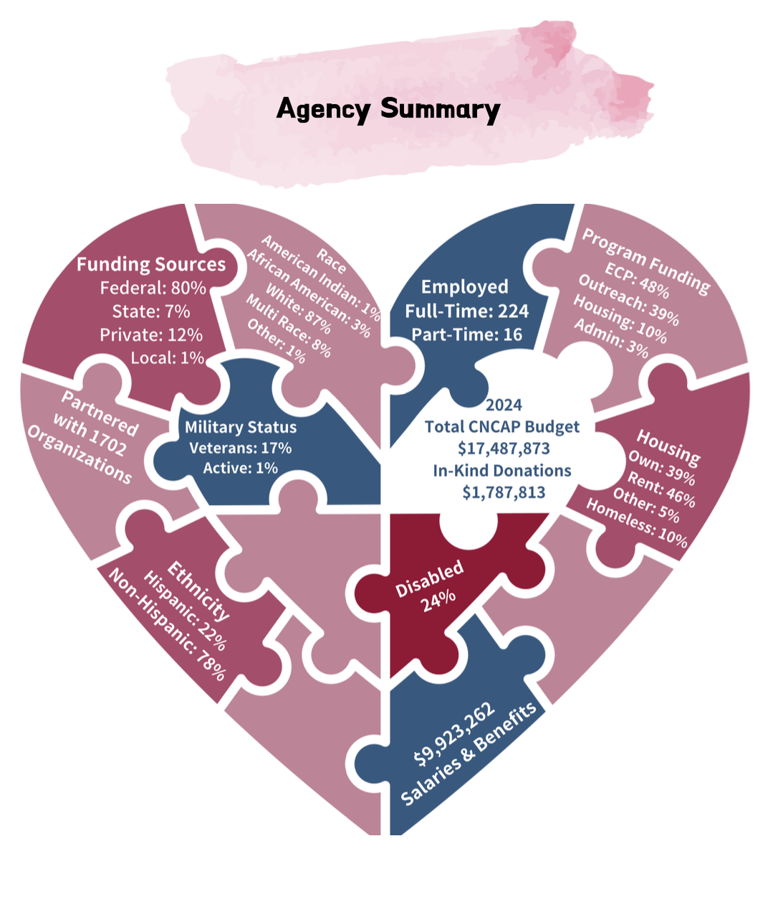

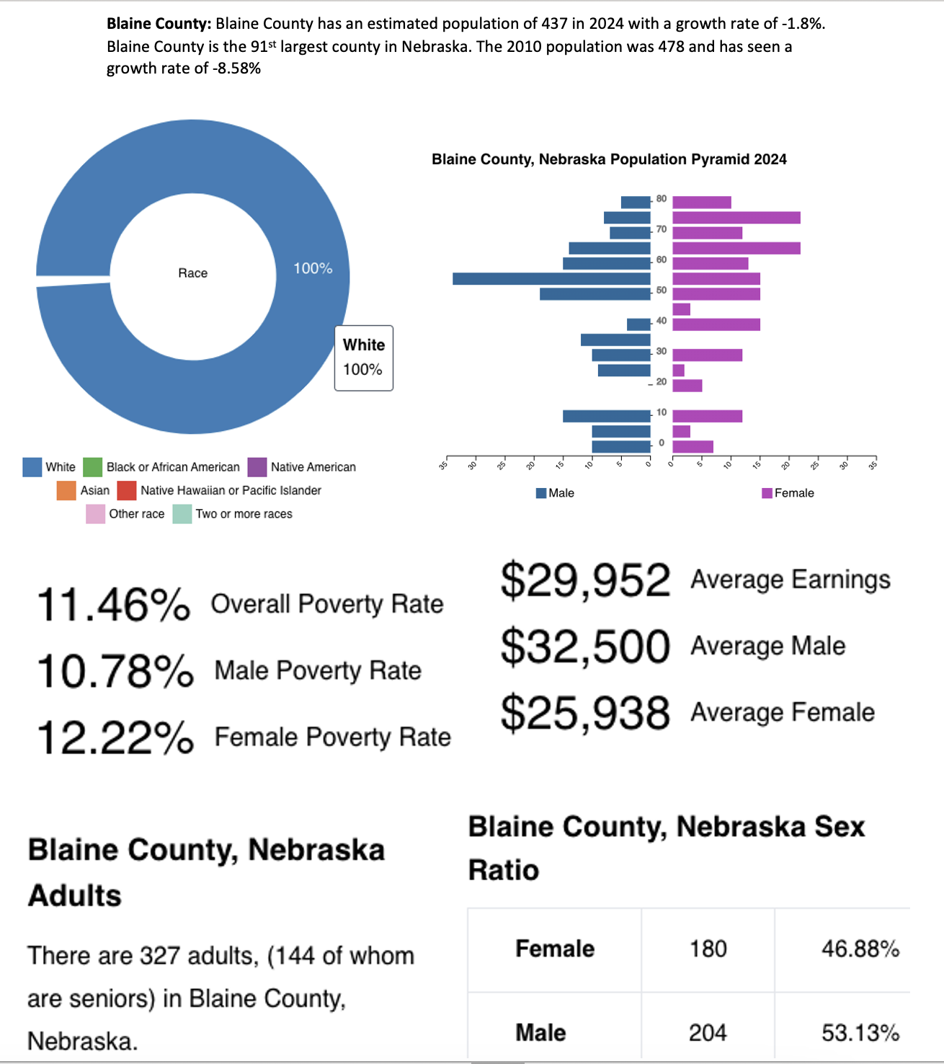

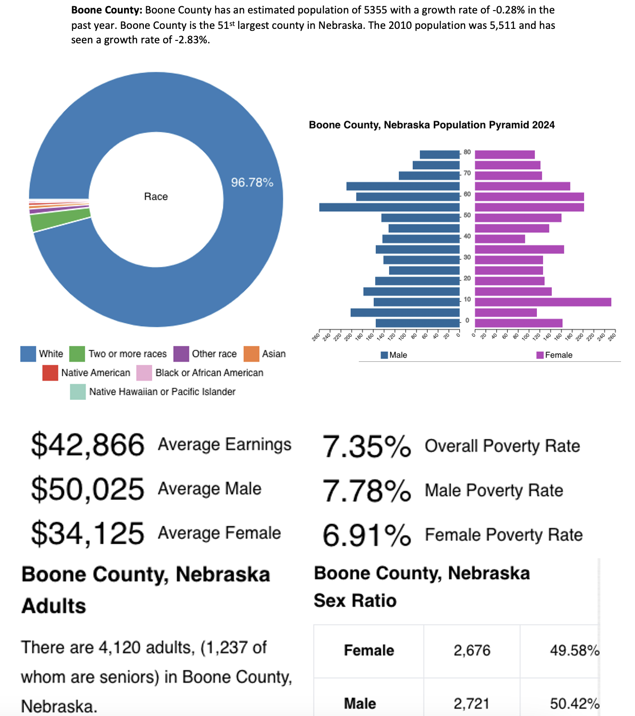

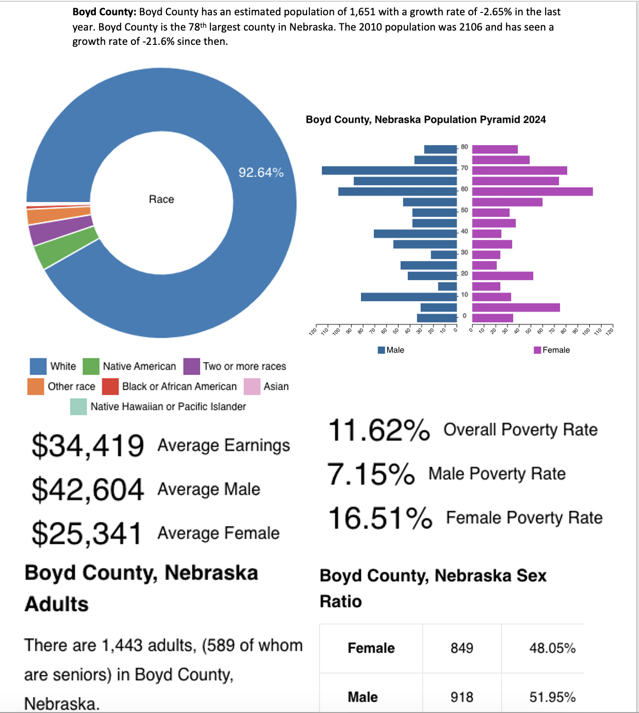

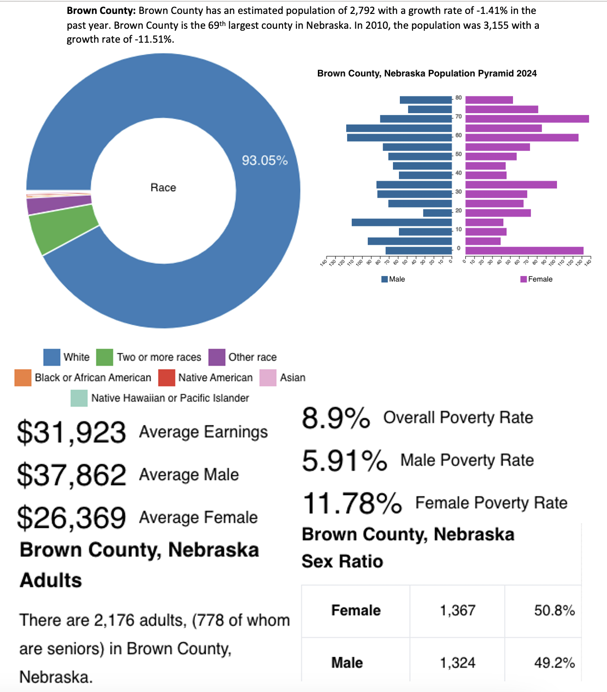

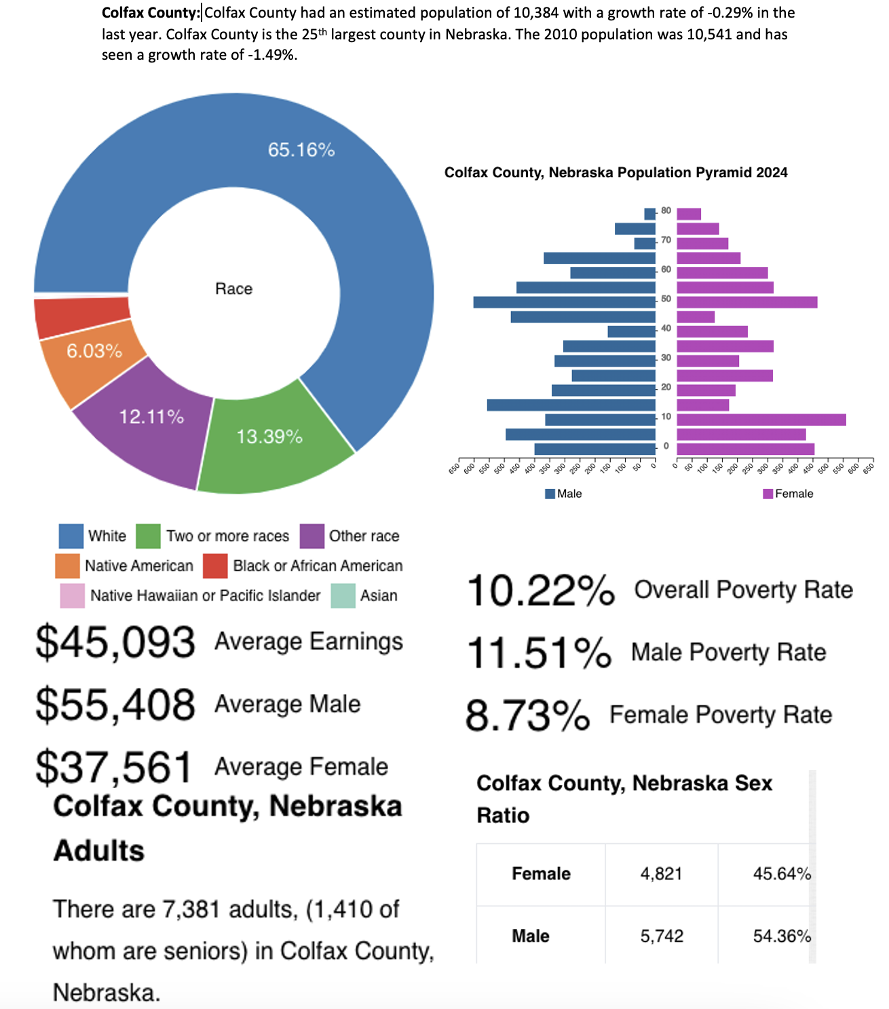

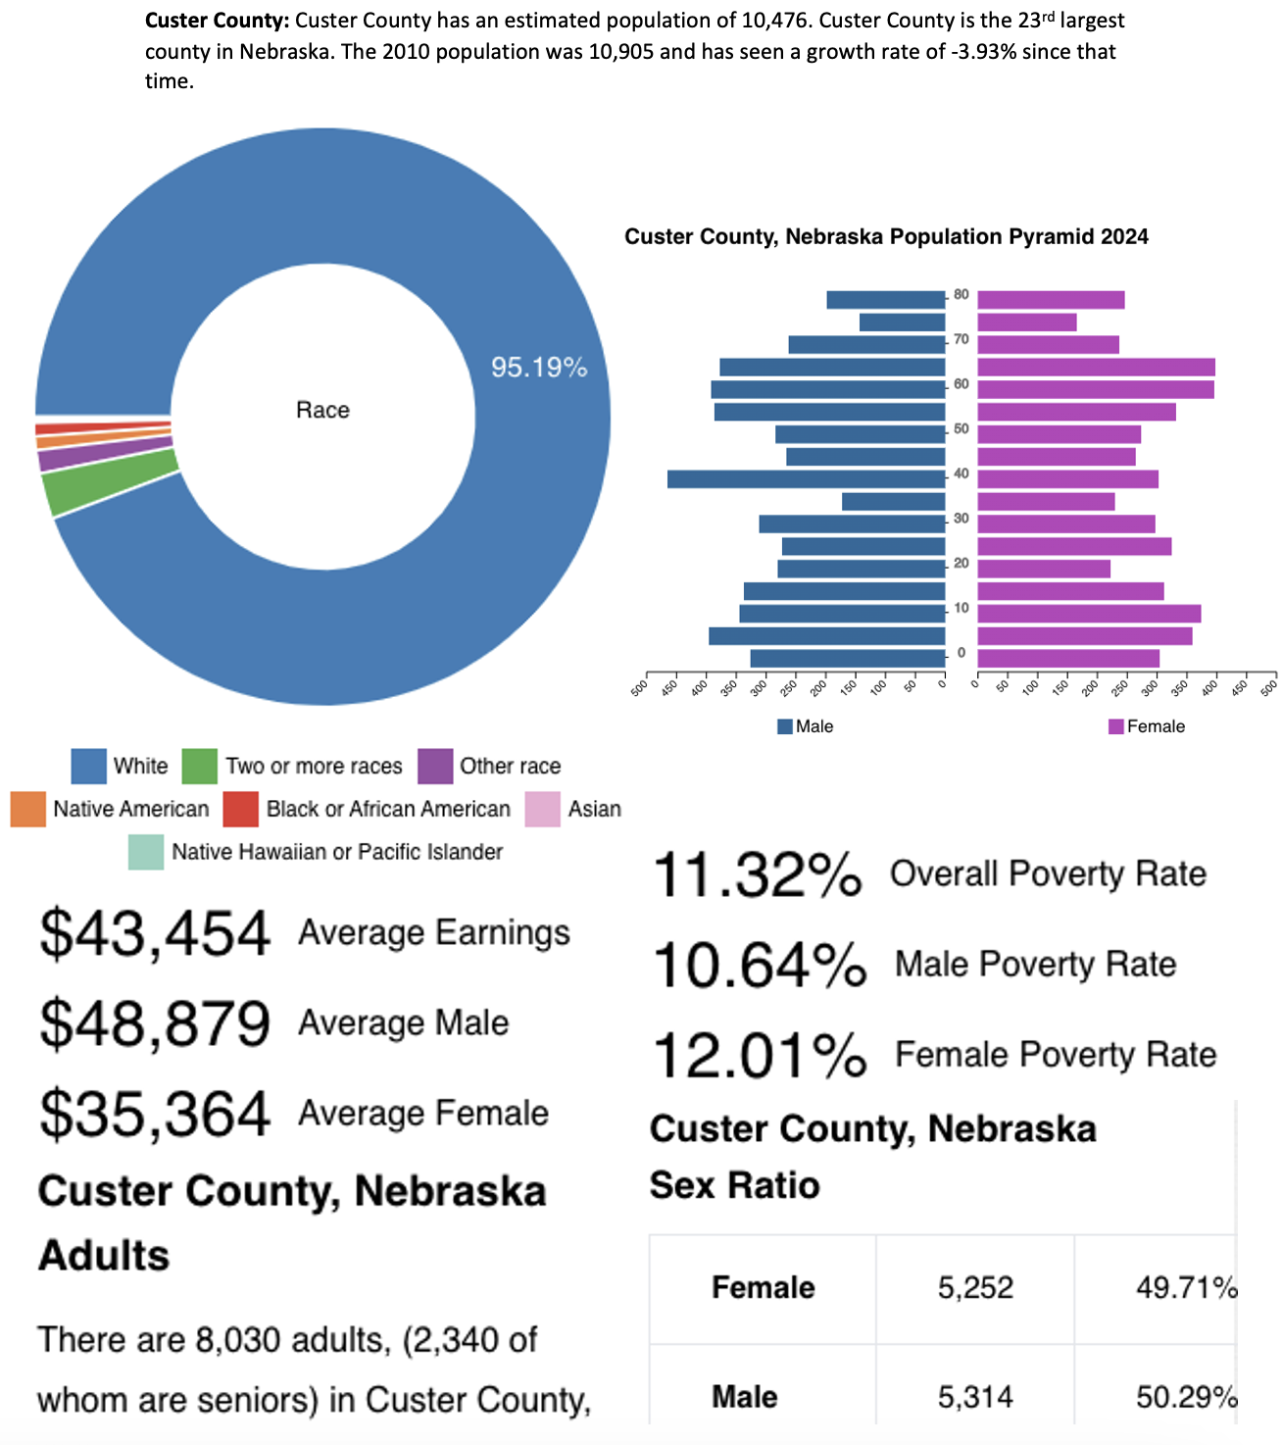

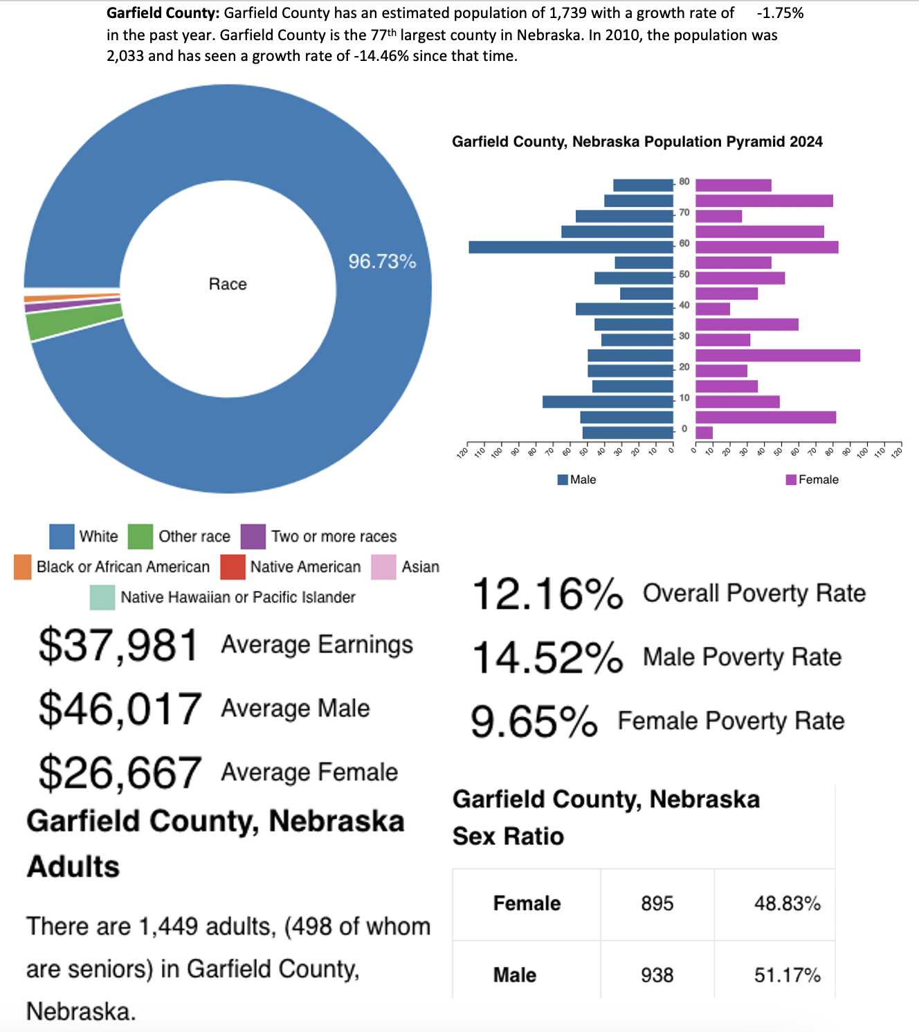

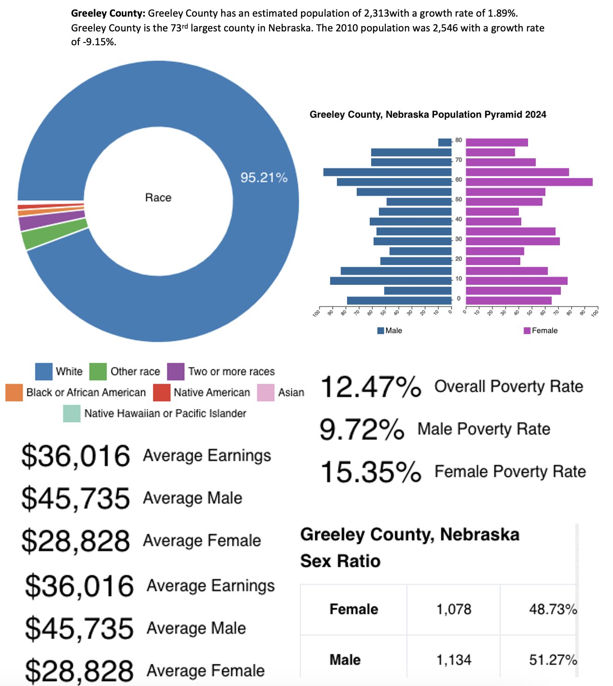

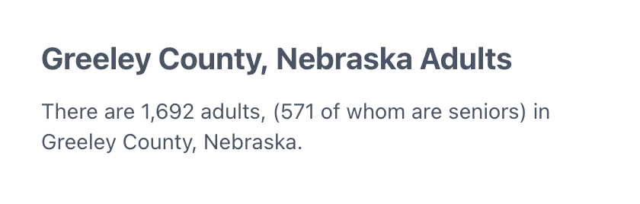

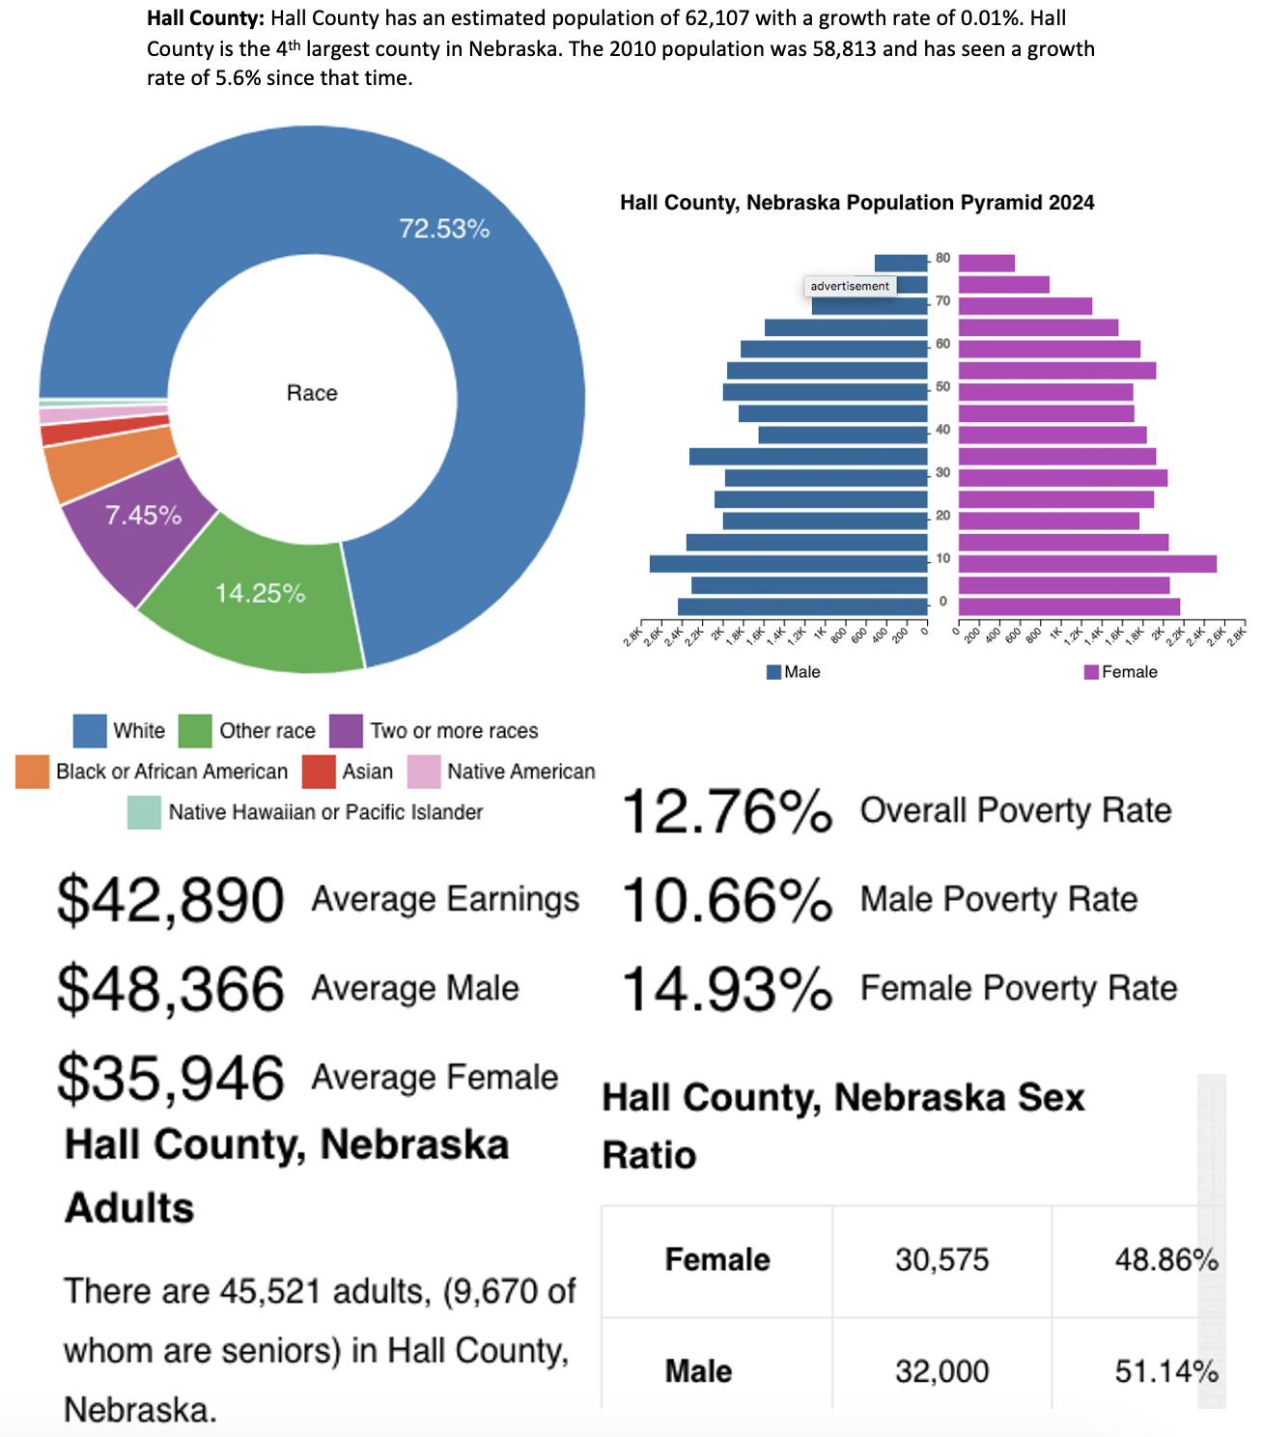

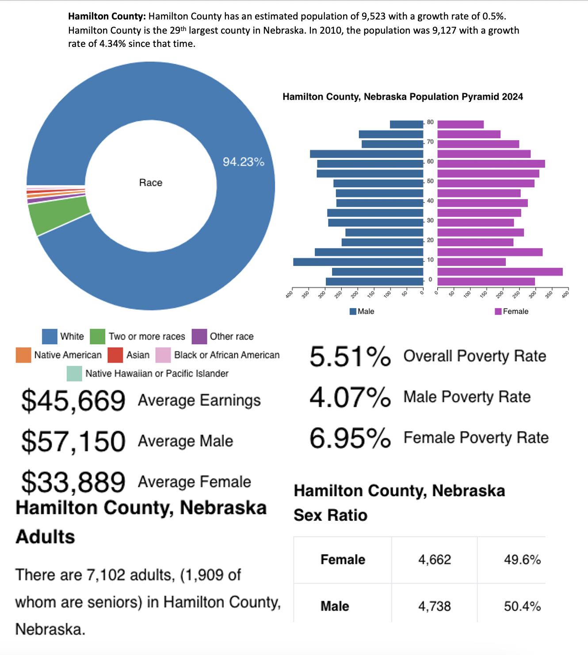

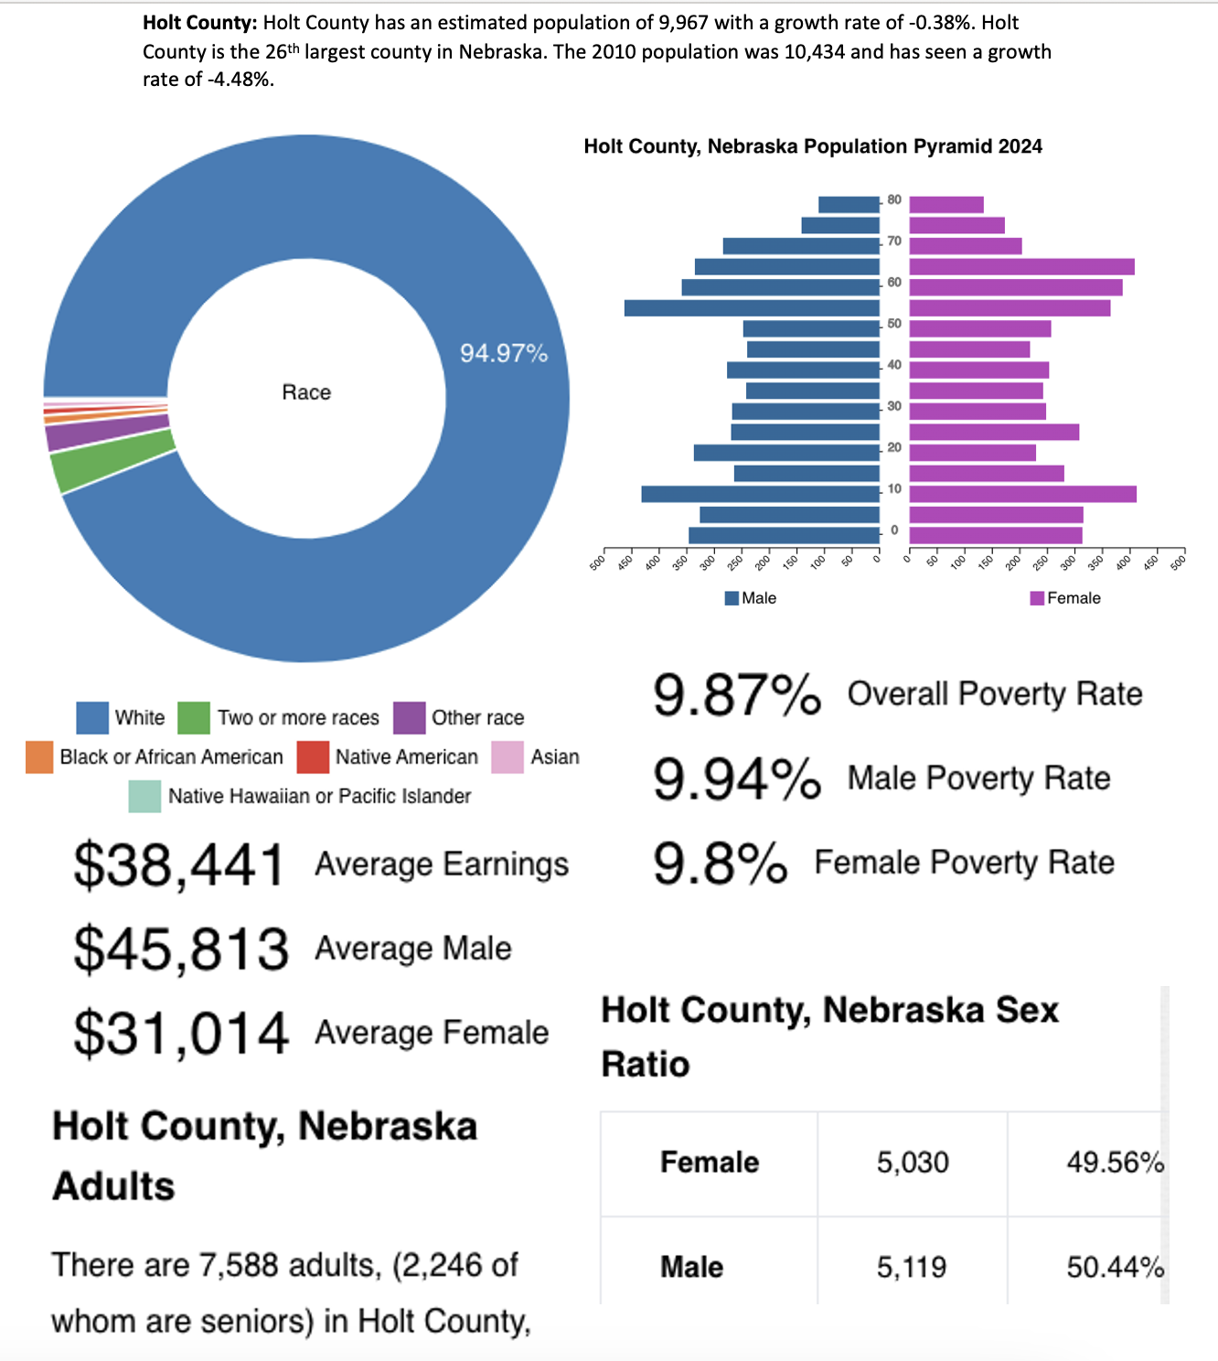

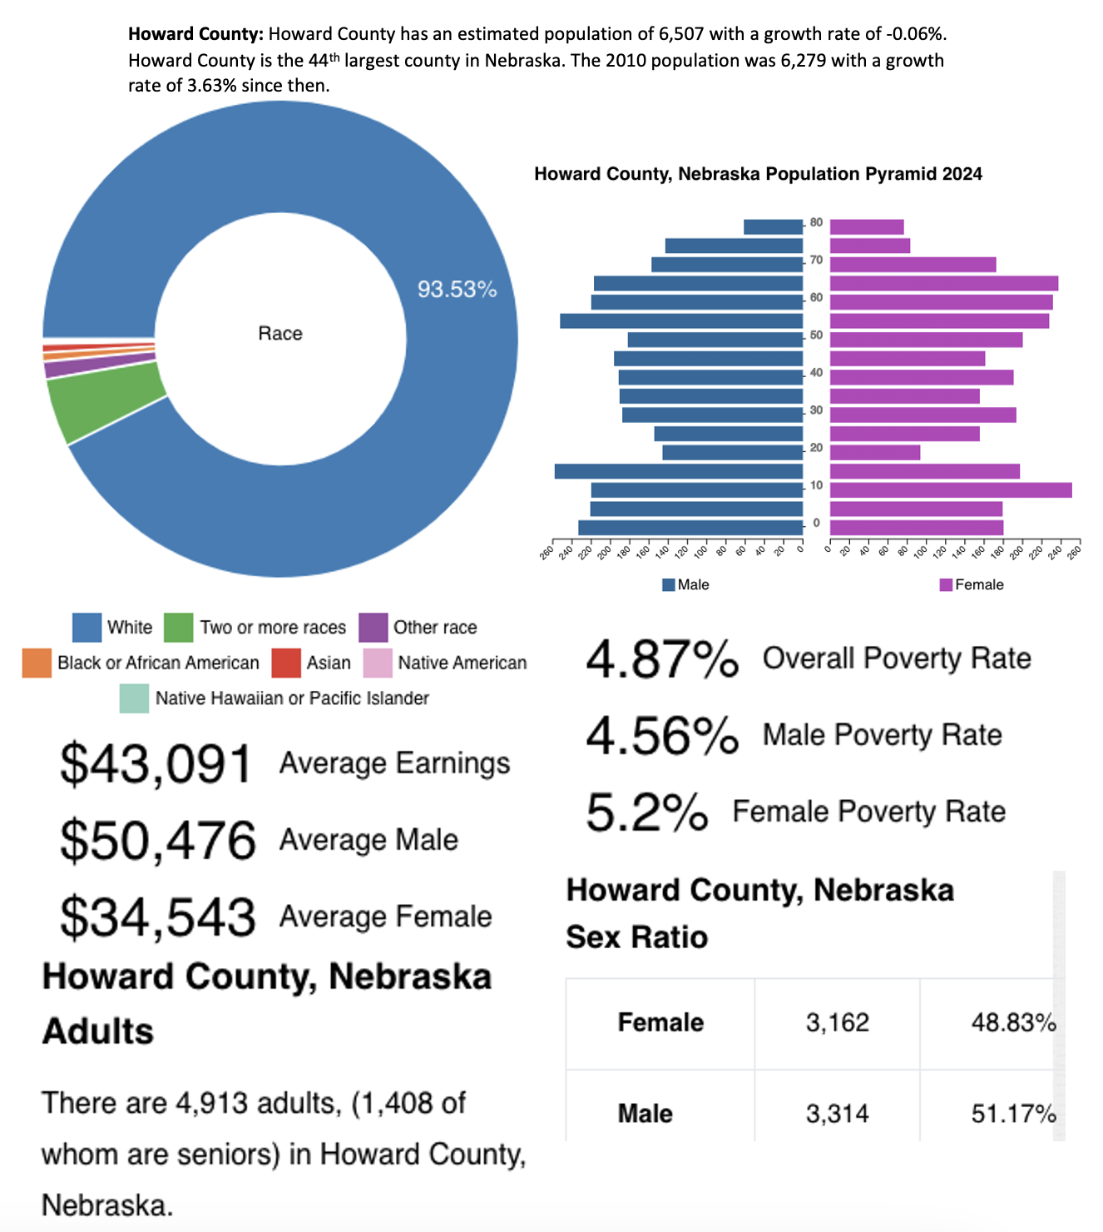

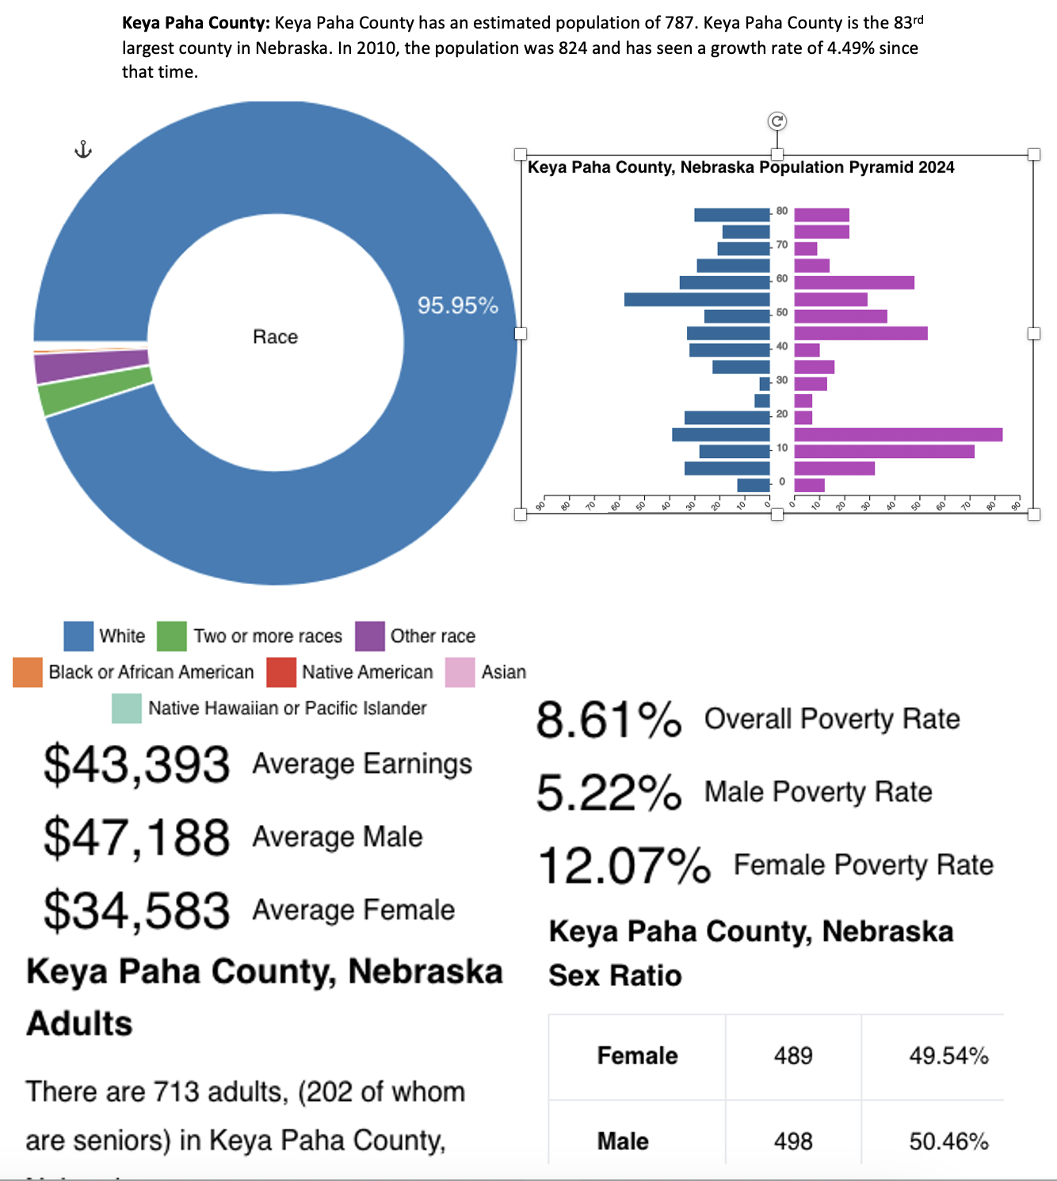

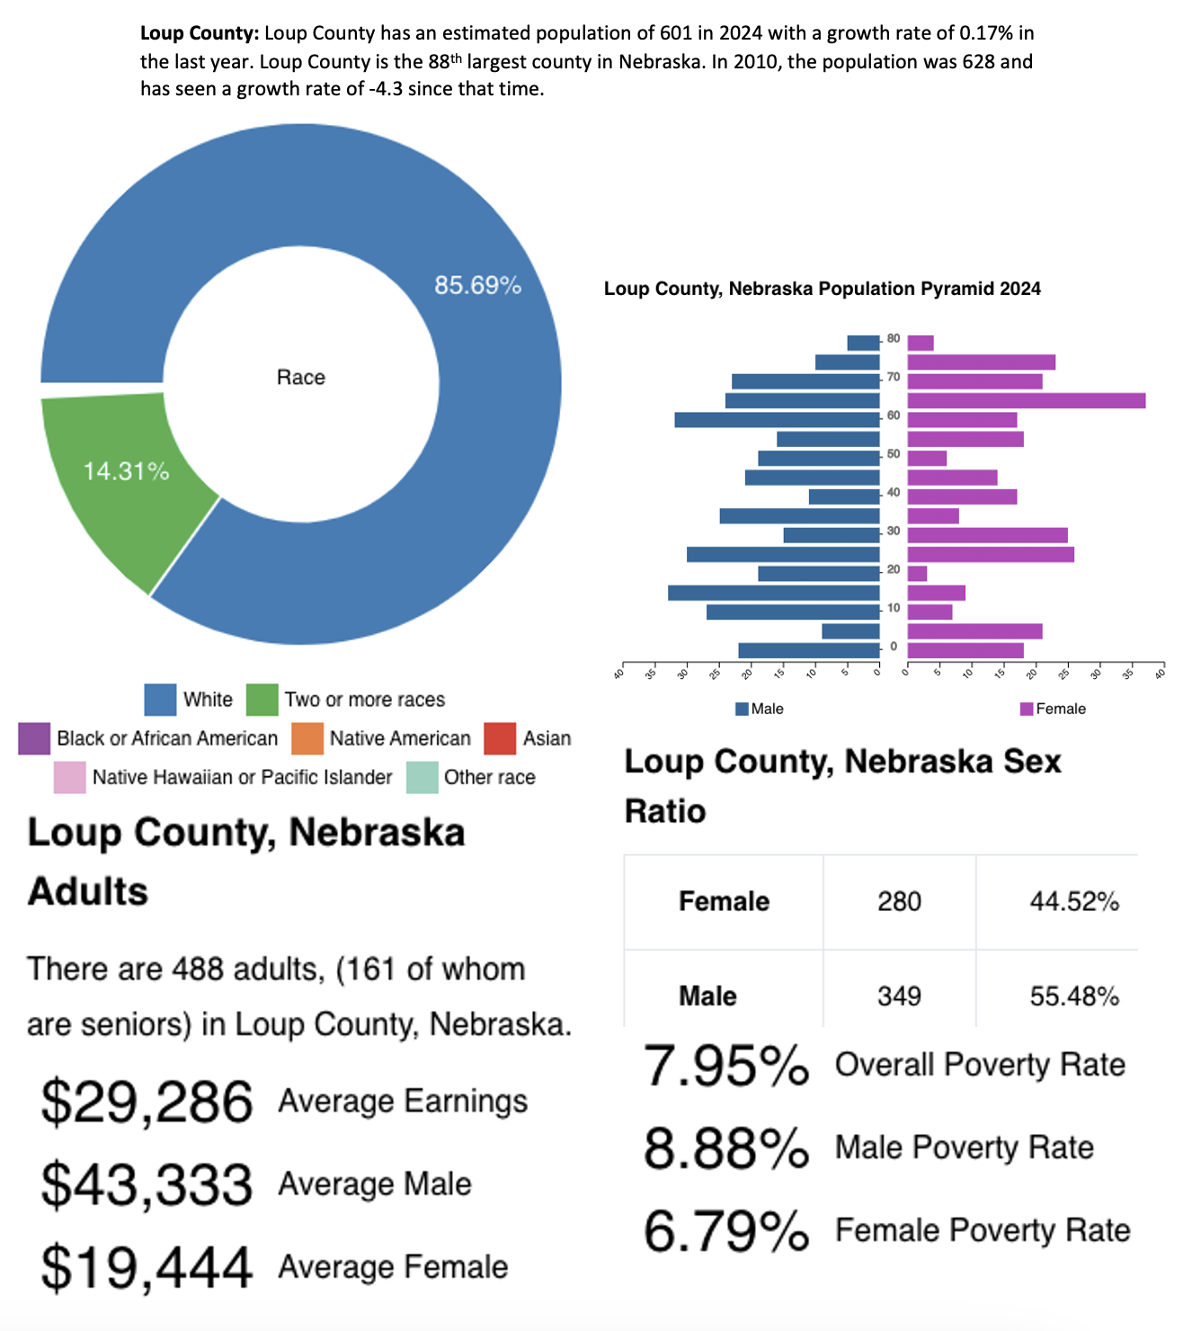

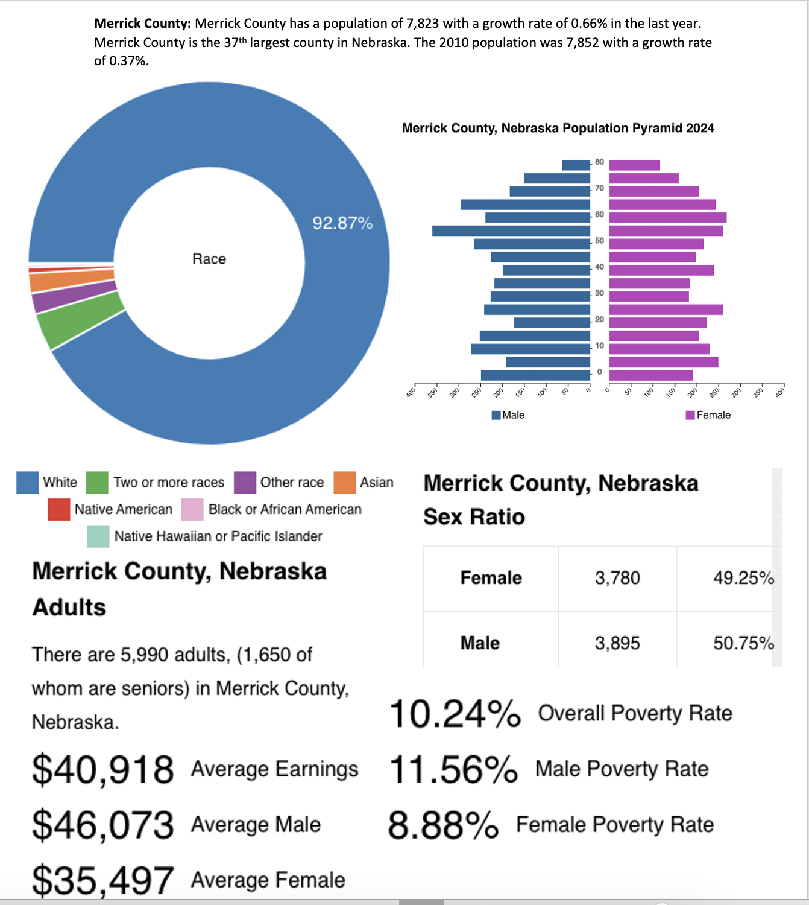

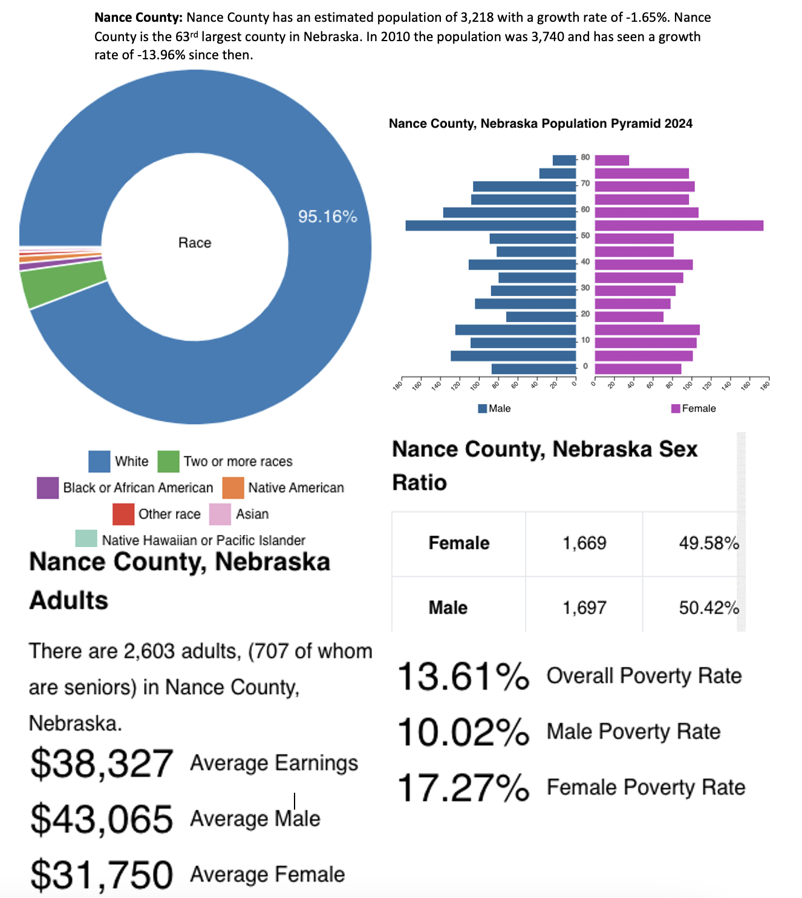

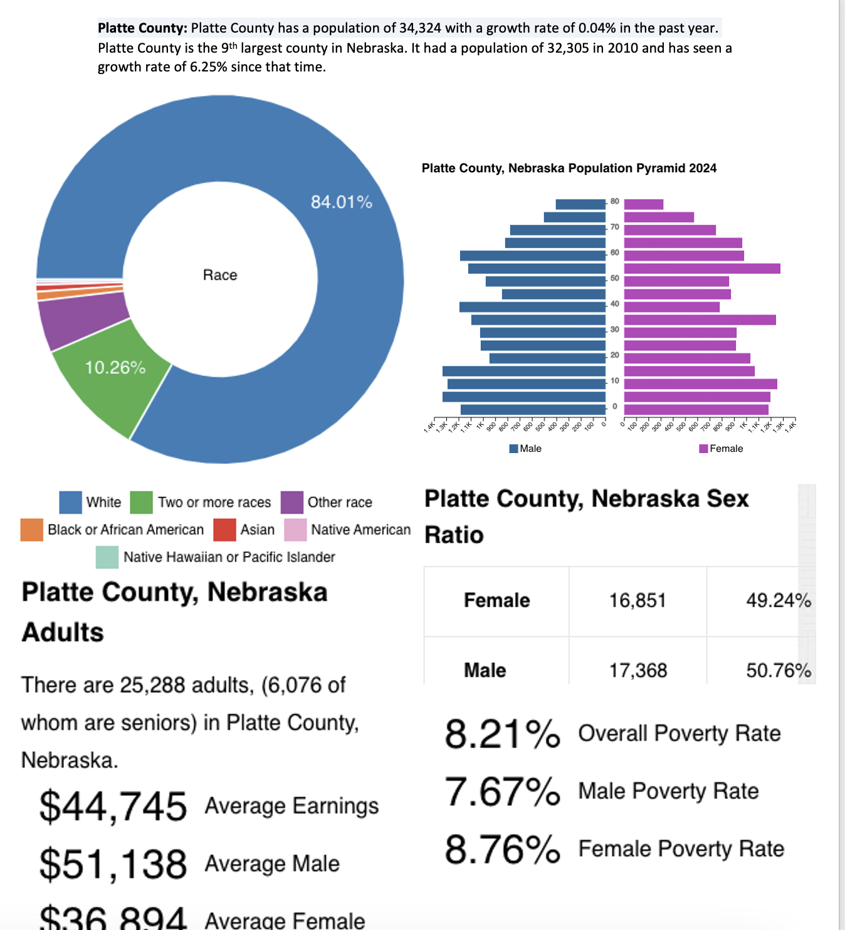

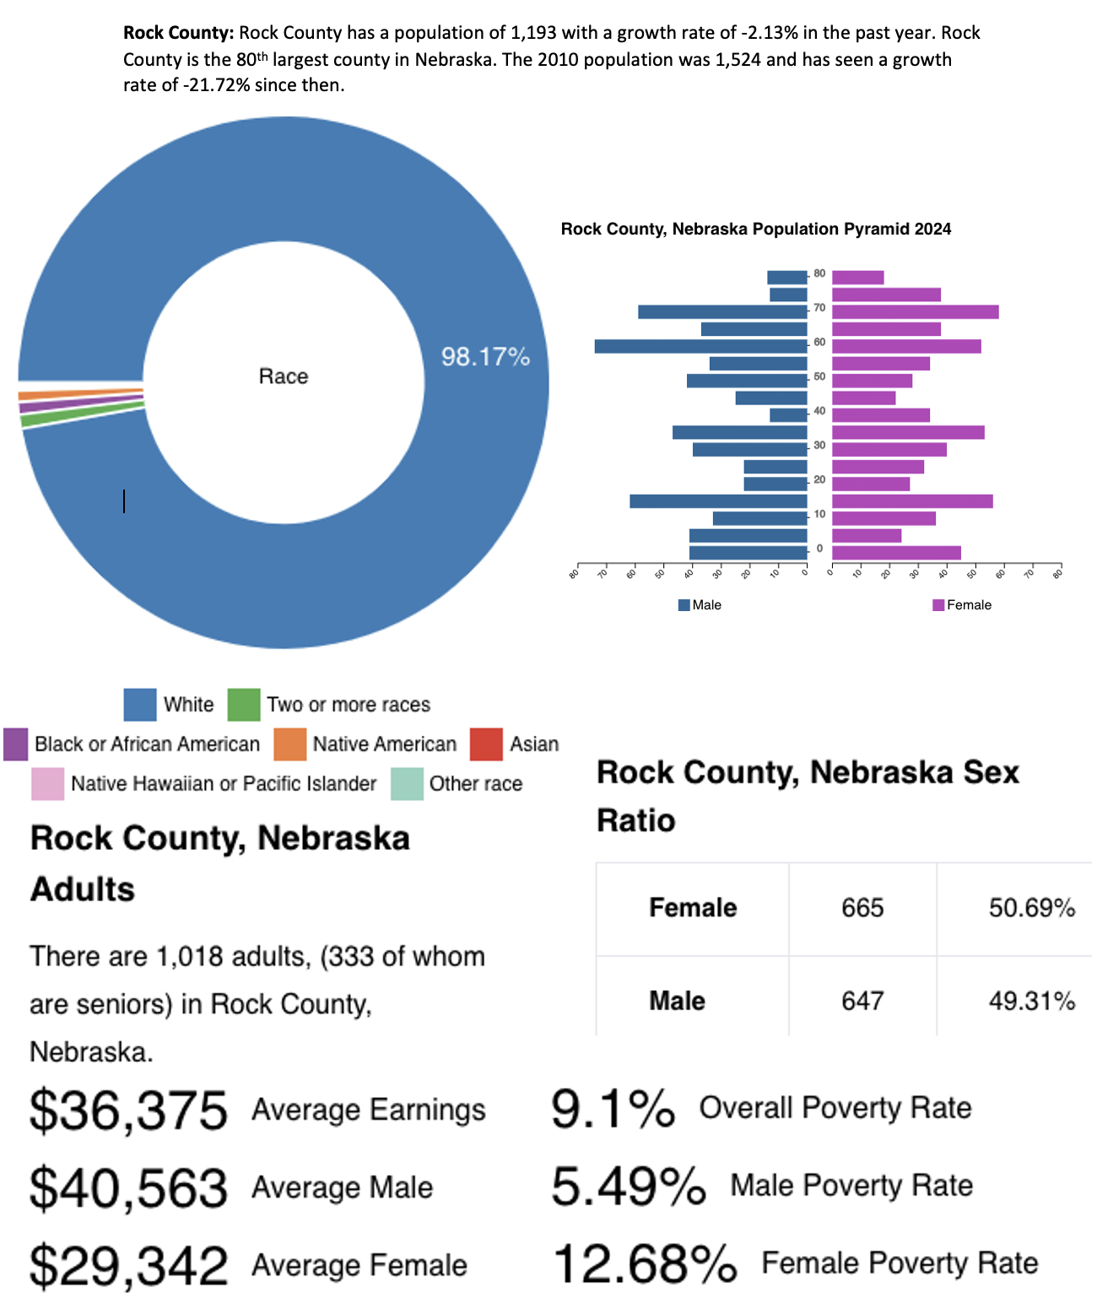

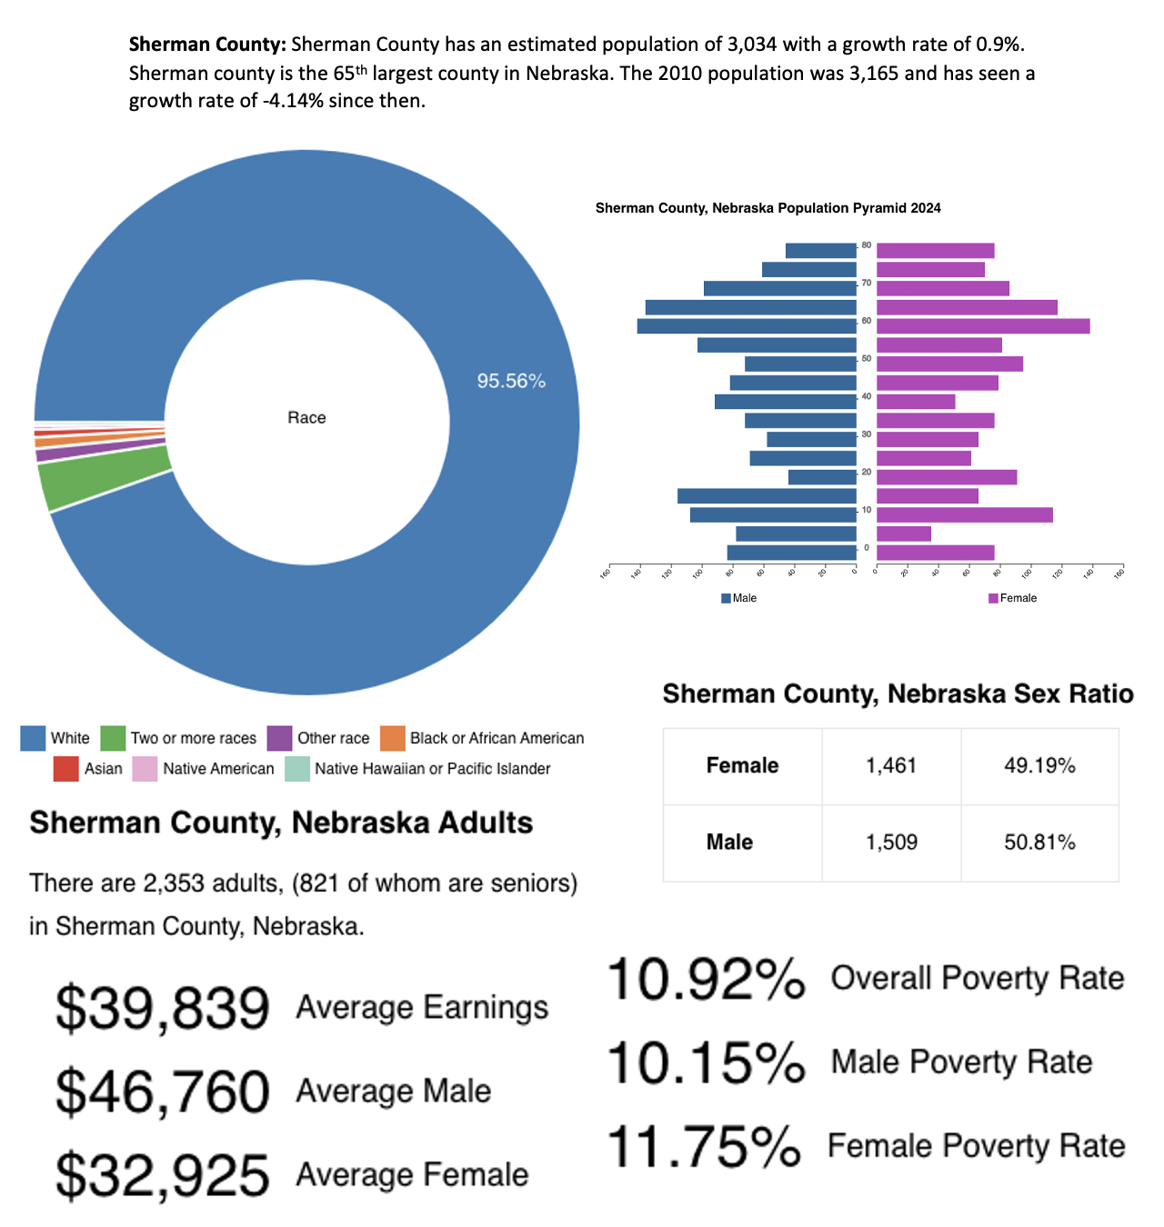

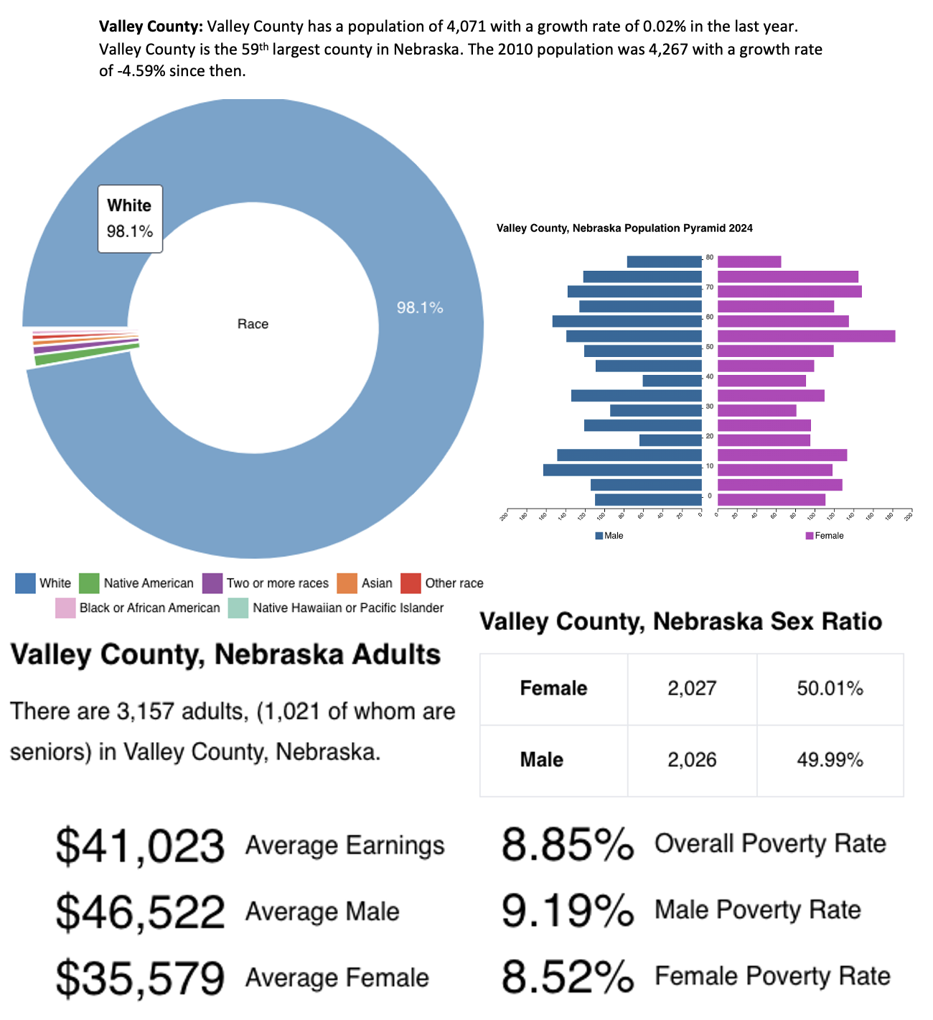

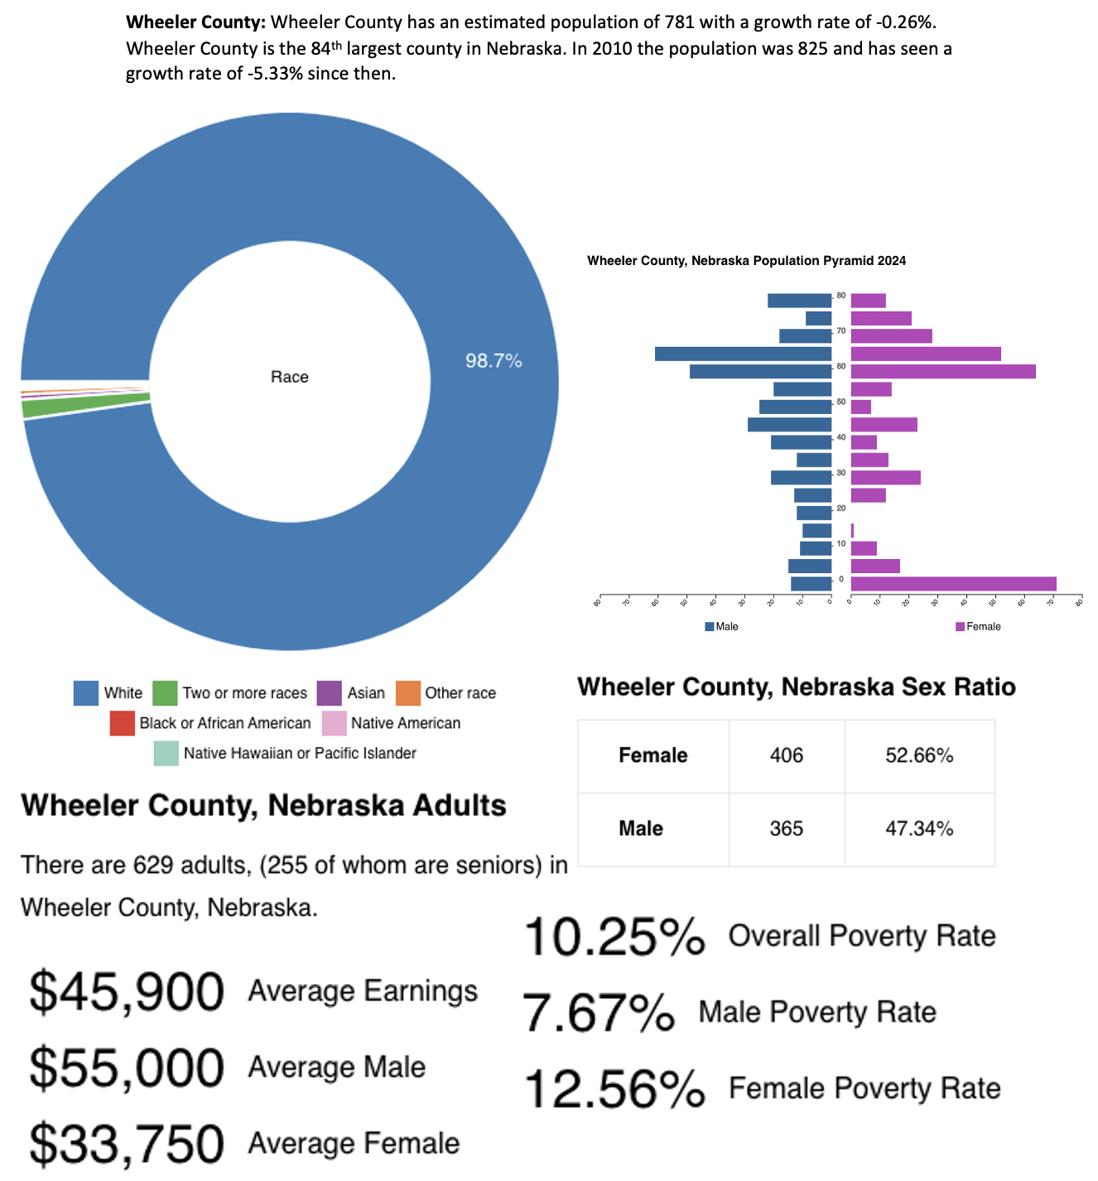

The demographics of the CNCAP service area is essential to the programs and their efforts. From determining each and every community need, to the needs of a specific family, the data and research provided helps to make a difference in the lives of every community. This helps to determine where we can utilize our best efforts to encourage both growth and stability among each and every community. By knowing the age of the population among our service area, we can identify their specific needs. The aging population spends more on health care and commuting to places of need, while the younger population is concerned about access to quality income, daycare, education for their children. These may be harder to access in rural communities due to distance and lack of availability.

Economy

Income
Median income is the amount which divides the income distribution into two equal groups, half having income above that amount, half having income below that amount. Mean income (average) is the amount obtained by dividing the total aggregate income of a group by the number of units in that group. The means and medians for households and families are based on all households and families. Means and medians for people are based on people 15 years old and over with income.

The county with the highest average income was Colfax County at $99,448.00 this year. In the previous year, Hamilton County was the highest median income. Colfax and Hamilton are a couple of the more urban counties within the service area. This is part of what draws the younger generation out of rural communities in search of more opportunity. The county with the lowest average income is Loup county with $66,438.00. This includes the income of the householder and all other individuals 15 years old and over in the household, whether they are related to the householder or not. Because many households consist of only one-person, average household income is usually less than average family income. Nebraska’s average household income is $100,193. Although Colfax county remains close to the state average, there is a large gap for counties like Loup county.

The cost of living in Nebraska remains the same as the previous year at 9% lower than the national average. Housing is 21% lower, utilities is 14% lower, food is 4% lower, healthcare is 2% lower, and transportation is 1% lower. These numbers stayed close to the same as the previous year, but food went from 5% lower down to 4% lower. The median income for Nebraska is $74,985 compared to the United States at $78,538.https://www.rentcafe.com/cost-of-living-calculator/us/ne/

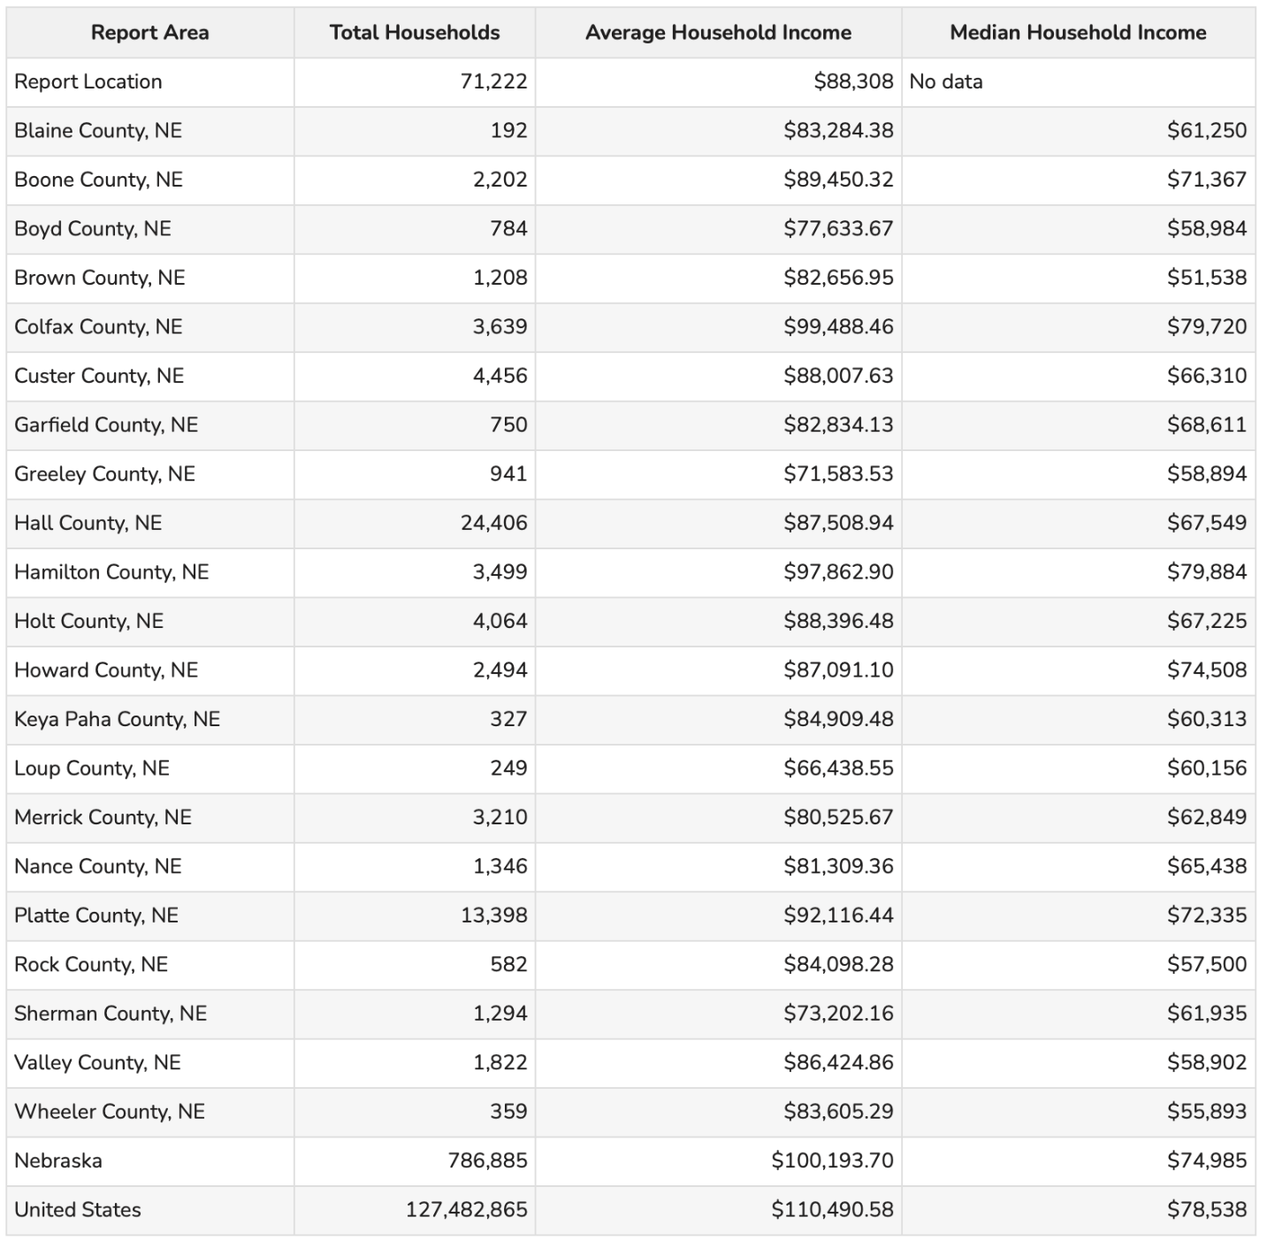

In order to live comfortably in the state of Nebraska, a family must make 3,630/month and a single person must make at least $2,600. This is the absolute minimum a person must make.

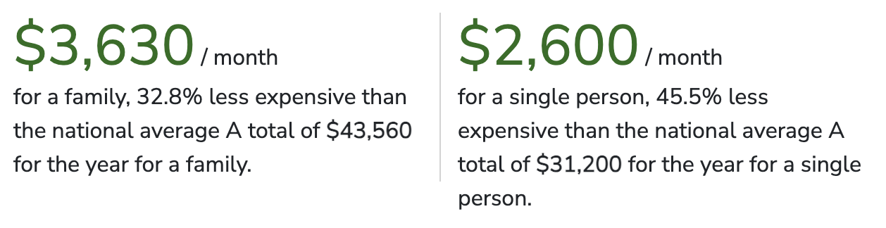

The living wage is the hourly rate that an individual in a household must earn to support themselves and/or their family, working full-time or 2080 hours per year. The tables below provide living wage estimates for individuals and households with one or two working adults and 0-3 children. In households with two working adults, all hourly values reflect what one working adult requires to earn to meet their family’s basic needs assuming the other adult also earns the same. This data is current as of February 10, 2025.

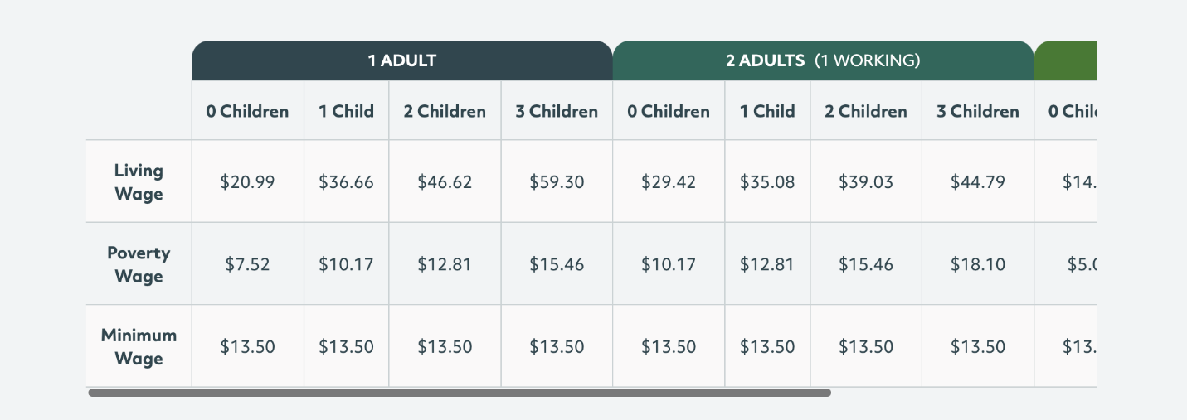

The table below shows the cost of each basic need that goes into the living wage estimate.

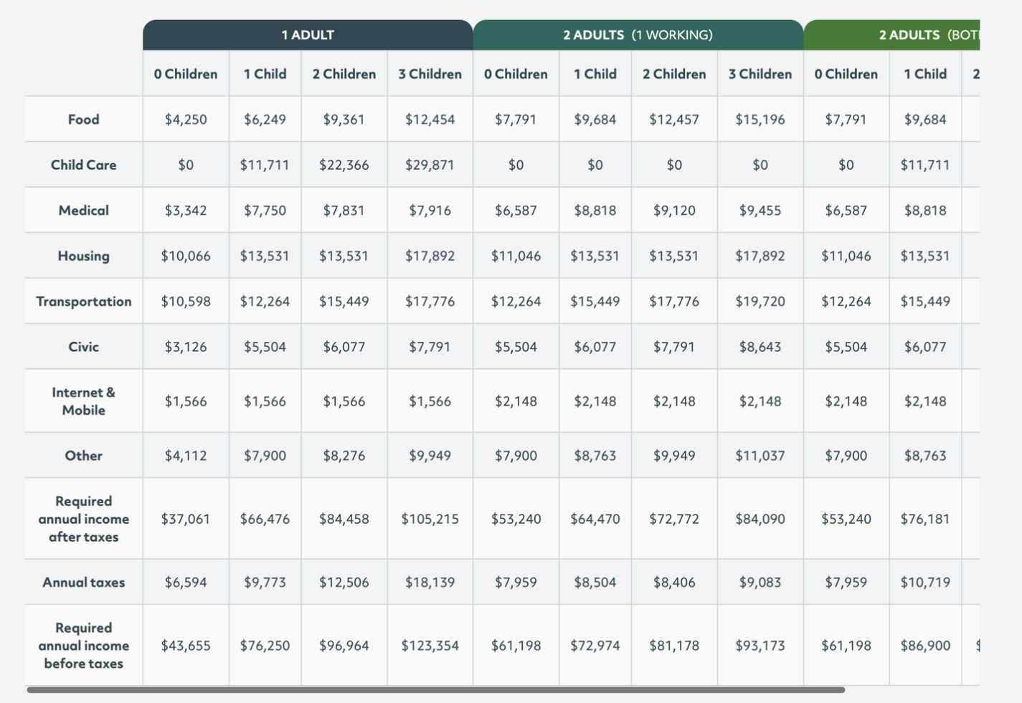

The average wage in Nebraska is about $1.1k per week in Nebraska as of December of 2024. This is about 3.3% higher than a year before. These average weekly earnings are lower than the US overall. In Nebraska, workers in the financial activities sector had the highest average weekly earnings at $1,619 per week and leisure and hospitality workers had the lowest at $468.00

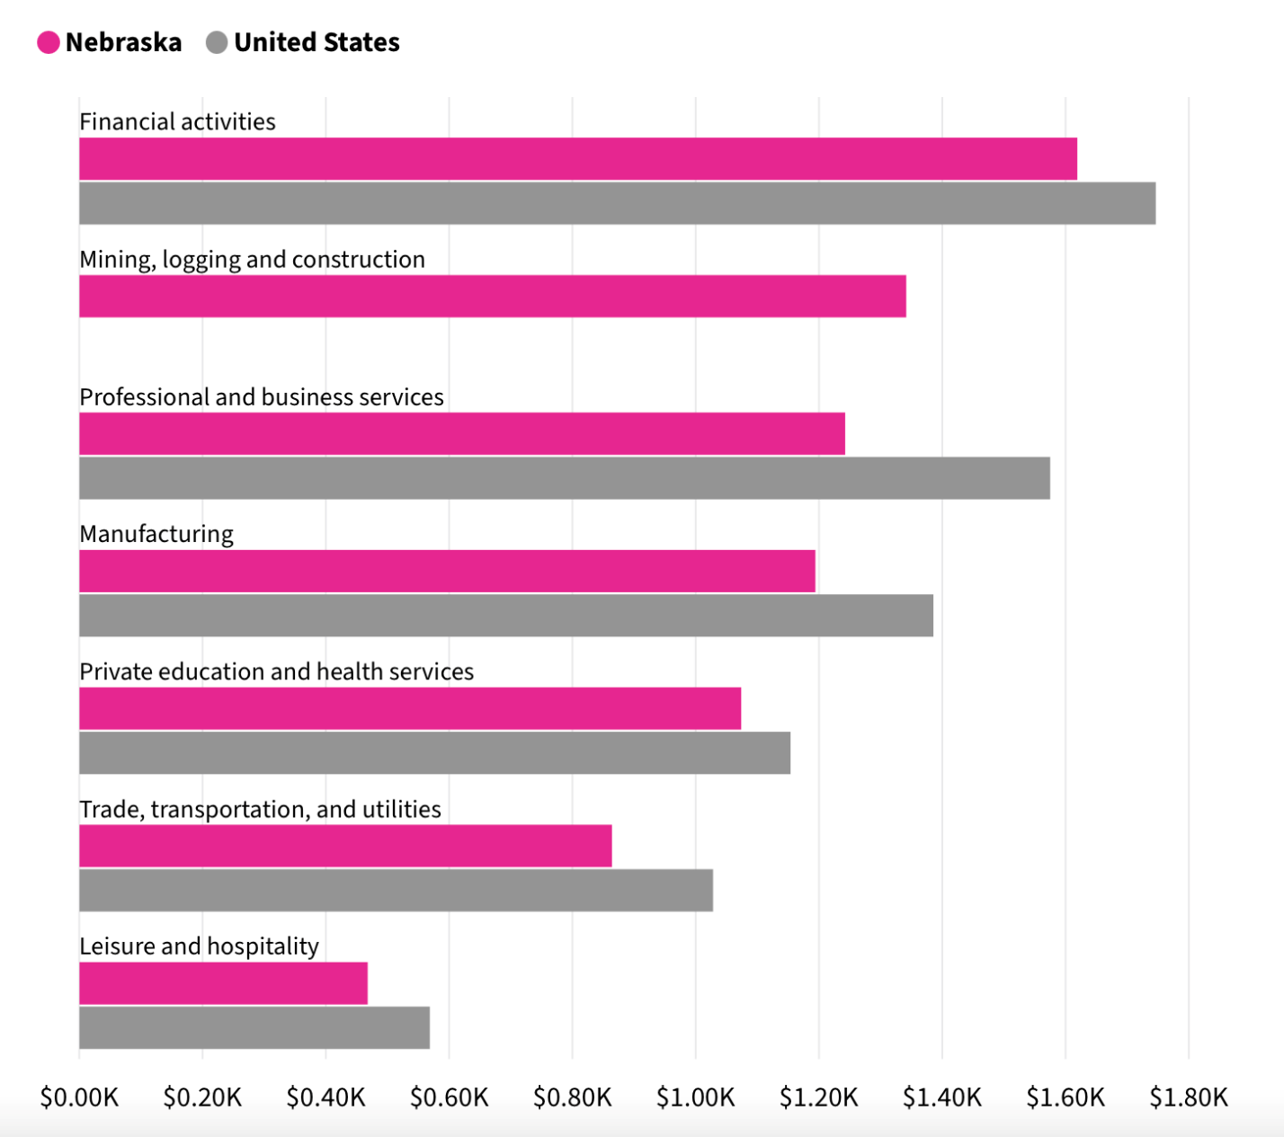

Grand Island is among the top 5 for highest wages. Grand Island is the largest city within the service area and also one of the largest cities in the state.

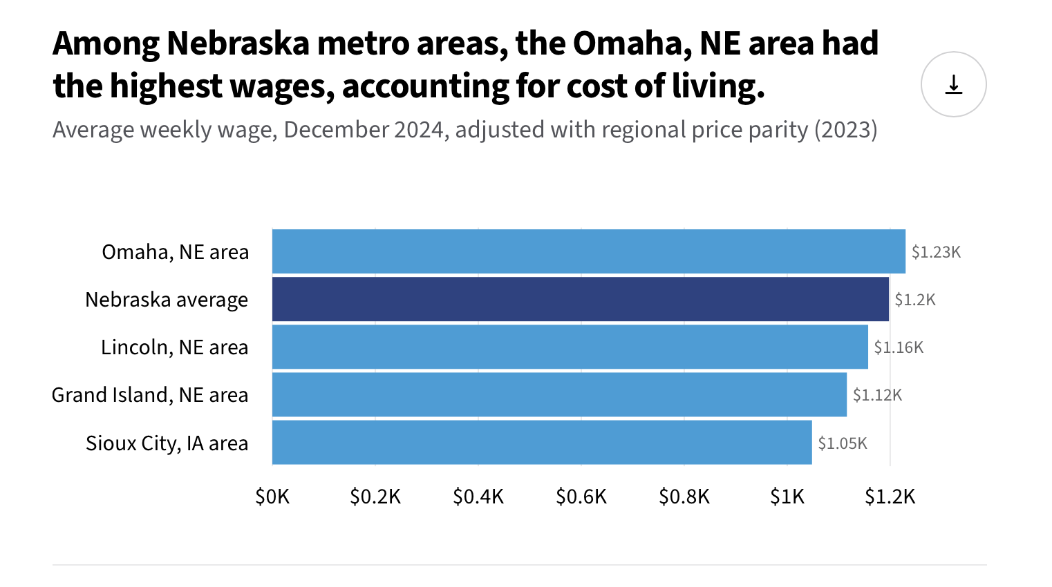
https://usafacts.org/answers/what-is-the-average-wage-in-the-us/state/nebraska/
https://livingwage.mit.edu/states/31

The minimum income needed for basic needs in Nebraska:
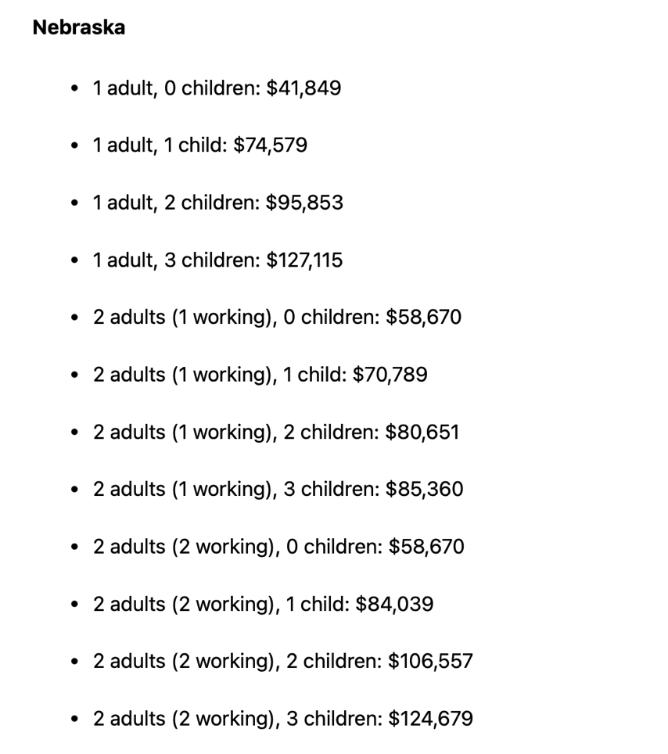

POVERTY

The federal poverty level in Nebraska remains the same as the previous year at $15,060.00 for an individual and $32,150 for a family of four. As the population of the service area has gone down from 177,387 to 176,885. The population living in poverty has increased to 17,642. Poverty creates barriers to access including health services, healthy food, and other necessities that contribute to poor health status. The percentage of CNCAP’s service area living in poverty has increased to 9.98% in the last year. This number has been on a steady incline over the years. Nance county has the highest poverty rate at 16.13%. Wheeler County has the lowest percentage living in poverty at 5.22%. This is a large spread among the counties. There are 7,939 males living in poverty and 9,703 females. Both of these numbers have increased since the previous year.
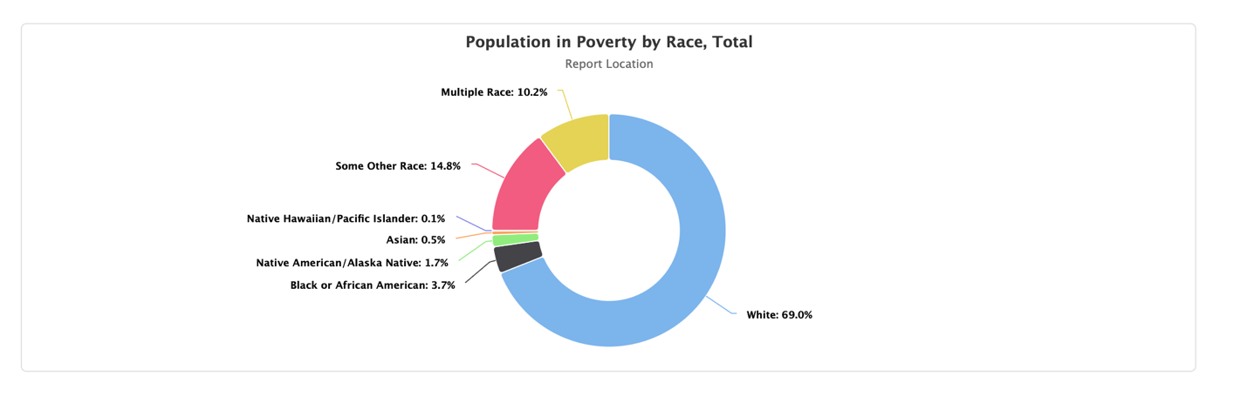

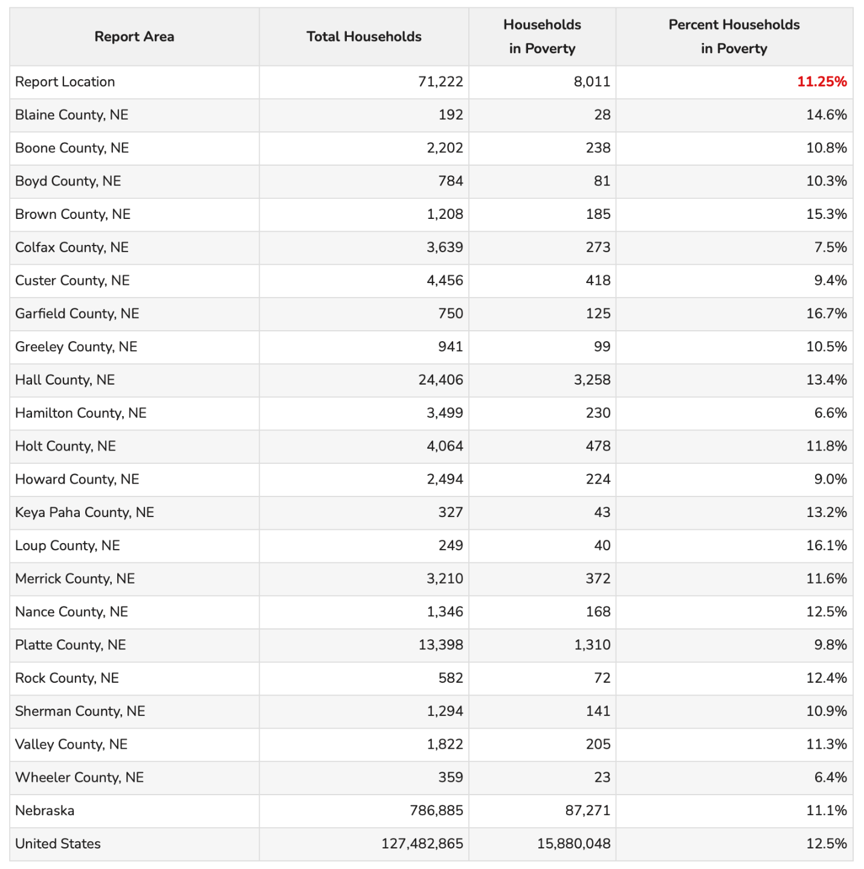
In the previous year, there were 70,312 total households with 6,931 living in poverty. This was a poverty rate of 9.86% This year the poverty rate for the service area is 11.25%. This number is on the rise. There are 1,761 households in poverty with a female householder, compared to 212 households that have a male householder.

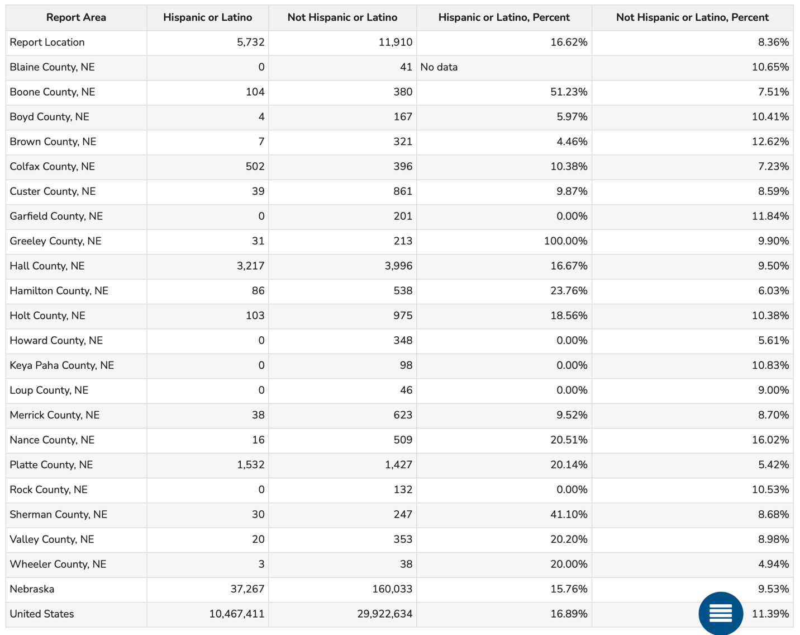
There are 45,862 people under the age of 18 living in the service area, 5,405 are living in poverty, or 11.79%. Nance county has the highest poverty rate under 18, at 22.11%. Wheeler county has the lowest poverty rate at 1.54%. Of these 5,405 children, 2,598 are female and 2,807 are male.
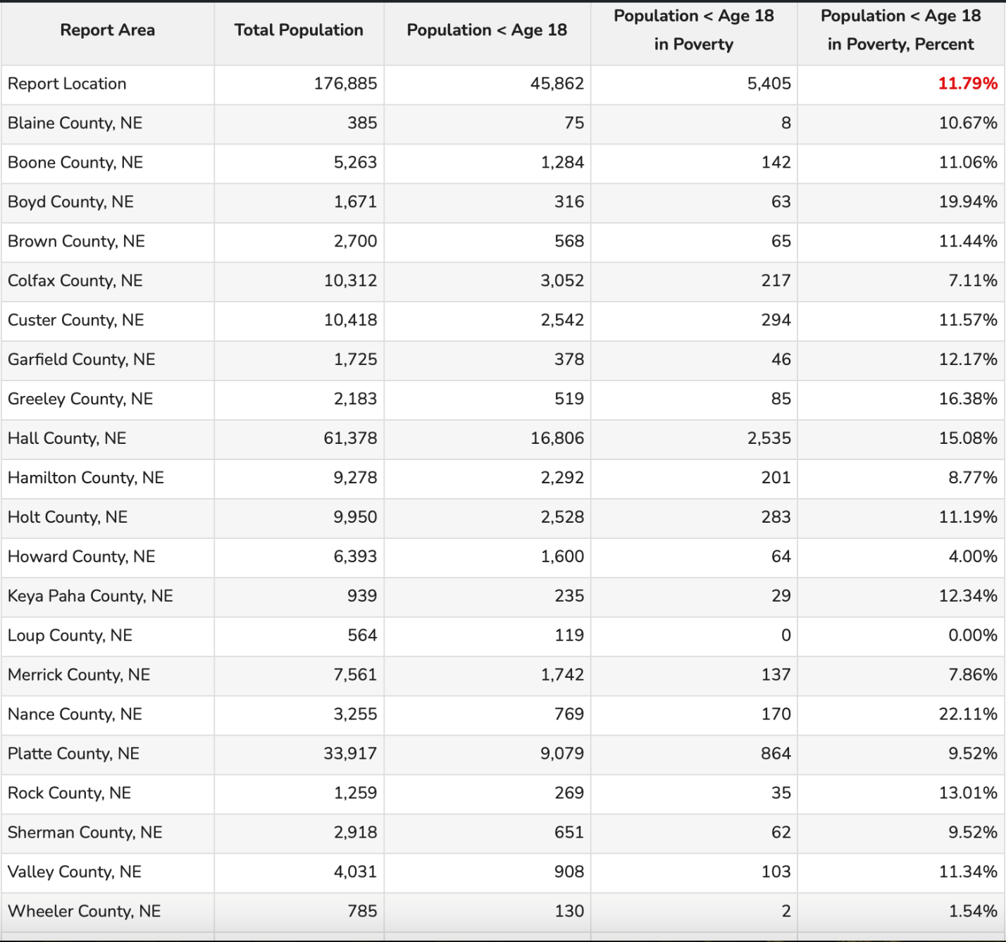
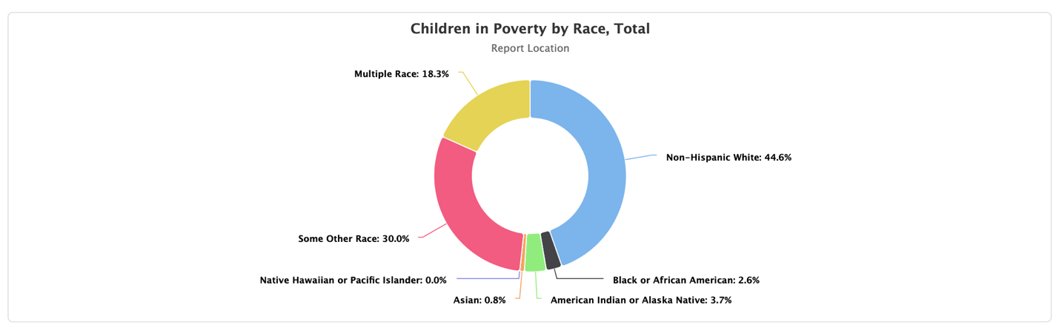
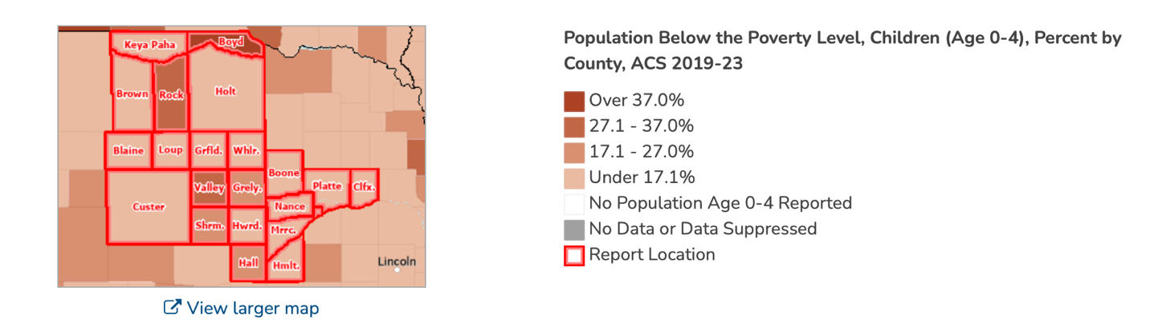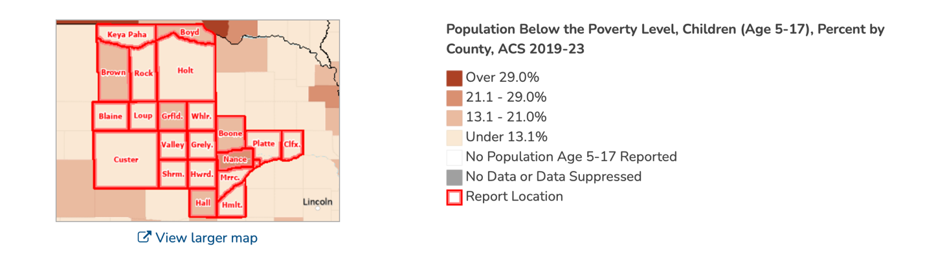
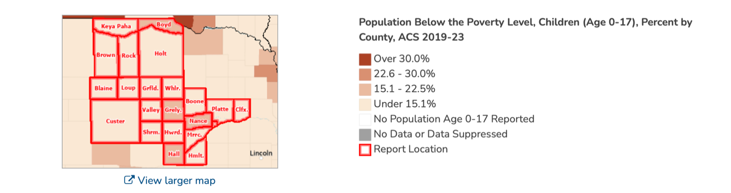

Of the estimated 179,828 total population in the report area, an estimated 34,102 persons are adults aged 65 and older, representing 18.96% of the population.
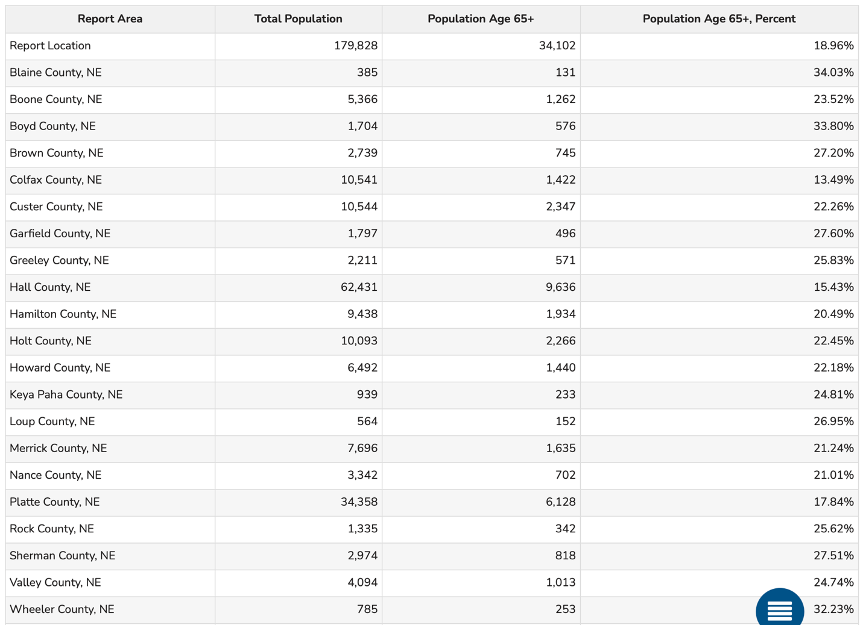

The annual cost of raising a child in Nebraska is $22,773.00 and the cost of additional housing for families is $2419.00. The annual cost of childcare is $11,231.00 and the additional cost of food is $1,883.00. Timing, geography, economics and health can affect the cost of raising a family. Big cities do tend to have higher living costs and smaller communities may be more affordable.

According to USDA data and inflation statistics from the BLS, raising a child in 2023 could cost an average of $331,933 from the time the child is born to age 18. The average cost to raise a child in 2015 was an estimated $233,610. There has been a stark increase since that time. Based on the 2015 data from the USDA, a married couple with two children could expect to spend $12,980 annually per child. However, accounting for inflation, today this number is more likely to be in the neighborhood of $16,978 per child.

According to the USDA, child related expenses account for about 16 percent of what a middle-income family spends its before-tax income on. And of the money an average two-child, married couple family spends on a child, the USDA says they will spend 29% on food, 18% percent on food, 16% on childcare and education, 9% on healthcare, 7% of miscellaneous expenses, 6% on clothing.
https://www.northwesternmutual.com/life-and-money/how-much-does-it-cost-to-raise-a-child/
https://www.parents.com/how-much-does-it-cost-to-raise-a-child-11681839
https://smartasset.com/data-studies/family-minimum-income-state-2024
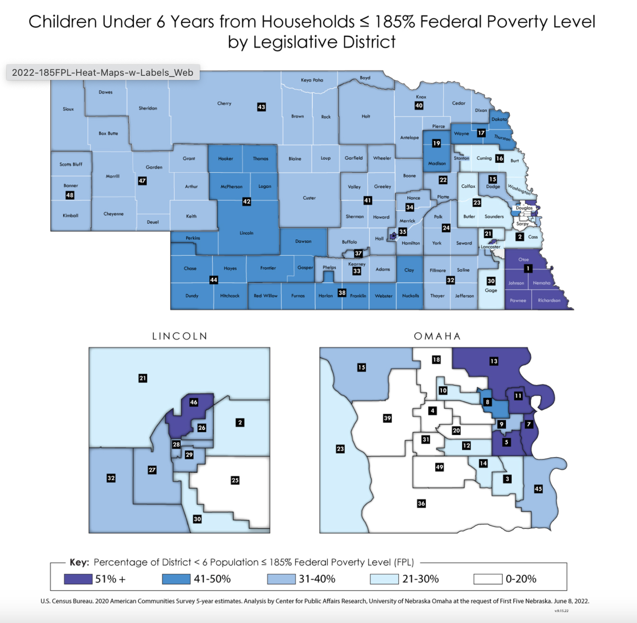

EMPLOYMENT/UNEMPLOYMENT

The unemployment rate in Nebraska as of December 2024, was 2.8%. At this time, the national unemployment rate was 4.1%. Across the state, there were 1,059,931 people in the labor force. Of them, 29,972 were unemployed and 1,029,959 were employed. Nebraska is ranked fifth lowest in the nation for unemployment rates. Nebraska had 29,972 unemployed residents in 2024. In addition, there were 24,200 workers who were employed part-time for economic reasons. This is known as involuntary part-time. These individuals were working part time because of slack work or being unable to find a full-time job.

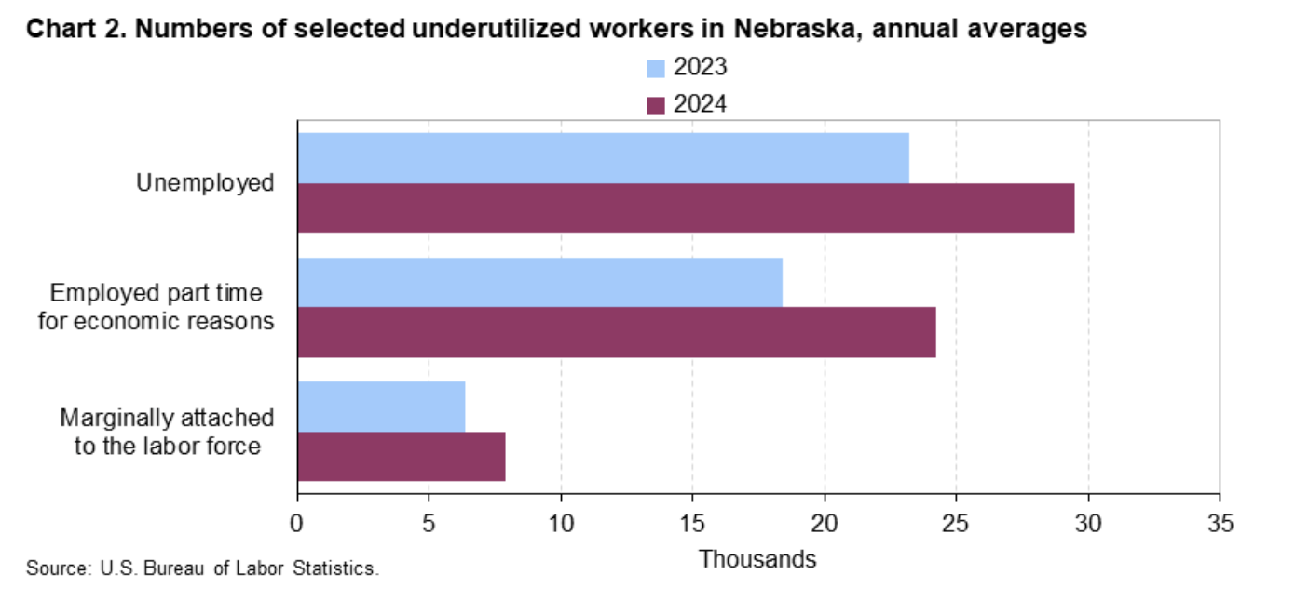
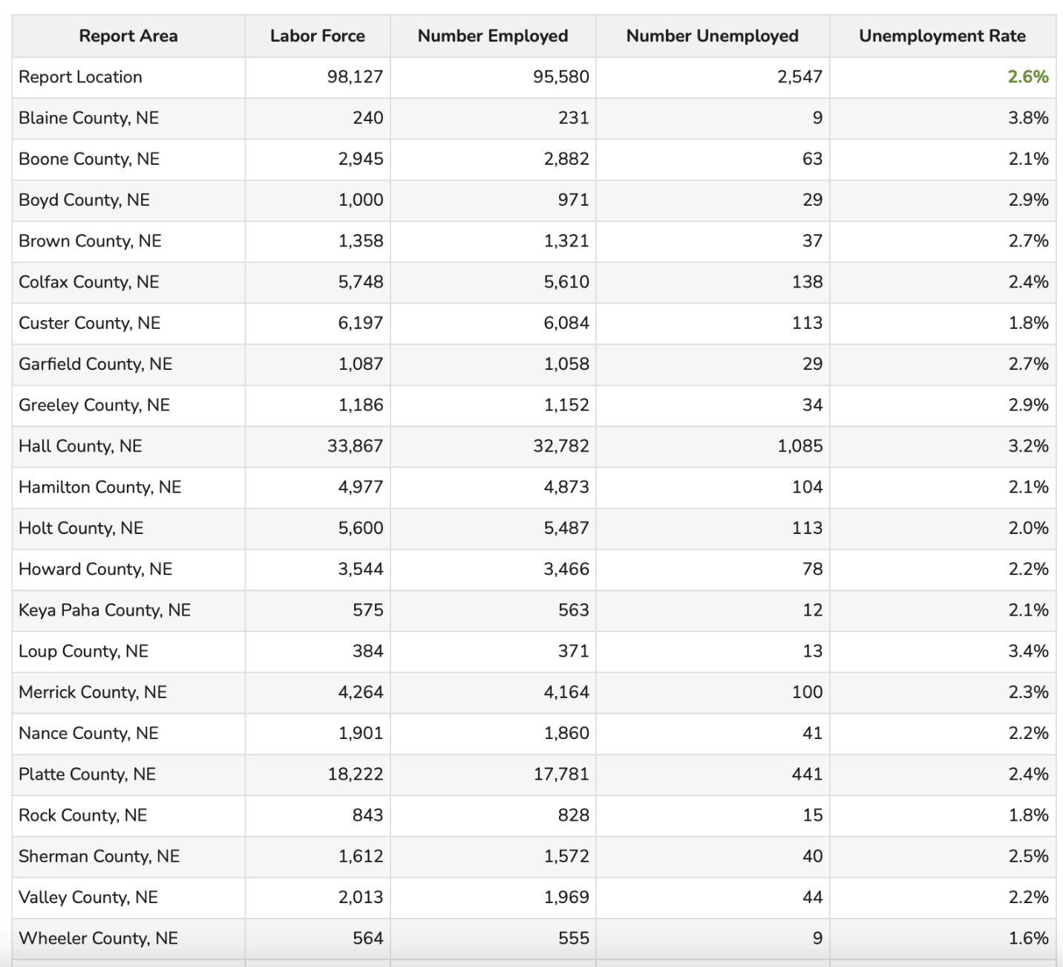
There are currently 98,127 people in the labor force within the CNCAP service area. Of those, 95,154 are employed and 2,032 are unemployed. This unemployment rate of 2.1% is lower than the state average. The unemployment rate in Nebraska increased by 0.3% from December of 2023 to December of 2024. In Nebraska, Total non-farm employment, a count of filled jobs, was 1,028,791 in December, down 1,582 over the month and up 20,668 over the year. Private industries with the most growth month to month were trade, transportation, and utilities (up 2,234 jobs); private education and health services (up 927 jobs); and financial activities (up 542 jobs). Private industries with the most over-the-year growth were private education and health services (up 7,367 jobs); leisure and hospitality (up 2,341 jobs); and manufacturing (up (2,340 jobs). Nebraska faces critical workforce shortages, despite having low unemployment. In 2021, 46% of the state’s nursing jobs went unfilled. 88% of teaching jobs. 73% of technology jobs. 91% OF HVAC and appliance jobs. It is believed one of the reasons for the worker shortage is the median annual salary for high skilled jobs being lower in Nebraska compared to the national average. Wheeler county has the lowest unemployment rate at 1.6% and Blaine county has the highest rate at 3.8%. Nebraska had over 52,000 job openings as of September 2024. The ratio for numbers of people per job opening was 0.5% in September. This is low compared to the rest of the United States. There is an average of 39 workers available for every 100 job openings. The quit rate is 2.3% and the hiring rate was 3.6%.

Inflation may have reached its peak in 2023 at 4.1%. By the end of 2024, inflation was at 3.4%. Everything remains costly for rural Nebraska. Food, building materials, fuel, daycare, housing etc. The high prices maintaining over the last year and the continuing shortages bring uncertainty to the lives of Nebraskan’s every day, especially those in rural Nebraska, which most of our service area is. Finding access to affordable, high-quality housing is a huge challenge among the CNCAP service area as new houses are not being built and more houses become uninhabitable without getting fixed. Not only is it costly to build new homes, but supplies are hard to come by as materials have been heavily affected by inflation. Due to lack of housing and opportunities, rural communities lose population as people move to the city in order to find better opportunities. As people leave small communities, businesses are affected and job opportunities decrease, leading to higher rates of unemployment. Another major challenge in rural communities is lack of access to affordable, high quality daycare which then causes parents to miss work, turn down promotions, reduce hours or leave the workforce entirely. With over 52,000 job openings online in Nebraska, and nearly a third of parents with children under the age of five saying they had at one point left the workforce due to lack of affordable childcare, it is clear that the rising prices and lack of opportunity in rural Nebraska is taking its toll.

https://dol.nebraska.gov/webdocs/Resources/Trends/December%202024/LAS%20Area%20Summary%20State.pdf
https://www.bls.gov/regions/midwest/news-release/2025/laborunderutilization_nebraska_20250221.htm

TRANSPORTATION

Rural America is not known for its public transportation. But as its residents get older faster than their urban counterparts, the need is increasing. In rural areas, residents can be miles away from essentials such as doctors and grocery stores instead of minutes. Without transportation, people who don’t have a car or can’t drive often have to move closer to services. More than a third of state rural health offices reported lack of transit was the biggest barrier to elderly people being able to stay in their own homes. Rural America tends to be sicker, poorer and older than its urban counterparts. There is a greater need for transportation among older adults in rural communities which will only increase as the years continue and the population continues to age in rural areas. According to the National Transit Database, 82% of counties nationwide had some level of rural transit available in 2019. This means that 18% of counties do not have public transportation across the nation. In order to help rural communities, maintain their population, it is important to have some form of public transportation readily available. In a neighboring county to the service area, Cherry county, there was no public transportation. Elderly residents could be seen walking to the hospital in the heat. Once public transportation was added to Cherry county, nearly half of its transports were for medical appointments. During an interview, some residents even stated that they delayed medical care due to lack of transportation opportunities. This is a challenge much of rural Nebraska is facing as well.

This indicator reports the number and percentage of households with no motor vehicle based on the latest 5-year American Community Survey estimates. Of the 71,222 total households in the report area, 3,123 or 4.38% are without a motor vehicle.

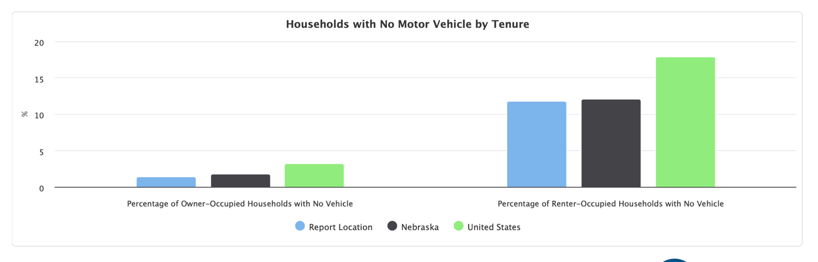
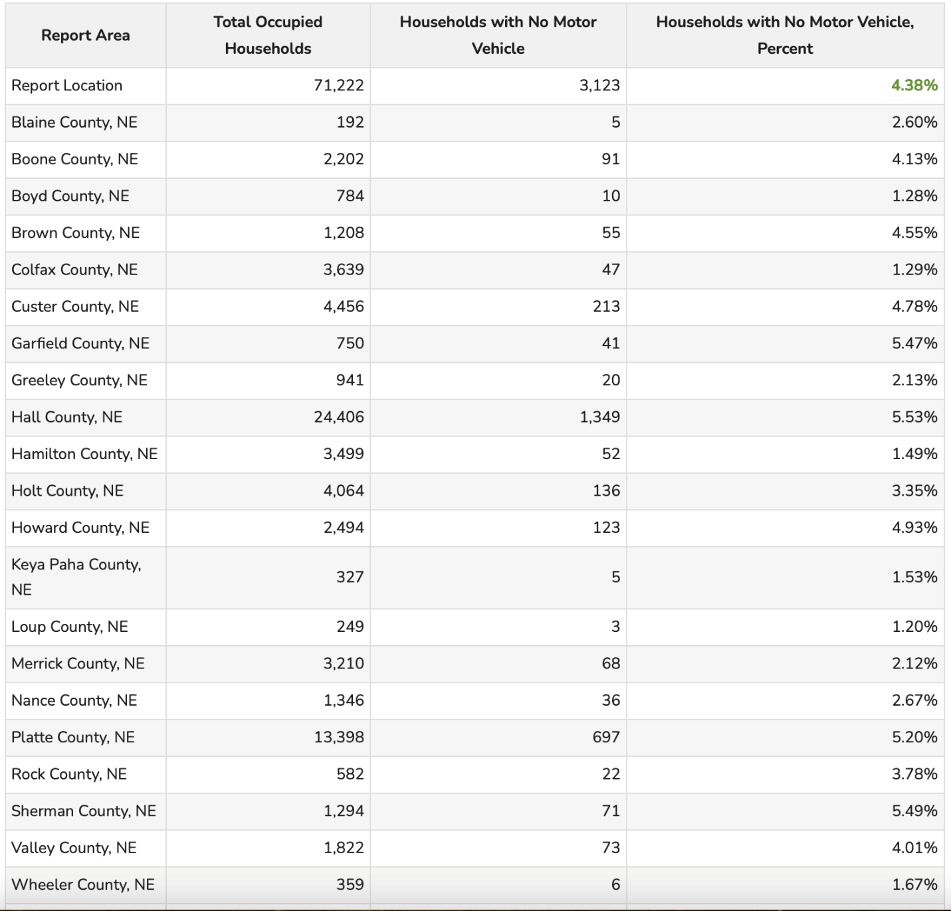

Travel time for workers who travel to work (do not work at home) is shown for the report area. The average commute time, according to the American Community Survey (ACS), for the report area is on average 7.04 minutes compared to the national average commute time of 26.79 minutes. Due to higher wages, more opportunities and childcare, many of the people within our service area commute to work instead of working in their hometowns.

With the percentage of our service area commuting a distance greater than 30 minutes to work every day, it is important to consider the cost of fuel across the nation. The Nebraska average price of gas per gallon is $3.14 and diesel is $3.67. Fuel prices may force some businesses to re-evaluate their hiring plans, holding off hiring because they are uncertain about the economy’s health. Less discretionary spending results in decreased sales, both of which can influence a company’s ability to hire.

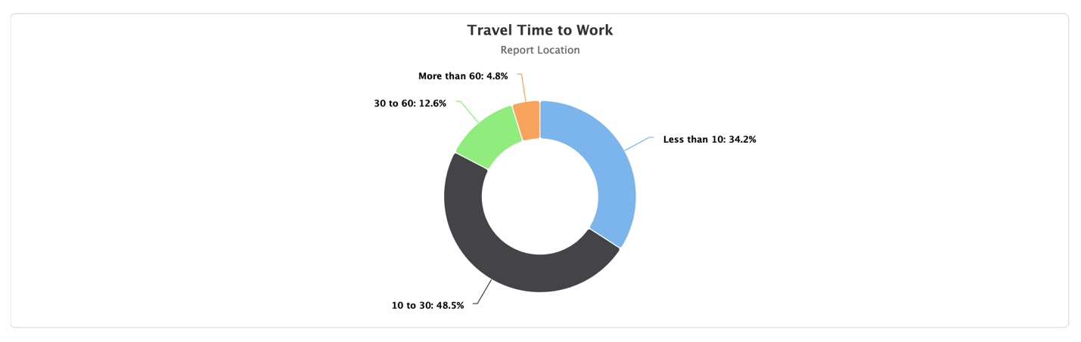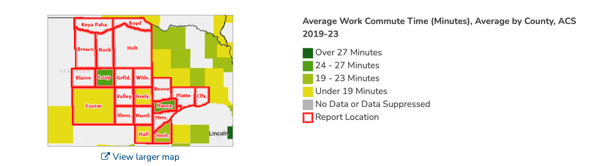
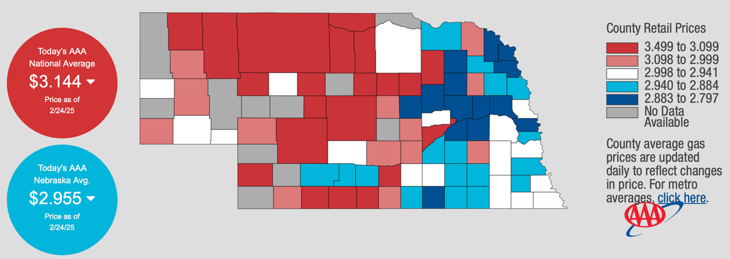

https://nebraskapublicmedia.org/es/news/news-articles/getting-around-rural-america-without-a-car-is-hard-these-communities-developed-solutions/

HEALTH

Access to Healthcare

Rural health providers across America continue to face a growing series of challenges—magnified by the public health crisis of the early 2020s. The increasingly sparse population in many regions of Nebraska has resulted in a shrinking number of health care services and an overall less healthy population. 66% of Nebraska counties have been deemed medically underserved, and at least 91 of Nebraska’s 93 counties suffer a primary health care shortage in at least one specialty. On top of that, Nebraska’s rural population is aging. Nearly 20% of rural Nebraska residents are over the age of 65. This is high compared to about 11% of urban residents. Over 40% of the state’s family practice physicians are over 55 years old. Rural residents have higher hypertension rates, are more likely to binge drink and less likely to wear seat belts, engage in physical activity, visit the dentist regularly and consume healthy fresh foods. All of these factors into making rural residents statistically more vulnerable to untreated cancer and chronic disease. Rural hospitals are particularly critical in Nebraska, making up about 35% of all hospitals nationally, but over 68% of hospitals in Nebraska. Nebraska has more rural residents living at least 25 minutes away from an ambulance than all but two other states. Approximately 16% of Nebraska mothers must travel at least 30 minutes to find a maternal care provider, which is about twice the national rate.
https://iloveruralhealth.com/tomorrow/, https://www.nebraskahospitals.org/advocacy/roadmap-to-strong-rural-health-care.html

As the population in our rural community’s decline, other services become harder to access. Quality healthcare in rural areas has been directly affected by the lack of opportunities in the area. Steadily, access to healthcare becomes an increasing challenge in rural Nebraska. With much of CNCAP’s 21 counties being considered rural, this challenge directly affects our service area. In the previous year there were 69 primary care facilities in the CNCAP service area offering 147 providers. This number has decreased to 59 primary care facilities, and increased to 165 providers. The counties increasing the number of providers is the more urban counties such as Hall and Platte counties. There are 47 dental facilities in the CNCAP service area and 111 providers. In the previous year there were 244 mental health care providers among 59 facilities. This year there are 233 providers in 47 facilities. While the need for mental healthcare has increased, the number of providers has gone down. Wait times to get into appointments have also lengthened.

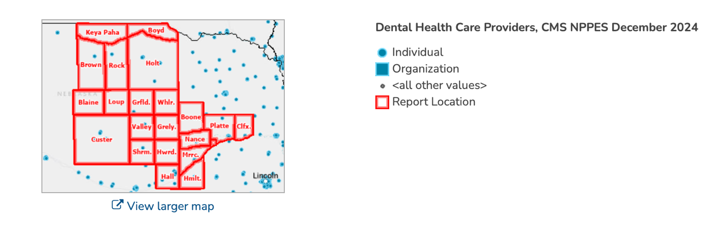
https://cap.engagementnetwork.org/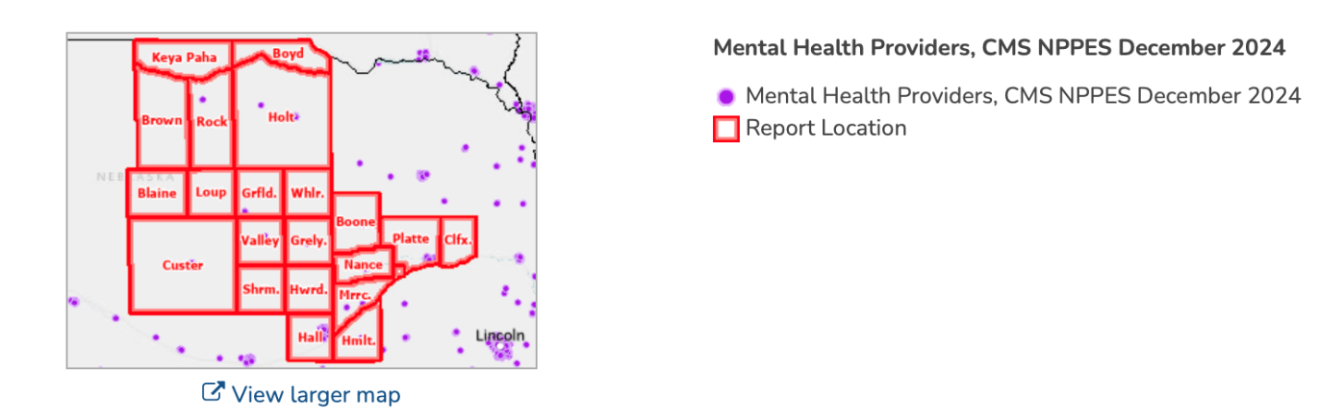
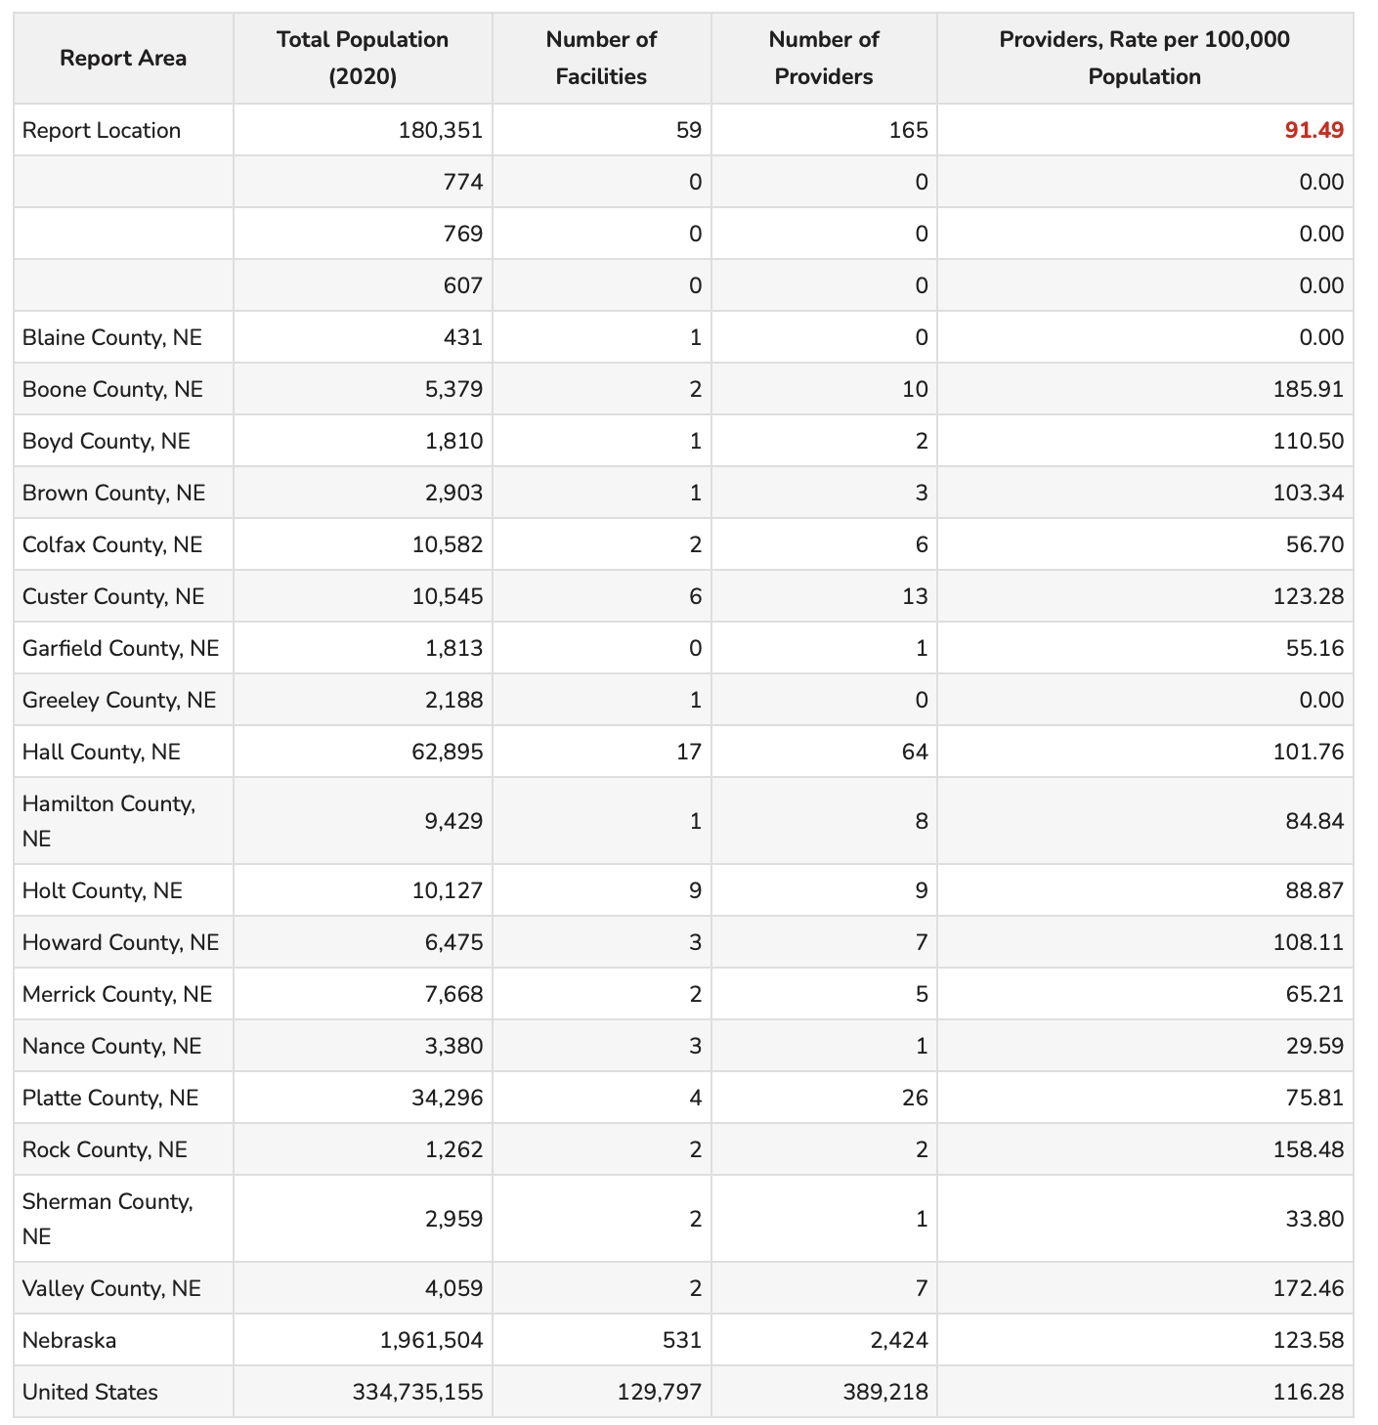
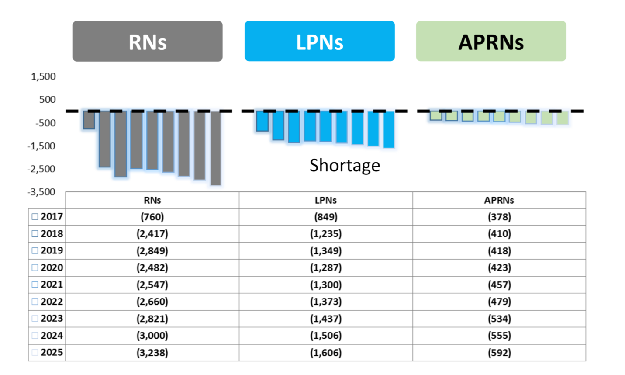
Projections show that Nebraska will experience a workforce shortage of over 5,000 nurses in 2025. The Nebraska Center for Nursing projects that Nebraska is very likely to see nearly 1000 nurses between the ages of 24 and 55 leave their employment over the next 12 months. 58% of RNs are employed in Nebraska hospitals. 2% of RNs in Nebraska are unemployed. 49% of APRNs are employed in Nebraska hospitals and 30% are employed in Ambulatory care. There is a gap of nearly 400 between how many APRNs Nebraska has and how many are needed. According to the Nebraska Department of Labor, the RN positions is the most highly advertised position online with 3,068 job openings, followed closely by nursing assistants and LPNs.
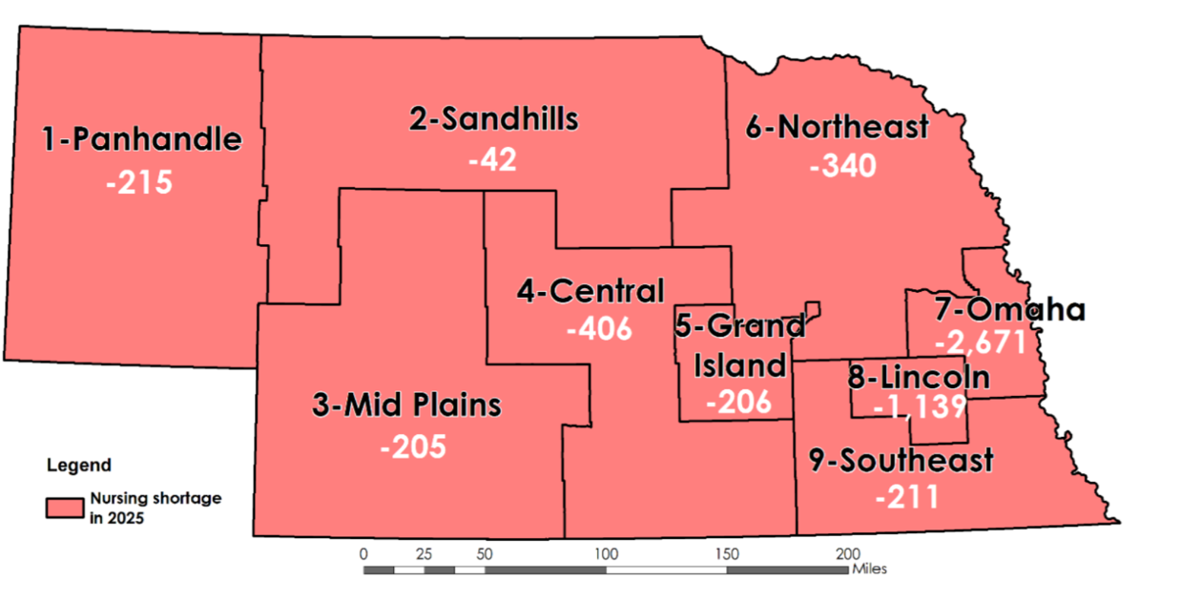
Nebraska is not producing enough new nurses to offset those who are retiring. The average age of nurses in Nebraska is 44. Not only that, but nurses are also experiencing burn out during staffing shortages, sometimes taking on double the normal number of patients. The nursing shortages during COVID also drove many nurses to retire early. While there is no legal cap on nurse to patient ratios, the suggest number of patients to one nurse never gets above five. There have been times since COVID where nurses were taking care of 8-10 patients in a shift. These same nurses were working 4-5 days per week compared to the usual three 12-hour shifts. On top of that, shifts that are supposed to be twelve hours have now struggled with turning into 13-15-hour shifts. Nursing shortages prove to be the biggest challenge Nebraska is facing in healthcare. https://www.nebraskanewsservice.net/news/nebraska-nursing-shortage-deteriorates-hospital-conditions/article_16373b65-5f89-50af-9772-f4bb2d1728d3.html

This workforce shortage may continue to be a problem as the future size of the healthcare workforce suggests a steady growth for most professions.

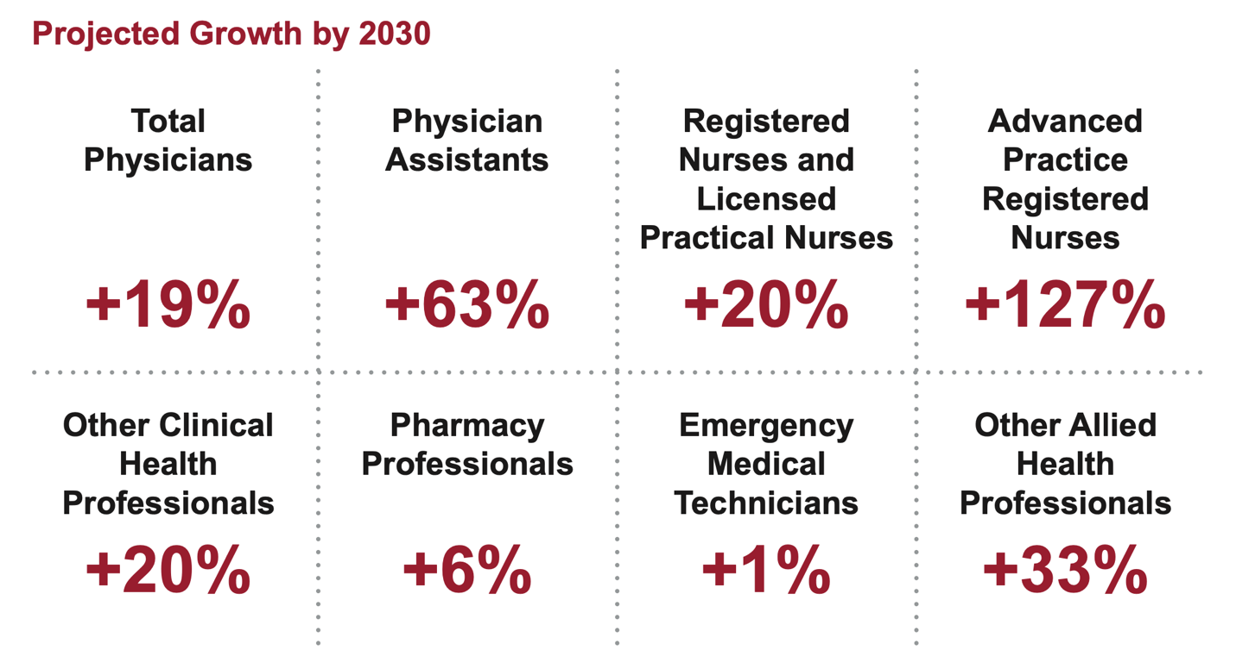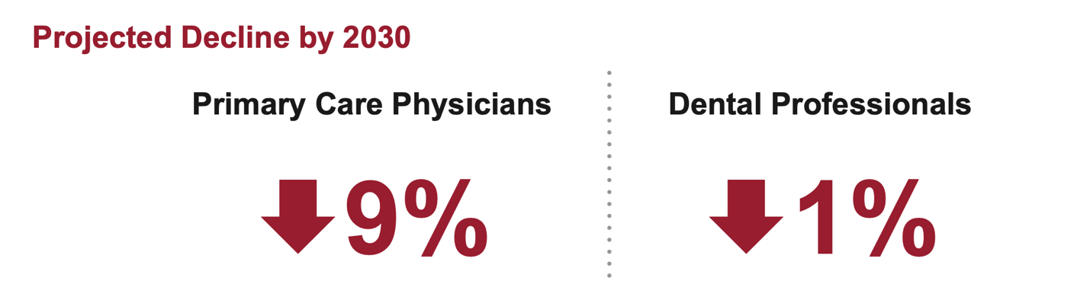

The OB/GYN shortage is shown in the map below, with only one county in Nebraska having sufficient numbers.

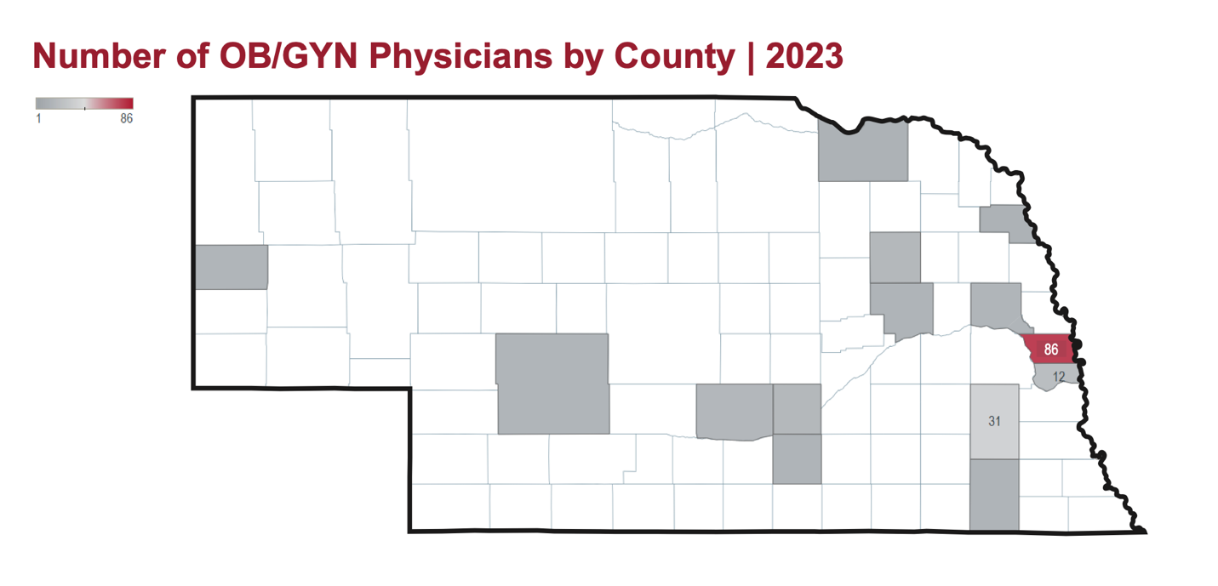

Physician Assistants have increased in the last year, with PA’s being active in 67 out of the 93 counties. However, that still leaves 26 counties without adequate access to PA’s.
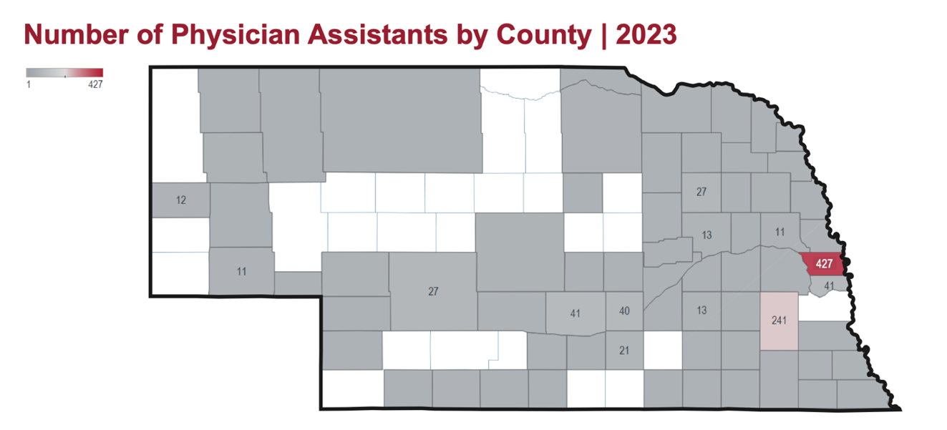
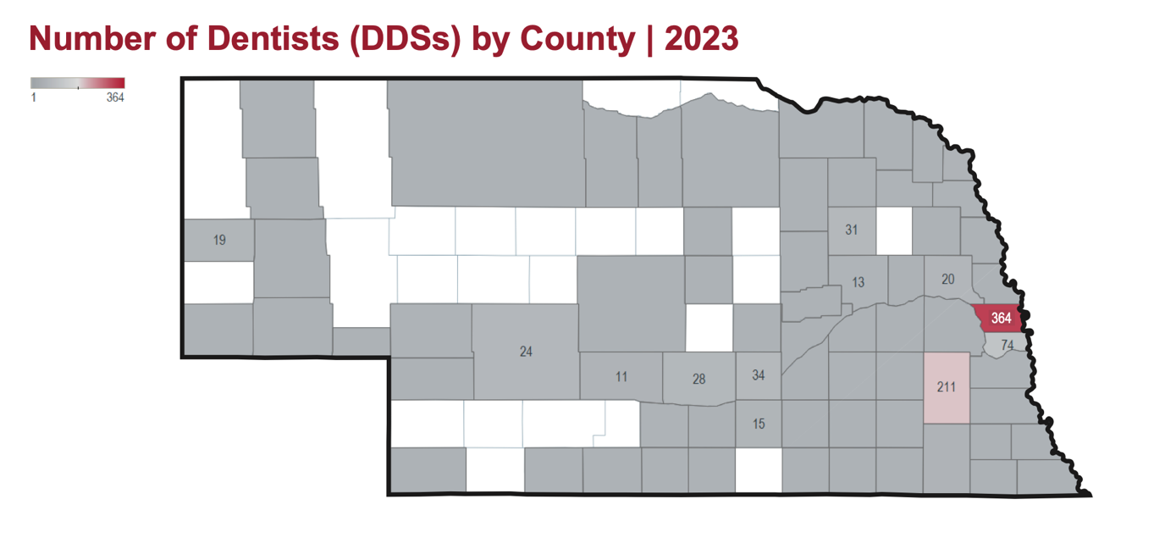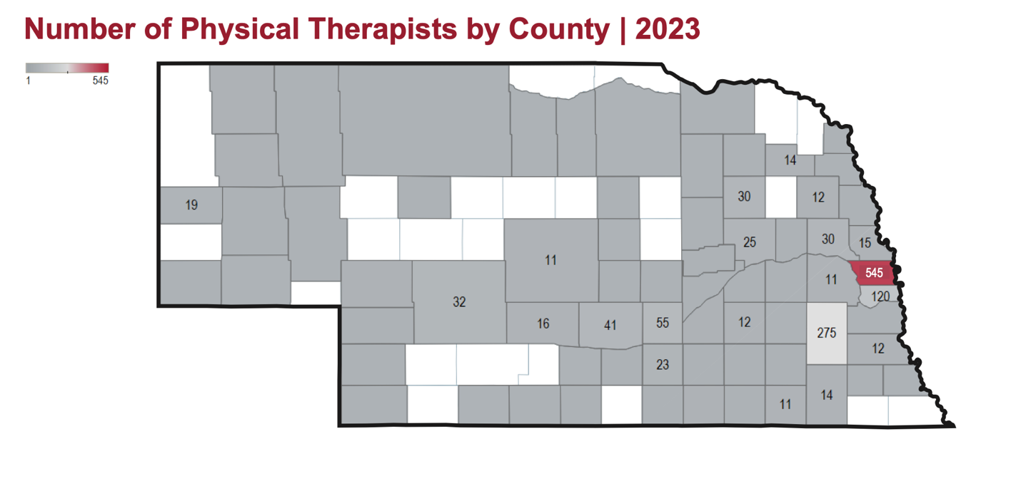
https://www.unmc.edu/familymed/_documents/ahec/healthcare-workforce-2024.pdf

Women, Infants, and Children (WIC) aims to improve the health of low-income pregnant, postpartum, and breastfeeding women, infants, and children up to the age of five who are at a nutritional risk. The program provides nutritious foods to supplemental diets, information on healthy eating, breastfeeding promotion and support, and referrals to healthcare.
During 2024 CNCAP’s WIC served:
- 919 Total Participants
- 207 Women
- 153 Infants
- 559 Children

Mental and Behavioral Health

Mental and behavioral health have been major challenges for Nebraska in the past few years. Especially in the wake of COVID-19. As stated above, there is already a shortage in mental health providers, especially for rural residents. This further pushes the mental health crisis, which becomes more prevalent every year. A 2024 study shows that almost 26% of Nebraskans reported having a mental-health illness in the past year which is nearly 3% higher than the national average. Providers of Nebraska’s behavioral health care system are also facing more challenges as budget cuts loom. In the last legislative session, $15 million was cut from the state’s behavioral health services budget and the head of state government divisions are now being asked to find more cuts. The cuts brought total budget reductions to Nebraska’s behavioral health system to nearly $50 million over the last six years. Among Nebraska counties, 88 out of 93 had a shortage of behavioral health providers in 2023. 29 counties do not have a provider at all. With many rural Nebraskans already facing considerable challenges accessing behavioral health care, these additional budget cuts will only create more challenges. These cuts caused several satellite locations to close and even a planned office to be unable to open. Mental Health America ranked Nebraska 44th in the nation for a higher prevalence of mental illness, coupled with lower access to care. For specific populations, Nebraska ranked 34th for adults and 49th for children.

1 in five Nebraskans has a mental health or substance use disorder in 2023. The average for psychiatrists is 14 per 100,000 [people],” he said. “Nebraska's, in urban areas, is like 12, so it's pretty close. But if you take a look at rural areas, it's down to less than two. So, it's like two per 100,000 people, and there's only 11 counties in the entire state that have psychiatrists, out of 93.” The numbers for licensed mental health practitioners are better, though still not ideal. There are slightly over 48 per 100,000 people in urban Nebraska, and approximately 19 in rural areas. There is a higher need for behavioral care, but less opportunity for access. More than 40 percent of adults in Nebraska who needed behavioral care were not treated because of how much it costs. Cost is a factor that is particularly prevalent in vulnerable communities.

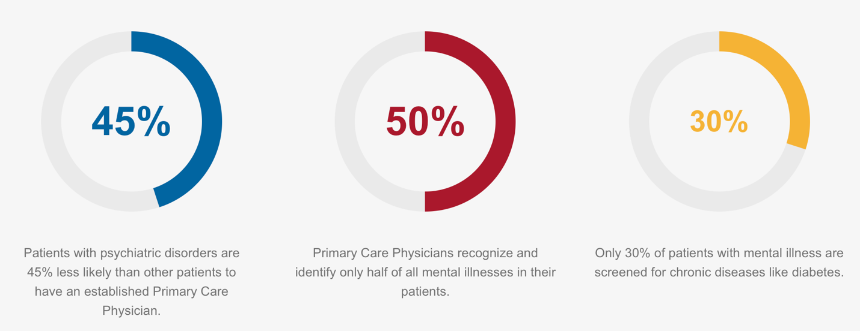

Mental health is essential to our overall well-being and is equally as important as physical health. We are better able to take care of ourselves when our mental health is good. When we are able to best take care of ourselves, we are more involved in our communities and tend to take better care of ourselves physically. Mental health includes emotional, psychological and social well-being.

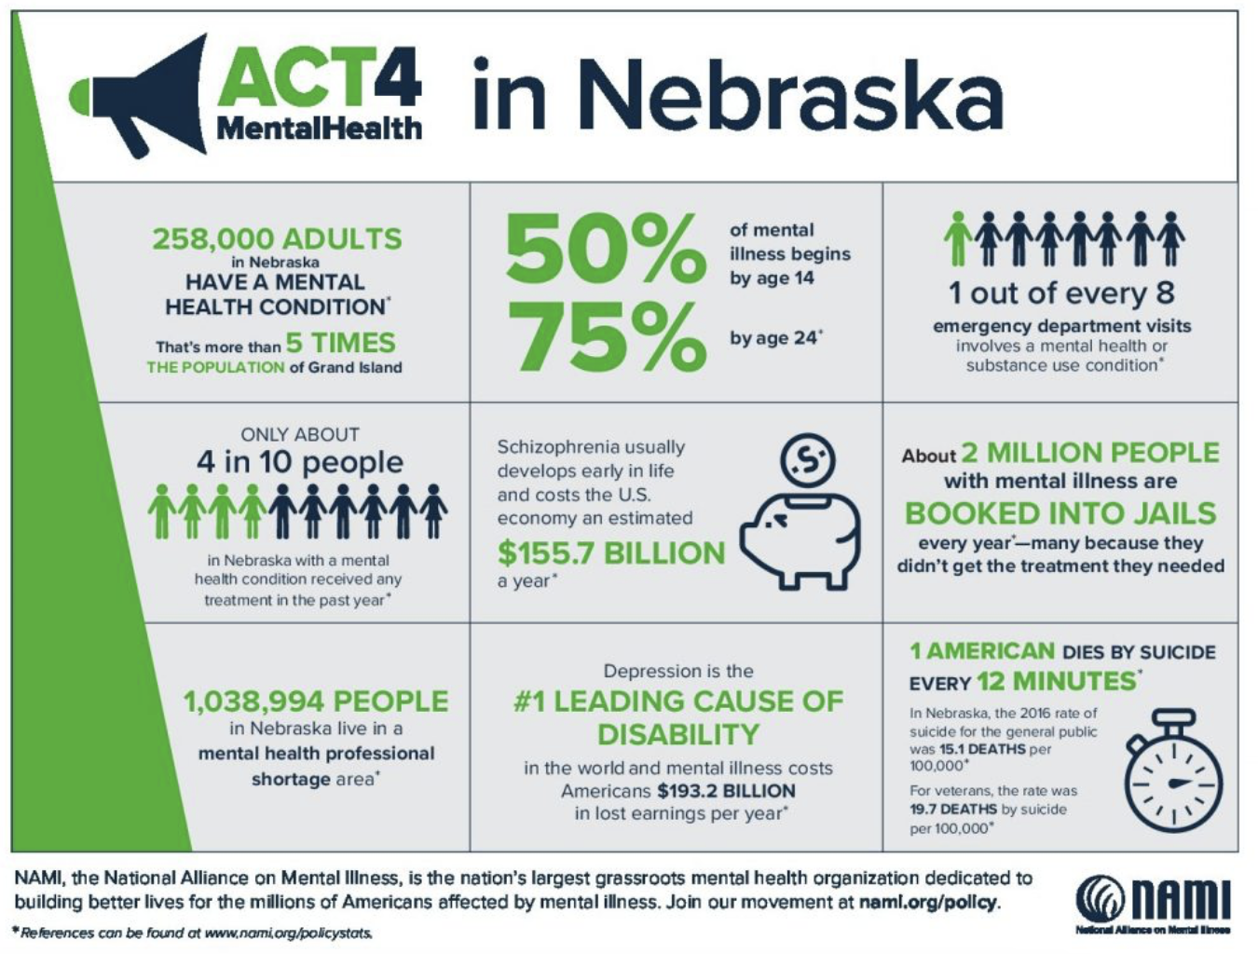

Rural communities are especially struggling with access to mental health care. Between excessive wait times for appointments, cost of traveling to communities with providers, and cost of care, it is often not feasible for many. Nebraska’s rural suicide rate is above the national average, but has stayed lower in neighboring states.
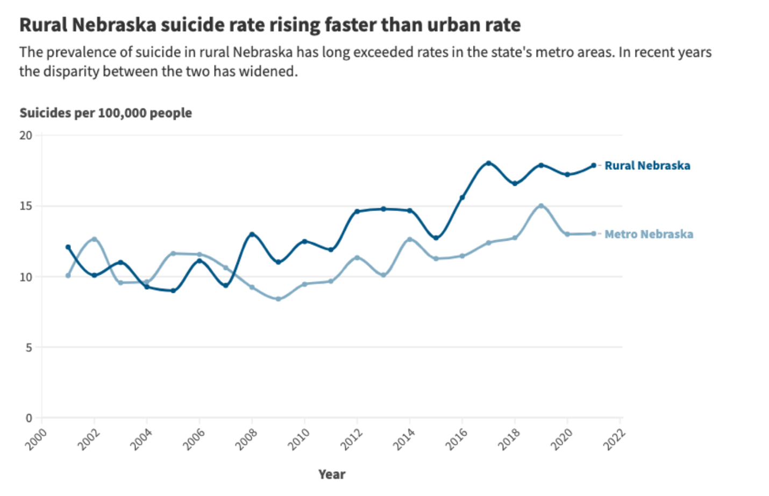
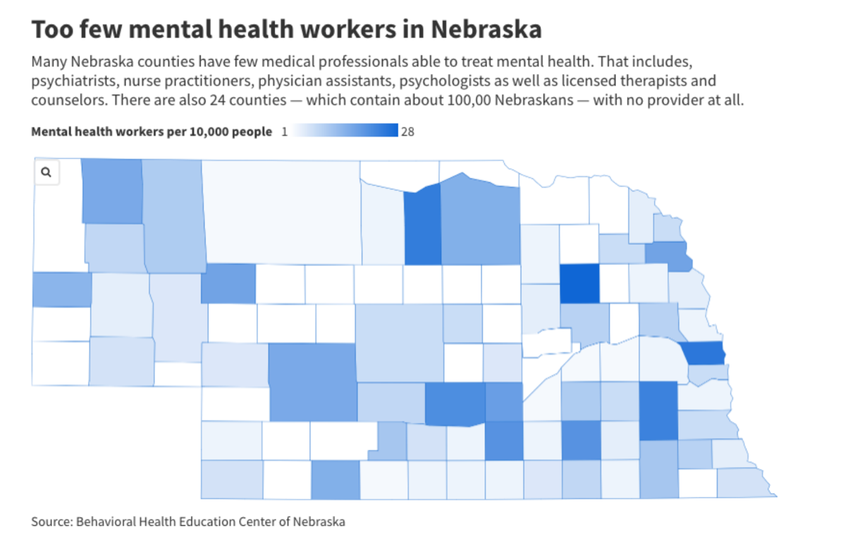
As can be seen from the map above, the rural communities are especially sparse when it comes to Mental Health Care providers.
One way of attempting to alleviate the shortage is by expanding the tele- and virtual mental health care. The use of telehealth has increased since the pandemic and has remained a constant source of mental health care. These tele-health services are both safe and effective in eliminating the barrier of access to care, although they do still pose challenges to rural Nebraskans with spotty internet.
The following is a summary of the major findings identified in this report:
- Both rural and urban families reported relatively high rates of utilization of telehealth services in the past 12 months.
- The pandemic caused an obvious decline in children’s emotional wellbeing. Over 50% of children received services related to mental or behavioral health during the pandemic.
- Many immigrant families indicated a strong need for interpretation services in order to access care. A lack of interpreters, distance from provider, and travel were all identified by families as barriers to accessing services.
- Nearly 1 in 4 families indicated accessing services was either moderately difficult or impossible to do on their own, and almost 3% of respondents reported they were unable to access needed services during the pandemic.
- 1 in 3 families pay for accessed support services completely out-of-pocket, and nearly 50% of respondents stated these out-of-pocket expenses cause at least some financial hardship.
- Families experienced upheavals in education delivery. The rate of homeschooling in Nebraska nearly doubled, with almost 5% of families choosing that option compared to 2.75% of families in 2018-2019.
https://dailyyonder.com/in-small-town-nebraska-with-suicide-rates-high-one-family-delivers-hope-for-thousands/2024/02/19/
https://mhanational.org/issues/2023/mental-health-america-all-data
https://nebraskaexaminer.com/2023/09/21/we-must-do-more-nebraska-lawmaker-investigating-mental-behavioral-health-needs/

Infant/Child Mental Health
Mental health is essential at every stage of life, all of the way from childhood and into adulthood. It is also prevalent in both youth and adults. Especially now, after the mental toll the pandemic had on our people. There are many things that impact mental health, from biological factors such as genes or brain chemistry, life experiences such as trauma or abuse, or family history of mental health problems. The grief, trauma and physical isolation of the last two years have driven Americans to a breaking point. Our youth have been greatly impacted by disruptions from normal routines and relationships. This increased social isolation, anxiety and learning loss. Social media platforms have further driven the mental crisis in the United States. There is significant evidence that social media is harmful to kids and teens mental health, well-being, and development. With the national shortage of mental health providers, and the current mental health system, it is hard for mental health providers to meet people where they are.
Children’s mental health problems were on the rise before the pandemic, but it likely worsened the emotional health and stress levels of adolescents. More than half of parents said two years after the start of the pandemic that it negatively affected their children’s mental health. Increased time at home caused attachment issues for some children who developed separation anxiety when the time came to return to normal, and crying, tantrums, hesitation to interact with others and clingy behavior were increasingly common signs of developing attachment issues. https://www.unmc.edu/healthsecurity/transmission/2023/10/04/kids-mental-health-spending-soared-26-during-pandemic/

- A major barrier to mental and behavioral health services lies in the inadequacy of health insurance coverage of needed services. The majority of children are covered with health insurance, but one-third of parents/caregivers' report paying out-of-pocket for care.
- • There is an urgent need to improve access to pediatric mental and behavioral health services providers in Nebraska, in terms of both quantity and quality. More providers are needed, especially those who are trained to serve diverse pediatric populations in underserved communities across Nebraska.
- Nebraska is ranked 30th for overall youth mental health
- 21% of Nebraska youth experienced at least one major depressive episode in the past year.
- 14.18% of Nebraska youth have had serious thoughts of suicide in the last year.
- 8.86% of Nebraska youth are experiencing a substance use disorder in 2024.
- 65.1% of youth with a major depressive episode did not receive mental health services in 2024.
- 8.3% of youth with private insurance did not have coverage for mental or emotional problems in 2024.
- 48.1% of youth who reported treatment or counseling, said it helped them.

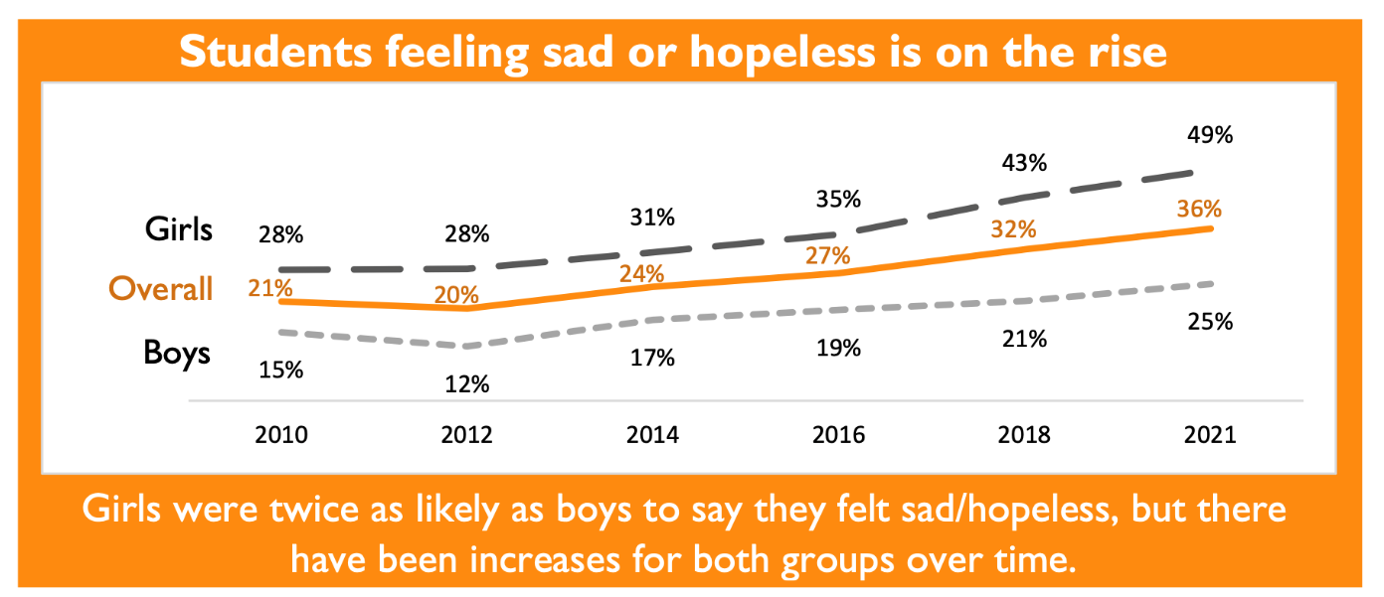

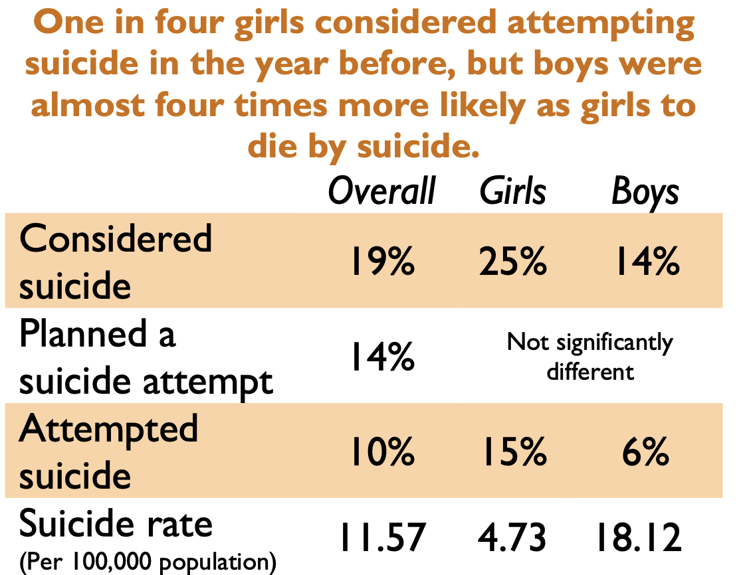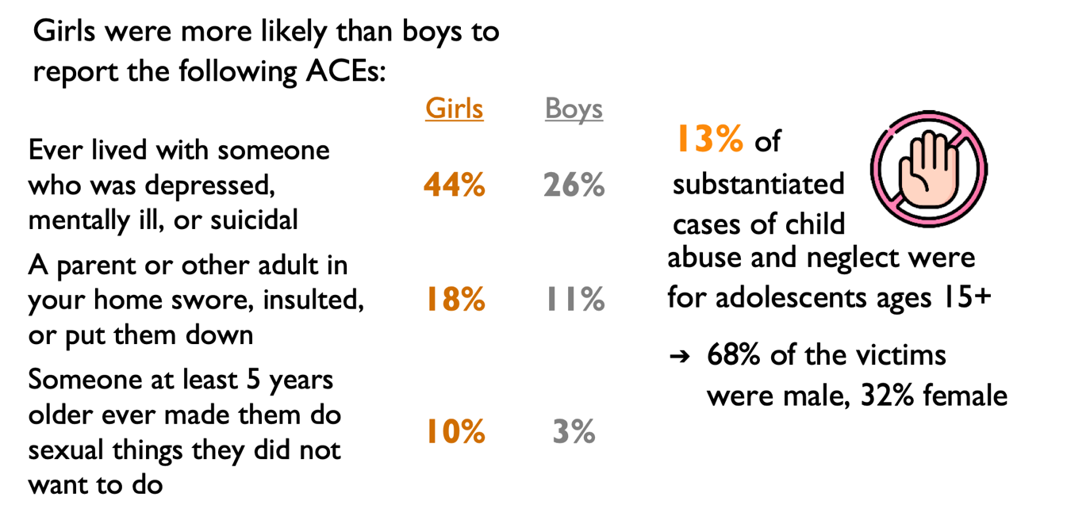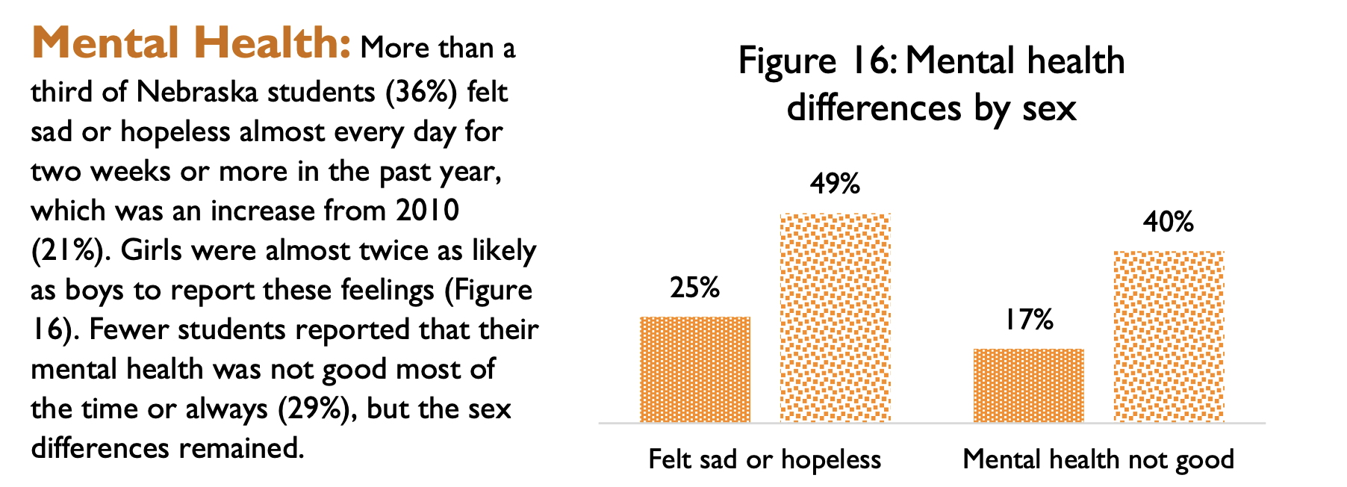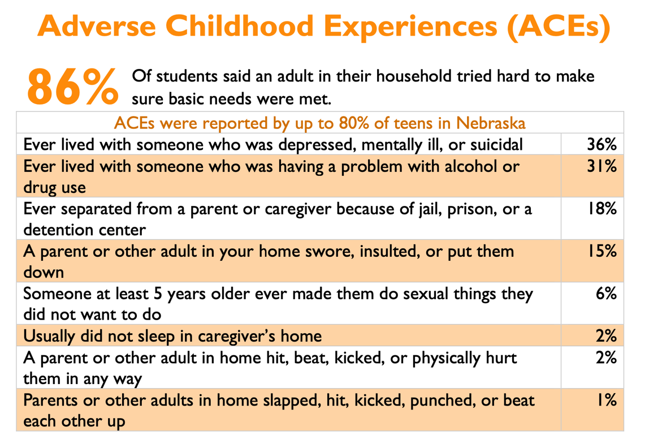
The true progress in addressing our youth mental health crisis requires a focus on systemic issues. 47.6% of children do not have a medical home and 78,687 children face anxiety, ADHD/ADD, depression, or Autism Spectrum adversities in Nebraska. Solutions to this include
- Increasing funding and accessibility for equitable mental health services across Nebraska.
- Recruiting and expanding provider networks for youth mental health services.
- Implementing cultural competency training for all mental health professionals in the state.
- Expanding school-based mental health services with a focus on equity.
https://neappleseed.org/47512
https://www.addictiongroup.org/nebraska/drug-statistics/
https://www.education.ne.gov/wp-content/uploads/2024/01/2023-Adolescent-Health-Report-updated-FINAL.pdf
https://mhanational.org/issues/2024/mental-health-america-youth-data

Adolescent Mental Health
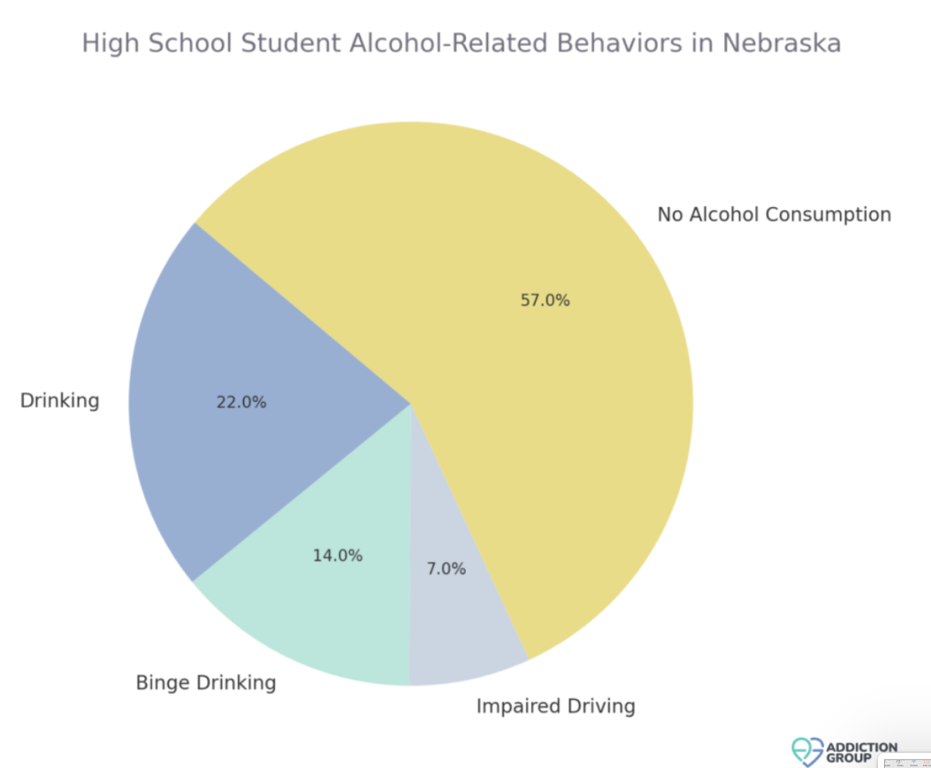
- The binge-drinking rates among young adults has increased along with treatment admissions for methamphetamine.
- 17.1% of high school students used electronic vapor products in 2020.
- Females in high school reported 24.7% of current use of alcohol in Nebraska, compared to 17.4% among males.
- Alcohol-attributed deaths rose by 64% in 2020.
- 11.6% of high school students reported current marijuana use in 2019. Around 5.6% of young adults reported driving under marijuana’s influence.
- 12% of Nebraska high school students had their first drink of alcohol before the age of 13. Nearly half of the students surveyed (45%) had drank alcohol and 19% reported having had at least one drink in the last 30 days.
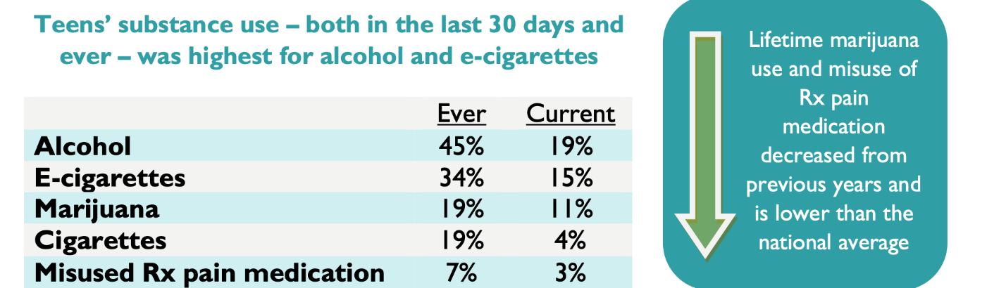
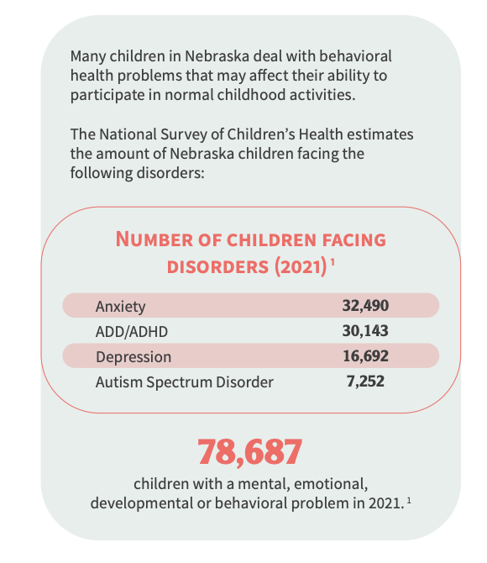
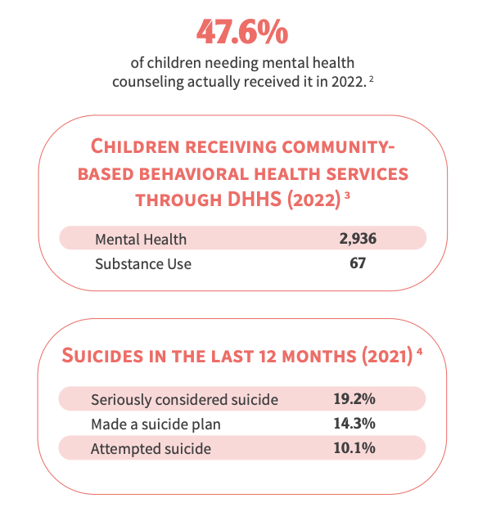
Adult Mental Health

States that are ranked 1-13 have a lower prevalence of mental illness and higher rates of access to care for adults. States that are ranked 39-51 indicate that adults have a higher prevalence of mental illness and lower rates of access to care.

- Nebraska is ranked 37th for adults with any mental illness at 25.71% in 2024.
- Nebraska is ranked 15th for adults with a substance use disorder at 17.58%.
- Nebraska is ranked 49th for adults with serious thoughts at 6.15%.
- Nebraska is ranked 34th for adults with a mental illness who are uninsured with a rate of 9.4%.
- Nebraska is ranked 49th for adults with a mental illness who have private insurance that did not cover mental or emotional problems in 2024. This is 17.6% of the population.
- Nebraska is ranked 30th, with 23.52% of adults who experienced more than 14 unhealthy days a month who could not see a doctor due to costs in 2024.
- Nebraska is ranked 26th, with 75.19% of adults with a substance use disorder who needed treatment but did not receive it in 2024.

https://mhanational.org/issues/2024/mental-health-america-adult-data
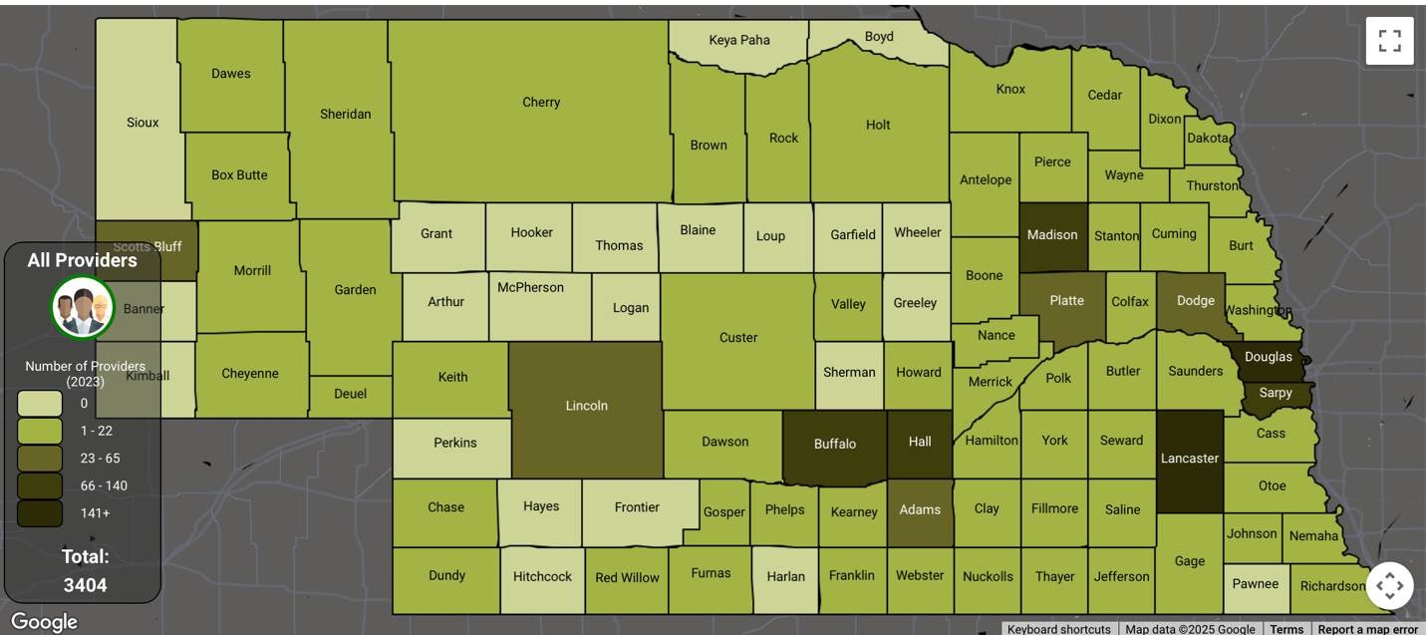
https://app1.unmc.edu/publichealth/bhecn/#/home

Only Platte and Hall counties within the service area have providers. Keya Paha, Boyd, Blaine, Loup, Garfield, Wheeler, Greeley, Sherman all have no providers. These rural counties of our service areas are suffering. Substance use has increased tremendously throughout rural communities as a result of the lack of access to affordable, quality mental health care. Many of these counties are not even close to a sufficient number of providers in neighboring counties.
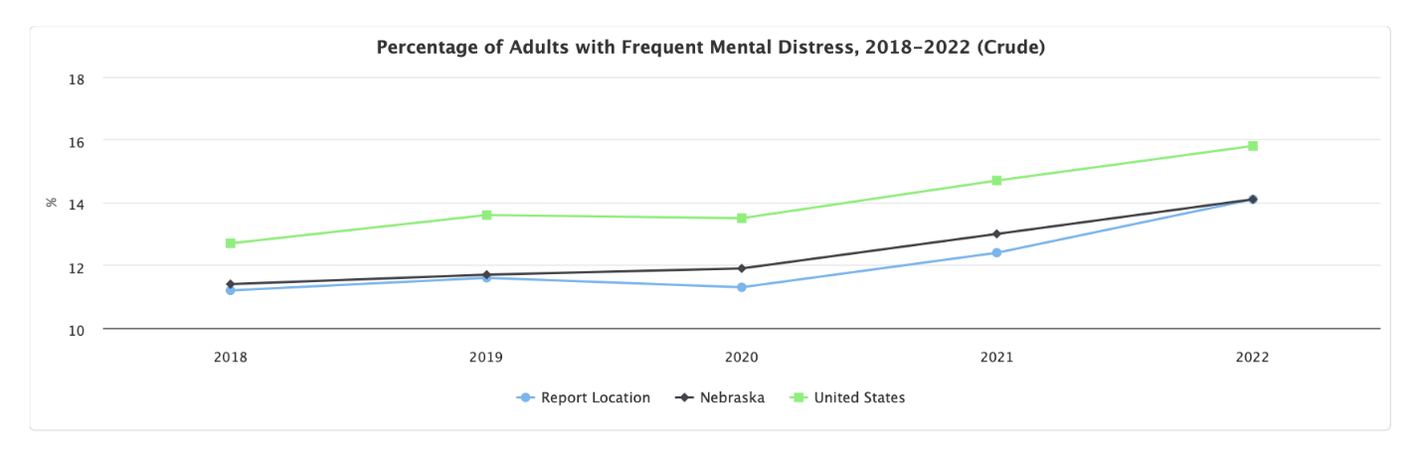
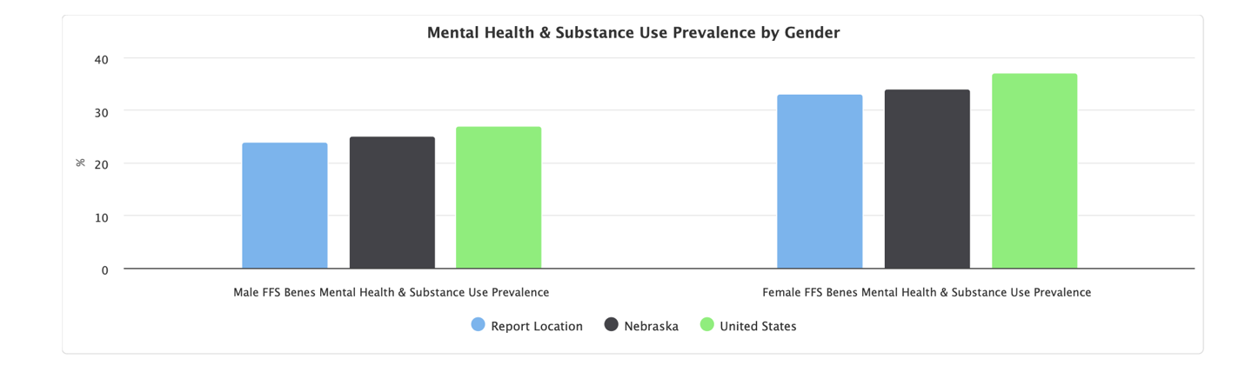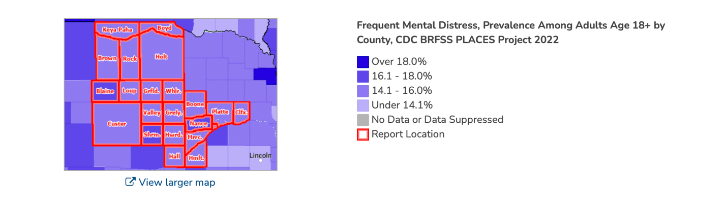

In a White House report in 2023, it stated,” Our nation is facing a mental health crisis among people of all ages, and the COVID-19 pandemic has only made these problems worse”. There are 3 distinct crises, which partially overlap: a youth mental health crisis, people with serious mental illnesses, and ongoing substance use disorder fueled by opiates. Dr Thomas Insel made a statement that “our nation is facing historic numbers of young people contending with anxiety, a lack of care for people with serious mental illness, and rising deaths from drug overdoses.”
Source:pewresearch/charitabletrusts

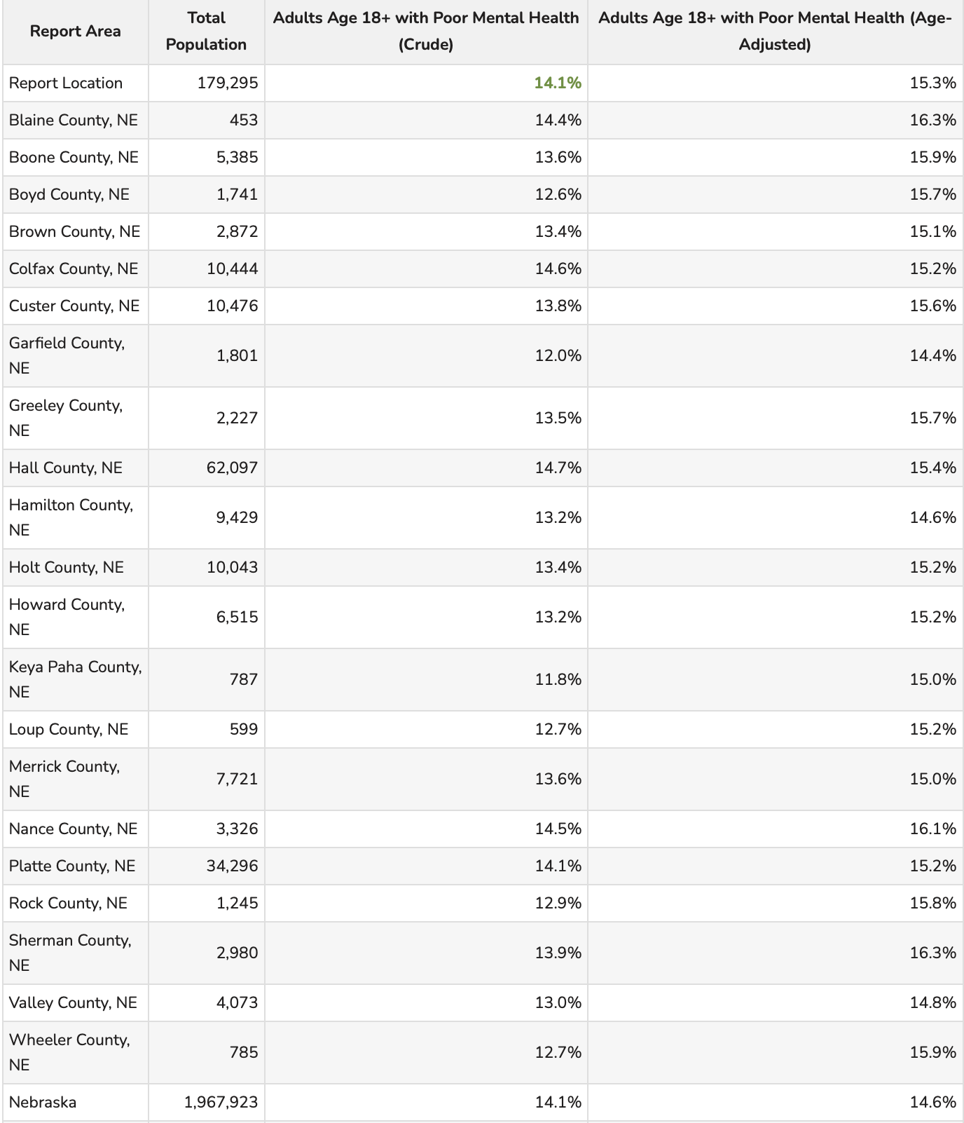
This indicator reports the percentage of adults age 18 and older who report 14 or more days during the past 30 days during which their mental health was not good.
Within the report area, there were 14.1% of adults 18 and older who reported poor mental health in the past month of the total population age 18 and older.

Substance Abuse

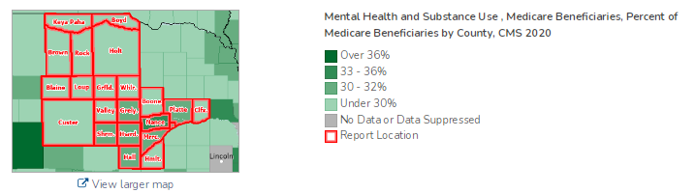
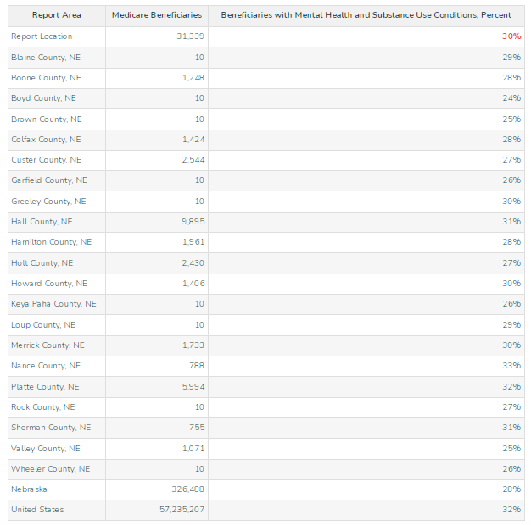

https://mhanational.org/issues/2023/mental-health-america-all-data
https://nebraskaexaminer.com/2023/09/21/we-must-do-more-nebraska-lawmaker-investigating-mental-behavioral-health-needs/
https://www.publicnewsservice.org/2024-10-03/mental-health/strain-on-ne-behavioral-health-system-could-worsen-need-remains-high/a92735-1

Drug use has been a rising problem in the state of Nebraska and it has been facing the problems of addiction and overdose deaths. The state has been seeing a higher percentage of youth substance use compared to the national average.
- Methamphetamine treatment admissions rose more than 200% from 2008 to 2018.
- An average of 720 deaths in Nebraska are due to excessive alcohol use.
- Nebraska youth continue to report a higher percent usage among each grade level than the national average.
- The annual average prevalence among people aged 12 or older was 9.9% from 2017 to 2019.
- From 2015 to 2019, 5% of Nebraska adults reported cocaine use in the past year.
- From 2015 to 2019, 6.4% of Nebraska adults reported current marijuana use. These numbers have only continued to rise since then.
- In 2020, Nebraska had 214 drug overdose deaths, with an 11.4% mortality rate per 100,000 population.

Nebraska has been working to address the challenges of substance use disorders through various treatment and recovery initiatives. In a single-day county, 5868 people in Nebraska were enrolled in a substance use treatment.
In 2022, there were 225 drug overdose deaths. For every 100,000 people living in Nebraska, 11 died of a drug overdose. The drug overdose death rate in Nebraska has increased in 16 out of the past 23 years for which data was available. The overdose rate has increased 59% since 2018 and 82% since 2013. This is likely due to the growing use of fentanyl and other synthetic opioids. In 2022, fentanyl and other synthetic opioids were involved in more overdose deaths than any other drug. These made up 45% of the total drug overdose deaths in Nebraska. These rates increased 4.6 times between 2010 and 2022.
https://www.addictiongroup.org/nebraska/drug-statistics/
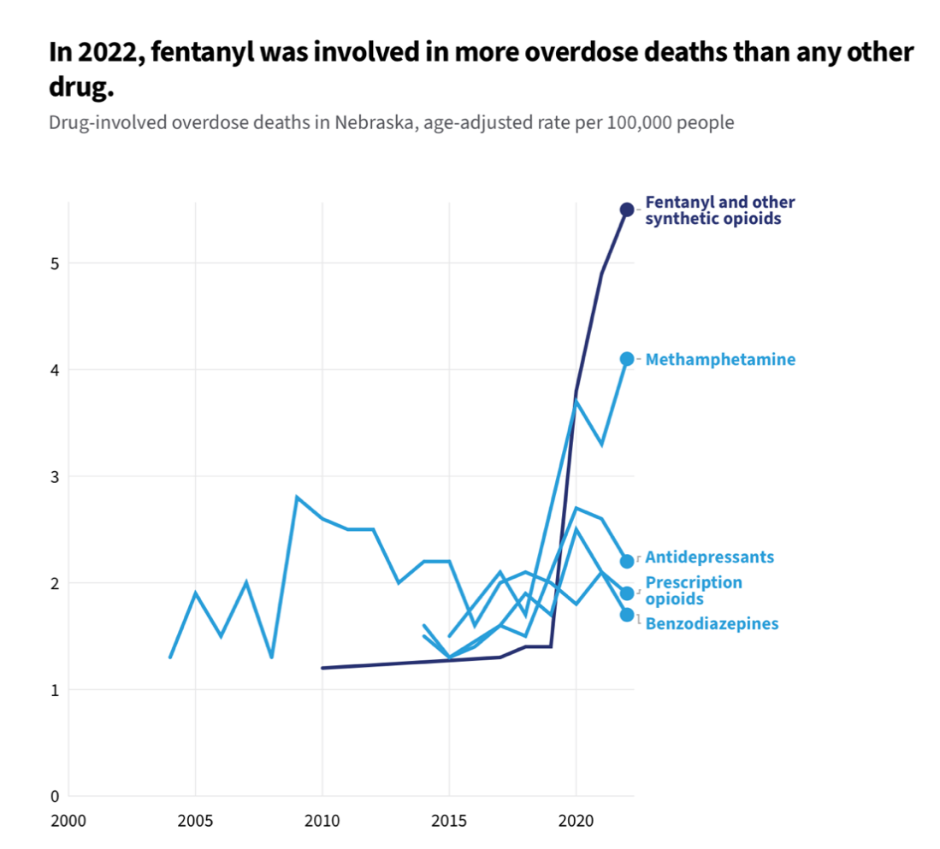
https://usafacts.org/answers/how-many-drug-overdose-deaths-happen-every-year-in-the-us/state/nebraska/

The number of surveyed community members in Nebraska who admitted to substance use:
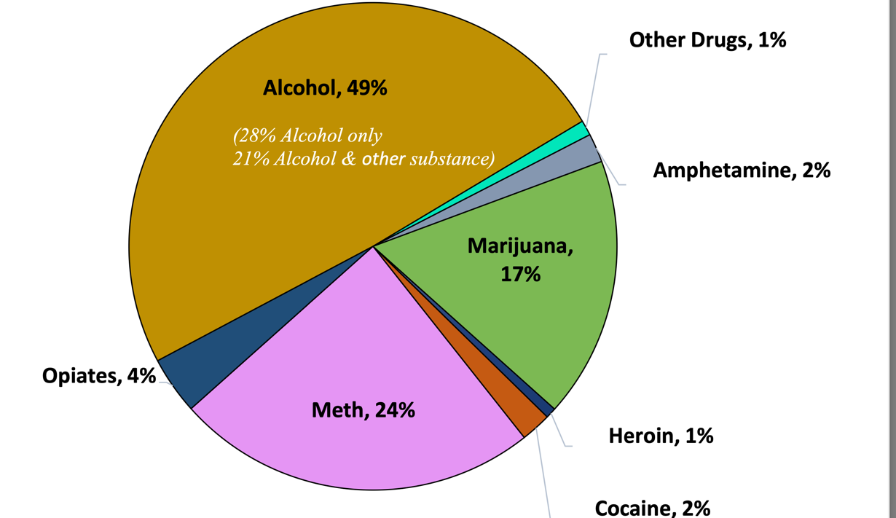
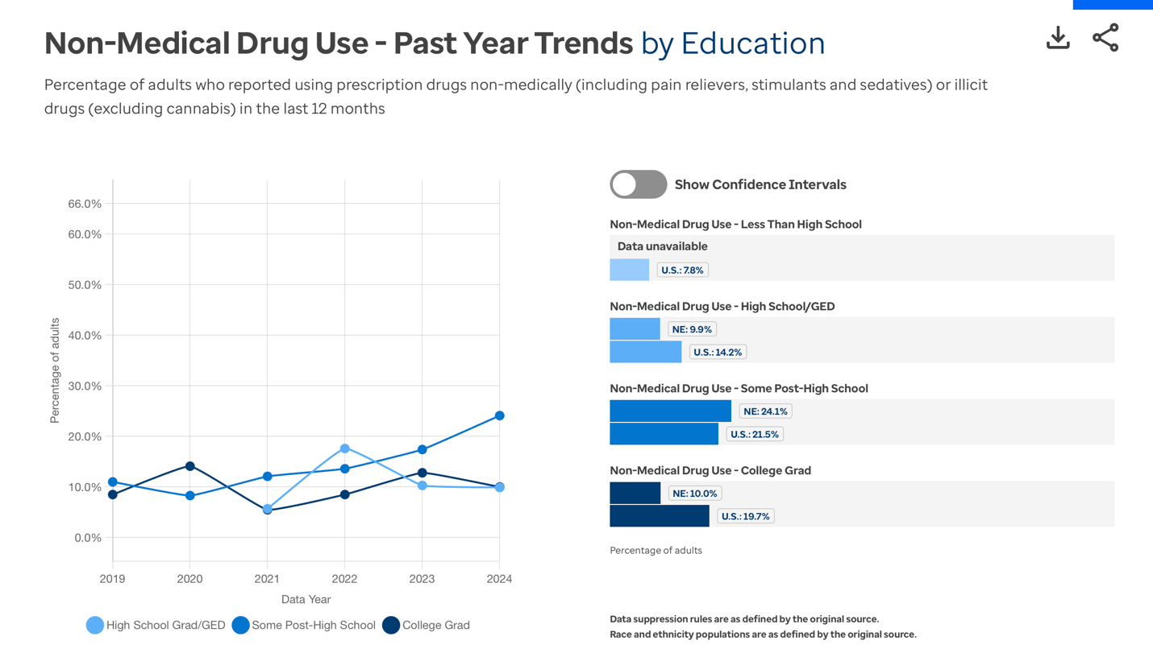
Using illicit drugs, including prescription drugs without a doctor’s guidance can be dangerous and have long-lasting consequences. Although the specific effects vary depending on the drug. Common negative health outcomes of illicit drug use include asthma, aggression, brain damage, sleep issues and increased risk of contracting HIV. Drug use can also lead to addiction which tends to be a lifelong battle. These challenges are both costly to individuals and society. In 2007, it was estimated that illicit drug use cost the U.S. a total of $193 billion dollars and the opioid epidemic alone cost the U.S. nearly 1.5 trillion in 2020.
Men are more at risk then women for substance use disorders. Adults with an annual household income of less than $25,000 are also more at risk compared to those with higher incomes.
https://www.americashealthrankings.org/explore/measures/drug_use/drug_use_less_hs/NE

Disabilities

The disabled population is growing across the United States. This number is growing due to an increase in noncommunicable diseases and people living longer. Persons with disabilities die earlier, have poorer health and experience more daily limitations than others. Some key facts:
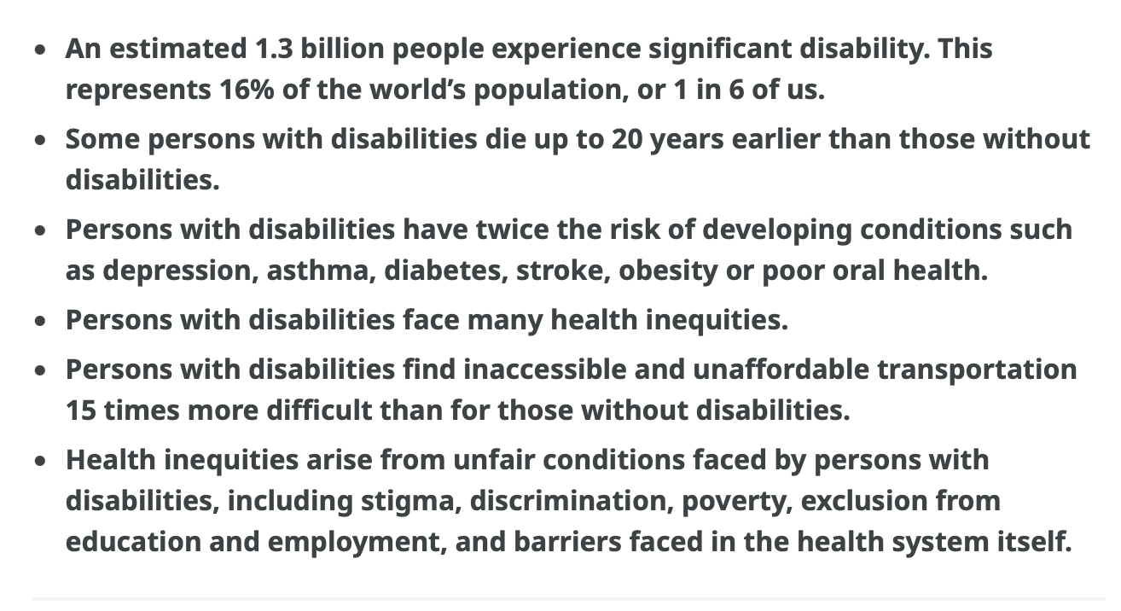
Health Inequities arise from unfair conditions faced by persons with disabilities. Persons with disabilities experience ableism, stigma and discrimination. This affects their physical and mental health. Poverty, exclusion from education and employment, poor living conditions all add to the risk of poor health and unmet needs among persons with disabilities. Persons with disabilities are more likely to have risk factors for noncommunicable diseases such as smoking, poor diet, alcohol consumption and a lack of physical activity. They face barriers in all aspects of the health system. For example, a lack of knowledge, negative attitudes toward practices, inaccessible health facilities and information and lack of data collection on disability, all contribute to health inequities faced by this group. https://www.who.int/news-room/fact-sheets/detail/disability-and-health#:~:text=An%20estimated%201.3%20billion%20people%20–%20or%2016%25%20of%20the%20global,diseases%20and%20people%20living%20longer.

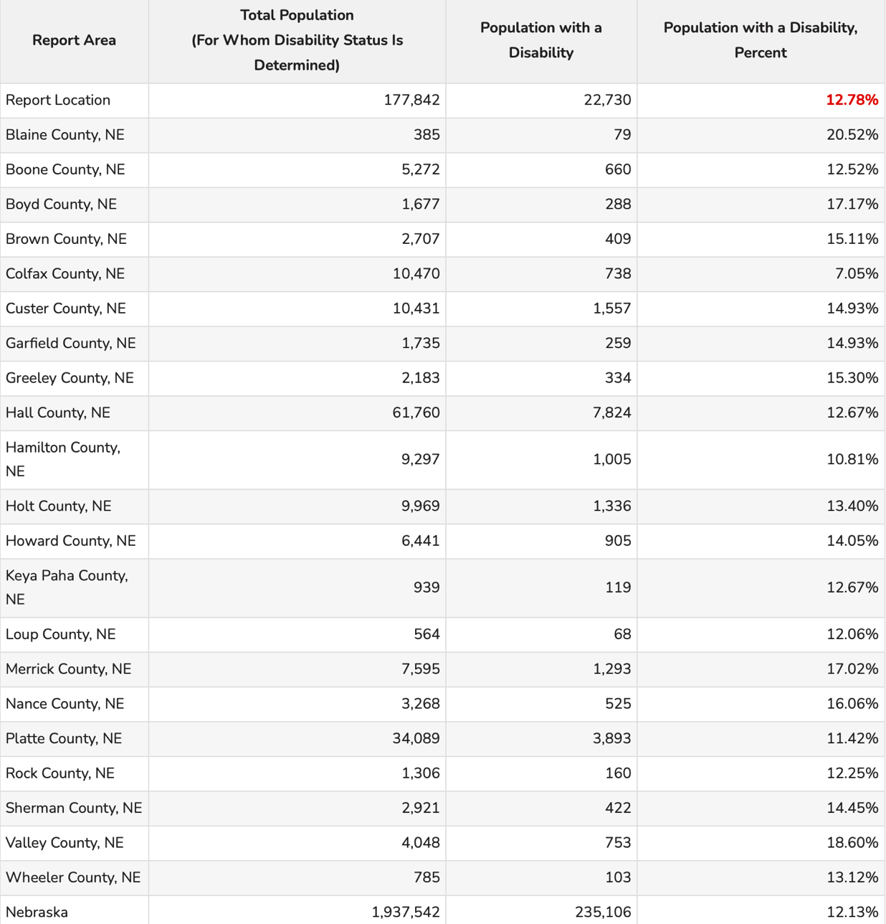

This indicator reports the percentage of the total civilian non-institutionalized population with a disability. The service area has a total population of 177,842 for whom disability status has been determined, of which 22,730 or 12.78% have any disability. This indicator is relevant because disabled individuals may require targeted services and outreach by providers.

Of the total male population in the report area, the percentage with a disability is 13.41%. Of the total females in the report area, the percentage with a disability is 12.13%.
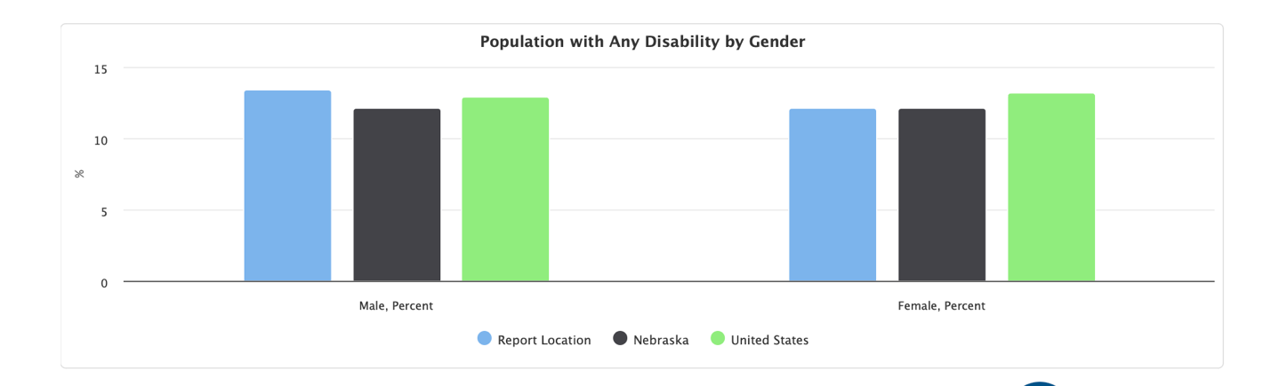

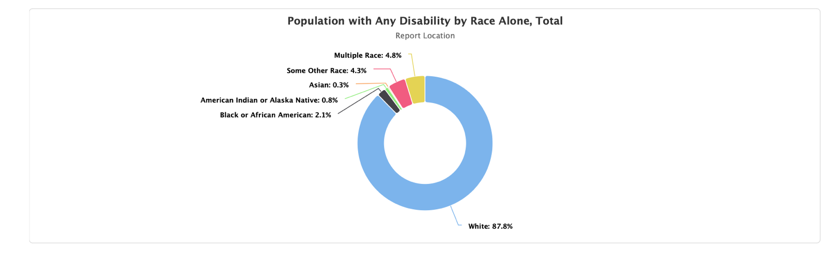

Within the service area, individuals with hearing difficulty are 4.67% of the total population; individuals with vision difficulty are 2.23% of the total population; individuals with cognitive difficulty are 4.85% of the total population age 5+; individuals with ambulatory difficulty are 6.13% of the total population age 5+; individuals with self-care difficulty are 2.30% of the total population age 5+; and individual’s with independent living difficulty are 5.19% of the total population age 18+.
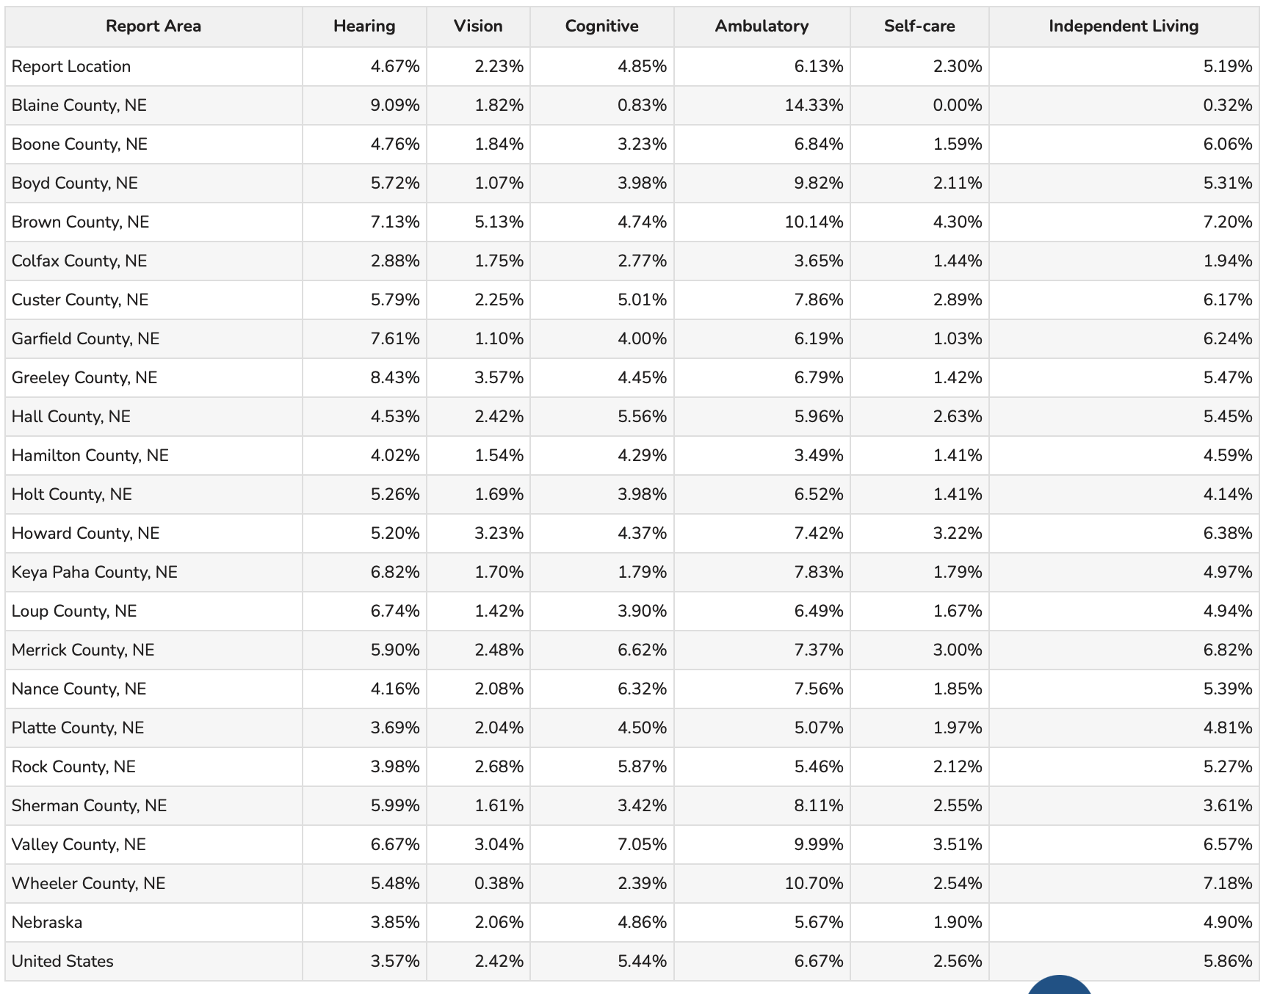

Health Insurance

Access to affordable health insurance is still a major challenge that families face across Nebraska, aside from lack of providers. Below is the number of people without health insurance within our service area. Every person deserves to have affordable healthcare, both physical and behavioral. Yet Nebraska still has an uninsured rate of 6.3% among adults. Quality and consistent preventative healthcare, beginning even before birth, gives children the best chance to grow up to be healthy and productive adults. Children and families must be able to access and maintain affordable health insurance, and policies should maximize availability and robust investment in Medicaid and the Children’s Health Insurance Program. Our health care systems and policies should prioritize preventative services including immunization, developmental screenings, early intervention, and home visiting. Policies should promote timely and equitable access to a complete range of health care services within a home and community-based environment and families across the lifespan. Lack of insurance is a primary barrier to healthcare including regular primary care, specialty care and other forms of care that contribute to poor health status.

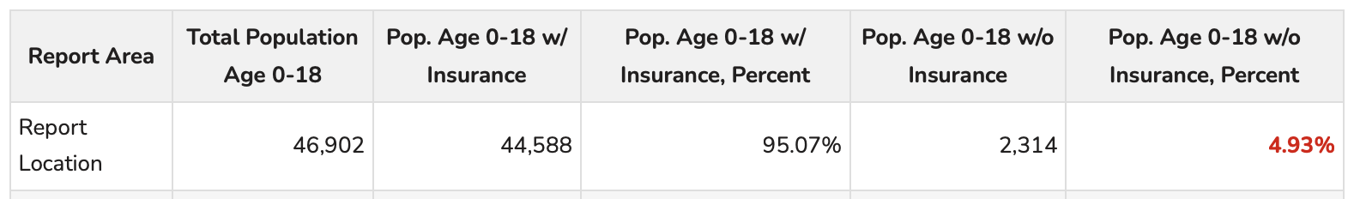
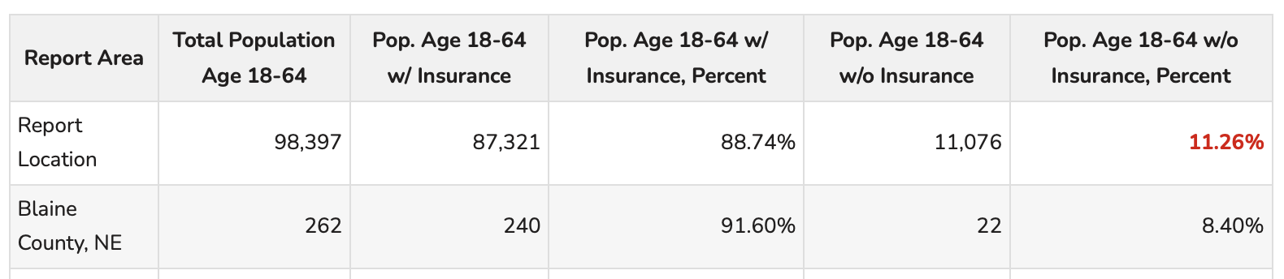

The percentage of uninsured adults and children have both gone down on the last year. For another year, Colfax remains the county with the highest rate of uninsured adults and children. Loup county remains the county with the lowest rate of uninsured adults and wheeler county has the lowest rate of uninsured children. In Nebraska, there were 121,800 uninsured people in 2023. The U.S. population that is uninsured is 8.0% compared to Nebraska’s 6.3%. The number of uninsured in the service area went down since the previous year. While over 90% of the population has some form of health insurance, medical debt continues to be an issue with at least $221 billion owed in 2021. Over 20 million people have purchased nongroup coverage through the Affordable Care Act (ACA) and most (93%) qualify for premium tax credit assistance through health insurance marketplaces. The premium tax credit assistance was enhanced with the passage of the American Rescue Plan Act (ARPA) in 2021 and extended by The Inflation Reduction Act (IRA).
- During 2024, 114,932 Nebraska residents enrolled in a plan through the marketplace. Enrollment in the state has increased by 39% since 2020.
- About 95% of enrollees in the state received an advanced premium tax credit to help them pay their premium.

Nationwide, however, the number of uninsured has started to increase after finally reaching record lows. This is due to the fact that more than 24.8 million people have been disenrolled from Medicaid since March of 2023. This number is expected to worsen by 2026, due in part to declines in Medicaid enrollment and the end of temporary subsidies. Health insurance is critical for ensuring that children receive the medical care they need to achieve and maintain good health. Children with health insurance coverage are more likely to have a usual source of care and less likely to delay or forgo necessary medical care because of cost. When compared to privately insured children, uninsured children have more health disadvantages including: more hospitalizations, higher mortality rates, less stable and frequent preventative care, lower rates of vaccine coverage. Across the United States, the uninsured rate is highest among American Indian/Alaska Native, Native Hawaiian or other Pacific Islander and Hispanic Children compared with non-Hispanic white, Black and Asian children. Children from lower-income families compared with those from higher-income families. High cost is often cited as the reason for lack of coverage. Health coverage is important for children because it improves access to pediatrician-recommended care and services that support healthy development. When children get the health care they need, they are more likely to succeed in school, graduate from high school and attend college, earn higher wages, and grow up into healthy adults. Scroll down for an in-depth look at child health care trends across Nebraska.

While over 90% of the United States has some form of health insurance, medical debt also continues to be an issue. Over $220 billion was owed in 2021. 11% of Nebraska adults reported having medical debt in a given year between 2019 and 2021. This is higher than the United States average of 8.6%. https://www.kff.org/statedata/election-state-fact-sheets/nebraska/

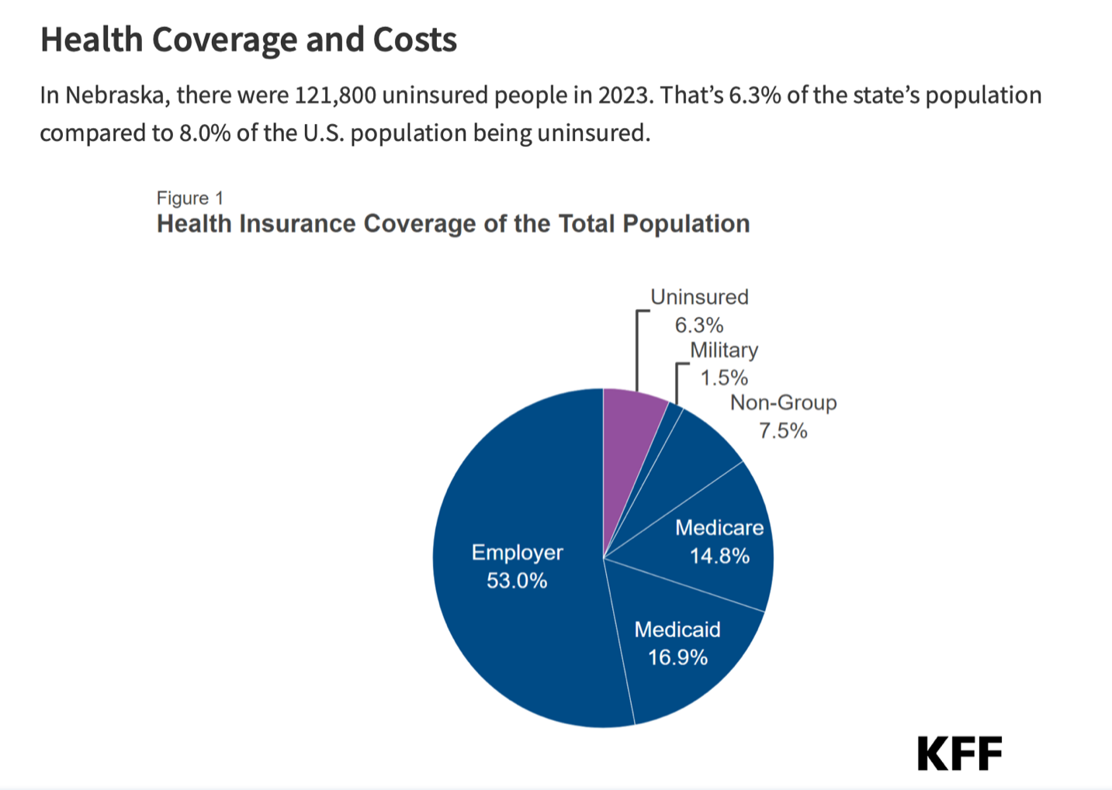

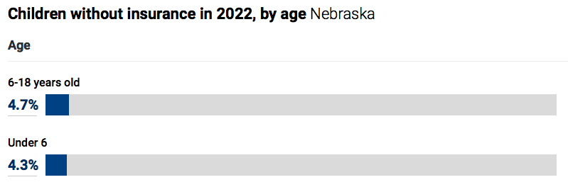
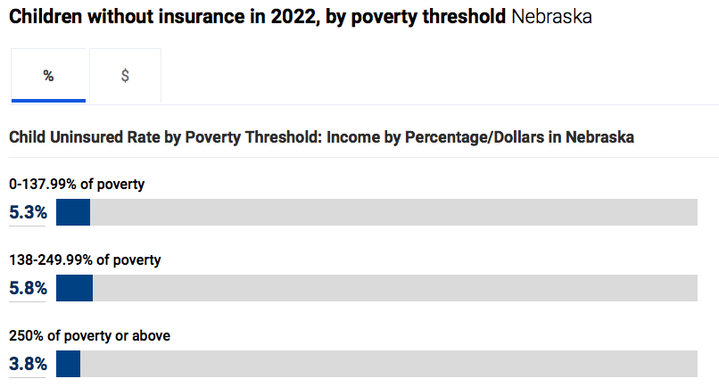

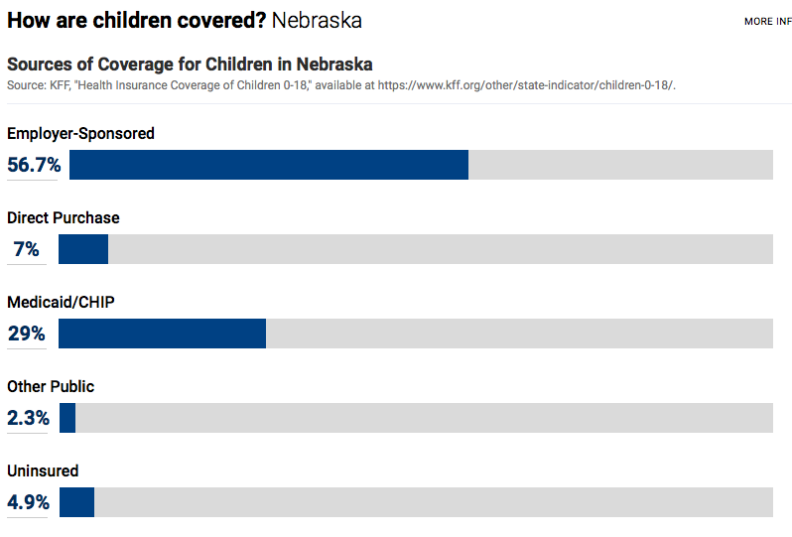

https://www.kff.org/statedata/election-state-fact-sheets/nebraska/
https://www.neohospitals.org/thecenterforhealthaffairs/mediacenter/newsreleases/2024/August/CDC-Reports-a-Rise-in-the-Number-of-Uninsured-Americans-After-Record-Lows
https://kidshealthcarereport.ccf.georgetown.edu/states/nebraska/

Teen Pregnancy

The number of teen pregnancies in the state of Nebraska has increased from 14 births per thousand to 15 births per thousand. Nebraska is ranked 24th for pregnancy rates in the United States.

The number of teen births within the CNCAP service area has decreased from 56 to 36 according to the table below. There are several counties in the CNCAP service area that have no reported teen births. The majority of the teen births are reported in Hall County and Platte County with additional teen births in Holt County and Brown County. Within the service area there was a total of 6 births per thousand teens.

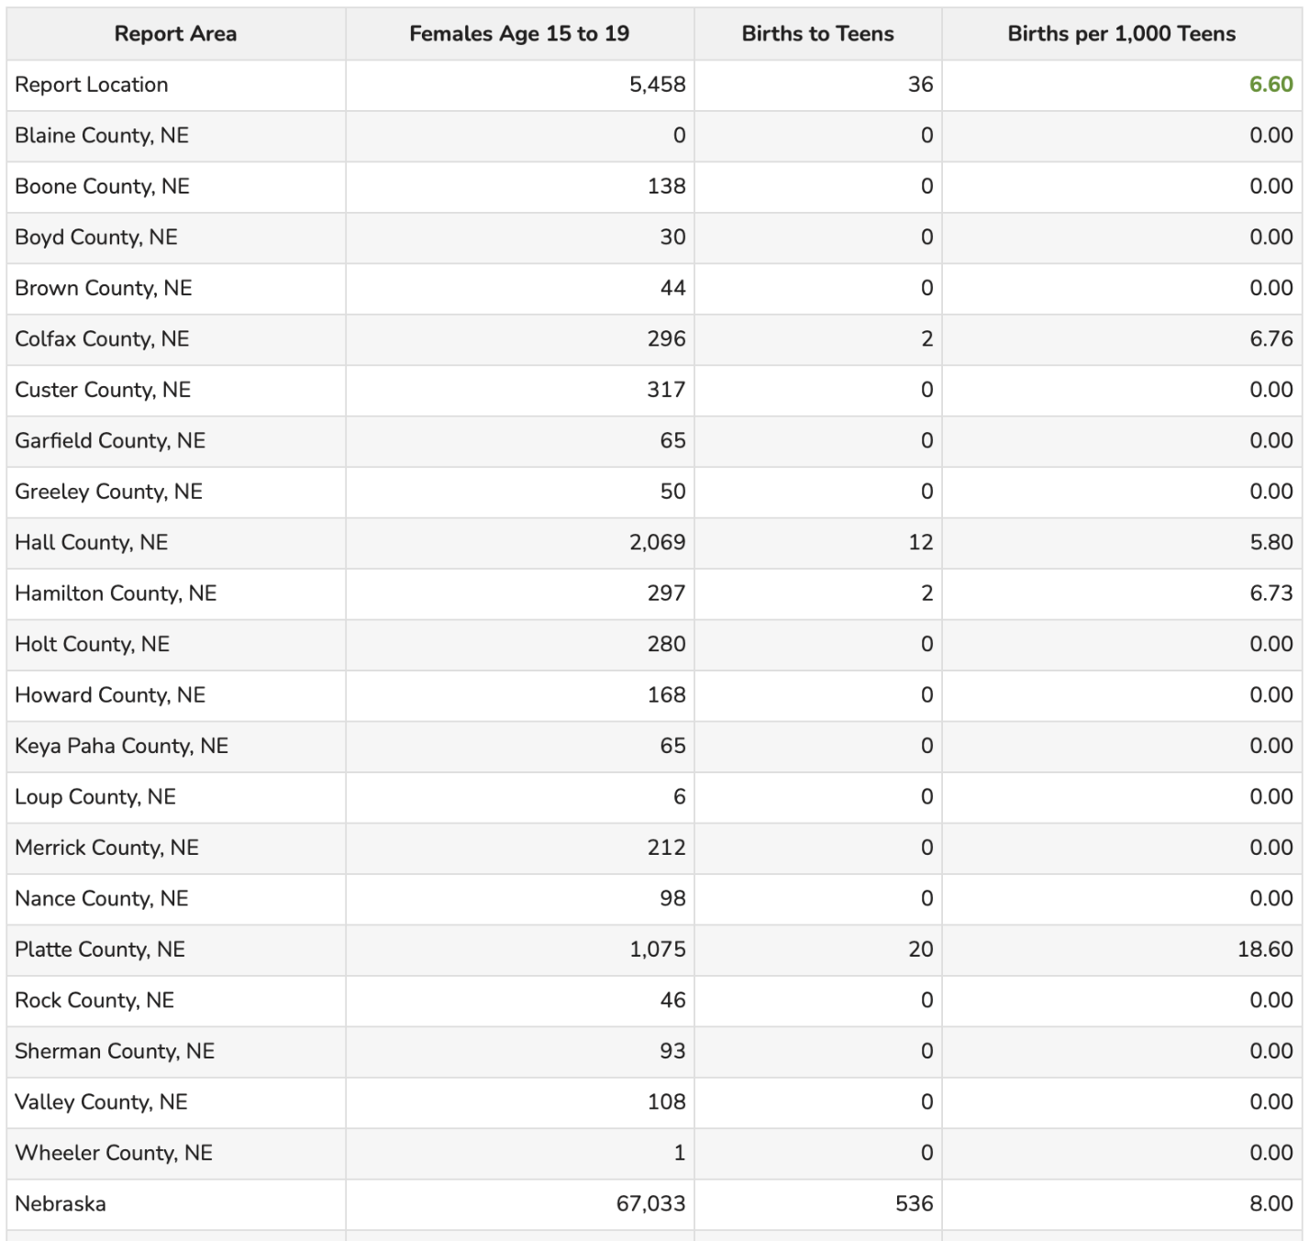

Substantial social, economic and health costs are associated with teen pregnancy and childrearing. Teen mothers are significantly more likely to drop out of high school and face unemployment. The children of teen mothers have a higher risk of dropping out of school, being hospitalized, dying during infancy or childhood and becoming teen mothers themselves. While teen births have declined steadily over the last several decades, disparities still persist. The rate of teen pregnancy is higher among:
- Teenagers aged 18-19 with a rate 4 times higher than those ages 15-17.
- Teenagers in foster care with a rate more than twice of those not in foster care.
- American Indian/Alaska Native, Hispanic, Black and Native Hawaiian/Pacific Islander teenagers, with pregnancy rates that are all more than double of non-Hispanic white teenagers from higher-income counties.
- Teenagers living in lower-income counties compared to teenagers from higher-income counties.
- Teenagers from counties with lower educational attainment compared to teens from counties with higher educational attainment.
- Teenagers living in rural counties compared to teenagers living in urban counties.
Birth statistics:
- In 2023, 1 in 9 babies (11.1% of live births) was born preterm in Nebraska.
- In 2023, 1 in 13 babies (8.0% of live births) was low birthweight in Nebraska.
- In Nebraska in 2022, 142 infants died before reaching their first birthday, an infant mortality rate of 5.8 per 1,000 live births.
- In Nebraska in 2023, 80.1% of infants were born to women receiving adequate/adequate plus prenatal care.
- In Nebraska in 2023, 29.4% of live births were Cesarean deliveries.
- In 2021, about 1 in 11 women of childbearing age (9.4%) was uninsured in Nebraska.
- There are an average of 463 babies born in Nebraska every week.
https://www.marchofdimes.org/peristats/data?reg=31&top=2&stop=5&slev=4&obj=3&sreg=31
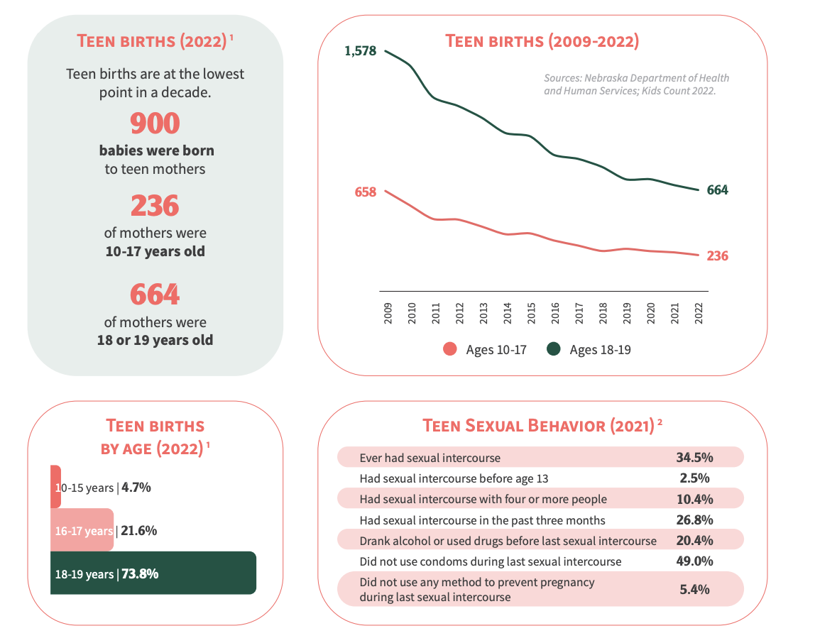

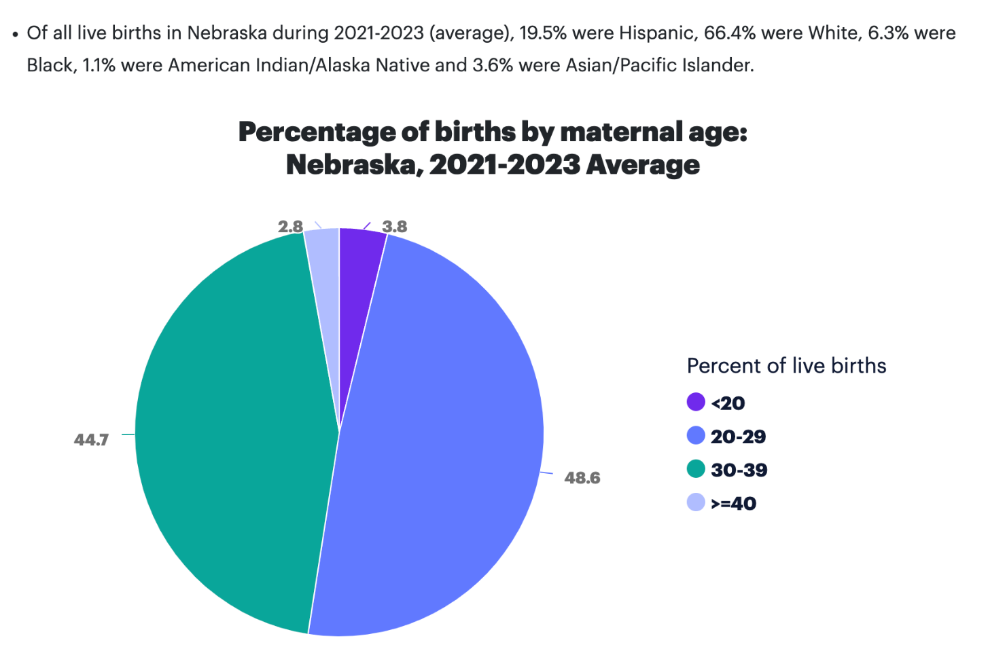
Childcare

From 2020 to 2022, there has been a 17% decline in the number of licensed child care facilities statewide. In 2022, the last year of available data, nine of the state’s 93 counties had zero licensed child care facilities and an additional 23 counties failed to meet the licensed childcare needs for at least half of their young children. On top of that, childcare has surpassed college tuition. Many small-town communities feared that their towns would not survive unless they gained better access to childcare. Even before the daycare shortage, the expense of childcare strained budgets. The Average annual price of center-based childcare for one infant in 2021 was $11,068.

Across the state of Nebraska, early learning opportunities serve more than 30,003 children and families or 19% of children ages 5 and under. High quality child care and early learning programs support child development and offer parents peace of mind while they work or attend school. The demand for quality care far outweighs the supply. So many families struggle to access and afford the care option that they want or need. The national economy looses 122 billion annually from lost earnings, productivity and revenue due to parents leaving the workforce as a result of shortages.
https://nebraskaexaminer.com/2024/03/28/new-kids-count-report-focuses-on-child-care-crisis-in-nebraska/
https://www.ffyf.org/wp-content/uploads/2024/07/2024-Nebraska-State-Fact-Sheet.pdf
https://voicesforchildren.com/wp-content/uploads/2024/03/KC2023_FullDocument_FINAL.pdf
https://ruralpoll.unl.edu/sites/unl.edu.ianr.alec.rural-poll/files/media/file/24%20Report%20-%20Community.pdf
https://nebraskacaresforkids.org/f_2024-wcfk-surveydeck-final/

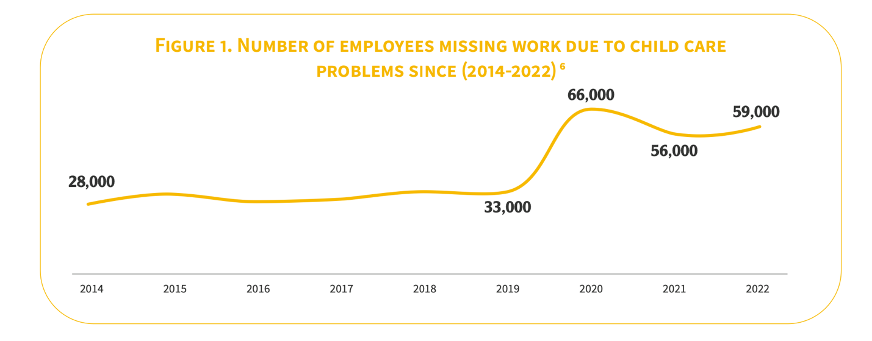
The number of employees missing work due to lack of childcare has doubled since 2014. Two counties within our service area do not have a single childcare facility: Keya Paha and Blaine counties. A major challenge in rural communities is lack of access to affordable, high quality daycare which then causes parents to miss work, turn down promotions, reduce hours or leave the workforce entirely. This is an issue that has increased since the previous year. Nebraska lost almost 10% of its childcare programs since COVID-19 hit. In August of 2023, there were nearly 68,000 job openings online in Nebraska but at the same time Nebraska was experiencing some of the lowest unemployment rates in the country. According to a survey done by Nebraska Extension, nearly a third of parents with children 5 and under said they left the workforce because they could not find affordable childcare.

The average rate of center-based care for an infant now absorbs 10% of the median income of a married couple and 33% of the median income of a single mother. Having two young children in need of care becomes especially costly at 19% of a married couple’s income and 61% of a single mother’s income. While the cost of college tuition has garnered much national attention in the previous years, a year of childcare in Nebraska surpasses a year’s tuition and fees at public universities.

Yet at the same time, the median yearly wage for child care workers is $28,000, which places their earnings slightly above those of cashiers. Overall, child care workers rank among the lowest paid workers in the country at 673rd out of the 693 occupations with data tracked by the U.S. Bureau of Labor Statistics. With the high level of economic and social importance of the child care work itself, along with the low-pay and high-level of responsibility placed on the childcare workers, the workers often suffer from burn out. This burn out can be seen through the 30% turnover rate among Nebraska’s child care workers from 2022 to 2023.

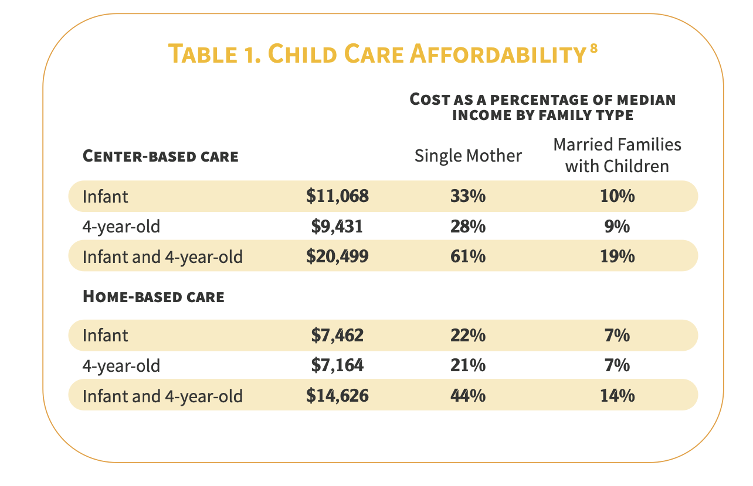

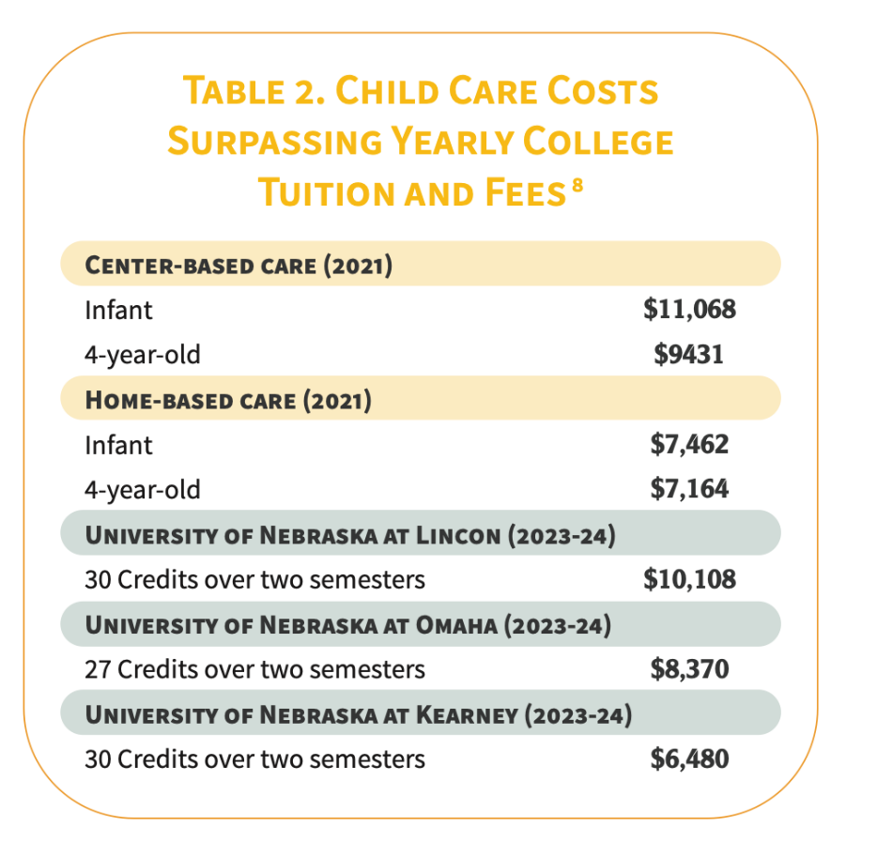
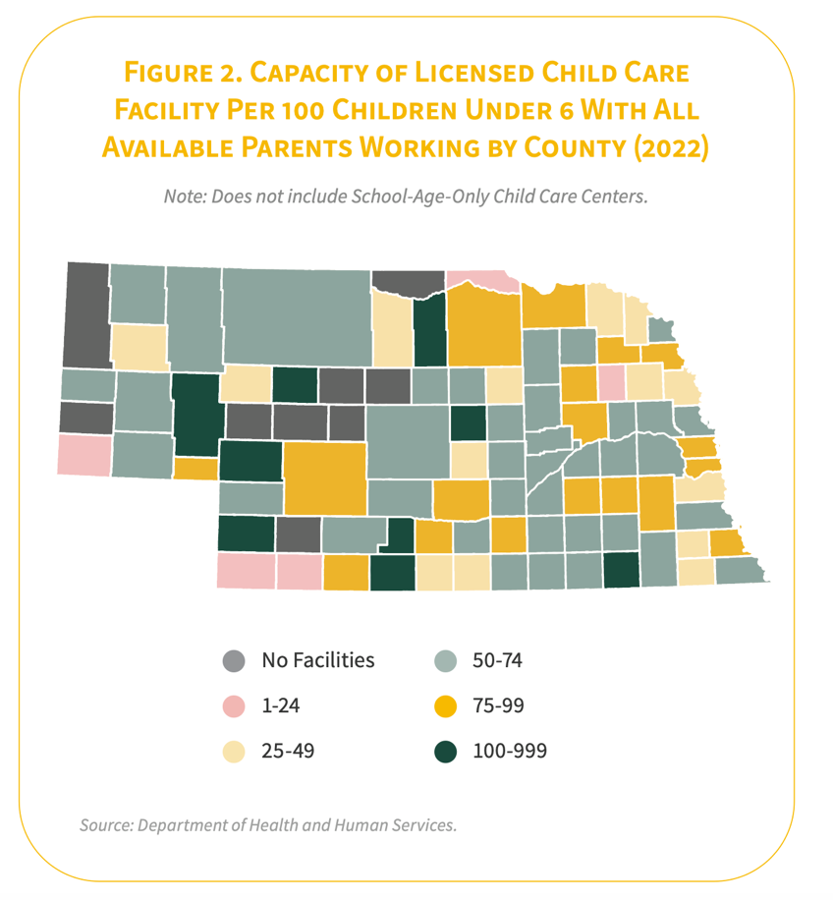
When it comes to the cost of Child Care in Nebraska, there are several factors that can influence the price you pay. Here are some of the key factors that can impact the cost of Child Care in Nebraska:
Location
The location of the Child Care can have a significant impact on the cost of care. For example, Child Care centers in urban areas or larger cities tend to be more expensive than those in rural areas. Additionally, Child Care centers located in more affluent neighborhoods may also charge higher rates than those in less affluent areas.
Type of Care
Generally, center-based care is more expensive than home-based care. This is because center-based care typically has more staff, more resources, and more overhead costs. Additionally, the age of your child can impact the cost of care, as infant care tends to be more expensive than care for older children.
Duration of Care
Typically, full-time care (defined as care for more than 30 hours per week) is more expensive than part-time care. Additionally, some Child Care centers may offer discounts for longer-term contracts or for siblings attending the same center.

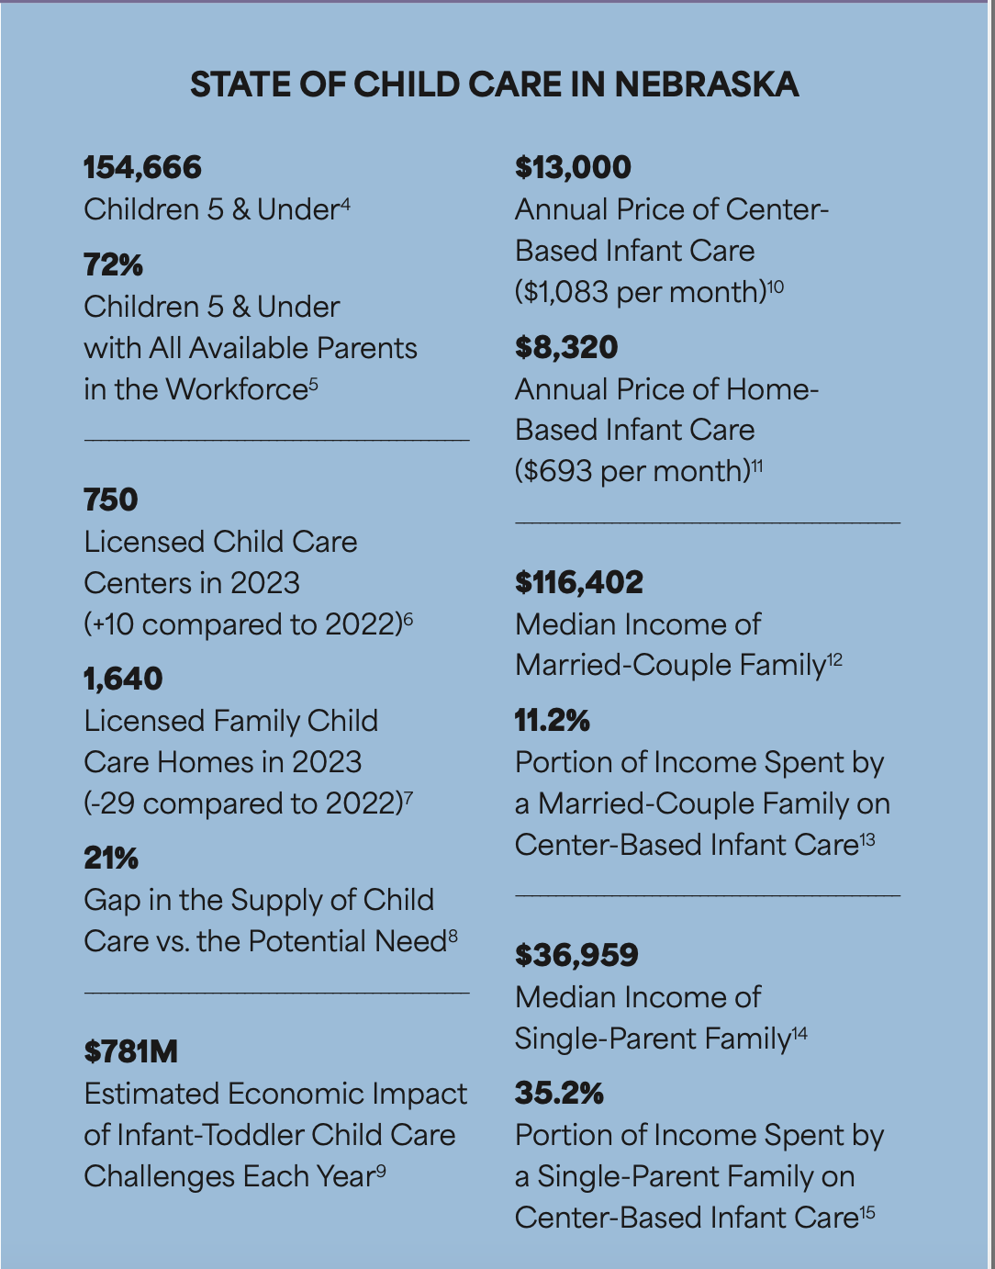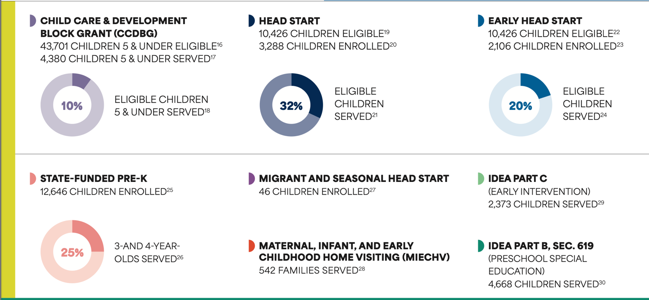

In the 2024 Nebraska Rural Poll, it was found that young people are more likely than older people to express dissatisfaction with the child care services in their community. Just over 6/10 people between the ages of 19 and 29 are dissatisfied with the child daycare services, compared to just over 2/10 people over the age of 65. People living in communities with populations between 500 and 999 are the community size most likely to be dissatisfied with their childcare services, which much of the CNCAP service area is. Other groups most likely to be dissatisfied with their community’s childcare services are people with higher household incomes, the highest education levels and people with healthcare support or public safety occupations.

Almost 90% of Nebraskans believe that ensuring affordable day care for working families is an important priority. Only 11% of Nebraskan’s said that it is not an important priority for Nebraska. 79% of Nebraskans believe that lack of quality childcare is affecting thousands of working families in Nebraska and requires bigger solutions.
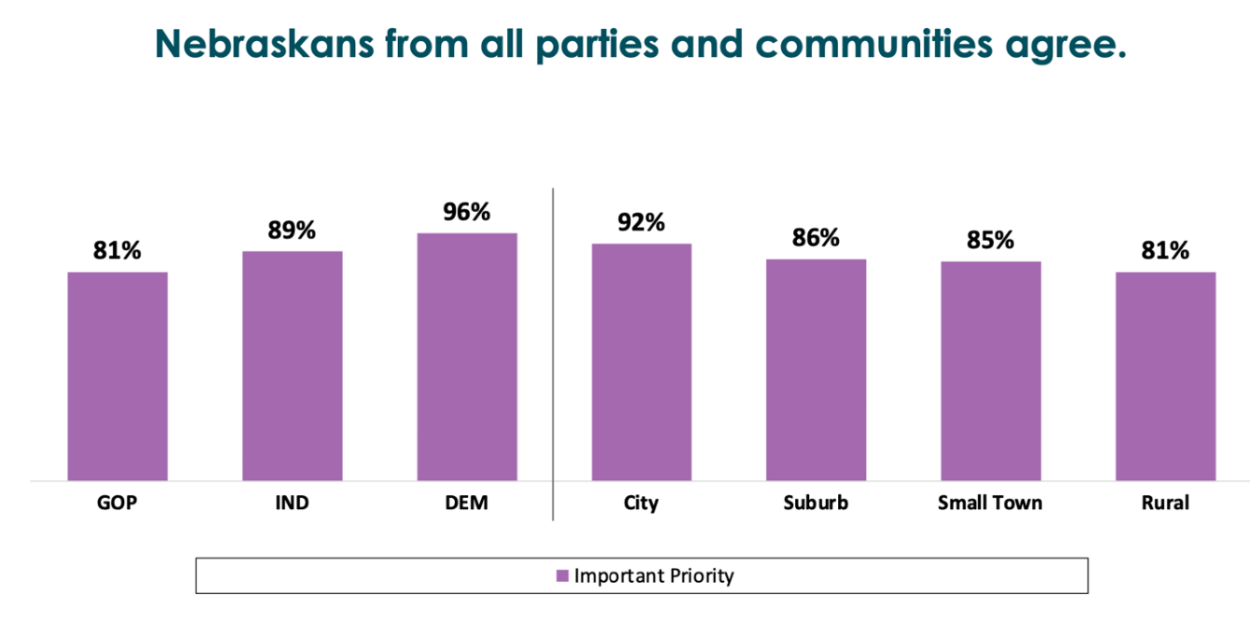
Human Trafficking

There were 12 people convicted of felonies for human trafficking related charges with cases still open in several counties. Through the Nebraska Human Trafficking Hotline, 23 cases were identified across the state with 33 victims being involved in these cases. 17 of these cases were sex related and 5 cases were labor related. 19 of these were adults and 7 were minors and 19 were female and 6 were male. There have been 27 convictions in the state’s history.

https://humantraffickinghotline.org/en/statistics/nebraska

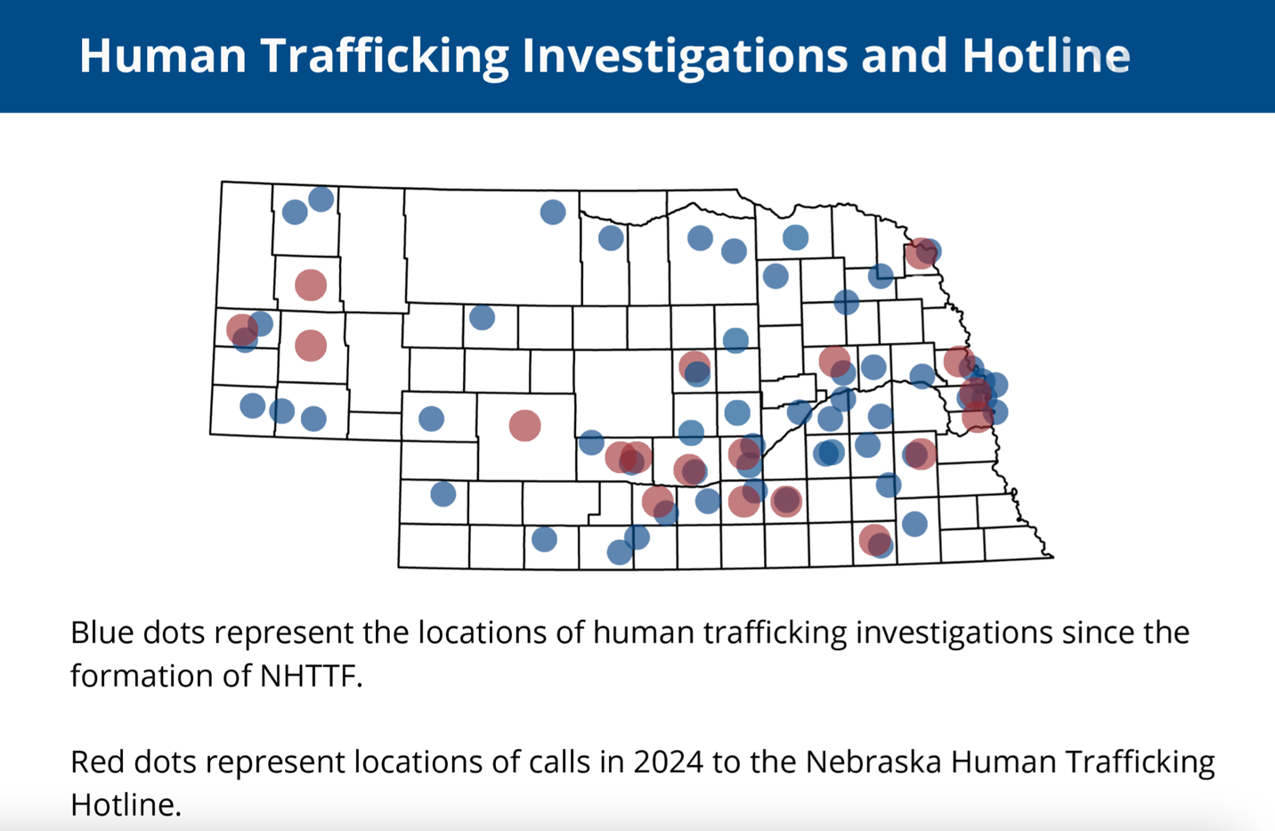

In 2024, the Nebraska hotline received 113 calls. 94 law enforcement tips. 15 law enforcement dispatches and 4 requests for resources.
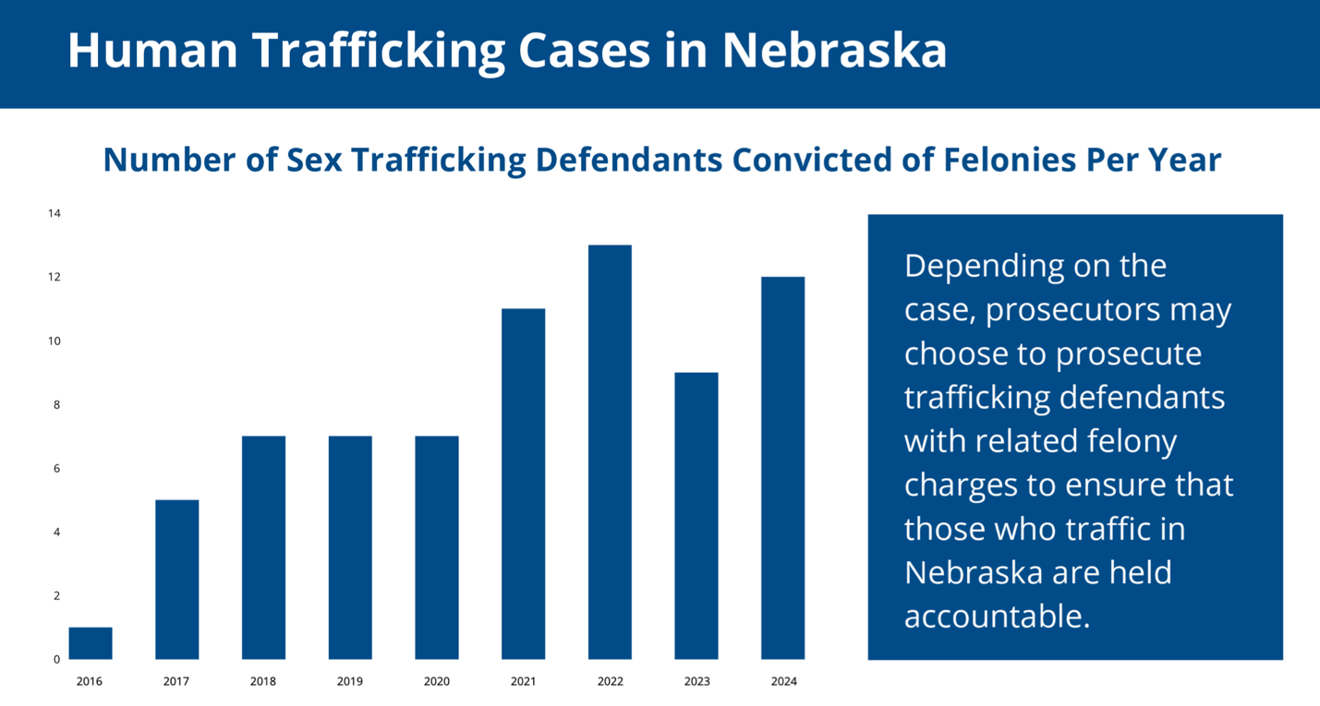

Disconnected Youth/Youth Homelessness

In the service area, of the 32,710 students enrolled in reported districts during the 2021-22 school year, there were 347 or 1.06% students experiencing homelessness, which is higher than the statewide rate of 0.95%.

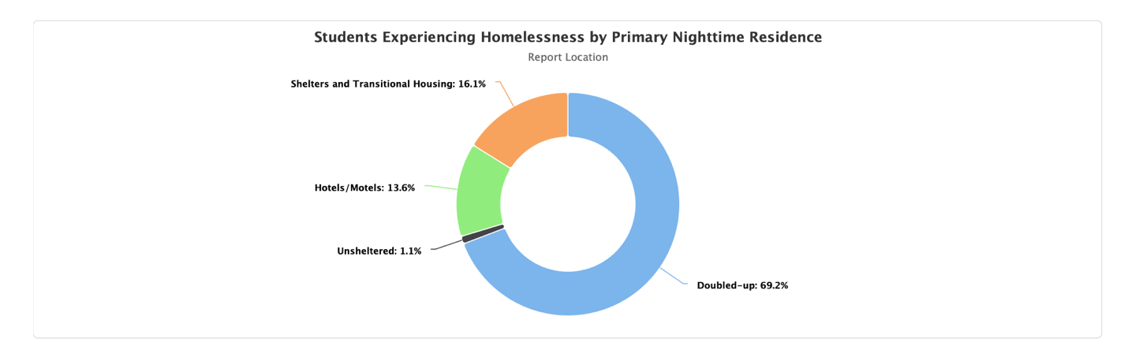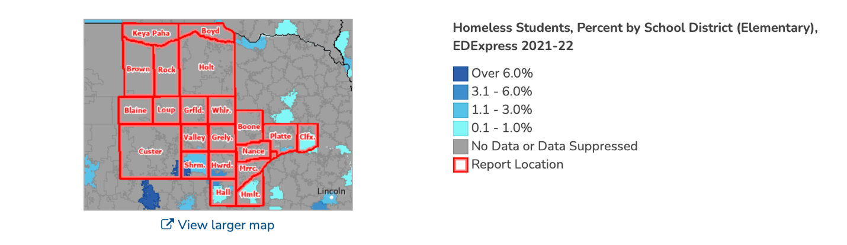

Across the state, there were 2,545 students at risk of homelessness in 2023. There were 431 families served who were homeless with children and 987 children homeless under the age of 18. In 2024, 2720 people were experiencing homelessness in Nebraska and 11% of them were unsheltered. There was an increase in homelessness in the last year for Nebraskans.

Within our school systems, here is the number of homeless/unaccompanied youth:
Ansley: Homeless students – 1
Aurora: Homeless students – 2
Centura: Homeless students – 21
Columbus: Homeless students – 72
Grand Island: Homeless students – 221; unaccompanied youth – 51
Litchfield: Homeless students – 9
Loup City: Homeless students – 7; unaccompanied youth – 2
O’Neill: Homeless students – 2
Schuyler: Homeless students – 4; unaccompanied youth – 1
Wood River: Homeless Students – 3
https://www.education.ne.gov/wp-content/uploads/2022/08/Homeless-and-Unaccompanied-Count.pdf

The KIND (Keeping Independent Needs Defined) is a joint TH-RR housing program that serves literally homeless youth between the ages of 18-24 with crisis intervention housing assistance as well as serving homeless and near homeless youth ages 18-24 by rapidly rehousing them and offering case management, with possible financial assistance to work towards permanent housing while focusing on employment and education. In 2024, The KIND program assisted 9 households and 12 beneficiaries in the transitional category of KIND and 41 households with 78 beneficiaries in the rapid re-housing category of the KIND program. KIND youth paid $21,794 in debt for 14 households with 31 beneficiaries. The program also had 12 households with 26 beneficiaries save a total of $8,728.

The KIDS (Keeping Independence Defined in Society) program assists individuals and families whose household is between the ages of 18-24. The core elements of the KIDS program are: 1. Stable housing 2. Education and Employment 3. Social and emotional well-being 4. Permanent connections. The program assists youth in homeless situations get into housing. While in the program, youth will have the opportunity to participate in case management to address specific barriers the family is having. The KIDS program serves all 21 counties.

https://www.huduser.gov/portal/sites/default/files/pdf/2024-AHAR-Part-1.pdf

Crime
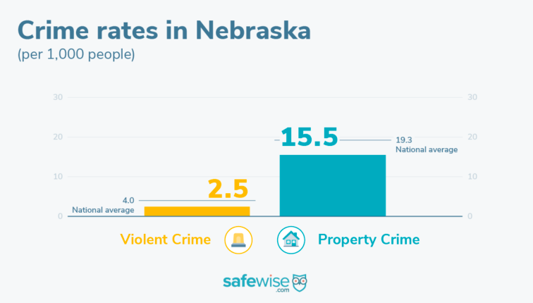
Nebraskans surveyed said they experienced more property crime year over year, and they're more concerned about property crime than they were last year.
- 47% of survey respondents say they are highly concerned about property crime (US 52%). Concern grew 12% year over year.
- More Nebraskans (29%) reported personal experiences with property crime this reporting year compared to last year (19%). That's two points higher than the national average.
- 39% of participants reported experiencing package theft in the last 12 months, putting Nebraska above the US average of 35%.
- 4 in 10 respondents (40%) told us they increased their security measures in the 12 months prior to the survey (US 35%)
- 20% of people in Nebraska use no form of property protection. This is below the 25% national average.
- The top form of property protection in Nebraska this year was security cameras with 43% of survey respondents using them. This is a higher adoption rate than the national average of 39%. Guard dogs came in second with 30%.

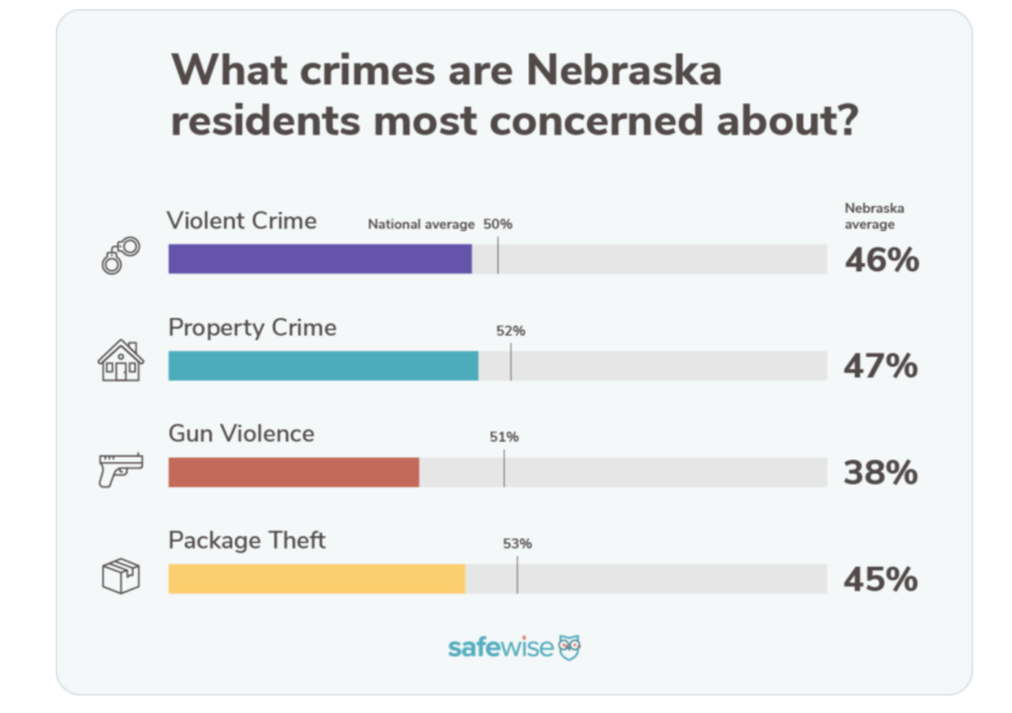

- 46% of Nebraskans said they are very worried about violent crime.
- 60% reported feeling safe in their state compared to 45% of Americans
- 10% report having a personal experience with violent crime in the last twelve months.
- 40% report using some form of personal protection.
- Pepper spray is the top pick for personal protection in the state.
- 10% say they have had an experience with gun violence.
- Nebraska experienced 2 mass shootings in 2023.

https://www.safewise.com/blog/safest-cities-nebraska/

Dr Debra Pinals stated, “For too many with mental illness, America’s prisons and jails are the default placement.” Our criminal justice system is filled with people who bounce through courts, jails, prisons, parole, and probation-people who need mental health and substance use care to prevent them from re0entering the system at a cost to them and to society.
Source:pewresearch/charitabletrust

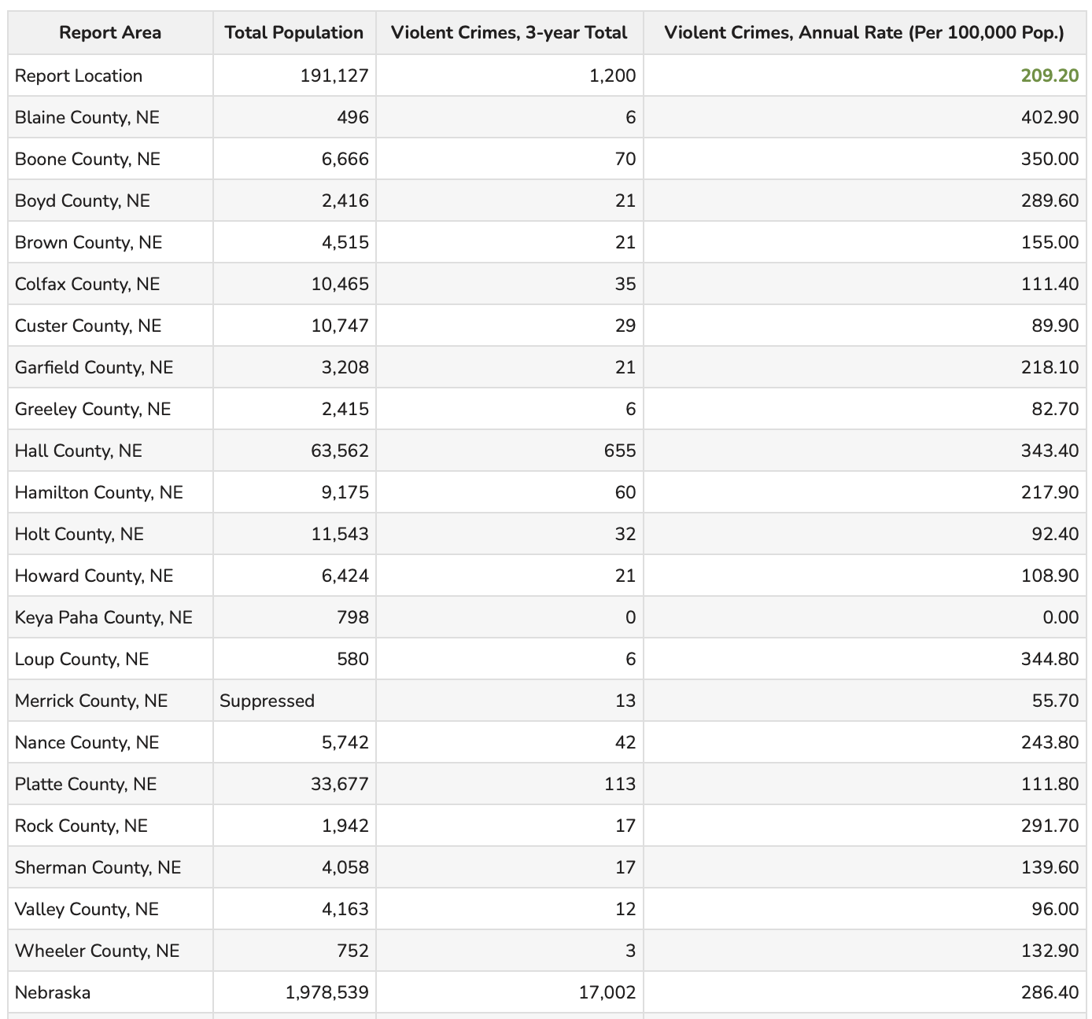
Violent crime includes homicide, rape, robbery, and aggravated assault. Within the service area, the 2015-2017 three-year total of reported violent crimes was 1,200, which equates to an annual rate of 209.20 crimes per 100,000 people, lower than the statewide rate of 286.40.
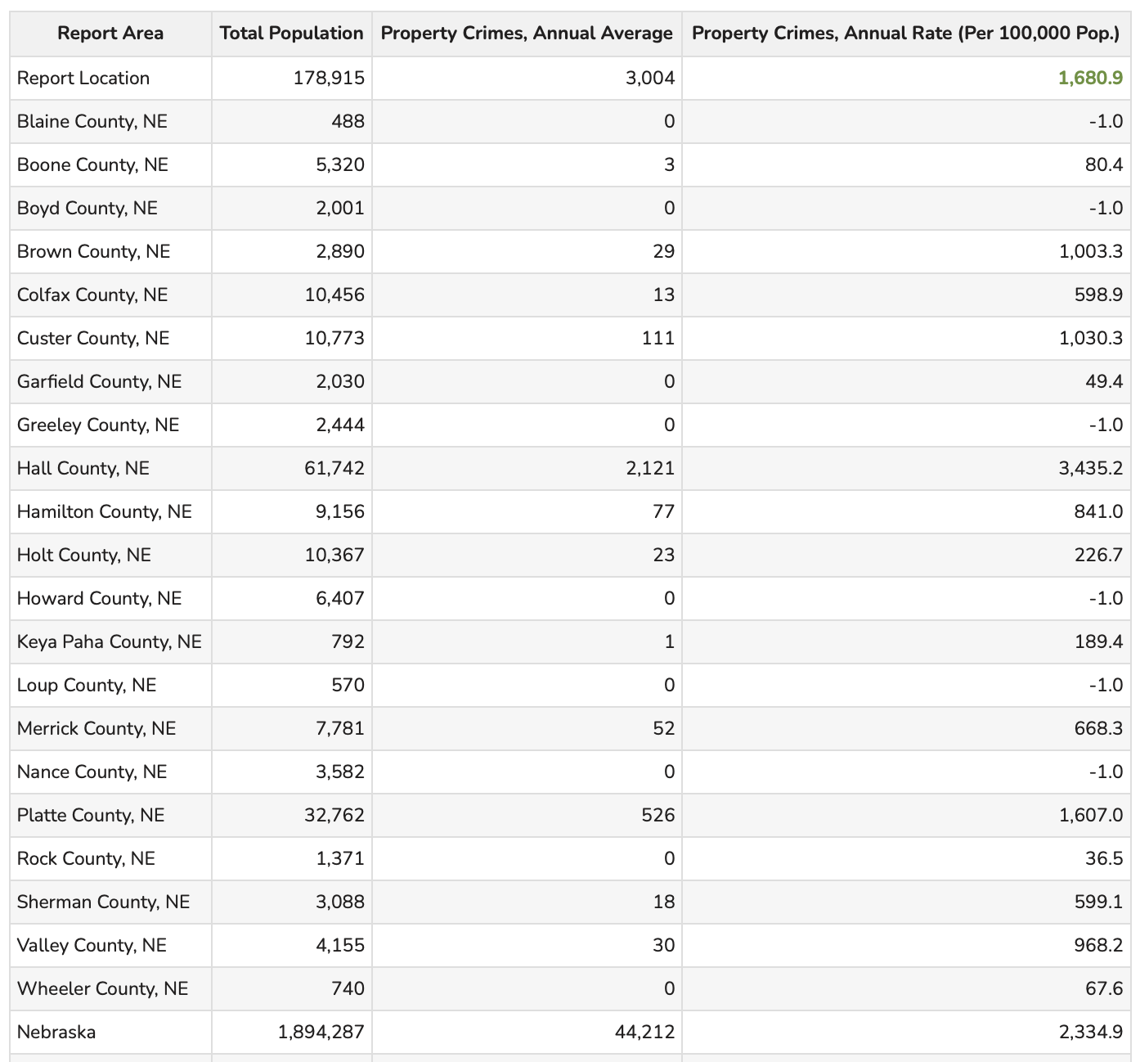
This indicator reports the rate of property crime offenses reported by law enforcement per 100,000 residents. Property crimes include burglary, larceny-theft, motor vehicle theft, and arson. This indicator is relevant because it assesses community safety.
In the service area, 3,004 property crimes occurred in 2014 and 2016 (two years). The property crime rate of 1,680.9 per 100,000 residents is lower than the statewide rate of 2,334.9 per 100,000.

Domestic Violence

In the wake of a 2025 domestic violence homicide which happened in Seward Nebraska in February, Nebraska is warning of an increase in domestic violence across the state. The director of Friendship Home stated that they are seeing an increased level of violence. Coming out of the pandemic they have seen threats of homicide, strangulation and stalking increase by 10% since 2021. This number has continued to rise across the entire state. https://nebraska.tv/news/crime/update-on-domestic-shooting-in-seward

33.7% of women over the age of 18 who were surveyed have suffered from domestic violence at least once in their life. 0.72 out of 100,000 females are murdered in Nebraska. 28% of men have experienced domestic violence. In 2021 there were 603 forcible rapes and in 2022 there were 592 in the state of Nebraska.
Assaults per county in 2022:
Blaine: 0
Boone: 0
Boyd: 0
Brown: 5 simple domestic assaults
Colfax: 2 aggravated domestic assaults; 7 simple domestic assaults
Custer: 1 aggravated domestic assault; 14 simple domestic assaults
Greeley: 0
Garfield: 4 simple domestic assaults
Hall: 46 aggravated domestic assaults; 200 simple domestic assaults
Hamilton: 0 aggravated domestic assaults; 5 simple domestic assaults
Holt: 0
Howard: 3 simple domestic assaults
Keya Paha: 0
Loup County: 0
Merrick: 1 aggravated domestic assault; 4 simple domestic assaults
Nance: 1 simple domestic assault
Platte: 4 aggravated domestic assaults, 27 simple domestic assaults
Rock: 0
Sherman: 0
Valley: 1 simple domestic assault
Wheeler: 0
https://ncc.nebraska.gov/sites/default/files/doc/2023%20Domestic%20Assault%20and%20Arrest%20by%20County.pdf

Law Enforcement

Sworn Personnel
- 3,717 full-time sworn officers with 262 vacant positions.
- 1012 officers employed full-time in Sheriffs' departments.
- 2114 officers employed full-time in Police departments.
- 591 officers employed full-time in State Agencies
- 3.5 full-time sworn officers per 1,000 people (based on a population of 1,870,050).
- 302 part-time sworn officers with 21 vacant positions.
Civilian Personnel
- 1,693 full-time civilian employees.
- 214 part-time civilian employees.
- 95 vacant positions (both full-time and part-time).
Reserve Officers
- 13 reserve officers.
- 6% of the total agencies use reserve officers.
Contractual Agreements
33 departments reported they have contracts with communities, etc., to provide law enforcement coverage. https://ncc.nebraska.gov/sites/default/files/doc/2022%20Employment%20Data.pdf

Health Trends

A bill was passed that may directly affect Nebraska healthcare. This bill includes a nearly 10% cut to Medicaid, a joint federal and state program that helps cover costs for those with limited income. Nebraska Hospital Association President Jeremy Nordquist said that more than 300,000 Nebraskans are served by the program—mostly children—a significant portion of whom live in rural areas. Around 40% of the state’s rural hospitals are operating in the red, and that’s before potential cuts. Without a payer source from patients, hospitals are less sustainable. Rural hospitals make up more than 68% of all hospitals in Nebraska. The state also has more rural residents living more than 25 minutes away from an ambulance than all but two other states. 14 of Nebraska’s 93 counties do not have a primary care physician. Coverage for children, maternal care and behavioral health in rural communities is funded substantially through Medicaid. Already those services are being restricted in some locations which has forced patience to drive significant distances for care. Data from the Nebraska Hospital Association shows that around 16% of expectant mothers in the state must travel at least 30 minutes to find a provider which is twice the national rate. “If we want those services across the state, we need Medicaid” Nordquist said “We need it to be well-funded.” If these bills pass even the urban areas of Nebraska will likely face a reduction in services. https://www.klkntv.com/nebraska-hospitals-take-issue-with-medicaid-cuts-in-house-budget-bill/

Women, Infants and Children, (WIC) Programs

WIC is a Special Supplemental Nutrition Program for Women, Infants and Children, which is a nutrition program for pregnant, breastfeeding women and families with children younger than 5. WIC is the nation’s most successful and cost-effective public health nutrition program. Wholesome and nutritious fresh food is provided, nutrition education and community support for income eligible women who are pregnant, breastfeeding or post-partum, and for infants and children up to five years old. In Nebraska, WIC helps approximately 35,000 people at over 100 clinic sites

Income guidelines for WIC:
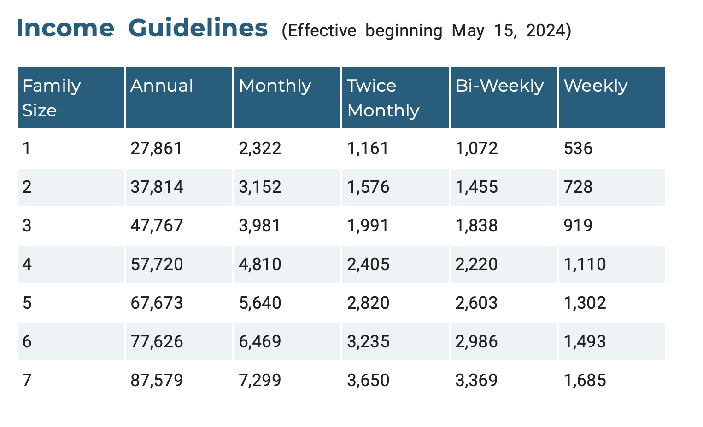
WIC helps eligible families with:
Healthy Food
Breastfeeding Support
Nutrition Education
Health and Community Resources

Who can apply?
Pregnant women, breastfeeding women, new mothers, infants, children to age 5, foster children to age 5. Support is also offered to anyone—working or not—who cares for a child including: moms, single fathers, grandparents, foster parents, step-parents, guardians.

Nutrition

Food insecurity is a lack of access—at times—to enough food for an active, healthy life for household members and limited availability of nutritionally adequate foods. Many households that experience food insecurity do not qualify for federal nutrition programs and need to rely on their local food banks for support. Early Childhood Programs also provide children with nutritious food they may not always have access to at home. This indicator reports the number of neighborhoods in the service area that are within food deserts. The USDA Food Access Research Atlas defines a food desert as a neighborhood that lacks healthy food sources due to income level, distance to supermarkets or vehicle access. The report area has a population of 22,518 living in food deserts. Three counties within the service area make up the food desert. Blaine, Keya Paha and parts of Custer counties are identified as areas having lack of access to healthy foods.

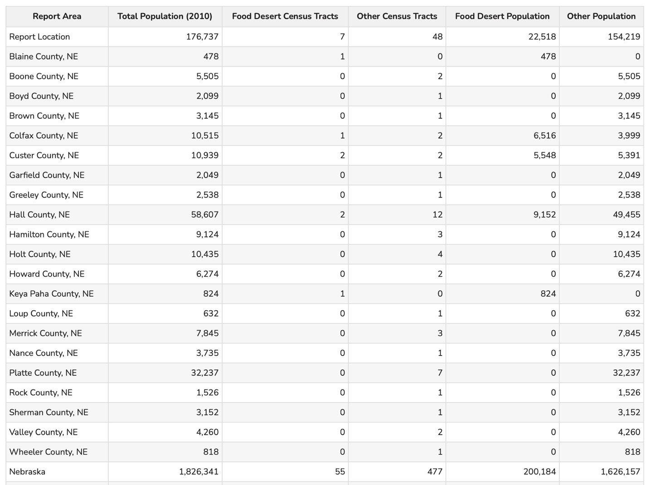

One in every seven people in Nebraska may not know where their next meal will come from. Additionally, an estimated 91,240 kids in Nebraska—or one in every five—is experiencing food insecurity at higher rates than the general public population. The Food Bank of Lincoln and Food Bank for the Heartland, both members of the Feeding America network, serve the entire state. Combined, the two food banks connected approximately 1.3 million people to meals in 2019. This year, food banks are projecting service to nearly 2.7 million individuals. Prices of food are also historically high and residents are running into the expiration of pandemic programs. This creates a larger need for food assistance. Another major challenge for Nebraska is that 59% of people facing hunger in Nebraska may not qualify for SNAP due to eligibility restrictions based on household incomes, adding to the demand for food assistance provided by food banks. Not only that, but escalating housing costs and wages not keeping up with inflation is also a huge challenge residents are facing. A Nebraska family of four needs about $60,000 to live without safety net services.

https://www.1011now.com/2024/05/17/hunger-levels-rise-cornhusker-state-new-report-says/
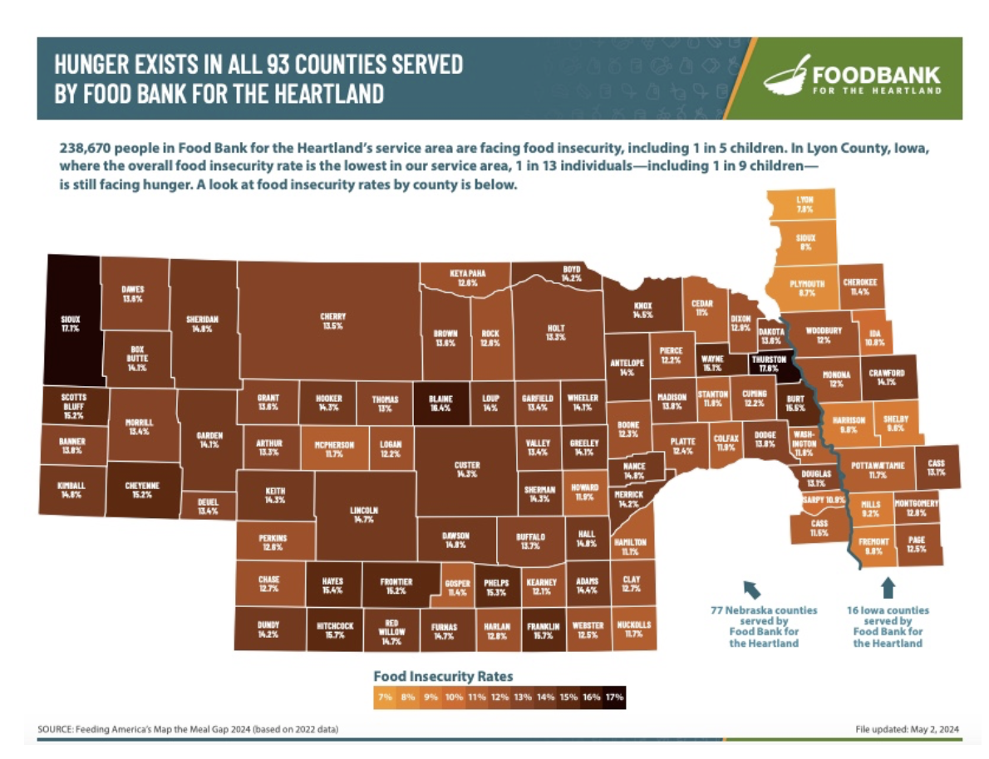
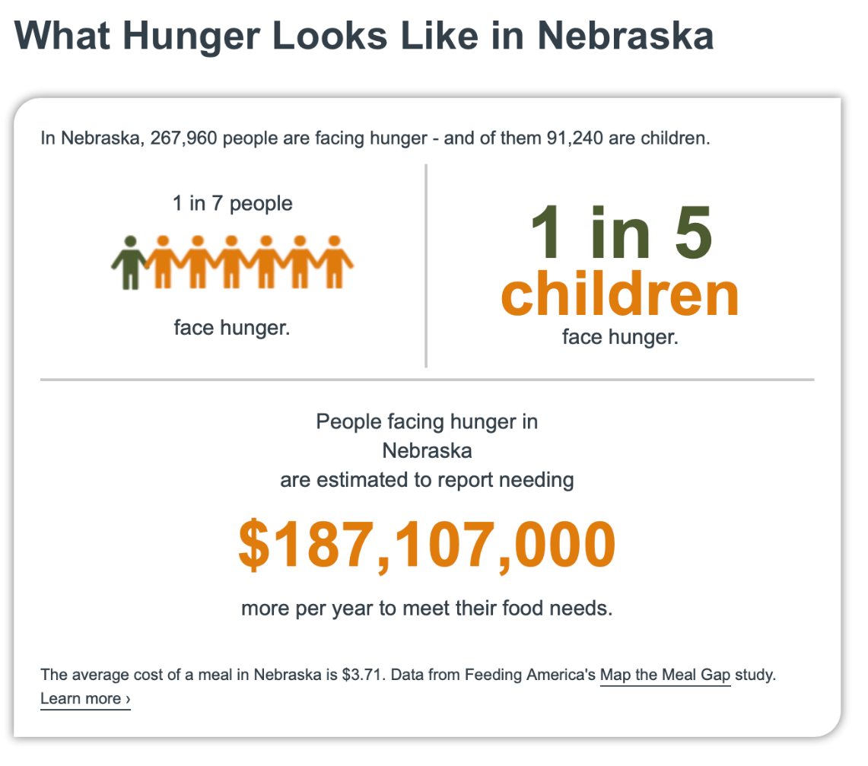
https://www.feedingamerica.org/hunger-in-america/nebraska

Hunger and health are deeply connected. People who are food insecure are
disproportionally affected by diet-sensitive chronic disease such as diabetes and high blood pressure, and according to research, food insecurity is also linked to many adverse effects to overall health. For children, food insecurity is particularly devastating. Not having enough physical and mental health, academic achievement and future economic prosperity. Research shows an association between food insecurity and delayed development in young children; risk of chronic illnesses like asthma and anemia; and behavioral problems like hyperactivity, anxiety and aggression in school-age children.
This indicator reports the percentage of the low-income population with low food access. Low food access is defined as living more than 1 mile (urban) or 10 miles (rural) from the nearest supermarket, supercenter, or large grocery store. This indicator is relevant because it highlights populations and geographies facing food insecurity.
22.63% of the low-income population in the CNCAP service area have low food access. The total low-income population in the report area with low food access is 12,549.

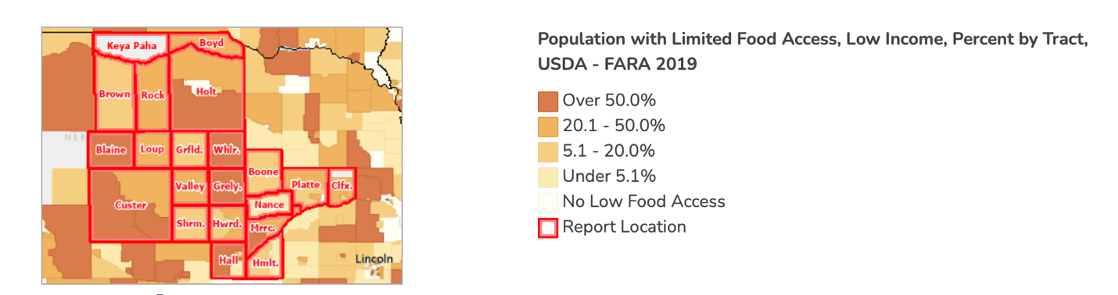

SNAP Benefits

The Supplemental Nutrition Assistance Program (SNAP) is the largest federal nutrition assistance program. SNAP provides benefits to eligible low-income individuals and families via an Electronic Benefits Transfer card. This card can be used like a debit card to purchase eligible food in authorized retail food stores.

To be eligible for SNAP, most households must meet a certain bank balance limit. A household with an elderly (over 60) or disabled household member may have a higher bank balance limit.

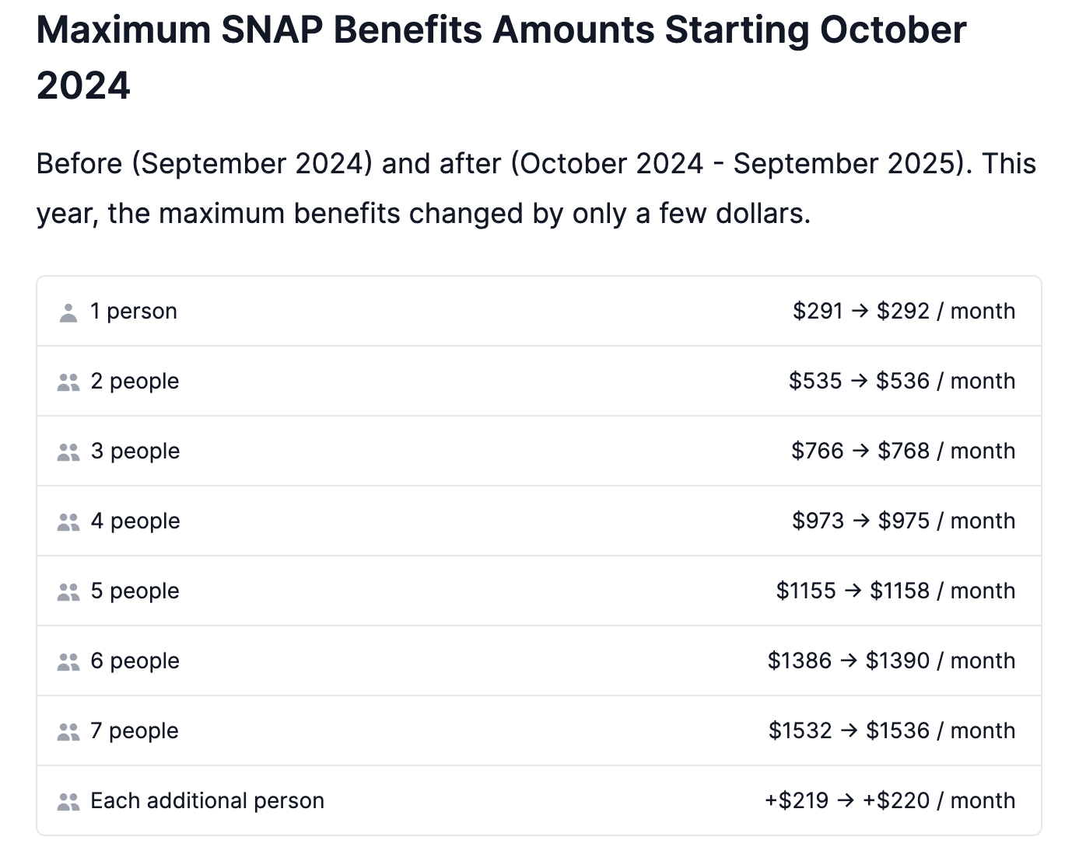

155,000 Nebraska residents, or 8% of the state population (1 in 13) use SNAP benefits. More than 68% of SNAP participants are families with children. More than 30% are in families with members who are older adults or are disabled. More than 49% are working families. Most SNAP participants in Nebraska have incomes above the poverty line. 35% of SNAP participants are at or below 50% of the poverty line. 43% are between 51-100% of the poverty line. 22% has income above 100% of the poverty line. SNAP was able to life 32,000 above the poverty line in Nebraska including 18,000 children per year between 2015 and 2019.

https://www.cbpp.org/research/food-assistance/a-closer-look-at-who-benefits-from-snap-state-by-state-fact-sheets#Nebraska

The below table shows that according to the American Community Survey (ACS), 5,143 households (or 7.2%) received SNAP payments during 2019-2023. During this same period there were 5,692 households with income levels below the poverty level that were not receiving SNAP payments.

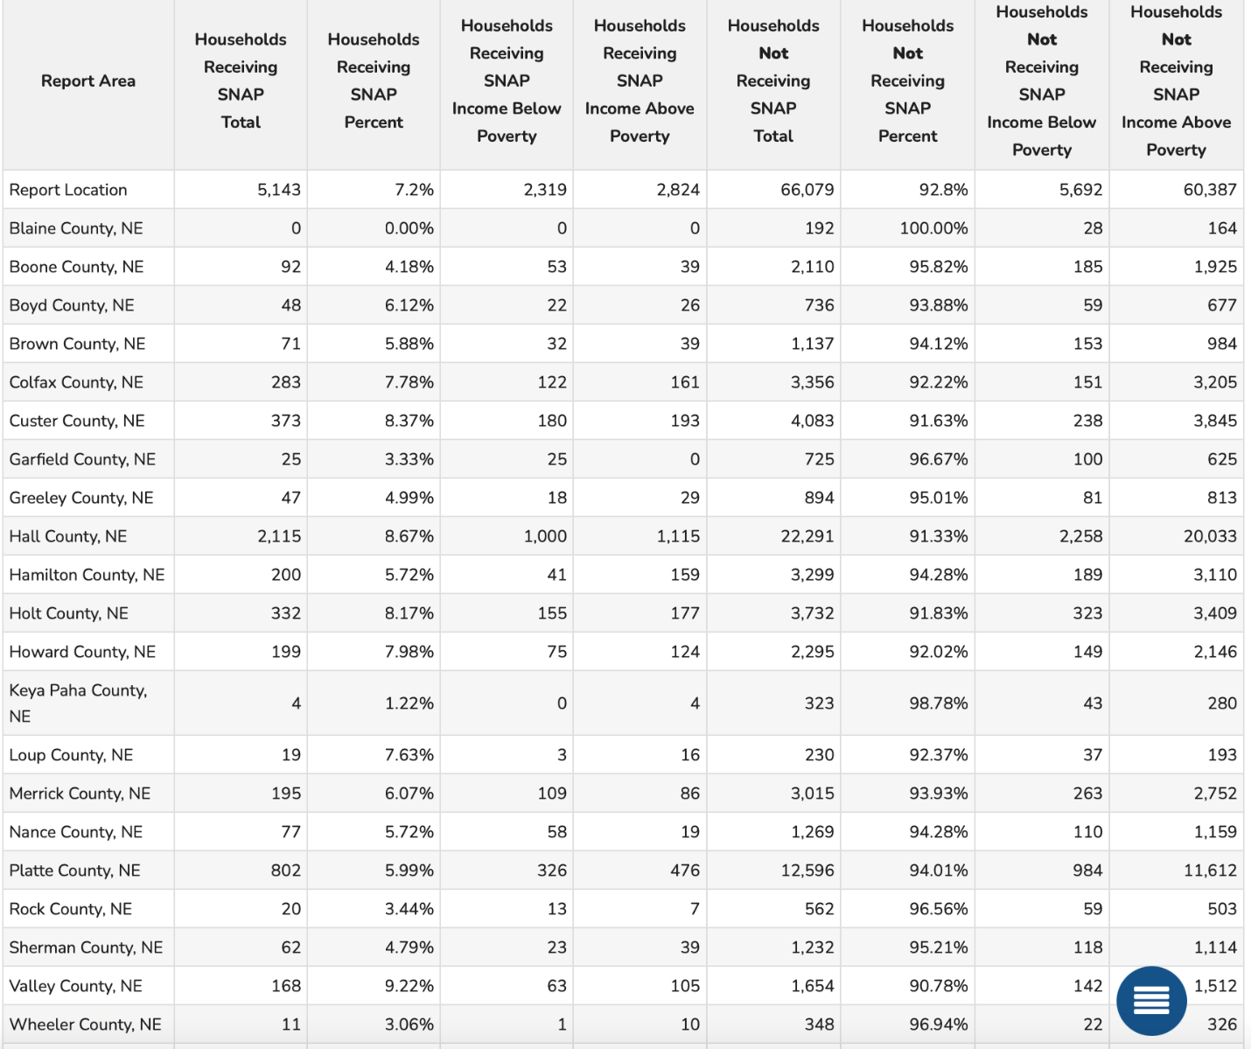

Free and Reduced School Lunch

Free or reduced-price lunches are served to qualifying students in families with income between under 185 percent (reduced price) or under 130 percent (free lunch) of the US federal poverty threshold as part of the federal National School Lunch Program (NSLP).
Out of 32,998 total public-school students in the report area, 14,049 were eligible for the free or reduced-price lunch program in the latest report year. This represents 46.9% of public-school students, which is higher than the state average of 37.7%.
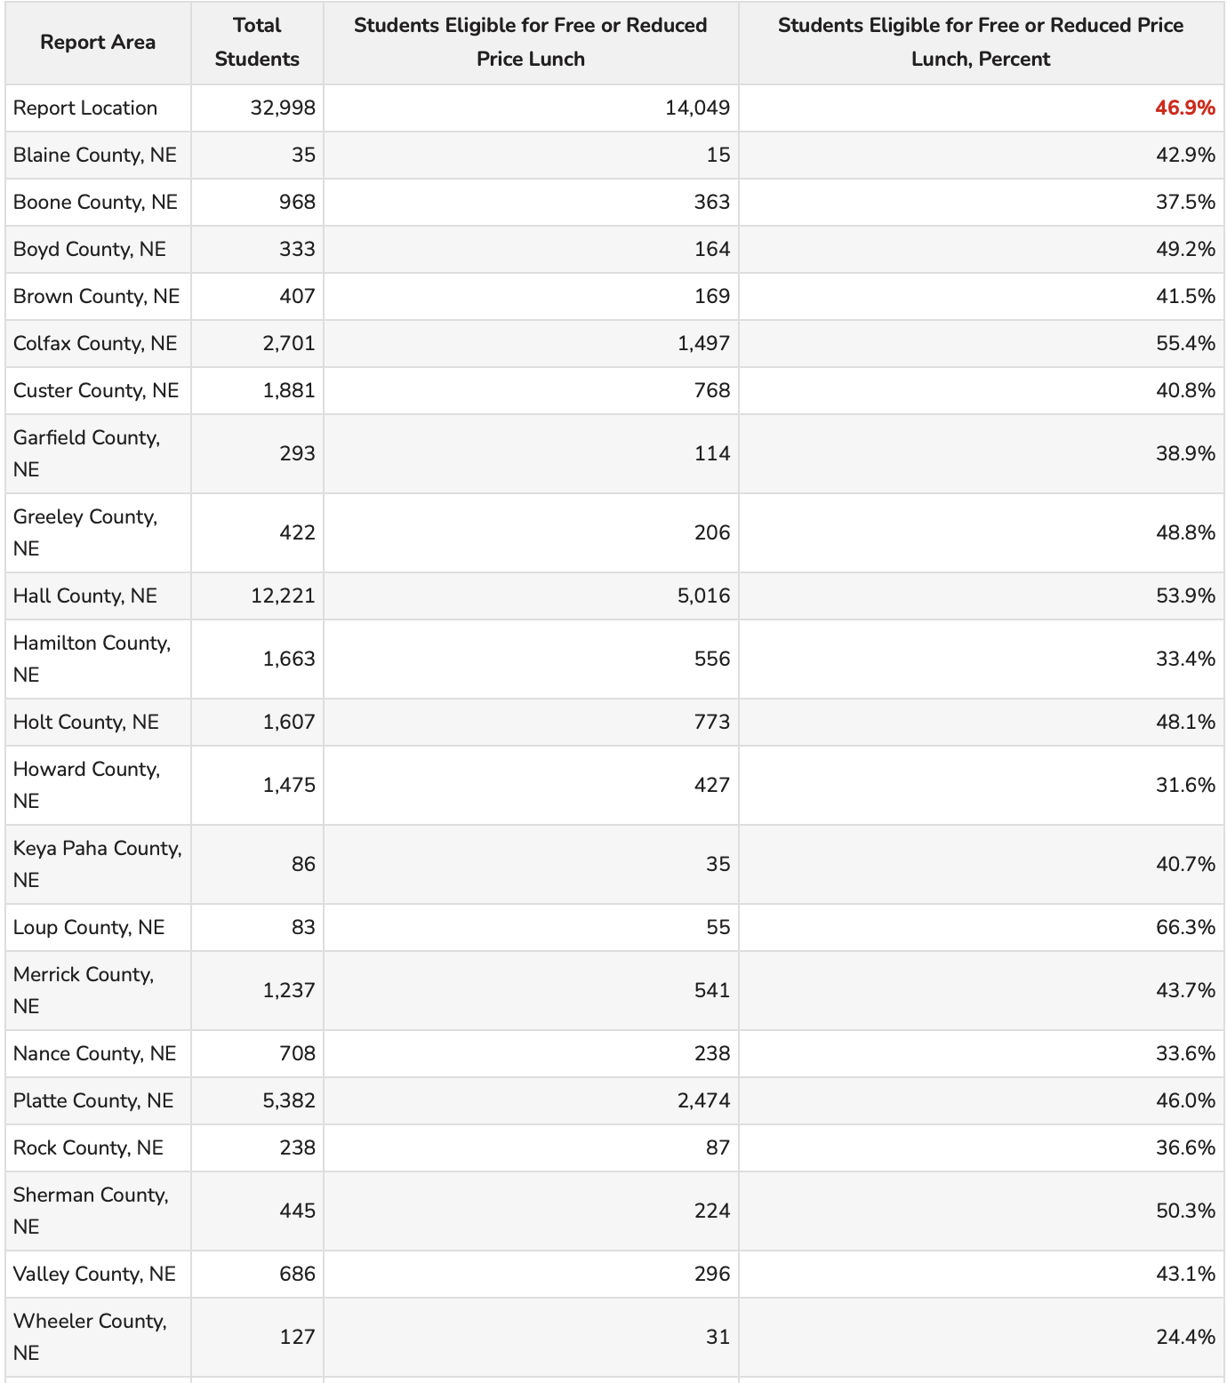

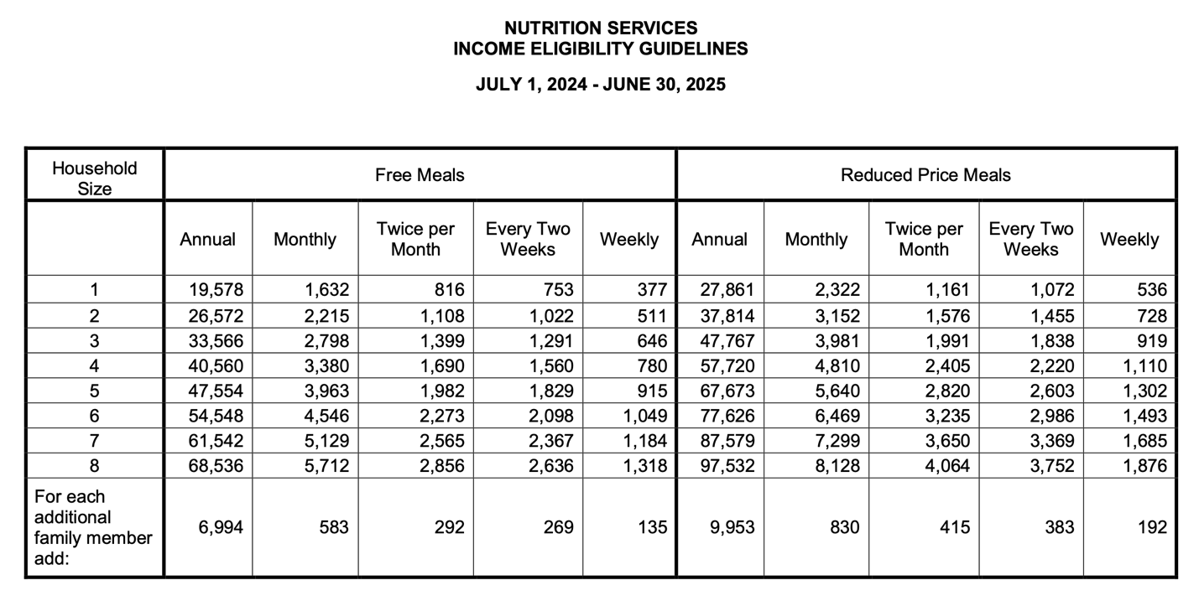
During the 2023-2024 school year, 48.2% of Nebraskans enrolled in public schools were eligible to receive free or reduced school lunch. Any child at a school participating in the National School Lunch Program may purchase a meal through the program. Children from families with incomes at or below 130% of the poverty level are eligible for free meals. Those between 130% and 185% are eligible for reduced-price meals, for which children are charged no more than 40 cents. Children from families with incomes over 185% of poverty pay full price, though their meals are still eligible for small amounts of reimbursement. Local school food authorities set their own price for full meals.

Schools can charge no more than 40 cents for a reduced-price lunch. USDA sets no limit on the amount schools can charge for full-price meals. In Nebraska for the 2024-2025 school year, a family of four earning $40,560 or less qualifies for free meals and a family earning 57,720 or less qualifies for reduced-price meals.
https://www.education.ne.gov/ns/nslp/overview/#1626021371019-f7730fbf-a2e0

Trending

The challenges of the Nebraska housing market have remained a top concern for residents across the state. Interest rates have been at an all-time high, with few home buyers. The market in 2024 shows signs of stabilization after a period of rapid growth. While home prices remain elevated, the pace of appreciation has slowed, and the number of homes sold has decreased compared to the previous year. This suggests a shift towards a more balanced market, with buyers having slightly more leverage in negotiations. The overall number of houses sold in 2024 shows a decrease compared to 2023. There was a total of 23,532 residential properties sold in Nebraska in the last year. Rising interest rates have been a major impact in the decline of house sales. Limited inventory has also remained a challenge for buyers, as many houses are becoming uninhabitable and less are being built. Another major reason for the decrease in house sales is because of economic uncertainty. Many are hesitant to commit to the purchase of a house in an unpredictable economy.
The availability of new construction has increased in some parts of Nebraska to meet the demand for housing. However, the pace of new construction has not been able to keep up with the overall need. Some trends for the housing market include:
- Slowdown in home price appreciation
- Increase in housing inventory
- Decrease in sales volume
- Reduced foreclosure activity.

Some areas of the state might see small price increases while others may see slight dips. Factors that affect the housing market variations across the state include:
- Interest rates
- Job market
- Inventory of homes
- Economic Growth

Predicting the housing market in the coming years is always challenging. However, if interest rates do not come back down, buyers may continue to be hesitant to make the long-term commitment. Nebraska’s population grown has remained slow, as this is likely to continue it could limit the demand for housing. The pace of new home construction also plays a major role in the supply and demand balance. The rapid increases of the past few years have slowed down, the number of homes sold has decreased, and the inventory of available homes has modestly increased in some areas. The market is projected to remain relatively stable in the coming years. https://www.noradarealestate.com/blog/nebraska-housing-market/

Diversity

Age and Gender

Race in the CNCAP service area:
White: 143,440
Black: 3,099
American Indian: 1,758
Asian: 1,020
Native Hawaiian: 69
Other: 15,206
Mixed Race: 15,236

The white population makes up 79.77% of the service area. The black population makes up 1.72%. The Asian population takes up .57%. American Indian takes up .98%. Native Hawaiian takes up .04%. Other races take up 8.46% and 8.47% are two or more races.
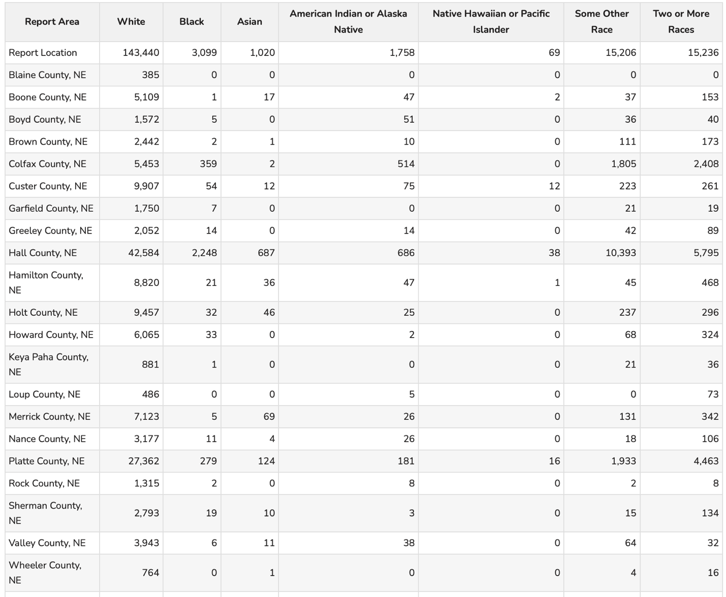

The population of the CNCAP service area is broken down by:
Age 0-4
Male: 6,328
Female: 6,007

Age 5-17
Male: 17,776
Female: 16,600

Age 18-64
Male: 51,557
Female: 47,458

Over 64
Male: 14,354
Female: 18,038

Working age population throughout the CNCAP service area is:

18 to 24: 13,588

25 to 34: 20,521

35 to 44: 21,130

45 to 54: 19,914

55 to 64: 23,862
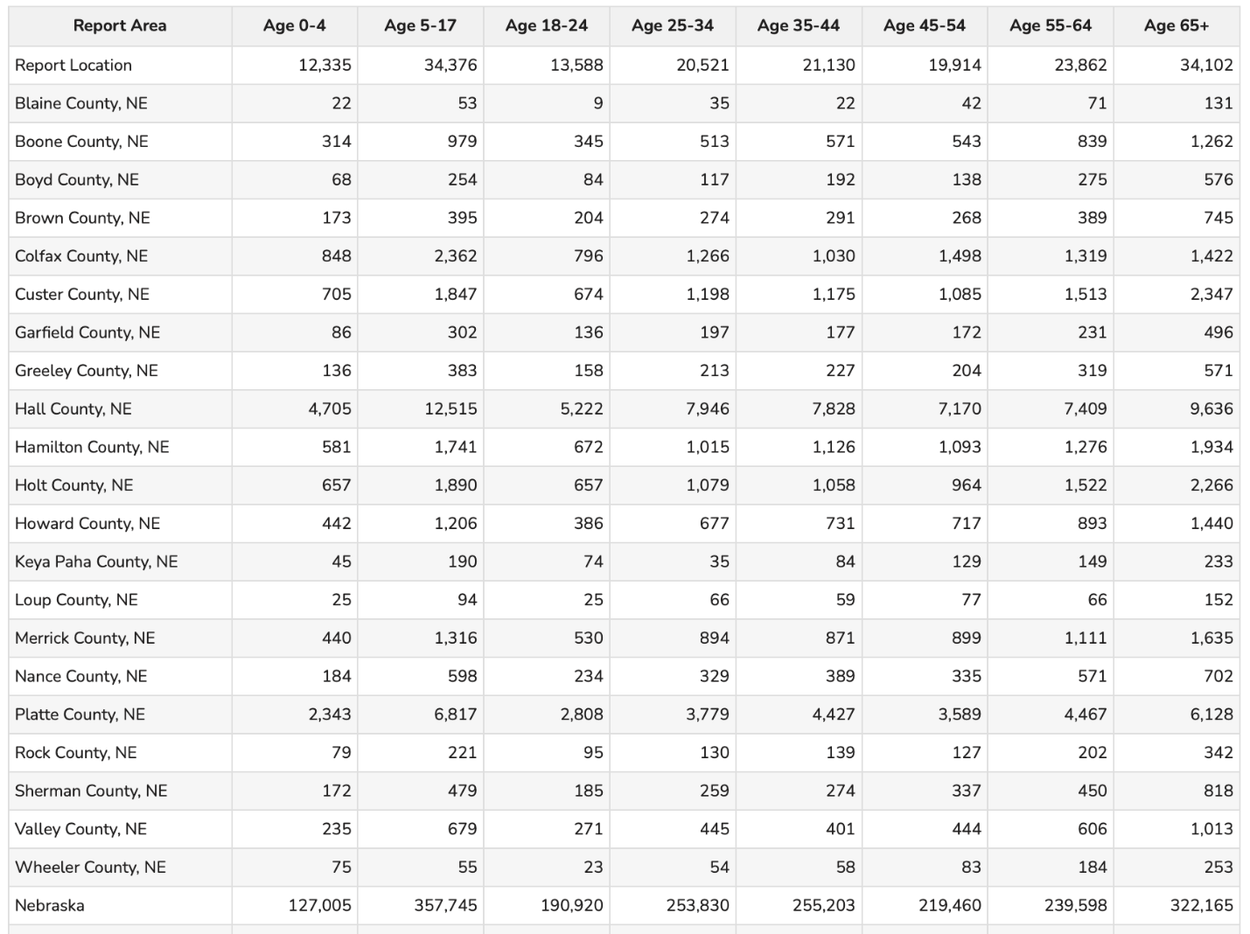

The younger working age of our service area has the lowest numbers. Retirement age and young children take up the majority of our service area. The retirement age has one of the highest populations, also being the closest to leaving the workforce. There are currently only 13,588 people between the ages of 18-24 to replace them. This remains a direct result of the challenges discussed earlier: housing shortages, daycare shortages, lack of jobs, lower wages, lack of overall opportunity. Challenges that rural Nebraskans are frequently facing. This creates a challenge within small communities as they try to keep the younger generation in their communities to fill jobs and raise children. Every year, the rural counties decrease in population as young families move to urban areas in search of more opportunities. School systems get smaller, businesses close down, daycares shut down and fill up fast.
The median age per county within the CNCAP service area is above 40 in every county except for Platte County, Colfax County and Hall County. These are the more urban counties with a median age of 36 to 38. This just further drives the point that the rural areas are struggling to keep the young people in their towns for a lack of opportunities. When these rural towns lose their employees to retirement, there will be a shortage of young employees to replace them.

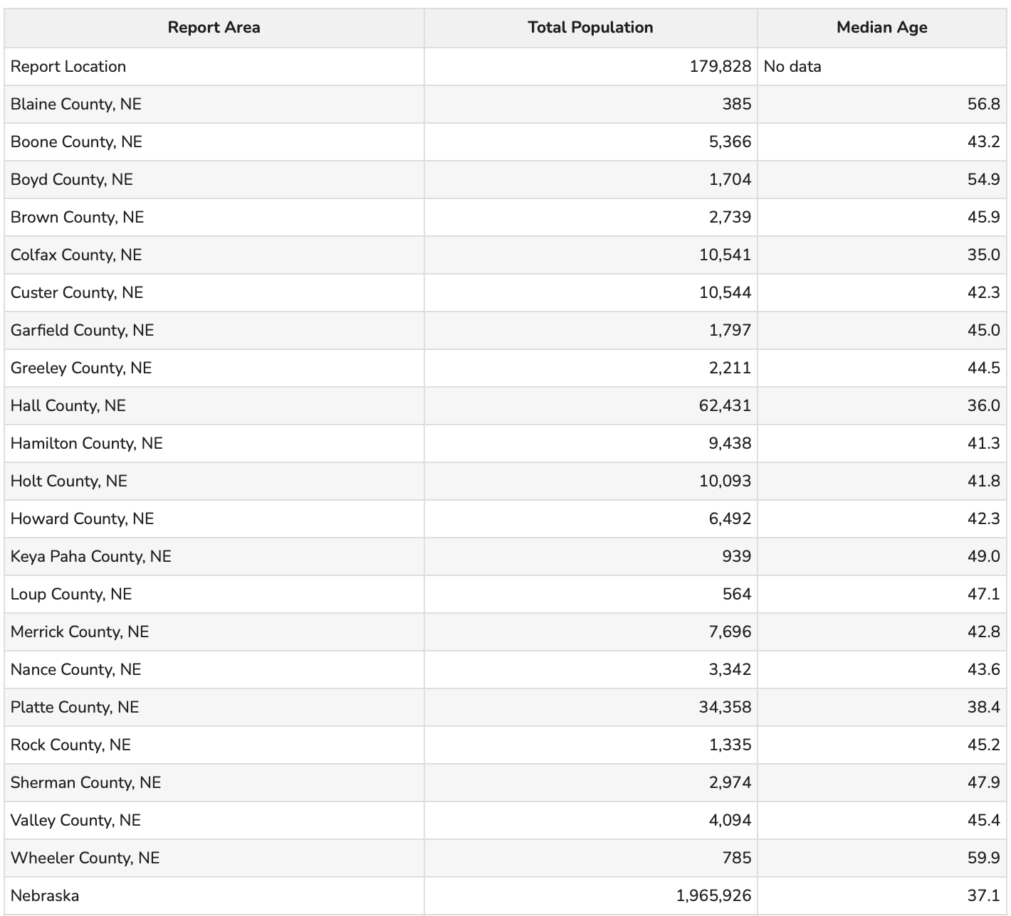

Rural Population

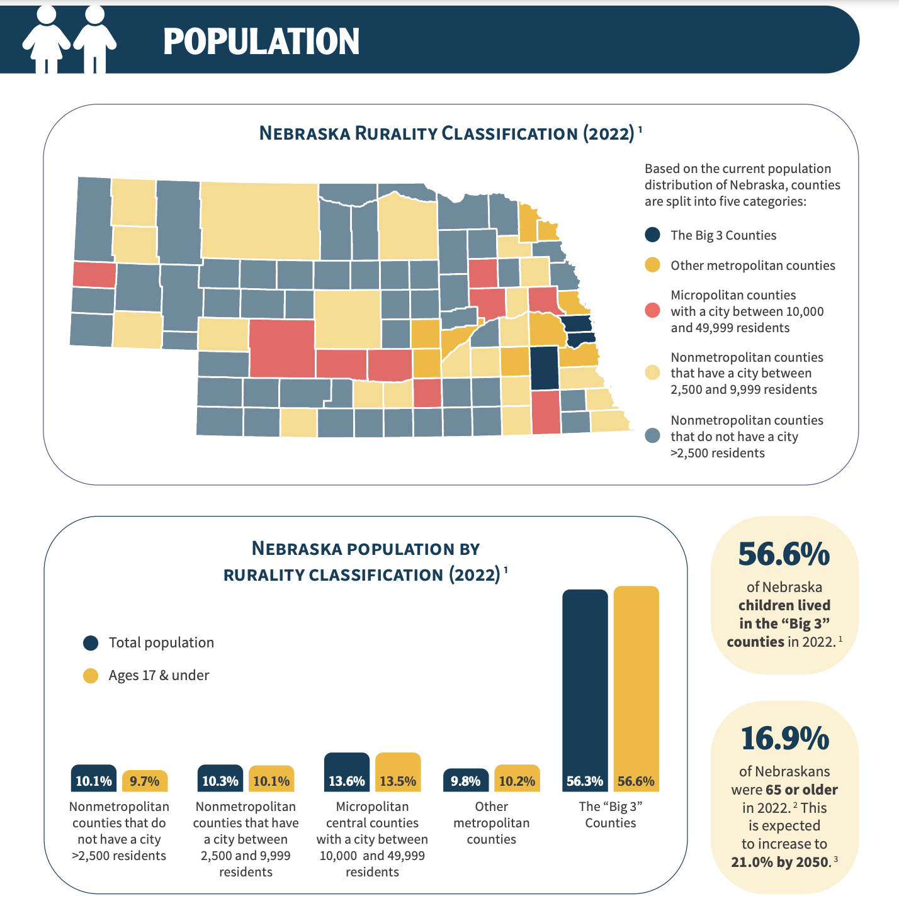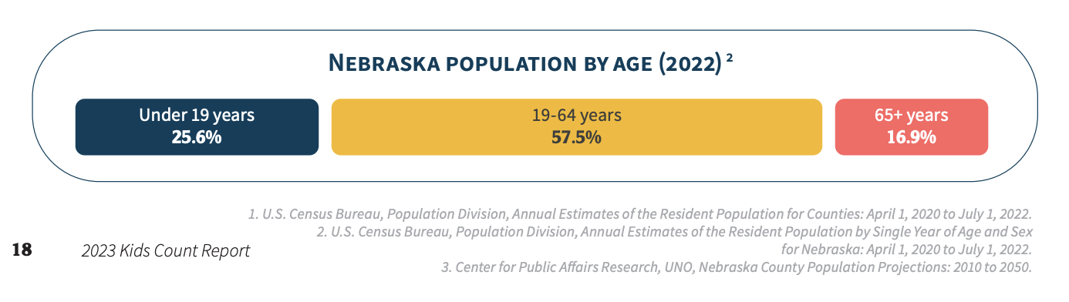

Seventy two percent (72%) of Nebraska Communities have a population between 100-800. 12 of the 93 counties are under 1,000 people. Two of those 12 counties have populations under 500. It’s not easy to provide key services such as roads, health care, education and others to counties so small. One of the major downsides to having areas with low population is that it can be hard to maintain that population. 73% of Nebraska counties lost population between 2010 and 2020. The state’s rural population is shifting and that has been happening for many years. While Nebraska as a whole, saw a slight population increase, 51% of the state’s counties lost residents between mid 2021 and mid 2022. In a rural poll, this year Nebraskans are feeling more pessimistic about their current situation than they’ve been in the past ten years. The proportion that believe they are worse off than they were five years ago was 27%, up from the 21% last year and 11% in 21. This is the highest level since both 2003 and 2009, when 28% believed they were worse off. This increase in pessimism was matched with a decrease in optimism. This year, less than one-half or 45% of rural Nebraskans believe they are better off compared to five years ago, down from 50% last year. Rural Nebraskans optimism about the future has declined in the past four years. The proportion stating they will be better off ten years from now has always been greater than the proportion saying they will be worse off ten years from now. In fact, the gap between the two has gradually widened between 2013 to 2019. However, that gap has narrowed considerably in the past four years. This year, rural Nebraskans optimism about their future is lower than last year. Just under decrease from 44% last year. The past four years have shown a steady decline from 52% in 2019. The proportion of respondents stating that they will be worse off ten years from now increased, compared to last year from 22% last year to 27% this year.

In the past four years rural Nebraskans have also seen an increase in feelings of powerlessness. The past four years have been a steady decline in the proportions who either strongly disagree or disagree that people are powerless to control their own lives from 54% to 45%. The proportion of rural Nebraskans that either strongly agree or agree with the statement has steadily increased from 24% in 2019 to 34% this year. Younger persons are more likely than older persons to believe they are better off compared to five years ago and will be better off ten years from now. Just over ¾ of people age 19 to 29 (76%) believe they are much better off or better off than they were five years ago. However, just over ¼ of persons age 65 and older share this opinion. Similarly, just over six in ten compared to only 12% of persons age 65 and older. Persons with a lower education level are more likely than persons with more education to believe that people are powerless to control their own lives. Most rural Nebraskans describe their mental health or emotional well-being as good (55%) or excellent (28%). Rural Nebraskans are less pessimistic about the economy than they were last year.

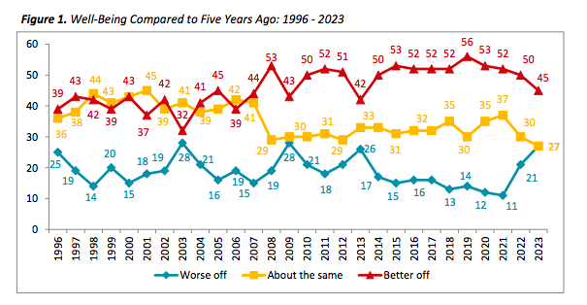

https://ruralpoll.unl.edu/pdf/23wellbeingandeconomy.pdf
https://ruralprosperityne.unl.edu/news/challenges-being-rural/
https://www.nebraska-demographics.com/counties_by_population

Blaine has moved from the smallest county to the 3rd smallest county as of 2025.

Boone County is ranked 52nd
Brown County is ranked 67th
Boyd County is ranked 78th
Colfax County is ranked 24th
Custer County is ranked 23rd
Garfield County is ranked 77th
Greeley County is ranked 73rd
Hall County is ranked 4th
Hamilton County is ranked 29th
Howard County is ranked 45th
Holt County is ranked 26th
Keya Paha is ranked 83rd
Loup County is ranked 89th
Merrick County is ranked 37th
Nance County is ranked 64th
Platte County is ranked 9th
Rock County is ranked 80th
Sherman County is ranked 66th
Valley County is ranked 60th
Wheeler County is ranked 84th
Rural communities face challenges related to demographic changes, workforce development, capital access, infrastructure, health, land use, and environment and community preservation. Compared to their urban counterparts, rural areas have less internet access, fewer educational institutions, see more hospitals close and less economic growth. Rural education also faces unique challenges, such as limited resources, constrained tax base and demographic shifts. The rural population is decreasing, aging and migratory. This lack of access means rural residents are more likely to have lower educational attainment. Residents in rural counties often face difficulty accessing health care services. Those living in rural counties are more likely to be uninsured, live within a health professional shortage area and experience a local hospital closure. In addition to the scarcity of primary care providers and services in rural areas, the people who live there also often lack access to mental health and other behavioral health services, long-term care options for seniors, emergency medical services, and other essential services. Agriculture, including food, fiber, fuel and other bio-based products, has been an important economic and social driver in rural communities. Producers, distributors, processors and retailers all play a role in the food system to get agricultural products from farm to table in both domestic and international

This indicator reports the percentage of population living in urban and rural areas as of 2020. Urban areas are identified using population density, count, and size thresholds. Urban areas also include territory with a high degree of impervious surface (development). Rural areas are all areas that are not urban. Of the report areas 180,351 population, 86,459 or 47.94% of the population is classified urban while 93,892 or 52.06% is rural.

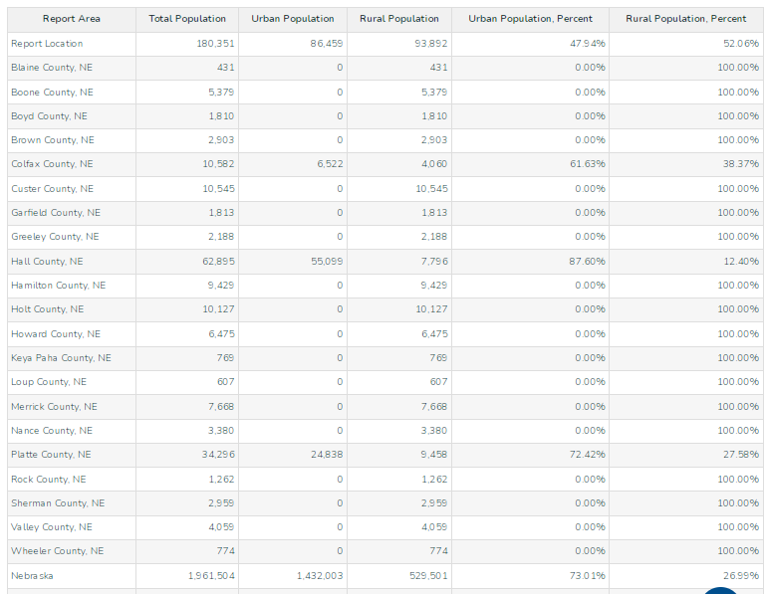

Family

Every day, over 2,400 divorces are finalized in the United States. 1 out of 4 child custody cases ends up in court. Family dynamics refers to the ways in which family members interact with each other. Family dynamics are important in the growth and development of each family member, having the ability to affect the way they see and interact with the world. Family dynamics also play an important role in mental health and well-being. Close family relationships afford a person better health and well-being, as well as lower rates of depression and disease throughout a lifetime. But in many families, getting along is not a given. 22million children live with a single parent, more of whom are women. In a functional family, parents strive to create an environment in which everyone feels safe and respected. Family dynamics shape a child’s emotional well-being, playing a critical role in their psychological development. While conflict is normal in families, chronic dysfunction in families can negatively impact a child’s mental health. Exposure to high levels of conflict is linked to increased anxiety, depression and behavior issues. Today it is not uncommon for children to experience multiple parental partnerships throughout their childhood. Whether through divorce, separation, or the formation of blended families. Children who experience conflict and instability are more vulnerable to mental health problems. Multiple parental partnerships can create a sense of instability and uncertainty. Research has shown that children who experience multiple parental partnerships may be at an increased risk for suicidal thoughts and behaviors. Divorce is one of the most common forms of multiple parental partnerships that children experience. Research has also shown that children of divorced parents are more susceptible to mental health problems.

https://hupcfl.com/the-impact-of-family-dynamics-on-childrens-mental-health/
https://www.kidsvillepeds.com/blog/1249405-how-family-dynamics-influence-pediatric-mental-health/#:~:text=Family%20dynamics%20profoundly%20shape%20a,effects%20on%20pediatric%20mental%20health.

19% of children in the CNCAP service are living in single-parent households. Loup county has the highest number of children living with a single-parent at 29.41% Boone county has the lowest rate at 8.2% of children.
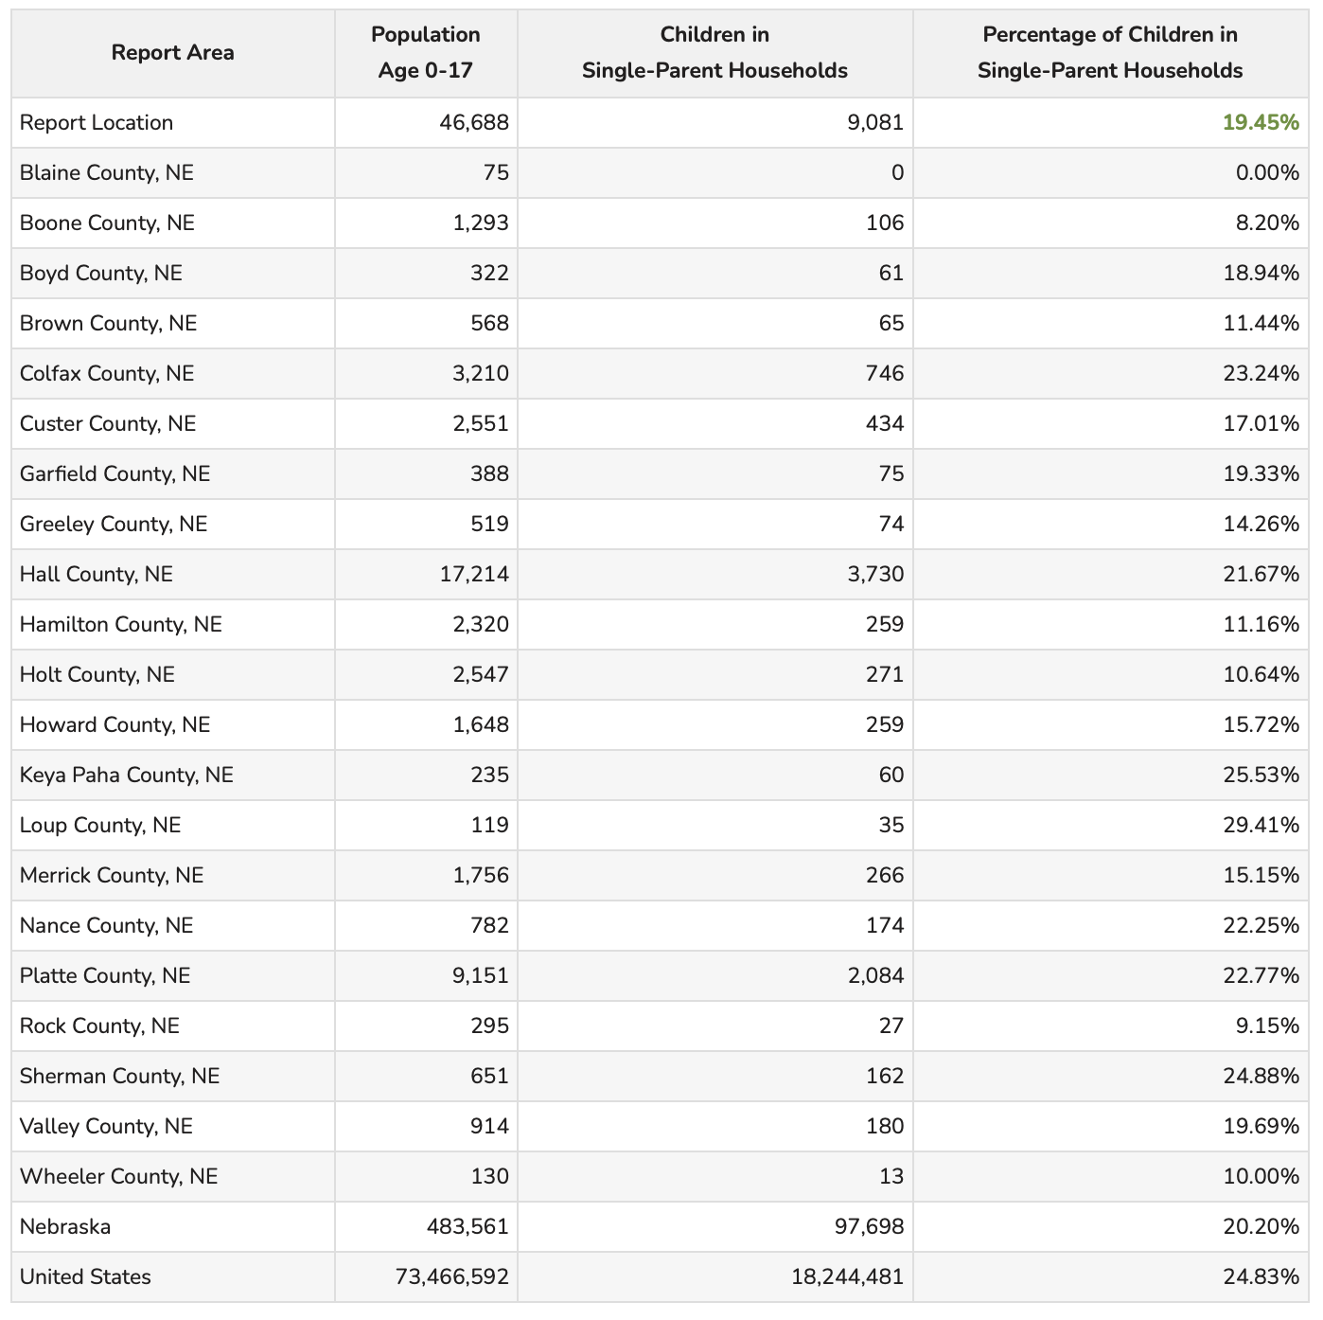

According to the most recent American Community Survey estimates, 30.31% of all occupied households in the report area are family households with one or more child(ren) under the age of 18. As defined by the US Census Bureau, a family household is any housing unit in which the householder is living with one or more individuals related to him or her by birth, marriage, or adoption. A non-family household is any household occupied by the householder alone, or by the householder and one or more unrelated individuals.

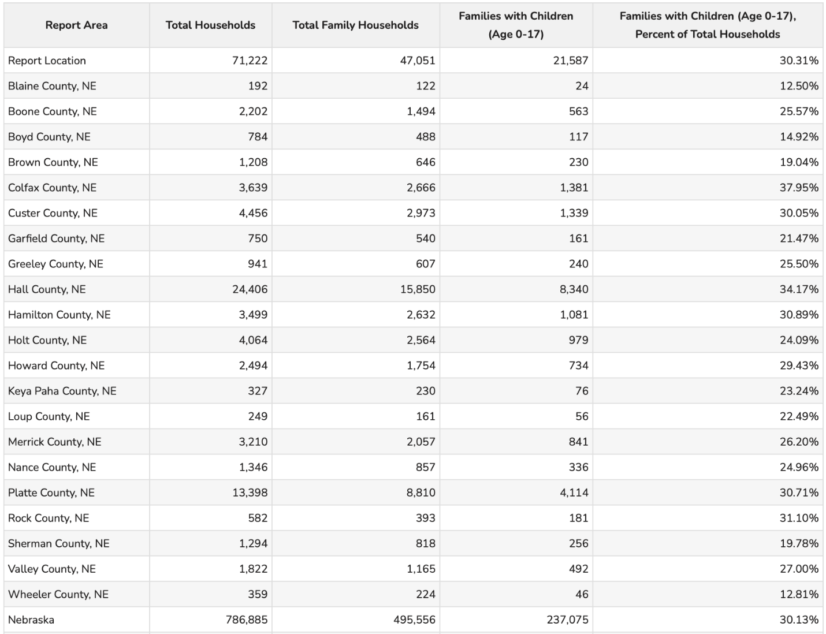

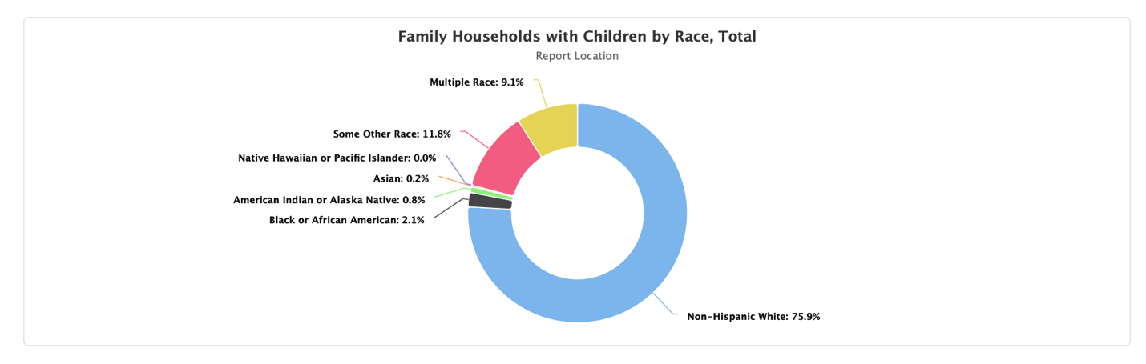

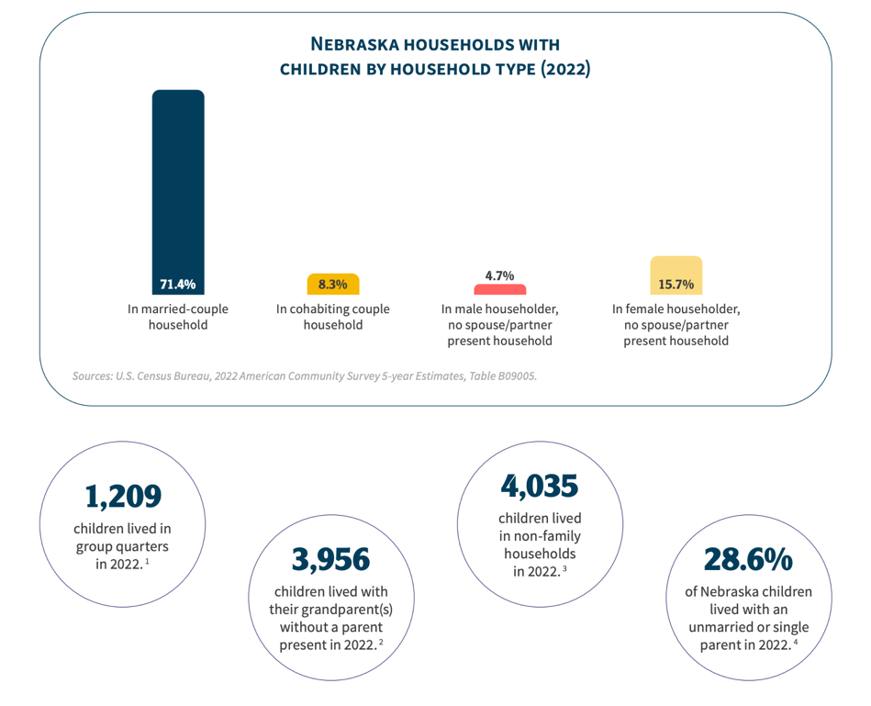

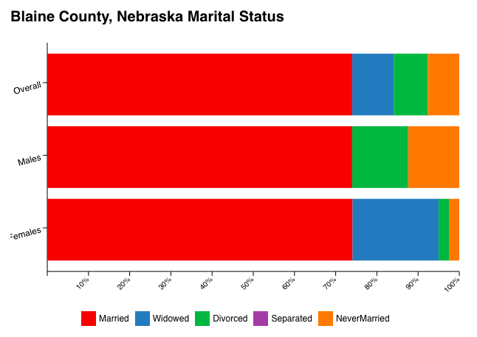

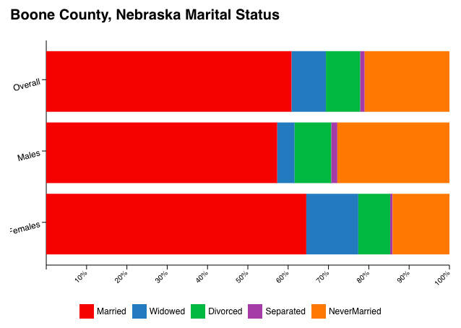

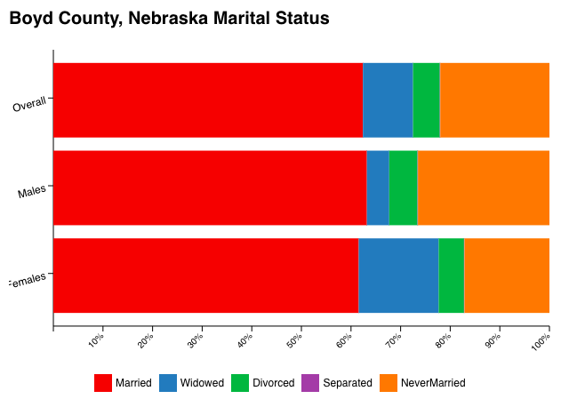

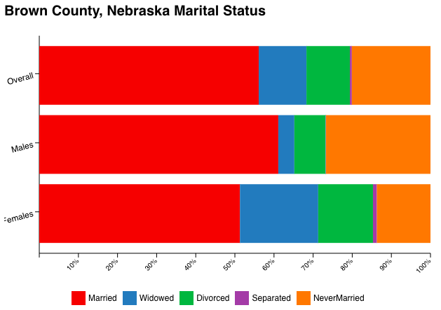

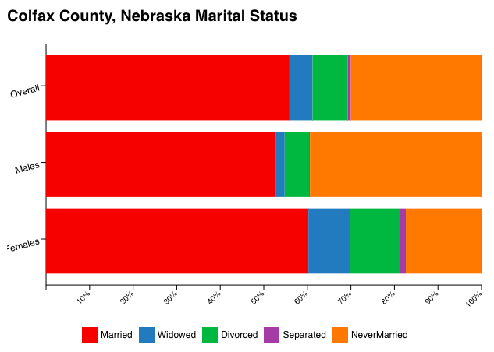

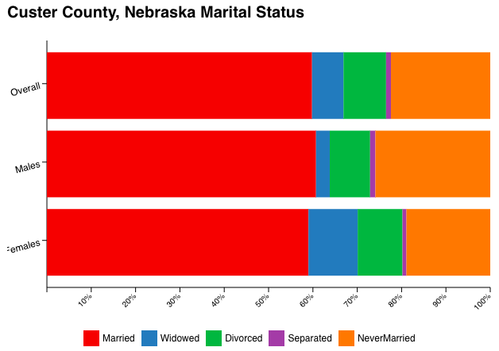

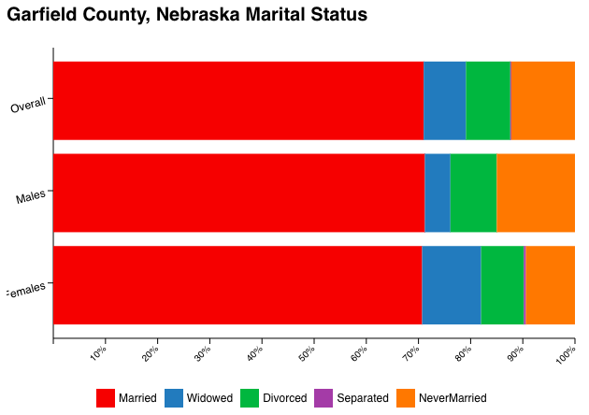

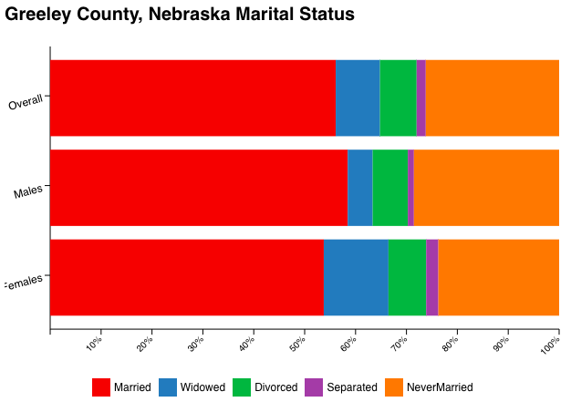

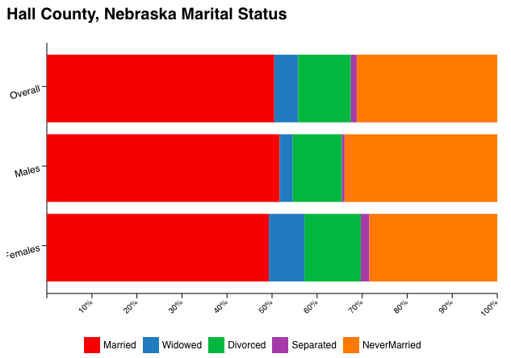

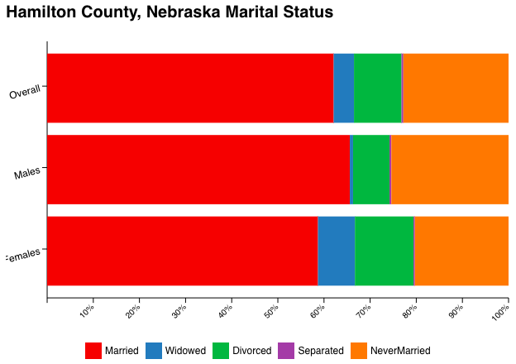

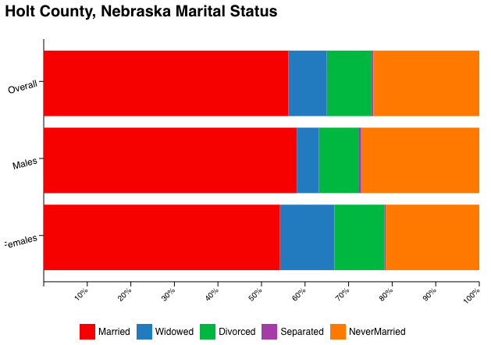

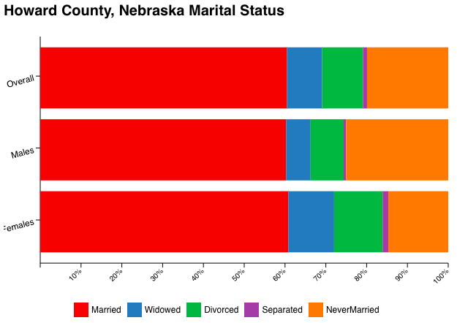

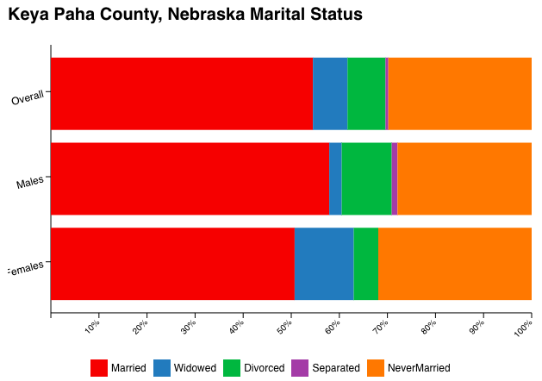

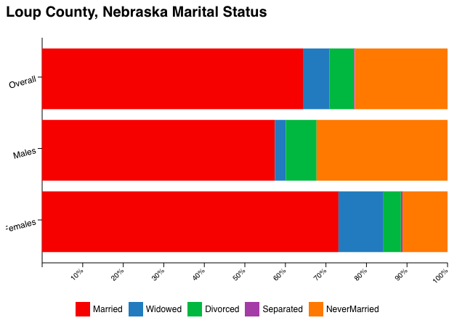

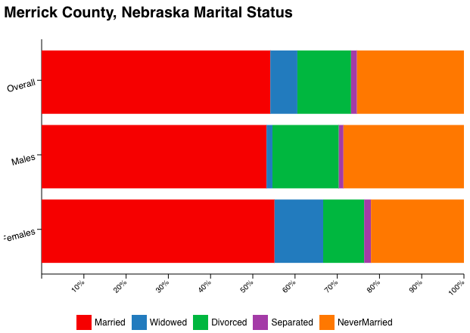
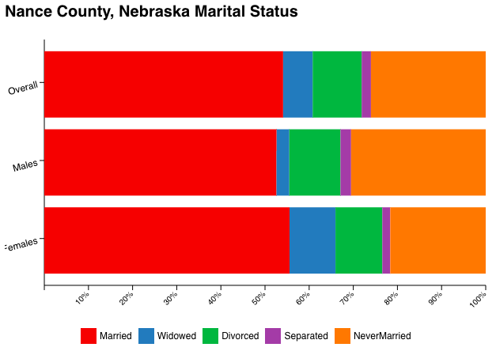

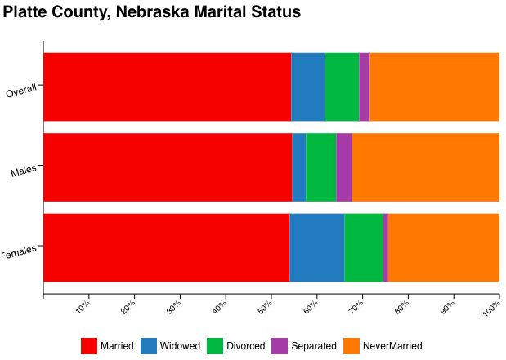
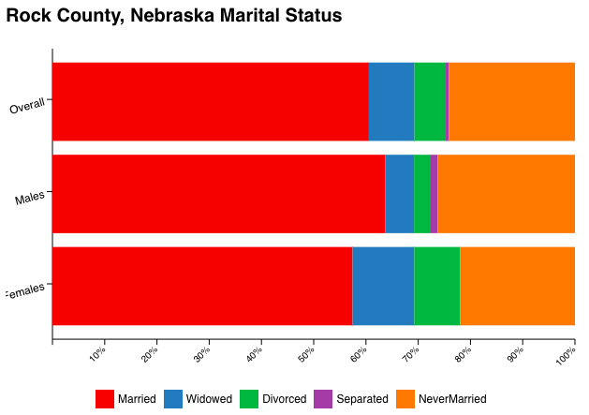

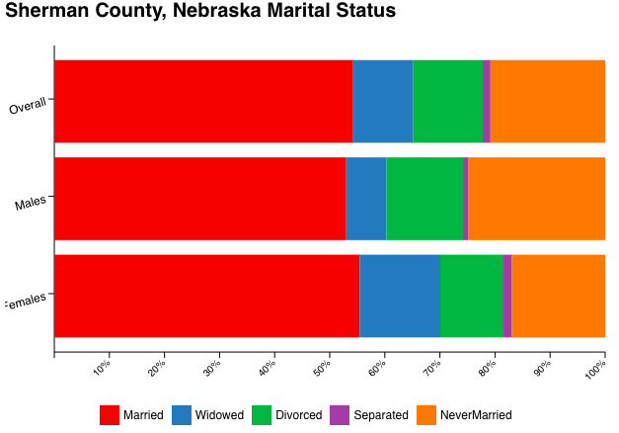
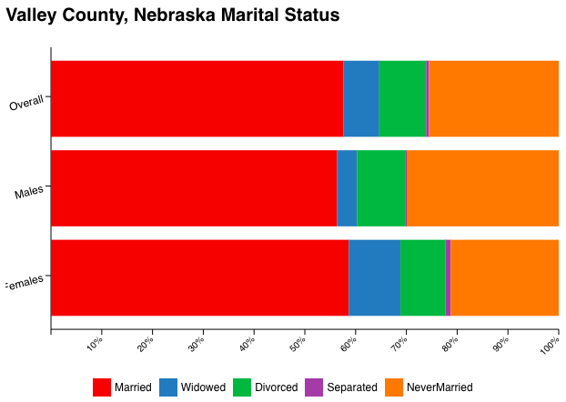

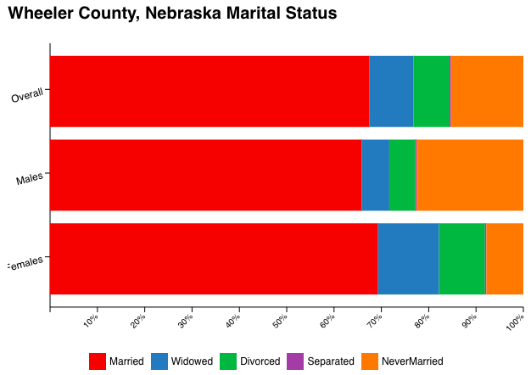

https://worldpopulationreview.com/us-counties/ne/wheeler-county-population
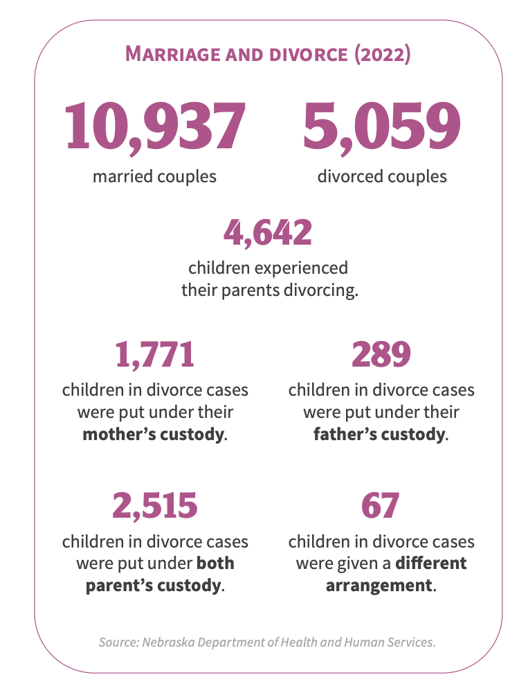
Families with Children

4,141 Nebraska children were in out-of-home or trial home placements under DHHS/CFS. Most wards in out-of-home placements or trial home visits (96.8%) were placed in family-like settings. Over half of those children were placed with relatives or kin (54.8%). Depending on the geographic area, between 8.4% and 37% of the children have had five or more caseworkers since entering the child welfare system. Furthermore, 119 children statewide had 10 or more workers in that timeframe. Missing from care continues to be an issue. 39 children and youth were missing from care as of 9/30/24. There were 2.4% fewer children in out of home care on September of 2024 compared to September of 2023. Of the children placed in family-like settings, 54% were in a relative or kinship placement. On 9/30/24 there were 81 males and 22 females placed at a YRTC. This is a 32% increase from the previous year.

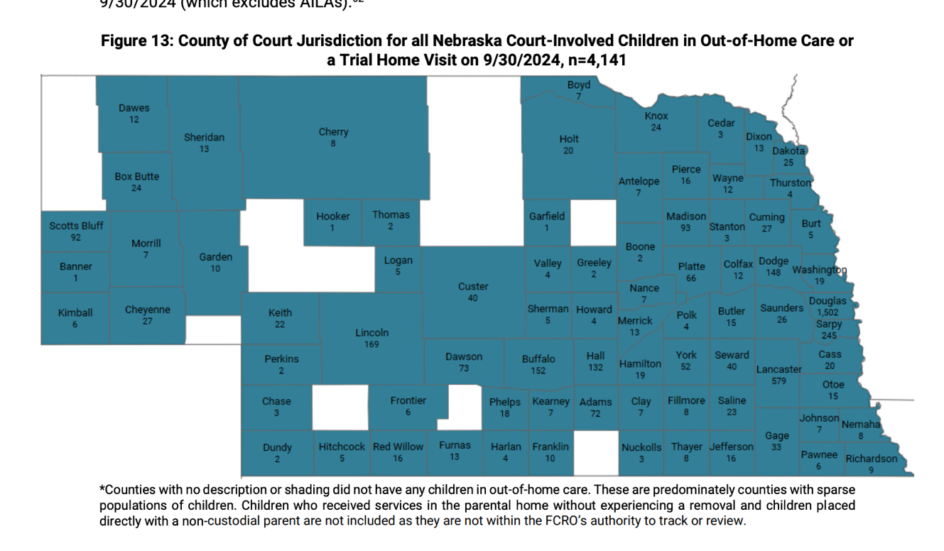
https://fcro.nebraska.gov/pdf/FCRO-Reports/2024-q4-quarterly-report.pdf

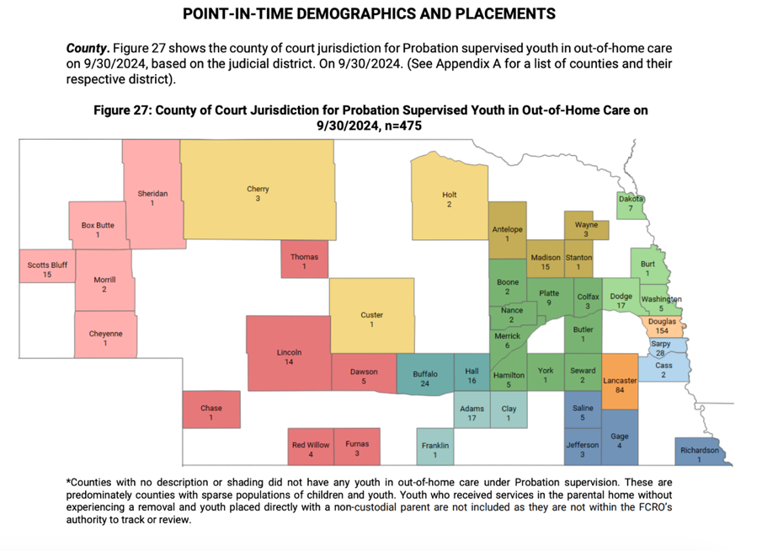
Adoption

By November of 2024, more than 300 children had been adopted across the state of Nebraska. More than 150 children are able to be adopted as of November. On National Adoption day, November 23, 60 more children were adopted. Adoptions can be done through two main avenues: private adoption and foster adoption. In private adoptions, the parents have chosen to give up their parental rights to the adoptive parents. In foster adoptions, these occur when the child is a ward of the state because their biological parents’ rights were terminated. Foster adoptions generally occur after the parents have been the child’s foster family for some time. These adoptions can either be open adoptions or closed adoptions. The cost of adoptions ranges from $25,000 to $60,000.
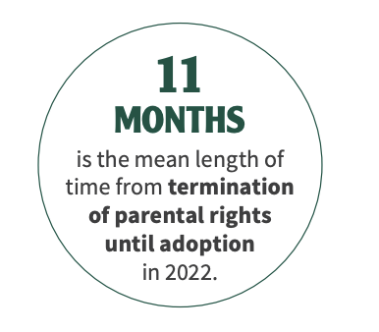
https://voicesforchildren.com/wp-content/uploads/2024/03/KC2023_FullDocument_FINAL.pdf
https://ruralradio.com/kuvr/news/november-named-adoption-awareness-month-in-nebraska/

Child Abuse

The Nebraska Alliance of Child Advocacy Center served 9,212 children in 2023. The children served: The Nebraska Alliance of Child Advocacy Center is dedicated to enhancing Nebraska’s response to child abuse throughout all 93 counties.

0-6 years: 2,514
7-12 years: 3,513
12-18 years: 2,973
Undisclosed: 213

11.8% came for witnessing violence. 5.9% came for endangerment. 12.7% came for neglect. 46% came for sexual assault and 9.6% came for other reasons.

38.7% of these children were males. 59% were female.

52% were White/non-Latino
14.5% were Hispanic/Latino
11.3% were Black/African American
2.4% were American Indian/Alaska Native
.80% were Asian/Pacific Islander
1.2% were other and 17.3% were undisclosed

The Nebraska Office of Inspector General of Child Welfare released their report stating that 21 child deaths were reported in the 2023-2024 fiscal year, which is up from 11 in the previous year. Although some of the deaths reported were due to accidents or medical issues, three were being investigated, three were the result of child abuse or neglect but the family was not known to DHHS at the time amd seven involved co-sleeping or unsafe sleep. Two of those involved an intoxicated person. There were also 27 serious injuries to children that were reported, which is up from 15 in the previous year. Seven of these were caused by serious abuse or neglect. In the year of 2023, there were 29,654 reports of child abuse/neglect in Nebraska to DHHS. Of those, 14,419 were accepted. Of the accepted reports, 7,572 were accepted as neglect, 3,934 were abuse, 1951 were both abuse and neglect and 962 were no allegation reports.

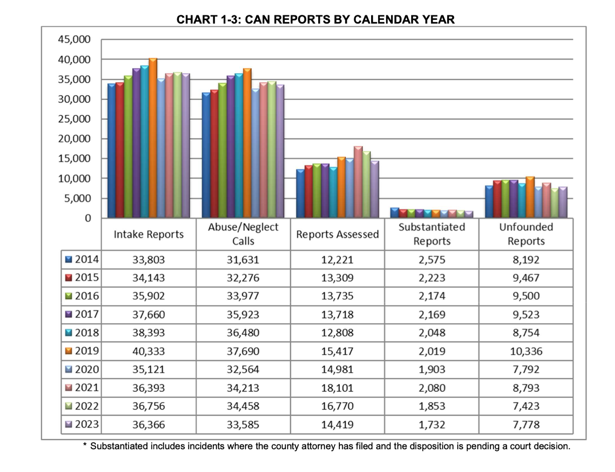

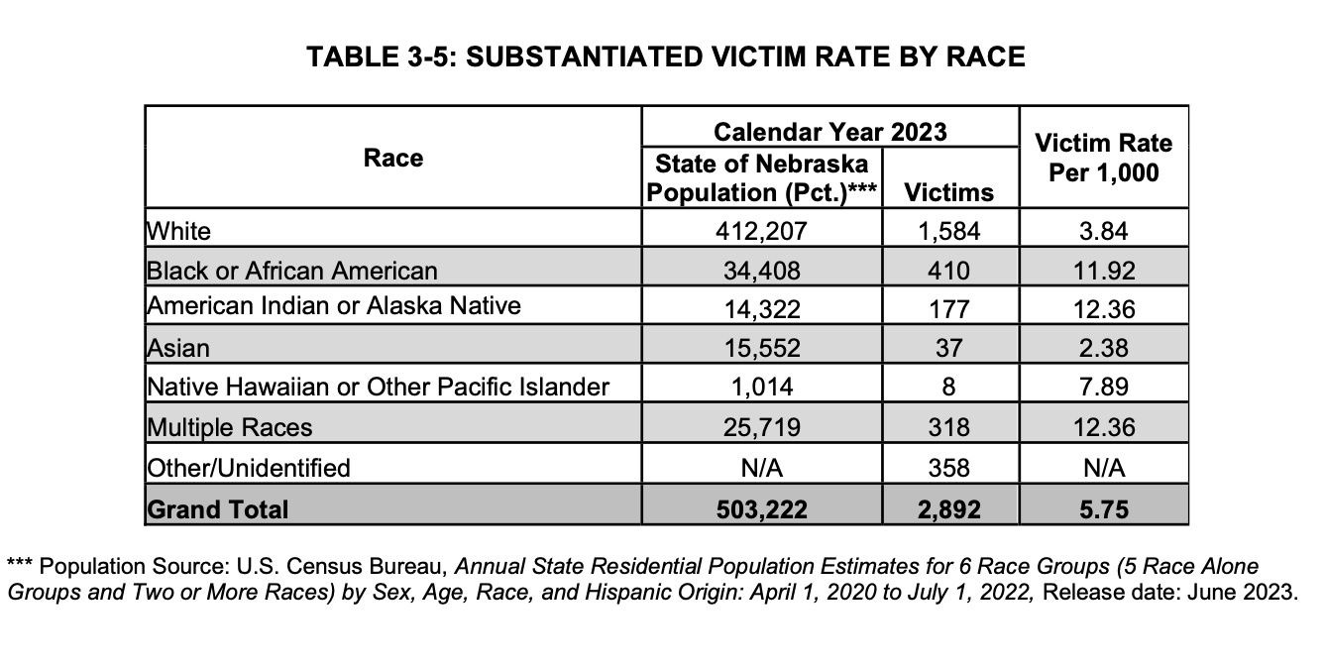
https://www.nebraskacacs.com/what-we-do/statistics.html
https://www.ketv.com/article/thats-concerning-nebraskas-child-welfare-report-shows-disturbing-uptick/62233144
https://dhhs.ne.gov/DCFS%20Data%20and%20Reports/CAN%202023%20Annual%20Data%20Report.pdf

Children Living with Grandparents

Grandparents are raising their children all throughout the United States in a growing number of families. Drug abuse plays a heavy role in these numbers. Teen pregnancy is another reason grandparents are raising their grandchildren. A teen mother’s youth and inexperience may have an impact on the grandparent’s child-raising responsibilities. Parent in jail or prison, military deployment, and child abuse are other reasons why grandparents raise their children. 50 is the average age to become a first-time grandparent and 52% of grandparents raising their grandchildren are under the age of 60.

Nebraska is higher than the national average for the percentage of the population living with grandchildren who are responsible for their coresident.

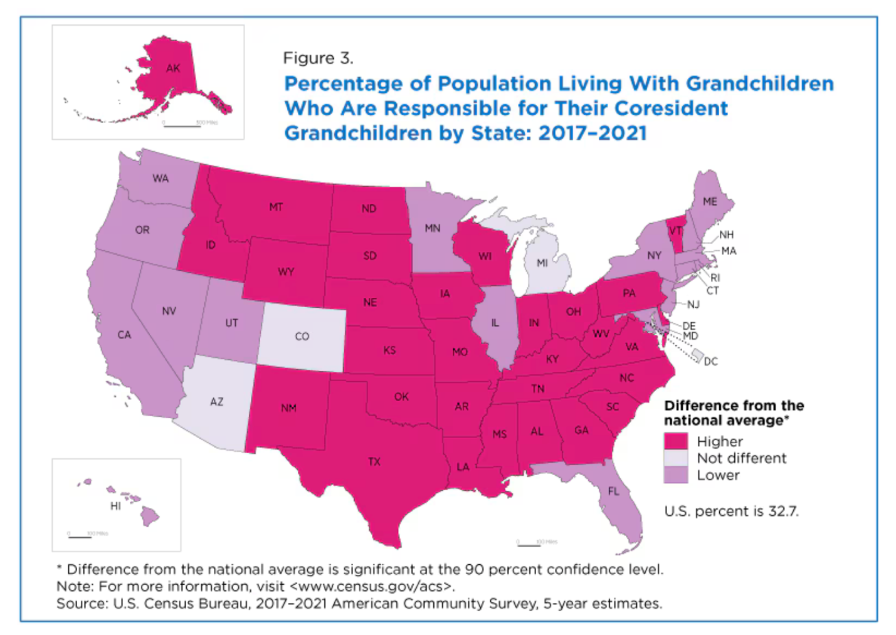

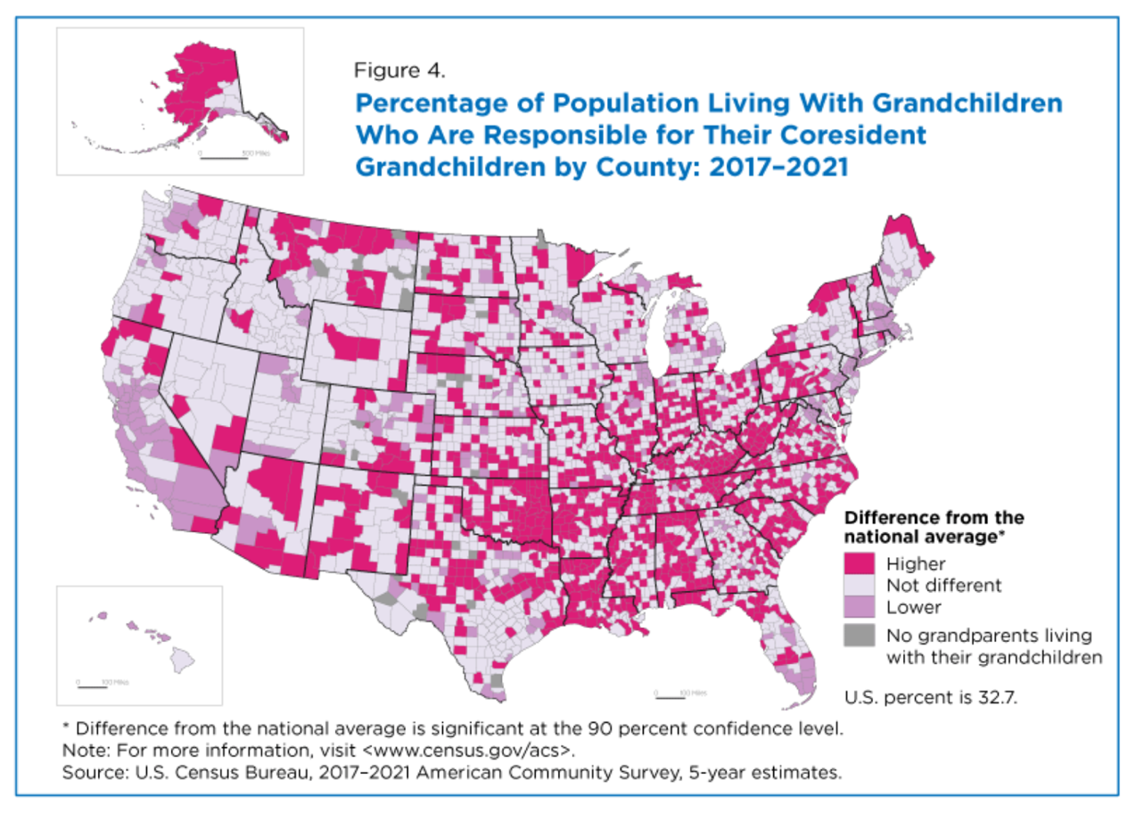
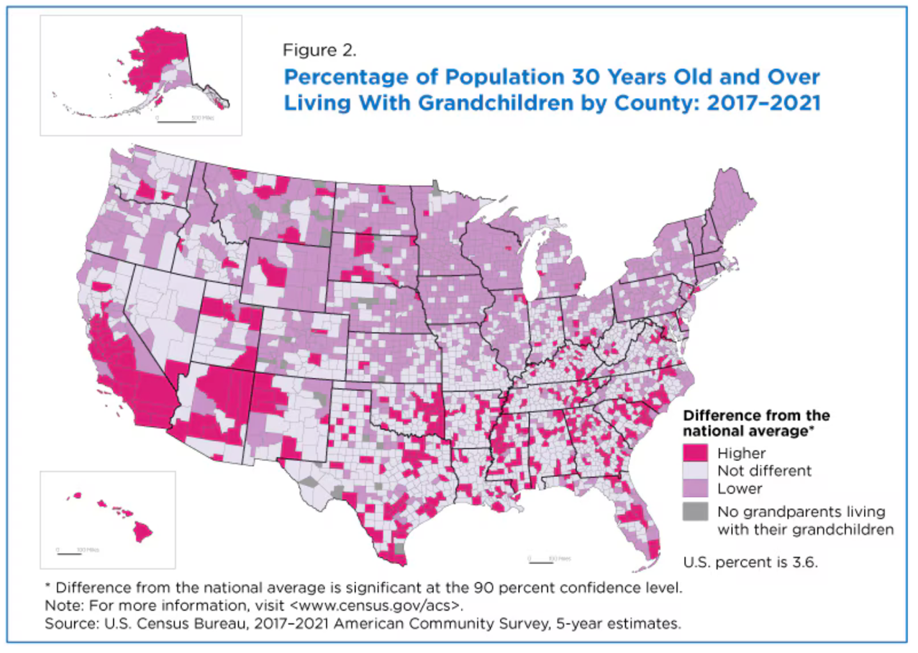

https://www.census.gov/library/stories/2024/03/grandparents-living-with-grandchildren.html

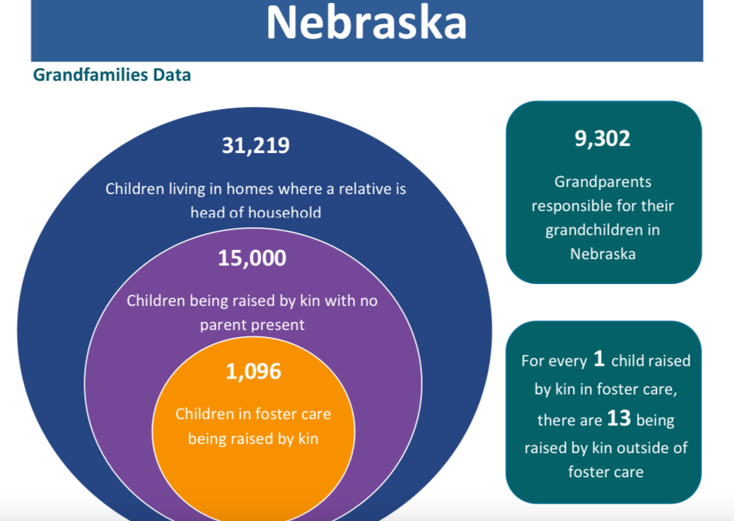
https://www.grandfamilies.org/Portals/0/State%20Fact%20Sheets/Nebraska%20GrandFacts%20State%20Fact%20Sheet%202021%20Update.pdf

Minorities

According to the most recent ACS, the racial composition of Nebraska was:
White: 81.84%
Two or more races: 6.33%
Black or African American: 4.78%
Other race: 3.54%
Asian: 2.49%
Native American: 0.95%
Native Hawaiian or Pacific Islander: 0.07%

This indicator reports the percentage of the population that is foreign-born. The foreign-born population includes anyone who was not a U.S. citizen or a U.S. national at birth. This includes any non-citizens, as well as persons born outside of the U.S. who have become naturalized citizens. The native U.S. population includes any person born in the United States, Puerto Rico, a U.S. Island Area (such as Guam), or abroad of American (U.S. citizen) parent or parents. The latest figures from the U.S. Census Bureau show that 18,565 persons in the report area are of foreign birth, which represents 10.32% of the report area population. This percentage is less than the national average of 13.87%.

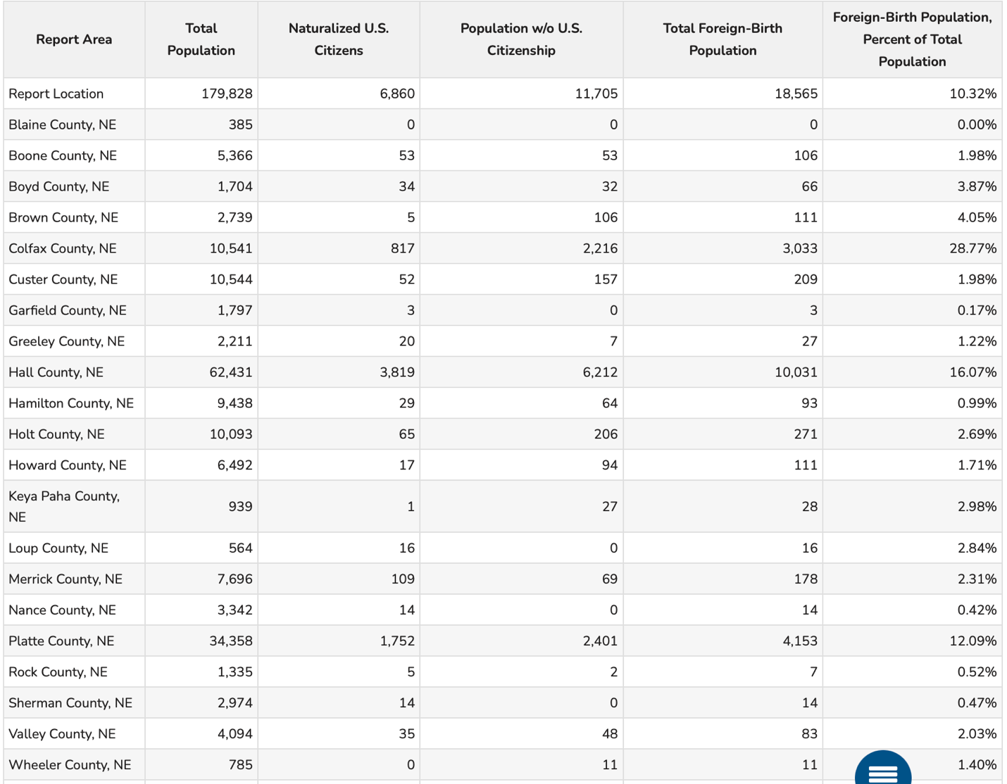

Of the service area, 18,565 are foreign born. Hall county has the highest amount of foreign-born population at 16.07%. Blaine county has the lowest at zero. The Hispanic population has grown the most since 2010.

Nebraska’s diversity score is 33/100. Nebraska is less diverse than other states. The eastern part of the state is the most diverse part of state. The areas in green are more diverse and the areas in red are much less diverse. Diversity in this case, means a mixture of people with different race and ethnicity living close to one another. For example: all-black and all-white areas in the state are considered to be lacking diversity.
https://bestneighborhood.org/race-in-nebraska/

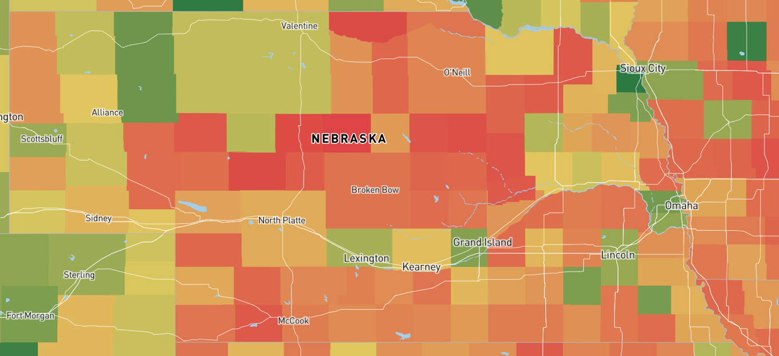

Immigration and Language

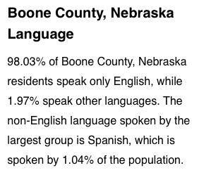
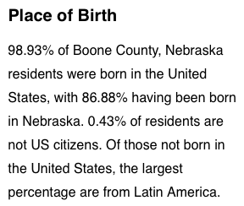

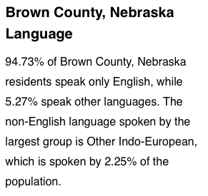
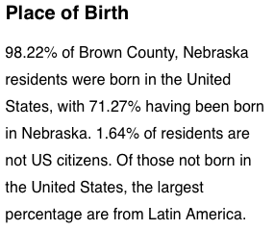

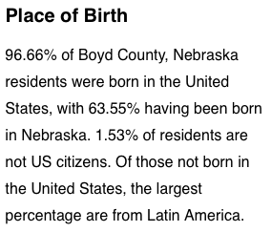
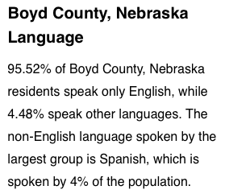

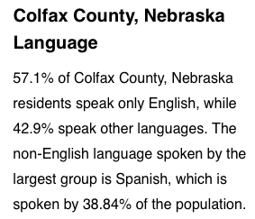
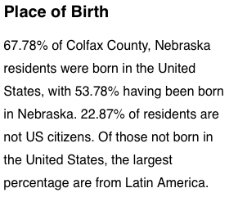

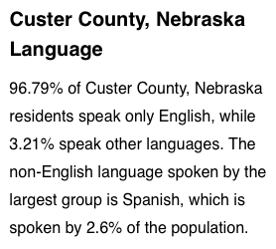
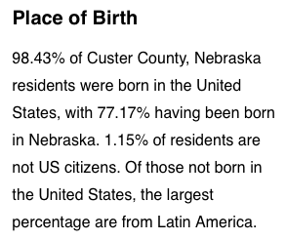

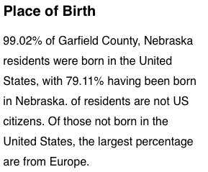
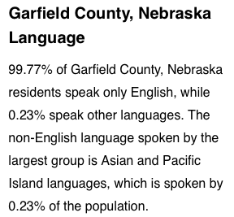

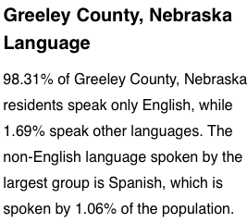
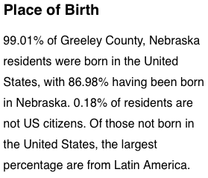

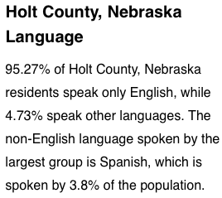
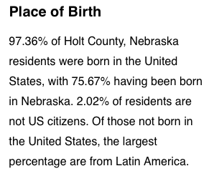

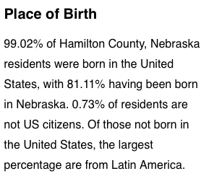
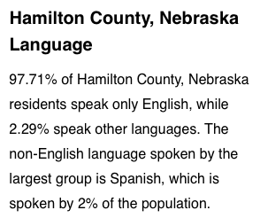

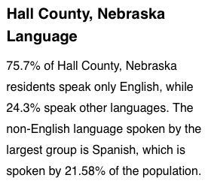
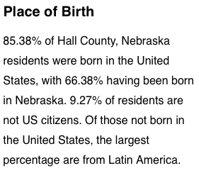

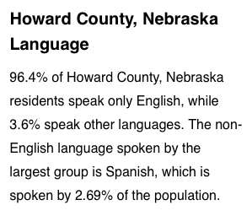
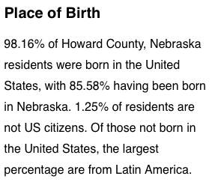

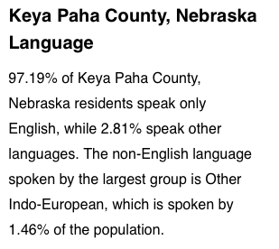
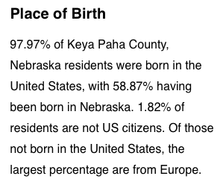

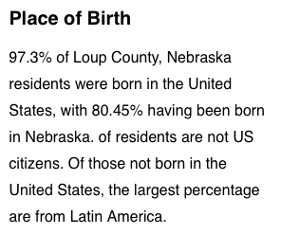
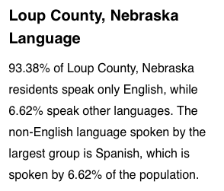

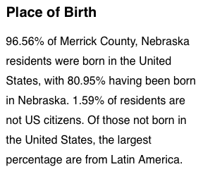
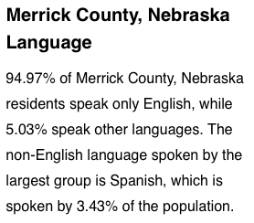

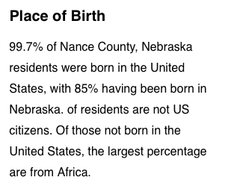

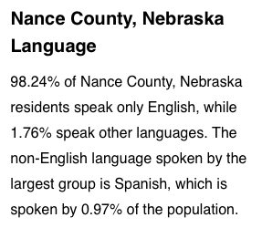

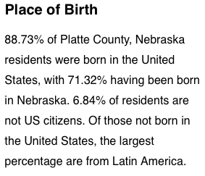
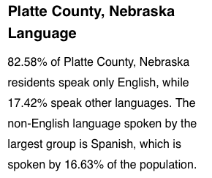

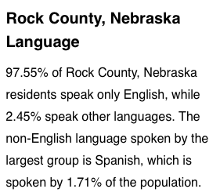
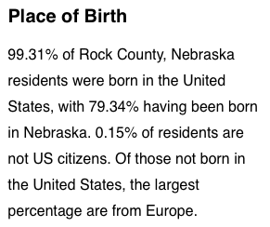

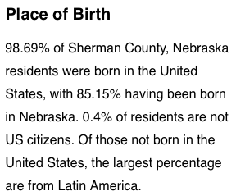
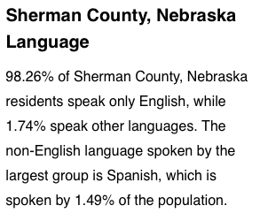

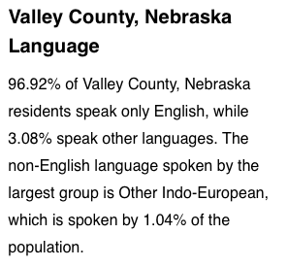
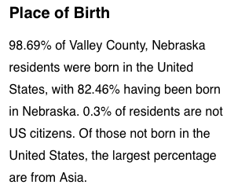

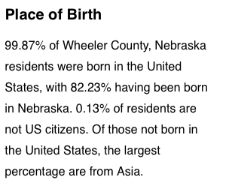
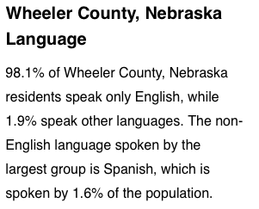

Ethnicity

The estimated population that is of Hispanic, Latino, or Spanish origin in the report area is 35,024. This represents 19.48% of the total report area population, which is greater than the national rate of 18.99%. Origin can be viewed as the heritage, nationality group, lineage, or country of birth of the person or the person’s parents or ancestors before their arrival in the United States. People who identify their origin as Hispanic, Latino, or Spanish may be of any race.

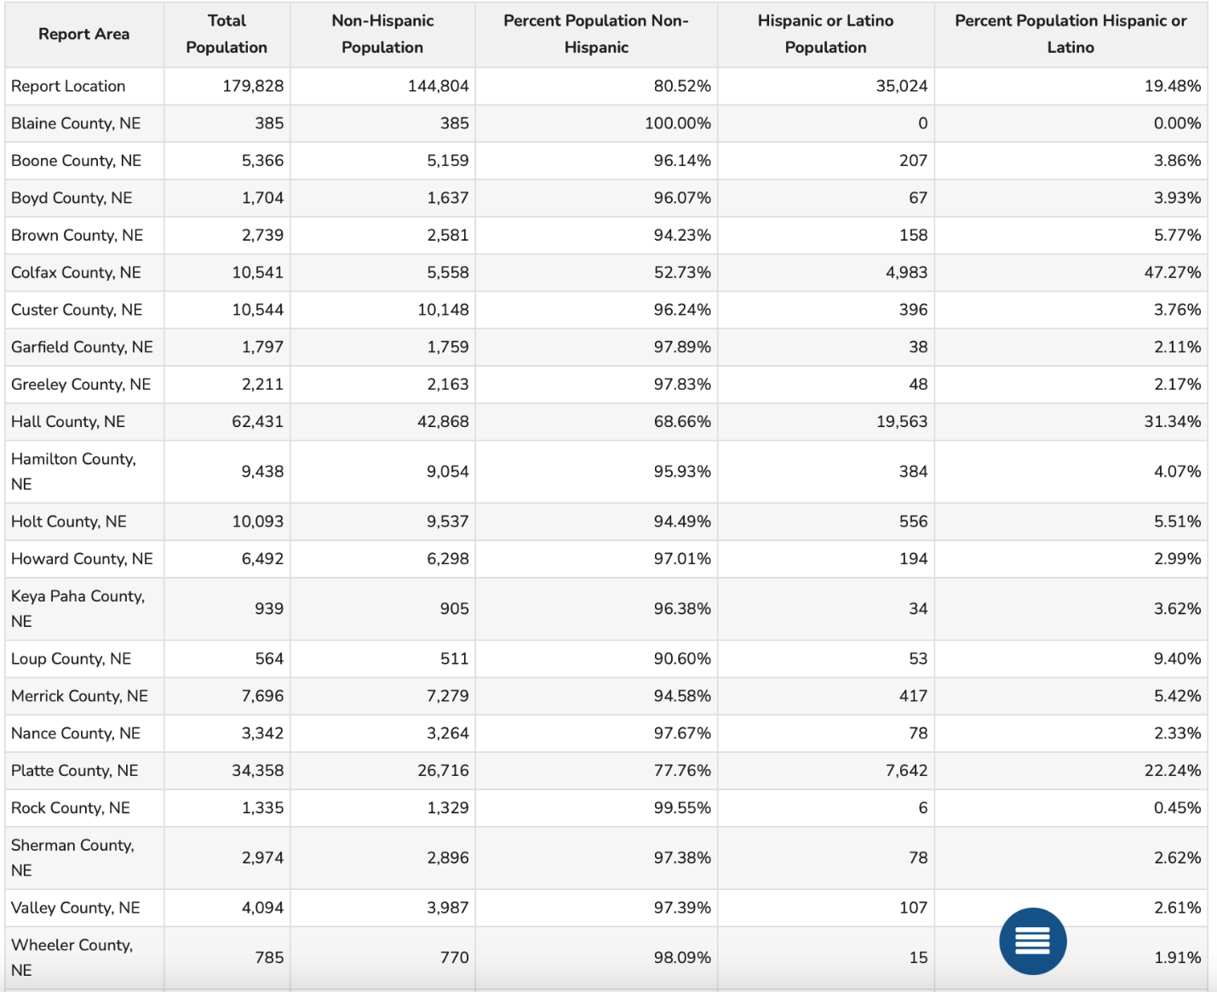

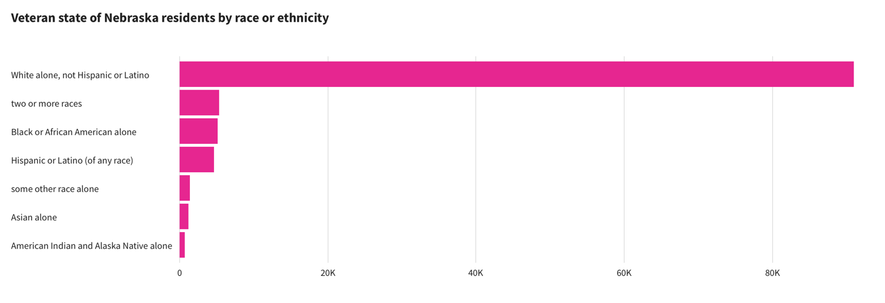
Veterans

Within the CNCAP service area, there are 8,527 veterans. 6.41% of the service area are veterans. Blaine county has the highest number of veterans at 13.87%. Rock county has the lowest number at 3.48%. Of these, 7,914 are male and 613 are female. Hall county has 253 female veterans. The veteran population of the service area is predominately over the age of 65. 18-34 is the age range with the least number of veterans at 458.
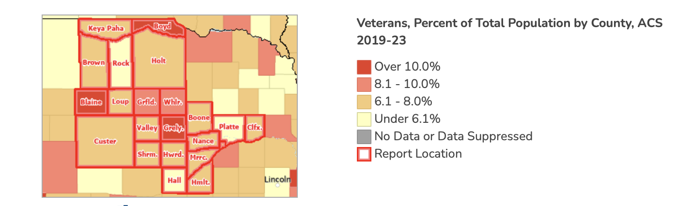

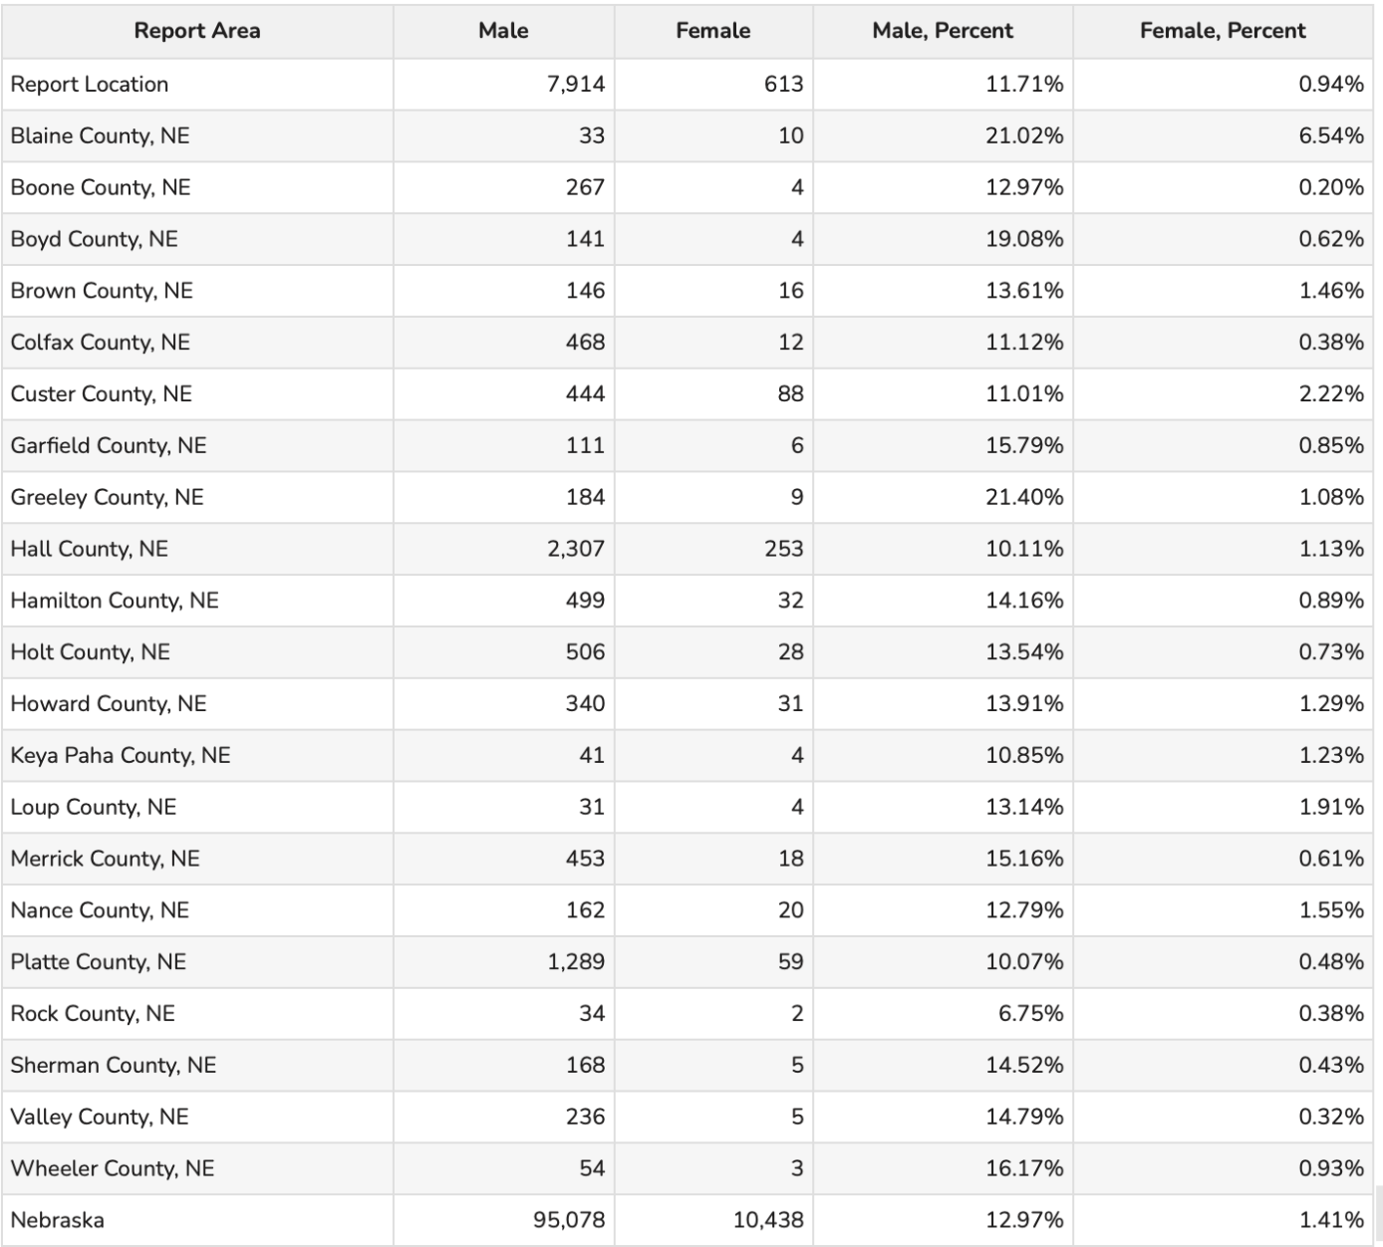
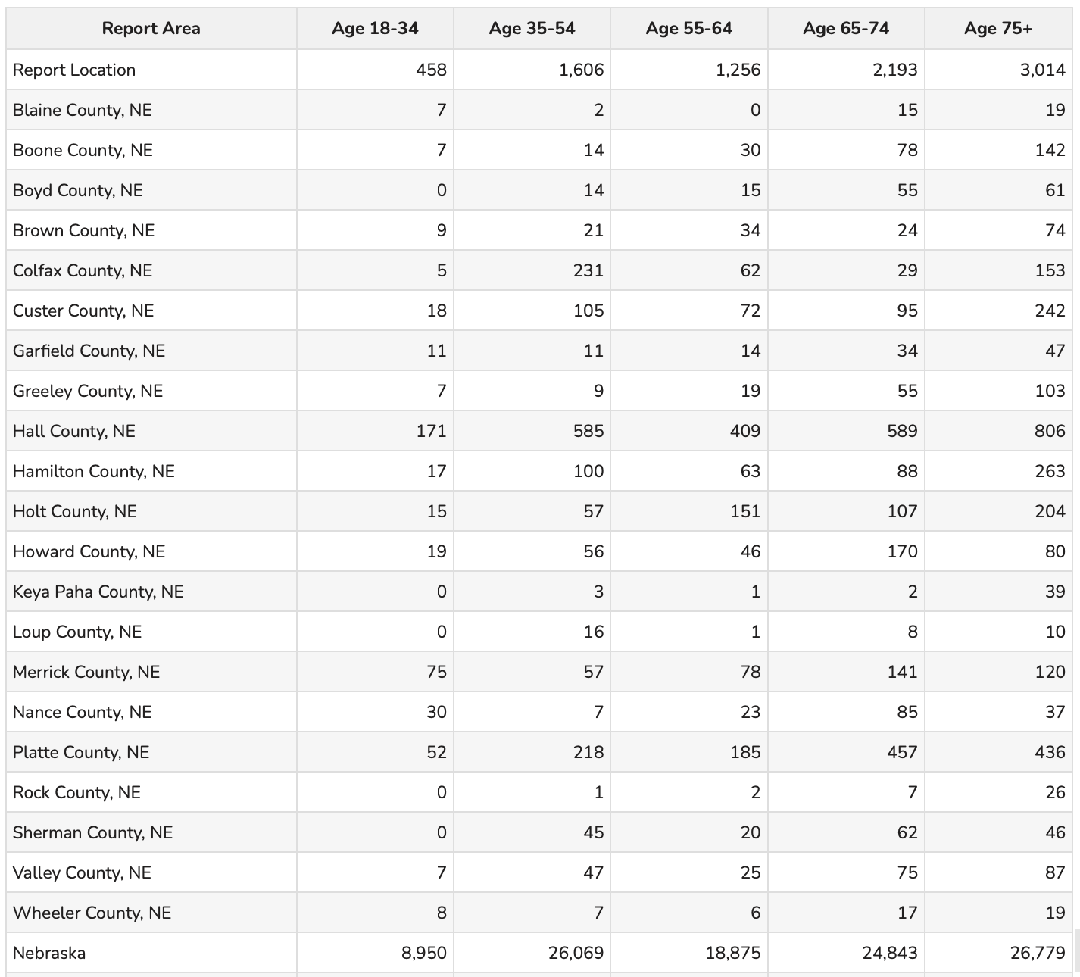
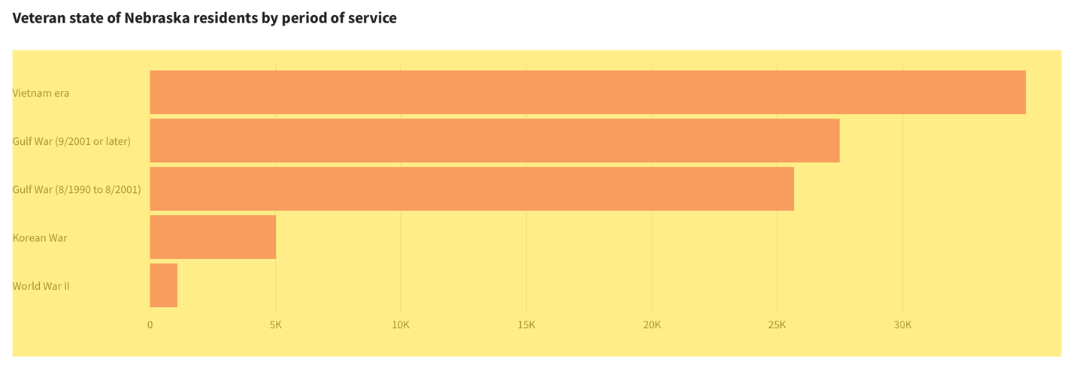
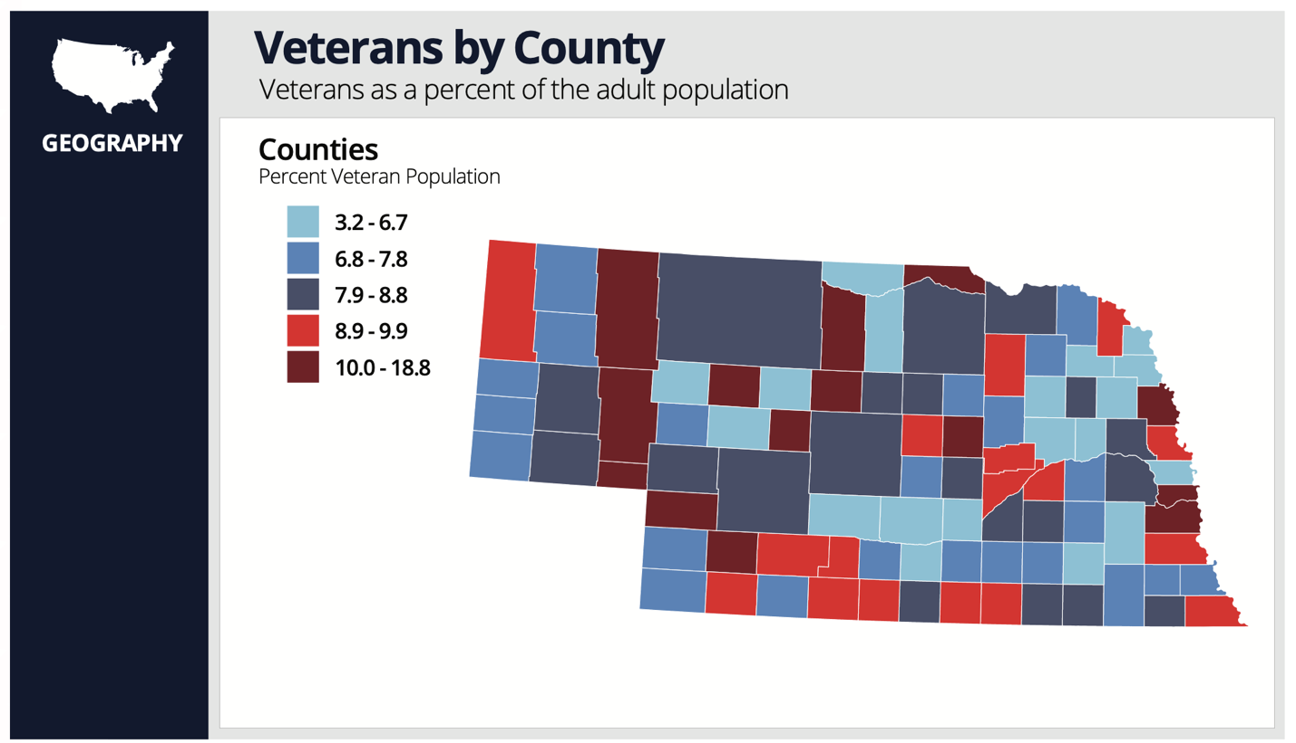

https://usafacts.org/topics/veterans/state/nebraska/
https://veteransdata.info/states/2310000/NEBRASKA.pdf

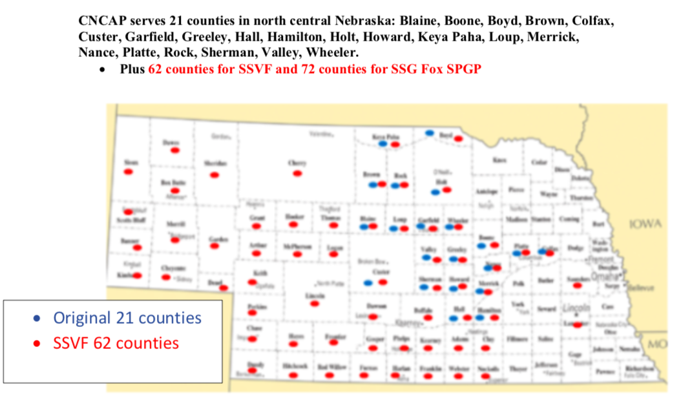
CNCAP Awarded SSG Fox SPGP Grant
Central Nebraska Community Action Partnership was awarded a Staff Sergeant Gordon Fox Suicide Prevention Grant Program (SSG Fox SPGP) through the Department of Veteran Affairs in the amount of $667,380 to support local Veterans.
The SSG Fox SPGP intent is to utilize community-based organizations to provide support through peer support activities to address the mental health needs of eligible Veterans and their families. During the initial implementation, the program was first aligned with the 62 counties covered by the SSVF program. However, CNCAP expanded the territory to 72 counties for services and now has Peer Specialists in Scottsbluff, Lincoln and Omaha with plans to hire additional staff. The program assists Veterans with support through various activities such as movie nights, golf outings, art, music, and support groups to get them engaged with other Veterans and build a support system. CNCAP helps Veterans in our communities every day, and the SSG Fox SPGP efforts will work well with the other Veteran programs already provided through Central Nebraska Community Action Partnership to meet the needs of the Veterans.
SSG Fox SPGP honors Veteran Parker Gordon Fox, who joined the Army in 2014 and was a sniper instructor at the U.S. Army Infantry School at Fort Benning, Georgia. Known for a life of generosity and kindness to others in need, Fox died by suicide on July 21, 2020, at the age of 25.
Education
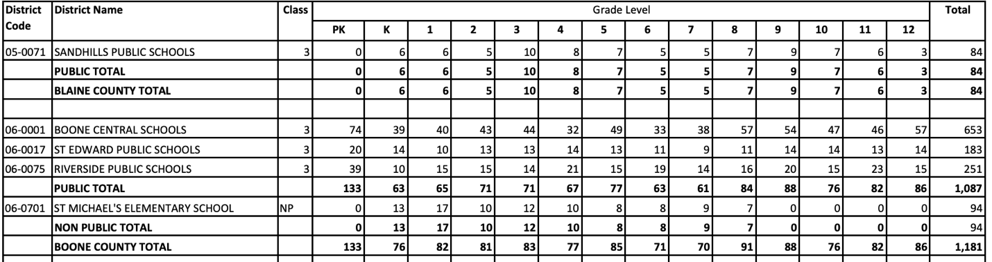
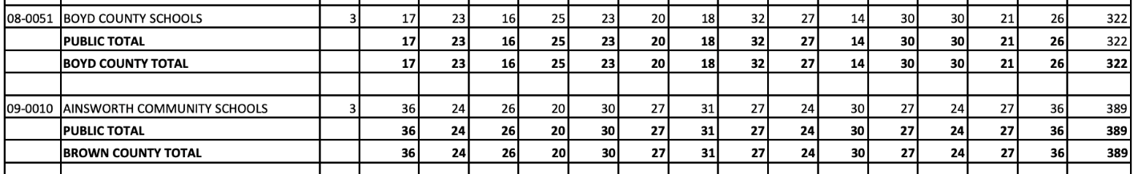

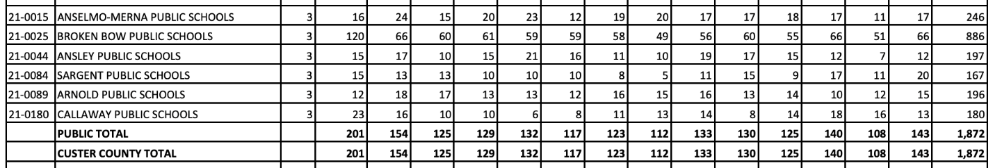
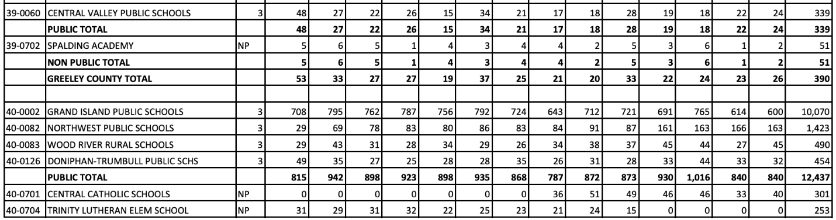
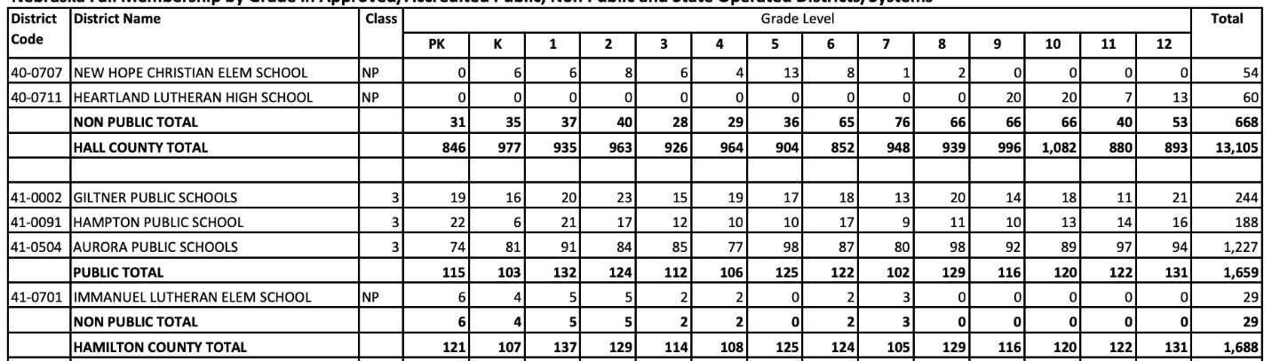
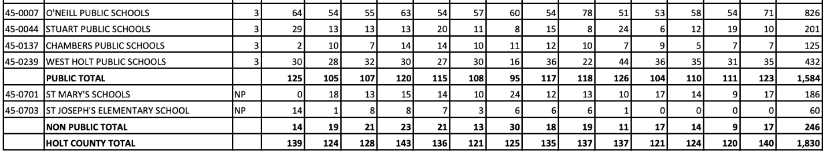
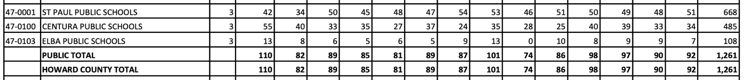
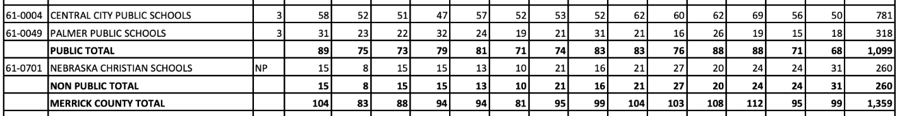
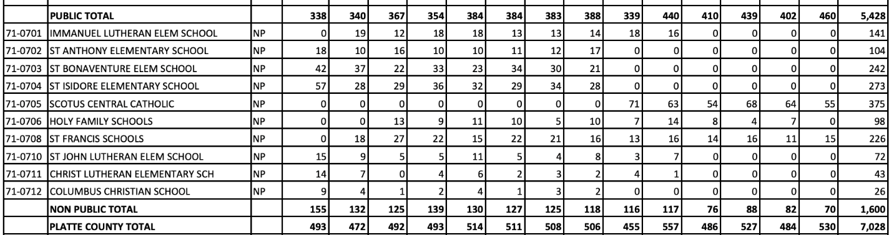
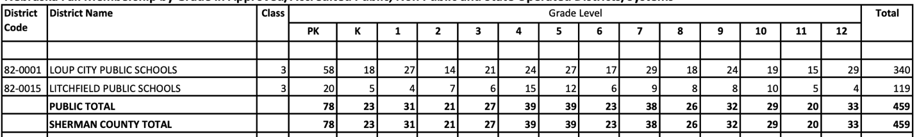
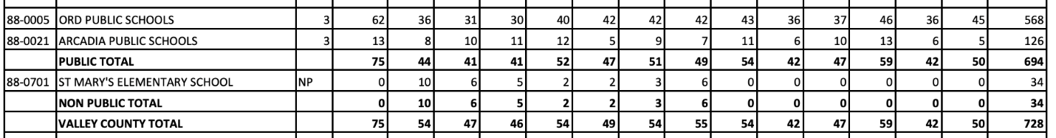
https://www.education.ne.gov/wp-content/uploads/2024/02/Statsfacts_20232024.pdf

Educational Attainment shows the distribution of the highest level of education achieved in the report area, and helps schools and businesses to understand the needs of adults, whether it be workforce training or the ability to develop science, technology, engineering, and mathematics opportunities. Educational attainment is calculated for persons over 25 years old, and is an estimated average for the period from 2019 to 2023. For the service area, 15.57% have at least a college bachelor’s degree, while 32.49% stopped their formal educational attainment after high school.

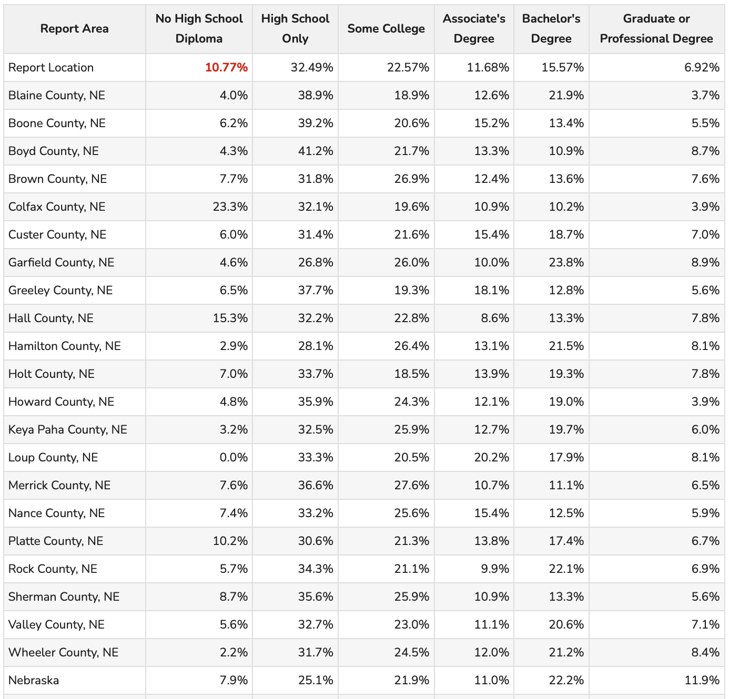
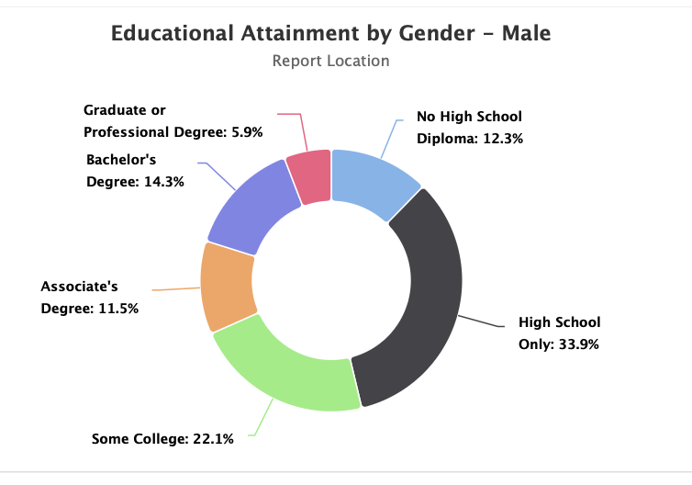
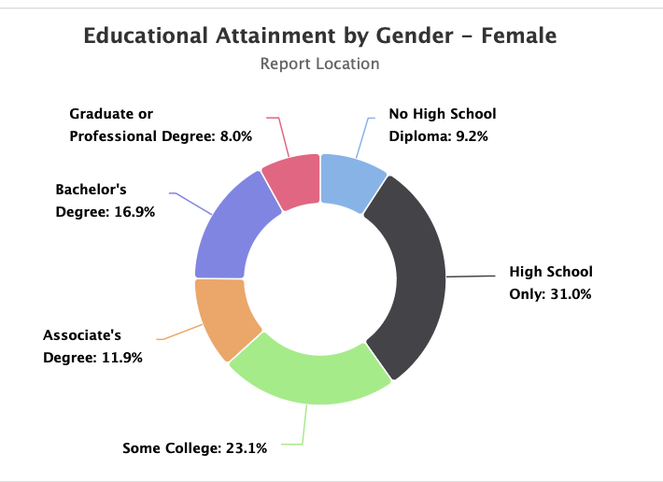

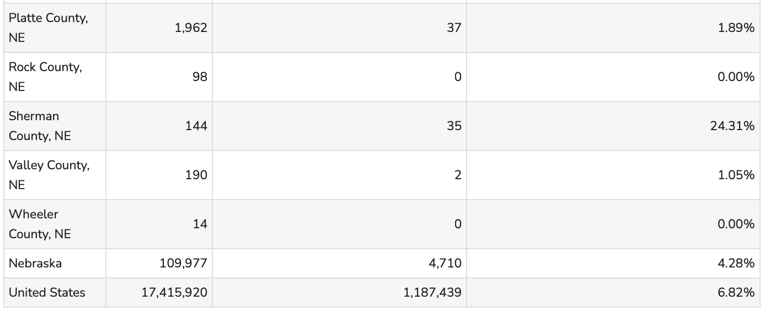
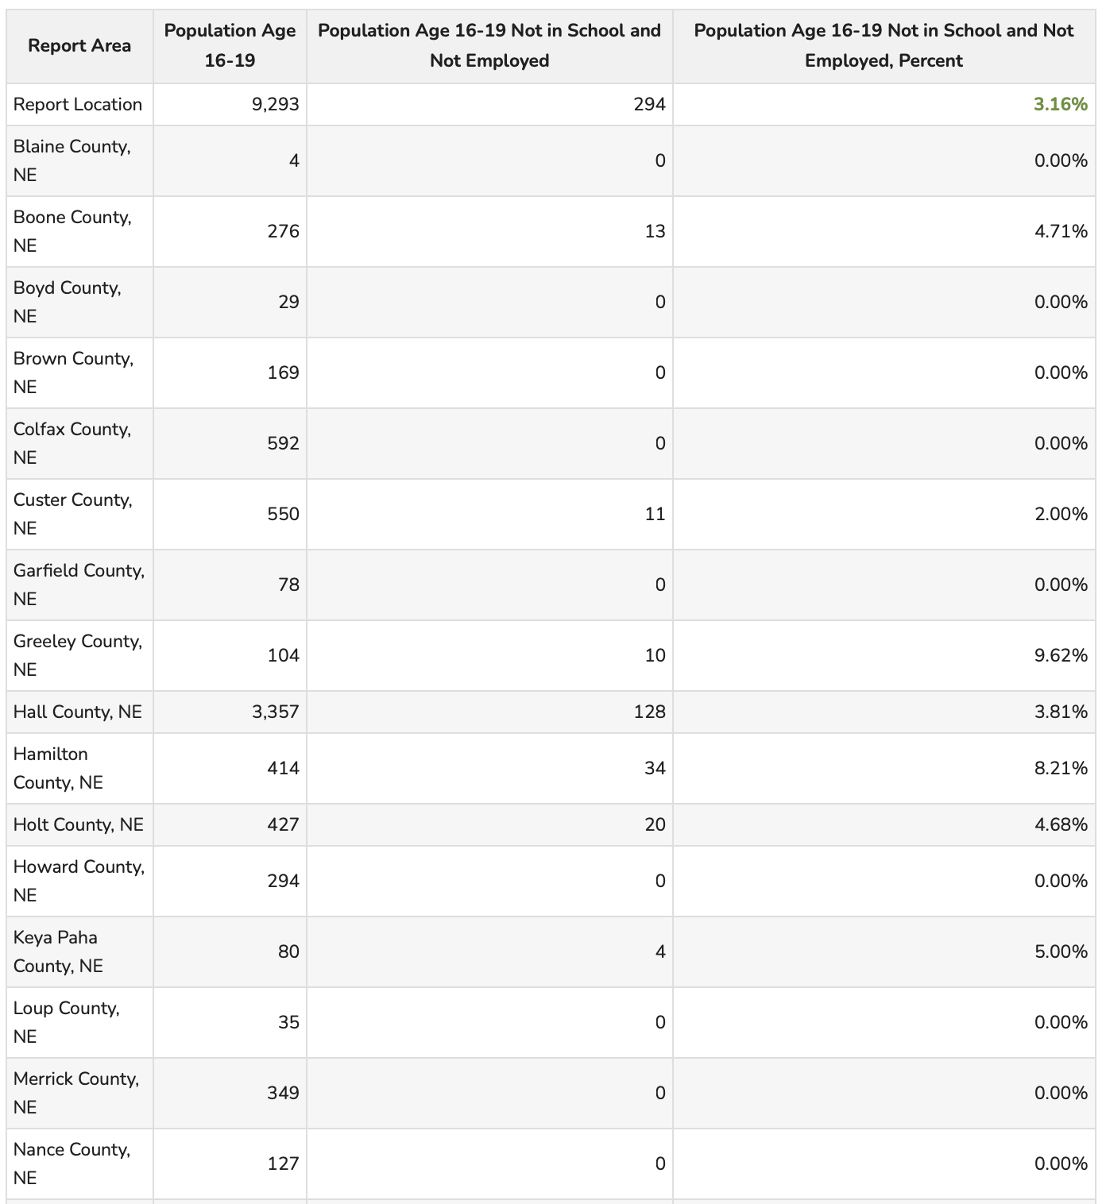

This indicator reports the percentage of youth age 16-19 who are not currently enrolled in school and who are not employed. The service area has a total population of 9,293 between the ages, of which 294 are not in school and not employed.

Housing

According to the Rural Poll, most rural Nebraskan see housing as important to the growth of their community. Most also think that their community lacks options for rentals or home purchases. 90% of rural Nebraskans who were surveyed, said that high-quality, affordable housing is important for their community growth. Most agree that inadequate housing options result in worker shortages locally. 52% believe their community should invest in public housing resources to support the availability of housing. Many respondents do not find it affordable for a person working in their community to purchase a home. Respondents were asked to rate the adequacy of various housing types locally. Most respondents found there is not enough types of housing in their community: homes available for rent (60%), move-in ready homes available for rent (56%) existing homes available for purchase (55%) move in ready homes available for purchase (54%) and safe and affordable apartments for rent (54%). These perceptions have worsened since 2016. The proportion rating the number of move-in ready homes available for rent declined from 40% in 2016, to 25% in 2024. The rate of existing homes available for purchase as adequate declined from 39% to 30%.

This has remained one of the top concerns for the state of Nebraska. Housing shortages have continued to wreak havoc on the state of Nebraska. Compared to just five years ago, the pains Nebraskans now endure to acquire an affordable house or apartment are much worse. Especially for those below the median household income. Affordable housing challenges for low income workers only appear to be increasing. More than a third of Nebraska households earn less than $50,000. As the cost of building a house surged in recent years, fewer houses were constructed, which only further inflated the cost of the remaining supply. In many Nebraska counties, the available housing stock is decades older than the national average and suffers from serious housing problems like a lack of complete kitchen or plumbing facilities. Workers earning a median wage in Nebraska are often unable to obtain a proper housing unit, especially with the recent values. Many Nebraskans near (and above) the median income are not eligible for housing subsidies and assistance, yet still have difficulty obtaining and affording a house that truly meets their needs.

Income plays a major role in home ownership. Owner-occupied housing units have a median annual income of over 91,000. However, households renting their units earned just over $44,200. There are some major challenges for buying a home in the past couple of years. The cost of purchasing a home being the greatest challenge. According to the National Association of Home Builders, between April and September of 2020, lumber costs increased by roughly 175%. In 2021, the framing lumber rose another 55%. Interest rates are another challenge as they reached above 8%. Homeowners stuck with their low interest rates instead of selling and acquiring an undesirable mortgage rate. The interest rates of 2024 would increase the monthly payment by nearly $700.00 from $1,174 to $1,827. This increases the total interest from $143,000 to $378,000. On top of rising home prices and interest payments, are closing costs and insurance increases. Homebuyers can expect to spend $11,000.00 or more on closing costs and down payments when buying a home. The median sale price has increased from $200,000 to $280,000. At the median purchase price, with a conventional 30-year loan, the interest rate and loan value would cost between $2,000 and $2,200.00. Payments on the typical home in Nebraska cost approximately $2,300.00 monthly. Yet in January of 2022, the typical $250,000 home came with a $1,200 monthly payment. Another major challenge is the appraisal gap. The difference between the fair market value for a newly constructed housing unit vs. what a bank or lender appraises it at, has become a central issue in Nebraska’s housing market. New homes coming into the market must be appraised based on existing comparable homes in the area. Especially in rural areas, similar sized homes are likely to be appraised at a lesser value than a new built home. This gap causes developers to avoid building in areas where large appraisal gaps exist unless they are ensured a profit for their work.

Another major challenge in Nebraska is the rising rent prices. The nationwide average cost to rent a house was $1,959 in April 2024, an increase of nearly 30% since the start of the pandemic. This dramatic increase has priced out many in the Great Plains region. Between the years of 2016 and 2020, the total number of units for rent at $500 to $999 remained stable, but the number of units paying less than $500 per month for rent fell 45%. The number of expensive units between $1,000 and $1,499 increased 150%. In august of 2023, the fair market rent price for a 1-bedroom unit was nearly $790 which would be affordable to an individual earning more than $31,500 annually. For a two-bedroom unit, a fair market rent was nearly $1,000 which is affordable to someone making nearly $40,000 per year. According to the National Low Income Housing Coalition, Nebraska suffers from a shortage of over $40,000 rental units that are affordable and available for the extremely low-income households.

Further challenges include: increasing population and stagnant housing construction. There were fewer single-family homes built from 2010 to 2020 than any decade since the 1960s. Since 2020, the number of households has grown faster than the new construction of housing units at 40,000 households to 17,000 units. Supply of houses on the market is another key challenge. In August of 2023, there were just over 4,700 homes for sale across the state which was 12% lower than the number available in August of the previous year. Age of houses is another major issue. In Nebraska, 20% of homes were built before 1939, and 60% were constructed before 1980. Older homes are more likely to have deteriorated due to long-term deferred maintenance which decreases the condition of the houses. The median year housing units were built in the US was 1981. In some rural communities of Nebraska, the average is 40 years prior. In rural counties, the median year homes were built is much earlier than compared to urban areas.

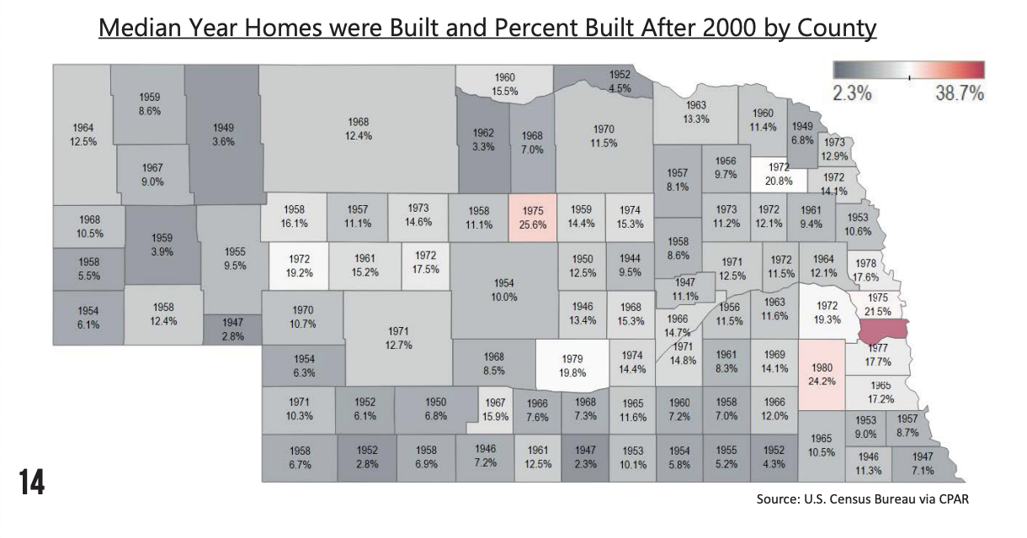

The availability of houses is another major challenge. Although in some counties over 30% of the houses are vacant, not all vacant houses are habitable, accessible, or available for purchase. An average of only 2% of homes across the state are available for sale or rent which is higher than some of the fastest growing counties in the state. A healthy vacancy rate is typically in the range between 7 and 8%.

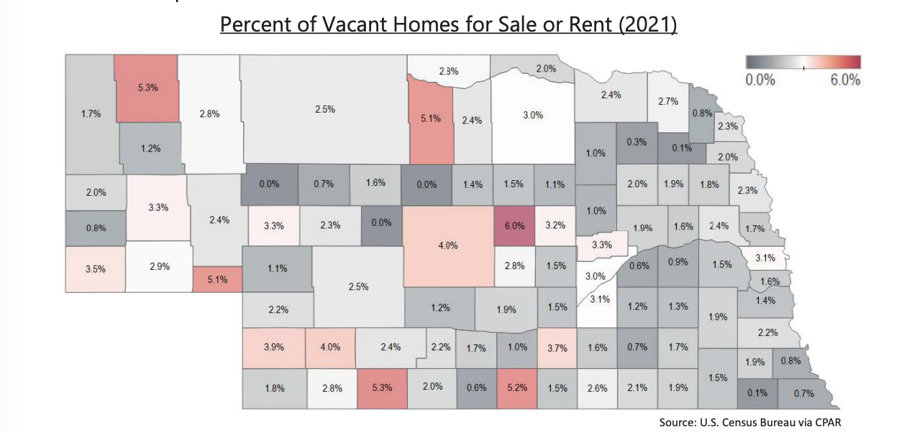

The condition of many owner and renter occupied housing units is another challenge. Many have structural or other issues that reduce their habitability and value. Housing problems include houses that have one or more severe problems including lack of a complete kitchen or plumbing facilities, being over-crowded, having more than one person per room, or being severely cost-burdened. Households spending more than 50% of their income on rent or mortgage, utilities and other fees are considered housing cost-burdened. Renter occupied units are more likely than owner-occupied to have multiple housing problems. However, even for owner-occupied units, rural areas of the state have higher rates of homes with one or more severe issues compared to urban areas.

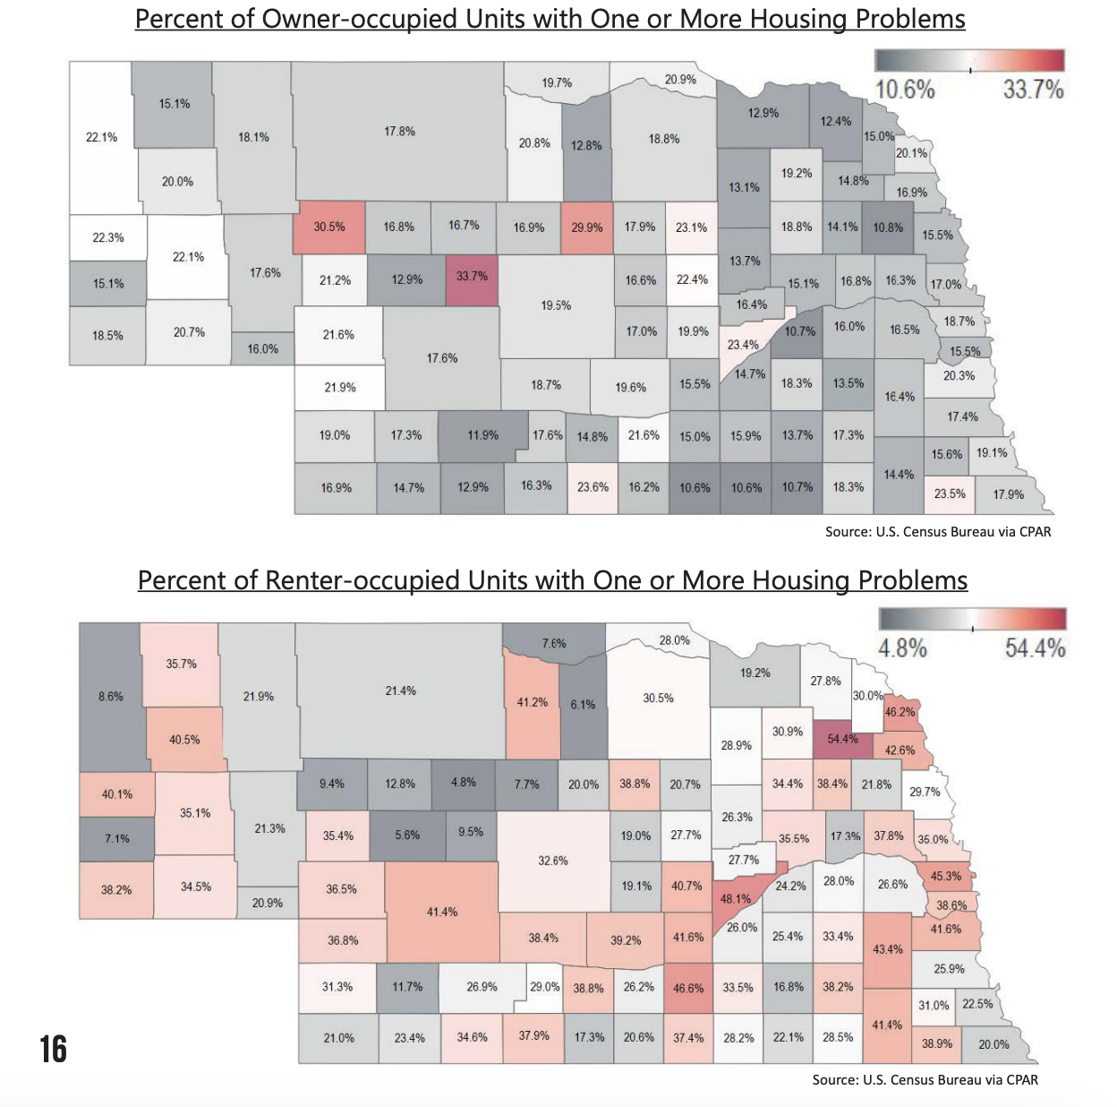

Other barriers that affect the housing market include:

Limited land availability- there is a lack of ready-to-develop land.
Lack of housing diversity- diverse housing refers to the blend of housing unit types that any given community requires. A lack of sufficient housing diversity can lead to a limited workforce for employers and fewer options for low-income and fixed-income households. The shortage of rental units for extremely low-income households and the shortage of low to middle workforce housing units are essential and missing across the state.
Workforce challenges- employers drive the need for housing, and the construction of housing is related to the number of construction companies and workers per household in the area. Especially in rural areas of the state, the deficit of construction businesses and workers has created significant housing development challenges. The ratio of the number of households per construction employee helps to indicate whether there is a sufficient amount of workforce available in the area. Urban areas of the state feature 12 households per construction worker. However, the ratio in rural areas averages 27 households to one construction employee and more than 50:1 ratio in some areas of Nebraska.

https://nebraskalegislature.gov/pdf/reports/research/affordable_housing_challenges.pdf

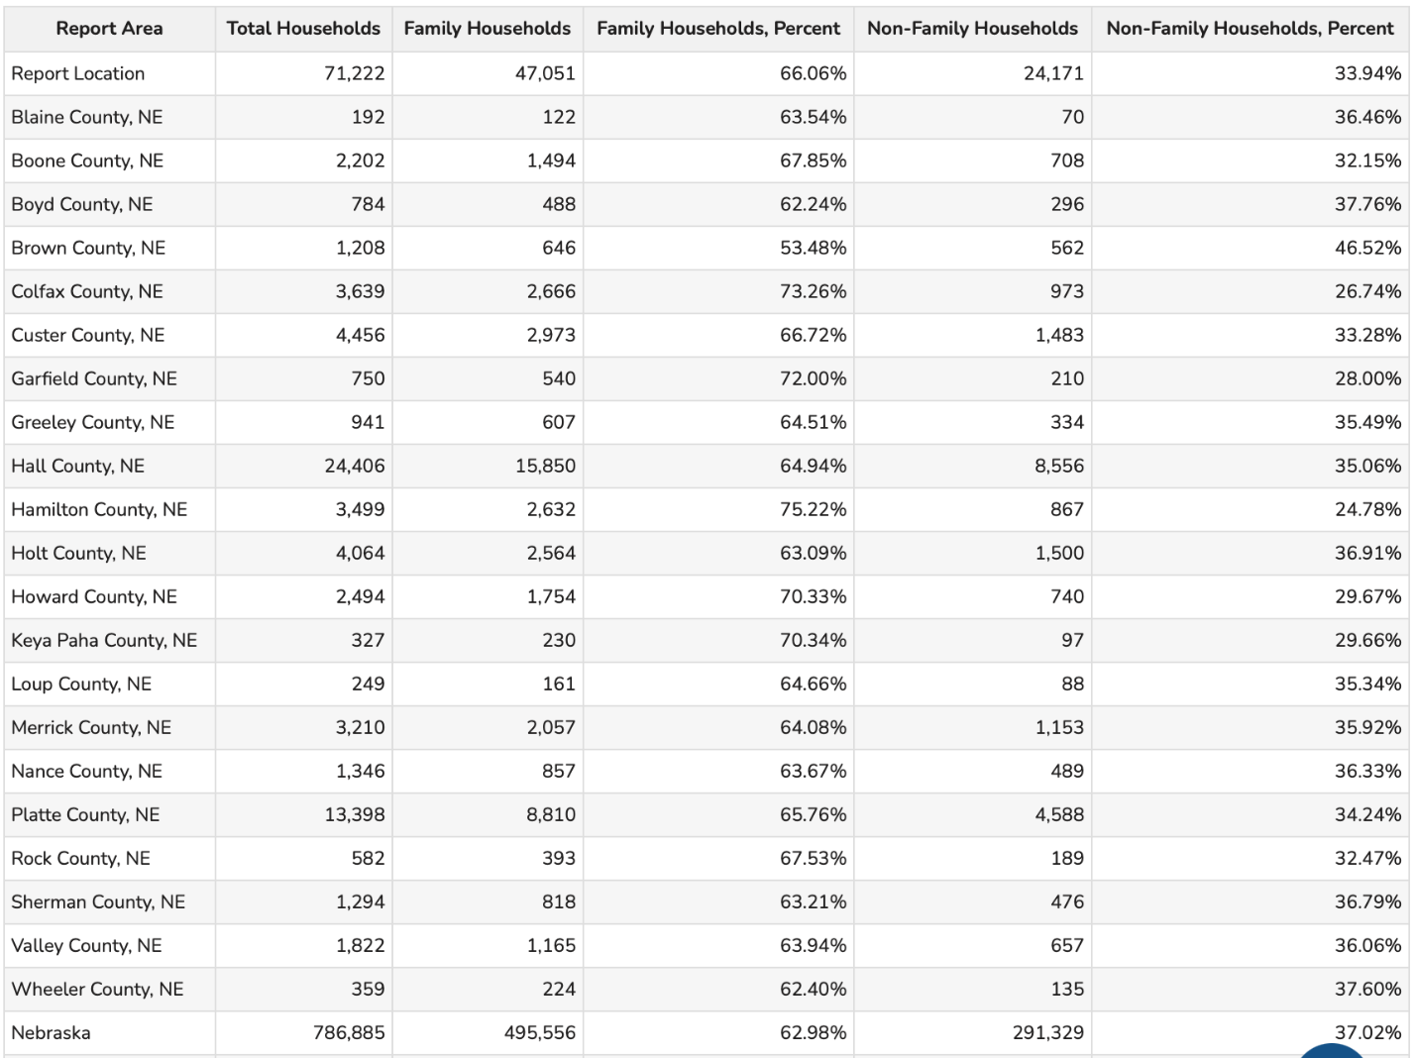

There is a total of 71,222 households within the CNCAP service area. Of them, over 37,000 are married family households and almost 3,500 are male single households. Nearly 6,600 of them are single female households and over 24,000 are non-family households.
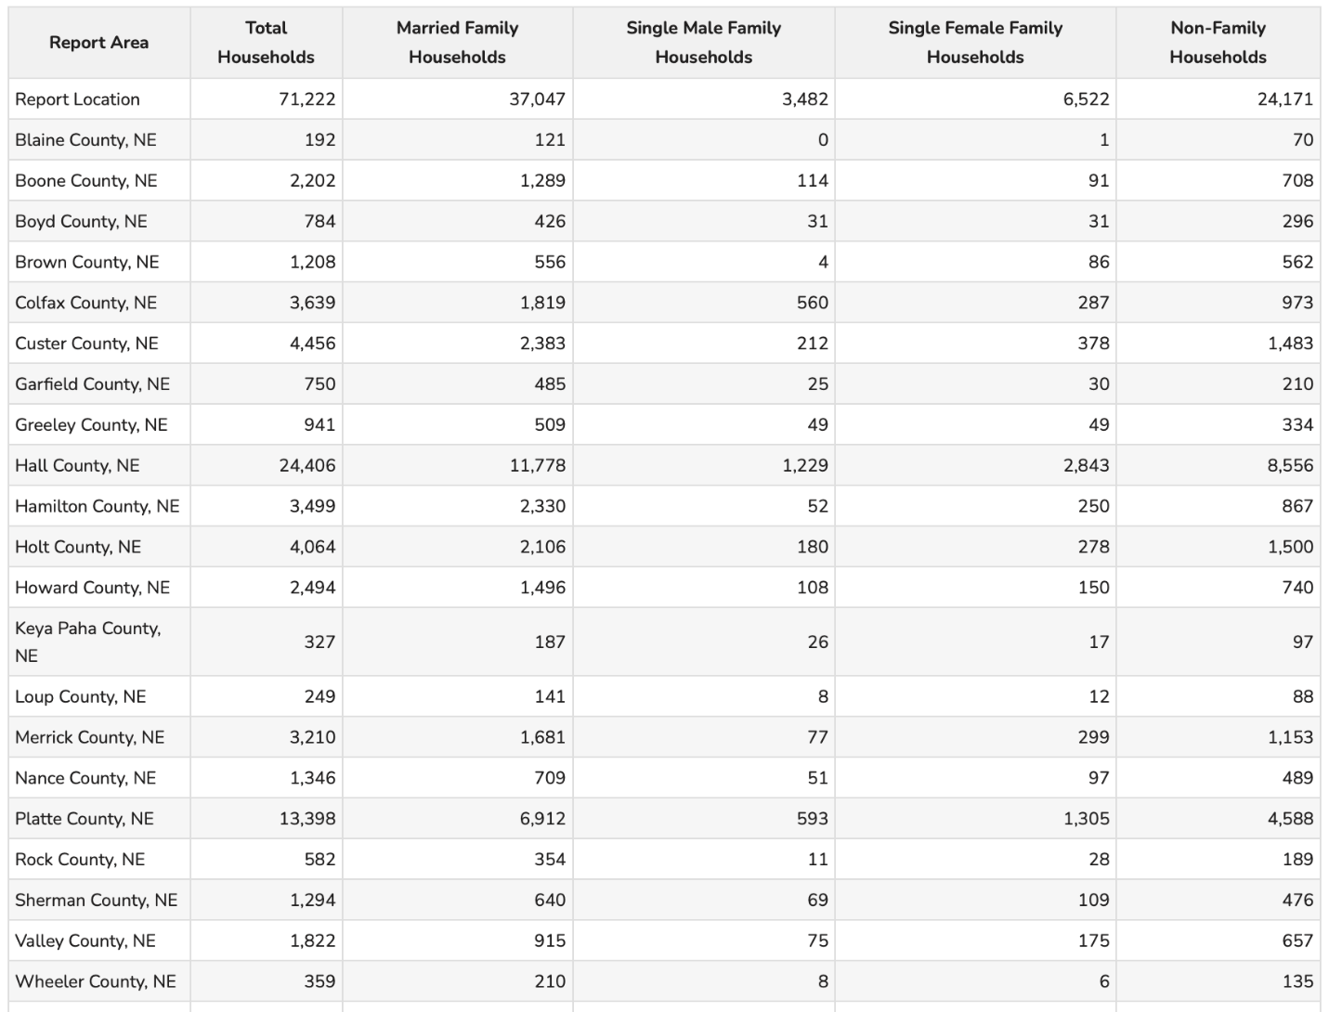

Vacancy

Of the 88,351 residential addresses in the service area, 1,430 are vacant, leading to a 1.6% vacancy rate. Of the 8,331 business addresses, 776 are vacant which is a vacancy rate of 9.3%.
The number of housing unites vacant in the service area, is quite a low number. Especially given the age of most houses in rural Nebraska. Many are uninhabitable or not available. This further exacerbates the already short list of houses available for families. With the lack of options, families are living in houses that are not suited for their family. This leads to issues of overcrowding, lack of access to proper plumbing and kitchens and other challenges.

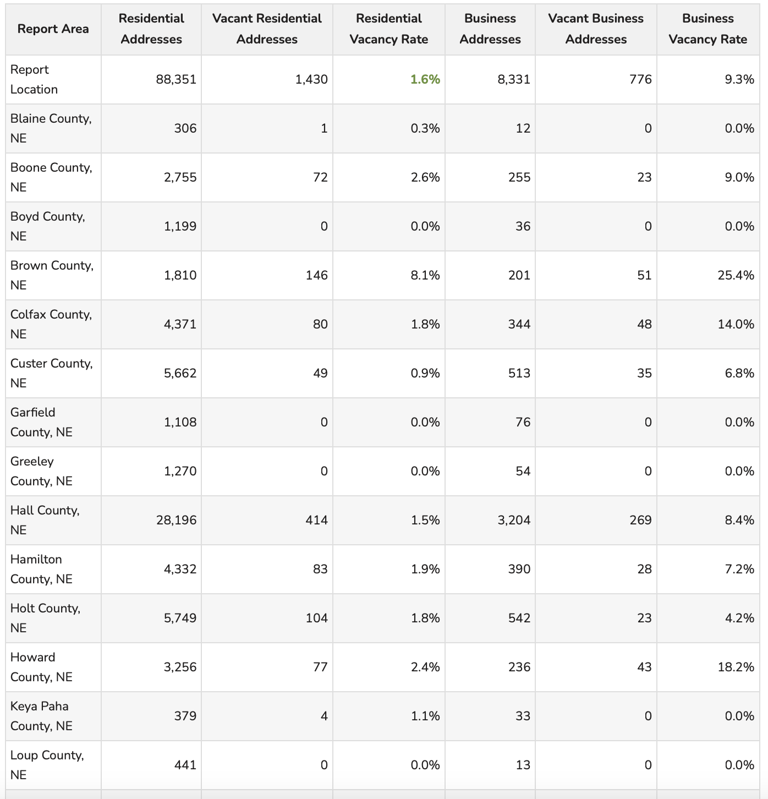

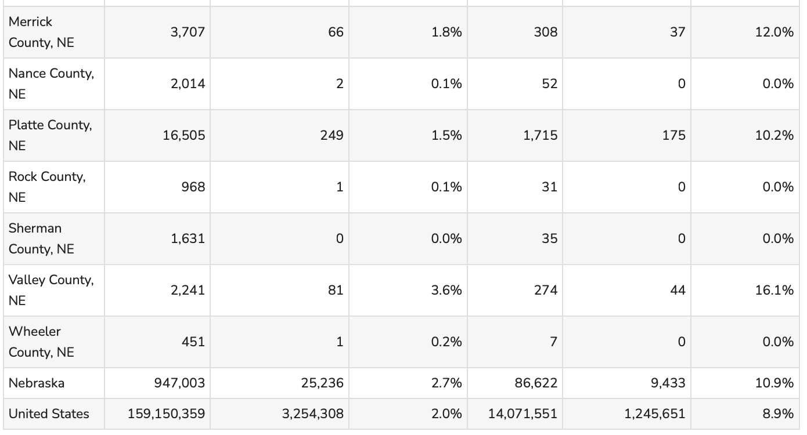

The number of vacant houses in the service area has decreased since the previous year. This number was already low to begin with, having decreased by nearly 200 houses. The worsening housing shortage has now turned into an eviction crisis. Statewide, the average number of evictions reported between 2016 and 2019 was 6,286 annually. In 2023, that number had risen to 10,989. This situation affects a staggering number of Nebraska children. Most children are at risk of being part of an eviction before the age of 5. This may also be caused by the worsening of housing prices and the rising costs making it difficult for families to find affordable housing and in turn, not being able to afford the house they are living in, thus causing evictions.
Rent vs. Own

Rent prices have gone up yet again, since the previous year. This is challenging as this is often the most affordable way to live as a middle to low-income household. As if the housing prices are not high enough as it is, renting a house does not offer much more comfortability in terms of finances. There fair market value has seen yet another increase.

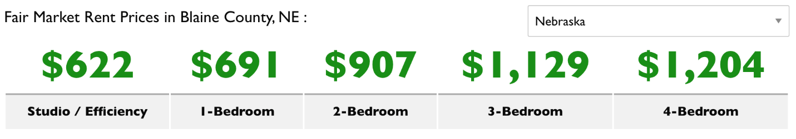
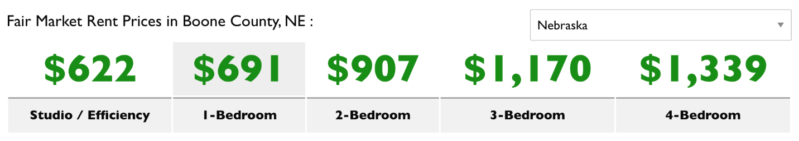
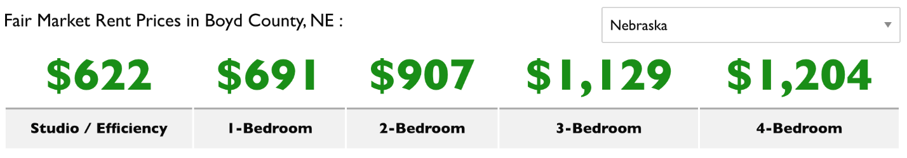
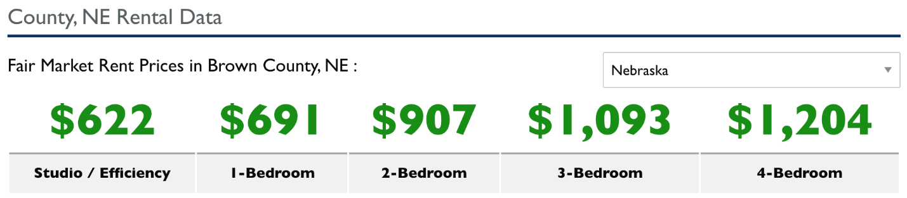
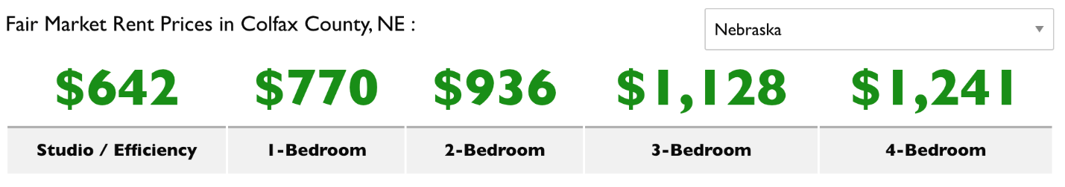

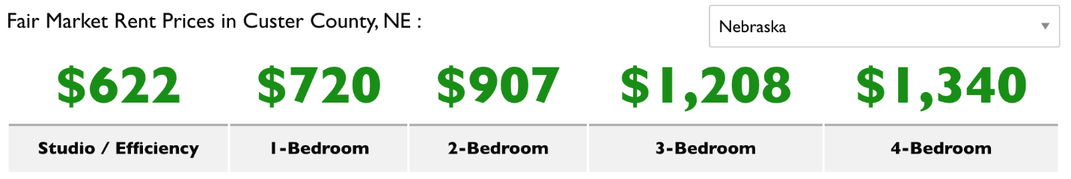
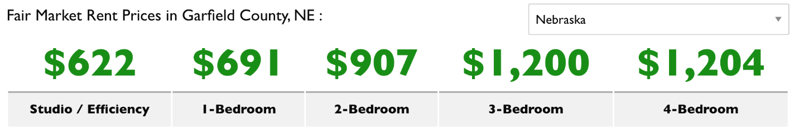
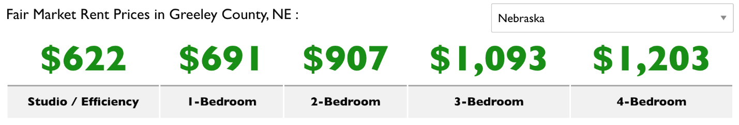

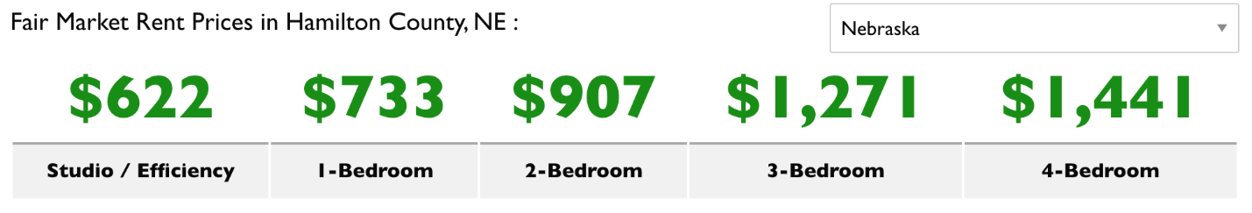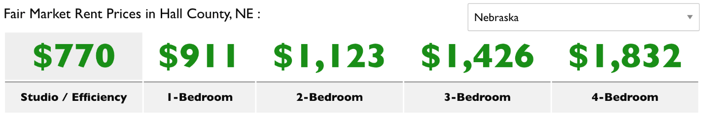
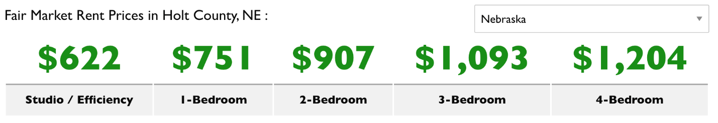
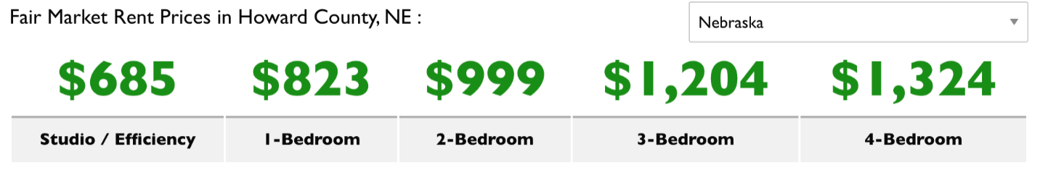
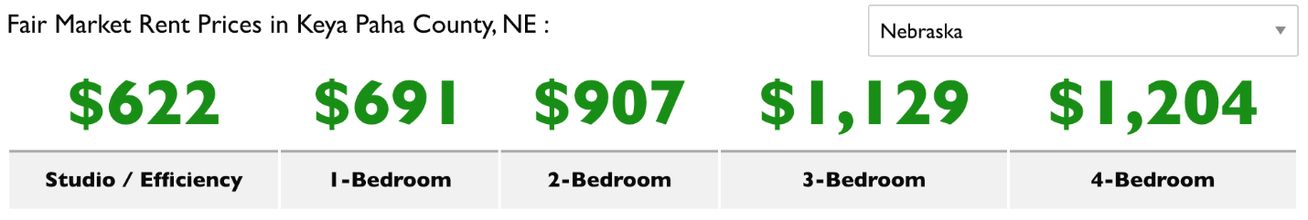
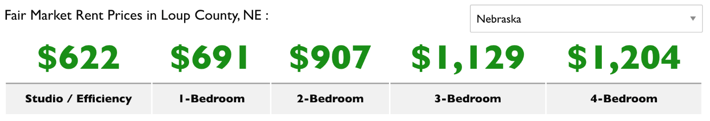
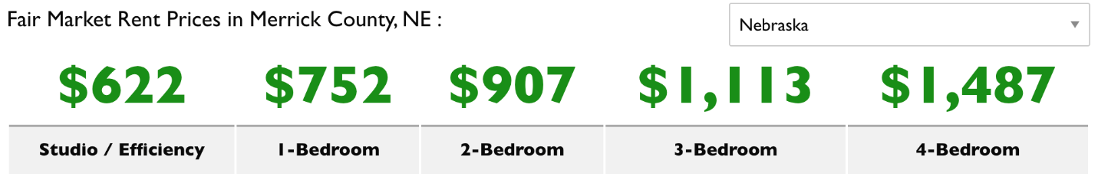
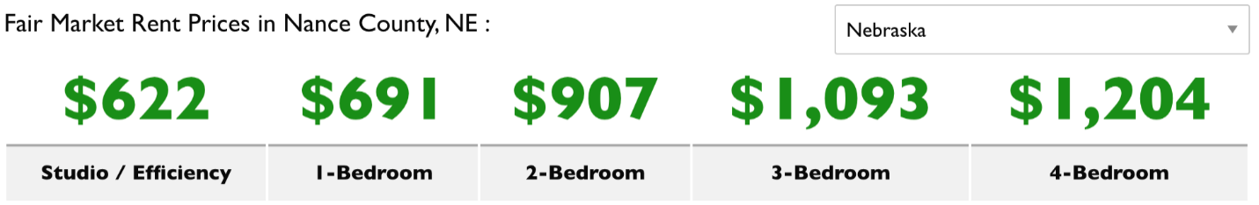

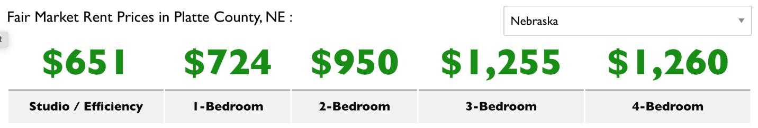
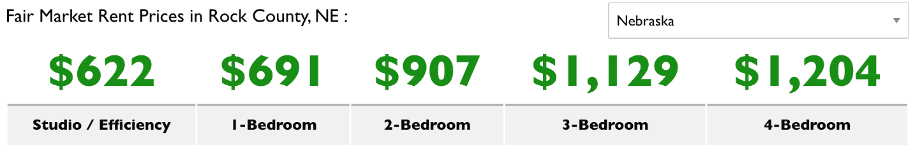
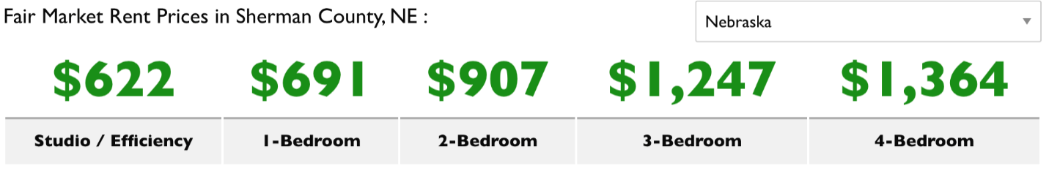
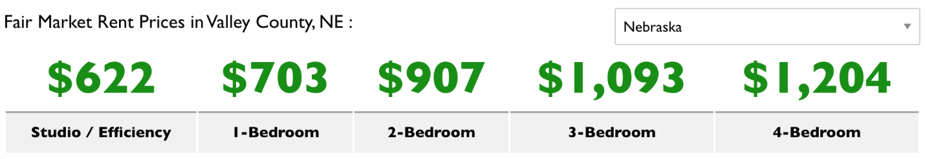
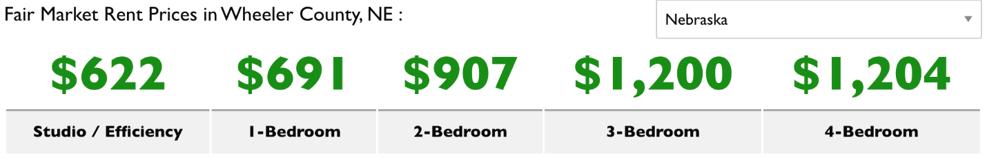

Owning a house has become increasingly difficult in the last year as well, as the median sale price across the state has reached $280,000 and the number of houses sold decreased by 5%. Not only that, but foreclosures have picked up as well, reaching to 267 in the first quarter of the market analysis.

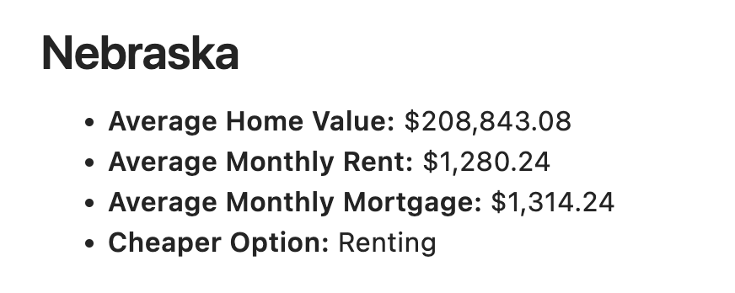
Across Nebraska, there is a shortage of rental homes affordable and available to extremely low-income households, whose homes are at or below the poverty guideline or 30% of their area median income. Many of these households are severely cost burdened, spending more than half of their income on housing. Severely cost burdened poor households are spending more than half of their income on housing. Severely cost burdened poor households are more likely than other renters to sacrifice other necessities like healthy food and healthcare to pay their rent, and to experience unstable housing situations like evictions. 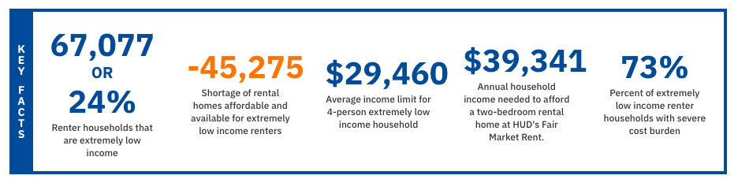
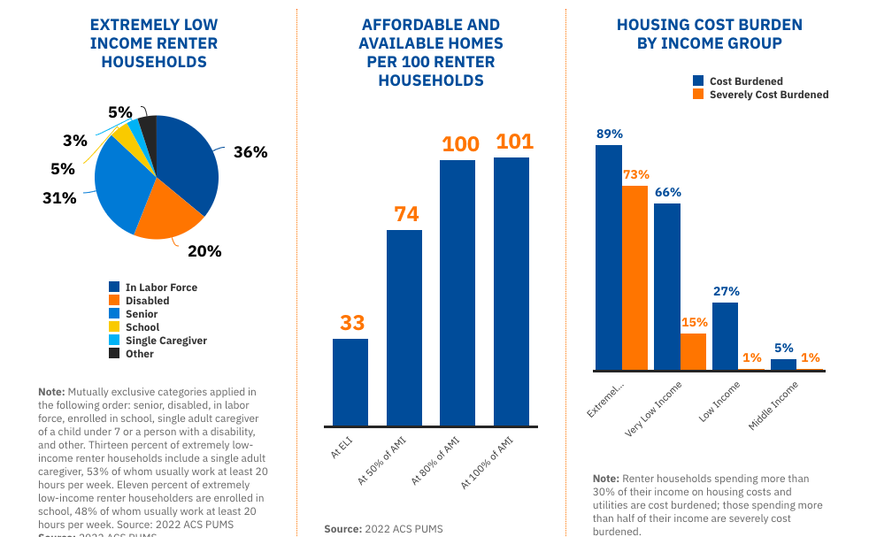
https://nlihc.org/housing-needs-by-state/nebraska

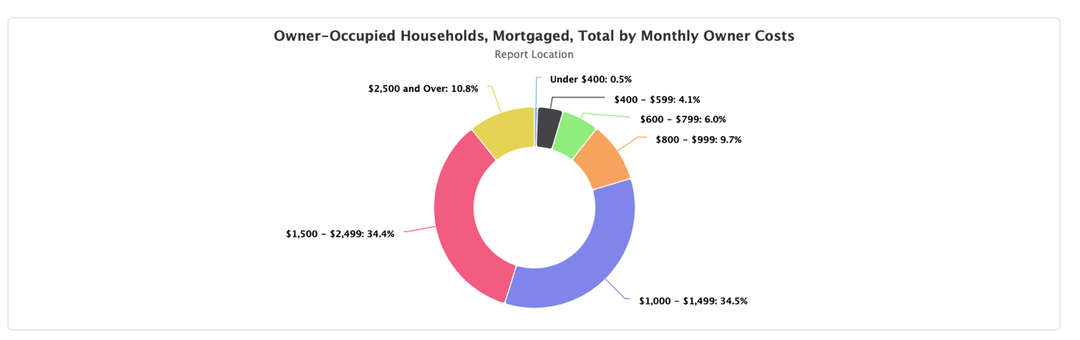
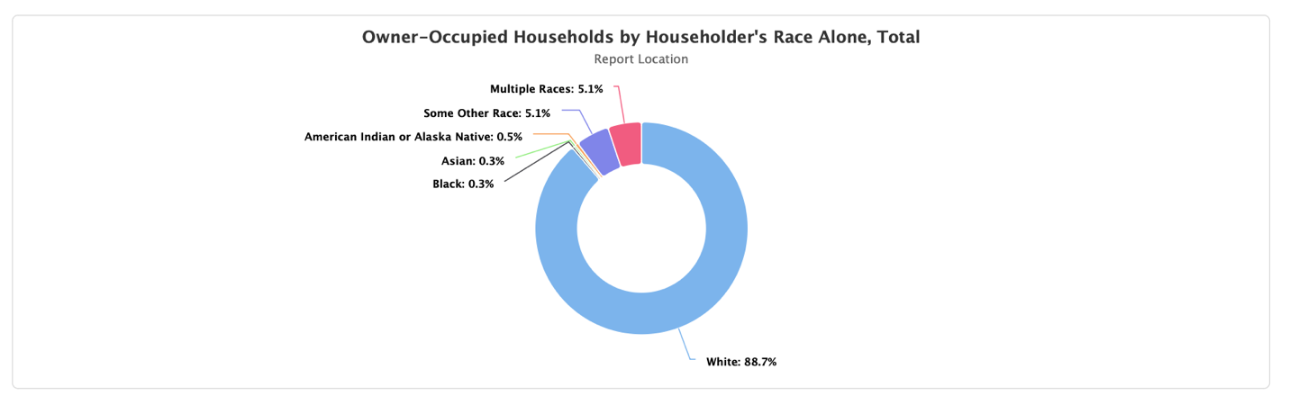
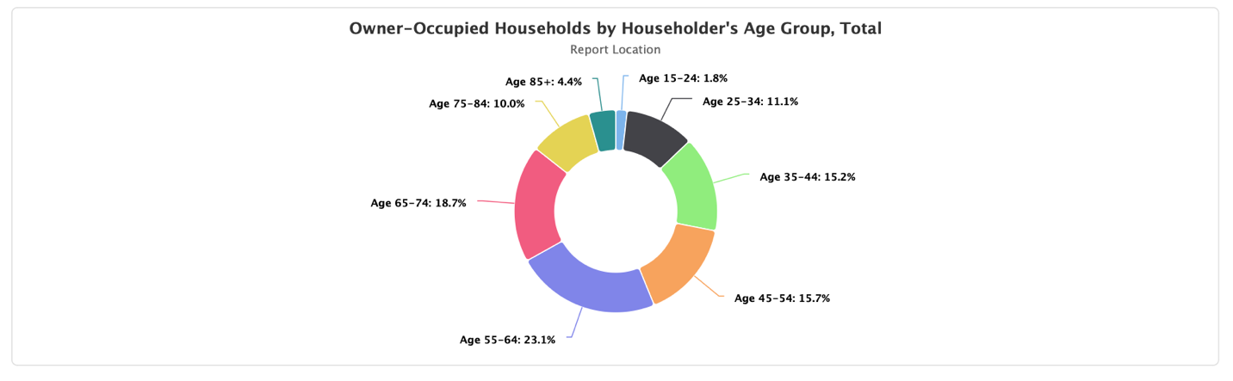
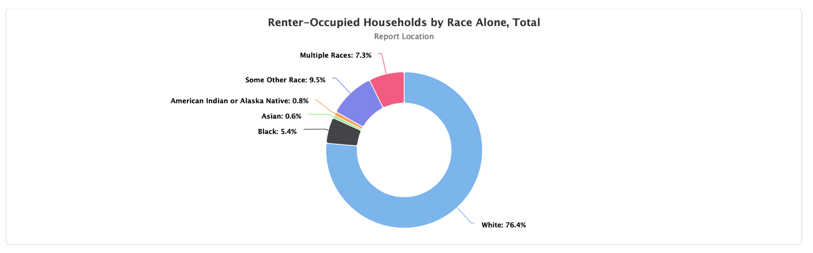
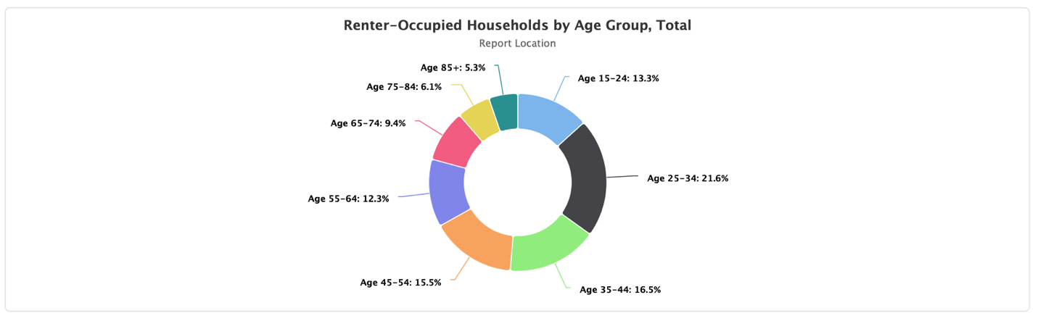
Age 55-65 is the largest group that owns their own homes. Age 25-34 is the largest group that rents their own homes. The older generation is owning their homes at higher rates than younger within the service areas. This poses a challenge across the state, as the buying a family-sized home with three or more bedrooms to be manageable for the younger generation but that is no longer the case. The older generation will not part with their homes, which creates a challenge for young families trying to move somewhere for a job. The older generation is staying in their larger houses for longer, preferring to stay in place. As a result, empty nest baby boomers own 28% of large homes and families with children own just 14%. Even if the older generation did want to sell their homes, the younger generation faces challenges in trying to afford it. This has changed from the historical norm according to research. Ten years ago, young families were just as likely as empty nesters to own large homes.
https://www.cnn.com/2024/01/16/economy/boomers-own-more-larger-homes-than-millennial-families/index.html

Cost
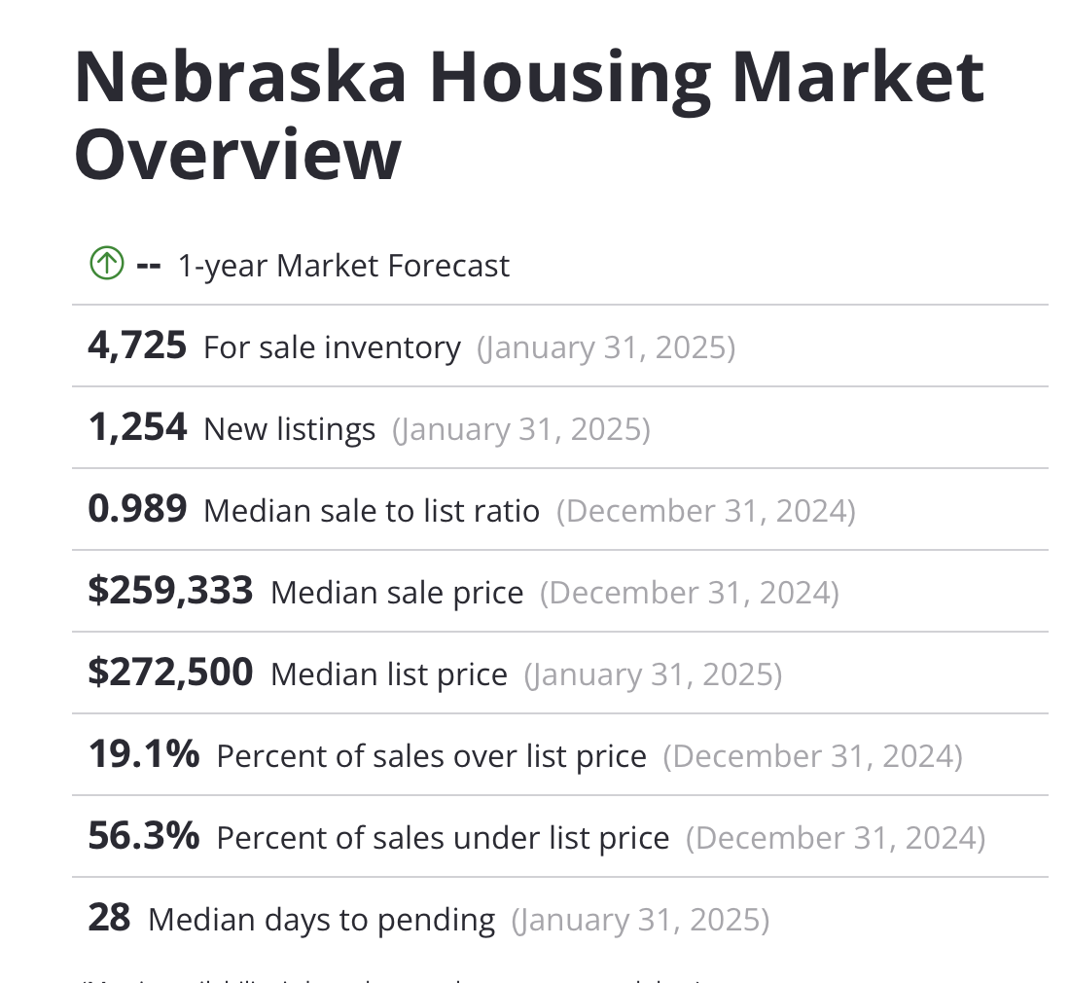

Even as inflation begins to slow, Nebraska is still feeling the burden of expensive housing. This is fueled by high demand, low inventory and high mortgage rates. 23.44% of CNCAP’s service area are considered cost-burdened by spending 30% or more of their income on their mortgage.

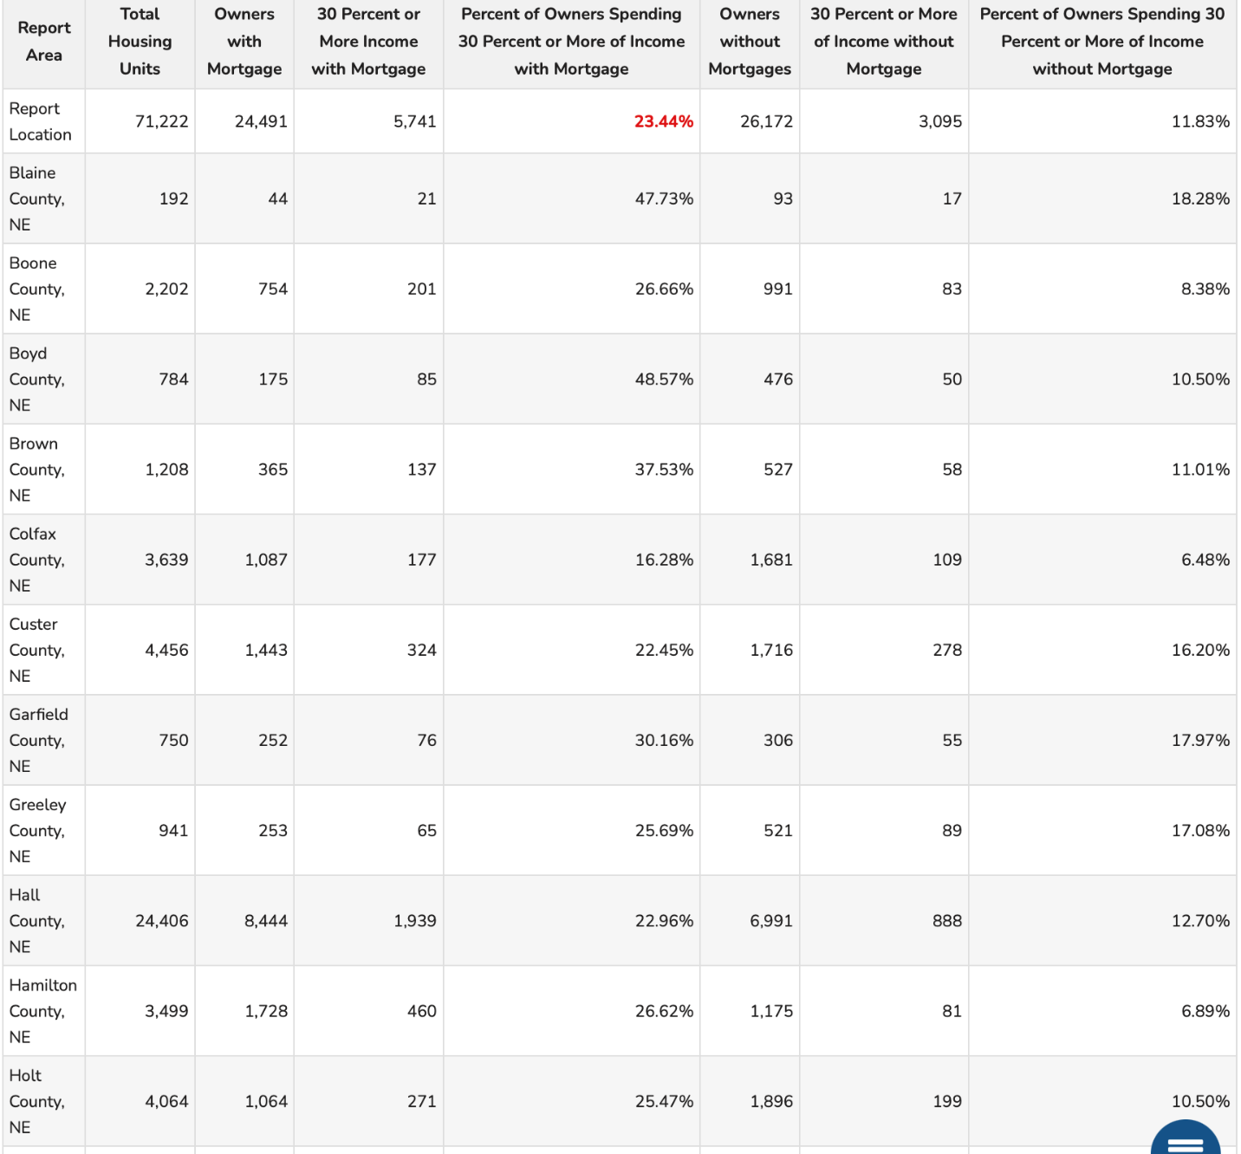
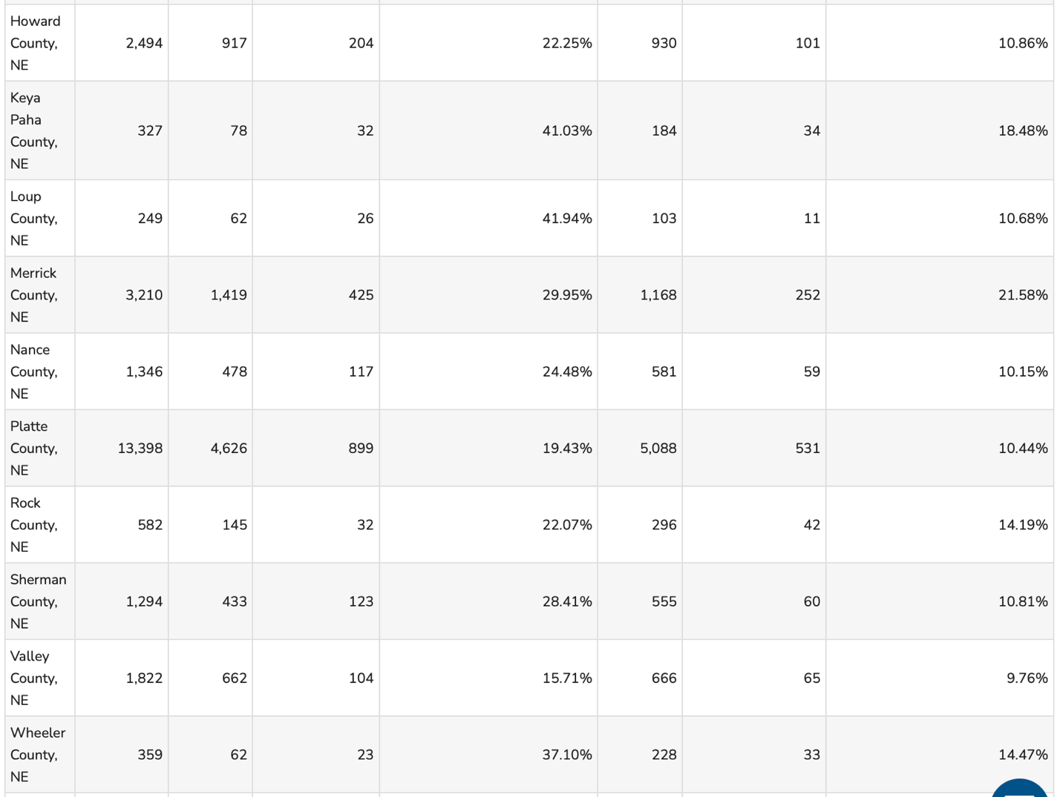

The average monthly owner cost of $1,136.00 in the service area. This has increased since the previous year. The average house in Nebraska sat on the market for 28 days in 2024. High housing prices are causing affordability challenges, especially for low-income households and are even pushing some toward homelessness, while impacting the rental markets as well. The rising cost of housing is driving families toward homelessness with many struggling to meet basic needs like utilities, insurance, groceries and childcare. Many households are struggling to make ends meet, with many spending a large portion of their income on housing. With reduced affordability of single-family homes, more people are seeking to rent which is pushing up rental prices.
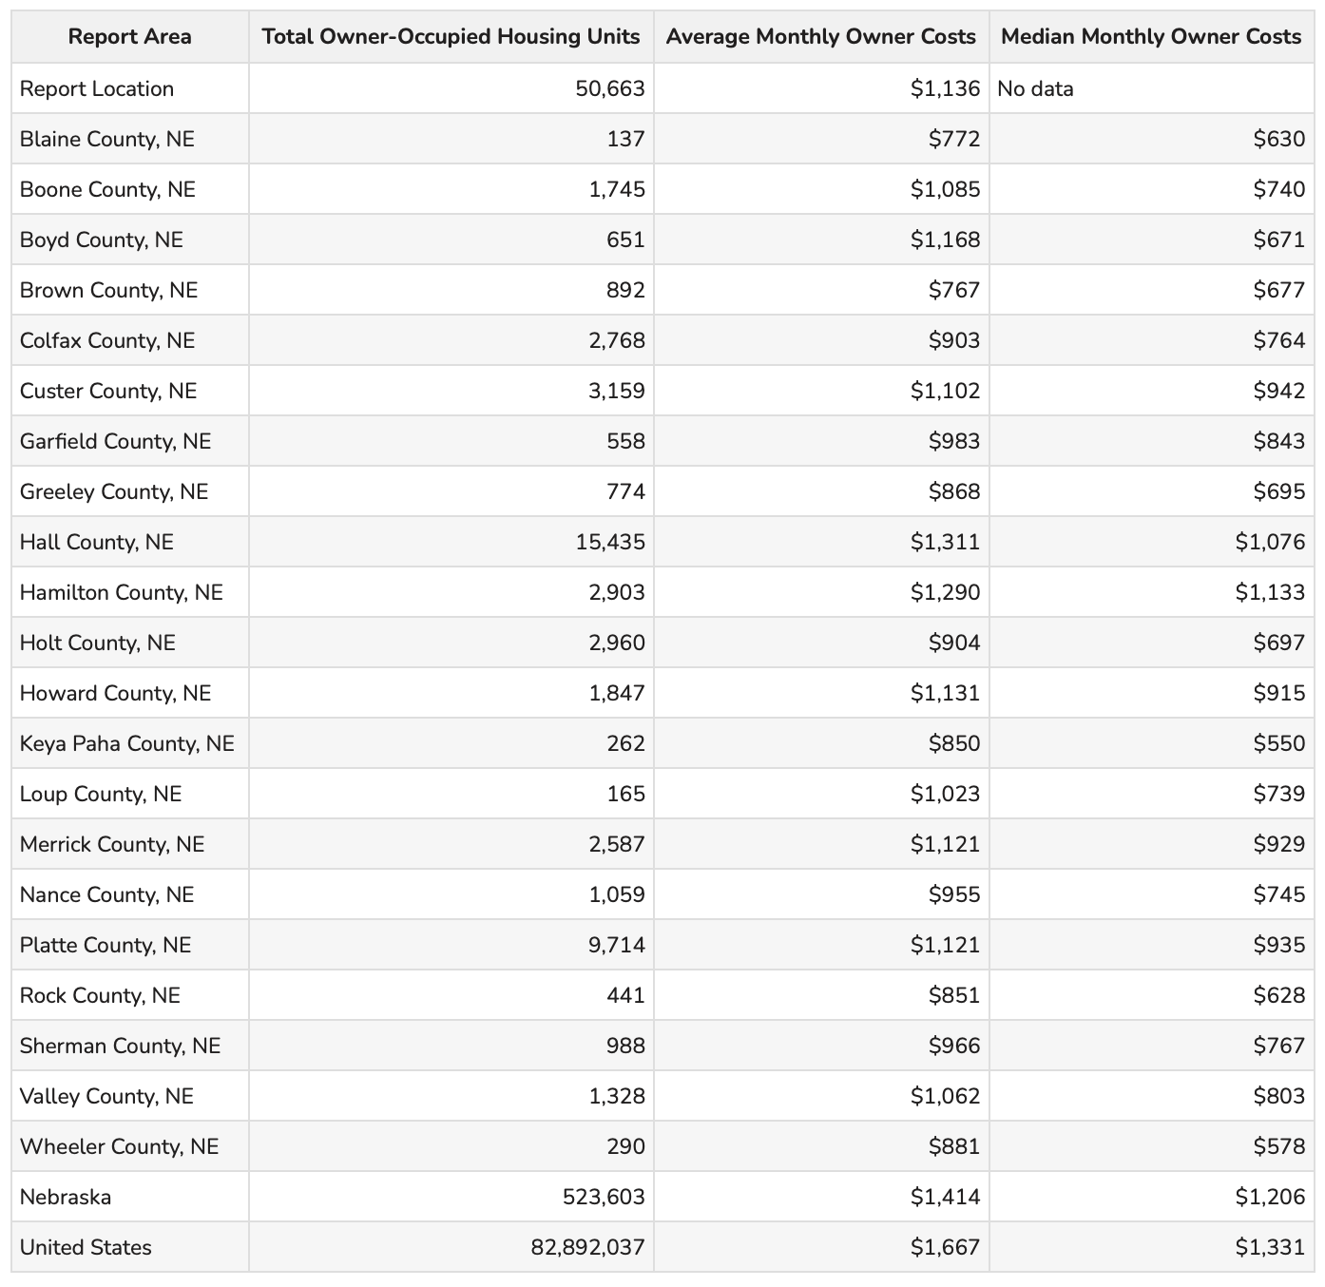
Housing Age

The age of houses across Nebraska is higher than the average age of houses across the United States. In some rural counties, the age of houses averages is older than the 1940’s. These houses are at a higher risk for experiencing safety hazards and health risks.

This indicator reports, for a given geographic area, the median year in which all housing units (vacant and occupied) were first constructed. The year the structure was built provides information on the age of housing units. These data help identify new housing construction and measures the disappearance of old housing from the inventory, when used in combination with data from previous years. This data also serves to aid in the development of formulas to determine substandard housing and provide assistance in forecasting future services, such as energy consumption and fire protection.
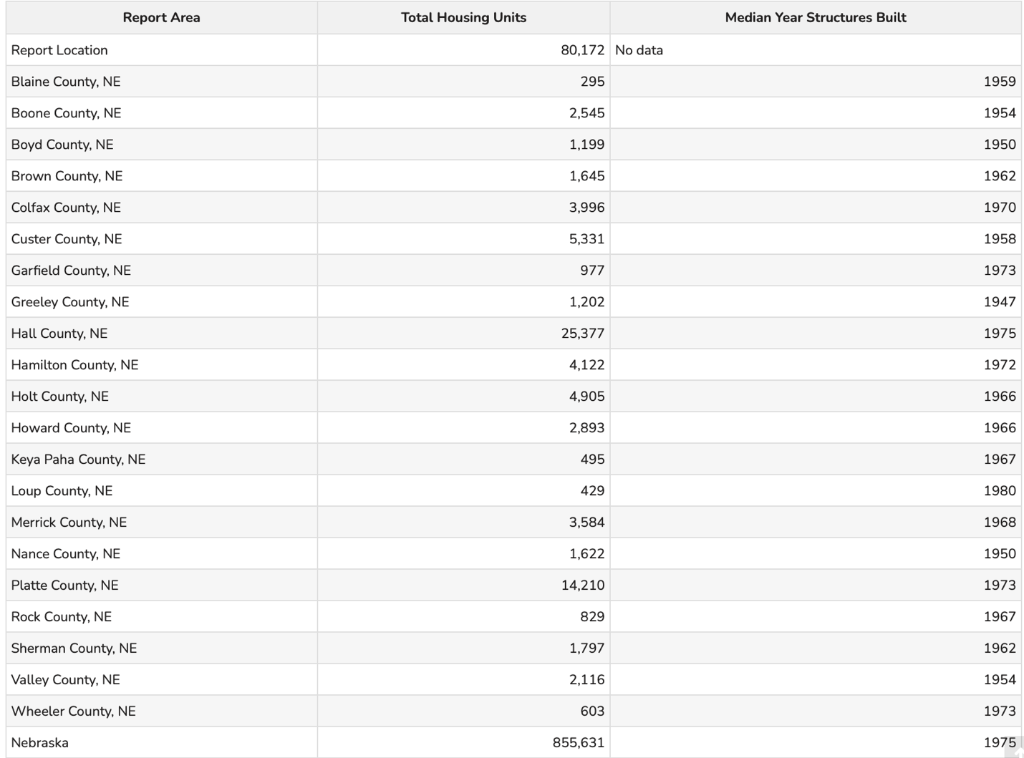

Over 40% of the CNCAP service area owns houses that were built before 1960. Only about 8% of the service area own houses built after 2010. As we continue into the severe housing shortage in the state of Nebraska, we struggle with losing houses to their age. These older houses become uninhabitable as they wear down, are affected by the elements or just become too old to maintain anymore.
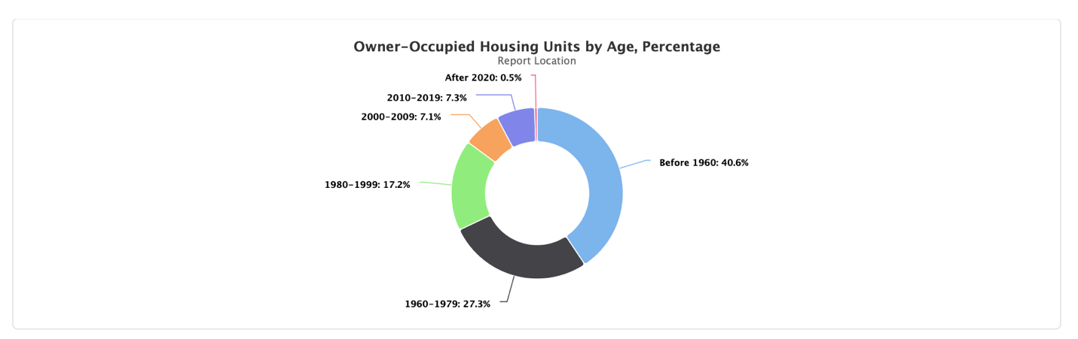
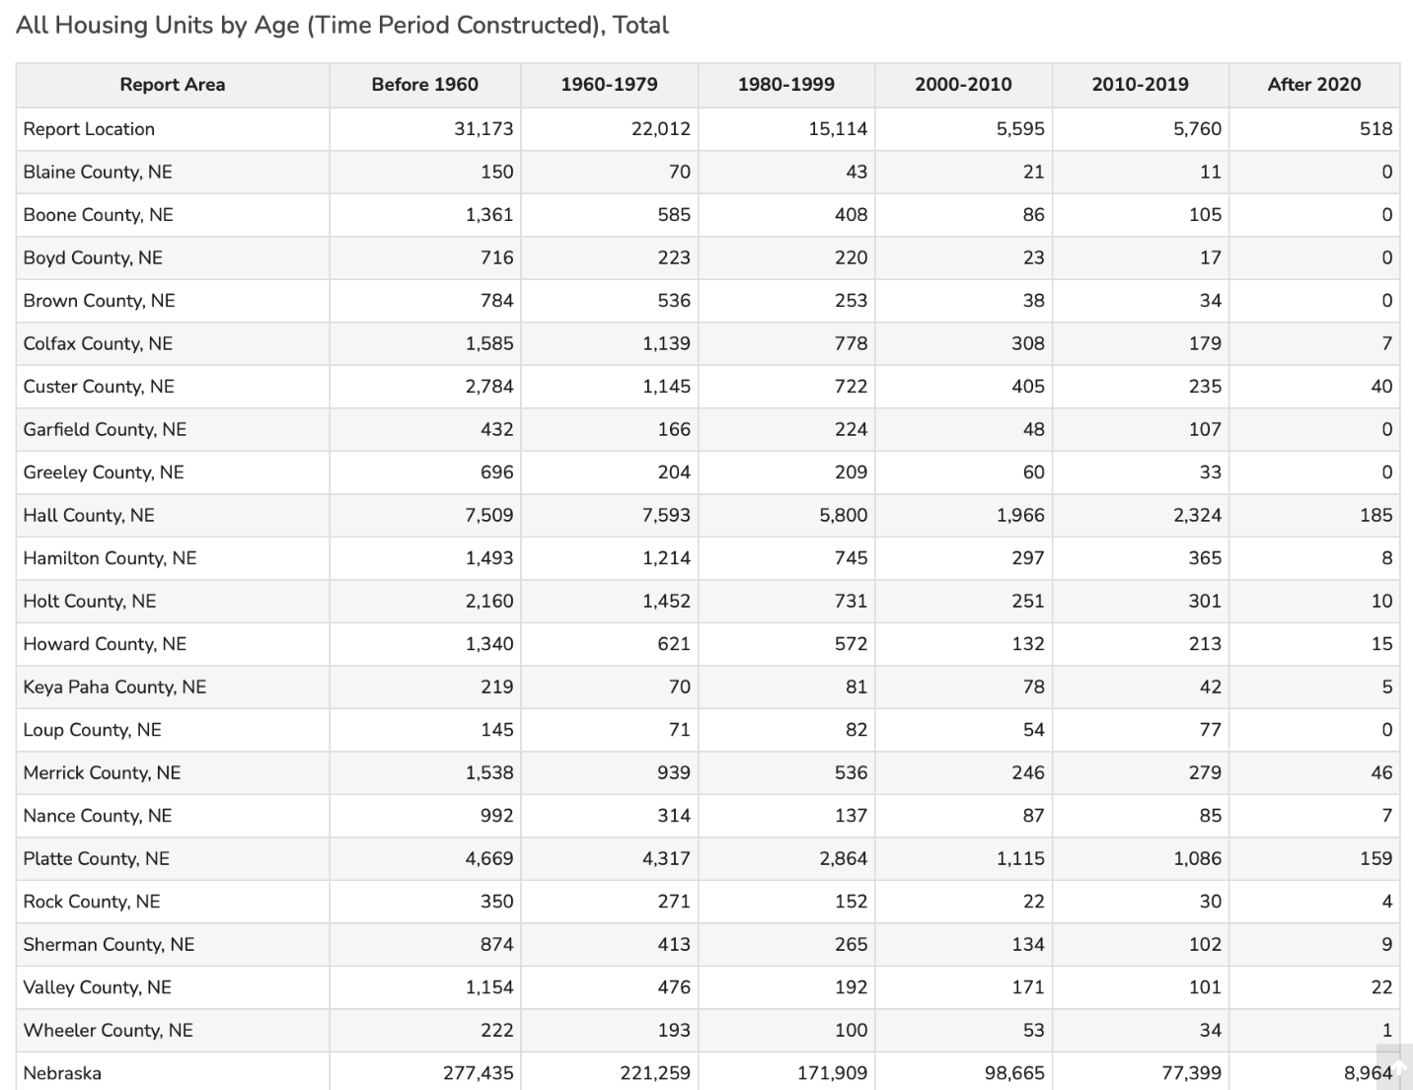

Overcrowding

Overcrowding is defined as the presence of more people or things in a space than is comfortable, safe, or permissible. Overcrowding in housing is defined as multiple occupants per room and has a number of negative effects on physical health and well-being. Residential crowding makes it easier for diseases to spread. Overcrowding and a lack of ventilation can also promote a moist environment mites, roaches and molds, which can all contribute to respiratory problems. Overcrowding can also give rise to psychological distress and is also associated with behavioral issues and poor academic performances in children. The number of households living in crowded housing conditions spiked in the US during the great recession. Rates of crowded housing have not returned to pre-recession levels. Those at greater risk of experiencing housing-related health conditions: low-income families and individuals, renters over homeowners, racial and ethnic minorities, individuals with mental illness, children, older adults.

Occupied housing units, overcrowded housing units, and percent overcrowded for 2014-2019 and 2019-2023 American Community Survey Estimates are provided for the service area below. The average for the report area for 2023 is 1.69%, compared to a statewide average of 2.08%.

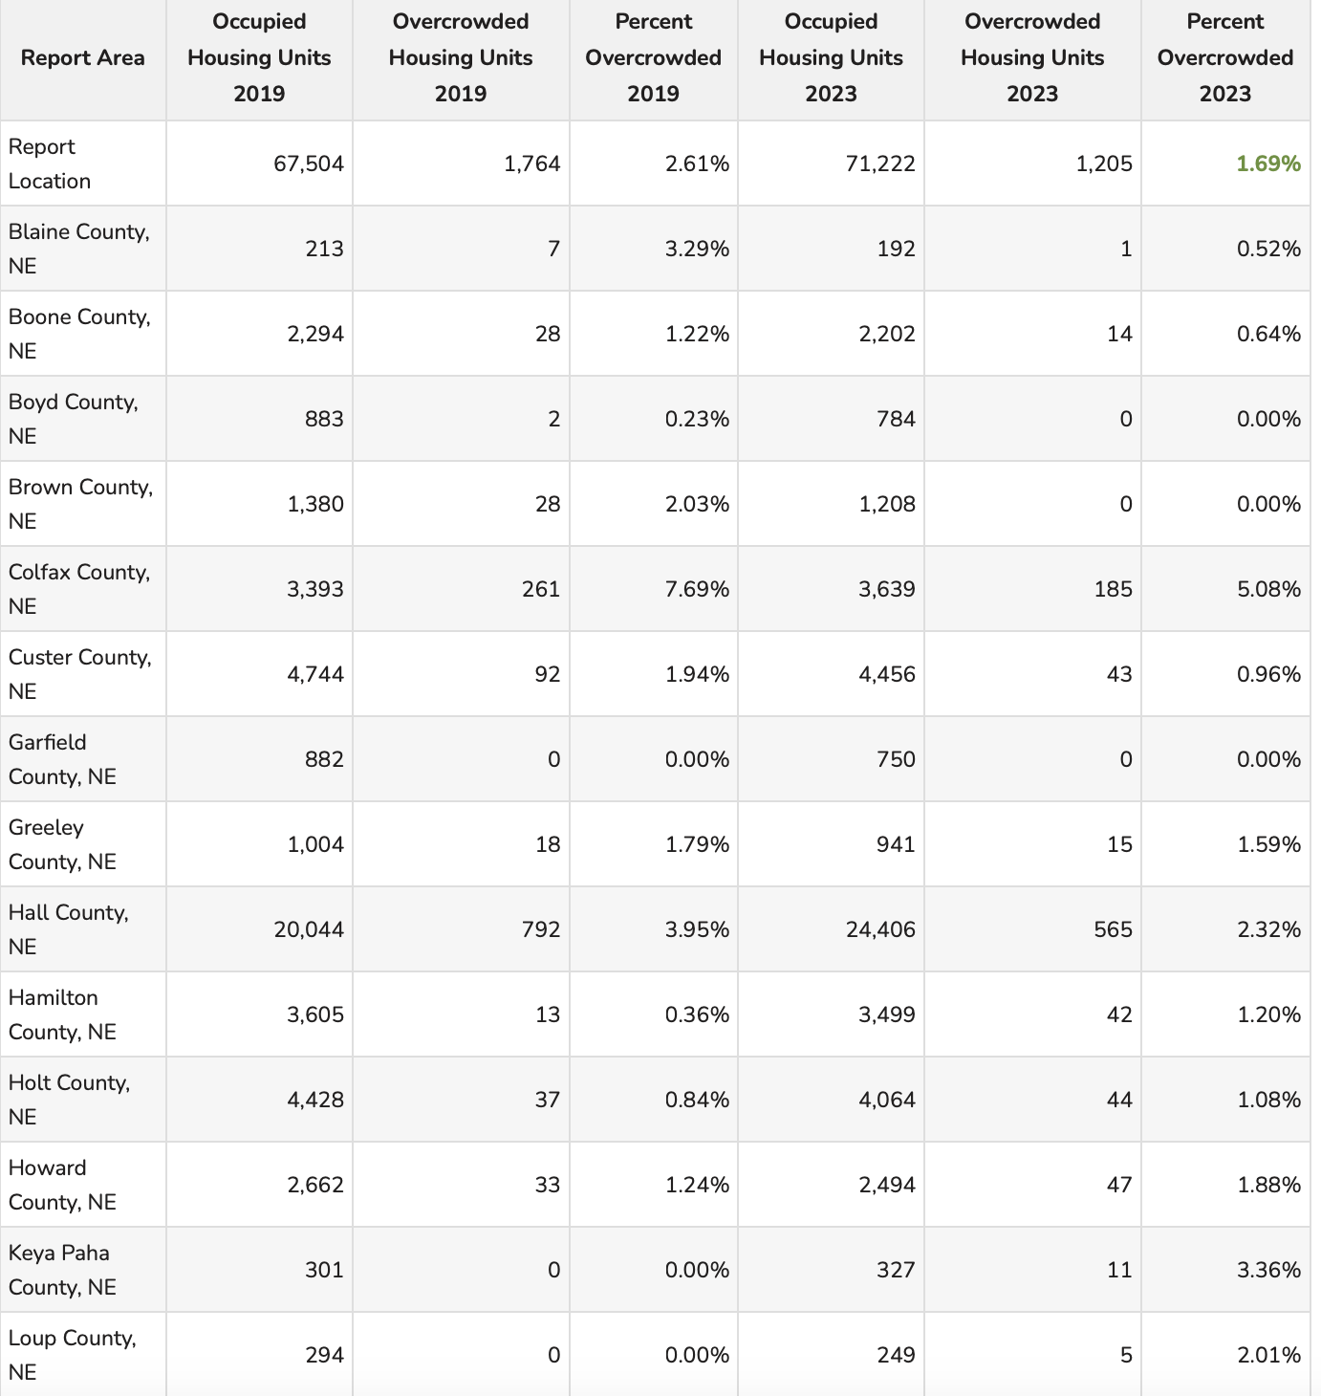

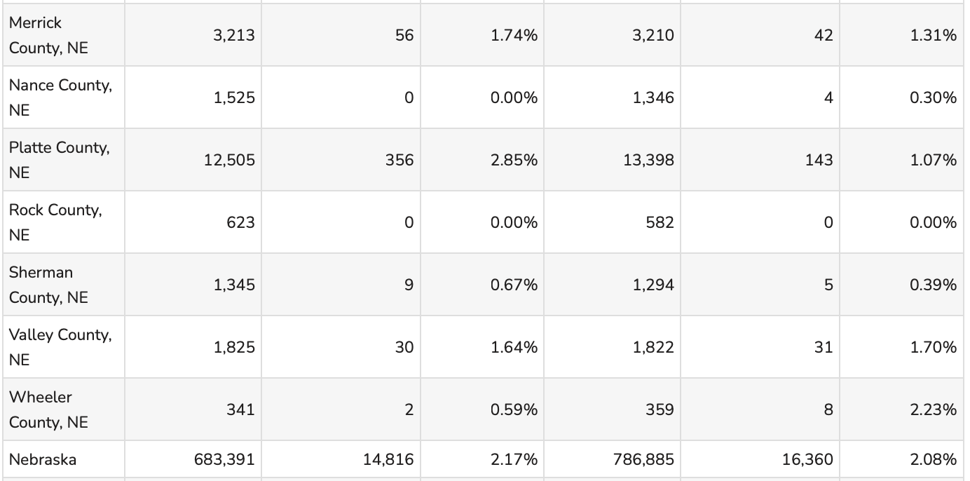

Nearly 2% of the CNCAP service area is living in overcrowded housing. Not only does this cause health issues and behavioral issues among children, but it also opens them up to situations of physical and sexual abuse. Overcrowding is caused by two main problems within our service area: the price of housing, and the lack of housing available. Not being able to afford housing, not being able to find housing available drives people to live in smaller houses than they are needing. Sometimes in order to save money and sometimes in order to have a place at all, because nothing else is available in their community. This problem even drives families to live in the same households, exposing children to even more threats at home.
• A higher proportion of urban adults (18.8%) live in crowded housing than rural adults (14.4%), with differences by race and ethnicity. Urban Hispanic adults have the highest proportion in crowded housing, followed by both rural Hispanic adults and rural American Indian adults.
• A higher proportion of urban adults are housing cost burdened than rural adults, meaning they spend at least 30% of their income on housing. Looking across differences by race and ethnicity reveals that one-third of rural Black Americans are housing cost burdened as well.
Over 35% of urban adults with disabilities and nearly 30% of rural adults with disabilities are housing cost burdened.

Most Americans spend about 90% of their time indoors and an estimated 2/3’s of that time in the home. Very young children spend even more time at home and are especially vulnerable to household hazards. Factors related to housing have the potential to help or harm our health in major ways. Housing affordability, conditions of the homes within a neighborhood, and the physical conditions of the homes shape the neighborhood conditions but also affect the overall ability of families to make healthy choices. Healthy homes promote good physical and mental health. Good health depends on having homes that are safe and free from physical hazards. In contrast, poor quality and inadequate housing contributes to health problems and can even have harmful effects on childhood development. Poor indoor air quality, lead paint, and other hazards often coexist in homes, placing children and families at great risk for multiple health problems. Residential crowding has been linked to both physical illness and psychological distress among both children and adults.

Nebraska is ranked 26th in the United States for challenges with crowded housing. Into 2023, the number of people living in crowded housing across the state saw an increase.

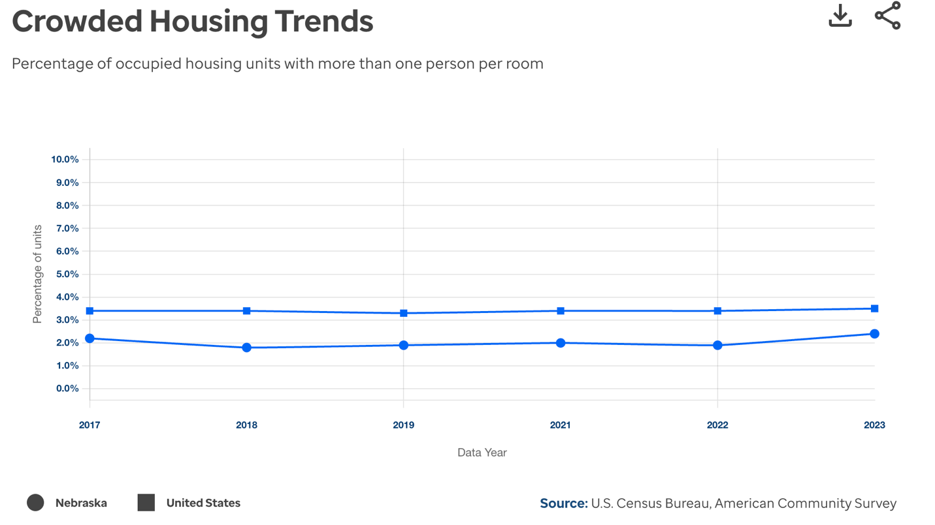
https://www.americashealthrankings.org/explore/measures/crowded_housing/NE#measure-trend-summary

Substandard Housing
Substandard housing means any housing unit lacking complete plumbing or sanitary facilities for the exclusive use of the occupants; or any housing unit which has been found by an appropriate local authority to have one or more violations of an applicable housing code that poses a material threat to the health or safety of the occupant; or any housing unit that has been declared unfit for human habitation; or any housing unit that has been found to be substandard in the most recent housing conditions survey conducted by the local government, done in conjunction with the local comprehensive plan or otherwise, provided that there is no evidence that this dwelling has since been rehabilitated. Examples of substandard housing could include homes: without adequate heat, electricity, or water; with unsafe heat sources or electrical service; with unsafe conditions, such as holes in flooring; with a kitchen or plumbing that is inoperable; or condemned by housing or other government authorities. Substandard housing can also refer to conditions that go beyond the structure of the building such as overcrowding. Substandard housing such as water leaks, poor ventilation, dirty carpets and pest infestation can lead to an increase in mold, mites and other allergens associated with poor health. Cold indoor conditions have been associated with poorer health, including an increased risk of cardiovascular disease. Housing is commonly considered to be affordable when a family spends less than 30% of its income to rent or buy a residence. The shortage of affordable housing limits families and individuals’ choices about where they live, often relegating lower-income families to substandard housing in unsafe, overcrowded neighborhoods with higher rates of poverty and fewer resources for health promotion. The lack of affordable housing affects family’s ability to meet other essential expenses, placing many under tremendous financial strain. High housing-related costs place a particular economic burden on low-income families, forcing tradeoffs between food, heating and other basic needs. https://www.rwjf.org/en/insights/our-research/2011/05/housing-and-health.html#:~:text=Substandard%20housing%20such%20as%20water,increased%20risk%20of%20cardiovascular%20disease.

12.3% of the state’s occupied housing units have at least one of the following problems: lack of complete kitchen facilities, lack of plumbing facilities, overcrowding, or severely cost burdened. 27% of one and two-person households with adults age 62 or older are living with these same problems. Rural Nebraska is experiencing a higher rate of housing problems than urban. Loup county is the second highest percentage of owner-occupied houses experiencing one or more housing problems. 29.9% of Loup County’s owner-occupied houses are experiencing substandard housing. Rental properties in Nebraska experience substandard housing at a much greater rate than owner occupied. CNCAP counties with a high rate of rental homes with substandard housing:
Brown: 41.2%
Garfield: 38.8%
Custer: 32.6%
Howard: 40.7%
Hall: 41.6%
Merrick: 48.1%
Platte: 35.5%

This indicator reports the number and percentage of owner- and renter-occupied housing units having at least one of the following conditions: 1) lacking complete plumbing facilities, 2) lacking complete kitchen facilities, 3) with 1.51 or more occupants per room, 4) selected monthly owner costs as a percentage of household income greater than 50%, and 5) gross rent as a percentage of household income greater than 50%. Selected conditions provide information in assessing the quality of the housing inventory and its occupants.

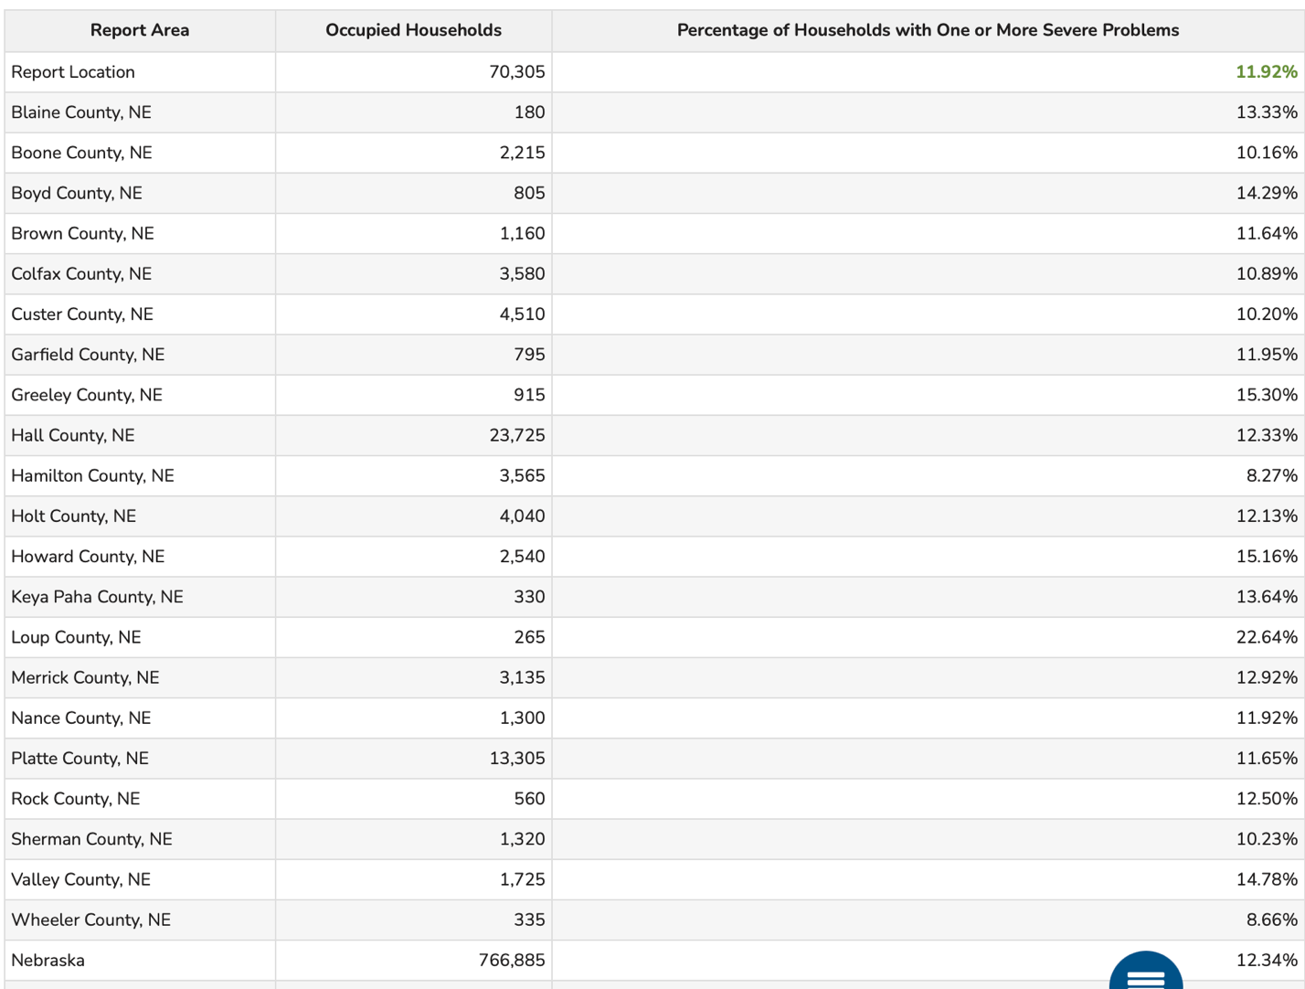

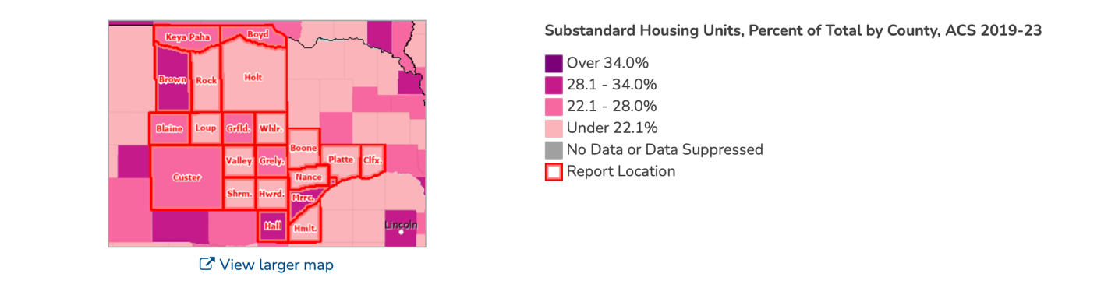
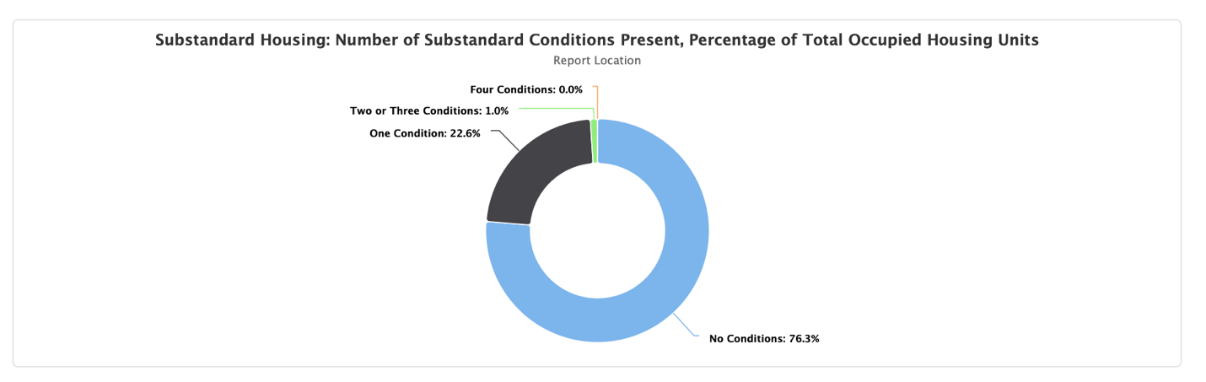
22% of the CNCAP service area is experiencing at least 1 substandard condition.
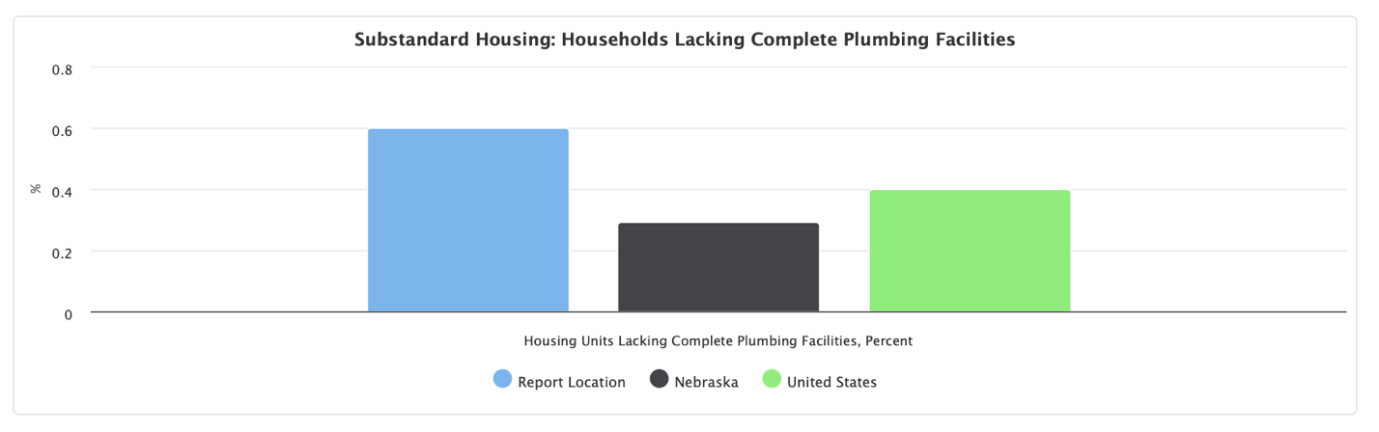
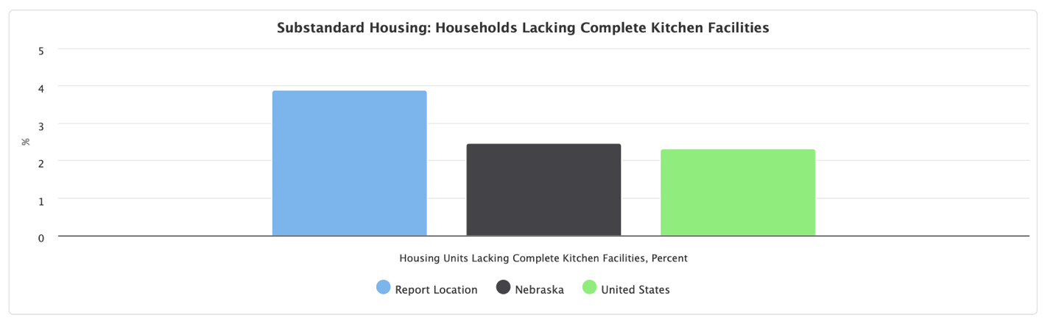
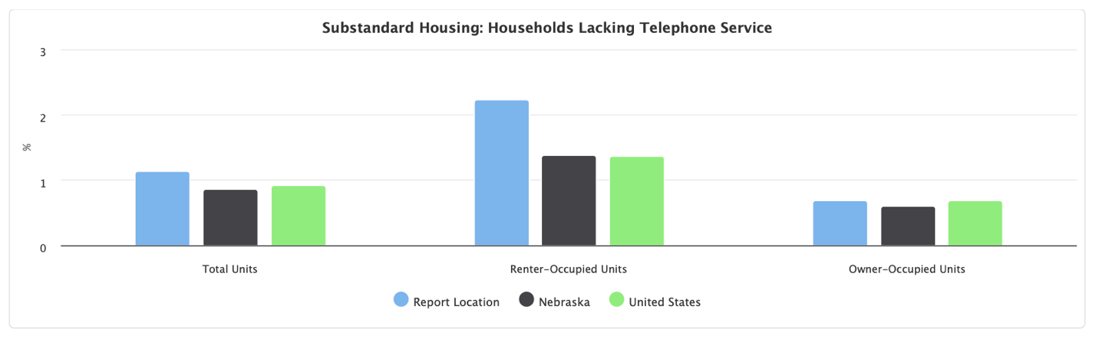

Farm Land Values
Nebraska’s agricultural land values declined by 2% over the past year, averaging $3,935 per acre as of February 2025. This is the first decline in the non-inflation-adjusted market value of agricultural land in six years and follows a record high of 4,015 per acre in 2024. This decline was attributed to the current crop prices, interest rate levels and farm input costs. High interest rates and lower crop prices have tightened farm finances, leading to cautious land and equipment investments. With borrowing costs at multi-decade highs, land markets have slowed as producers navigate these financial pressures. Net farm income in Nebraska decreased by about 17% in 2024. Lower corn and soybean prices reduced crop receipts in the state by about 1.59 billion but were partially offset by higher cattle and calf prices. Dryland cropland with no irrigation potential decreased by 2%. Center pivot irrigated cropland averaged 4% lower across the state. Dryland cropland with irrigation potential dropped 3%. Average grazing land and hay land values increased between 1% and 7%. Rental rates for pasture and cow-calf pairs increased by approximately 3% to 4% compared to the previous grazing season. Net farm income is forecast to decline again in 2025 due to ongoing crop prices and input expenses. Lenders have also noted that the tightening of financials for many farm and ranch operations in the region mean lower income.
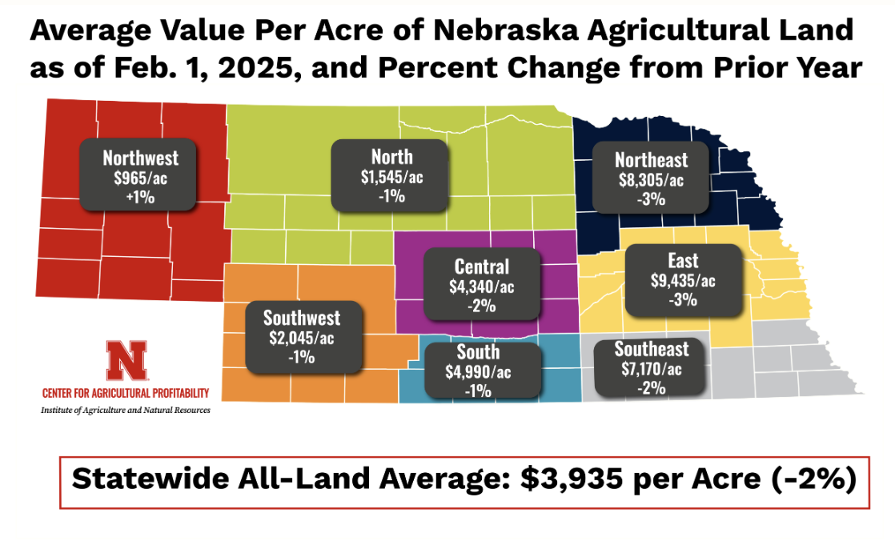
Homelessness

There was a slight decrease in the homeless population from 2,404 people experiencing homelessness on any given night to 2,246 in 2023. Between 2023 and 2024, there was an increase in homelessness to 2,720. This is a 10% increase in the number of people homeless on any given night. This increase put Nebraska at second place for the largest spikes. The housing shortage which plagues Nebraska heavily, may be a major reason for this increase. If housing is not affordable, nor even available, this drives people out of housing opportunities and sometimes onto the streets. This is a major challenge all on it’s on, not including the shortage of shelter space which Nebraska has already been struggling with on the rise.

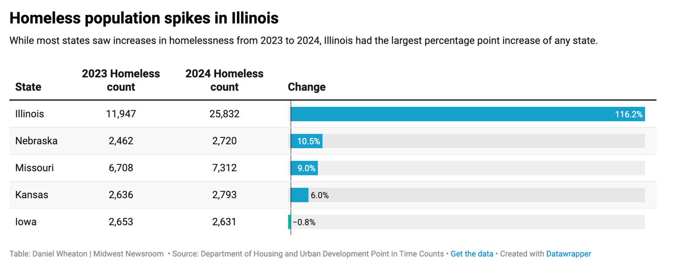
Nebraska's homeless population numbered 2,246, placing it 41st out of all US states in terms of the total number of homeless individuals. This figure represents a decrease of 6.6% from 2020 and a substantial decrease of 36.4% since 2007, suggesting that the state is making significant strides in tackling homelessness. This is further supported by the fact that Nebraska ranks 23rd in terms of homelessness per capita, with 11.4 individuals experiencing homelessness per 10,000 people. However, the state's unsheltered homeless rate, at 9.6%, is the 44th highest nationwide, demonstrating that while the total number of homeless is declining, there's still a proportion who lack access to regular, secure accommodation.
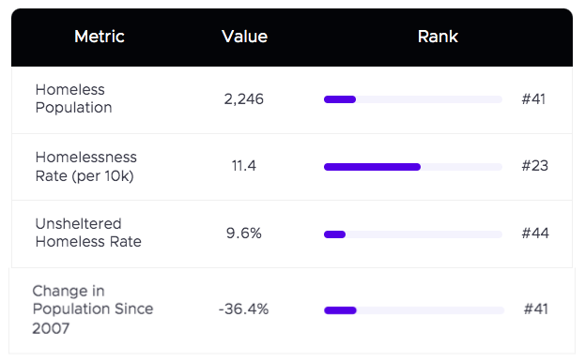
December is one of the coldest months of the year. Statistics show that in the last 15 year, the homeless rate in Nebraska has dropped significantly. On any given night in 2007, the state’s homelessness was 3,531 people. There has been a 36% decrease since that time. While this may be true, some cities in Nebraska are not feeling the effects of a homelessness decrease. In the bigger cities, shelters are filling up, beds are crowded, and mats are being used for overflow. There is no such thing as affordable housing. As a result of this, homeless people are needing to stay in the shelters long term, but the longer a person stays there, the less permanent housing can be provided to someone in the shelter. The length of stay used to be approximately 30 days, but shelters have seen that number triple. Even though there has been a steady decrease in homelessness since 2007, Nebraska has seen a 50% increase in unsheltered homeless over the past few years. The biggest issue for this is affordable housing. A lot of public housing has been taken down for the right reasons such as being an eyesore or creating issues, but these homes are not being replaced. Especially as new homes are not even being built. Apartments are full and even with vouchers, people are still struggling to find their own place. They also can’t find anywhere to go, because less and less landlords are accepting vouchers. Trying to find housing is becoming nearly impossible, especially when most tenants are only able to pay $400 a month. https://www.ketv.com/article/unsheltered-homelessness-on-the-rise-shelters-look-for-help/45789679

Central Nebraska Community Action Partnership was able to provide assistance to 155 individuals through the Weatherization program and the Housing Choice Voucher Program was able to provide rental assistance to 135 households in 2024.
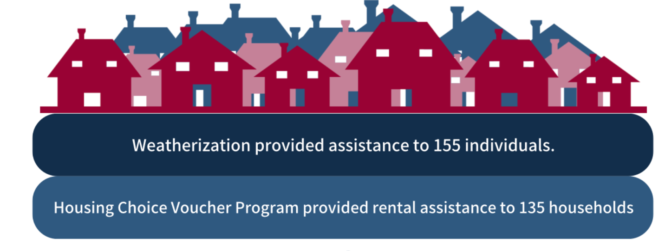
In 2024, CNCAP was able to provide rental assistance to 135 households with Section 8 vouchers and weatherization was able to serve 155 individuals with furnaces, water heaters or refrigerators The THRIVES program was able to pay $117,148 in debt, serve 51 households and 45 beneficiaries. The THRIVES program saved $26,972, serving 26 households and 140 beneficiaries. There were $34,663 child support payments incurred, 20 households served and 55 beneficiaries. THRIVES paid $80,407 in taxes, serving 59 households and 159 beneficiaries. THRIVEs served a total of 278 individuals. The HART program participants paid $30,564 in debt, serving 26 households and 48 beneficiaries. They had $3,745 in child support payments incurred, serving 3 households and 14 beneficiaries. $15,040 in taxes were paid, serving 27 households and 64 beneficiaries. HART served 38 individuals.

Central Nebraska Community Action Partnership’s Family Outreach Department prides itself on working with families to provide stability and build skills leading to a more independent lifestyle. Families participate in intensive case management with a case manager that assists them in setting goals in 12 life areas of: transportation, family relations, parenting, alcohol/drug, children’s education, adult education, income and budgeting, employment, health, nutrition, housing and legal.

https://www.datapandas.org/ranking/homeless-population-by-state
https://nebraskapublicmedia.org/es/news/news-articles/homeless-residents-in-midwest-cities-are-increasingly-hard-to-track-and-help/

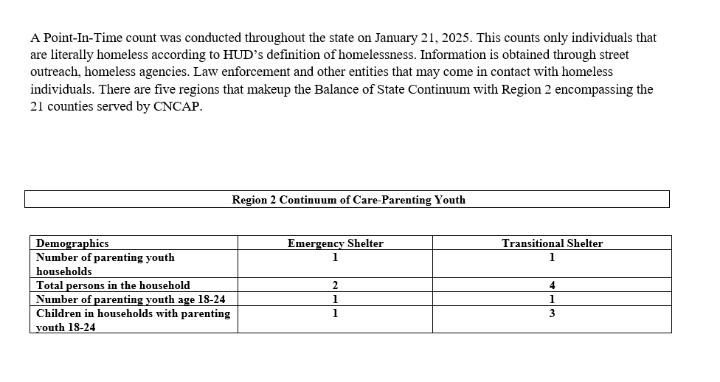
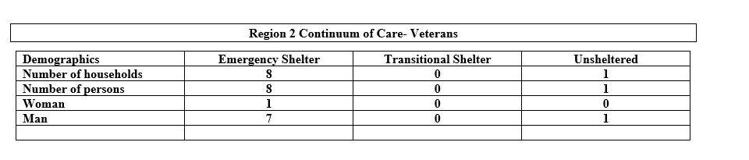

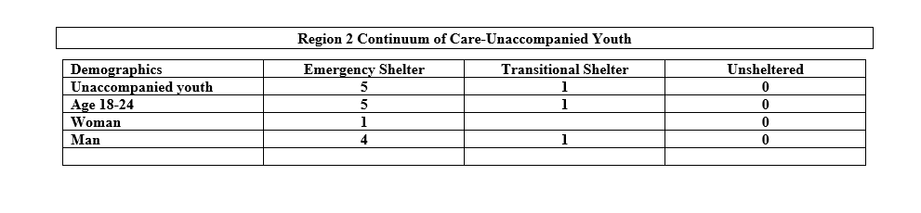

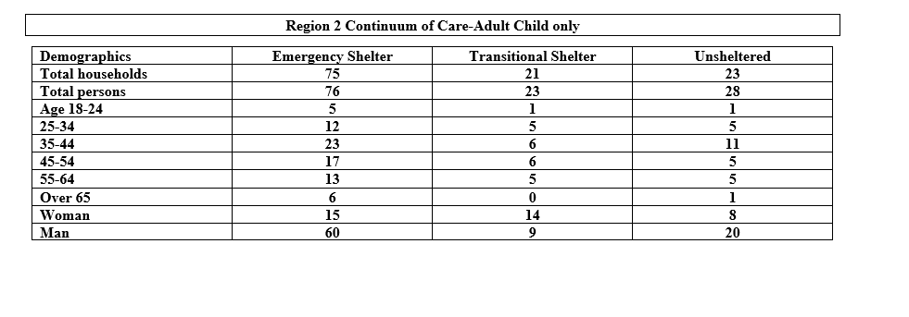

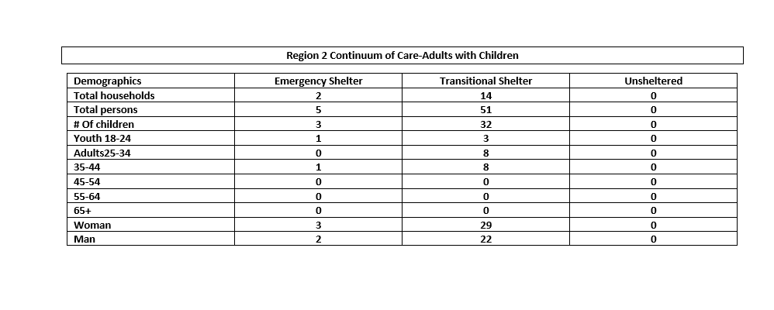

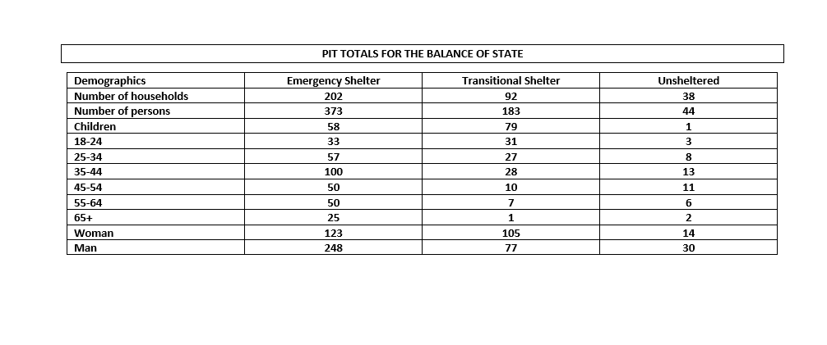

https://ccfl.unl.edu/community-services-management/2023%20BOS%20Homeless%20Population%20Report.pdf
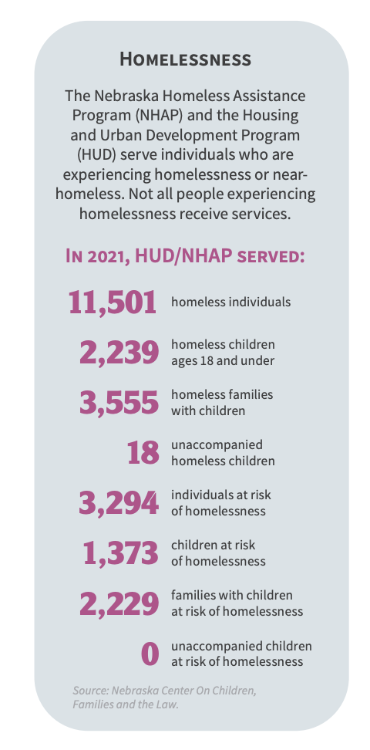

Rural vs Urban

This indicator reports the percentage of population living in urban and rural areas as of 2020. Urban areas are identified using population density, count, and size thresholds. Urban areas also include territory with a high degree of impervious surface (development). Rural areas are all areas that are not urban. Of the service areas 180,351 population, 86,459 or 47.94% of the population is classified urban while 93,892 or 52.06% is rural. The majority of the service are is made up of rural residents.

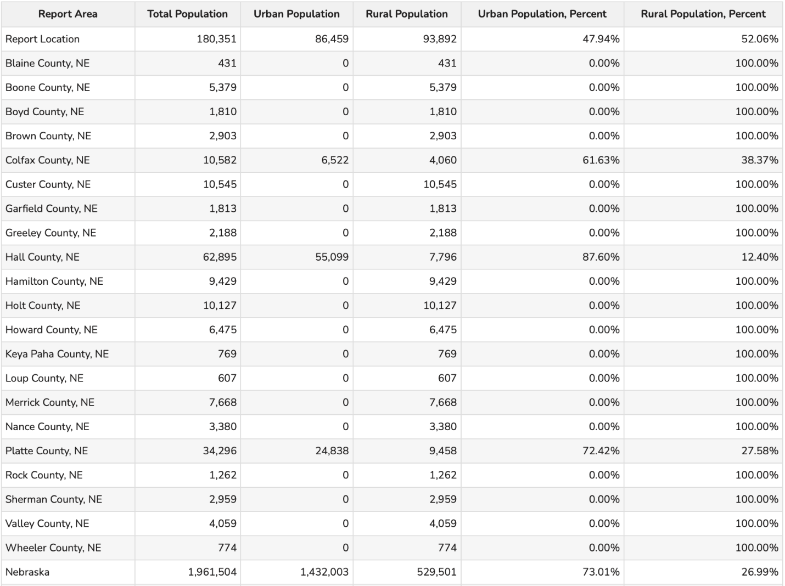
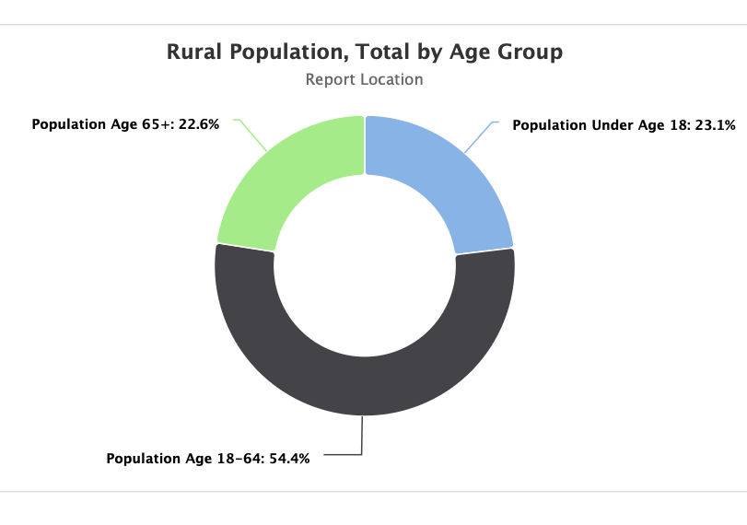
The rural population under the age of 18 increased from 19,830 to 21,429. The population between the ages of 18-64 is 50,450 and the population over 65 is 20,938. With over 22% of the rural population being over the age of 65, will there be enough youth to replace them in these rural communities to help maintain businesses, employment, school systems and such?

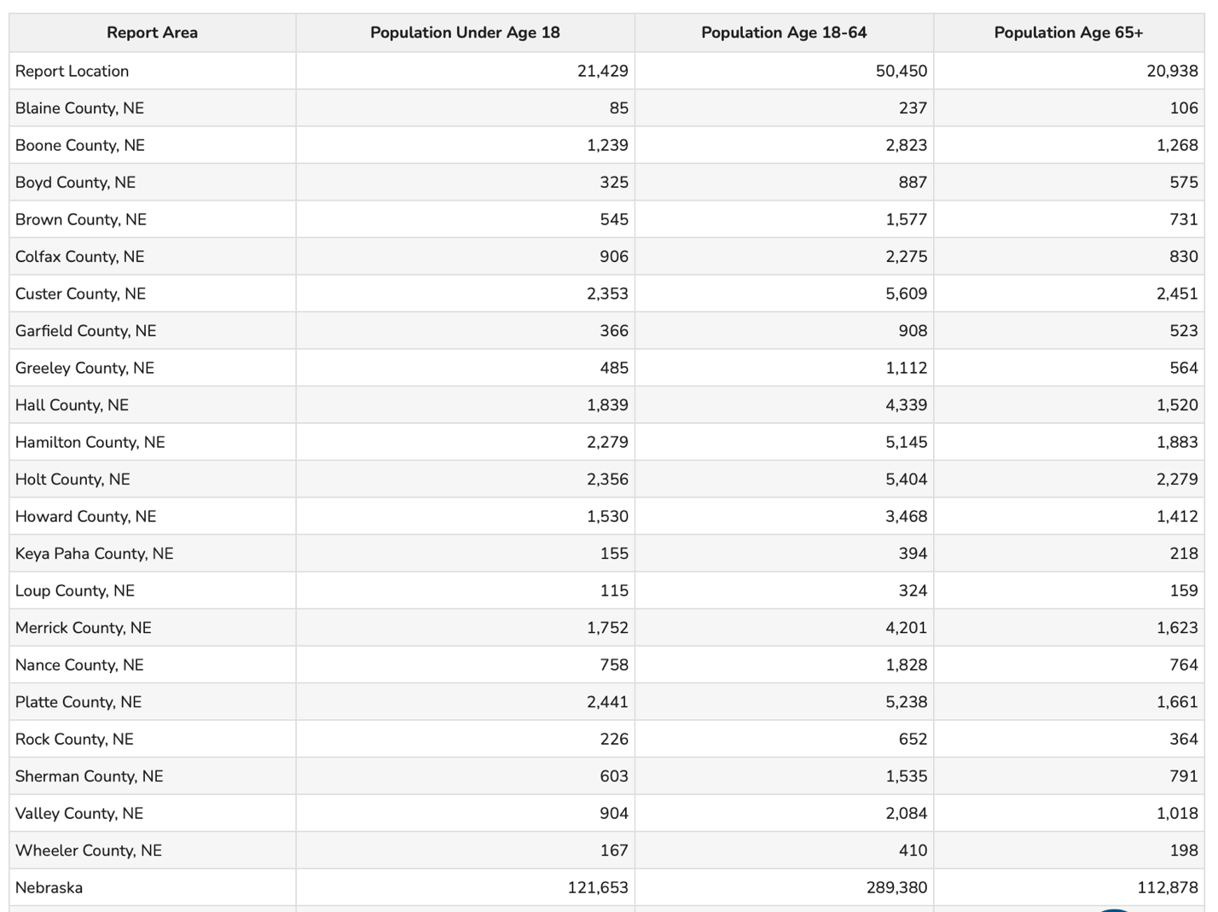

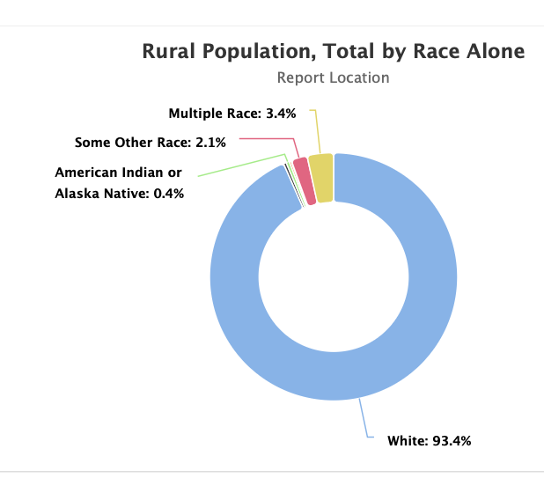

Community Satisfaction

Housing shortages have continued another year, inflation has maintained itself, and times have gotten more difficult, more costly. These challenges have left lasting effects on CNCAP communities that we are still experiencing today. Having increased poverty, substance use, mental health issues, homelessness and an extreme housing shortage has made waves across the state. Given the challenges CNCAP wanted to know how their community members feel about their community and whether they are satisfied with the services provided. CNCAP collected feedback through surveys with community-based organizations, faith-based organizations, private sector and educational institutions, low-income clients and the Board of Directors.

Community Surveys

CNCAP collected feedback on existing needs in area communities. Community stakeholders including businesses, public schools, faith-based organizations and other non-profit organizations were asked which of the following were serious challenges within their community. 92% of stakeholders within the CNCAP service area said that housing was a greatest need within their community. 92% also said that childcare was a greatest need within the service area. This is compared to the previous year, when 88% said that housing was a greatest need and childcare was only 41%. The top needs for the prior year according to the community stakeholders was housing 88%, and Healthcare Services and Transportation Services both at 59% seeing it as a greatest need.
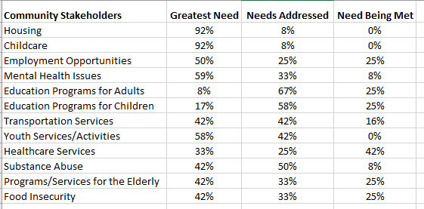
Of the low-income clients that were surveyed, 92% said that housing was a serious challenge within the CNCAP service area. 54% said that childcare was a serious challenge. This is only a little bit less than the community stakeholder surveys, with housing and childcare being the two biggest issues among both. In the previous year, Housing and Mental Health were the top two greatest needs among the low-income clients. 62% believed that housing was a greatest need and 56% believed that mental health issues and transportation services were a greatest need. There has been a noticeable increase in low-income clients who believe that housing is a serious challenge within the service area. Childcare also increased from 41% to 58% in just one year. Mental health has remained nearly the same as the previous year 56% to 53% and it is still one of the greater needs as of the current year.
When asked to list the top 3 most important needs within the community, 92% placed housing in the top 3 and 43% placed childcare in the top 3. 36% placed mental health in the top 3 challenges within the area.

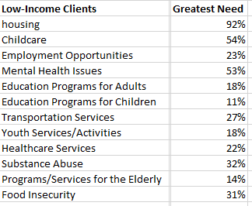

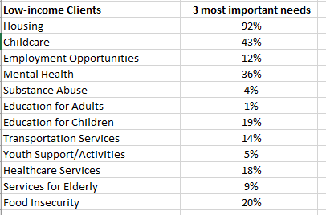

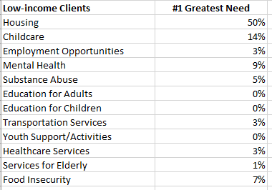

Any other needs that you feel are important but not listed above?
- Medical assistance
- Youth activities
- Programs for challenged kids with ADHD
- Car repairs help
- More family centers
- Dental services—specifically ones that accept Medicaid
- Community involvement for children
- Overnight childcare
- Child abuse & child sexual abuse

2023-2024 Parent Survey Responses

This survey is completed every year to help us improve service delivery to our families.
Please return by March 21st 2024.

To keep the survey anonymous, please do not include your child's name or any staff person's name.

How would you rate the program on each of the following?
Staff Members/Classroom staff:

1. Overall quality
Excellent (344) Good (72) Fair (4) Poor

2. Staff warmth and friendliness/ Welcoming to the classroom
Excellent (361) Good (53) Fair (4) Poor (2) NA
3. Staff communication with parents- i.e..returns calls, face to face conversations, emails, and notes promptly
Excellent (344) Good (67) Fair (6) Poor

4. Staff communication with children
Excellent (353) Good (61) Fair (5) Poor (1)

5. Staff confidentiality
Excellent (356) Good (61) Fair (3) Poor

Program:
1. The program offers opportunities to learn and improve parenting and other child related activities.
Excellent (343) Good (69) Fair (7) Poor (1)

2. Parent meetings and/or socializations
Excellent (325) Good (79) Fair( 12) Poor (1)

Facilities:
1. Safety and security
Excellent (356) Good (52) Fair (4) Poor NA(8)

2. Cleanliness
Excellent (348) Good (46) Fair (2) Poor NA (7)

3. Outdoor space
Excellent (338) Good (62) Fair (8) Poor (2) NA(8)

General:
1. Meals/Snacks prepared for my child are healthy.
Excellent (327) Good (79) Fair (2) Poor (3) NA (8)

2. Written information about the program or activities (newsletters, calendars, handbooks)
Excellent (344) Good (69) Fair (1) Poor

3. How much screen time does your child use per day? (TV, iPad, video games, computer, etc.,)
Less than 1 hour (102) 1-2 Hours (242) 3-4 hours (60) more than 5 hours (7)

Additional Questions:

1. Why did you choose this program?
○ It was recommended to me/return family (100)
○ Price (19)
○ Location (42)
○ Early start for education/Socialization (113)
○ Great Program (37)
○ Staff (38)
○ Good opportunity/option for my child/ family (9)
○ Relationship to public school/Bussing (8)
○ So I can work/ got to school (6)
○ Spend more time with my child (4)
○ Easy transition (3)
○ Best one around/available (5)
○
○ environment, adversity
○ It is good and trustworthy
○ Everyone genuinely shows what it takes to raise a village of children
○ Program looked well thought out and needed for my child
○ It’s a great environment,
○ Overall quality and structure
○ very organized and clean
○ Because of the outstanding care and experiences our children receive
○ School hours work perfect!
○ For the care so that I can work
○ Because it is very good, trusting and my other children also assisted here.
○ My daughter enjoyed it previously. My son benefits from full day instead of 2-3 hours like
preschool.
○ values
○ Free healthy meals and snacks quality, DAP practices
○ Because they have wonderful one on one
○ good experience
○ Because it interested me
○ trust that the program will provide good education and good community
○ It interested me a lot because it is full day and children learn learn more
○ This was the program we were accepted to
○ IEP
○ It was offered through home visits with sixpence
○ Accountability to continue current parenting goals
○ For the excellent services and value and teaching
○ Great program teaches life skills, using silverware, communication, sharing, clean up
○ To help my children grow up
○ look forward to meetings
○ Ras provided excellent service
○ Because it adapts to my needs and it has small groups and the care is more
individualized.
○ It is safer

2. Would you recommend this program to other parents? Please explain your answer.
○ Yes/absolutely/of course (332)
I. Love the Program/Prep for school (139)
ii. Great staff (100)
iii. Location (2)
iv. Positive Environment/great place (19)
v. Price (2)
vi.
vii. Great experience
viii. diversity, good schedule
ix. our child is well taken care of and we have seen so much improvement over the
year
x. wish it was offered for the “late 5-year olds”
xi. he has really improved his speech and over all socialization with other children.
xii. without this program my child would not excel the way they have
xiii. I tell everyone I can about this place. The diversity, the one on one effort with the
children
xiv. absolutely especially for working parents or to save daycare expenses
xv. overall quality and understand EC development
xvi. helped us with our sons everything, he’s intelligent and kind with lots of new
stuff to talk about
xvii. I would recommend it to other people because it helps primarily in health.
xviii. very well structured and maintained
xix. and they serve a meal
xx. Resources and parent support is great Socializations are good for kids and
parents
xxi. because it is beneficial for the child and develops his skills.
xxii. for teen parents it such a great help
xxiii. I would recommend the program because it is of great help to the development
of the children.
xxiv. my child loves going to the socializations and home visits
xxv. I would, because I’ve seen how my kid has improved in many aspects
xxvi. Excellent communication with parents
xxvii. Yes and no, because services can be hard to get and there is not always enough
staff/help for children with extra needs
xxviii. Maybe- having 3-year old’s and 5-year old’s doesn't seem to work there is too
much of a difference academically, emotionally, etc.
xxix. Shares and speaks well in English

3. Share what success your child has made this year. Examples: Language, Social,
Pre-academic. etc.
○ Language/communication/Speech/Vocab (149)
○ Social/emotional behavior (169)
○ Pre academic: counting, coloring, letter recognition, spelling, writing, numbers, letters,
shapes, reading,etc. (149)
○ potty training/self-care/confidence/independence (17)
○ I’ve seen success (38)
○ Walking/crawling/sitting up/rolling over (7)
○ Prenatal 2
○
○ She laughs more and she holds her own bottle
○ SEL skills,
○ Only been 2 weeks
○ left and right identification, higher language skills with clearing speech,

○ understanding rules
○ Goes above and beyond to help when needed. Answers my questions even when not at
school
○ No is perfect but you all do amazing and we are grateful for all of you
○ Good he has had good success learning and developing new abilities
○ I feel very grateful for the help given, and the great positive progress that my son has
had with the program and the staff
○ They have processed a lot
○ Improvement in speech and independence, learning things appropriate to their age. More
○ name’s remembering,
○ trying new foods
○ Social and participation for sure. New words and pronunciation of words.
○ and communicate and
○ Is learning a lot of things like the language and to be more independent
○ Communicates more with myself and with dad. Is friendly and shares at home, is
learning day by day.
○ nutrition,
○ Good
○ Ellyssa has been doing more recalling
○ Attention span-sitting for longer periods of time, socialization, communications, imitation
4. Please share with us any suggestions for improvement or additional comments you might have
○ Please just take a bit more time to help littles wipe on the potty.
○ A practice of physical activity that is more focused could help with discipline. It could be a dance, physical stretching, Literature with a project where they can visualize the
literature. With the meals they could offer less carbohydrates since the kids arrive without
eating and the meal they receive have tons of glucose.
○ There should be a variety of food choices and spread throughout the month.
○ Offer bus transportation
○ Two options for lunch/snack
○ More communication from teachers
○ A gym for the winter months to help so kids can run around and get exercise.
○ Having extra staff to help so school doesn’t have to be canceled and more help for
teachers so they are not getting burnt out and have the help they need.
○ Maybe let the kids set the table for breakfast, lunch, snack.
○ Separate ages better/more, there is a big difference between 3 yr olds and 5 yr olds.
○ It is good if they continue to give meetings so that parents can put things in practice at
home.
○ No outside time when really windy
○ More teacher/parent interaction and communication.
○ Not having a pile of hats that kids can wear- lice spreads, not challenging enough
curriculum for 2nd year pre-k for the students on track, parking is an issue.
○ Only if they could extend their days to more work days since it is hard to find a job for
half the week.
○ Investment from the government in our children.

Central Nebraska Community Action Partnership
Early Childhood Programs

Dental Professionals
14/25 or 56%

The Central Nebraska Community Action Partnership (CNCAP) Early Childhood Programs (ECP) Department is conducting a survey of professional partners involved in the care and education of children. Please take a few moments to consider the following questions. Thank you for your time and willingness to share your knowledge.

1. Did you examine any of our CNCAP Early Head Start or Head Start/Preschool participants within the last year?
• Yes 13
• No
• Unsure-1

Comments:
2. Did you find our required dental forms easy to fill out and accessible?
• Yes-12
• No - 1
• NA-1
Comments:
● However, lots of the time I’d fill out the forms and fax them over and then get a request to re-fax
the same ones
● We like the Head start forms. I’ll attach an example, it seems really clear and informative rather than
having to write things out.. and for you having to read rather than look and see at a quick glance
● very understandable and easy to fill out and send back

3. Did you encounter any problems with the dental appointments with our families?
• Yes- 2
• No - 10
• NA-2
Comments:
● Some no-showed- but it’s just like any other
● Not sure which patients are families of yours or not. There are always some that break appts.. and
one case of a neglect but Lisa has been very helpful in that case
● A lot of no-shows

4. Did you receive payment from CNCAP for dental exams/treatment on uninsured children?
• Yes- 7
• No- 5
4a. If yes, was payment paid in a timely manner?
• Yes-6
• No
Comments:

● Not that I’m aware of x2
● NA

5. Are you able to communicate with center staff, center nurses, or the Central Office when needed?
• Yes - 11
• No
• NA-3
If No please explain
● Don’t usually need to!
6. Do you have any suggestions for our program to improve services?
● I would like to give more talks if needed!
● Thanks! Keep it up!
● N/A if we have worked with any of these programs we have used our own “Head Start” forms as one
was not provided to us, personally we have not recorded! Thank you.
● As of January 1st 2024, we are no longer accepting Medicaid insurance- Loup Valley Dental home with child/parent and staff come to us looking for forms or we receive requests from the main office for the same forms.

Family Outreach

A sample of surveys:

1. How long have you been in the program?
a. Less than one month (0)
b. 1 to 6 months (66.7%)
c. 7 to 12 months (22.2%)
d. 13 months to 1 ½ years (11.1%)
e. More than 1 ½ years (0)
2. What services do you receive from this agency or program?
a. Case Management Services (55.5%)
b. Mental Health Services (11.1%)
c. Employment (11.1%)
d. Substances Abuse Services (0%)
e. Medical (0%)
f. Education (0%)
g. Rent/ Utility Assistance (100%)
h. HIV Prevention Education (0%)
i. Assisting Accessing benefits (SSI) (0%)
j. Security Deposits (Rent/ utilities) (0%)
k. Transportation (11.1%)
l. Food/ Nutrition Assistance (11.1%)
m. Income Tax Assistance (0%)
n. Life Skills (22.2%)
o. Vocational/ Rehabilitation Services (0%)
p. Mental Health Services (0%)
q. Parenting (0%)
2a. Are your service needs being me in this program?
a. Always (100%)
b. Most of the time (0%)
c. Some of the time (0%)
d. Never (0%)
3. Overall How satisfied are you with the assistance you have received from the agency or
program?
a. Very Satisfied (100%)
b. Somewhat satisfied (0%)
c. Somewhat dissatisfied (0%)
d. Very dissatisfied (0%)
4. Has assistance from this agency helped you to maintain your housing or improve your housing situation?
a. Very Much (100%)
b. Somewhat (0%)
c. A little (0%)
d. Rarely/Never (0%)

5. Has this program been helpful in maintaining or increasing your income (Employment
assistance, benefit support
a. Very Much (88.8%)
b. Somewhat (11.1%)
c. A little (0%)
d. Rarely/ Never (0%)
6. Overall did Staff:
Treat you with dignity and respect
a. Always (100%)
b. Most of the time (0%)
c. Sometimes (0%)
d. Rarely/ Never (0%)
Seem to understand your situation and needs
a. Always (88.8%)
b. Most of the time (11.1%)
c. Sometimes (0%)
d. Rarely/ Never (0%)
Do a good job of explaining program requirements
a. Always (100%)
b. Most of the time (0%)
c. Sometimes (0%)
d. Rarely/Never (0%)

7. Overall was staff:
Responsive in a timely manner
a. Always (100%)
b. Most of the time (0%)
c. Sometimes (0%)
d. Rarely/ Never (0%)
Sensitive to your ethnic and cultural background
a. Always (100%)
b. Most of the time (0%)
c. Sometimes (0%)
d. Rarely/ Never (0%)
Able to communicate with you in a language you can understand
a. Always (100%)
b. Most of the time (0%)
c. Sometimes (0%)
d. Rarely/Never (0%)

Knowledgeable about available services
a. Always (100%)
b. Most of the time (0%)
c. Sometimes (0%)
d. Rarely/ Never (0%)
Treat your personal information confidentially
a. Always (100%)
b. Most of the time (0%)
c. Sometimes (0%)
d. Rarely/ Never (0%)

8. Do you feel that you can make decisions about what happens to you in this program?
a. Always (88.8%)
b. Most of the time (11.1%)
c. Sometimes
d. Rarely/Never
9. Have you had the chance to give input into how the program is run (for example: consumer advisory board or tenants’ council, grievance procedure, suggestion boxes, consumer involvement in agency/ board Membership)?
a. Yes (77.7%)
b. No (22.2%)
10. Do you feel safe in this program/facility?
a. Always (100%)
b. Most of the time (0%)
c. Sometimes (0%)
d. Rarely/ Never (0%)
11. Is the program’s facility clean and well-maintained?
a. Always (100%)
b. Most of the time (0%)
c. Sometimes (0%)
d. Rarely/Never (0%)
12. When you have a problem or complaint, is a staff person available to help you?
a. Always (100%)
b. Most of the time (0%)
c. Sometimes (0%)
d. Rarely/ Never (0%)
13. Has the quality of your life improved since you entered this facility or program?
a. Greatly (100%)
b. Somewhat (0%)
c. Stayed the same (0%)
d. Gotten worse (0%)
i. Please Explain
1. Helped me get housed and help buy fuel and employment clothes
2. Got a place to live
3. Now have a place to live and car to drive
4. I’m able to provide for my kids
5. Helped me keep a budget
6. CNCAP helped me get an apartment and helped pay rent/ utilities
7. I would have been evicted. It is still financially tight- but the crippling
fear I had was made so much less by your assistance. Than you

14. This is what I like about the program/ facility
a. Staff is very friendly and understanding, able to meet my needs
b. Very helpful when needed, very friendly
c. That the program is able to help when needed
d. Very helpful with needs and listening
e. Case manager was helpful.
f. Help with rent/gas/ clothes for work
g. Case manager was very nice, help with rent and gas.
h. The nonjudgmental compassion and courtesy of the staff. The professional efficiency
was also reassuring, I didn’t feel like you asked for, more than was needed.

15. This is what I wish were different about the program/ facility
a. Na (88.8%)
b. I wouldn’t know this is my first experience (11.1%)

Any Other Comments
• Thank you
• Case manager was helpful
• Kimberly is a keeper. Not shorting the other staff- her warm manner and competence is
top notch!

Board of Directors

The self-assessment survey is designed to provide an opportunity to examine board effectiveness and make improvements.
Agency Mission: Partnering with individuals and families to encourage economic stability to gain independence through community based solutions

# | Topic | 1  Strongly Agree | 2  Agree | 3  Disagree | 4  Strongly Disagree | 0  I don’t know
1 | The roles, responsibilities and expectations of board members are clearly understood. | 75% | 25%
2 | Board members know and understand the organization’s mission. | 50% | 50%
3 | Board members are knowledgeable about the organization’s programs and services. | 63% | 37%
4 | The governance structure is clear.  (Board, officers, committees, executive director and staff) | 65% | 37%
5 | The Board has been presented with the agency strategic plan. | 65% | 37%
6 | The Board regularly receives updates on progress toward program performance. | 100%
7 | The Board approves policy-related decisions which effectively guide operational activities of staff. | 87% | 13%
8 | The Board receives regular reports on finances/budgets, program performance and other important matters. | 87% | 13%
9 | The Board meets with the auditor annually. | 87% | 13%
10 | The Board evaluates and reviews performance related activities of the Executive Director annually. | 100%
11 | The Board reviews executive compensation annually. | 87% | 13%
12 | The Board effectively represents the communities that the agency serves. | 75% | 25%
13 | The Board meetings facilitate focus and progress on important organizational matters. | 100%
14 | The Board has approved personnel policies which have been reviewed by a qualified professional. | 100%
15. Please list any issues you believe the board should focus its attention on in the coming year: (Use the back if needed)
I have no issues at this time

16. What are your suggestions to improve Board effectiveness? (Please use the back of this page if needed)

I am a really new board member but feel it is very efficient

Weatherization



WIC Survey Results

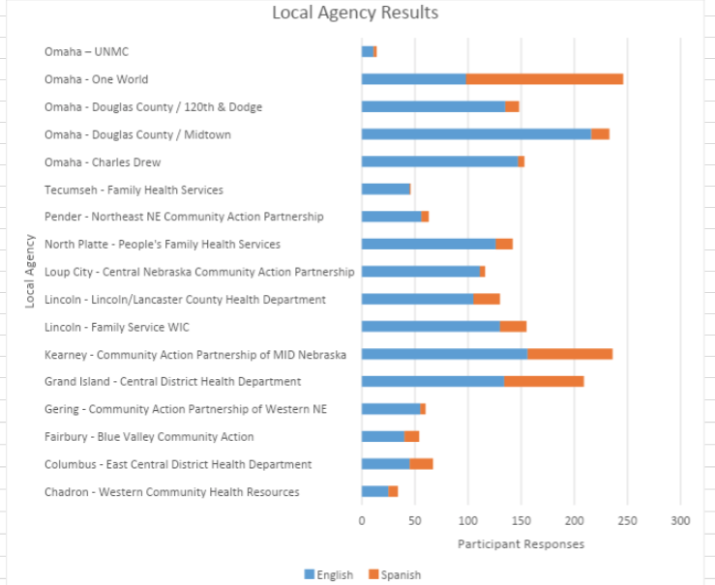

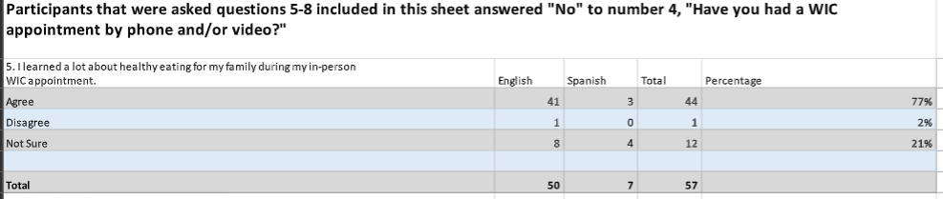
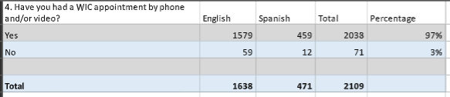
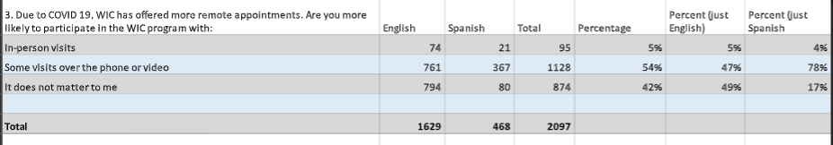
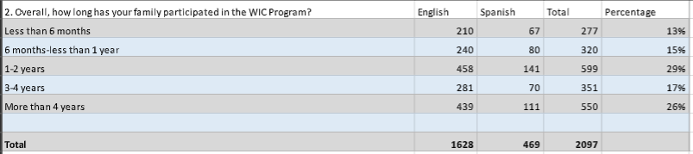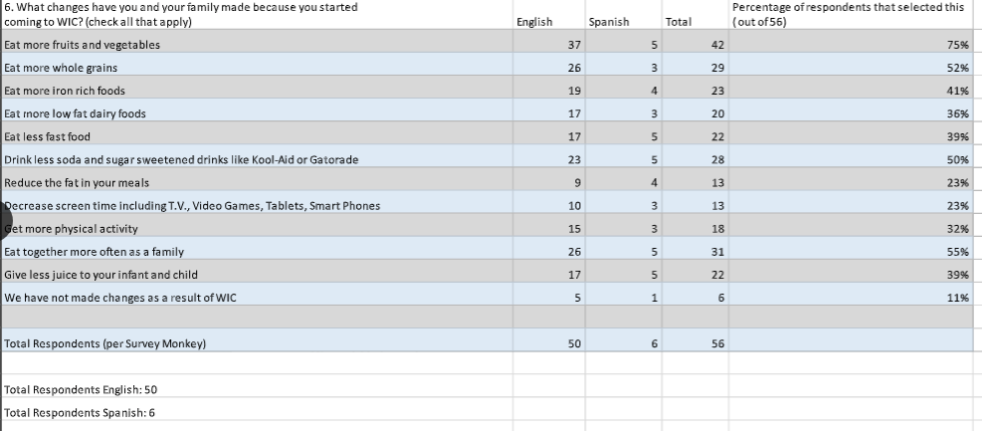

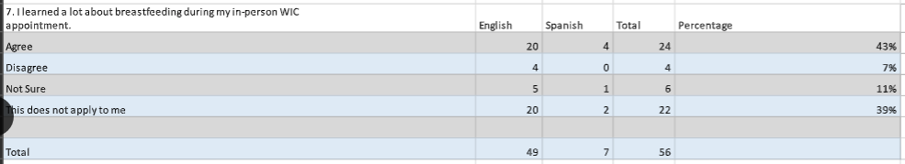

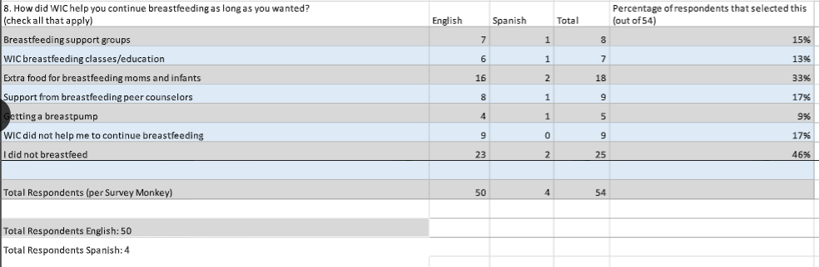
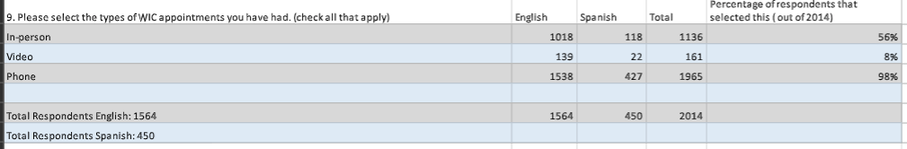
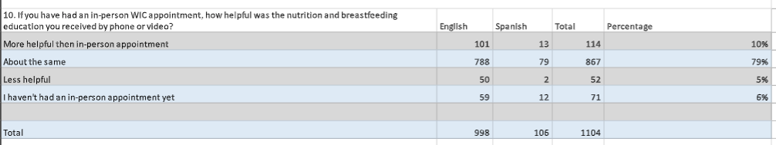
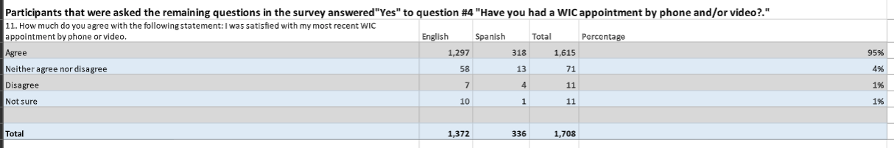
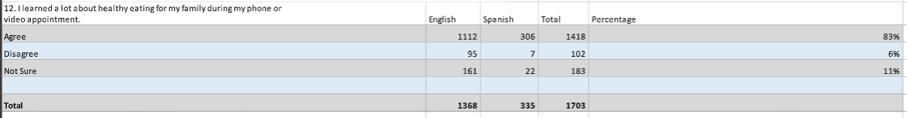
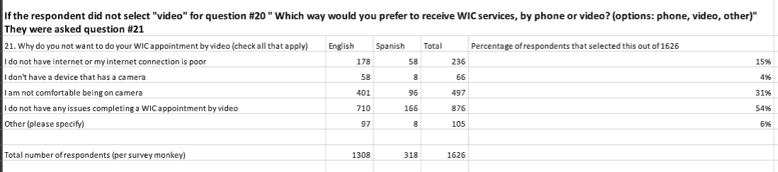
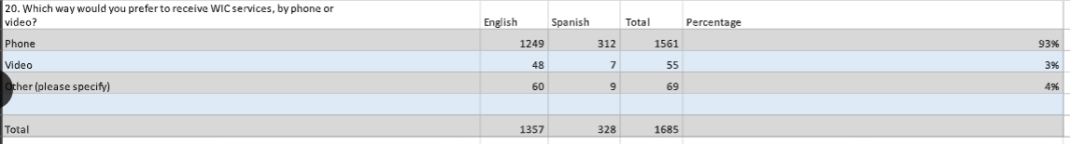
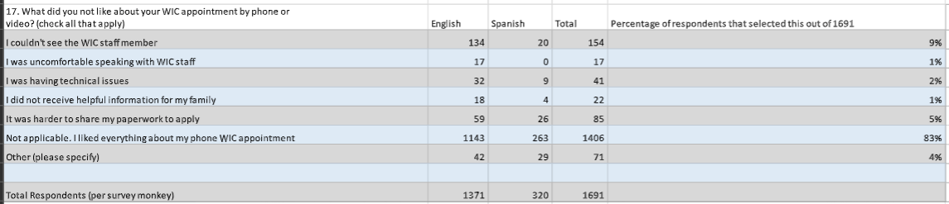
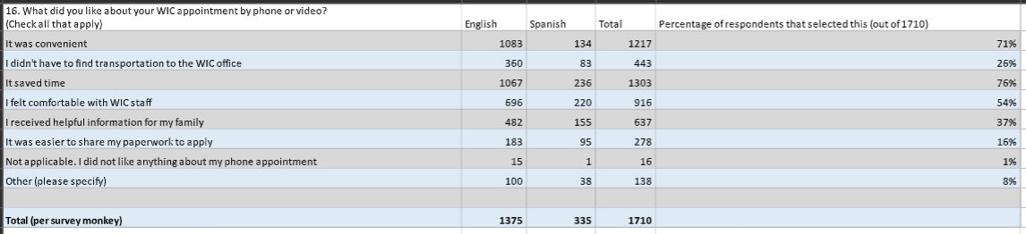

Resources
Addiction Group
https://www.addictiongroup.org/nebraska/drug-statistics/

America’s Health Rankings
https://www.americashealthrankings.org/explore/measures/drug_use/drug_use_less_hs/NE

Best Neighborhood
https://bestneighborhood.org/race-in-nebraska/

Center on Budget and Policy Priorities
https://www.cbpp.org/research/food-assistance/a-closer-look-at-who-benefits-from-snap-state-by-state-fact-sheets#Nebraska

Center for Health Affairs
https://www.neohospitals.org/thecenterforhealthaffairs/mediacenter/newsreleases/2024/August/CDC-Reports-a-Rise-in-the-Number-of-Uninsured-Americans-After-Record-Lows

Children’s Health Care
https://kidshealthcarereport.ccf.georgetown.edu/states/nebraska/

CNN
https://www.cnn.com/2024/01/16/economy/boomers-own-more-larger-homes-than-millennial-families/index.html

Community Action Partnership

https://cap.engagementnetwork.org/assessment-tools

Daily Yonder
https://dailyyonder.com/in-small-town-nebraska-with-suicide-rates-high-one-family-delivers-hope-for-thousands/2024/02/19/

Data Pandas
https://www.datapandas.org/ranking/homeless-population-by-state

Feeding America
https://www.feedingamerica.org/hunger-in-america/nebraska

First Five Years
https://www.ffyf.org/wp-content/uploads/2024/07/2024-Nebraska-State-Fact-Sheet.pdf

Flatwater
https://flatwaterfreepress.org/nebraska-faces-a-child-care-crisis-these-companies-are-easing-the-pain-for-working-parents/

Foster Care Review Office
https://fcro.nebraska.gov/pdf/FCRO-Reports/2024-q4-quarterly-report.pdf

Harmony United Psychiatric Care
https://hupcfl.com/the-impact-of-family-dynamics-on-childrens-mental-health/

Housing Assistance Council
https://veteransdata.info/states/2310000/NEBRASKA.pdf

KETV
https://www.ketv.com/article/thats-concerning-nebraskas-child-welfare-report-shows-disturbing-uptick/62233144
https://www.ketv.com/article/unsheltered-homelessness-on-the-rise-shelters-look-for-help/45789679

Kidsville Pediatrics
https://www.kidsvillepeds.com/blog/1249405-how-family-dynamics-influence-pediatric-mental-health/#:~:text=Family%20dynamics%20profoundly%20shape%20a,effects%20on%20pediatric%20mental%20health.

KFF
https://www.kff.org/statedata/election-state-fact-sheets/nebraska/

KUVR
https://ruralradio.com/kuvr/news/november-named-adoption-awareness-month-in-nebraska/

Living Wage
https://livingwage.mit.edu/states/31

March of Dimes
https://www.marchofdimes.org/peristats/data?reg=31&top=2&stop=5&slev=4&obj=3&sreg=31
Mental Health America
https://mhanational.org/issues/2024/mental-health-america-youth-data

National Human Trafficking Hotline
https://humantraffickinghotline.org/en/statistics/nebraska

Nebraska Alliance of Child Advocacy Centers
https://www.nebraskacacs.com/what-we-do/statistics.html

Nebraska Appleseed
https://neappleseed.org/47512

Nebraska Cares For Kids
https://nebraskacaresforkids.org/f_2024-wcfk-surveydeck-final/

Nebraska Department of Education
https://www.education.ne.gov/wp-content/uploads/2024/01/2023-Adolescent-Health-Report-updated-FINAL.pdf
https://www.education.ne.gov/wp-content/uploads/2022/08/Homeless-and-Unaccompanied-Count.pdf
https://www.education.ne.gov/ns/nslp/overview/#1626021371019-f7730fbf-a2e0
https://www.education.ne.gov/wp-content/uploads/2024/02/Statsfacts_20232024.pdf

Nebraska Department of Labor
https://dol.nebraska.gov/webdocs/Resources/Trends/December%202024/LAS%20Area%20Summary%20State.pdf
https://ncc.nebraska.gov/sites/default/files/doc/2023%20Domestic%20Assault%20and%20Arrest%20by%20County.pdf
https://ncc.nebraska.gov/sites/default/files/doc/2022%20Employment%20Data.pdf

Nebraska Department of Health and Human Services
https://dhhs.ne.gov/DCFS%20Data%20and%20Reports/CAN%202023%20Annual%20Data%20Report.pdf

Nebraska Examiner
https://nebraskaexaminer.com/2024/03/28/new-kids-count-report-focuses- on-child-care-crisis-in-nebraska

Nebraska Grand Families
https://www.grandfamilies.org/Portals/0/State%20Fact%20Sheets/Nebraska%20GrandFacts%20State%20Fact%20Sheet%202021%20Update.pdf

Nebraska Legislature
https://nebraskalegislature.gov/pdf/reports/research/affordable_housing_challenges.pdf

Nebraska Low Income Housing Coalition
https://nlihc.org/housing-needs-by-state/nebraska

Nebraska News Service
https://www.nebraskanewsservice.net/news/nebraska-nursing-shortage-deteriorates-hospital-conditions/article_16373b65-5f89-50af-9772-f4bb2d1728d3.html

Nebraska Now
https://www.klkntv.com/nebraska-hospitals-take-issue-with-medicaid-cuts-in-house-budget-bill/

Nebraska Public Media
https://nebraskapublicmedia.org/es/news/news-articles/getting-around-rural-america-without-a-car-is-hard-these-communities-developed-solutions/
https://nebraskapublicmedia.org/es/news/news-articles/homeless-residents-in-midwest-cities-are-increasingly-hard-to-track-and-help/

Nebraska Rural Poll
https://ruralpoll.unl.edu/sites/unl.edu.ianr.alec.rural-poll/files/media/file/24%20Report%20-%20Community.pdf

NHA
https://www.nebraskahospitals.org/advocacy/roadmap-to-strong-rural-health- care.html

Norada Real Estate
https://www.noradarealestate.com/blog/nebraska-housing-market/

Northwestern Mutual
https://www.northwesternmutual.com/life-and-money/how-much-does-it-cost-to-raise-a-child/

NTV
https://nebraska.tv/news/crime/update-on-domestic-shooting-in-seward

Parents
https://www.parents.com/how-much-does-it-cost-to-raise-a-child-11681839

Pewresearch/charitabletrusts

Rent Café
https://www.rentcafe.com/cost-of-living-calculator/us/ne/

Robert Wood Johnson Foundation
https://www.rwjf.org/en/grants/active-funding-opportunities.html?channelid=xps&cid=1003570&gad_source=1&gclid=Cj0KCQjw-e6-BhDmARIsAOxxlxVYMOwNQSUdQLR2JdOxPfZByGuLkt3xPzlGsJn8OEP8x6aPqSZbVKgaAk8wEALw_wcB

Rural Health
https://www.rwjf.org/en/insights/our-research/2011/05/housing-and-health.html#:~:text=Substandard%20housing%20such%20as%20water,increased%20risk%20of%20cardiovascular%20disease

https://iloveruralhealth.com/tomorrow/,

Safewise
https://www.safewise.com/blog/safest-cities-nebraska/

Smart Asset
https://smartasset.com/data-studies/family-minimum-income-state-2024

University of Nebraska – Lincoln
https://cap.unl.edu/news/updated-nebraska-land-values-cash-rents-published-2025-nebraska-farm-real-estate-report/

UNMC
https://www.unmc.edu/familymed/_documents/ahec/healthcare-workforce-2024.pdf
https://www.unmc.edu/healthsecurity/transmission/2023/10/04/kids-mental-health-spending-soared-26-during-pandemic/
https://app1.unmc.edu/publichealth/bhecn/#/home

US Bureau of Labor Statistics
https://www.bls.gov/regions/midwest/news-release/2025/laborunderutilization_nebraska_20250221.htm

United States Census Bureau
https://www.census.gov/library/stories/2024/03/grandparents-living-with-grandchildren.html

U.S. Department of Housing and Urban Development
https://www.huduser.gov/portal/sites/default/files/pdf/2024-AHAR-Part-1.pdf

USA Facts
https://usafacts.org/answers/what-is-the-average-wage-in-the-us/state/nebraska/

Voices For Children
https://voicesforchildren.com/wp- content/uploads/2024/03/KC2023_FullDocument_FINAL.pdf

World Health Organization
https://www.who.int/news-room/fact-sheets/detail/disability-and-health#:~:text=An%20estimated%201.3%20billion%20people%20–

World Population Review
https://worldpopulationreview.com/us-counties/ne/wheeler-county-population

1011 Now
https://www.1011now.com/2024/05/17/hunger-levels-rise-cornhusker-state-new-report-says/

