

2022
Central Nebraska Community Action Partnership, Inc.

Community Needs Assessment
Executive Summary
Key Overall Findings
180,351 people live within the CNCAP 21 county service area, with 88,309 being female and 88,997 being male. There are 100,778 people between ages 18-64, making it the largest age group.
The median age is 45 years old. The median age in Hall, Colfax and Platte counties is lower than the rest of the counties. They are the only three counties with the median age being in the thirties. In smaller counties, such as Blaine or Loup county, the median age is into the fifties. Of the working aged people in the service area, the largest number of adults are in the 55-64 age group. This age group is made up of people who are either leaving or have already left the work force. There are over 24,000 people between the ages of 55-64. The smallest age group is between 18-24, with only 13,500 people in the service area. This is a result of the younger generation moving into the bigger cities in search of better opportunities for their families and themselves. While Hall county increased by 4,288 people in the last ten years, and Platte increased by 2,059 people the rest of the rural counties are struggling. 16 counties within the CNCAP service area have decreased in population over the past decade. Lack of housing, childcare and employment are the driving factors.
Housing proves to be the number one challenge within the 21 counties. 92% of CNCAP’s low income clients who were surveyed said that housing was a top need within their community. 50% said it was the number 1 greatest need within their community. 94% of the Board of Directors said that it was a top need within the community and 47% said it was the number 1 greatest need. 92% of the community stakeholders said it was a top need within their community. The impact of the housing shortage and affordable housing shortage is being felt across the board. CNCAP clients stated:
- “Affordable housing is very hard, even for someone working full time at a decent wage.”
- “The price of rent and availability. It seems really high and there isn’t much for rent. I need a 3 bedroom house and they are going for $1200 and up. If it is that there would be nothing left for daily needs, food, daycare and what not.”
- “Rent increases while wage increases don’t happen. People who work full time still have difficulty paying rent.”
- “Resources should be easier to find when it comes to housing. The lack of affordable housing makes people feel stuck and they can’t get out of a bad situation.”
Of the 86,307 residential addresses within the CNCAP service area, only 1,680 of them are vacant. And of those 86,307 housing units, only 50,626 were owner occupied. That number has decreased significantly from 71.93 in 2000, to 61.67% in 2021. There are currently 311 housing units without plumbing within the 21 counties. The same high up jobs have been denied multiple times due to a lack of housing—even when the wages were competitive. Small towns are unable to get people to move there because they have nowhere to live. What few are available are aging and in desperate need of repair as the majority of them were built prior to 1970.

Childcare shortages continue to plague the CNCAP service area in the wake of the pandemic. While affordable housing shortages prove to be a challenge, people can’t go to work to pay their bills without someone to take quality care of their children. 92% of community stakeholders found childcare to be a top need in their community. 54% of low-income clients found it to be a top need within their community. 14% saw it as the number 1 need and 53% of the Board of Directors found it to be the greatest need. Parents across Nebraska have had to cut hours, stay home from work, turn down promotions or leave the workforce altogether as a result of the daycare shortages. 71% of children under the age of 6 have all parents in the workforce. Parents cannot afford to stay at home with the children anymore, but they have no where to send their children while they are at work. The number of family child care providers dropped 21% between 2010 and 2017, and has only declined from there. As a result of the pandemic, 17% of single parents and 12% of full time parents went from full-time to part-time job in 2020. 91% of Nebraska counties do not have sufficient child care, with 11 counties not even having a single licensed child care provider. Besides quality care being difficult to find, the available daycares are also expensive. The average cost of childcare per month for an infant in Nebraska is $1048 and its $952 per month for a 4-year old. For comparison, rent and college tuition in the state of Nebraska cost less than child care services. More than 20% of a household’s income goes toward care for only one child.

Mental health takes the biggest hit when times get tough. With the current challenges regarding life in Nebraska, it’s no surprise that mental health is suffering. Isolation, unemployment, rising costs, financial stress, loss of security—the pandemic took everything that was a constant and rattled it to its core. The grief, trauma, and physical isolation over the last two years have driven American’s to a breaking point. 59% of CNCAP’s community stakeholders believed that mental health is a greatest need within their community. An additional 33% found it to be something that needs addressed. 53% of low-income clients believe that mental health has the greatest need in their community. 40% of the board of directors believe mental health to be the greatest need.
Low-income clients stated:
- “I feel like mental health is an issue that is not talked about enough and not affordable for normal income people, let alone low-income.”
- “Sometimes it is hard to find what is available out there for help. People feel stuck because they don’t know where to go for help, or they think getting help is not in their reach.
- “All of these things need to be normalized. If more people were educated about “hush hush” topics—mental health and eating disorders—all areas would improve.”
18.08% of Nebraska adults have some sort of mental illness, equaling 257,000 people throughout the state. Many of them go without treatment. Of the 77,000 adults in Nebraska who did not receive needed mental health care, 41.9% did not because of the cost. 11.9% adults have had serious thoughts of suicide in the past year. Income plays a role in mental health as well. 25.2% of Nebraskan’s who make less than $25,000 were depressed, compared to 12.2% of Nebraskan’s who made $75,000 or more.
13.1% or 20,000 Nebraska youth had a Major Depressive Episode (MDE) in 2020. As mental illness becomes more prevalent, the mental health provider shortage becomes a bigger issue. 1,037947 people in Nebraska live in a community that does not have enough mental health professionals. Within the CNCAP service area, Keya Paha, Boyd, Brown, Rock, Blaine, Loup, Garfield, Wheeler, Greeley, Sherman, and Nance counties do not have a mental health provider. Many of these families have to drive over an hour to access mental and behavioral health. 88 of the 93 counties in Nebraska are designated as behavioral health shortage areas. 60.1% of Nebraska children with depression did not receive any care within the last year. 271 lives were lost to suicide in Nebraska last year. There is a critical need for mental health care within the state.

Substance use can seem like the only way to find relief from the challenges many face every day. 42% of community stakeholders found substance abuse to be the greatest need within their community. Another 33% saw it as an issue that needs addressed. 53% of the Board of Directors saw substance abuse as a greatest need within their community and another 20% saw it as a serious need. 32% of low-income clients saw substance abuse as a serious challenge within their community. 9% saw it as the number 1 challenge. Low-income clients stated:
- “Law enforcement needs to do more about substance abuse.”
- “Offer more places for substance abuse support.”
Deaths due to drug overdose have increased in Nebraska from 6 per 100,000 in 2015 to 11 per 100,000 in 2020. Prior to the pandemic, 0.3% of people age 12 and older reported opioid dependence or abuse in the past year. Since the pandemic 1.8% of adolescents and 6.1% of adults in Nebraska reported having alcohol use disorder in the past year. 2.7% of adolescents and 2.5% of adults have an illicit drug use disorder in the past year. Nebraska is ranked 20th for youth with a substance use disorder in 2020. Nebraska is the 9th ranked state where overdose deaths increased the most during COVID-19 with a 44.6% increase from 2020 to 2021. There were 214 overdose deaths in Nebraska in 2021. Many arrests for distribution of methamphetamine have taken place throughout the CNCAP service area as well. People have resorted to the easiest drug to access, when their preferred drug was experiencing shortages. Access to meth is increasing as the intent to distribute it for financial gain becomes more enticing.

Poverty in Nebraska remains a serious challenge year after year. 17,365 people in the 21 county service area are currently living in poverty. A total of 8,360 males are living in poverty and 9,507 women are living in poverty. 2,041 children under the age of four are living in poverty in the CNCAP service area. Poverty in Nebraska is defined as an income threshold of $25,465 for a family of four with two children or $17,308 for a single parent of one child. Keya Paha has the second highest poverty rate in the state of Nebraska, and Loup county is fourth. While prices have increased significantly in the last two years, the median household income has not. There is a noticeable increase between 2020 and 2021. Brown county increased from $28,038 in 2020 to $46,200 in 2021, but then in 2022 it decreased to $43,098. These changes are most likely a reflection of employers raising their wages in an attempt to fill empty positions after the pandemic. As time has gone on, these numbers have slowly dropped or stayed the same.

Unemployment saw an all-time high in Nebraska as a result of the pandemic in 2020. April of 2020 broke the record for being the highest rate in the history of Nebraska at 8.3% or the equivalent of 86,300 people. Unemployment rates in the CNCAP service area was 999 unemployed out of 92,385. Jobs remain open and unemployment numbers throughout the state have remained up since 2020, resting at 2.8% finishing out 2021. Many people in hospitality and leisure industry are looking for work in a different industry. Many people have enjoyed not having a commute and are looking for job that allows them to work remote. There is a disconnect between jobs open and the people who are looking for work. Extended unemployment benefits and relief in the meantime allows workers to be choosy in the search for their next job. Many have had to leave the work force in order to compensate for lack of daycare options as well.

In order to assist the people of our service area as they navigate the various challenges in life, the Family Outreach program uses an evaluation tool. Case managers meet with the clients and let the clients establish areas of life they would like to improve and then help guide them through it. The twelve domains of life include transportation, family relations, parenting, alcohol/drug, childrens education, adult education, income budget, employment, health, nutrition and housing. From October 2021 to September 21, 395 households wanted to improve transportation in their life. Of those, 387 showed an increase in their profile with the assistance of CNCAP services. 395 wanted to improve family relations in their life and 380 were able to increase that area of their life. 202 households wanted to improve their parenting and 198 showed an improvement in their goals. 367 clients wanted to improve drugs and alcohol in their life and 353 showed an increase. 370 wanted to improve adult education in their life and 355 showed improvement. 396 clients wanted to work on their income and budgeting and 391 showed improvement. 370 wanted to improve their employment and 362 showed improvement. 395 wanted to improve their health and 390 showed improvement. 392 wanted to show improvement in nutrition and 387 did. 395 wanted to improve housing and 392 were able to do so. CNCAP programs are the hand up that many people need, allowing them to find some relief among the stress and guiding them toward independence.

TABLE OF CONTENTS
EXECUTIVE SUMMARY
CENSUS INFORMATION
COMMUNITY NEEDS ASSESSMENT
AREA DEPRIVATION
AGENCY SURVEYS AND DATA COLLECTION
ORGANIZATIONAL OVERVIEW
NEBRASKA AT A GLANCE
NE/CNCAP DEMOGRAPHICS

ECONOMY
Income…………………………………………………………………………….48
Poverty…………………………………………………………………………….50
Employment/Unemployment……………………………………………………...58
Transportation……………………………………………………………………..62

HEALTH & SAFETY
Access to Healthcare……………………………………………………………...65
Mental Health……………………………………………………………………..67
Substance Abuse…………………………………………………………………..75
Disabilities………………………………………………………………………...77
Health Insurance…………………………………………………………………..79
Childcare…………………………………………………………………………..82
Human Trafficking………………………………………………………………..87
Disconnected/Homeless Youth…………………………………………………....88
Crime……………………………………………………………………………...95
Health Trends……………………………………………………………………..99
COVID-19……………………………………………………………………….109
A Look into the Future…………………………………………………………..113

DIVERSITY
Age and Gender………………………………………………………………….116
Rural Populations………………………………………………………………..119
Family……………………………………………………………………………124
Minorities………………………………………………………………………..137
Veterans………………………………………………………………………….145

EDUCATION
School Information………………………………………………………………159
Districts…………………………………………………………………………..160

Blaine…………….…. Boone………….…… Boyd………..………. Brown………………
Colfax…..……………. Custer….…………… Garfield….……..…. Greeley….………….
Hall……......…..…... Hamilton…………… Holt……….……… Howard….………….
Keya Paha………..…. Loup……………….. Merrick………….….. Nance………………..
Platte………….… Rock…………. Sherman………….Valley………….Wheeler…………

Adult Education………………………………………………………………….165

HOUSING
Vacancy………………………………………………………………………….167
Rent vs Own……………………………………………………………………..169
Cost………………………………………………………………………………180
Housing Age……………………………………………………………………..185
Homelessness…………………………………………………………………….193
Rural vs Urban…………………………………………………………………...200
Community Satisfaction……………………………………………...………….202

RESOURCES

2021

With the affects of the pandemic still lingering in 2021, becoming familiar with the needs of our service area is more prevalent than ever as we try to make the changes necessary to our communities. The 2020 Census bureau and many other studies and statistics will help us gain valuable insight into the needs of those individuals affected most greatly by the pandemic. Economic, educational and environment resources will be of great assistance in our journey to make a difference in 2022.

CENSUS

The census is required by the U.S. Constitution to determine the number of seats each state gets in the House of Representatives. It also provides data for redrawing legislative districts. Responding is important because state, local and federal lawmakers use statistics from the decennial census to help them determine how more than $675 billion in federal funds will be spent every year for the next ten years.

Interesting Facts about CNCAP’s 21 counties:
Blaine: Halsey is part of Blaine county and serves as the headquarters for Nebraska National Forests at Halsey where there is over 90,000 acres of hand-planted trees, making it the largest hand planted forest in the United States. https://www.cornnation.com/2018/6/7/17439520/nebraska-blaine-county-countdown
Boone: Boone county was named after Daniel Boone, an American pioneer who was famous for his exploration of what is now Kentucky.
Boyd: The first courthouse in Boyd county is remembered as having been the color pink.
https://boydcounty.ne.gov/webpages/about/about.html
Brown: It is not known who Brown county was named after. There were five legislators with the last name Brown and it is known that the county was named to honor two of them—just not which two. https://www.ereferencedesk.com/resources/counties/nebraska/brown.html
Colfax: Colfax was named after the president at the time. https://www.ereferencedesk.com/resources/counties/nebraska/colfax.html
Custer: there are 12 unincorporated communities in Custer county. https://kids.kiddle.co/Custer_County,_Nebraska
Garfield: Garfield county thrives mostly on ranching. https://www.ereferencedesk.com/resources/counties/nebraska/garfield.html
Greeley: The county seat was originally in Scotia and was later moved to Greeley.
https://www.cornnation.com/2018/7/1/17479652/nebraska-county-countdown-62-greeley-county
Hall: Grand island is the fourth largest city in Nebraska. https://www.hallcountyne.gov/content.lasso?page=6005
Hamilton: Hamilton County Fair is the oldest county fair in continuous annual operation in Nebraska, having begun in 1872. http://negenweb.net/NEHamilton/hamhist.html
Holt: Holt county is the 5th largest county in Nebraska by area. https://www.ereferencedesk.com/resources/counties/nebraska/holt.html
Howard: Almost every state of the Union is represented and the German, Danish, Swedish, Polish, Bohemian and Scotch nationalities are settled here in large numbers. http://genealogytrails.com/neb/howard/countydata_howardcounty1904.htm
Keya Paha: The name derived from the Dakota words Ke-ya Pa-ha Wa-kpa, which translated means turtle hill river, named after the numerous small hills that make up the terrain. https://nacone.org/webpages/counties/countywebs/keya_paha
Loup: A local rancher wanted the county seat to remain in Taylor so he donated a building to the county to be used as the courthouse. It was used as the courthouse for 74 years, but deteriorated to the point it was deemed Loup county’s “winter icebox” and was retired in 1958. https://nacone.org/webpages/counties/countywebs/loup
Merrick: Merrick county was named after Elvira Merrick, the maiden name of the wife of territorial legislator Henry W. DePuy. https://kids.kiddle.co/Merrick_County,_Nebraska
Nance: this area was designated as the Pawnee Reservation. https://www.ereferencedesk.com/resources/counties/nebraska/nance.html
Platte: Platte county was named after the Platte River, which is its southern border.
Rock: Rock county was either named for Rock Creek which flows through the county or for its rocky condition. It’s known for the twin lakes and the Niobrara river which borders the north side of the county. http://rockcountynebraska.org/
Sherman: the village of Hazard earned worldwide fame in 1992 when Richard Marx recorded his hit song “Hazard” based on a fictitious murder with the lyrics “this old Nebraska town”. https://junkjaunt.com/sherman-county-ne/
Valley: Valley county’s name derives from the local terrain which consists of valley land lying between the North and Middle Loup rivers. https://kids.kiddle.co/Valley_County,_Nebraska
Wheeler: the county was named for Major Daniel H. Wheeler, longtime secretary of the Nebraska State Board of Agriculture.

Community Needs Assessment
Helping a community or family out of poverty and devastation is an ongoing process of Community Action. With the first phase of the Results Oriented Management and Accountability (ROMA) Cycle at its core, Community Action Agencies are dedicated to promoting self-sufficiency, family stability and community revitalization through their programs. Identifying the resources and needs that exist within a community, through the Community Needs Assessment, every three years and on a regular basis will guide and develop how these resources should best be implemented to serve the most vulnerable residents, agencies and organizations that co-exist in the area.

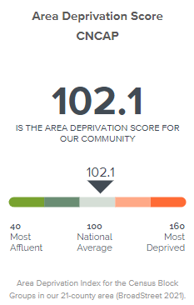
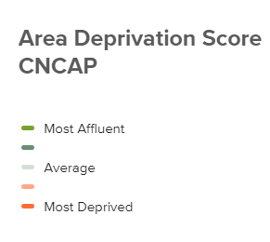
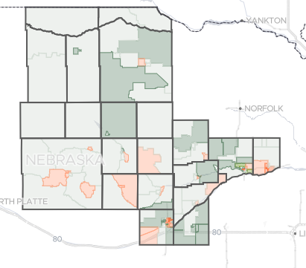
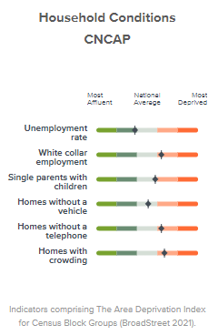

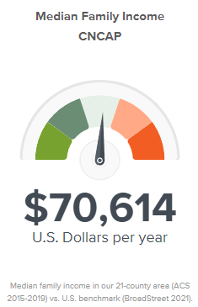
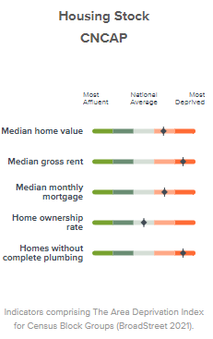

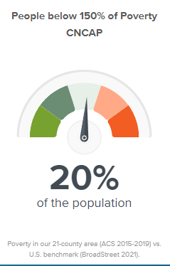
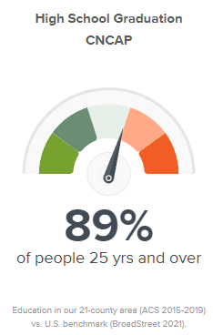

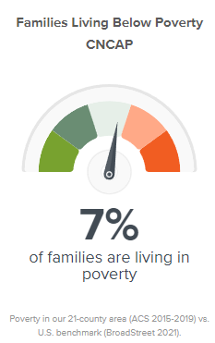
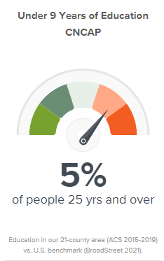
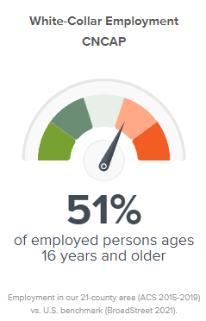
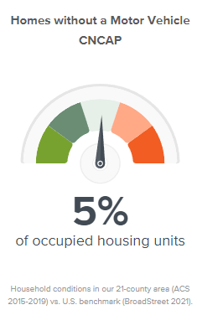
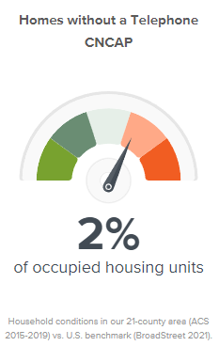
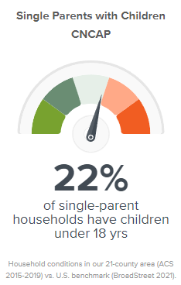
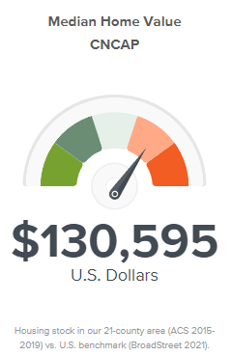
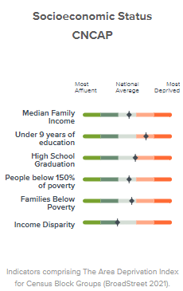
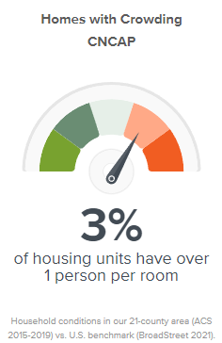

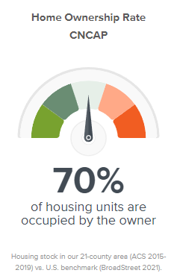
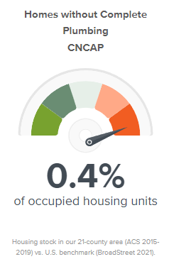
https://www.broadstreet.io/board/pubboard/Qm9hcmRDYXJkVXNlTm9kZTo3OTYzMjM%3D

AGENCY SURVEYS AND DATA COLLECTION
Surveys
Surveys are a great way to get direct feedback from community members, business owners, board members, schools and clients in order to identify the needs of the CNCAP service are. The CNCAP ECP department sends out surveys to area organizations, professionals and individuals to identify concerns and successes in serving children birth to five and their families on a local and regional basis. Our Family Outreach and Housing Departments conduct satisfaction surveys. These survey results are incorporated into the Community Assessment. The results of these surveys are also used for our annual strategic planning which is designed to improve program deliveries as well as all program outcomes for children and families served by CNCAP. Community providers, policy/decision makers and CNCAP work together to affect positive changes in availability and delivery of services by regularly attending area meetings, publishing and disseminating informational materials relevant to the healthful development of children and families assuring that key stakeholders at regional, statewide and national levels are given opportunities to comment on the design and delivery of services that best meet the needs of our populations.
Data Collection
CNCAP strives to use the most current documentable data available. Data is compiled from sources that are published through a variety of entities including but not limited to: local, state, and federal government; educational institutions; private foundations; and public and private human service initiatives.
US Census Information (source: www.census.gov) The U.S. Census Bureau is the leading source of statistical information about the nation’s people. Our population statistics come from decennial censuses, which count the entire U.S. population every ten years, along with several other surveys. The American Community Survey (ACS) helps local officials, community leaders, and businesses understand the changes taking place in their communities. It is the premier source for detailed population and housing information about our nation.
All of the information we collect through censuses and surveys, as well as the administrative data we obtain, is confidential and protected by federal law. Data are only linked to answer questions that are part of a research projects that are approved by the Census Bureau and support our mission.
Research results that are published do not identify any individuals. Rather, summarized data is released that represent groups of people—generally in tables of numbers. Before releasing any statistics to the public, the Census Bureau reviews them to make sure none of the information or characteristics could identify someone (or a business).
Methodology

Community demographics and census data was collected from the U.S. Census Bureau, Community Action Partnership’s Data Hub, and World Population Review. Data was also collected from community surveys and reports available within the communities, counties, and the state. Additional data was collected from available online databases such as the Kids Count in Nebraska Report, the Dept. of Education and the Dept. of Labor. A complete listing of sources can be found in the reference section of this report.

Central Nebraska Community Action Partnership (CNCAP) surveys the Board of Directors to determine area of needs within our service area. In these surveys, members are asked to rank as to the greatest need and how satisfactorily these needs are being met in their county.
Central Nebraska Community Action Partnership (CNCAP) surveys partner agencies, area schools, community members, CNCAP clients and staff to determine areas of need within our service area. In these surveys, individuals are asked to rank as to the greatest need and how satisfactorily these needs are being met in their county. (In our last survey Mental Health/Substance abuse were separated out and Immigration & Trafficking were added due to current issues)

Consensus
Community needs in our 21 counties continues to struggle around 4 basic concerns: mental health, housing, child care, and employment opportunities.
With the after affects and variants of COVID-19 still affecting the lives of everyone in Nebraska, everyday tasks become issues and challenges. Job loss, unemployment, mounting debt, food insecurity, educational challenges with children, lack of child care, shutdowns, housing shortages and other challenging circumstances bring uncertainty to the lives of Nebraskan’s every day.
Finding access to affordable, high-quality housing is a huge challenge among the CNCAP service area as new houses are not being built and houses become unlivable without getting fixed. Not only is it costly to build new homes in Nebraska, but supplies are hard to come by as we still recover from the pandemic. Due to lack of housing and opportunities, rural communities lose population as people move to the city in order to find better opportunities. As people leave small communities, businesses are affected and job opportunities decrease, leading to higher rates of unemployment.
Another major challenge in rural communities is lack of access to affordable, high-quality daycare which causes parents to miss work, turn down promotions, reduce hours or leave the workforce entirely. There are 49,671 children across CNCAP’s service area and only 76 childcare facilities within the 21 counties (https://childcarecenter.us/state/nebraska?display=all).
The above listed challenges force people to make life-altering decisions for their families. Do they pay their bills? Feed their families? Move somewhere with better opportunity? Quit their job to take care of their children? These major life decisions become every day choices.
All of these challenges and sacrifices and decisions take a toll on mental health. Mental health includes emotional, psychological, and social well-being. Mental health affects a person’s ability to make healthy decisions that affect both them and their entire family. Mental health is essential at every stage of life, from childhood and adolescence through adulthood. Mental health affects all stages of life.

ORGANIZATIONAL OVERVIEW

Central Nebraska Community Action Partnership Inc. (CNCAP) provides quality services to individuals, children and/or families within all of the programs offered within our 21 county service area. Adherence to these program mandates is monitored by internal and external reviews and audits to ensure progressive qualitative services are provided for the needs of our communities.
Information regarding those needs is collected from various sources throughout the year; Department of Labor, U.S. Census data, internal agency databases, Kids Count Data Center (National KIDS COUNT, Voices for Children in Nebraska), as well as other data sources published annually and listed at the end of this assessment report.
Input on community needs as well as customer satisfaction is collected from low-income residents and local elected officials provided input during Agency Board of Directors meetings. Our staff provides vital information regarding community needs and challenges during group meetings and the survey process. These combined data resources help us to discover and make informative decisions regarding what the collected data says of our community needs.
The results of the Community Needs Assessment are presented to Policy Council and the CNCAP Board of Directors annually. It is important to stay informed of the challenges that exist in our communities in order to respond with increase awareness and to make informed decisions regarding the welfare of our communities.
Policies and procedures are in place to ensure the programs remain progressive and respond to the needs of the communities we serve. This needs assessment report is just one of the many tools used in this process.
Central Nebraska Community Action Partnership (CNCAP) is one of nine Community Action Agencies in Nebraska. CNCAP is a 501 (c) 3 non-profit human services agency that offers programs related to basic health, education, community development services and human service needs of individuals and families. CNCAP provides services throughout Region 2 covering the counties of Blaine, Boone, Boyd, Brown, Colfax, Custer, Garfield, Greeley, Hall, Hamilton, Holt, Howard, Keya Paha, Loup, Merrick, Nance, Platte, Rock, Sherman, Valley and Wheeler. Satellite offices are located in Broken Bow, Columbus, O'Neill, Grand Island, and Central City, with the central office located in Loup City.
Nebraskans, from birth to the older adult population benefit from the services offered through CNCAP. Vulnerable populations include child dependents, youth and older adults who rely in whole, or in part, on others to help meet their personal needs. Our service area spans nearly 17,000 square miles in central and north central Nebraska.

A 27-member Board of Director’s, representing the entire geographic service area, guides the organization. The tripartite board is comprised of public elected officials, low-income representatives, and private interest groups – including members from business and religious affiliations. Among these representatives are members with expertise in Finance, Early Childhood Education, Business and Nebraska Law. The board oversees operations providing financial oversight and direction to the CNCAP Executive Director.

Administrative Structure
Administration: Includes the Executive Director, administrative office staff, Fiscal Department, Human Resource Department, maintenance staff, technical support staff and resource development. The administration staff provides support to all CNCAP departments and programs.

Early Childhood Programs
Head Start - 11 Locations Head Start provides comprehensive education, health, nutrition, and parent involvement services to children and their families. The program consists of dental/health exams, vision/hearing screenings, immunizations, nutritious meals, and educational activities. Parents attend parent meetings and are actively involved in the children’s activities. (Ainsworth, Aurora, Burwell, Central City, Centura, Columbus, Fullerton, Loup City, Ord, St. Paul and Schuyler)

Early Head Start - 10 Locations Early Head Start promotes healthy prenatal outcomes and enhances the development of infants and toddlers. The program provides parents with opportunities to move toward self-sufficiency. Health, parenting skills, nutrition education, and home safety checks are also provided to participants. All 10 locations offer the Home-based option (Boone, Brown, Colfax, Custer, Hamilton, Howard, Holt, Garfield, Greeley, Merrick, Nance, Platte, Valley and Sherman). CNCAP provides an Early Head Start center-based option in Broken Bow, Columbus, O'Neill and Schuyler.

Pre-K Partnerships with Public Schools - 9 Locations CNCAP Early Childhood Programs has 9 formal partnerships with area schools to provide a comprehensive educational Pre-K program. Morning and afternoon center-based sessions are scheduled during the regular school year. Monthly contacts are made to families. Families receive assistance in goal development, parenting education, and links to the community and area resources. (Ainsworth, Burwell, Central City, Centura, Columbus, Loup City, Ord, St. Paul and Schuyler)

Early Childhood Sixpence Grants, Partnership with Public Schools - 5 Locations CNCAP Early Childhood Programs has 5 formal partnerships with area public school districts to provide comprehensive Home Visitation Services to at-risk prenatal women and children from birth to age three. Risk factors include families of low income, low birth weight or premature birth, teenage parents, parents lacking a high-school diploma, and households where English is not spoken as the primary language. (Aurora, Central City, Loup City, Ord and St. Paul)

Early Development Network – Provides service coordination and access to resources that help families meet determined goals. Antelope, Boyd, Brown, Cherry, Holt, Keya Paha, Pierce, Madison (excludes Norfolk), Rock, Stanton and Wheeler Counties

Housing
Weatherization: Income eligible homeowners and renters receive repairs and efficiency measures that result in saving energy. Available: All 21 Counties
Section 8 Rent Subsidy: Provides rent subsidy assistance to eligible households through the issuance of vouchers. Available: in the communities served by the Central Nebraska Joint Housing Authority
Affordable Rental Units: Affordable rental housing properties for income eligible families. Available: Ainsworth, Alda, Cairo, Central City, Greeley, Loup City, and O’Neill
Family Self Sufficiency Program: Case management support services provided to Section 8 participants to assist clients in achieving economic self-sufficiency with the potential to build a savings account. Available: in the communities served by the Central Nebraska Joint Housing Authority
4) Family Outreach Programs Homeless and near homeless persons are offered services
through:
Stability assistance: Funds available to provide financial assistance to homeless
or near homeless individuals/families for utility or rental assistance, or deposits.
Available: All 21 Counties and Cherry County
THRIVES (Traditional Housing for Rural Independence, Viability and
Economic Stability): Assists homeless individuals in obtaining safe and suitable
permanent housing. Participantsreceive intensive case management to enhance their
skills for self-sufficiency and secure and maintain permanent housing. Available:
All 21 Counties and Cherry County
HOPE (Hope Offers People Empowerment): Case management that
focuses on strengths of the family and provides intensive support services to
families/individuals that want toaddress challenges and improve their quality
of life. Available: All 21 Counties and Cherry County
SSVF (Supportive Services for Veteran Families): Case management
for individual Veteran’s or a family in which the head of the household is a Veteran. The
program focuses on housing stabilization through temporary assistance that serves as a
bridge to long term stability. Available: All 21Counties +41 additional counties.
Veterans RRH (Veterans Rapid Re-Housing):
Provides housing assistance and case management to homeless, disabled Veterans,
and their families to stabilize them in their housing situation. Available: All 21 Counties and Cherry County
HART (Homes, Advocacy and Referrals for Totality): Provides rent/utility
assistance to individuals and families in crisis.Available: All 21 Counties.
KIND (Keeping Independent Needs Defined) is a JOINT TH-RR housing program that serves lieterally homeless youth between the ages of 18-24 with crisis intervention housing assistance as well as serving homeless and near homeless youth ages 18-24 by rapidly re-housing them and offering cas management, with possible financial assistance to work towards permanent housing while focusing on employment and education. Available: Hall, Adams, Buffalo and Custer Counties
Food Pantries: Central City, Loup City
KIDS (Keeping Independence Defined in Society) is a Rapid Re-housing program that assists individuals and families whose household is between the ages of 18-24, focusing on stable housing, education and employment, social and emotional well-being, and permanent connections. This program helps youth in homeless situations to get into housing. Available: All 21 Counties
CSFP (Commodity Supplemental Food Program): Food supplement packages
are provided to income eligible elderly over age 60.Available: All 21 Counties and
Cherry County Clinic locations in Broken Bow, Columbus, O’Neill, Grand Island and
Loup City
5) Community Health Programs *(Under the direction of Admin):
Women Infants & Children (WIC): Serves pregnant and postpartum women and children, birth to five years. Provides health monitoring by registered dieticians, RNs, LPNs. Also provide nutrition and breast feeding education and referrals to healthcare or other programs. Supplement nutritious food with monthly food benefits. Clinic sites in Central City, Greeley, St. Paul, Broken Bow, Burwell, Ord, Aurora, Loup City, Valentine, Spencer, O’Neill, Ainsworth, and Atkinson
Peer Counseling: Provide breastfeeding information and support to mothers through frequent contacts. Contacts include addressing breastfeeding concerns, how to being breastfeeding, finding support systems, and basic tips.
Immunizations: Vaccinations to reduce risk of contracting childhood
illnesses and diseases for children ages birth through 18 years of age

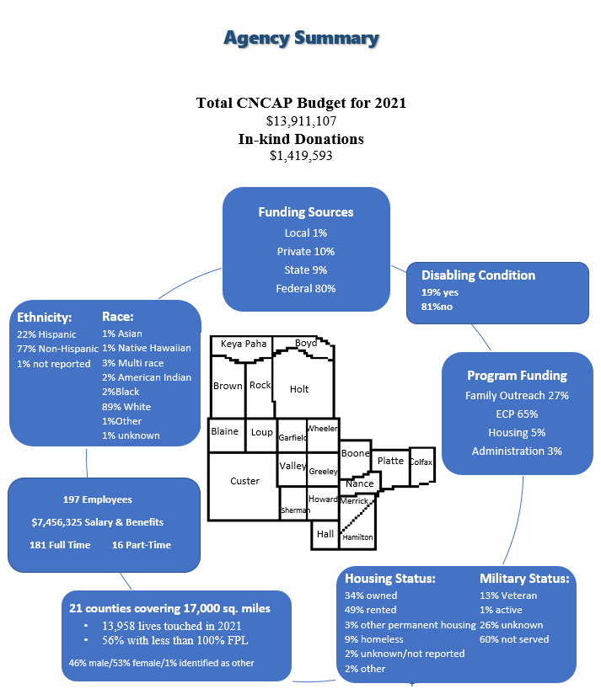

CNCAP Service Area at a Glance
2021 Area population: 178,922
17,000 sq. miles
Blaine:
Population: 477
Economy:
Median household income: $51,094
Median home cost: $116,300
Poverty: 14.15%
Health:
Number of children uninsured: 14
School:
Cost per student: $28,089

Boone:
Population: 5,279
Economy:
Median household income: $54,979
Median home cost: $162,900
Poverty: 8.09%
Health:
Number of children uninsured: 85
School:
Cost per student: $117,923

Boyd:
Population: 1,937
Economy:
Median household income: $47,778
Median home cost: $97,400
Poverty: 12.99%
Health:
Number of children uninsured: 39
School:
Cost per student: $17,468

Brown:
Population: 3,015
Economy:
Median household income: $43,098
Median home cost: $90,300
Poverty: 10.91%
Health:
Number of children uninsured: 60
School:
Cost per student: $14,187

Colfax:
Population: 10,714
Economy:
Median household income: $58,872
Median home cost: $132,600
Poverty: 8.16%
Health:
Number of children uninsured :289
School:
Cost per student: $10,892

Custer:
Population: 10,826
Economy:
Median household income: $52,184
Median home cost: $94,800
Poverty: 9.73%
Health:
Number of children uninsured: 187
School:
Cost per student: $14,727

Garfield:
Population: 2,001
Economy:
Median household income: $53,000
Median home cost: $127,300
Poverty: 12.08%
Health:
Number of children uninsured: 35
School:
Cost per student: $16,765

Greeley:
Population: 2,382
Economy:
Median household income: $47,869
Median home cost: $94,800
Poverty: 12.52%
Health:
Number of children uninsured: 61
School:
Cost per student: $21,113

Hall:
Population: 61,265
Economy:
Median household income: $57,104
Median home cost: $177,100
Poverty: 11.27%
Health:
Number of children uninsured: 980
School:
Cost per student: $14,789

Hamilton:
Population: 9,215
Economy:
Median household income: $64,210
Median home cost: $188,400
Poverty: 6.43%
Health:
Number of children uninsured: 106
School:
Cost per student: $13,009

Holt:
Population: 10,177
Economy:
Median household income: $60,387
Median home cost: $152,500
Poverty: 10.58%
Health:
Number of children uninsured: 187
School:
Cost per student: $15,106

Howard:
Population: 6,417
Economy:
Median household income: $59,348
Median home cost: $196,300
Poverty: 8.71%
Health:
Number of children uninsured: 111
School:
Cost per student: $13,443

Keya Paha:
Population: 760
Economy:
Median household income: $56,500
Median home cost: $96,400
Poverty: 17.03%
Health:
Number of children uninsured: 23
School:
Cost per student: $25,692

Loup:
Population: 605
Economy:
Median household income: $51,000
Median home cost: $215,000
Poverty: 16.14%
Health:
Number of children uninsured: 16
School:
Cost per student: $17,818

Merrick:
Population: 7,798
Economy:
Median household income: $55,649
Median home cost: $140,600
Poverty: 9.57%
Health:
Number of children uninsured: 95
School:
Cost per student: $14,458

Nance:
Population: 3,544
Economy:
Median household income: $49,032
Median home cost: $133,800
Poverty: 11.57%
Health:
Number of children uninsured: 46
School:
Cost per student: $15,185

Platte:
Population: 33,174
Economy:
Median household income: $62,305
Median home cost: 192,400
Poverty: 6.36%
Health:
Number of children uninsured: 625
School:
Cost per student: $13,898

Rock:
Population: 1,414
Economy:
Median household income: $56,250
Median home cost: $111,500
Poverty: 14.26%
Health:
Number of children uninsured: 23
School:
Cost per student: $16,476

Sherman:
Population: 3,033
Economy:
Median household income: $50,781
Median home cost: $117,600
Poverty: 11.22%
Health:
Number of children uninsured: 59
School:
Cost per student: $17,191

Valley:
Population: 4,206
Economy:
Median household income: $55,324
Median home cost: $124,500
Poverty: 11.20%
Health:
Number of children uninsured: 79
School:
Cost per student: $14,202

Wheeler:
Population: 783
Economy:
Median household income: $51,591
Median home cost: $139,200
Poverty: 12.66%
Health:
Number of children uninsured: 21
School:
Cost per student: $11,905

CNCAP service area:
Diversity:
White: 164,125
Black: 2,472
American Indian: 845
Asian: 1,207
Native Hawaiian: 256
Other: 7,440
Mixed Race: 2,577
Housing:
34% owned their home
49% rented
3% other permanent housing
10% homeless
2% other
2% unknown or not reported
https://www.usnews.com/education
https://cap.engagementnetwork.org/assessment-tools
https://www.bestplaces.net/county

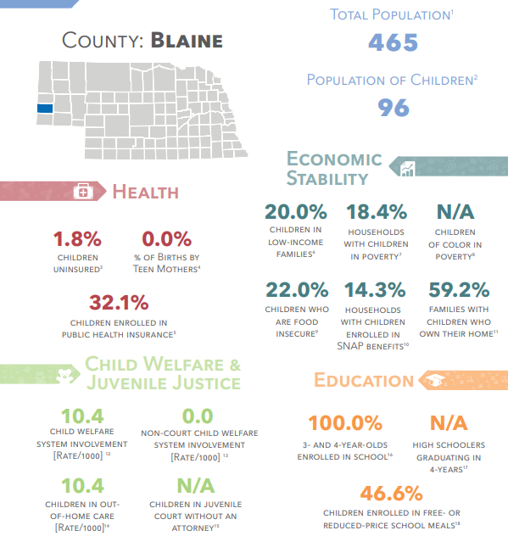
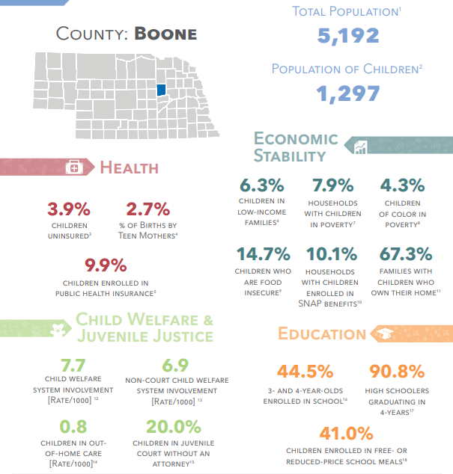

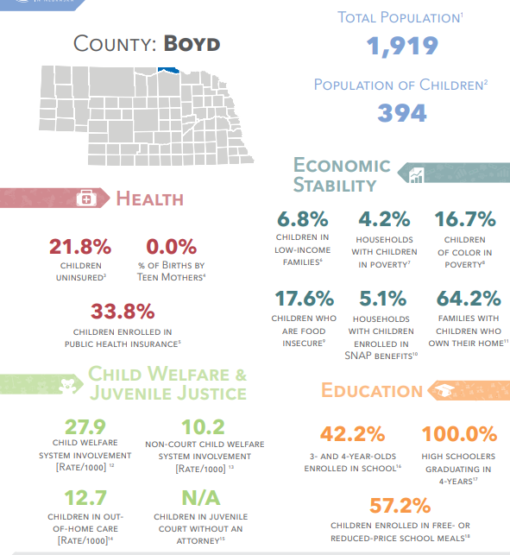

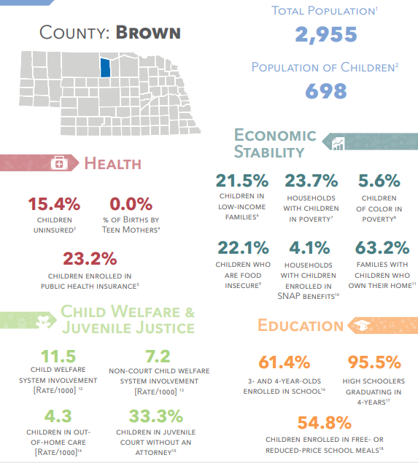
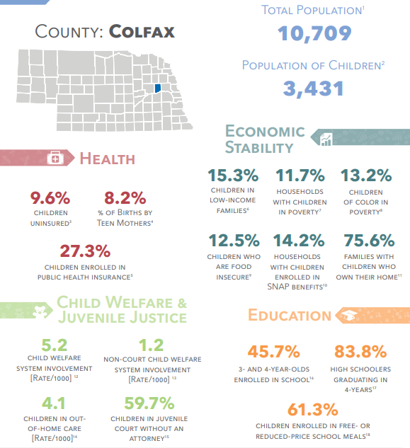

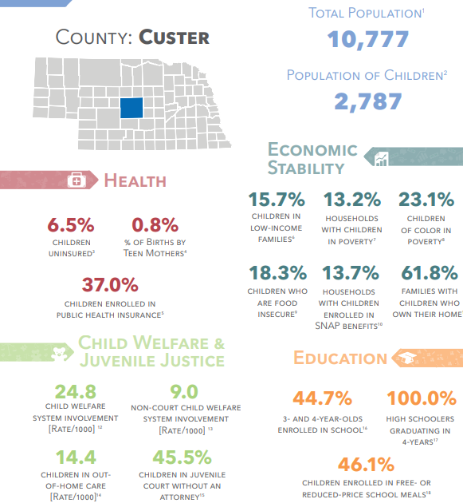

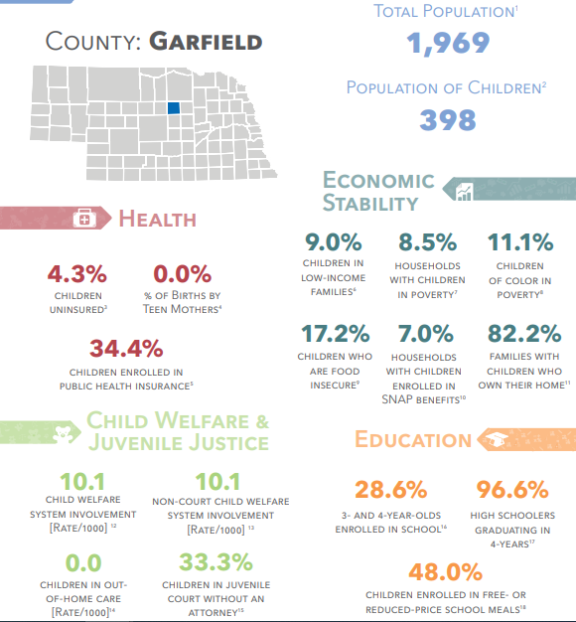

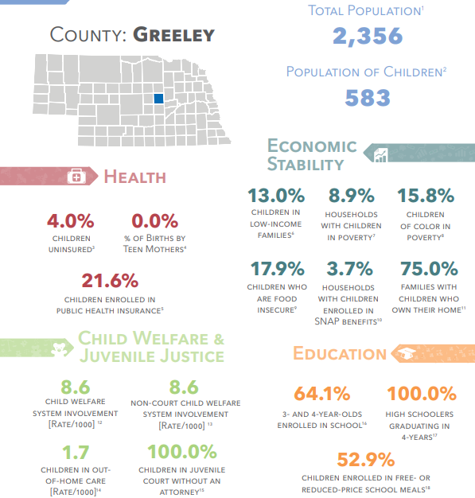

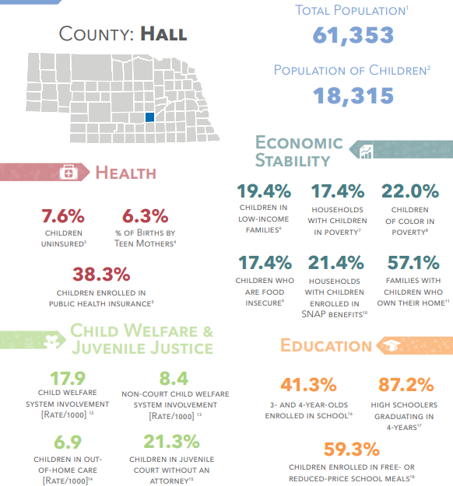

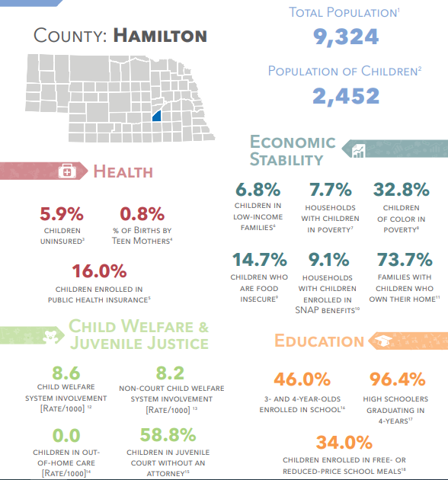

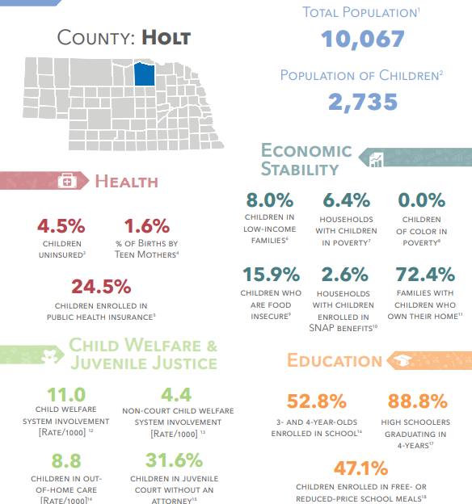

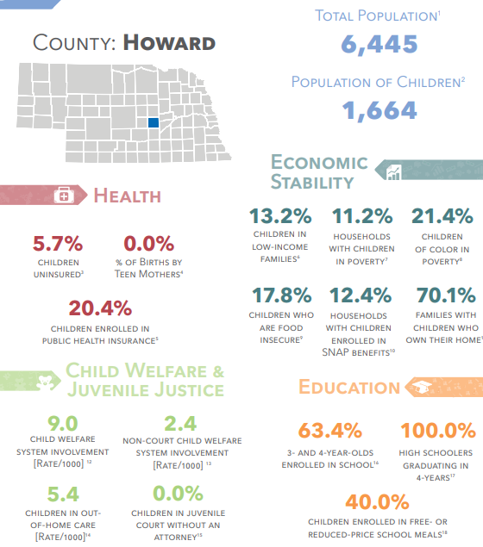

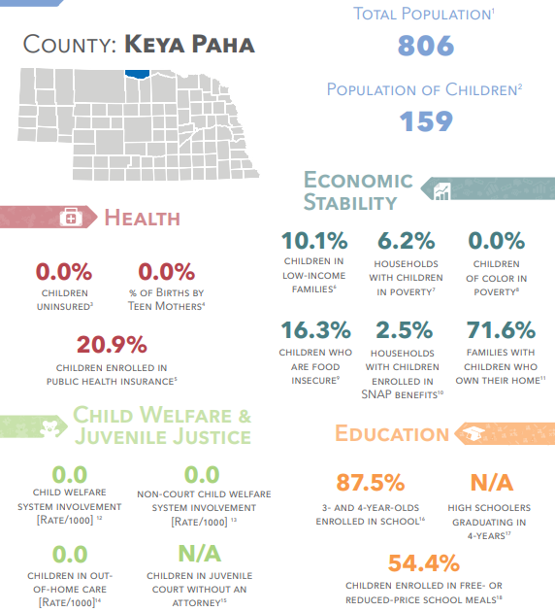

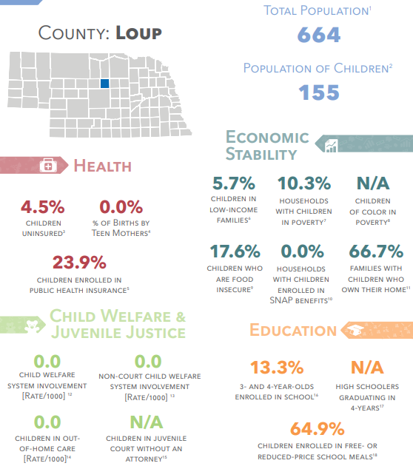

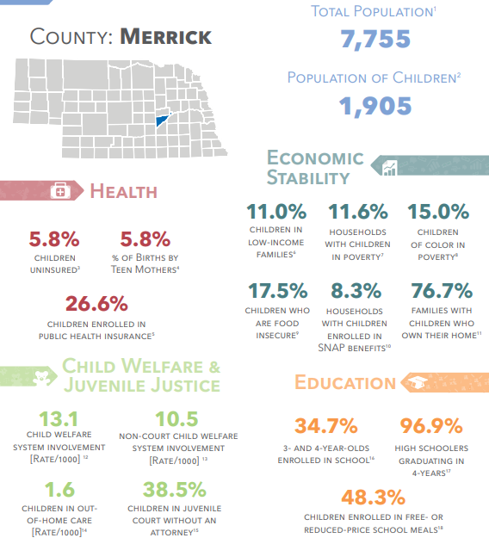

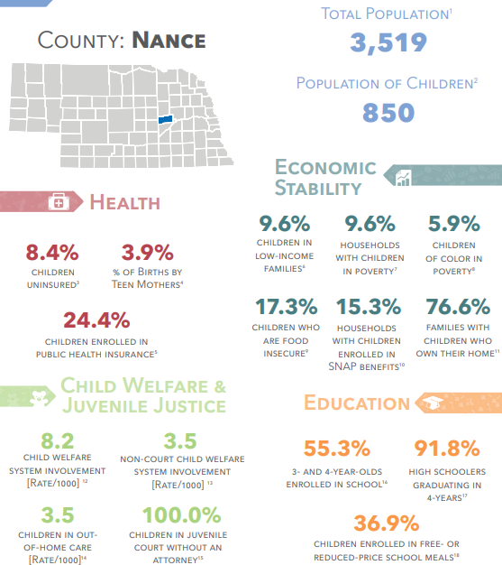

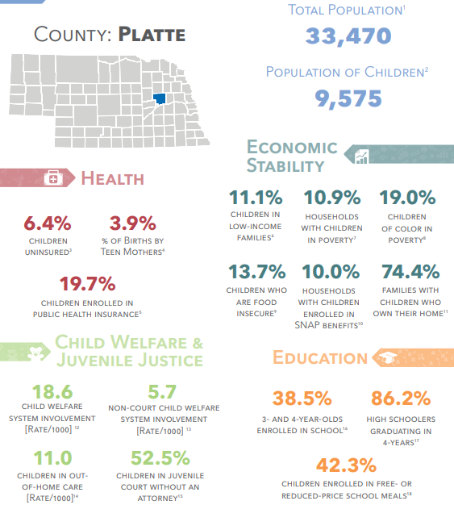

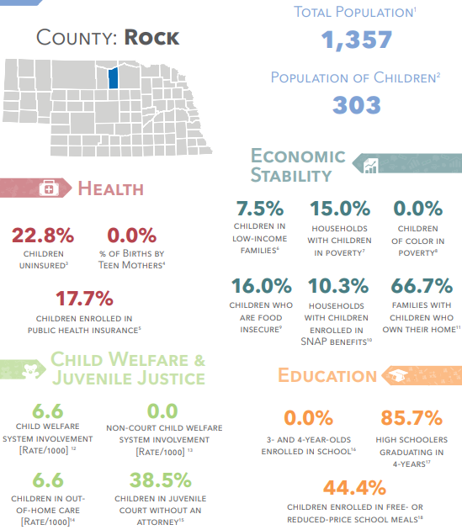

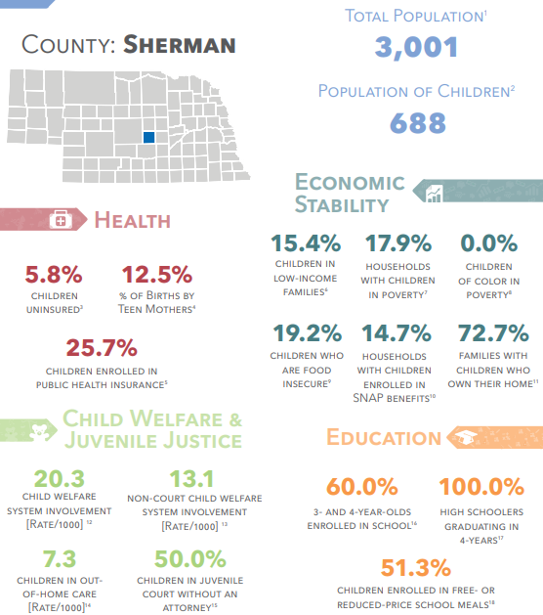

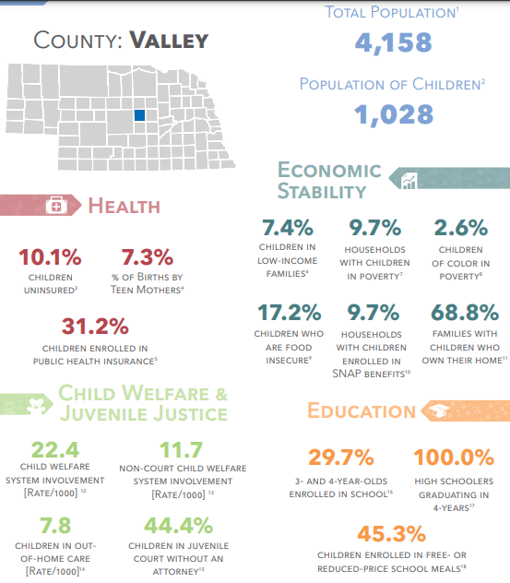

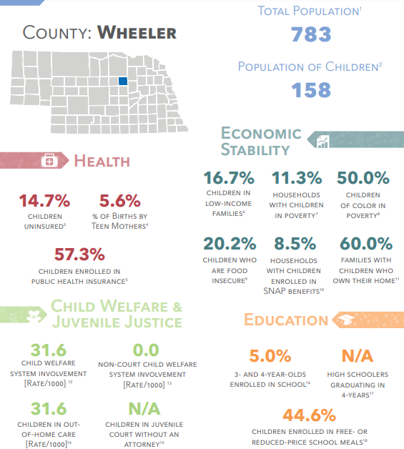

https://voicesforchildren.com/wp-content/uploads/2021/02/County-Fact-Sheets-All.pdf

The demographics of the CNCAP service area is essential to the programs and their efforts. From determining each and every community need, to the needs of a specific family, the data and research provided helps to make a difference in the lives of every community. This helps to determine where we can utilize our best efforts to encourage both growth and stability among each and every community. By knowing the age of the population among our service area, we can identify their specific needs. The aging population spends more on health care and commuting to places of need, while the younger population is concerned about access to quality income, daycare, education for their children. These may be harder to access in rural communities due to distance and lack of availability.
Economy
Income
Median income is the amount which divides the income distribution into two equal groups, half having income above that amount, and half having income below that amount. Mean income (average) is the amount obtained by dividing the total aggregate income of a group by the number of units in that group. The means and medians for households and families are based on all households and families. Means and medians for people are based on people 15 years old and over with income. — US Census Bureau, Frequently Asked Question, published by First Gov.^{[23]}

Below is the median household income comparison from the 2020 ,2021, and 2022 Community Needs Assessment.
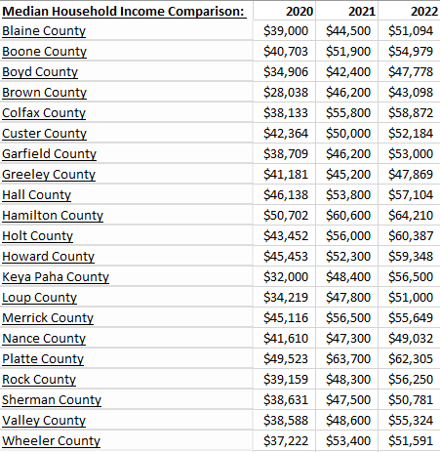
https://cap.engagementnetwork.org/

The cost of living in CNCAP counties ranked among the 93 counties:
- Boone county is ranked 9
- Holt county is ranked 11
- Colfax county is ranked 13
- Custer county is ranked 21
- Merrick county is ranked 24
- Hamilton county is ranked 36
- Howard county is ranked 37
- Platte county is ranked 41
- Hall county is ranked 49
- Blaine county is ranked 60
- Boyd county is ranked 61
- Rock county is ranked 63
- Greeley county is ranked 64
- Wheeler county is ranked 67
- Keya Paha county is ranked 68
- Sherman county is ranked 69
- Garfield county is ranked 71
- Nance county is ranked 72
- Brown county is ranked 77
- Valley county is ranked 81
- Loup county is ranked 87
https://www.niche.com/places-to-live/search/counties-with-the-lowest-cost-of-living/s/nebraska/?page=4

In order to live comfortable in the state of Nebraska, a person needs to make $51,520 annually in order to afford the average home. This is based on a 30-year mortgage with a 10% down payment. Housing is the biggest drain on a person’s paycheck. In order to rent a home, a person needs to make $4,137 per month in order to live comfortably. The most profitable industry in Nebraska is the meat industry. https://www.onlyinyourstate.com/nebraska/cost-of-living-in-ne/

Four counties within the CNCAP service area had towns listed in the top ten rising income Nebraska cities within the last five years. Hall county, Custer county, Boone county and Garfield county all have a city with a rising income listed.

Rising income by county:
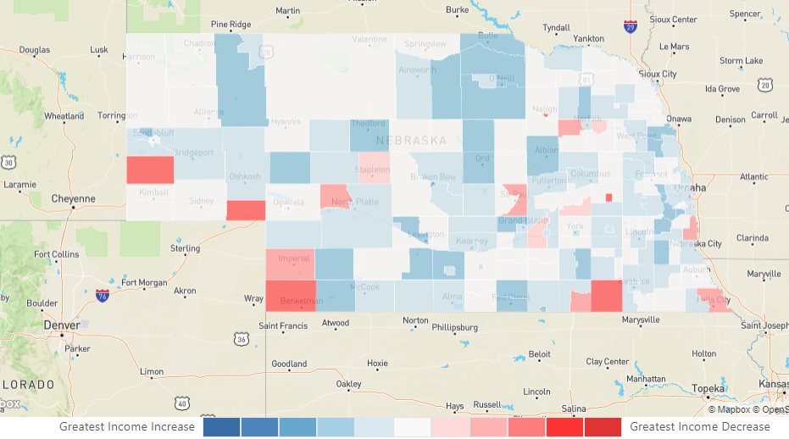
https://www.neighborhoodscout.com/ne/demographics

One program that CNCAP offers to assist low-income households with their finances is the HOPE (Hope Offers People Empowerment) program which is case management that focuses on the strengths of the family and provides intensive support services to families/individuals that want to address challenges and improve their quality of life. This program is available to all 21 counties and Cherry county. HOPE assisted 9 households in 2021 and 9 benefactors. The program saved $131.00 in debt for 1 household and 3 benefactors. The savings accumulated was $2,187 from one household and 2 benefactors.

Poverty
Poverty in Nebraska is defined as an income threshold of $25,465 for a family of four with two children or $17,308 for a single parent of one child. Keya Paha has the second highest poverty rate in Nebraska with 131 people living in poverty. Loup county is fourth with 98 people living in poverty. The total population of the CNCAP service are that are living in poverty is 17,365 which is a poverty rate of 11.22%. 11.5% of households with children are in poverty. There are 8,360 males living in poverty, 9,507 females and 2,041 children living in poverty between the ages of 0-4, which is 16.95%
Below is a comparison between the 2020, 2021, and 2022 Community Needs Assessment households living in poverty. The average per the CNCAP service area was 12.53% in 2020, 9.76% in 2021, 11.22% in 2022. There was a notable change in Keya Paha county going from 18.30% to 6.06% and back to 17.03% over the last three years. Rock county was similar with changes of 14.60% to 7.44% back to 14.26%. These are counties with smaller populations, which will cause the changes to vary at a larger rate.

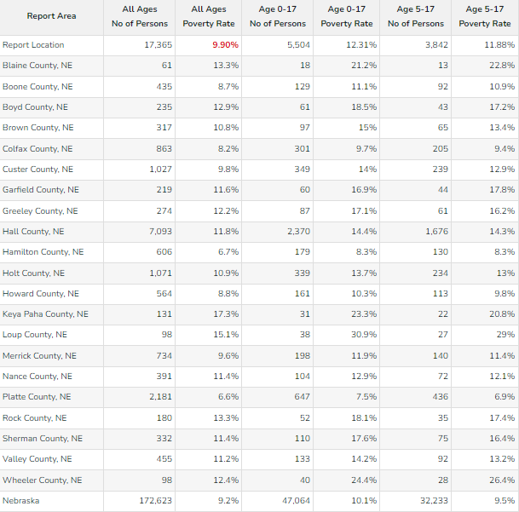
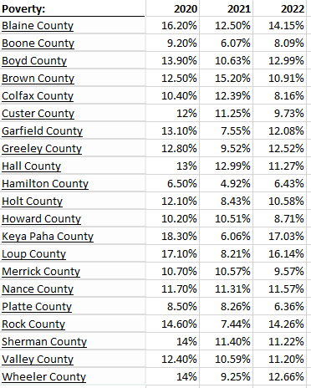
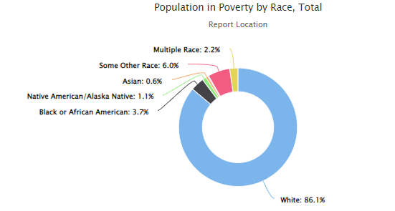
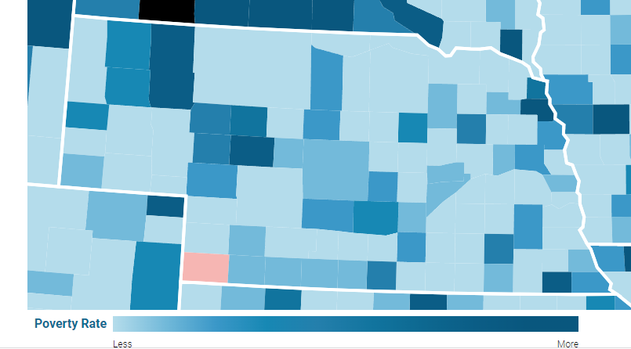
https://www.povertyusa.org/data/2019/NE

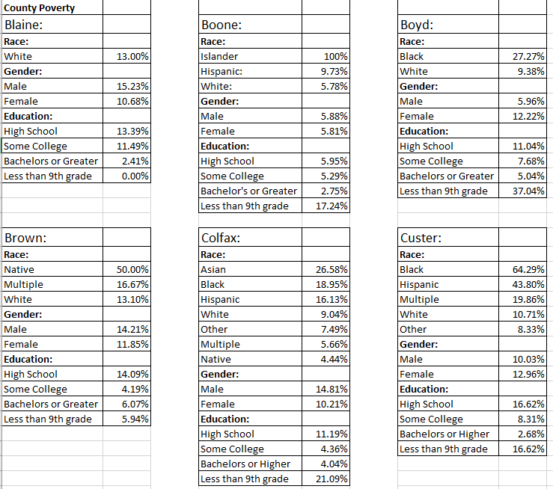

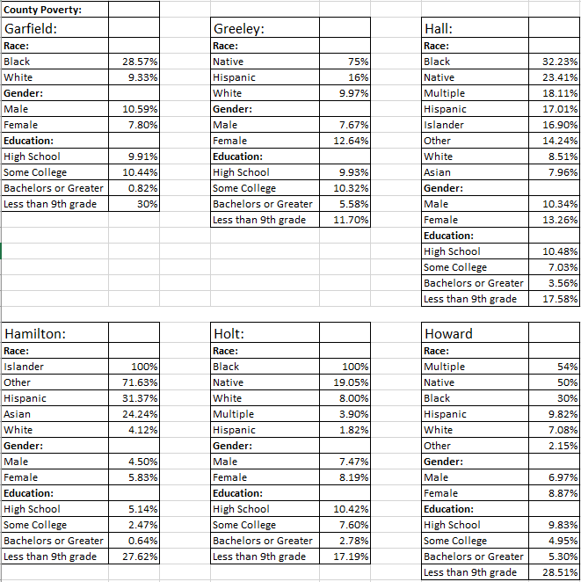

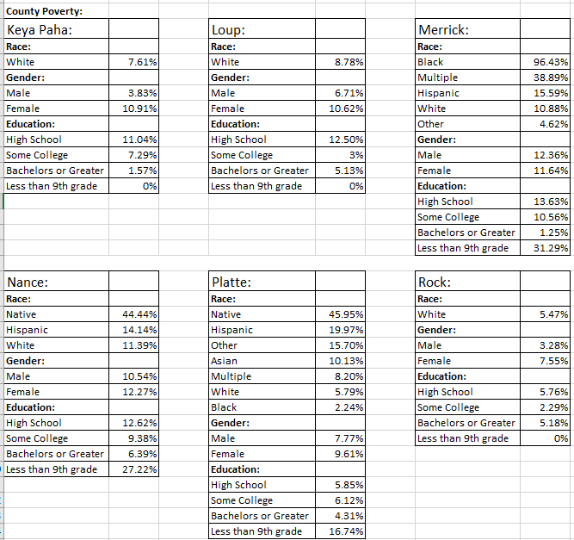

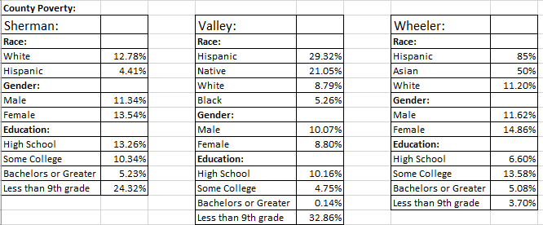
https://worldpopulationreview.com/us-counties/ne/wheeler-county-population
Federal Poverty Guidelines

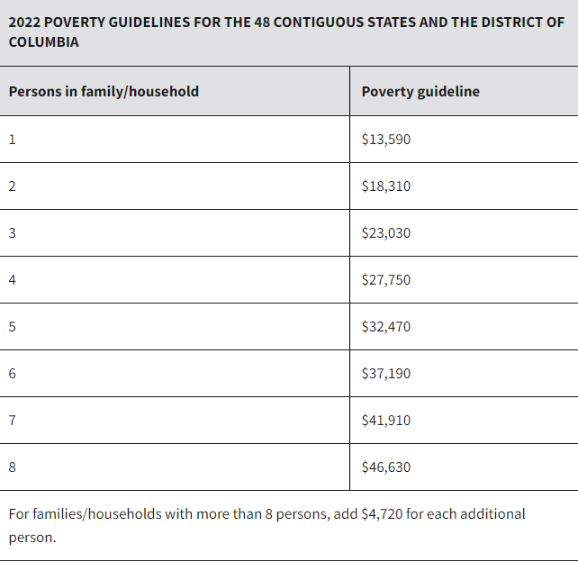
https://aspe.hhs.gov/topics/poverty-economic-mobility/poverty-guidelines

Cost of living impacts families and their abilities to meet their children’s basic needs. According to the U.S. Department of Agriculture, the average cost of raising a child to 18 years old is $272,049. Those numbers do not include other expenses such as sending a child to college. The largest cost associated with raising a child is housing, followed by food.
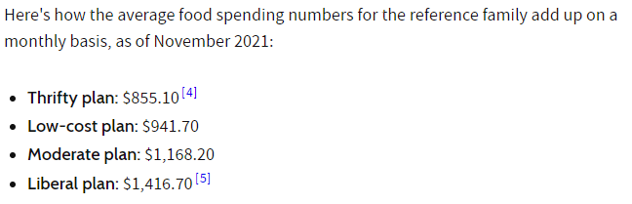
At the low end, a typical family of four is spending $10, 261.20 per year on food at home. On the high end, they’re spending $17,000.04 per year on food. 25% of their income, based off the median household income, is being spent on food.
Other expenses not factored in are:
- Transportation
- Healthcare and insurance
- Clothing
- Extracurricular activities
- Sports and hobbies
- School fees for field trips, activities, fundraisers, etc,
- Family trips or vacations
A family can expect to pay $1,411 in car insurance premiums. The average driver spends $3000 a year on fuel. The average mileage per year in the state of Nebraska is 10,952 miles a year. Average healthcare premiums for a single adult are $5,556 a year and the average for a family of four is $16,786. This is quite a bit more than the national average of $12,950. The average annual cost of childcare in Nebraska is $7,815. The average working adult in Nebraska pays $5,743 annually in taxes.
Cost of living per family of four per county:
Blaine: $84,889.33; 41st least expensive county
Boone: $84,518.55; 32nd least expensive county
Boyd:$84,860.33; 39th least expensive county
Brown: $88,746.33; 18th most expensive county
Colfax: $83,518.16; 19th least expensive county
Custer: $84,240.16; 28th least expensive county
Garfield: $83,765.34; 22nd least expensive county
Greeley:$85,191.31; 47th least expensive county
Hall: $88,474.05; 20th most expensive county
Hamilton: $89,836.53; 5th most expensive county
Holt: $84,700.81; 36th least expensive county
Howard: $86,953.85; 36th most expensive county
Keya Paha: $85,143.67; 45th least expensive county
Loup: $85,435.59; 46th most expensive county
Merrick: $86,936.55; 37th most expensive county
Nance: $84,871.58; 40th least expensive county
Platte: $85,712.21; 44th most expensive county
Rock: $84,146.77; 27th least expensive county
Sherman: $84,566.72; 33rd least expensive county
Valley: $83,715.56; 21st least expensive county
Wheeler: $85,578.63; 45th most expensive county
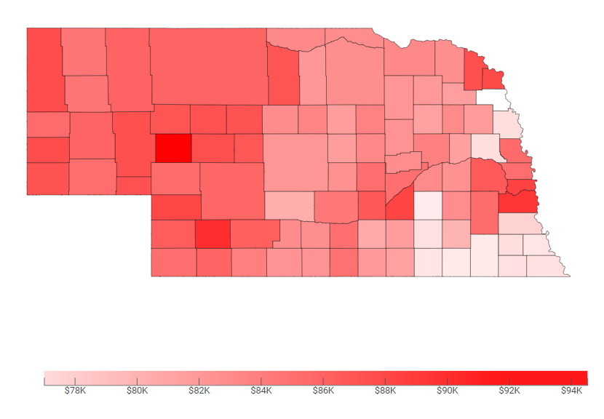
https://247wallst.com/state/cost-of-living-in-nebraska/

Employment/Unemployment

The Bureau of Labor Statistics released the state unemployment data for April 2020, which broke the record for being the highest rate in the history of Nebraska at 8.3% or the equivalent of 86,300 people. This rate nearly tripled from just a couple of months earlier, when the employment rate was 2.9% in February of 2020. This caused a lot of businesses to close permanently which affected job availability as small businesses and entrepreneurs are the spine of Nebraska’s economy. As of December 2021 the employment rate in Nebraska was 2.3%. As of November 2021 the unemployment rate of the CNCAP area was 1.1%, with 999 unemployed out of 92,385. Blaine County had the highest unemployment rate of the 21 counties at 1.7%.
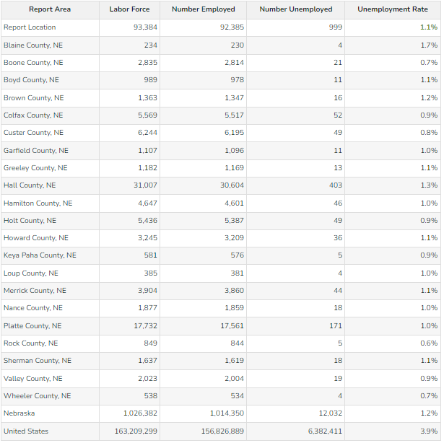

Below is the employment/unemployment rates per county for 2019 and 2020 for comparison. In 2019 there were 93,273 employed within the CNCAP service area and 2,936 unemployed. In 2020 there were 91,867 employed and 3,897 unemployed. In 2021 there were 93,385 employed and 999 unemployed. In 2019 the unemployment rate was 3.1% and as of 2021 the unemployment rate is 1.1%
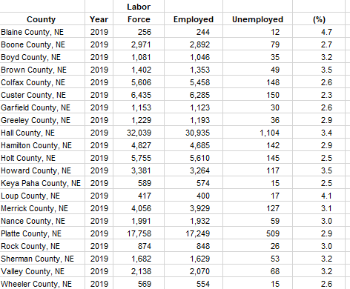
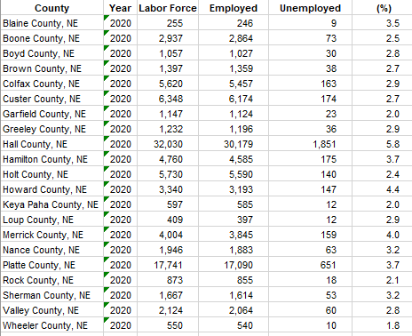
https://www.bls.gov/lau/home.htm#cntyaa

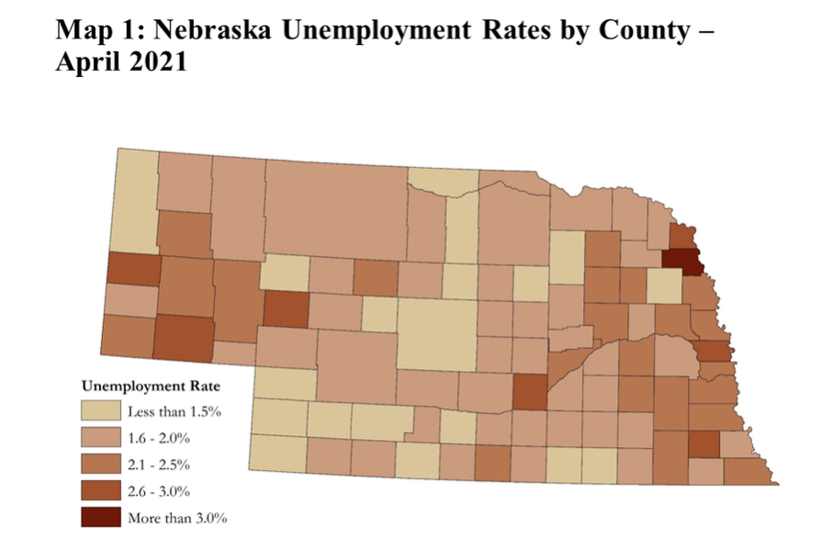
https://www.kansascityfed.org/omaha/nebraska-economist/Remote-Work-a-Challenge-and-Opportunity-for-Nebraska/

As challenges arose during the pandemic, a spiral began. As childcare facilities closed, parents were left with no other option than to stay home. Some cut their hours, some turned down promotions and some left the work force entirely. Those that had to work, relocated to where the opportunities were readily available, negatively impacting the rural communities across Nebraska. The number of young people staying in their hometowns or moving home continues to steadily decline. This affects businesses being able to find help or being able to stay open. Jobs get turned down, or people have to leave their jobs due to the lack of childcare in their communities and then there is not a lot of incentive to fill those vacant positions. According to a news release from the Hays Post, “Labor shortages plagues Midwest—with no easy solution.” In the rural areas of western Kansas and Nebraska, there are a handful of counties posting unemployment rates above 2%, which is a direct impact of the continuing worker shortage challenging communities. An economist from Creighton University said the worker shortage is among the top one or two concerns for most employers and cited three main factors as the cause: the pandemic is still at the top of the list for the majority of those who have dropped out of the labor pool entirely. “There are individuals out there who just don’t want to return to work,’ economist Ernie Goss stated, “there is a low participation rate, where people are not counted as either employed or unemployed”

Transportation

Due to housing shortages, lack of available jobs, or significant wage gaps, many people of the CNCAP service area commute to work. 79.6% of the workers within the CNCAP area drive alone to work, while 9.9% carpool and .2% use public transportation. 34.72% of the workers commute less than 10 minutes. 48.35% commute between 10-30 minutes and 13.44% commute between 30-60 minutes. 3.49% commute more than 60 minutes and the average commute time is 31 minutes. Blaine county is the only county within the service area that does not have public transit available.
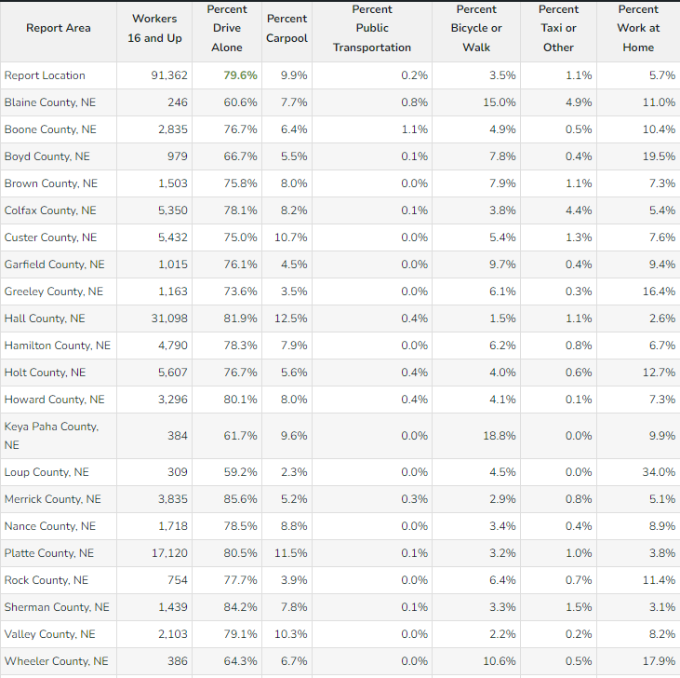

Nebraska average gas prices
One year ago, the average gas price in Nebraska was $2.371 for regular gasoline. In 2019 the average was $2.07. The current average as of 1/31/22 is $3.170 for regular gasoline. The increase in gas prices is yet another challenge community-members face when commuting to work due to housing shortages and lack of job availability, especially in rural counties. Another issue the rural population faces is having to commute due to shortages or lack of access to quality daycare. Community members within the service are may have to commute one way to drop their children off at daycare and then commute another direction just to get to work. As fuel prices increase, their expenses increase as well, adding another stressor to their financial situations.

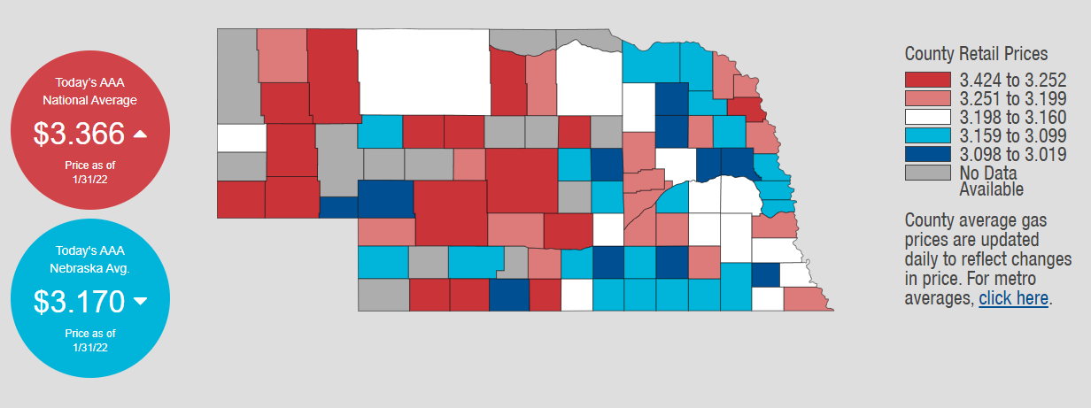

https://gasprices.aaa.com/?state=NE

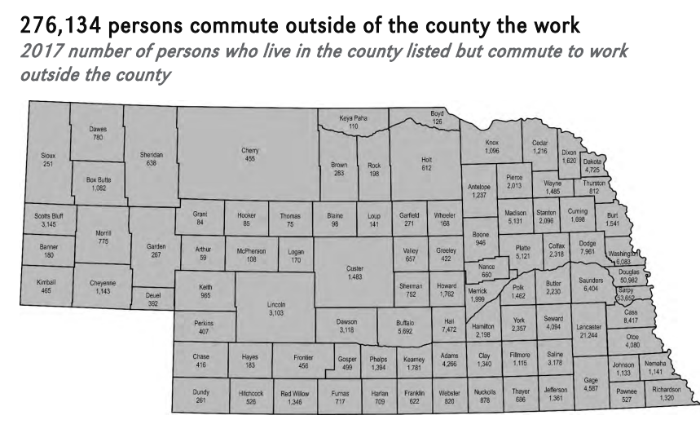
https://www.unomaha.edu
Health
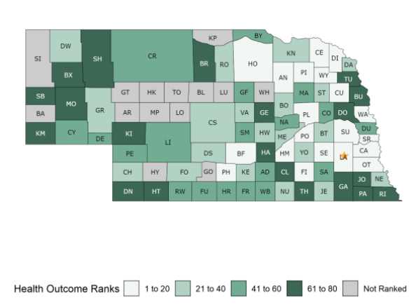
https://www.countyhealthrankings.org/app/nebraska/2021/downloads

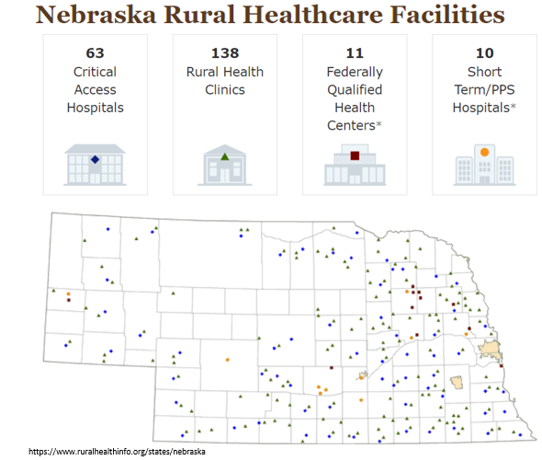

Access to Healthcare
As the population in rural communities decline, other services become even harder to access. Quality healthcare in rural areas has been directly affected by the lack of opportunities in the area. According to Council for a Strong America, “29 of the state’s 71 rural hospitals operate t a deficit, and many others are struggling.”
- In 13 Nebraska rural counties, there are no primary care doctors.
- There are only 2 federally qualified health centers in the CNCAP service area: Heartland Health Center in Hall County and Good Neighbor Community Health Center in Platte County.
- 17 of the 93 counties have no pharmacist.
- Only 39 counties have active OB/GYN
- 14 of 93 counties have no practicing primary care physician (although many of those counties have populations less than 1000 and would likely not be able to support a full-time physician)
- Nebraska is ranked fifth in the nation for early childhood obesity from ages 2-4.
- Children who are obese between the ages of 2-5 are four times more likely to become overweight or obese as adults. This is affected by less access to nutritional food and also, higher rates of food insecurity.
https://www.kff.org/statedata/election-state-fact-sheets/nebraska/
https://voicesforchildren.com/wp-content/uploads/2021/03/2020-Kids-Count-electronic-final-3-26-2.pdf
https://nebraska.tv/news/local/unmc-health-care-report-shows-rural-communities-need-more-health-care-professionals
https://www.unmc.edu/news.cfm?match=26318

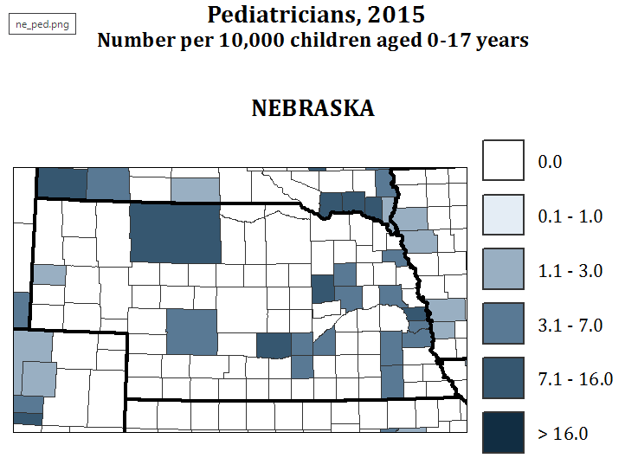
There are a total of 32,488 persons over 65 years old receiving medicaid, and there are 3,497 who are disabled within the CNCAP service area.
https://www.povertyusa.org/data/2019/NE/

Wheeler 21
https://www.countyhealthrankings.org/app/nebraska/2020/downloads
https://cap.engagementnetwork.org/
https://voicesforchildren.com/wp-content/uploads/2021/03/2020-Kids-Count-electronic-final-3-26-2.pdf

Women, Infants, and Children (WIC) aims to improve the health of low-income pregnant, postpartum, and breastfeeding women, infants, and children up to the age of five who are at a nutritional risk. The program provides nutritious foods to supplemental diets, information on healthy eating, breastfeeding promotion and support, and referrals to healthcare.
During 2021 CNCAP’s WIC served:
- 1273 Total Participants
- 301 Women
- 349 Infants
- 591 Children

Central Nebraska Community Action Partnership was awarded a grant for $48,596 for immunization activities supporting the rural clinics in Ord, O’Neill, Loup City, Greeley, St. Paul and Broken Bow. Along with administering the vaccinations, families are provided information and education on the importance of vaccinations for their children. The program focuses efforts on children 0-18 who are uninsured or underinsured, that may have health insurance that doesn’t cover immunizations, or those receiving Medicaid. The funding originates from the Center of Disease Control and is provided to the Department of Health and Human Services Immunization Program.
A total of 557 vaccinations were provided to 261 individuals, with 172 being children during the year of 2021 in the CNCAP service area. Children ages 2-5 are required to receive immunizations to attend a school-based program.

During the 2019-2020 school year, the number of children at Head Start in the CNCAP service area, who were determined by a health professional to be up-to-date on all immunizations appropriate for their age was 289 at enrollment and 231 at the end of the year. The number of children who had received all immunizations possible at the time of evaluation, but had not received all immunizations appropriate for their age was 30 at enrollment and 4 at the end of the year.

Compared to the 2020-2021 with the number of children determined by a health professional to be up-to-date on all immunizations appropriate for their age being 276 at the beginning of the year and 286 at the end. The number of children who had received all immunizations possible at the time of evaluation but had not received all immunizations appropriate for their age was 4 at enrollment and 7 at the end of the year.

From the 2019-2020 school year to the 2020-2021 school year there was an increase in students immunized throughout the school year. The number of children whose immunization needs were not fully met also decreased from one year to the next, going from 30 children to four at enrollment.

Mental and Behavioral Health

Youth affected by the COVID-19 pandemic:

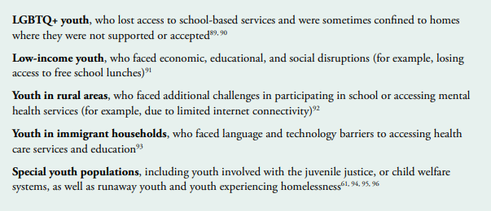
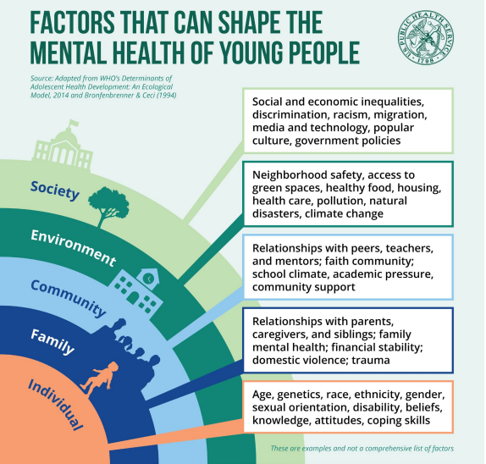
https://www.hhs.gov/sites/default/files/surgeon-general-youth-mental-health-advisory.pdf

Mental health is becoming a critical focus among our population and is finally being more openly discussed and addressed. Mental health includes emotional, psychological and social well-being. It affects how a person thinks, feels, and acts. It also helps determine how stress is handled, how people relate to each other, and how choices are made. Mental health is essential at every stage of life, all of the way from childhood and into adulthood. It is also prevalent in both youth and adults. Especially now, after the mental toll the pandemic had on our people. There are many things that impact mental health, from biological factors such as genes or brain chemistry, life experiences such as trauma or abuse, or family history of mental health problems. The grief, trauma, and physical isolation of the last two years have driven Americans to a breaking point. Our youth have been greatly impacted by disruptions from normal routines and relationships which has increased social isolation, anxiety and learning loss. A study has even found that students are five months behind in math and four months behind in reading as a result of the pandemic. On top of the pandemic, social media platforms have further driven the mental health crisis in the United States. There is great evidence that social media is harmful to kids and teens mental health, well-being, and development. There is a national shortage of mental health providers, and the current mental health system makes it hard for mental health providers to meet people where they are.

One way of attempting to alleviate the shortage is by expanding tele- and virtual mental health care. The use of telehealth has increased since the pandemic and has remained a constant source of mental health care. These tele-mental health services are both safe and effective and help eliminate the barrier of access to care.

According to Voices for Children, an estimated 47,691 Nebraska children have been diagnosed with a mental/behavioral condition in need of treatment. This has increased from 44,543 in the last year. These behavioral health problems inhibit children’s ability to participate in everyday childhood activities.
The National Survey of Children’s Health estimates the number of Nebraska children facing the following disorders.
- Anxiety: 34,079
- ADD/ADHD: 26,562
- Depression: 17,082
- Autism Spectrum Disorder: 9753
Only 61% of children needing mental health actually received it. A total of 37,887 children received behavioral health services through Medicaid.
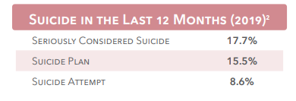
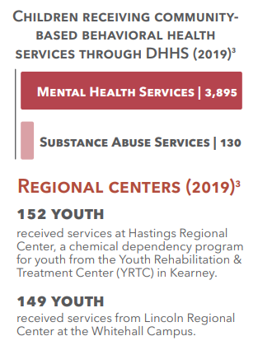
https://voicesforchildren.com
Where there is a lack of access to mental healthcare, more long-term issues arise. People who need help don’t receive it, whether it be because they can’t afford it or because it is not readily available to them. They go without the help they need and it impacts not only their lives but the lives of the people around them.
- 1,037,974 people in Nebraska live in a community that does not have enough mental health professionals
- 60.1% of Nebraskans age 12-17 who have depression did not receive any care in the last year.
- High school students with depression are more than 2x more likely to drop out than their peers.
- 2,404 people in Nebraska are homeless and 1 in 4 live with a serious mental illness.
- 271 lives were lost to suicide in Nebraska and 61,000 adults had serious thoughts of suicide last year.
- 1 in 4 people with a serious mental illness have been arrested by the police at some point in their lifetime. 2 million jail bookings of people with serious mental illness every year.
- 2 in 5 adults in jail or prison have a history of mental illness.
- 7 in 10 youth in the juvenile justice system have a mental health condition.

Nebraska is ranked 13th in the prevalence of mental illness as of 2020. According to SAMHSA, Any Mental Illness (AMI) is defined as having a diagnosable mental, behavioral, or emotional disorder, other than a developmental or substance use disorder. Any mental illness includes persons who have mild mental illness, moderate mental illness, and serious mental illness." 18.08% of Nebraska adults have some sort of mental illness, equaling 257,000 people in the state. 4.5% of adults have serious thoughts of suicide in the past year.
https://www.nami.org/NAMI/media/NAMI-Media/StateFactSheets/NebraskaStateFactSheet.pdf
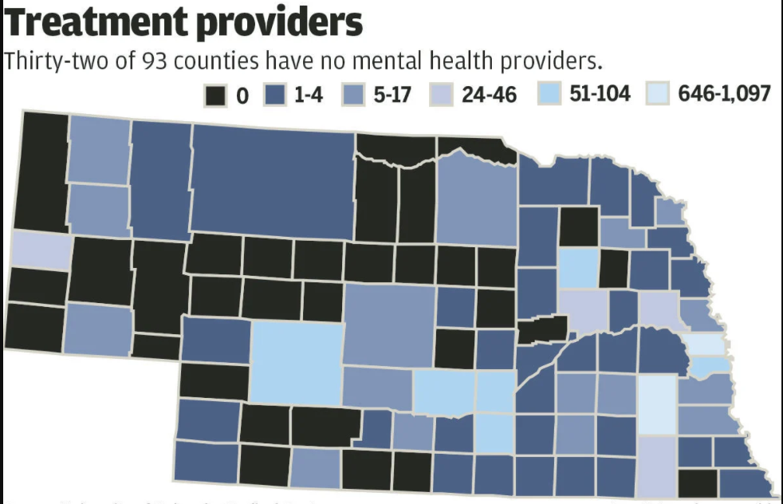

https://journalstar.com/news

Lack of mental health providers poses a huge issue among rural Nebraska. Within the CNCAP service area Keya Paha, Boyd, Brown, Rock, Blaine, Loup, Garfield, Wheeler, Greeley, Sherman and Nance counties do not have a mental health provider. Many of the families in these counties have to drive over an hour to access mental and behavioral health care. While 32 of the 93 counties have no mental health care provider, 88 of the 93 counties are designated as behavior health shortage areas. This is a massive issue within Nebraska, as that means only five counties within the entire state have adequate mental health providers. As mental health, substance abuse, anxiety and depression continue to increase, the need for mental and behavioral health providers becomes more prevalent. One of the major impacts on this issue is the fact that there is a lack of training opportunities for behavioral and mental health. If a student wants to obtain a graduate degree they will have to move to the Lincoln or Omaha area which lessens the likelihood that they return back home to their small towns.
ECP Staff of the CNCAP service area work with a mental health consultant to resolve issues regarding social-emotional challenges or behavioral concerns that may point to autism, a parent having a high depression scale, concerns pertaining to the child, concerns about a family or a personal wellness problem which a staff member may be facing. Depression Scales are a set of questions asked by the staff to a parent to assess their mental wellbeing. This is most often done on pregnant mothers or mothers who have recently given birth but CNCAP has recently implemented doing them on fathers as well, in order to make sure all child caregivers are doing okay mentally. These meetings are held via zoom as topics arise, where staff can talk with the consultant about the various situations. While the consultant does not meet directly with the children, he does observe the Head-Start locations throughout the service area so he can better advise staff members. During the year of 2021 there were 31 cases discussed:
- 15 children had high ASQ:SE-2 (emotional development)
- 4 parents had high depression scales
- 2 site observations were completed by the mental health consultant
- 10 teacher concerns about behaviors in children/families
- Not included in the 31 cases, there were also 14 child abuse/neglect reports

In addition to meeting with a consultant regarding concerns for children in their programs, staff also have the opportunity to receive consultation with any personal issue they may be experiencing. During the year of 2021, 20 staff members took advantage of this option, which is significant compared to 2020, when zero staff participated. The effects of the pandemic, the stresses of child behaviors from the shutdown and mandates, and extensive protocols have impacted the mental health of staff members as well as the children.

This pandemic has specifically affected young people. Children 11-17 who struggled with their mental health increased by 9% from 2019. Over half of the children reported experiencing frequent suicidal thoughts. A survey given to parents of young children by National Alliance on Mental Illness found that 35% of parents take serious consideration of their child’s mental health now more than before the pandemic. 44% are concerned about their child’s mental health, but only 16% sought help for them. Many parents reported changes in their kids’ activities and behaviors since the pandemic began, more of them being negative.
- 41% spend more time on screens
- 37% participate less in school activities
- 25% play or exercise less
- 16% are getting less sleep.
Parents who reported changes also said their kids are feeling:
- 20% anxious
- 19% irritated
- 14% sad
- 13% unable to concentrate
- 12% less interested in social activities
- 10% out of control.

Research has shown that high school students with significant symptoms of depression are more than twice as likely to drop out compared to their peers. Students aged 6-17 with mental, emotional, or behavioral concerns are more likely to repeat a grade. 37% of adults incarcerated in the state and federal prison system have a diagnosed mental health condition. 70% of youth in the juvenile justice system have a diagnosable mental health condition.
https://mhanational.org/sites/default/files/Spotlight%202021%20-%20COVID-19%20and%20Mental%20Health.pdf
https://www.americashealthrankings.org/explore/annual/measure/Depression_a/state/NE
https://www.nami.org/Support-Education/Publications-Reports/Survey-Reports/Poll-of-Parents-Amid-the-COVID-19-Pandemic-(2021)
https://www.kff.org/statedata/mental-health-and-substance-use-state-fact-sheets/nebraska
https://www.3newsnow.com/news

Infant/Child Mental Health

Infant mental health is defined as the healthy social and emotional development of a child from birth to three years. This also includes the promotion of social emotional wellbeing of other young children as well. Responsive relationships with consistent primary caregivers help build positive attachments that support healthy social-emotional development. The foundation of mental health for infants, toddlers and preschoolers is laid by these relationships.
Children’s mental health disorders include: anxiety, depression, oppositional defiant disorder, conduct disorder, attention-deficit/hyperactivity disorder, Tourette syndrome, obsessive-compulsive disorder, post-traumatic stress disorder according to https://www.cdc.gov.
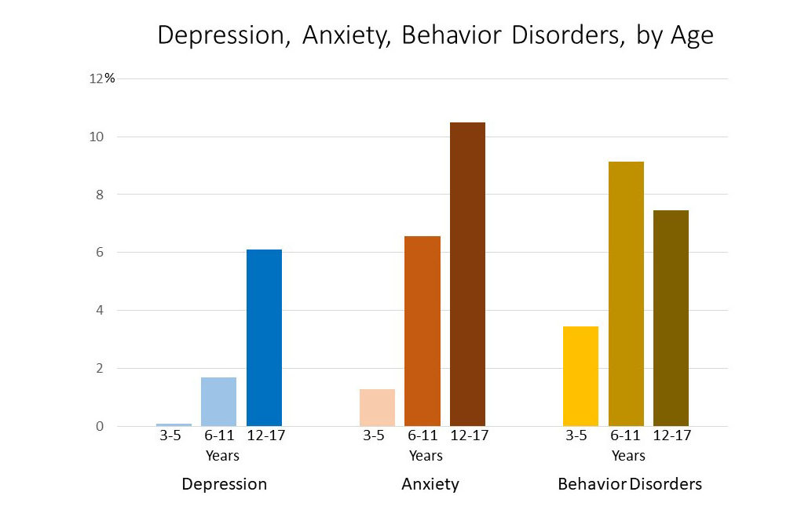
https://www.nebraskachildren.org
- Among children aged 2-8 years, boys were more likely than girls to have a mental, behavioral, or developmental disorder.
- Among children living below 100% of the federal poverty level, more than 1 in 5 (22%) had mental, behavioral, or developmental disorder.
- Age and poverty level affected the likelihood of children receiving treatment for anxiety, depression or behavior problems.
- 22,000 Nebraskans age 12-17 have depression.
Adolescent Mental Health
Nebraska is ranked 20 for youth with at least one major depressive episode in the year of 2020. 13.1 or 20,000 Nebraska youth had a major depressive episode (MDE) in 2020. 9.5% of students identified with Emotional Disturbance for an Individualized Education Program in 2020. Emotional disturbance (ED) is used to define youth with a mental illness that is affecting their ability to succeed in school. Inadequate education leads to poor outcomes, such as low academic achievement, social isolation, unemployment, and involvement in the juvenile system. 2,664 students in Nebraska have ED.
Common behavioral signs that might detect mental health problems:
- Changing groups of friends
- Irritable or short-tempered
- Eating or sleeping problems
- Alcohol or drug abuse
- Talk about death or suicide
- Increased period of depression or agitation
- Running away from home
- Starting fires
- Lack of interest in favorite activities
- Increased arguments or disobedience
- Suicidal thoughts or gestures
- Physical complaints and hyperactivity
- Treatment options include individual and family counseling, psychological evaluations and transitional services from mental health inpatient and partial hospitalization to outpatient counseling.

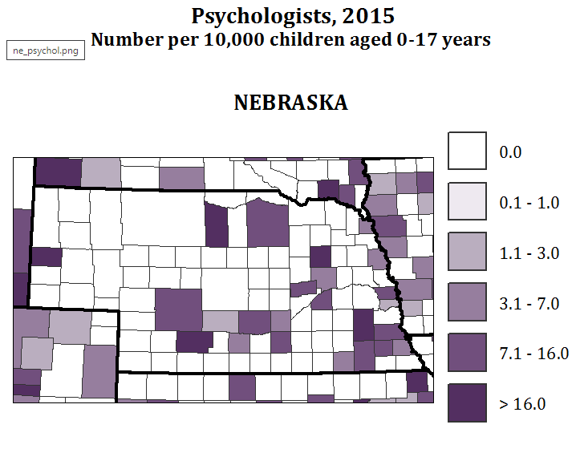
An essential part of treating behavioral issues among adolescents is having a psychological evaluation. However, this poses a huge threat to the CNCAP service area, as there are only five counties that have access to psychologists within their area. https://www.bryanhealth.com/services/counseling-mental-health/youth/

Adult Mental Health

COVID-19 has tremendously impacted mental health across the country. The number of people looking for help with anxiety and depression has skyrocketed in less than one year. Since the pandemic 37% of the people screened reported having thoughts of suicide more than half or nearly every day of September 2020. 11.9% of adults reported serious thoughts of suicide in Nebraska in the month of September 2020. 33% of adults reported symptoms of anxiety and/or depressive disorder from September 29-October 11, 2021. Yet is was 20.3% in 2019. In February 2021, 33.8% of adults in Nebraska reported symptoms of anxiety or depression. 21.5% of those people were unable to get the counselling or therapy they needed. Suicide increased 38% from 12.0 to 16.5 deaths per 100,000 population between 2015 and 2019. 15.5% of adolescents and 7.6% of adults in Nebraska reported having a major depressive episode in the last year.
- 28% of adults in Nebraska reported insufficient sleep in 2020.
- 16.8% had depression
- 62,000 adults in Nebraska experience serious mental illness each year.
- Of the 77,000 adults in Nebraska who did not receive needed mental health care, 41.9% did not because of cost.
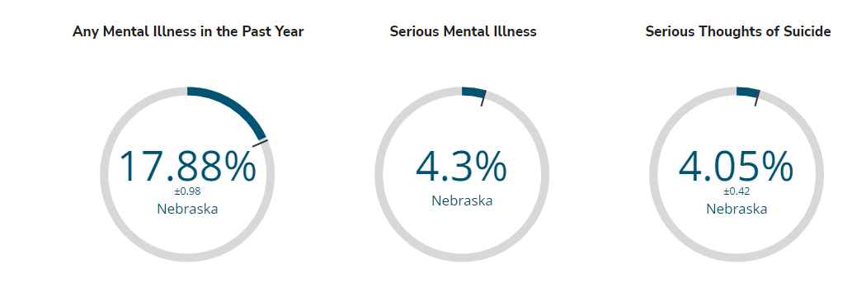
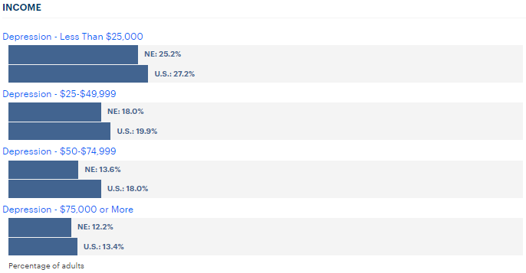
- 25.2% of Nebraskan’s who make less than $25,000 were depressed, compared to 12.2% of Nebraskan’s who made $75,000 or more.

Substance Abuse
There has been an increased concern around substance abuse during the pandemic. Deaths due to drug overdose have increased in Nebraska from 6 per 100,000 in 2015 to 11 per 100,000 in 2020. Prior to the pandemic, 0.3% of people age 12 and older reported opioid dependence or abuse in the past year. Since the pandemic 1.8% of adolescents and 6.1% of adults in Nebraska reported having alcohol use disorder in the past year. 2.7% of adolescents and 2.5% of adults have an illicit drug use disorder in the past year. Nebraska is ranked 20th for youth with a substance use disorder in 2020.
90,000 adults in Nebraska reported an unmet need for mental or behavioral health treatment in the past year. This may be for various reasons such as lack of insurance, lack of treatment centers, 37,000 people did not receive care because of the cost. Seeing as there are 17 counties within the CNCAP service area that lack mental and behavioral health, this proves to be a major issue. Through surveys sent out by CNCAP, 60% of our area board members categorized drug abuse and opioid addiction as a greatest need within our service area.
News paper headlines:
“Two individuals have been indicted on federal drug charges for incidents in central Nebraska-Grand Island.” These individuals were charged with one count of conspiracy to distribute more than 50 grams of methamphetamine. This happened in August 20, of 2021.
“Columbus woman sentenced for conspiracy of methamphetamine distribution”. This woman was sentenced in federal court for conspiracy to possess with intent to distribute 132 grams of methamphetamine. This happened in December of 2021.
“Grand Island police arrest unconscious man in running car”. This man was found with meth and marijuana on his person during the arrest. It was later found he had previous charges in Custer county in 2019. This happened in January of 2022.
“Drug Busts Increase in Valley County” an article written in the Ord Quiz states that over one weekend there was one arrest for felony possession of a controlled substance on January 21. The following day there was another arrest in Valley county for felony possession of a controlled substance, another arrest for felony possession of a controlled substance, criminal impersonation and obstructing a police officer, another transient was booked for felony possession of a controlled substance—both meth and cocaine—possession with intent to distribute, tampering with physical evidence, possession of a deadly weapon by a prohibited person, escape and resisting arrest. Along with multiple drug arrests, Valley County Sheriff’s Office noted a marked increase in local cases of burglary and theft in the area, typically in rural areas which are directly related to the drug activity which has been escalating. A K9 unit has been hired to help with the drug problem and hopefully reduce drug crimes within the area.
“Troopers located 33lbs of meth during I-80 traffic stop” The man was arrested with possession of methamphetamine, possession with intent to distribute, and no drug tax stamp.
The increase of arrests being made for drug distribution within the CNCAP service are, and repeat arrests further proves the issues of the lack of access to proper treatment and the negative impact of COVID on mental health which is still being dealt with today. The United States Attorney for the District of Nebraska’s office sees between 600-700 cases a year. Of that, half of the cases are related to drugs and a large majority of those cases involves meth. “We are seeing more and more cases where dealers are being located in smaller counties. It’s not just Lincoln and Omaha anymore, said Jan Sharp, US attorney for the District of Nebraska.
https://www.wowt.com/2021/12/10/columbus-woman-sentenced-conspiracy-methamphetamine-distribution/
https://www.ksnblocal4.com/2022/01/06/gi-police-arrest-unconscious-man-running-car/
https://foxnebraska.com/newsletter-daily/raquel-bloom-douglas-schmidt-indicted-on-federal-drug-charges-for-central-nebraska-drug-busts

https://www.livestories.com/statistics/nebraska/mental-health-overview
https://mhanational.org/issues/2020/mental-health-america-prevalence-data#one

Disabilities
The term “disability” means: A physical or mental impairment that substantially limits one or more major life activities; a record of such an impairment; being regarded as having such an impairment. The term disability does not include homosexuality, bisexuality, transvestism, transsexualism, pedophilia, voyeurism, exhibitionism, gender-identity disorders not resulting in physical impairments, other sexual behavior disorders, problem gambling, kleptomania, pyromania, or psychoactive substance use disorders resulting from current illegal use of drugs according to ADA.
334,062 adults in Nebraska have a disability. This is equal to 22% or one in five adults in Nebraska. Disability types include:
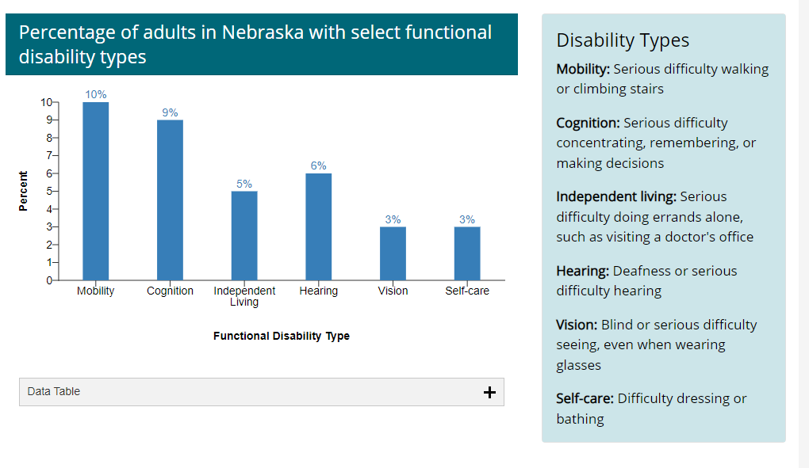
Adults with disabilities in Nebraska typically experience health disparities and are more likely to: have obesity, smoke, have diabetes, have heart disease.
- About 4.6 billion per year or up to 31% of the state’s healthcare spending goes to disability healthcare costs.
- This cost is about $17,500 per person with a disability.
- 20.1% of males in Nebraska have a disability and 24.4% of females in Nebraska have a disability.
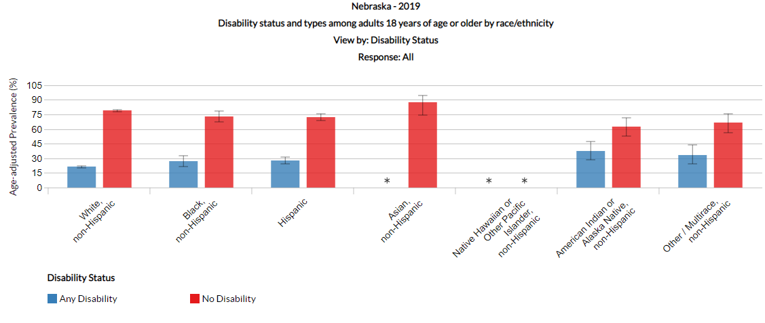
Disabled persons in poverty by county:
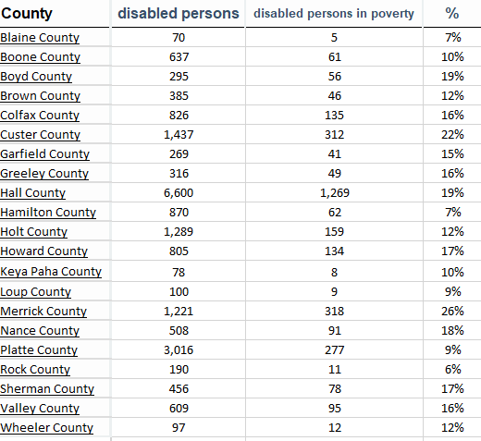
https://www.blr.com/HR-Employment/Discrimination/Disabilities-ADA-in-Nebraskahttps://www.cdc.gov/ncbddd/disabilityandhealth/impacts/nebraska.html
https://www.povertyusa.org/data/2019/NE/frontier-county

Health Insurance
Having access to quality health insurance also plays a major factor in both physical and mental health. Every person deserves to have affordable healthcare, both physical and behavioral. Yet Nebraska still has an uninsured rate of 10%. Medicaid and Children’s Health Insurance Program (CHIP) enrollment in the state of Nebraska was 292,221 in the year of 2021 Which increased from 254,159 in 2020. Quality and consistent preventative health care, beginning even before birth, gives children the best chance to grow up to be healthy and productive adults. Children and families must be able to access and maintain affordable health insurance, and policies should maximize availability and robust investment in Medicaid and the Children’s Health Insurance Program. Our health care systems and policies should prioritize preventative services including immunization, developmental screenings, early intervention, and home visiting. Policies should promote timely and equitable access to a complete range of health care services within a home and community-based environment for children and families across the lifespan. (Voices for Children).
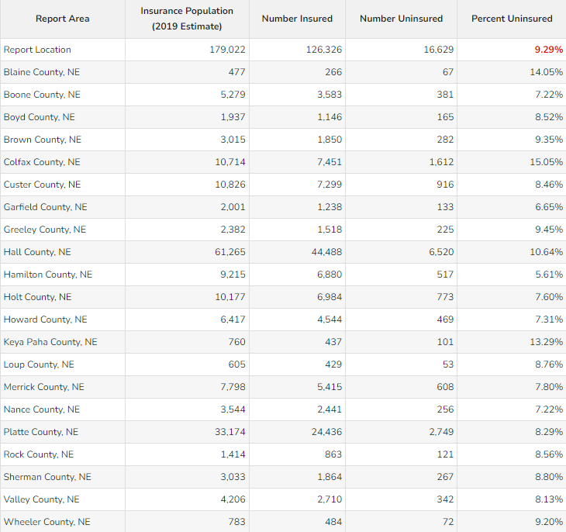

Number of children uninsured per county:

Blaine 14 Holt 187
Boone 85 Howard 111
Boyd 39 Keya Paha 23
Brown 60 Loup 16
Colfax 289 Merrick 95
Custer 187 Nance 46
Garfield 35 Platte 625
Greeley 61 Rock 23
Hall 980 Sherman 59
Hamilton 106 Valley 79
A total of 5.7% of children in Nebraska are uninsured. This causes children to have unmet health needs, undiagnosed health issues, and lack regular care which impacts their ability to grow into healthy and productive adults. 16,629 people are uninsured in the CNCAP service area, which is 9.29%.
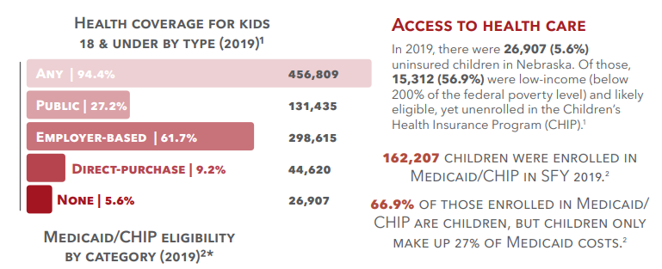
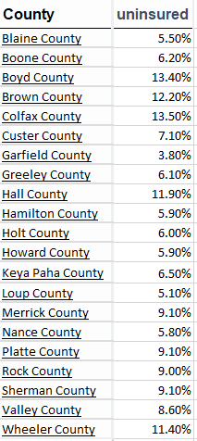

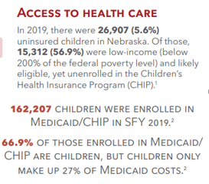

During the year of 2020, 86,805 Nebraska residents enrolled in a plan through the marketplace and about 95% of these enrollees received an advanced premium tax credit to help them pay their premium.
An average of 18,314 Americans between 25-64 years old die annually due to lack of health insurance. The excessively high cost of insurance is the reason many people do not buy health insurance despite the Affordable Care Act. 73% of Americans who were uninsured in 2019 claimed that it was because of the high cost of health insurance. Insurance premiums have increased by 55% in the last decade. Medical bills can put great strain on the uninsured and threaten their financial well-being.
A healthy life entails regular visits to the doctor, to determine whether there is any pre-existing condition bound to cause trouble later down the road. Therefore, being uninsured poses an issue to being able to track that early on. This is a direct result of the expensive costs associated with preventative and investigatory services. Lack of health insurance during medical emergencies leaves people buried in medical debt that is difficult to repay. Quality of life is linked to healthcare access; lack of health insurance leads to increased stress and anxiety over medical bills and the what-if’s in regards to potential medical bills. According to a study published by KFF, the majority of the uninsured American’s come from low-income households. Adults are at a higher risk of being uninsured compared to children and the elderly. A total of 79 million Americans have medical debt problems, resulting in an estimated $140 billion dollars.
https://policyadvice.net/insurance/insights/how-many-uninsured-americans/
Teen Pregnancy
The CNCAP area has a teen pregnancy rate of 2.8% with Sherman county having the highest percentage at 12.5% and 9 counties having no teen pregnancies at all according to the 2021 Voices for Children report. In 2019 alone, there were 993 births to teens. 72.6% of these teen births were to older teens (18-19). Ages 16-17 had a pregnancy rate of 22.7% and 14-15 were 4.7% 17% of the teen births were to teens who already had a child. 43% of these pregnancies were described by them women as “unplanned”.
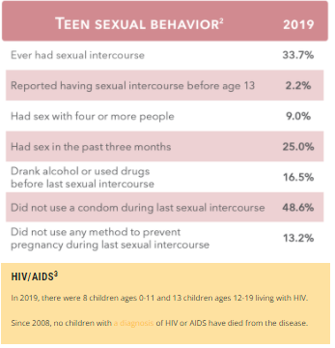
Childcare
As small Nebraska counties lose population to the “Big 3 counties” due to rural residents moving to seek more job opportunities, poverty in rural Nebraska increases. According to the Council for a Strong America, the rural children of Nebraska have a poverty rate of 16% compared to 13% for urban children. Children in rural communities lack the same resources available in bigger cities which includes quality early childhood care and education. Children having access to early childhood care and education can help these rural communities flourish, both now and in the future. 71% of children under the age of 6 in Nebraska have all parents in the workforce (Council for a Strong America). Lack of daycare proposes a massive issue for working parents who do not have the option to stay home with their children. These working parents rely on early childhood education to be able to go to work and support their families as they try to build a better life.
Early childhood education offers a stimulating and nurturing environment for children which is essential during the first five years of a child’s life. This is where the foundation of lifelong skills are laid, many of which can apply to 21st-century jobs. According to Council for a Strong America, “a longitudinal study of more than 1,300 children found that children in higher-quality child care were better prepared for school at the age of 4 compared to children in lower-quality child care. At age 15, they were still performing slightly above their peers.” Another study also showed that the children in higher-quality care had better language skills by the age of three. Those skills then resulted in both academic and social skills being better in kindergarten. (Council for a Strong America). Children of rural Nebraska have less access to quality early childhood care and education. 36% of rural Nebraskans live in a child care “desert”, with a total of 3 children under the age of 5 for each licensed child care slot. Home-based childcare is more prevalent in rural communities, which serve a much smaller quantity of children compared to care centers. “Quality early childhood care and education are critical for communities to thrive. They provide safe learning environments while parents are at work and teach children the skills necessary for success in life,” says Kevin Spencer, chief of police at the Scottsbluff Police Department.
The pandemic impacted daycare facilities, leaving families unable to return to work until they can get their kids into a good daycare, and they just don’t have options. High quality childcare is a must in rural communities.
From the time a child is born to five years old is the most essential period of brain development. More than one million new neural connections form every second, forming the foundation of children’s cognition, health and behaviors throughout life. Children who lack a stable environment and responsive caregivers experience a prolonged activation of the stress response which can lead to long-term deficits. This can include visual, hearing, and sensory-motor problems. The results of these negative experiences can start showing as early as nine months of age. There is scientific consensus that brain development between birth to five years old sets the stage for children’s future success, yet many Nebraska children do not have access to quality child care. Due to educational deficits, health issues and behavioral problems, 71% of Nebraska youth are not able to serve in the U.S. military.
Statistics:
- 40% of rural preschoolers attend home-based child care.
- The number of family child care providers dropped 21% between 2010 and 2017, contributing to a shortage of childcare in rural areas, which we still see today.
- 44% of slots in rural areas were in child-care homes (Council for a Strong America)
- 75% of Nebraska children are in some form of childcare while their parents work
- 17% of single parents went from full time to part time and 12% of married parents in 2020
- Only 1,932 children age 3-4 are enrolled in an early childhood program out of 4,950. 39.03%.
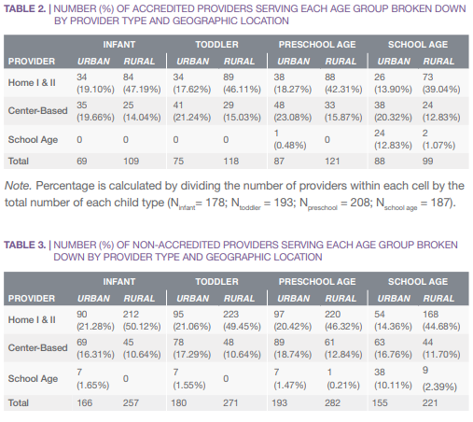
- Only 8% of child care centers in Nebraska are accredited.

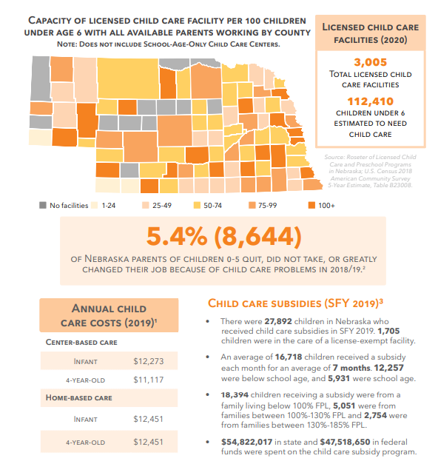
https://dhhs.ne.gov/Child%20Care%20Market%20Rate%20Surveys/2021%20Market%20Rate%20Survey%20Report.pdf
Report (firstfivenebraska.org)
https://www.strongnation.org
https://hayspost.com/posts/a4436d12-8920-454e-979f-00e36ce8893d

According to Buffett Institute of Nebraska, 91% of Nebraska counties do not have sufficient child care, with 11 counties not even having a single licensed child care provider. Unlicensed childcare is a private arrangement between parents and a caregiver. Sometimes this may be called informal childcare. Caregivers who look after five children or less do not have to be licensed. Unlicensed childcare facilities fill faster and cannot look after as many children. This major issue causes parents to miss work, switch to part-time, turn down promotions and sometimes leave the workforce altogether. This alone, costs Nebraska families $489 million annually (Buffet Institute of Nebraska). Which in turn affects Nebraska businesses by losing $234 million due to turnover rates because of childcare shortages. $21 million is lost to the State of Nebraska in lost tax revenue as well. Lack of childcare does not only affect the working families of Nebraska, it affects the whole state. In total, $745 million a year is lost within the state of Nebraska because of inadequate childcare. When finances are tight, families tighten up their budget which then also affects the communities and businesses around them. “Inadequate childcare is a serious barrier for improving family incomes, the bottom line of businesses and the economic growth of our state,” said Jason Prokop, director of First Five Nebraska. “To support the economic vitality of Nebraska families, businesses, and our economy, it is imperative that parents, local stakeholders, employers and government come together to create effective, community-driven solutions that strengthen Nebraska’s early childhood infrastructure.”
- 51% of 1050 rural parents reported they had to miss work because of childcare issues during the pandemic.
- 44% said they had to reduce their work hours because of childcare issues.
- 38% said they don’t have sufficient child care for their needs.
- 91% of counties are deemed to have a shortage of quality childcare in Nebraska.
Besides quality childcare being difficult to find, it is also expensive. The average cost of childcare per month for an infant is $1048 and $952 per month for a 4-year-old. For comparison, rent and college tuition in the state of Nebraska cost less than child care services. More than 20% of a household’s income goes toward childcare for only one child.
https://buffettinstitute.nebraska.edu/-/media/beci/docs/2021-market-rate-survey-report-final-spreads.pdf?la=en
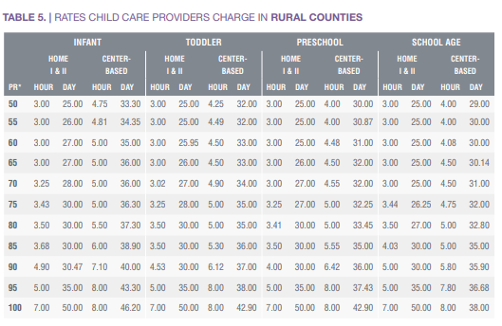
https://www.procaresoftware.com/resources/child-care-costs-by-state-2020/
The bottom line is that parents cannot work if they don’t have affordable, high quality child care. In one way or another, that affects the entire state.

Human Trafficking
Humans are trafficked in Nebraska, being bought and sold and treated as property, forced against their will to work for those who think they own them. Human trafficking affects not only those who are living in poverty, but middle and upper classes as well. There were 72 cases of human trafficking reported in the state of Nebraska in 2021. This has increased from 63 in 2020 and 33 in 2019.
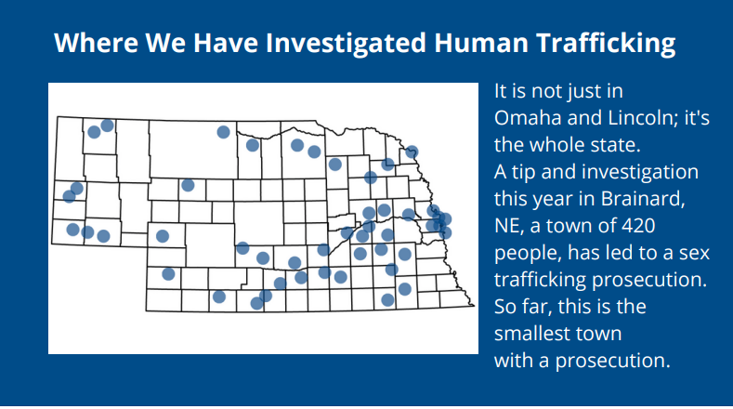
https://ago.nebraska.gov/sites/ago.nebraska.gov/files/doc/2021%20Task%20Force%20Update%201.18.22_0.pdf
https://humantraffickinghotline.org/es/state/nebraska
2021 had the largest sex trafficking prosecution in the state’s history. Of the 72 cases reported in Nebraska:
- 49 were sex trafficking
- 12 were labor trafficking
- 7 were not specified
- 4 were sex and labor
Of the 72 cases reported:
- 61 were female
- 8 were male
- 3 were gender minorities
- 44 were adults
- 26 were minors
- 2 were not reported

In 2019 there were 63 cases reported. Of the 63 cases there were
- 42 sex trafficking
- 8 labor trafficking
- 7 trafficking type not specified
- 6 sex and labor
Of the 63 cases reported:
- 50 were female
- 7 were male
- 6 were not reported
- 38 were adults
- 14 were minors
- 11 were not reported

There have been 9 convictions of human trafficking in the last three years in the state of Nebraska and this does not include the number of people who have plead down to a lesser charge, or the cases in Nebraska which have gone to federal and were prosecuted under the national law. Signs of sex trafficking can include:
- Considerably older boyfriend or girlfriend
- Multiple phones
- Abnormal amounts of cash
- Unexplained absences
- Children missing from care
- Frequent travel
- Hotel key cards
A Hamilton county man is charged with sex trafficking in Buffalo County. The 31 year old man from Aurora was charged with felony sex trafficking of a person 18 years or older on May 5th. He was arrested in Hamilton county. https://kearneyhub.com/news/local/crime-and-courts/aurora-man-charged-with-felony-sex-trafficking-in-buffalo-county
Disconnected Youth/ Youth Homelessness
The KIND (Keeping Independent Needs Defined) is a joint TH-RR housing program that serves literally homeless youth between the ages of 18-24 with crisis intervention housing assistance as well as serving homeless and near homeless youth ages 18-24 by rapidly rehousing them and offering case management, with possible financial assistance to work towards permanent housing while focusing on employment and education. The KIND program assisted 52 households during the year of 2021, and 20 beneficiaries. KIND youth paid $16,997 in debt for 2 households and 4 beneficiaries. The total savings accumulated was $2,150 for 3 households and 5 beneficiaries.
The KIDS (Keeping Independence Defined in Society) program assists individuals and families whose household is between the ages of 18-24. The core elements of the KIDS program are: 1. Stable housing 2. Education and Employment 3. Social and emotional well-being 4. Permanent connections. The program assists youth in homeless situations get into housing. While in the program, youth will have the opportunity to participate in case management to address specific barriers the family is having. The KIDS program serves all 21 counties. In 2021, KIDS helped a total of 38 households and 29 beneficiaries. Participants paid $10,362 in debt and accumulated savings of $8,854 for 14 households and 31 beneficiaries.
  - A one-night count of homeless youth in Nebraska determined that 51% had been in the foster care system.
During the 2019-2020 school year, Nebraska districts reported over 4,000 children/youth who were experiencing homelessness. 300 of these were considered unaccompanied homeless children—child is not in the physical custody of a parent or guardian. The majority of these children are in “doubled-up” situations which means sharing the housing of other persons due to loss of housing, economic hardship or similar situations.
Unaccompanied youth typically range from 16 to 22. The major causes of homelessness for unaccompanied youth are mental illness, substance abuse and lack of affordable housing. Family conflict is a primary cause of youth homelessness with 46% having experienced abuse and an estimated 20-40% identifying as lesbian, gay, bisexual, or transgendered across the state of Nebraska. Homelessness is traumatic for children because they often experience frequent moves, family split-ups, and living in crowded places before using homeless shelters.
Households that are headed by females are typically more vulnerable to homelessness, (especially when the woman has limited education and job skills). Teen parents are also at risk for homelessness as they lack education and income of adults who become parents. Lack of affordable housing poses a big threat to homelessness, particularly to families who devote 50% of their household income to paying rent, or those who experience a foreclosure.
Homelessness effects children and youth more strongly, affecting things like hunger, poor physical and mental health, and missed education opportunities. These children lack stability in their lives, often having moved at least once on an annual basis. This causes disruptions in schooling and negatively impacts academic achievement. Homeless children are twice as likely to have a learning disability, repeat a grade or be suspended from school. They are twice as likely to experience hunger. A quarter of homeless children have experienced violence and 22% have been separated from their families. Half of homeless children experience depression and anxiety. Often homeless youth engage in sexually risky behaviors (in some cases for survival) and risk HIV and other STD’s or accidental pregnancies.
Homeless youth often lack the financial, social, and emotional resources needed to function on their own. Homeless youth are at risk for
- Self-medication or substance abuse
- Sexually risky behaviors “survival sex”
- Physical or emotional victimization
- Unemployment
- Incarceration
- Academic struggles
- Health risks
- Psychological issues-major depression, anxiety, PTSD, or even suicide.
- Lack of trust in people—not reaching out for assistance from service providers.

Throughout the Head Start and Early Head Start programs in the CNCAP area, there were 20 homeless in Early Head Start (EHS) and 22 homeless in Head Start (HS) during the school year July 2020- June 2021. The definition of homeless within Early Childhood Programs is homeless children and youth as individuals who lack a fixed, regular, and adequate nighttime residence. This includes children and youth who are living in cars, parks, public spaces, abandoned buildings, substandard housing, bus or train stations. Families who live in hotels, motels, or live with family members (grandparents, aunts, uncles) due to lack of housing or job are also considered homeless. This has increased from 24 homeless in EHS and 13 homeless in HS during the school year July 2019-June 2020. When children in the early childhood programs are considered homeless, staff provide the families with several resources referring them to other CNCAP programs and then help them build a Family Goal to help them attain housing.
https://www.usich.gov/homelessness-statistics/ne/
https://www.education.ne.gov/federalprograms/title-vii-b/
Downloads/Youth-Homelessness-Fact-Sheet%20(1).pdf
https://www.apa.org/

The total number of unaccompanied homeless students is 1,050. 150 are unsheltered, 1,082 are in shelters, 366 are in hotels/motels, and 2,777 are doubled up. There has been an increase between 2019 and 2020 in homelessness:
https://www.3newsnow.com/news/local-news/slight-homelessness-increase-in-nebraska-when-comparing-2019-to-2020
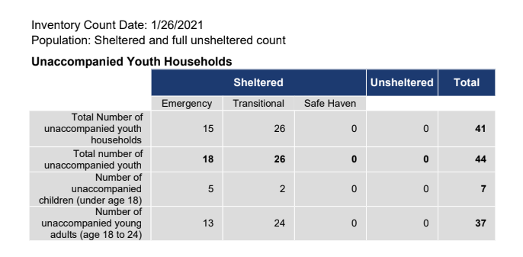
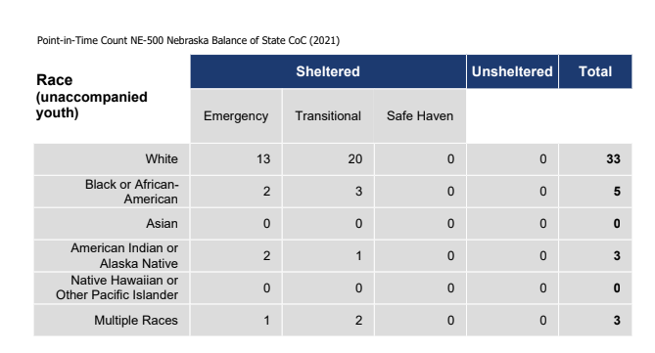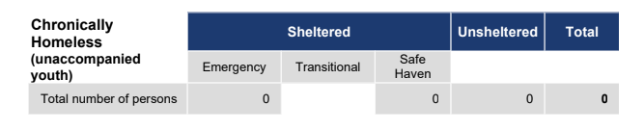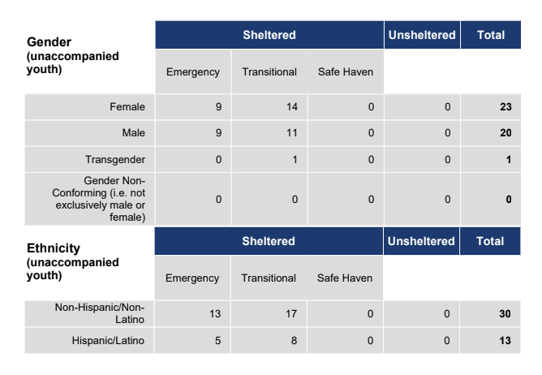
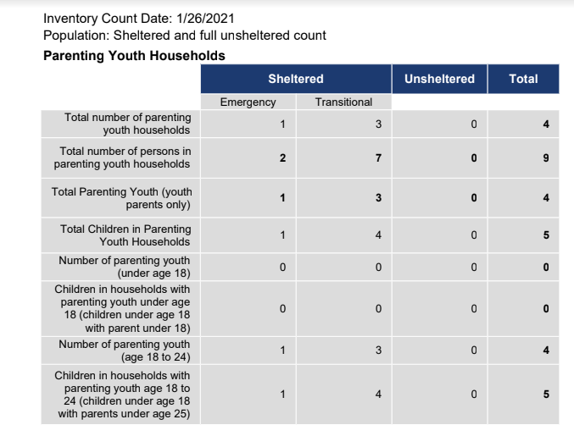
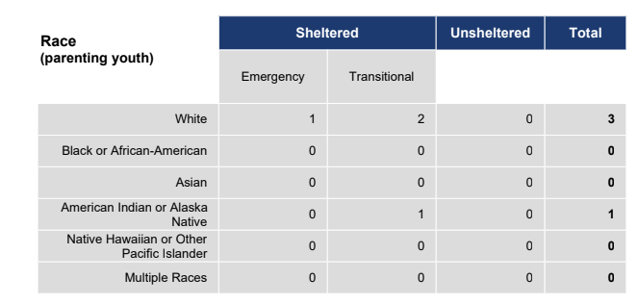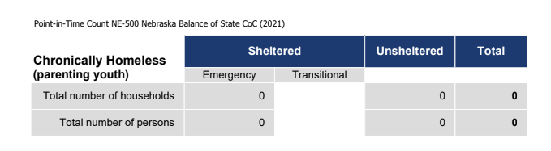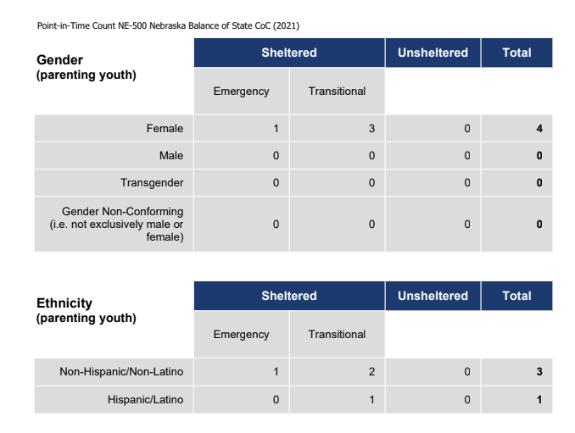
Crime
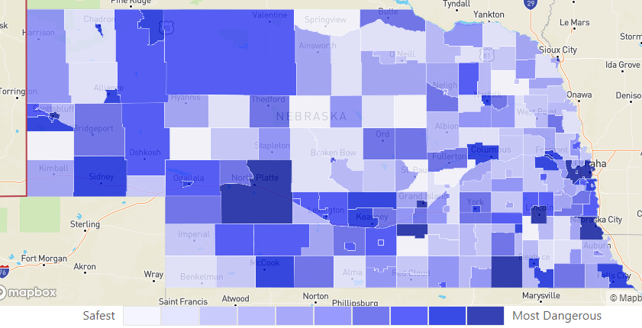
Violent crime includes murders, rapes, robberies and aggravated assaults. Families, neighborhoods and communities are all affected when violent crime occurs. These crimes cause not only physical harm, but social and emotional distress including injury, disability, premature death, depression, anxiety and PTSD. Where there is violent crime, people are less likely to be active in the area. They will avoid walking or riding a bike, they will even avoid living in such areas. Violent crime can impact a community tremendously. In the state of Nebraska in 2021, there were 6,473 violet crimes, 36,991 property crimes and 43,464 total crimes. The violent crime rate in Nebraska is 3.3 per 1,000 residents. This has increased from 3.0 in 2020 and 2.8 in 2019. Schuyler is ranked the number 1 safest city in Nebraska, with Columbus ranked number 5.
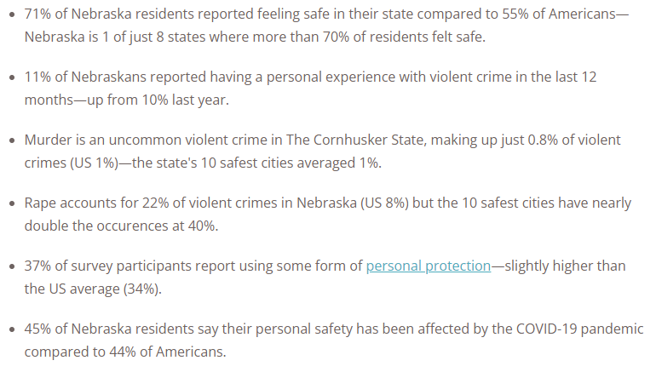
https://www.safewise.com/blog/safest-cities-nebraska/
https://www.neighborhoodscout.com/ne/crime

Hate crimes have been on the steady rise in the past several years. A bias or hate crime is a crime motivated by bias against race, color, religion, national origin, sexual orientation, gender, gender identity, or disability.
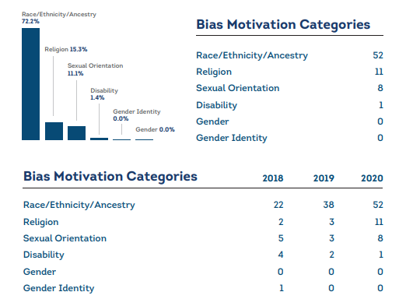
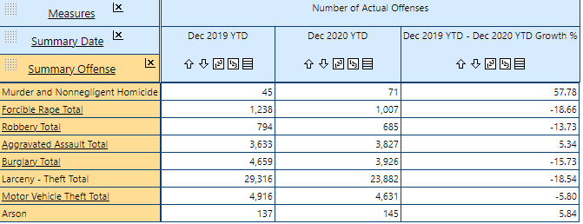
https://www.justice.gov/file/1440486/download

Domestic Violence

According to the Nebraska State Statute, there are four types of domestic abuse to be reported: Aggravated assault- unlawful attack by one person upon another for the purpose of inflicting sever bodily injury. This type of assault is accompanied by use of a weapon to inflict death or great damage.
Simple assault- all assaults which do not involve the use of a firearm, knife, or dangerous weapon and where the victim does not sustain serious injuries.
Domestic assault- applies to family or household members including spouses, former spouses, children, persons who are residing together or have in the past, persons who have a child in common, persons who are related, presently dating or involved in a relationship or have in the past.
Arrest or Exceptional means: an arrest means the clearance of an incident through law enforcement placing suspect into custody or citation/ticket was issued. Exceptional means refers to the clearance of a case when law enforcement have established the identity and location of suspect, have probable cause to support arresting/charging/prosecution of suspect but there are reasons outside of control of the law enforcement agency that prevent an arrest or citation from being issued. The following counties are listed with the amount of reports during the year of 2020, among the four report areas.
Blaine county: 0
Boone County: 3 aggravated domestic assaults, 8 simple domestic assaults
Boyd County: 0
Brown County: 0
Colfax county: 1 aggravated domestic assault, 9 simple domestic assaults
Custer county: 0 aggravated domestic assaults, 3 simple domestic assaults
Garfield county: 1 aggravated domestic assault, 1 simple domestic assault
Greeley county: 1 aggravated domestic assault, 0 simple domestic assaults
Hall county: 69 aggravated domestic assaults, 192 simple domestic assaults
Hamilton county: 0 aggravated domestic assaults, 6 simple domestic assaults
Holt county: 0 aggravated domestic assaults, 3 simple domestic assaults
Howard county: 0 aggravated domestic assaults, 13 simple domestic assault
Keya Paha county: 0
Loup county: 0
Merrick county: 0 aggravated domestic assaults, 3 simple domestic assaults
Nancy county: 0 aggravated domestic assaults, 3 simple domestic assaults
Platte county: 3 aggravated domestic assaults, 21 simple domestic assaults
Rock county: 0
Sherman county: 0
Valley county: 3 aggravated domestic assaults, 3 simple domestic assaults
Wheeler county: 2 aggravated domestic assaults, 0 simple domestic assaults
https://ncc.nebraska.gov/sites/ncc.nebraska.gov/files/doc/2019%20Domestic%20Assault%20and%20Arrest%20by%20County_0.pdf

A Silver Creek man was arrested in Nance County for threatening to kill his wife and preventing her from leaving their home. The man was charged with terroristic threats, first-degree false imprisonment, use of a firearm to commit a felony and third-degree domestic assault. The wife left the house after an argument and came back home to check on him. He pulled a handgun and told her to leave, following her then to her car and dragging her into the garage and up the stairs and holding her hostage. The man threatened to kill her and then himself. The woman then hid in a nearby field while he drove around spotlighting for her. https://nebraska.tv/

Another Nance County man was arrested in November 2021 for assaulting his girlfriend in front of her child and then threatening to kill her. The woman had multiple injuries and was transported to Genoa Community Hospital for treatment. The man was charged with 3rd degree domestic assault, strangulation, child abuse and terroristic threats. This man was on parole serving a four to seven year sentence that began in 2016 for assault charges in Platte county.

Law Enforcement
Sworn personnel
- In 2020 there were 3,825 full-time sworn officers with 144 vacant positions.
- 1,020 sworn officers employed full-time in Sheriff’s Departments
- 2,245 sworn officers employed full-time in Police Departments
- 560 sworn officers employed full-time in State Agencies
- 3.6 full-time sworn officers per 1,000 people (based on a population of 1,872,677)
- 201 part-time sworn officers with 23 vacant positions
Civilian personnel
- 1,655 full-time civilian employees
- 179 part-time civilian employees
- 36 vacant positions (both full-time and part-time)
Reserve officers
- 47 reserve officers
- 13% of the total agencies use reserve officers
Contractual agreements
- 32 departments reported they have contracts with communities, etc. to provide law enforcement coverage.
This is compared to 2018:
Sworn Personnel
3,893 full-time sworn officers with 116 vacant positions.
1,091 sworn officers employed full-time in Sheriffs' Departments.
2,217 sworn officers employed full-time in Police Departments.
585 sworn officers employed full-time in State Agencies.
2.0 full-time sworn officers per 1,000 people (based on a population of 1,921,971).
318 part-time sworn officers with 19 vacant positions.
Civilian Personnel
1,634 full-time civilian employees.
239 part-time civilian employees.
61 vacant positions (both full-time and part-time).
Reserve Officers
57 reserve officers.
26 agencies use reserve officers.
Contractual Agreements
30 departments reported they have contracts with communities to provide law enforcement coverage.

Health Trends
“Why Nebraska Hospitals Are Paying 2 to 3 Times More For Traveling Nurses” According to Nebraska Public Media, Nebraska could be short more than 5,000 nurses three years from 2021. Due to shortages, and staff nurses being burnt out from picking up extra shifts, hospitals across Nebraska are paying travel nurses $150 an hour to come help during times of need. This is expensive, but hospitals have no other choice. The Nebraska Center for Nursing reports a 34% increase in travel nurses between 2018 and 2021 and over 1,600 Nebraska nurses are expected to leave their current position within the next twelve months. Dissatisfaction with salary and personal and family reasons are the main reasons young nurses are leaving. They are receiving regular wages while travel nurses come in at $150 an hour. Pamela, a Broken Bow native left her position as a nurse at Kearney Regional Medical Center for various reasons and then returned back being paid double as a traveling nurse. While there is already a shortage of quality health centers in Nebraska, these shortages threaten those numbers even more. https://nebraskapublicmedia.org/en/news/news-articles/why-nebraska-hospitals-are-paying-2-to-3-times-more-for-traveling-nurses/
“Nursing Shortage at Crisis Levels in Nebraska” Eleven Nebraska counties have no registered nurses and it is expected there will be a massive shortage within the next five years. A quarter of the nursing workforce is over 55. After the pandemic, turnover is the highest it has been in years. There is a terrific amount of burnout within the nursing industry. 94% of nurses report burnout and 36% report their burnout is at a very high level. 10% say they plan to leave nursing and nearly a quarter say they are planning on early retirement.
https://nebraska.tv/news/local/nursing-shortage-at-crisis-levels-in-nebraska

“Senators urged to address the nursing shortage in Nebraska” Hospital patients have greater needs through the pandemic and there are not enough staff to care for them. CHI Health could hire over 750 registered nurses in a day if they were available. They are currently requiring every nurse take an extra 12-hour shift every month. They are looking to find a way to pay their nurses more money so they stop leaving their jobs to become travel nurses and get paid more. In 2021 there were 102 nurses at Nebraska Medicine who left within the first year of hire. As shortages become more prevalent, hospitals across Nebraska worry that patient safety is at a higher risk. Federal vaccine mandates are also impacting the nurse shortage and will continue to do so, especially in rural areas.
https://www.ketv.com/article/amazon-presidents-day-sales/38953388

Women, Infants and Children (WIC) Programs

WIC is a Special Supplemental Nutrition Program for Women, Infants and Children, which is a nutrition program for pregnant, breastfeeding women and families with children younger than 5. WIC is the nations most successful and cost-effective public health nutrition program. Wholesome and nutritious fresh food is provided, nutrition education and community support for income eligible women who are pregnant, breastfeeding or post-partum, and for infants and children up to five years old. In Nebraska, WIC helps approximately 35,000 people at over 100 clinic sites
Income guidelines for WIC:
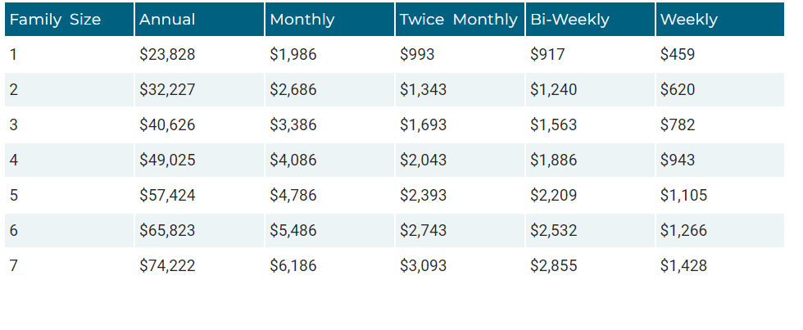
https://dhhs.ne.gov/pages/wic-about.aspx

WIC helps eligible families with:
Healthy Food
Breastfeeding Support
Nutrition Education
Health and Community Resources

Who can apply?
Pregnant women, breastfeeding women, new mothers, infants, children to age 5, foster children to age 5. Support is also offered to anyone—working or not—who cares for a child including: moms, single fathers, grandparents, foster parents, step-parents, guardians.

Last year CNCAP WIC conducted 10,494 visits and served 1,273 total participants, 301 women, 349 infants, 591 children.
This is compared to 914 participants in 2020.
In 2019 WIC served 1,329 total participants with 318 being women, 377 being infants, and 634 children.

Immunizations:

Along with administering the vaccinations, families are provided information and education on the importance of vaccinations for their children. The program focuses on children 0-18 who are uninsured or underinsured, that may have health insurance that doesn’t cover immunizations, or those receiving Medicaid. The funding originates from the Center of Disease Control and is provided to the Department of Health and Human Services Immunization Program. CNCAP was awarded $48,596 for immunization activities supporting the rural clinics in Ord, O’Neill, Loup City , Greeley, St. Paul and Broken Bow. A total of 557 vaccinations were provided to 261 individuals with 172 being children during the year of 2021. Children ages 2-5 are required to receive immunizations to attend a school based program.

From the 2019-2020 school year to the 2020-2021 school year there was an increase in students immunized throughout the school year. The number of children whose immunization needs were not fully met also decreased from one year to the next, going from 30 children to four at enrollment.

Nutrition

What is food insecurity?
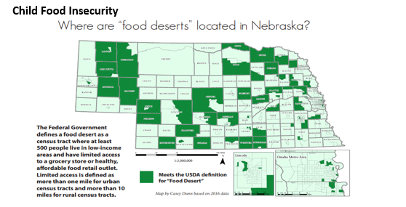
Food insecurity is a lack of access—at times—to enough food for an active, healthy life for household members and limited availability of nutritionally adequate foods. In Nebraska, 1 in every 9 people face hunger, 1 in six are children. Many of these households that experience food insecurity do not qualify for federal nutrition programs and need to rely on their local food banks for support. Early Childhood Programs also provide children with nutritious food they may not always have access to at home.

- Blaine County is the 5th highest county in Nebraska for child food insecurity at 24%. There were 30 children in Blaine County who were food insecure during 2019.
- Wheeler County is the 7th highest county at 22.5% with 40 children food insecure.
- Brown County is the 8th highest county at 21% with 130 children food insecure.
- There are 17,910 people that are food insecure within the CNCAP service area. This is 10.01% of the population.
- 7,730 of the 17,910 are children. This is a child food insecurity rate of 16.98%.
- 35% of the food insecure population are ineligible for assistance.

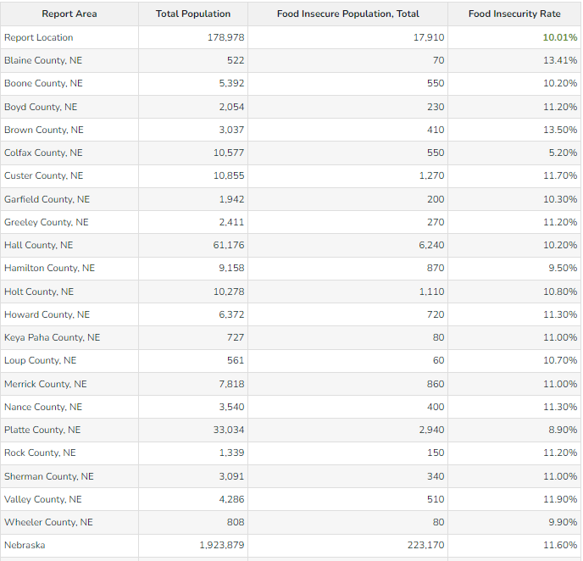

“Food security is important, as it is an indicator of overall well-being and is the basic foundation for sustaining a well-nourished, healthy population,” according to Nebraska Legislature. Food insecurity is only prevalent in 46% of poor households. This is because other factors make them substantially more likely to be insecure, such as financial management skills, lower education levels, renting rather than owning a home, limited savings, lack of access to credit and sudden sharp changes in income.
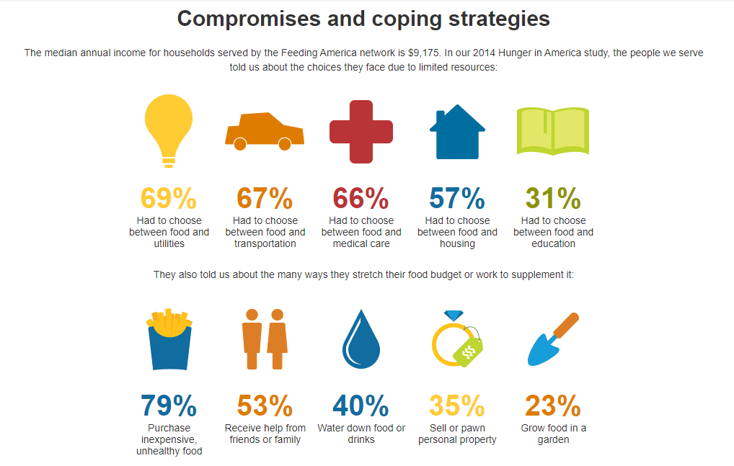
Families with children, especially single-parent families are more likely to face hunger. The number of children facing hunger in the United States rose during the pandemic—from more than 10 million children in 2019 to nearly 12 million children in 2020, and then to 13 million in 2021. 84% of households who are food insecure buy the cheapest food instead of healthy food, in order to provide their families enough to eat. This puts children at risk of:
- Chronic illnesses such as asthma and anemia
- Behavioral problems like hyperactivity, anxiety and aggression
- Higher risks of being hospitalized
- Worse oral health
- Obesity
21% of children in households at risk of hunger may be forced to rely exclusively on hunger relief assistance to make ends meet. There are four levels of food security used by the USDA: High, marginal low, low and very low.
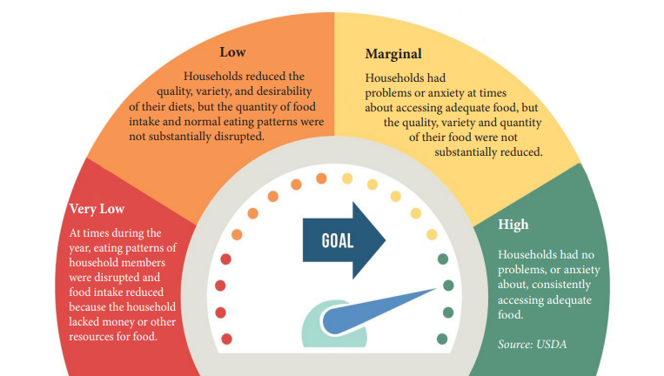
Food insecurity increases the risk of chronic disease, while suffering from a chronic disease increases the risk for food insecurity, creating a viscous cycle. Chronic disease associated with food insecurity include diabetes, hypertension, coronary heart disease, and chronic kidney disease. People suffering with a chronic disease may have a hard time finding and maintaining work and therefore be forced to choose between food and medication. This situation then affects mental health. Food insecurity is associated with higher rates of depression. Poor mental health can then in turn affect a person’s physical health by making it challenging to follow medical recommendations regarding their disease, such as a diabetic meeting his dietary needs.

On average, food insecure adults spend $1,834 more on healthcare per year than food secure adults in the United States. In Nebraska the average is $1,659 per food insecure adult.

Food banks work hard to get food to those in need. Churches and local agencies work together to help out those in need within their communities. CNCAP food programs such as the Commodity Supplemental Food Program (CSFP), Food Pantries and Mobile Food Pantries help supple those in need with nutritious food. This is available to all 21 counties in the CNCAP service area.
3,889 people were served through CNCAP Food Distribution Programs:
Food program valued at $195,300 of an average of 60$ per food box
1,996 served at Commodity Supplemental Food Program (CSFP)
110 served at Food Pantries and 783 served at Mobile Food Pantries
https://www.nebraskalegislature.gov/pdf/reports/research/food_insecurity_2020.pdf
USDA ERS - Measurement
https://stacker.com/nebraska/counties-highest-rate-food-insecure-children-nebraska
https://www.feedingamerica.org

The Supplemental Nutrition Assistance Program (SNAP) is the largest federal nutrition assistance program. SNAP provides benefits to eligible low-income individuals and families via and Electronic Benefits Transfer card. This card can be used like a debit cared to purchase eligible food in authorized retail food stores.

To be eligible for SNAP, most households must meet a certain bank balance limit. A household with an elderly (over 60) or disabled household member may have a higher bank balance limit.

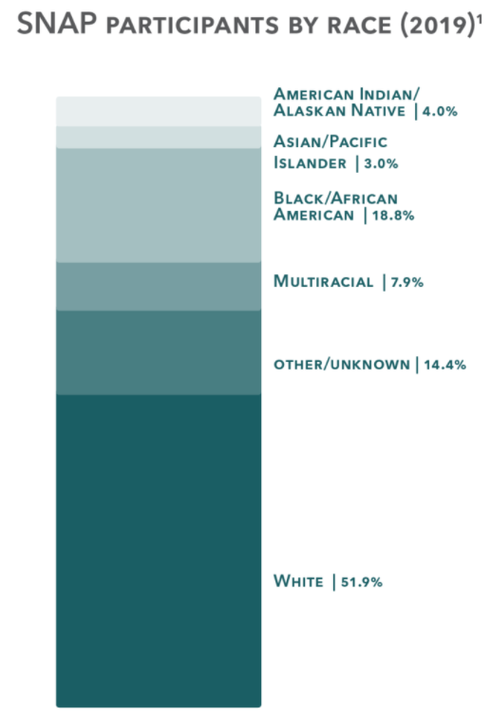
- 3 out of 4 SNAP recipients in Nebraska are families with children. Families in rural parts of the state rely on SNAP to keep food on the table (Voices for Children).

- In 2017 SNAP moved over 8,700 households above the poverty line

- In 2018 SNAP helped over 84,000 children in Nebraska

- Over 170,596 Nebraska children receive free or reduced school lunches. 47.7% of all Nebraska students.

- There are 5,481 total households receiving SNAP within the 21 counties.
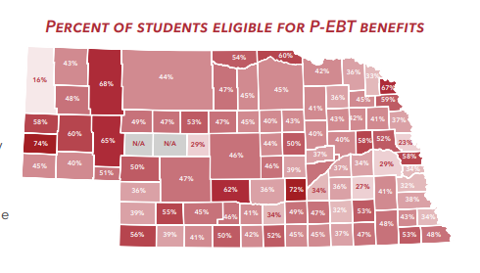

In Nebraska in 2019, 67,643 households with a total of 148,768 people received SNAP benefits each month. After the pandemic set in, in April of 2020 this increased to 76,281 households with a total of 165,801 people receiving SNAP benefits. This is a 13% increase. Loup county has the lowest rate of SNAP benefits with only 1.1% receiving. The monthly SNAP benefits in Nebraska average $273 per household, and $124 per person. Rural households in Nebraska use SNAP benefits at a higher rate than urban counties.
https://www.nebraskalegislature.gov/pdf/reports/research/food_insecurity_2020.pdf
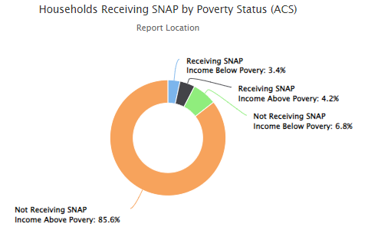
www.voicesforchildren.com
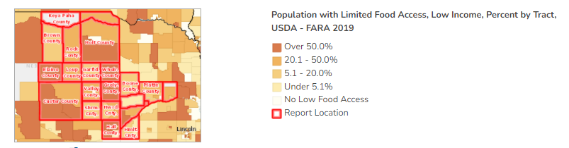
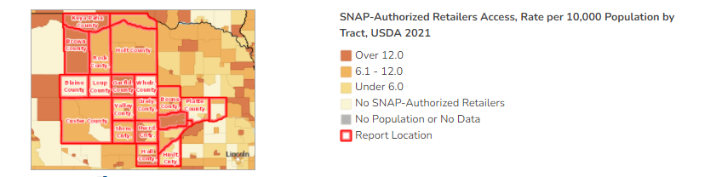
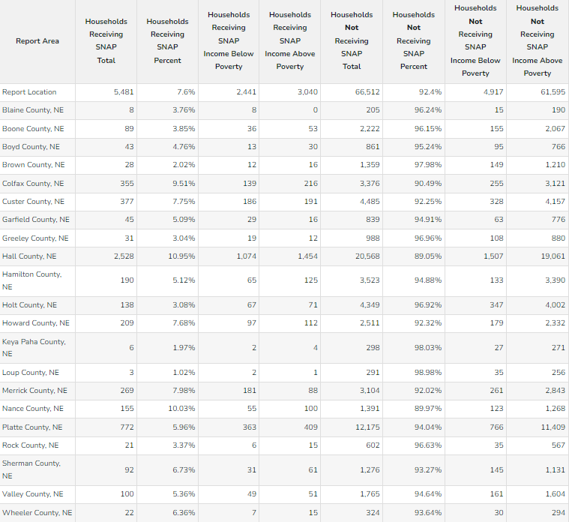

Free and Reduced School Lunch 2021-2022
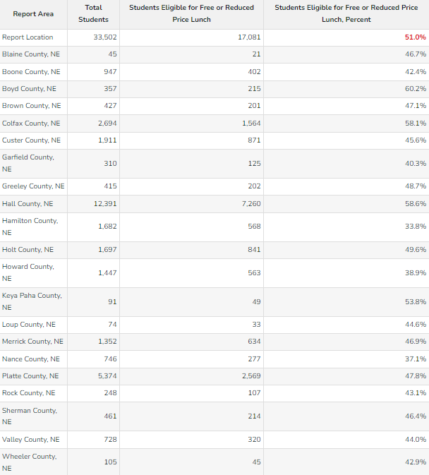
Children from families with incomes at or below 130% of the poverty level are eligible for free meals. Those between 130% and 185% of the poverty level are eligible for reduced-price meals, for which students can be charged no more than 40 cents.

A total of 1047 schools in the state of Nebraska participate in the National School Lunch Program with a total of 333,003 students having access to meals every day. 68% of the students who the program is available to participate (www.education.ne.gov). There are 33,254 public school students in the CNCAP service area, and 17,081 of those students were eligible for free or reduced school lunch in 2021. That is 51% of public-school students. This is higher than the overall state average of 45.6%. There are 13,342 eligible for free lunch and 3,733 eligible for reduced lunch between the 21 counties. If a household income is at or below the reduced meal guidelines, the students can receive lunch for the discounted price of $0.40 and breakfast for $0.30.

COVID-19

Since COVID struck in the spring of 2020, Nebraska has not been the same, however, this can be said for the entire world. Shut downs, cancelled events, illness, overflowing hospitals, nursing shortages, unemployment rates, business closures, mental health, and many other affects of COVID-19 continue to linger into 2022. 61% of Nebraskans indicated that the pandemic affected life overall a fair amount or great deal. Poll results suggest these effects on health, wellness and finances were experienced differently across the board. 25% in rural areas and 23% in metro areas said someone in their household contracted COVID-19. 18% of rural respondents reported friends or family in their community dying of COVID-19 compared to 13% of metro respondents. This affected the rural areas a little bit harder due to the fact that their populations are made up of an older age group, and COVID hitting the elderly a bit harder. 84% in metro areas and 68% in rural areas said their socialization with others was disrupted by COVID-19. 51% of metro areas and 40% of rural areas respondents said their mental health was affected. Those with the lowest incomes were financially affected the most by the pandemic. About 4 in 10 respondents with household incomes under $40,000 said their financial health was affected by the pandemic. Rural respondents working in production, transportation or warehousing were hit the hardest economically. These respondents were most likely to report that someone in their household was temporarily laid off, had their hours reduced or returned to work after being laid off temporarily. More than 100,000 Nebraskans applied for unemployment benefits since the economy shut down. Many waited a month or more to receive a check because of the record-breaking number of applicants. There were no significant differences between rural Nebraska and metro Nebraska in impacts felt as a result of the pandemic. Residents in metro counties were more likely to say that someone in their household quarantined during the past year because of possible COVID-19 exposure and that they saw an increase in income compared to residents of rural Nebraska. Residents were also asked to what extent various elements of their life were affected or disrupted by the pandemic. Rural residents were found to be more likely than metro residents to say their financial health was affected either a fair amount or a great deal by the pandemic. Residents were also asked questions about their work situations. Metro residents were more likely than rural residents to say they currently work at home at least some of the time when they took the survey in the spring. They are also more likely to say that they would like to work from home at least some of the time if they had the choice after the outbreak. They were then asked if they engaged in a variety of consumer activities during the pandemic more often, less often or about the same as they did prior. Metro residents are more likely to say they engaged in each activity listed more often during the pandemic than they did prior to it compared to rural residents. Although there are small differences in using self-service banking options and having medicine or medical supplies delivered. Respondents were then asked how likely they were to engage in those same activities going forward. Metro residents are more likely to engage in each of the activities going forward compared to rural residents. Respondents were asked if their internet service at home (if they had it) limited their ability to do various activities. There were not many differences between metro and rural residents saying their home internet service limits them from accomplishing the items listed. Overall, the pandemic has caused many challenges for everyone.
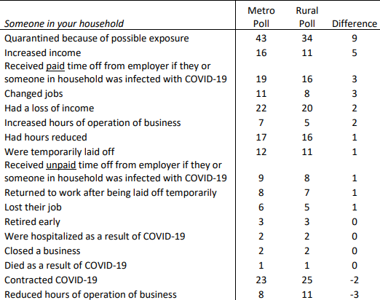

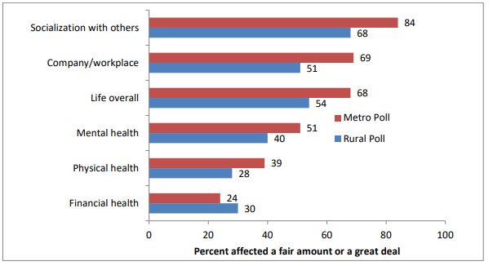
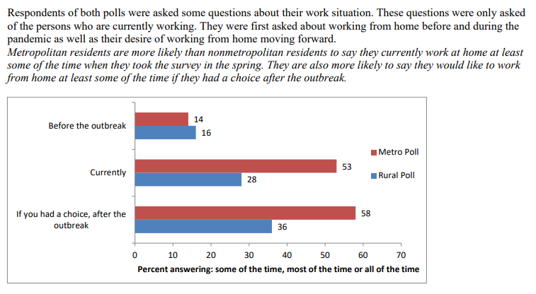
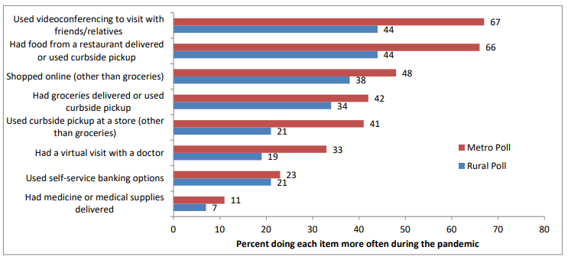
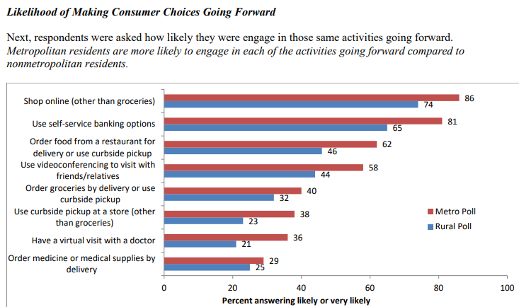
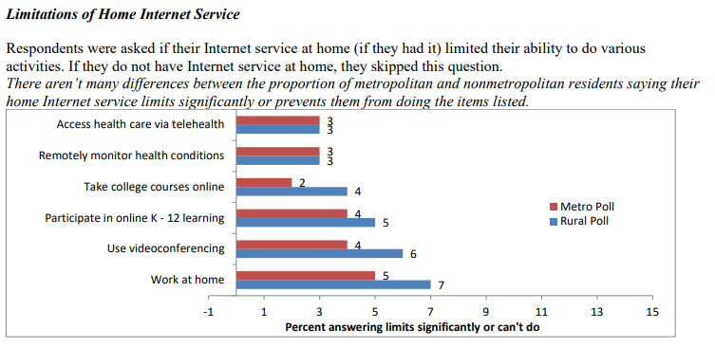

A survey from UNO found that 87% of businesses were negatively impacted by the pandemic and 16% feared going out of business. Daycares closed, impacting parents abilities to go to work. Nursing shortages met all-time highs due to burnout and salary gaps. Prices rose on items, fuel, groceries, housing, while incomes dropped and unemployment increased. The stresses of everything—loss, finances, lack of socialization—impacted mental health negatively. School closures left children under-socialized, sometimes underfed when not having access to nutrition provided by school. Even across the CNCAP service area, commodities provided to the elderly decreased because the elderly were afraid to get out and risk getting sick. The number of volunteers decreased as people opted to stay home—while volunteering offered the elderly and retired a great way to stay active and social. The lasting impact of COVID-19 has changed Nebraska as we continue to fight our way to the other side.

Hamilton county is offering property tax relief for low-income homeowners after the affects from the COVID-19 pandemic. They are also offering mortgage and utility assistance as people try to recover from the aftermath. Homeowners who are eligible make 80% or less of the area median income. For a 1-person household that is $47,850. 2-person household is $53,650. 3-person household that is $61,500. 4-person household is $68,300. Over 100 households have applied for mortgage and utility assistance. Over 22 million has been distributed for rent and utility assistance since July 2020, helping a total of 7,736 households. The need is everywhere in the wake of COVID-19.

https://news.unl.edu/newsrooms/today/article/polls-pandemic-affected-nebraskans-mental-health-finances-consumerism

A Look into the Future

The Russia-Ukraine war has caused a direct effect on US economy in just a few days. The price of oil, natural gas and other necessities skyrocketed immediately and supply chains which are still trying to catch up from the pandemic, rose as the United States, Europe and their allies tightened the screws on Russia’s financial transactions. Hundreds of billions of dollars were frozen and held abroad. Even while Russia has had a minor roll in global economy at just 1.7%, they cannot ignore the financial system that is controlled by governments and bankers outside of their control. In response to Putin mobilizing tens of thousands of his troops, allied governments have mobilized their vast financial power. “Now it’s a gamble between a financial clock and a military clock to vaporize the resources to conduct a war,” says Julia Friedlander, the director of the economic statecraft initiative. The invasion and resulting sanctions inject a huge dose of uncertainty and volatility to economic decision-making, which only heightens the risk on global outlook. Fears of a shortage of essential energy in Europe which is used to heat homes, power factories and fill gas tanks, caused a surge in energy prices. Russia and Ukraine are large exporters of wheat and corn, as well as palladium, aluminum, and nickel that are used in everything from mobile phones to automobiles. Transportation, which has already been exceptionally high, is also expected to sky rocket for both ocean and air. These rates could double or even triple, going from $10,000 to $30,000 a container, with airfare to jump even higher. On top of that, Russia closed its airspace to 36 countries, which means planes have to divert to roundabout routes, this causes them to spend more on fuel and may encourage them to reduce the size of their loads. Product shortages are also expected as companies are ramping up for summer volume, which will again affect the already struggling supply chain. Inflation was already at its highest in the US since the 1980’s before the war, but the impact of the war may have devastating affects on the economy. “The Fed is in a box, inflation is running at 7.5%, but they know if they raise interest rates, that will tank markets,” said Desmond Lachman, a senior fellow at the American Enterprise Institute, ‘The policy choices aren’t good, so I don’t see how this has a happy outcome.” Gas prices have already rose a dollar higher than a year ago, at a national average of $3.61.
According to an article by the Hill, there are five ways the Russian invasion of Ukraine will impact Americans.
- Energy and oil prices: Oil prices skyrocketed by only the fifth day, with crude oil topping $100 a barrel. In 2020, Russia was the third-biggest supplier of foreign petroleum for the U.S. It was responsible for 7% of imported oil. Russia also exported $13 billion in mineral fuels to the U.S. in 2019 which accounts for more than half of all imports sent to America. AAA spokesperson said “Like the U.S. stock market, the oil market responds poorly to volatility. It’s an explosive situation, and a grim reminder that events on the far side of the globe can have a ripple effect for American consumers.”
- Supply chain issues for farmers could drive higher food prices: Farmers in the U.S. are already bracing for the hike in the price of fertilizer, which was already at a record high before the conflict. Russia is a low-cost, high-volume global producer of fertilizers and the world’s second largest producer of potash—a key nutrient used on major commodity crops. Before the conflict it was already reported that farmers are likely to plant less corn and use less nitrogen fertilizer on their fields for next year’s growing season due to sky-high fertilizer prices and short supplies. A senior analyst at Third Bridge stated, “The most immediate impacts will be further inflation in agricultural commodities and ultimately food prices. Americans should expect to be paying more for their grocery bills this upcoming year.”
- Travel restrictions and rising airfare costs: Ukraine has closed its airspace and airlines have canceled flights out of Russia. A number of countries have also closed their airspace to Russian carriers. As airspace is closing and flights are restricted, this will trickle into the Middle East, Africa and Asia, driving fares higher and higher. This crisis will also be affected by the rising oil prices as jet fuel is one of an airlines biggest expenses.
- Stock market volatility: Stocks have fallen throughout the year as Russia amassed troops on its border with Ukraine. Investment experts are bracing for more speed bumps after years of torrid gains.
- Faster Fed rate hikes: Higher energy and food prices and deeper supply chain bottlenecks could put pressure on inflation and force the Fed to accelerate its pending series of rate hikes. The Fed was already poised to hike interest rates several times this year, beginning next month, after inflation rose well above levels the bank expected. Prices rose 6.1% in the past year. While a drop in the economy could ease inflation, experts believe the combination of a strong U.S. economy and potentially sever supply disruptions could make the Fed move quicker to tighten rates. “A very high inflation path in 2022 should make an easy case for steady hike rates at all seven remaining Fed meetings,” stated economist David Mericle. It’s expected that inflation minus food and energy prices to end 2022 at 3.7% which has increased from the previous estimate at 3.1%.
“The American dream of the middle class isn’t what it used to be” an article from CNBC makes three key points:
- The assumptions and expectations that come with being middle class have shattered over the last 10 to 15 years.
- Some middle-income households and experts believe a lack of supporting policies might be to blame.
- “There is no help whatsoever,” said Chantal Jacob, a middle-income parent from Texas. “There’s no policy in place to assist people.”
The middle class was once a symbol of the American dream, representing financial security and opportunity for a better future. But that portrait of the American middle class is quite different today. “It was at least a secure category.”
Chantal Jacob added, “As soon as you get a job, as soon as you’re working, they’re just like, ‘that’s all you need, a job. You got it, go forth and have at it.’” Close to 100 million people around the world are estimated to have been pushed into poverty because of the economic impacts of COVID-19. Lockdowns, lay-offs, and an economic recession have left many formerly middle-class families destitute and dependent on aid organizations for their basic needs.

From 2010 to 2020, the population of the CNCAP service area grew from 176,737 to 180,351. While this may be true, rural counties within the area decreased and the more populated areas such as Hall County and Platte County grew. 16 counties decreased in population over the last decade. When the population decreases in small towns and rural communities, the opportunities and availabilities decrease as well. The share of American adults who live in the middle-income has decreased by 10 percent in the last 30 years. Middle-class incomes have not grown at the rate of upper-tier incomes. The median middle-class income has increased from $58,100 to $86,000 from 1970 to 2019. This was considerably less than the increase for upper-income households whose median income increased from $126,100 in 1970 to $207,400 in 2019. Other than income, the wealth of a family is a key indicator of its financial security. Wealth, or net worth, is the value of assets owned by a family, such as a home or savings account, minus debt, such as mortgage or student loan. Accumulated over time, wealth is a source of retirement income, protects against short-term economic shocks, and provides security and socials status for future generations. The median net worth of American families climbed from $94,700 in 1995 to $146,600 in 2007. But the run up in housing process negatively impacted that increase starting in 2006. Home prices plunged, setting the median net worth of families back to $87,800 by 2013. By today it’s only slightly better than it was in 1998. Upper income families were the only income tier able to build their own wealth from 2001 to 2016, adding 33% to the median. Compared to middle income families who saw their net worth shrink by 20% and low-income families shrink by 45%. Essentially, the richest are getting richer faster as the middle class is getting smaller and smaller.
Earnings have been flat and stagnant for many middle-class workers in the US while healthcare, education, and housing costs rise. Middle class Americans are feeling the pain of inflation everywhere. Inflation is worrying the middle-income Americans with 49% choosing the threat of rising prices as the largest economic challenge facing the U.S. in 2022. 68% said their income is falling behind the cost of living, and slightly less expect their economic prospects to be worse this year. 90% noticed rising costs the most on groceries and gas as well as 87% noticing local home prices. Worries about being able to pay for groceries rose to 19% from 12% from 2020 to 2021. 71% ranked inflation among the top 3 issues causing them the most worry. One-third said they fear the middle class might disappear entirely. Another survey found that a third of middle-income adults don’t have as much as $400 to cover unexpected expenses.
The income needed to be considered middle class in Nebraska ranges from $24,244-$117,557 with the median being $80,062. Share of income held by the middle class is 48.2%. The majority of Nebraskans are considered middle-class, while there is nearly a $100,00 gap between the top side and bottom side. Just as Nebraskans began recovering from the pandemic, the Russia-Ukraine war tromped the economy again, posing new threats and challenges to the middle and lower classes.
https://www.nytimes.com/2022/03/01/business/economy/russia-ukraine-sanctions-economy.html
https://thehill.com/policy/finance/596203-five-ways-the-russian-invasion-of-ukraine-could-impact-americans?rl=1
https://www.thenewhumanitarian.org/podcast/2022/1/12/rethinking-humanitarianism-what-happens-when-middle-class-falls-into-poverty
https://www.bloomberg.com/opinion/articles/2022-02-23/housing-market-may-shrug-off-higher-interest-rates

Diversity

Age and Gender

Race in the CNCAP service area:
White: 164,125
Black: 2,472
American Indian: 845
Asian: 1,207
Native Hawaiian: 256
Other: 7,440
Mixed Race: 2,577

The white population comprised 91.68% of the area, black population represented 1.38%, 5.5% were the other races combined.

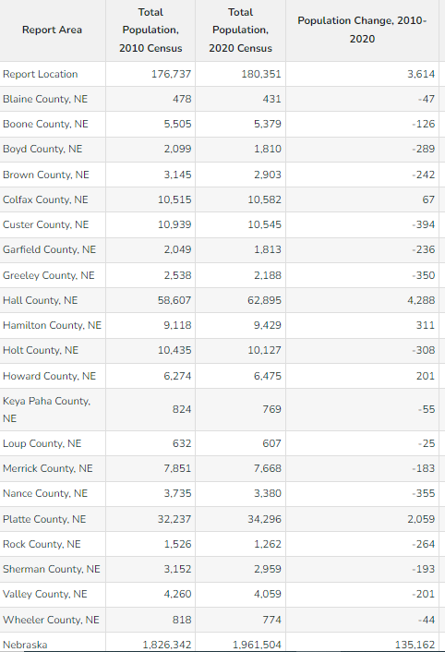

The population of the CNCAP service area is broken down by:

Age 0-4
Male: 6,689
Female: 5,806

Age 5-17
Male: 17,151
Female: 15,898

Age 18-64
Male: 51,886
Female: 48,892

Over 64
Male: 13,271
Female: 17,713

Working age population throughout the CNCAP service area is:

18 to 24
Male: 7,320
Female: 6,412

25 to 34
Male: 10,883
Female: 10,014

35 to 44
Male: 10,558
Female: 10,143

45 to 54
Male: 10,756
Female: 10,140

55 to 64
Male: 12,369
Female: 12,183

The overall working age population of the CNCAP area consists of mainly adults 35 and up. With the highest number of adults being from age 55-64. These are people who are either leaving or have already left the workforce. There is over 24,000 people within the service area in that age range with the smallest range of age is 18-24. This younger age population is lacking, with over 13,500 people. This age range is looking for a place to move to and establish their families. Lack of job opportunities, daycare, and housing are going to impact this group of people greatly. Finding a way to accommodate this age group is going to help sustain rural areas and bring families to smaller towns. The population adult ages (10-65) is broken down by county:
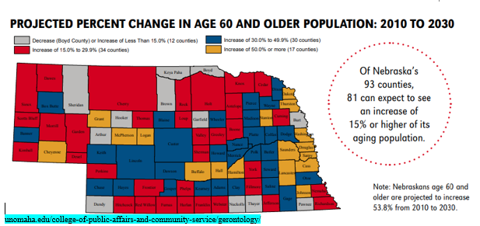
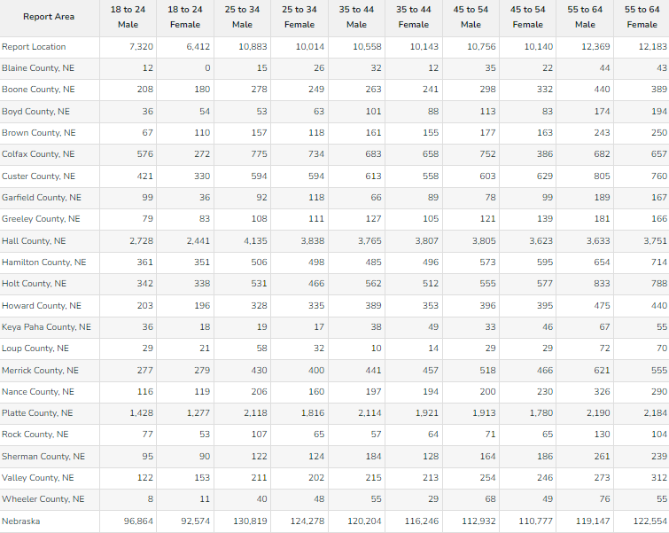
Rural Population

To be considered rural in Nebraska, the population of the counties must be less than 2500 residents. Of the CNCAP service area, 8 counties have less than 2500 residents. Another 8 counties have a population of less than 10,000 residents.

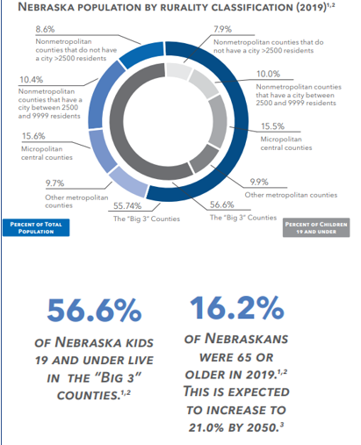
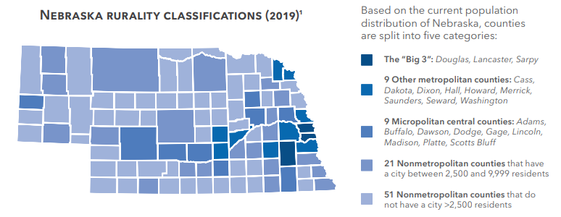

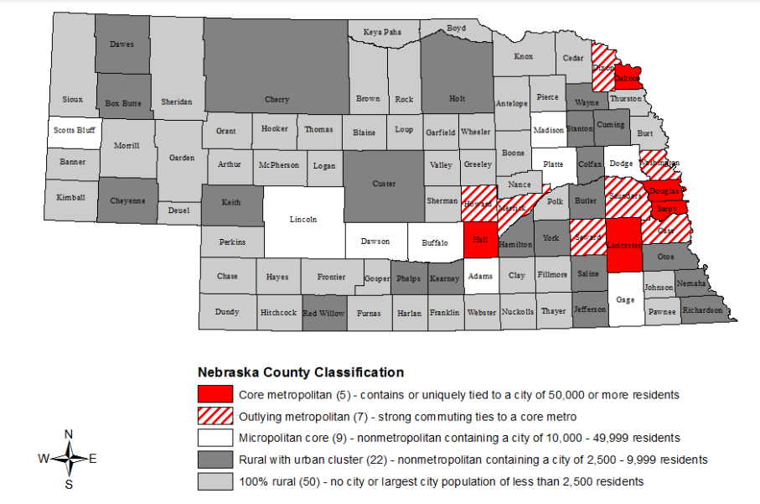
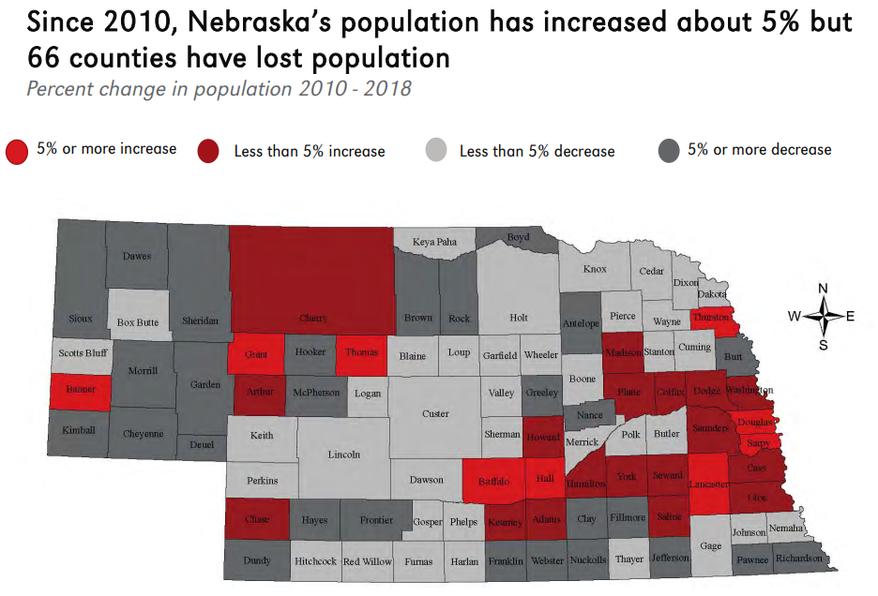
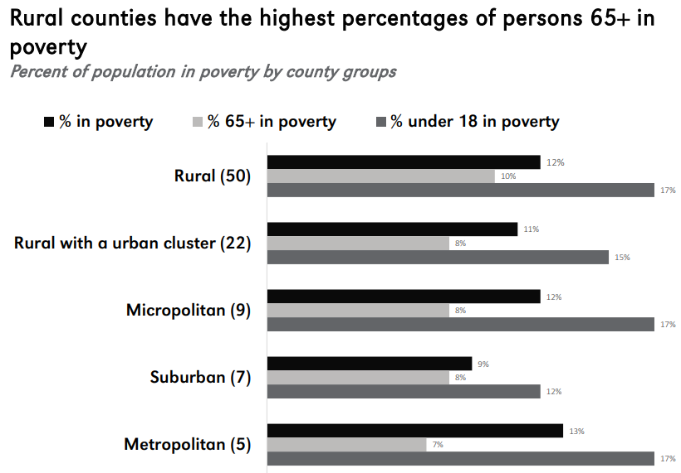
Rural counties lose population to the “Big 3 counties” every year. According to an article with AP News, “Census: Metro areas gained in Nebraska, rural areas lost”. Sarpy county had the largest increase in the state at 20% between 2010-2020. Douglas county gained 67,416 people in the last ten years. Younger people in these smaller communities move to the city for better opportunities. Nebraska also loses about 2,000 people per year to other states.
15 of the counties within the CNCAP service area showed a negative increase in population from 2010-2020. While Loup county showed a significant increase at 28%, the population is so small, it doesn’t take much to impact the percentage. Most of the counties that increased during the past ten years, are metro or counties that already had higher populations such as Platte, Hall, and Hamilton counties. For comparison, Saunders county showed a 7.77% increase in population, Sarpy county showed a 23.09% increase, Douglas county showed a 13.03% increase, and Lancaster county showed a 14.19% increase.
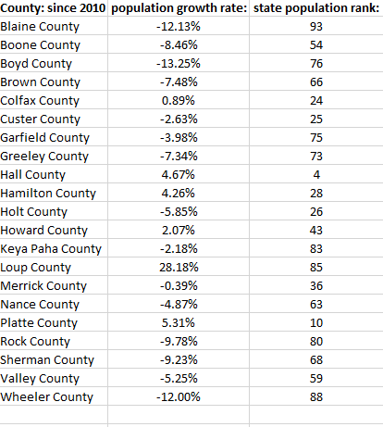
https://apnews.com/article/nebraska-census-2020-e9e6443240098a3ff831e865b8b31993
https://www.unomaha.edu
https://worldpopulationreview.com/states/nebraska-population

While rural living comes with many benefits, it has it’s challenges as well.
- Slow internet and cable services
- Less accessibility to many things: grocery stores, social activities, daycare,
- Lack of employment opportunities
- Poorer education-lack of quality school options.
- Fewer businesses
- Lack of public transportation
- Lack of healthcare

Family

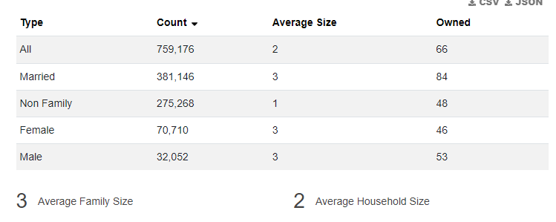

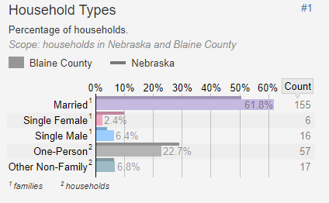
Blaine County:
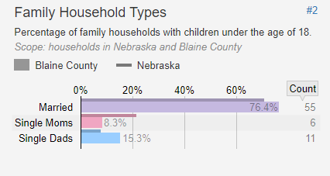

Boone County:
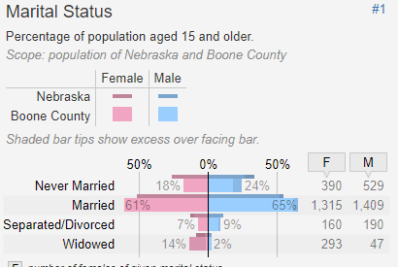

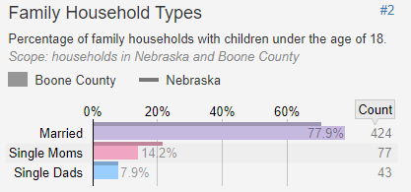

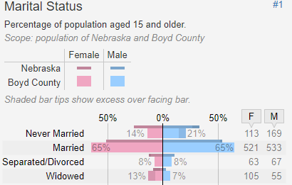
Boyd County:
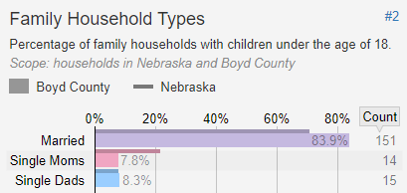

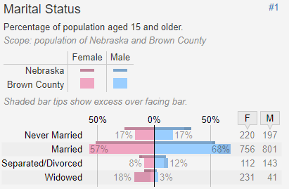
Brown County:
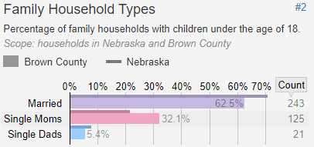

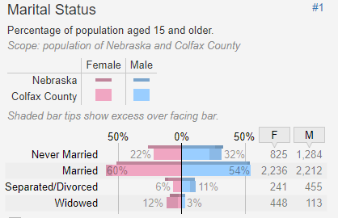
Colfax county:
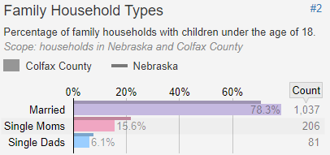

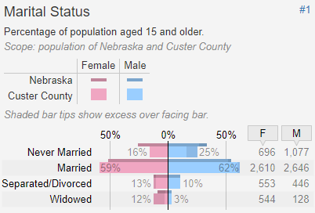
Custer county:
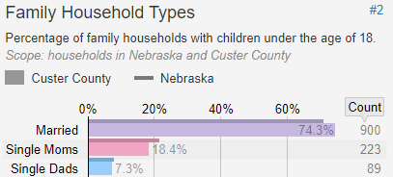

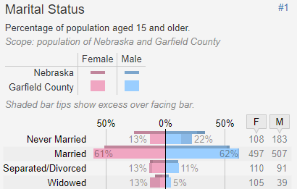
Garfield county:
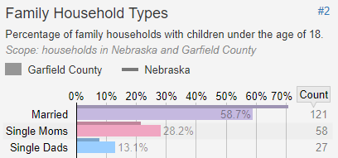

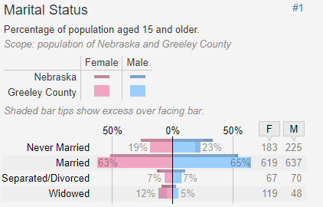
Greeley County:
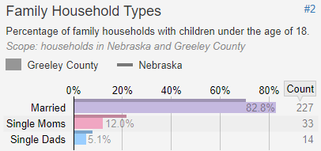

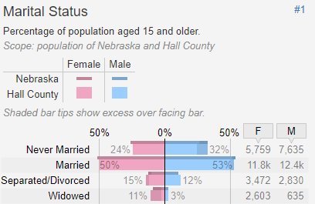
Hall County:
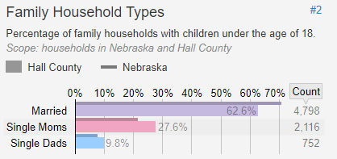

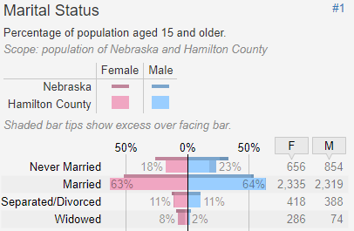
Hamilton County:
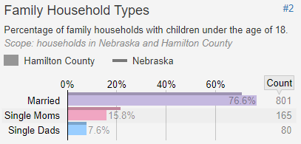

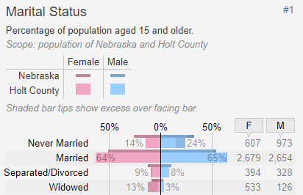
Holt County:
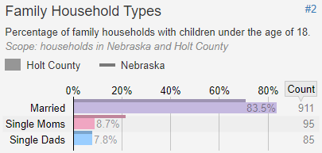

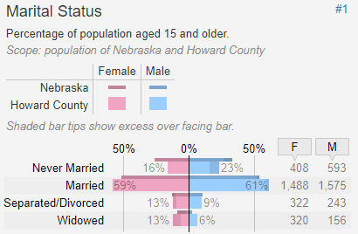
Howard County:
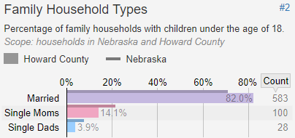

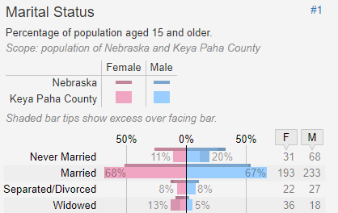
Keya Paha County:
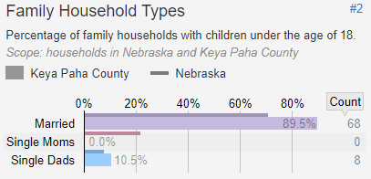

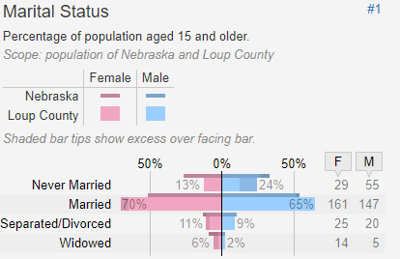
Loup County:
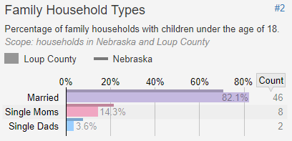

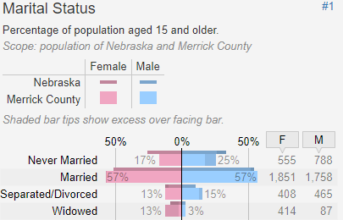
Merrick County:
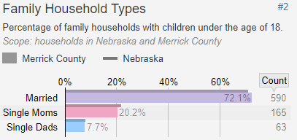

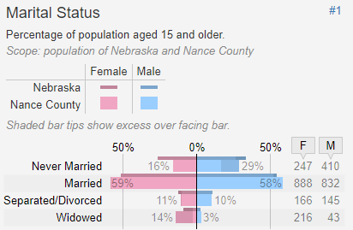
Nance County:
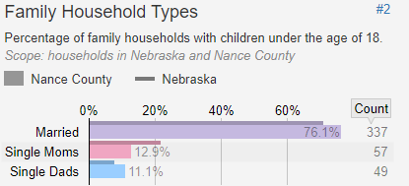

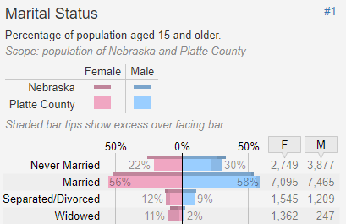
Platte County:
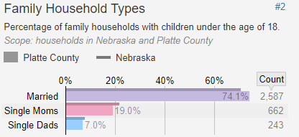

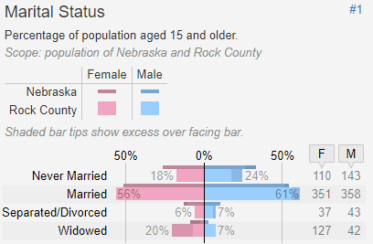
Rock County:
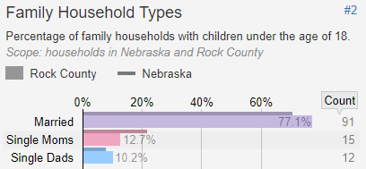

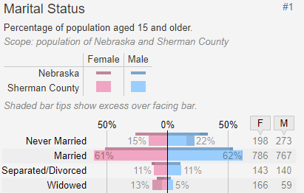
Sherman County:
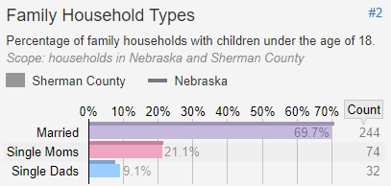

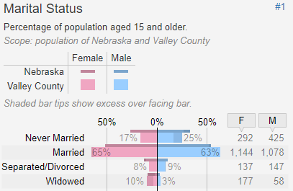
Valley County:
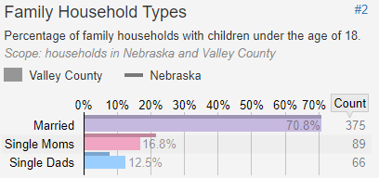

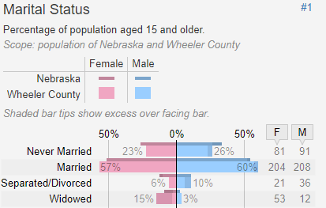
Wheeler County:
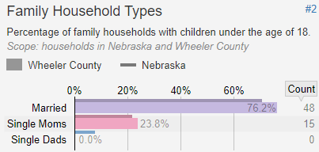

https://statisticalatlas.com/
Families with Children
Foster care types
Relative foster home
- Those who are related to the child or children by blood, marriage, or adoption
Kinship foster home
- Those who have a significant pre-existing relationship with the child or children for whom they care: current or former teacher, coach, neighbor
Licensed foster home
- Living at the same residence that cares for a child or children whom they have not previously known
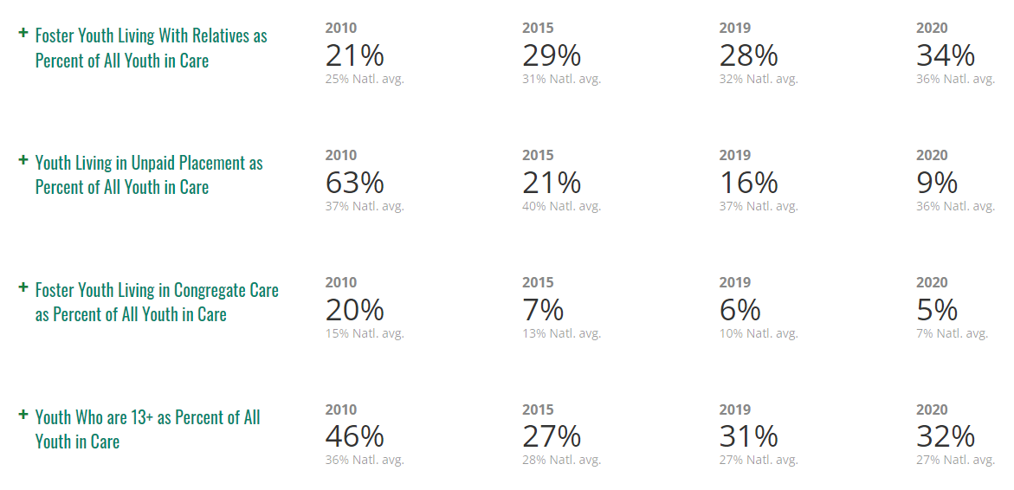
https://dhhs.ne.gov/Pages/Foster-Care.aspx
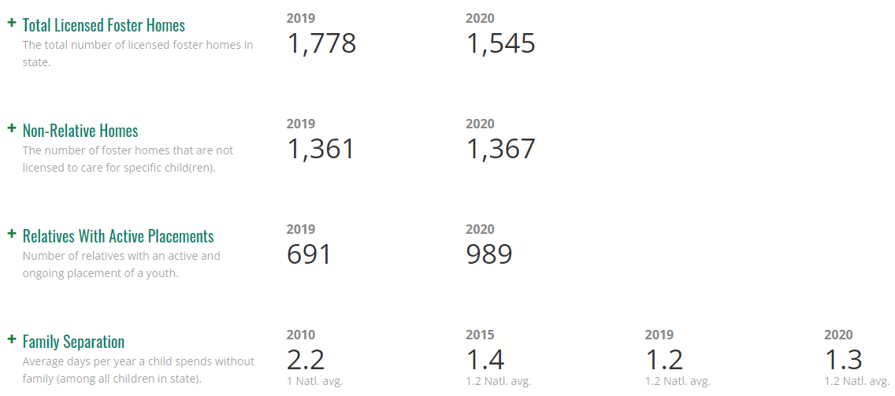
For comparison in Nebraska 2019-2020:
https://www.fostercarecapacity.com/states/nebraska
Number of children in foster care in 2021 per county:
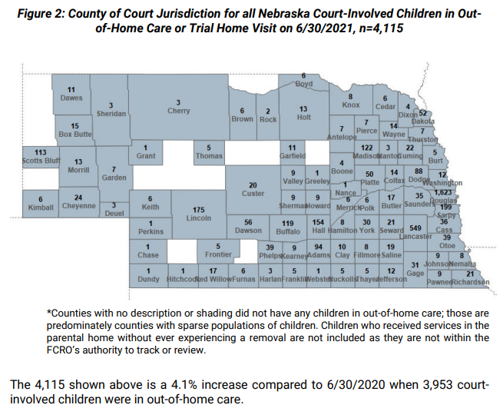
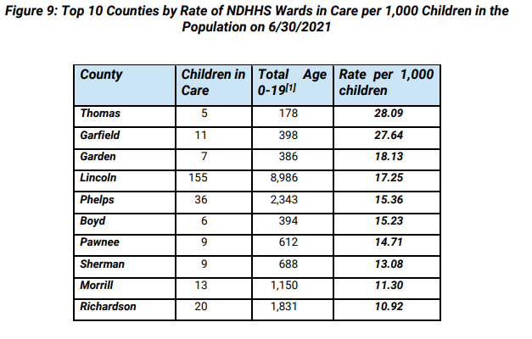
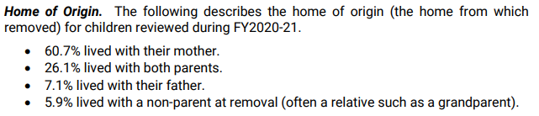
Reasons for removal
- Parental drug use (13.0%)
- Domestic violence (10.7%)
- Parental mental health (9.2%)
- Neglect (7.2%)
- Housing substandard unsafe (7.1%)
There were 9 children from the CNCAP service area at a youth rehabilitation and treatment center (YRTC) in 2021.
- 100% of the children in YRTC had been diagnosed with a mental health condition
- 76.3% of boys and 61.5% of girls placed at a YRTC were diagnosed with substance abuse issues
https://fcro.nebraska.gov/pdf/FCRO-Reports/2021%20Annual%20Report-FCRO-September.pdf

Types of adoption
International adoption
- Adopting from another country
Private adoption
- Adopting a child through a private agency
Foster care adoption
- Adopting a child from the U.S. foster care system

Number of children adopted in Nebraska:
2019: 547
2020: 360
2021: 304 (as of 10/31)

There are currently 646 children waiting to be adopted in 2021.

Child Abuse

According to DHHHS the definition of abuse is the non-accidental infliction of injury or an act that poses substantial likelihood of bodily injury. Such injury is considered abuse regardless of whether the caregiver intended to hurt the child. Indicators include: unexplained injuries, bruises and marks, arrives early to school and stays late, burns, bites, broken bones, black eyes, etc. Throughout CNCAP’s Early Childhood Programs, there were 14 child abuse/neglect reports during the 2020-2021 schoolyear.

Child maltreatment is known as any act or failure to act that results in death, serious physical or emotional harm, or sexual abuse. 80% of maltreatment in Nebraska is physical neglect, which is a failure to meet a child’s basic needs such as food, shelter, clothing. This is most often an economical issue. In 2019, there were 37,690 reports of alleged maltreatment in Nebraska, and 15,417 were assessed by DHHS or law enforcement. 2,019 of those reports were substantiated.

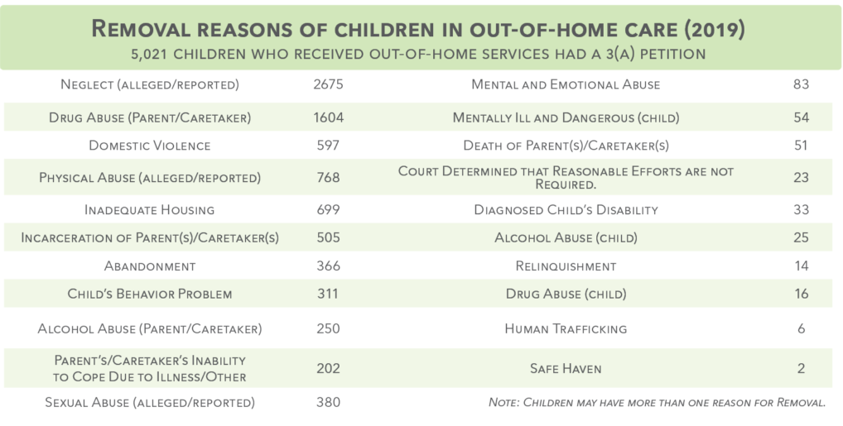

Where are the children in out-of-home care?
103 group home; 30 living independently; 40 missing youth; 15 emergency shelter; 69 medical facility; 1,198 foster and adoptive homes; 420 kinship care; 1,065 relative home; 136 detention center.
- 1,987 children in out-of-home care had a sibling in out-of-home care
- 62.8% were placed with all siblings
- 82.5% were placed with at least 1 sibling

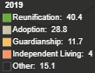
In the CNCAP service area there were 119 child abuse cases substantiated.
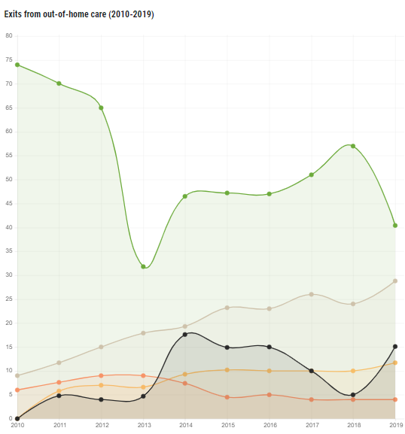
COUNTY CASES
Blaine County | 0
Boone County | 1
Boyd County | 2
Brown County | 3
Colfax County | 5
Custer County | 4
Garfield County | 1
Greeley County | 0
Hall County | 50
Hamilton County | 1
Holt County | 4
Howard County | 1
Keya Paha County | 0
Loup County | 0
Merrick County | 11
Nance County | 4
Platte County | 25
Rock County | 1
Sherman County | 2
Valley County | 4
Wheeler County | 0

In December of 2021, a Grand Island man was arrested in Hamilton County after a pursuit involving a child. Police attempted to pull the man over after an alleged assault where he strangled his girlfriend. The man then fled the scene with the couple’s three-year-old child. A high speed chase at over 100 miles per hour went on with the child on the man’s lap to be used as a shield. With two flat tires, the man continued on with the child still on his lap. When he was finally found at a residence, he was arrested for reckless driving, flight to avoid arrest, driving under the influence of alcohol, child neglect, transporting a child while intoxicated, no operators license, open alcohol container and numerous traffic violations. He was also charged with kidnapping, strangulation, third-degree domestic assault with no prior conviction, first degree false imprisonment, child abuse, willful flight to avoid arrest, protection order violation, obstruction, no seatbelt and a child restraint violation.
https://www.1011now.com/2021/12/21/pursuit-involving-child-leads-grand-island-mans-arrest/

Children living with grandparents

Why are grandparents raising the children? 10% of grandparents in the United States live with their grandchildren. This has increased from 7% in 1992. Drug abuse plays a heavy role in these numbers. Teen pregnancy is another reason grandparents are raising their grandchildren. A teen mother’s youth and inexperience may have an impact on the grandparent’s child-raising responsibilities. Parent in jail or prison, military deployment, and child abuse are other reasons why grandparents raise their children. 50 is the average age to become a first-time grandparent and 52% of grandparents raising their grandchildren are under the age of 60.
Within the state of Nebraska, 9,302 grandparents are responsible for their grandchildren in 2021. 31,219 children are living in homes where a relative other than a parent is the head of the household. 15,000 are being raised by kin with no parent present. 1056 children in foster care are being raised by a family member. Children who are being raised by grandparents are six times more likely to have experienced traumatic events. Grandparents are raising their grandchildren under challenging circumstances.
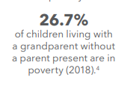
In the CNCAP service area, there are 31,153 people over the age of 65. 2,500 of them are in poverty. The average life expectancy is 78. During the 2020-2021 schoolyear, there were 7 children living with their grandparents in Head Start programs and 9 in Early Head Start. There were a total of six in foster care.

Minorities
Nebraska has been growing in immigrant population, with 1 in 14 Nebraskans having been born in another country. Immigrants are a essential part of the Nebraska labor force. 7% of Nebraska
residents are immigrants and another 7 percent of residents are native-born U.S. citizens with at least one immigrant parent. 61,618 women, 65,205 men and 12,130 children who are immigrants
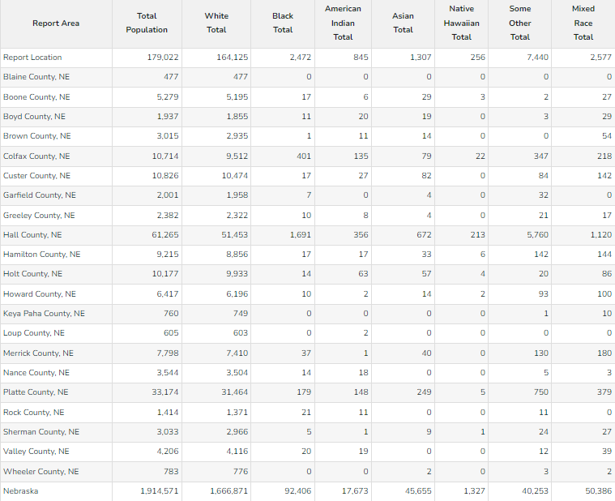
call Nebraska their home. The majority of immigrants across Nebraska are from Mexico, Guatemala, India, Myanmar, and Vietnam.

Minorities

Immigration and Language:
Blaine:

Languages spoken:
-98.44% English only
-1.56: non-English; 0.89% Spanish

Place of birth:
-100% born in the United States
-80.29% born in Nebraska

Boone:

Languages spoken:
-98.42% English only
-1.58 non-English; 1.03% Spanish

Place of birth:
-98.96% born in the United States
-87.08% born in Nebraska
-1.04% foreign born
-0.32% non-citizen
Of those not born in the USA, largest percentage is from Asia

Boyd:

Languages spoken:
-98.06% English only
-1.94% speak other languages; 1.34% Asian and Pacific Island

Place of birth:
-98.71% born in the United States
- 65.62% born in Nebraska
-1.29% foreign born; Asia
-0.98% non-citizen

Brown:

Languages spoken:
-96.40% English only
-3.60% speak other languages; 2.20% Indo-European; 1.1% Spanish

Place of birth:
-97.41% born in United States
-72.01% born in Nebraska
-2.59% foreign born; Europe
-2.26% non-citizen

Colfax:

Languages spoken:
-54.48% English only
-41.7 Spanish
-0.7% Asian and Pacific Island
-0.7% Indo-European
2.5% other

Place of birth:
-68.05% born in United States
-57.38% of those were born in Nebraska
-31.95% foreign born; Latin America; Africa
-22.09% of those were non-citizen
-9.86% naturalized

Custer:

Languages spoken:
-96.0% English only
-3.1% Spanish
-0.8% Indo-European languages

Place of birth:
-80.06% born in United States
-97.94% of those were born in Nebraska
-2.06% foreign born; Latin America
-1.21% non-citizen
-0.85% naturalized; Asia

Garfield:

Languages spoken:
-98.85% English only
-0.8% Indo-European
-0.2% Asian and Pacific Island
-0.2% Spanish

Place of birth:
-99.00% born in United States
-83.21% born in Nebraska
-1.0% foreign born
--1.0% of those are naturalized; Europe

Greeley:

Languages spoken:
-96.95% English only
-2.0% Spanish
-0.9% Indo-European

Place of birth:
-98.74% born in United States
-85.05% born in Nebraska
-1.26% foreign born; Latin America
-0.63% non-citizen
-0.63% naturalized

Hall:

Languages spoken:
-77.53% English only
-19.5% Spanish
-1.3% other languages
-1.1% Asian and Pacific Island
-0.5% Indo-European

Place of birth:
-86.15% born in United States
-67.28% born in Nebraska
-13.85% foreign born; Latin America
-9.07% non-citizen
-4.78% naturalized

Hamilton:

Languages spoken:
-97.40% English only
-1.9% Spanish
-0.4% Indo-European
-0.3% Asian and Pacific Island

Place of birth:
-98.95 born in United States
-80.68 born in Nebraska
-1.15% foreign born; Latin America
-0.30% non-citizen
-0.85% naturalized

Holt:

Languages Spoken:
-95.66 English only
-3.4% Spanish
-0.7% Indo-European
-0.1% other

Place of birth:
-97.37% born in United States
-75.0% born in Nebraska
-2.63% foreign born; Latin America
-1.20% non-citizen
-1.43% naturalized

Howard:

Languages spoken:
-97.46% English only
-1.7% Spanish
-0.8% Indo-European
-0.1% Asian and Pacific Island

Place of birth:
-98.27% born in United Sates
-83.06% born in Nebraska
-1.73% foreign born; Latin America
-0.72% non-citizen
-1.01% naturalized

Keya Paha:

Languages spoken:
-98.5% English only
-1.5% Spanish

Place of birth:
-99.74% born in United States
-64.34% born in Nebraska
-0.26% foreign born
-0.26% naturalized
Loup:

Languages spoken:
-100% English

Place of birth:
-100% born in United States
-86.28% born in Nebraska

Merrick:

Languages spoken:
-94.0% English only
-4.2% Spanish
-1.3% Indo-European
-0.5% Asian and Pacific Island

Place of birth:
-97.29% born in United States
-83.79% born in Nebraska
-2.71% foreign born; Latin America
-2.15% non-citizen
-0.55% naturalized

Nance:

Languages spoken:
-98.45% English only
-1.0% Indo-European
-0.6% Spanish

Place of birth:
-99.32% born in United States
-84.96% born in Nebraska
-0.68% foreign born; Europe
-0.62% non-citizen
-0.06% naturalized

Platte:

Languages spoken:
-83.2% English only
-16.0% Spanish
-0.4% Indo-European
-0.3% Asian and Pacific Island

Place of birth:
-89.60% born in United States
-73.54% born in Nebraska
-10.40% foreign born; Latin America
-6.29% non-citizen
-4.12% naturalized

Rock:

Languages spoken:
-98.1% English only
-1.6% Spanish
-0.3% Indo-European

Place of birth:
-99.29% born in United States
-75.60% born in Nebraska
-0.71% foreign born; Latin America
-0.71% naturalized

Sherman:

Language spoken:
-96.74% English only
-2.4% Spanish
-0.8% Indo-European
-0.1% Asian and Pacific Island

Place of birth:
-98.45% born in United States
-86.19% born in Nebraska
-1.55% foreign born
-0.76% non-citizen
-0.79% naturalized

Valley:

Languages spoken:
-97.67% English only
-1.0% Spanish
-0.9% Indo-European
-0.4% other

Place of birth:
-98.64% born in United States
-84.45% born in Nebraska
-1.36% foreign born; Latin America
-0.38% non-citizen
-0.97% naturalized
Wheeler:

Languages spoken:
-98.19% English only
-1.7% Spanish
Place of birth:
-99.49% born in United States
-81.48 born in Nebraska
-0.51% foreign born; Latin America
-0.51% non-citizen

Nebraska overall:

Languages spoken:
-88.5% English only
-7.5% Spanish
-1.6% Asian and Pacific Island
-1.5% Indo-European
-0.9% other

Place of birth:
-92.80 born in United States
-64.67% born in Nebraska
-7.20% foreign born; Latin America
-4.40% non-citizen
-2.81% naturalized

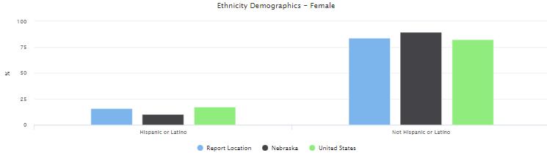
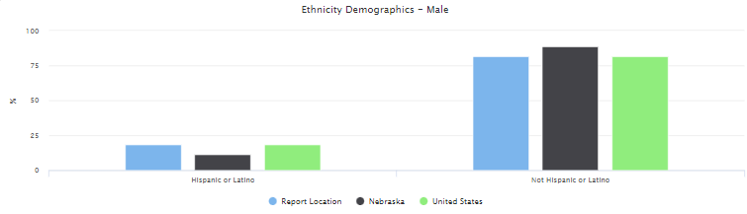
Ethnicity
https://cap.engagementnetwork.org
https://worldpopulationreview.com/states/nebraska-population

Veterans

According to the American Community Survey, 7.93% of the adult population within the CNCAP service area are veterans. This is more than the national average of 7.29%.
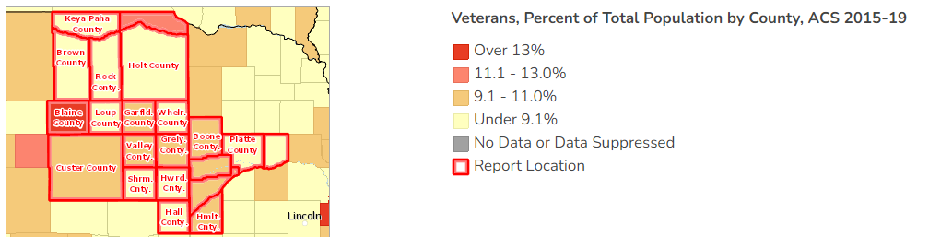
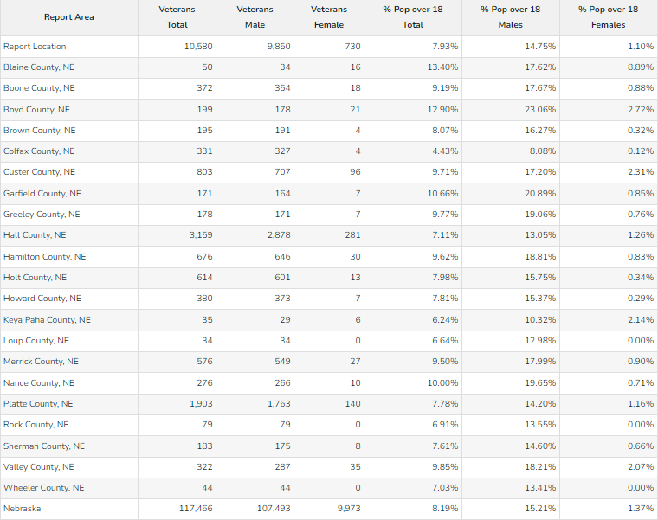
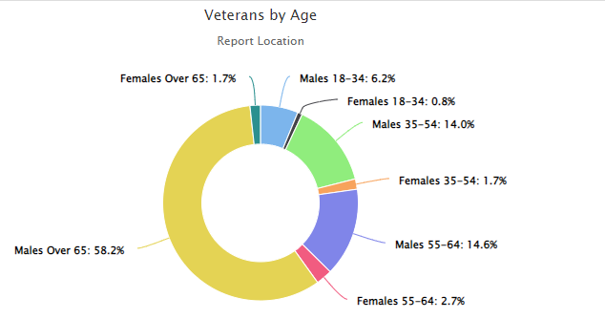

Veteran demographic by county:

Blaine County:
Veteran poverty rate: 4%
Veteran disability rate: 58%
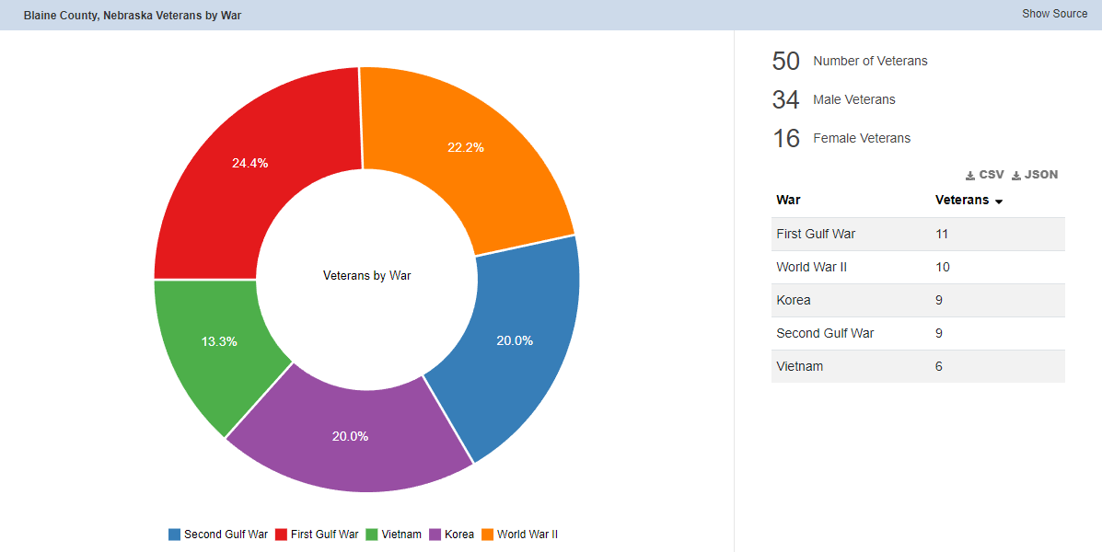

Boone County:
Veteran poverty rate: 5.71%
Veteran disability rate: 36.68%
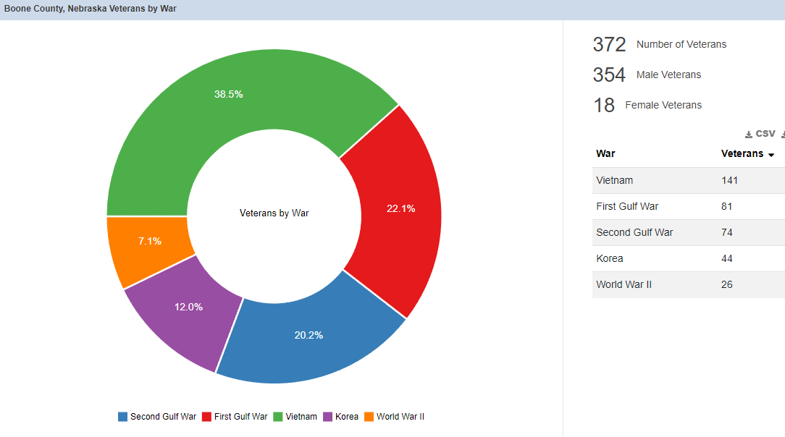

Boyd County:
Veteran poverty rate: 10.77%
Veteran disability rate: 46.67
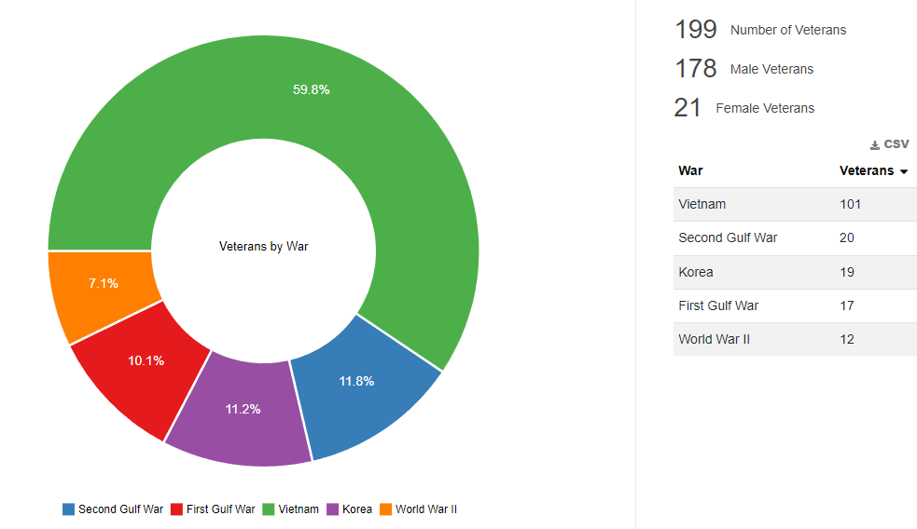
Brown County:
Veteran poverty rate: 7.94%
Veteran disability rate: 12.17%
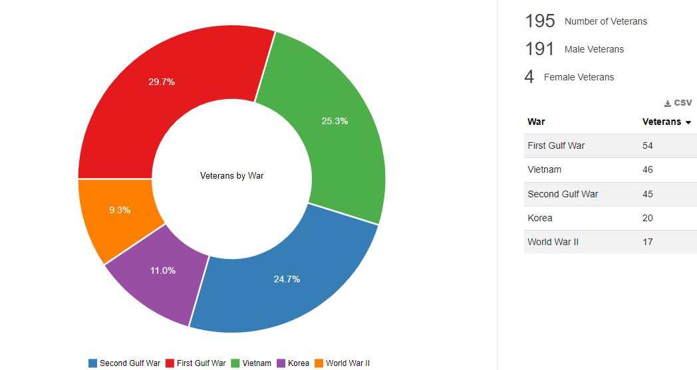

Colfax County:
Veteran poverty rate: 13.60%
Veteran disability rate: 44.11%
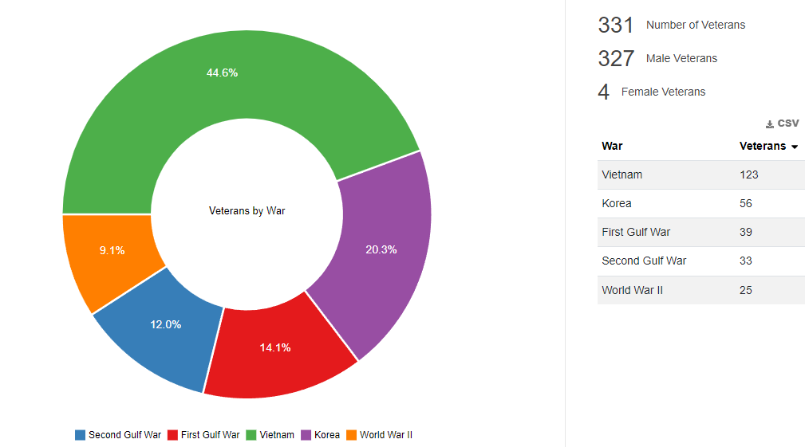
Custer County:
Veteran poverty rate: 8.73%
Veteran disability rate: 36.28%
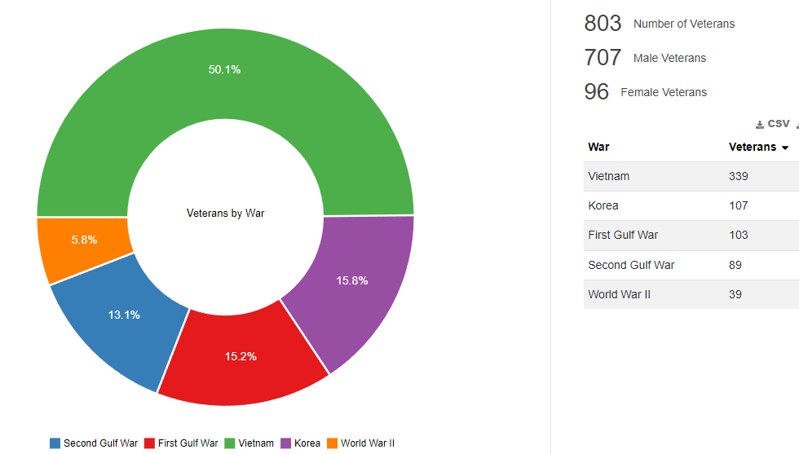

Garfield County:
Veteran poverty rate: 15.00%
Veteran disability rate: 45.63%
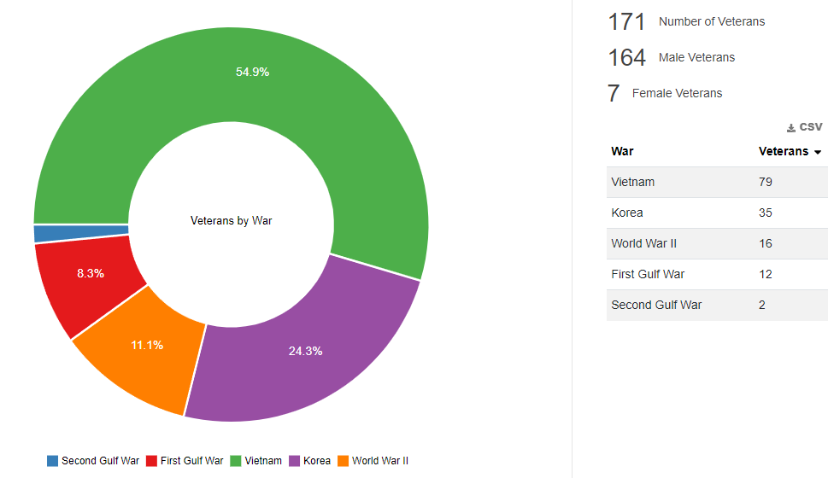
Greeley County:
Veteran poverty rate: 6.29%
Veteran disability rate: 47.43%
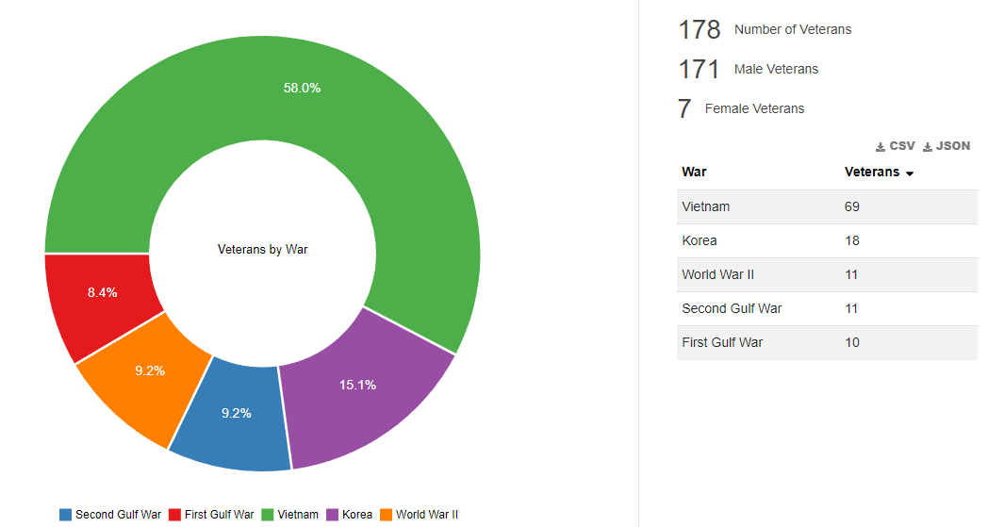

Hall County:
Veteran poverty rate: 7.35%
Veteran disability rate: 37.29%
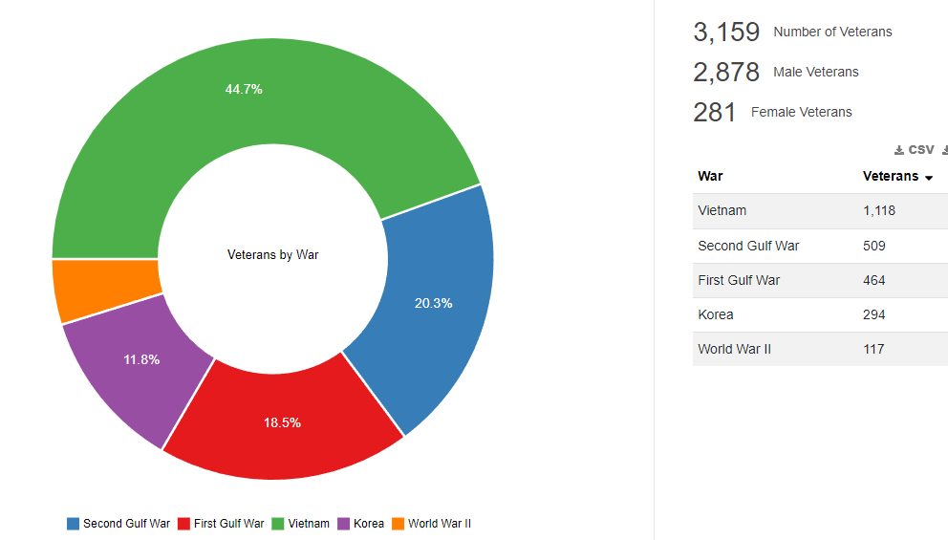
Hamilton County:
Veteran poverty rate: 3.19%
Veteran disability rate: 33.43%
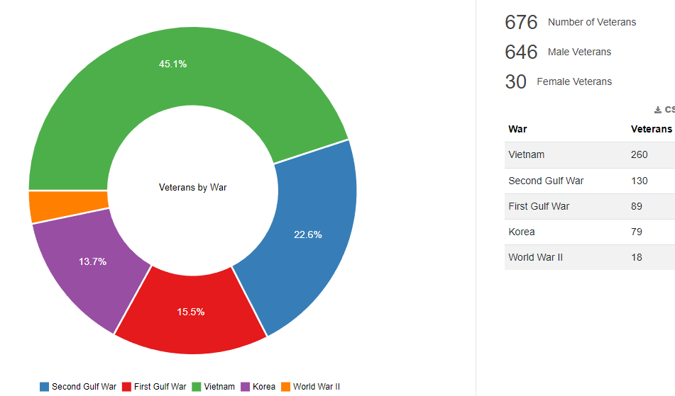
Holt County:
Veteran poverty rate: 10.30%
Veteran disability rate: 30.40%
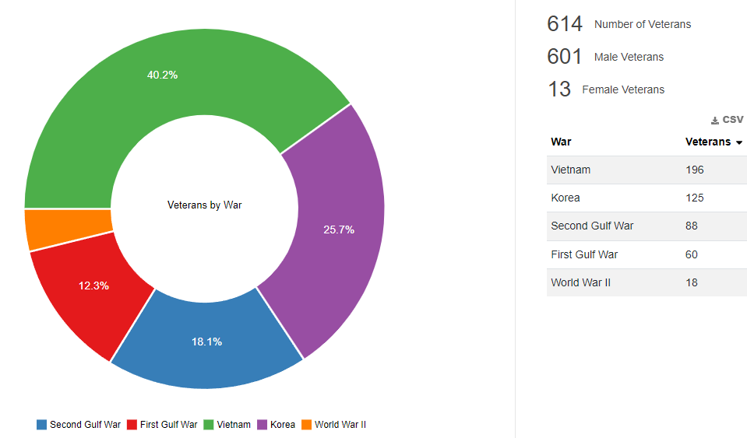
Howard County:
Veteran poverty rate: 3.16%
Veteran disability rate: 26.05%
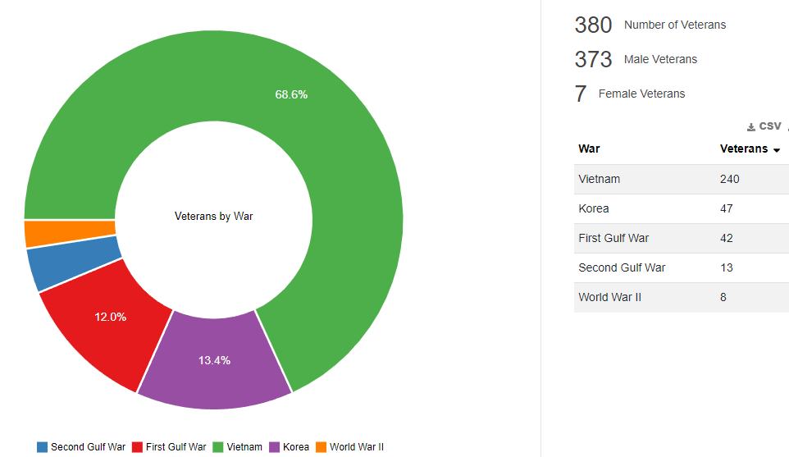
Keya Paha County:
Veteran poverty rate: 5.71%
Veteran disability rate: 31.43%
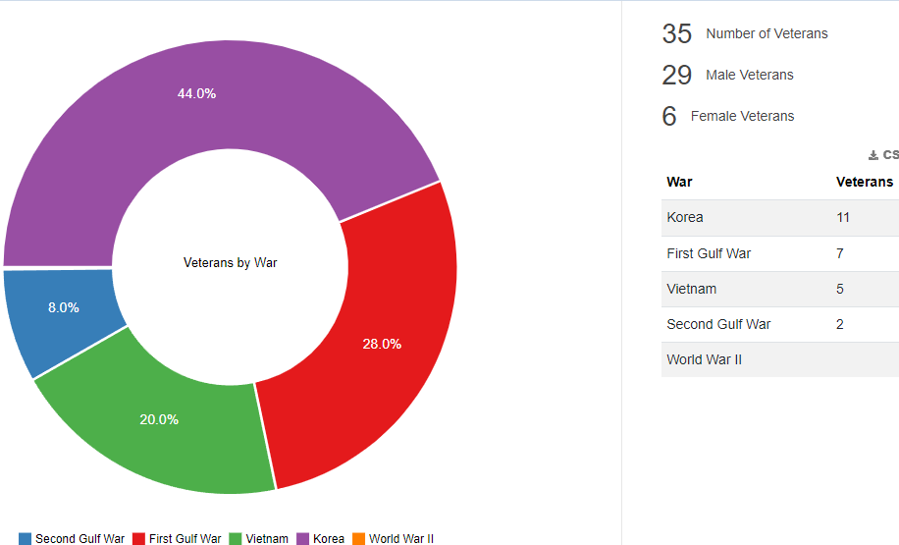
Loup County:
Veteran poverty rate: 2.94%
Veteran disability rate: 61.76%
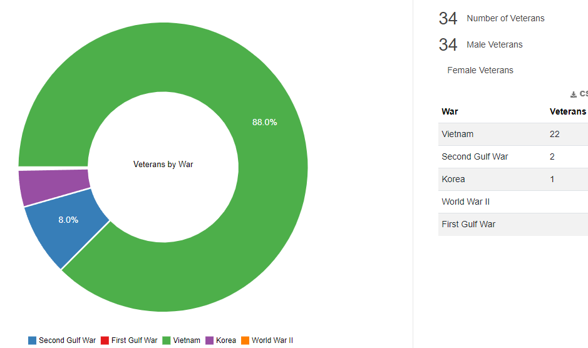
Merrick County:
Veteran poverty rate: 8.25%
Veteran disability rate: 39.82%
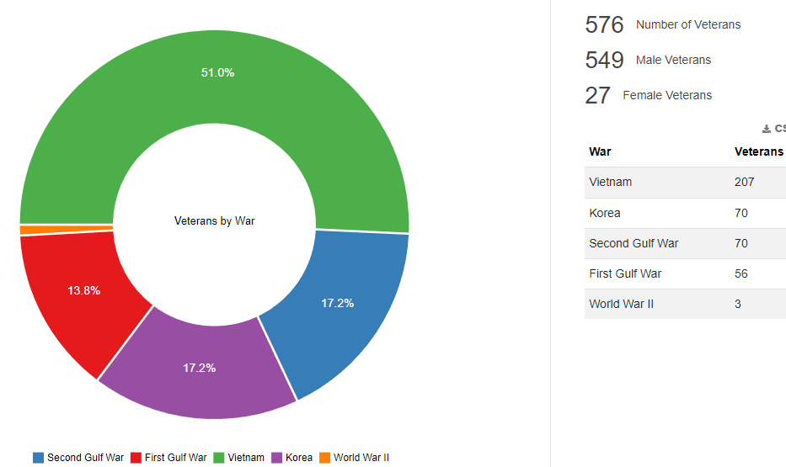
Nancy County:
Veteran poverty rate: 11.58%
Veteran disability rate: 29.73%
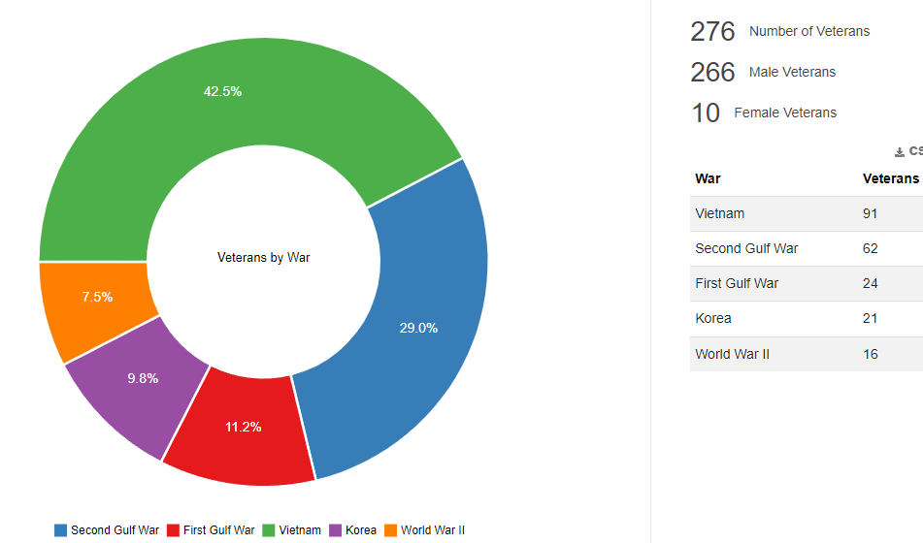
Platte County:
Veteran poverty rate: 4.41%
Veteran disability rate: 30.34%
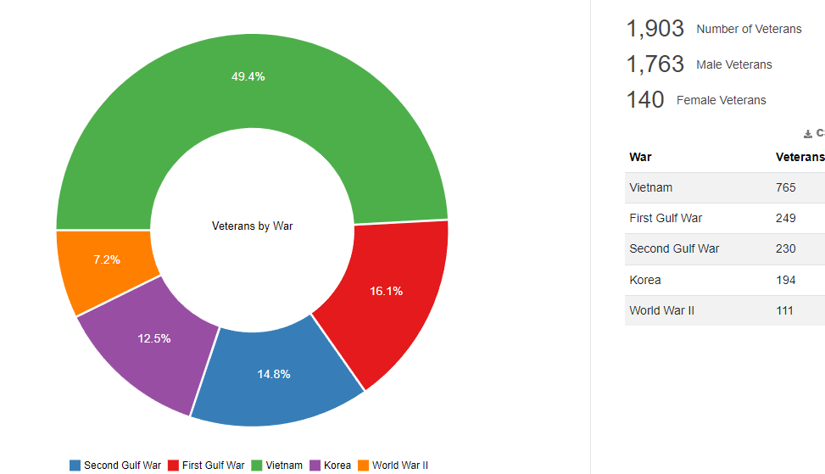
Rock County:
Veteran poverty rate: 2.53%
Veteran disability rate: 39.24%
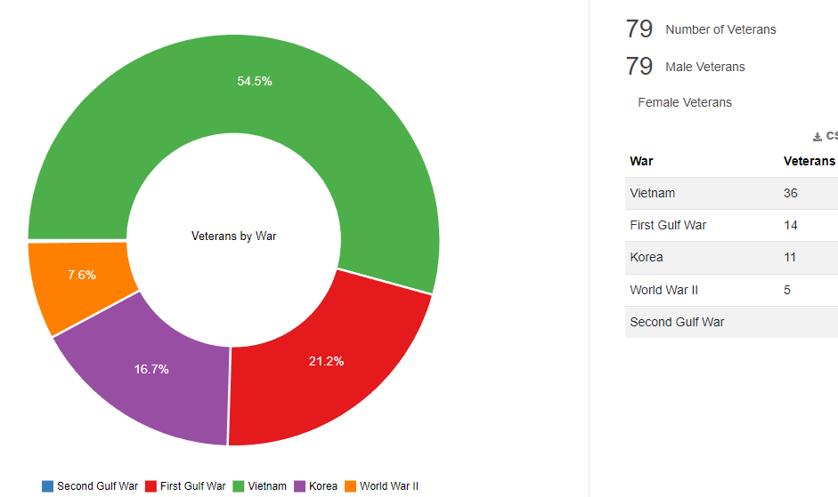
Sherman County:
Veteran poverty rate: 12.00%
Veteran disability rate: 38.29%
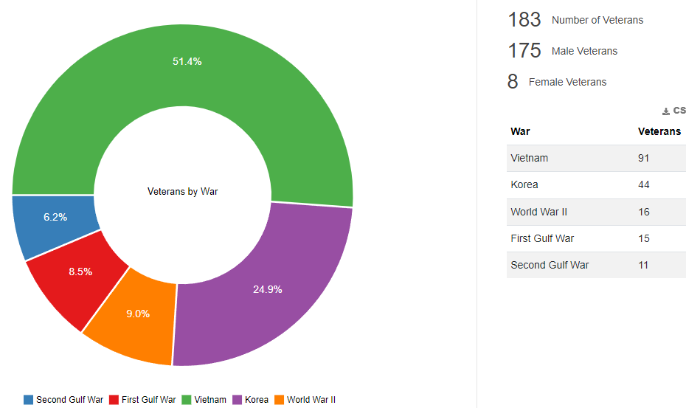
Valley County:
Veteran poverty rate: 13.08%
Veteran disability rate: 46.73%
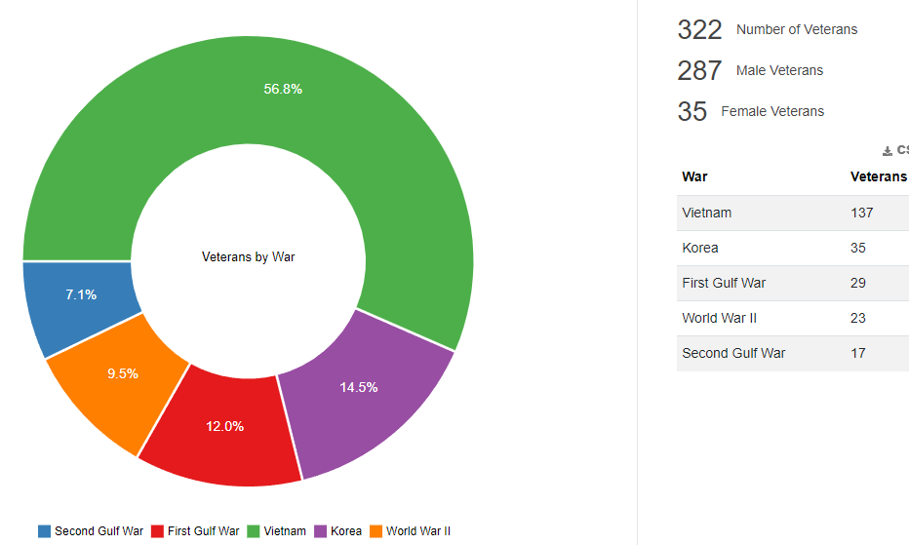

Wheeler County:
Veteran poverty rate: 6.82%
Veteran disability rate: 18.18%
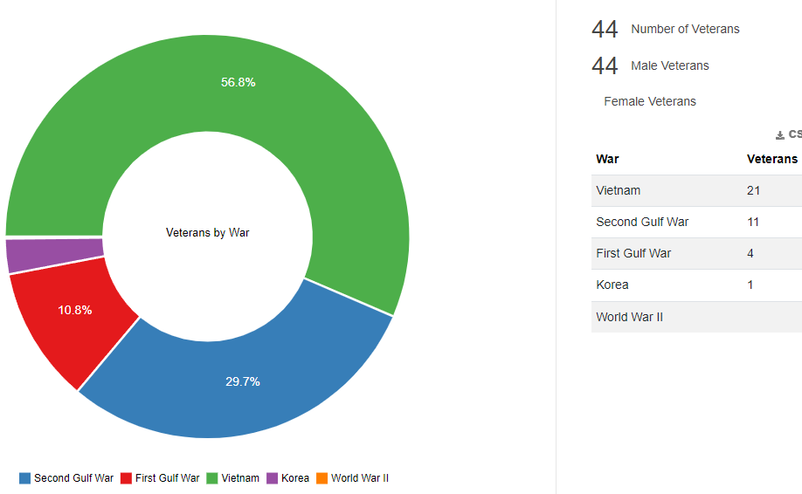
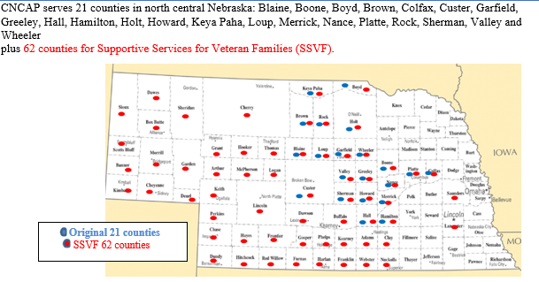
https://worldpopulationreview.com/us-counties/ne/wheeler-county-population

In a letter from the Biden Administration, the President explains that our nation has a sacred obligation to properly prepare and equip the troops we send into harm’s way, and to care for them and their families when they return home. Their service comes at a cost and it is our duty to help them build lives of opportunity when they arrive back home. This means providing them service by helping them find employment, providing pathways to home ownership, and providing financial support and relief to those who are struggling. The President’s American Rescue Plan provided $17 billion to help veterans by providing the Department of Veterans Affairs enough funding to offer health care services to veterans, including funding for homeless programs, and to implement a rapid retraining assistance program to help veterans impacted by the pandemic. This plan also eliminated all out-of-pocket medical costs for veterans and provided much needed financial relief to veterans experiencing economic hardship during the pandemic. Many of these services are only provided through a complex paper form with complicated eligibility requirements. Therefore, veterans may be deterred from applying for much-needed relief because the application process is too confusing and time-consuming. The plan of action is: simplifying the process for claiming medical forgiveness by setting a simple income threshold for receiving medical debt relief. Veterans are not always aware of benefits that they may be eligible for. There is a desperate need to raise awareness so they know they can receive help.

The Veterans Rapid Re-Housing (Veterans RRH) program provides housing assistance and case management to homeless, disabled Veterans, and their families to stabilize them in their housing situation. From October 1st, 2020-September 30th, 2021 the Veterans RRH program served 13 households & 25 benefactors and managed $47,325.00 debt. The savings accumulated was $28,651.00 for 10 households and 21 benefactors. This program is offered in all 21 counties of the CNCAP service area, and Cherry county
The Supportive Service for Veteran Families (SSVF) served 271 households and 458 benefactors between Oct 2020-Sept 2021. The program managed $61,479.00 debt for 271 households and 112 benefactors. The savings accumulated was $63,551.00 for 42 households and 70 benefactors. This program offers case management for individual Veteran’s or a family in which the head of the household is a Veteran. The program focuses on housing stabilization through temporary assistance that serves as a bridge to long term stability. This program is offered in all 21 counties plus the 41 additional counties.

Education
School Information
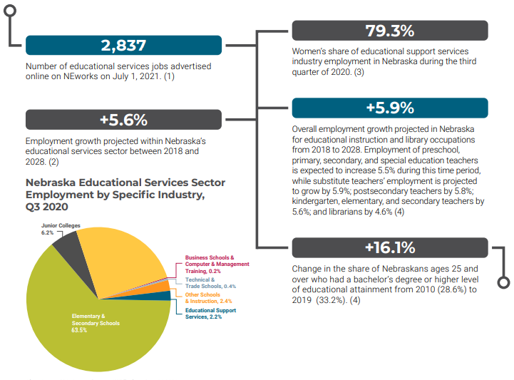
https://dol.nebraska.gov/webdocs/Resources/Trends/August%202021/Trends%20August%202021.pdf
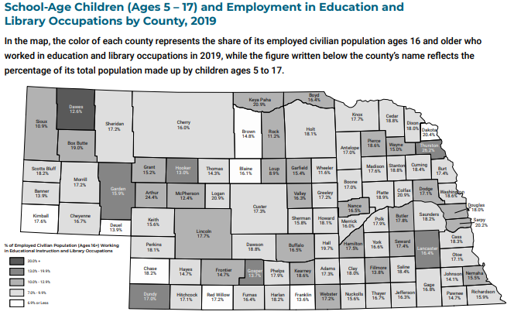
Number of students in school per county 2020-2021:

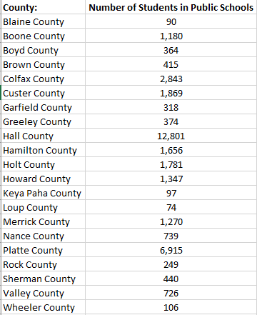

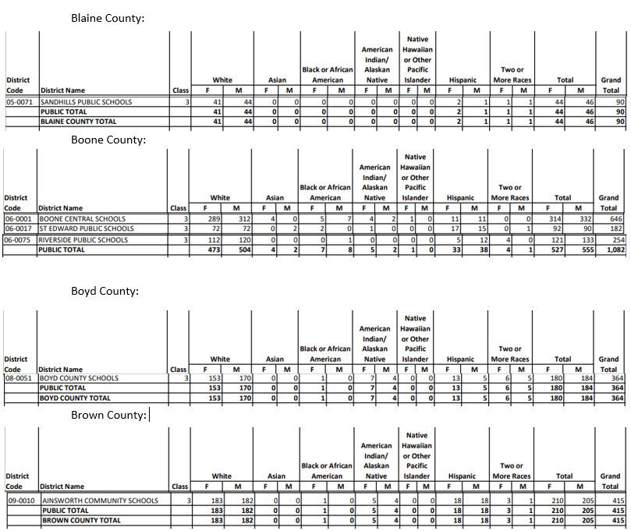
Race and Gender per school by county:

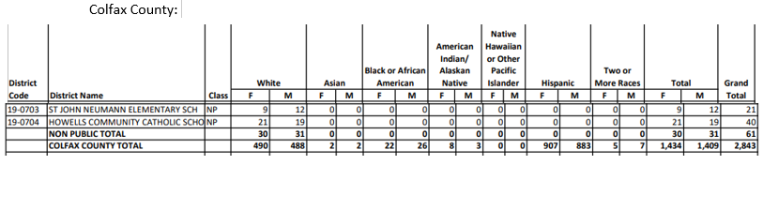

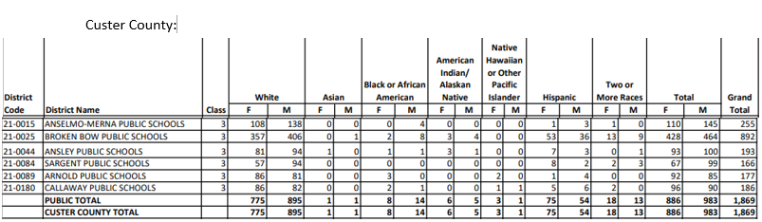
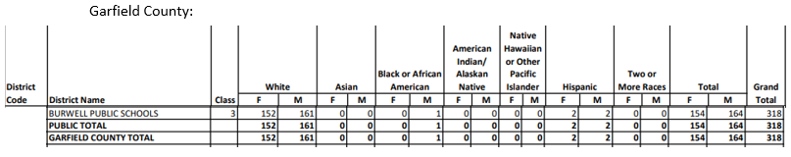
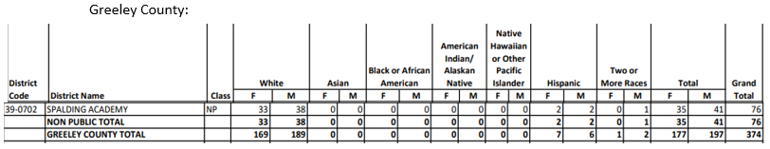
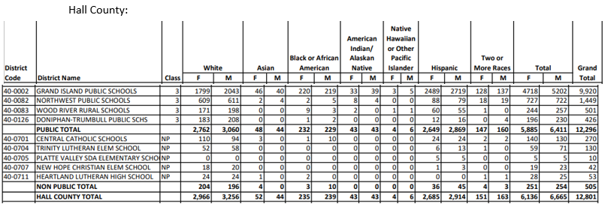
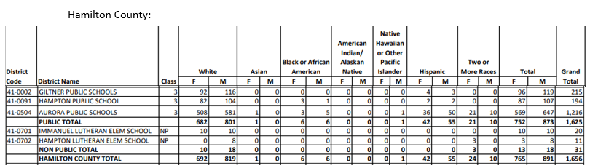
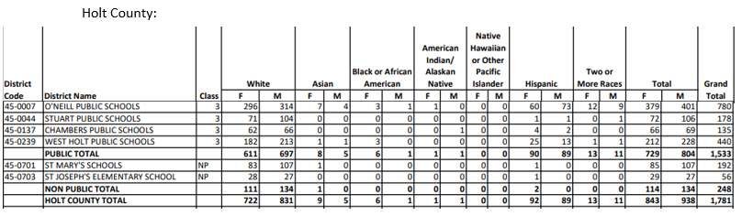
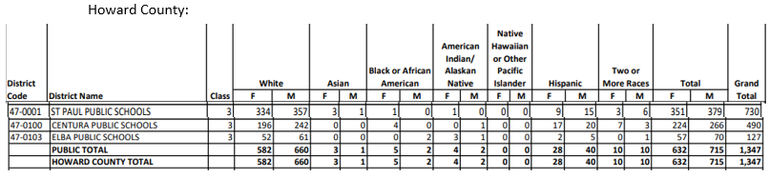
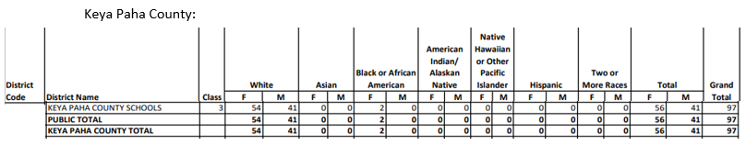
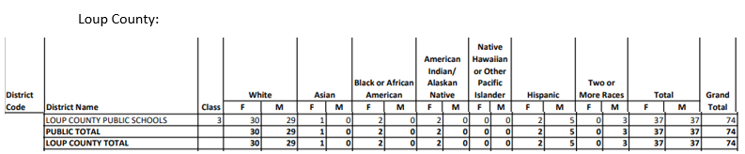
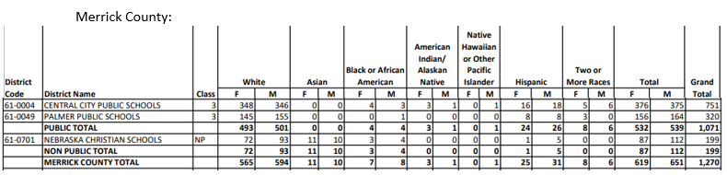
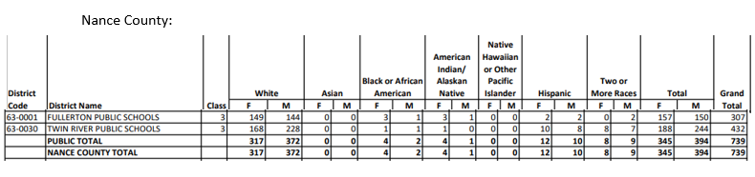
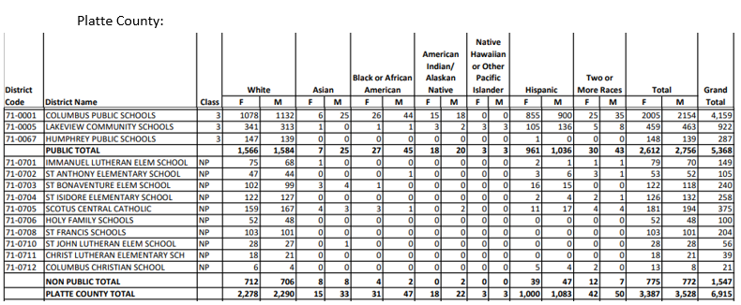
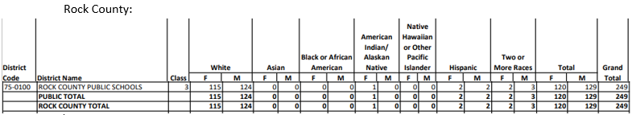
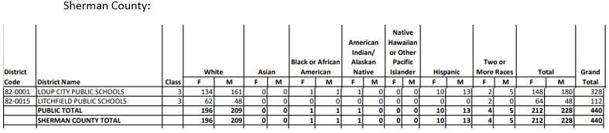
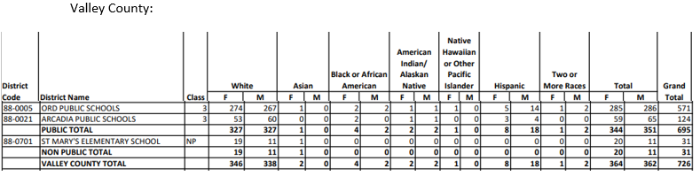
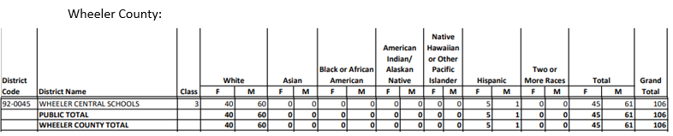
Education Levels
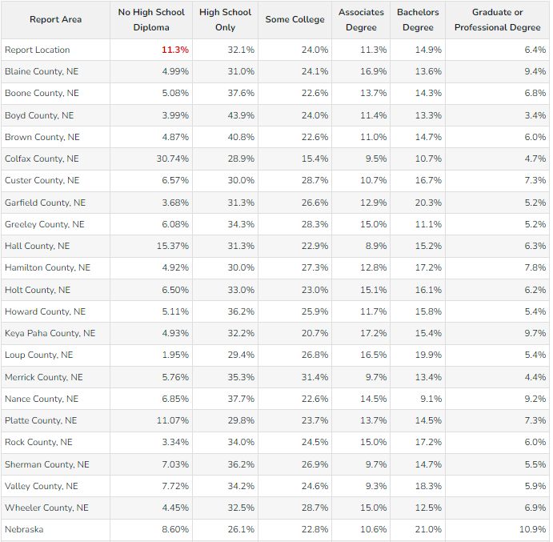

Housing

The U.S. Census Bureau estimated that there were 50,626 owner occupied homes of the estimated 82,092 housing units in the CNCAP service area. That is 61.67% owner occupied homes compared to 71.93 in 2000.
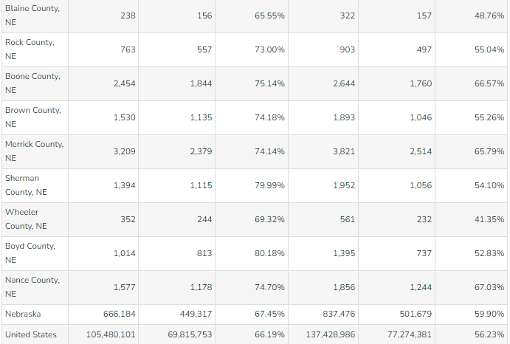

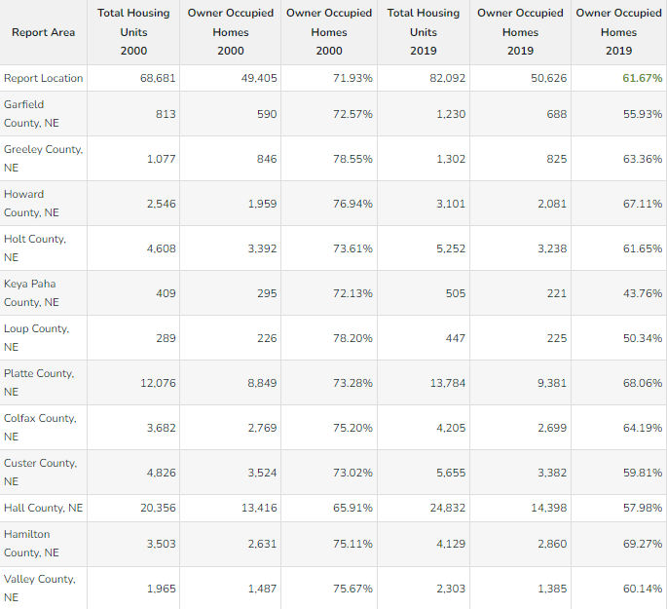
Fair Market Rent

Fair market rent is calculated as the 40th percentile of gross rents for regular standard quality units in a local housing market. Data is typically collected from recent move ins rather than long-term tenants, as long-term tenants generally receive a lower monthly rental rate.

The average cost of a home per county; fair market rent for 2 bedroom
Blaine: $116,300; $734 Greeley: $94,800; $734
Boone: $162,900; $734 Hamilton: 188,400; $734
Boyd: $97,400; $734 Holt: 152,000; $734
Brown: $90,300; $734 Hall: $177,100; $793
Colfax: $123,600; $734 Howard: $196,300; $734
Custer: $94,800; $734 Keya Paha: 96,400; $734
Garfield: $127,300; $734 Loup: $215,000; $739
Merrick: $140,600; $734 Rock: $111,500; $734
Nance: $133,800; $734 Valley: $124,500; $734
Platte: $192,400; $802 Wheeler: $139,200; $739
Sherman: $ 117,600; $734

Vacancy
Of the 86,307 residential addresses, 1,680 are vacant within the CNCAP service area.
There are 311 housing units without plumbing within the 21 counties.

Real estate across Nebraska is in high demand as less houses go up for sale, prices rise and houses sell as quickly as they hit the market. Grand Island specifically is in short supply of housing, with only 18 houses available on the market in April of 2021. Studies have shown that in order for a community that size to be healthy and thriving, at least 160 houses should be available at all times. Businesses still have not come back fully since the pandemic and therefore the supplies needed to build a house are hard to access.
A similar situation is found in Columbus as well, from a recent article “Housing study presented at Columbus City Council meeting.” It opens with: “Columbus, its growing. So much so that homes and apartments are being filled before they are even completed.” The population of Columbus has increased by 2000 people in the last ten years. Columbus has a healthy job market which has also supported its growth and kept stable the smaller communities around it. While the job market flourishes, the housing market does not, which poses an issue moving forward about keeping jobs filled when employees can’t find a place to live. Columbus is expected to increase by another 2000 people within the next decade, which means that 127 housing units should be constructed annually in order to meet the needs of the population. On top of that, there are already 2000 job openings in Columbus today and if even just one-third of those were filled, Columbus would need 670 more units just to provide adequate housing.
Broken Bow completed a housing study to get to the root of the same issue: housing shortages. The population of Broken Bow has remained consistent, however, the age population is made up
mostly people between 50-64. These are people who will be leaving the workforce within the next fifteen years. While there is a good representation of ages 25-34, there is not a lot of draw within the community to keep them there. Seeing as there were zero new houses build between 2010-2015. Bringing the renter-occupied vacancy rate from 15.2% in 2000 to 3.8% in 2016.

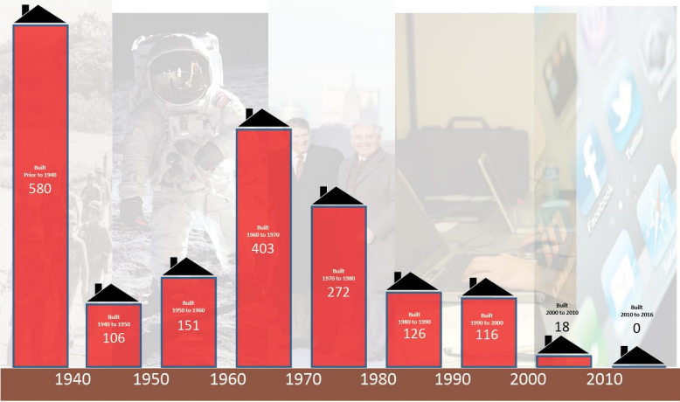

While this is only a few towns from within our service area, there is a similar theme across the board. These rural towns and smaller communities cannot prosper without proper housing and a shortage seems to be prevalent among a lot of communities. Another issue within rural towns is that Nebraska farmland is considered so valuable that farmers are not willing to sell their land to be turned into housing. So the land to build on is not always available, even if there is a need.

An article in the Columbus Telegram states, “Rural Nebraska’s housing crunch is costing towns new residents who ‘have nowhere to live’.
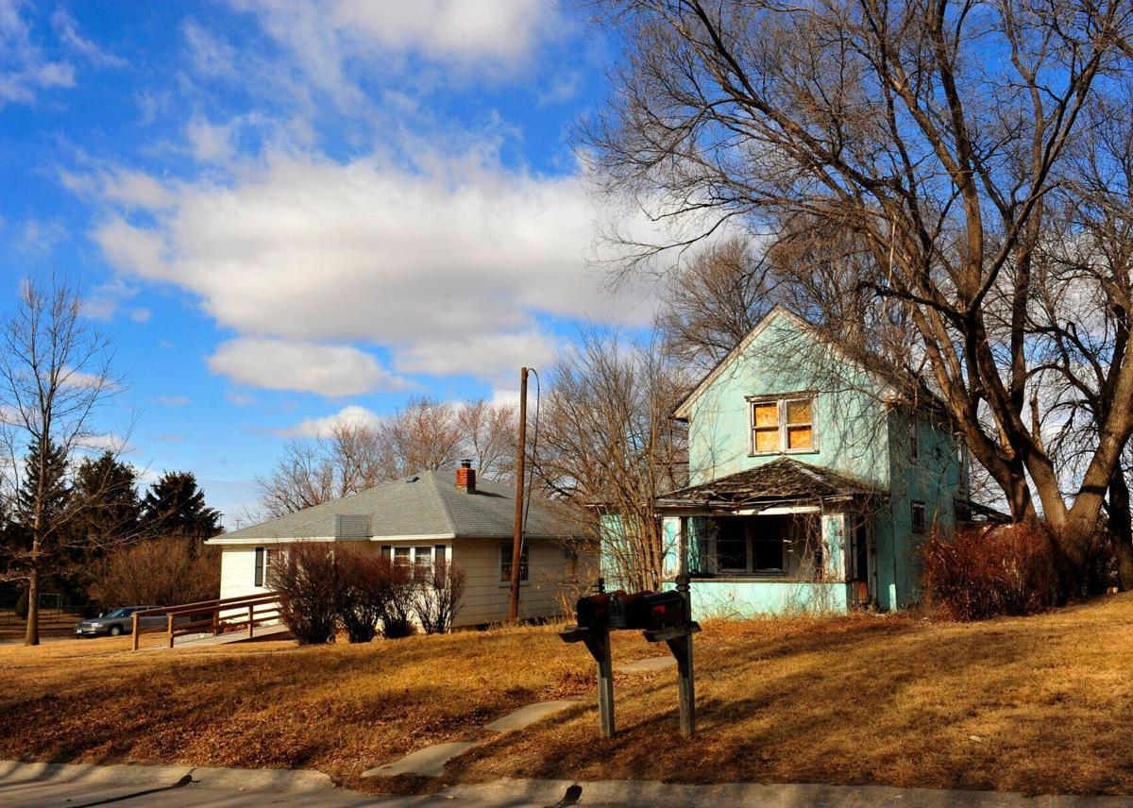
These older homes in Albion could be found in every community in the State. Nearly half of the state’s housing stock was build prior to 1970, and the share of older homes skyrockets in Nebraska’s smaller cities and towns. The same high up jobs have been denied multiple times due to lack of housing. Even with competitive wages small towns are unable to get people to move there, not for fear of rural America but because they have nowhere to live. This is a struggle to nearly every Nebraska mid-sized city and small town. There just simply aren’t enough houses. The few on the market are aging and in need of repair. This is a major barrier to towns trying to attract new families and new workers to fill frontline and managerial jobs. The director of Nebraska City Area Economic Development Corporation stated, “Job creation is the easy part. Without housing and childcare, its nearly impossible to attract workers to Nebraska’s smaller towns.” Housing construction has slowed in Nebraska. From 2010-2019, only 46,096 homes were built in the entire state. This is less than half the number built in the decade prior. Everybody kind of panicked and said, ‘we’re not going to build anymore. A lot of the construction firms went out of business,” states co-owner of Mesner Development. The firms that came back after the pandemic became more cautious, choosing to develop housing subdivisions in cities like Omaha, Lincoln and Grand Island where they know they are guaranteed to sell. In rural America, there is a far greater risk that is perceived by developers. On top of that, it is more expensive to build in small towns, costlier to bring in contractors and supplies and with strains on the supply chain its now more expensive than ever. Stuart has figured out how to rehabilitate aging homes in order to keep the houses livable and encourage people to move there. Even still, there is a shortage of construction workers and contractors. Most of them are scheduled a year and a half out before they can even think of building a new house. 68% of Stuarts houses were built before 1970. House prices have gone up almost 15% in the past two years. Even Stuart, which continues to rehabilitate old houses, didn’t have a new home build from 2010 to 2019. Sometimes businesses in Stuart even purchase houses as they hit the market in order to ensure new hires have a place to live.
https://www.huduser.gov/portal/datasets/fmr/fmrs/fy2021_code/2021summary.odn
https://cap.engagementnetwork.org/
https://www.ksnblocal4.com/2021/04/17/housing-market-shortage-hurting-businesses/
https://columbustelegram.com
https://cdn.cityofbrokenbow.org/uploads/2020/03/Broken_Bow_Housing_Study_DRAFT.pdf

Rent vs Own
Blaine County:
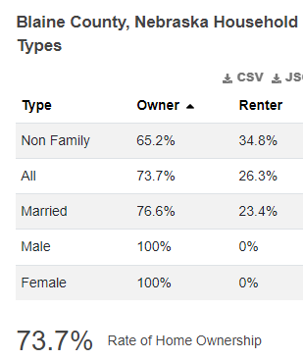
Boone County:
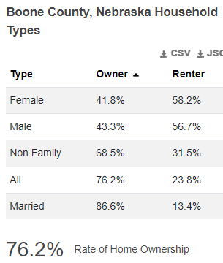

Boyd County:
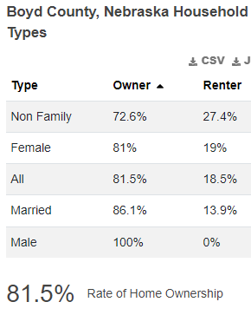
Brown County:
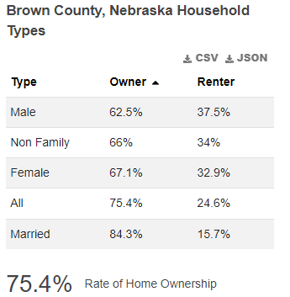

Colfax County:
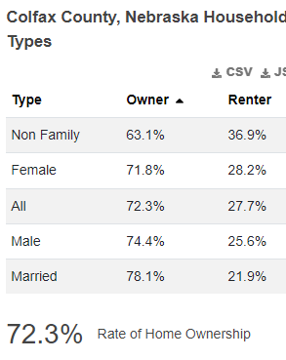
Custer County:
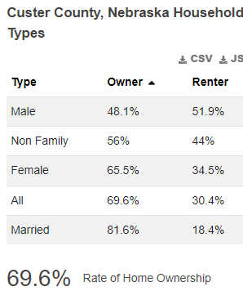

Garfield County:
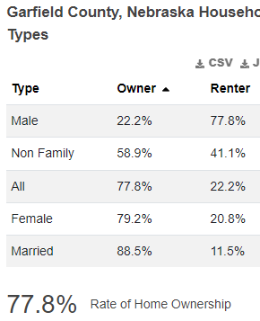
Greeley County:
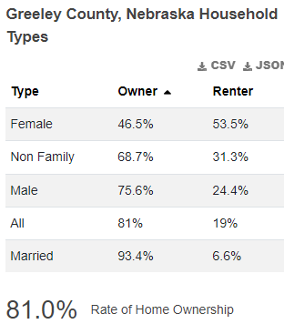

Hall County:
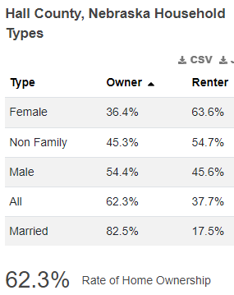
Hamilton County:
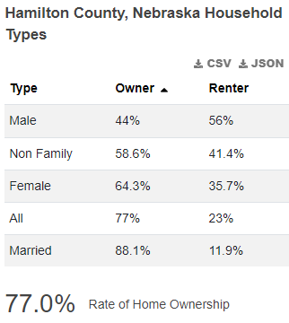

Holt County:
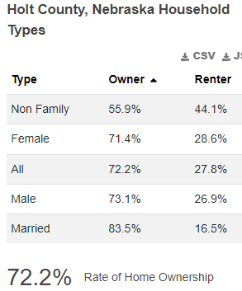
Howard County:
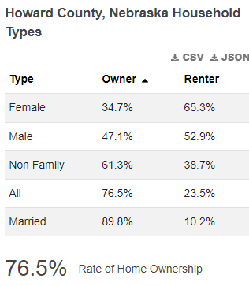

Keya Paha County:
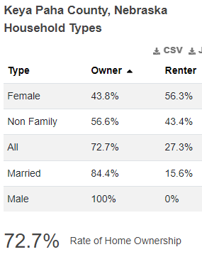
Loup County:
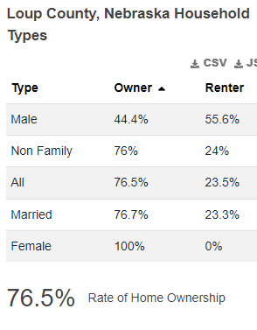
Merrick County:
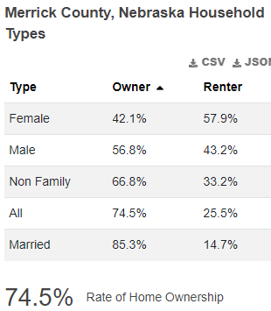
Nance County:
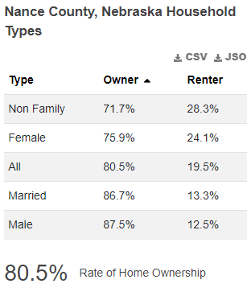

Platte County:
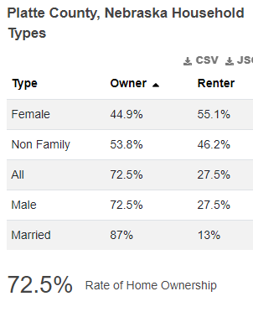

Rock County:
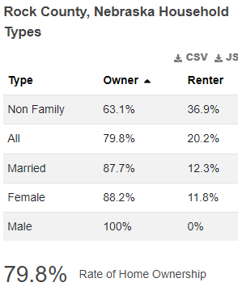

Sherman County:
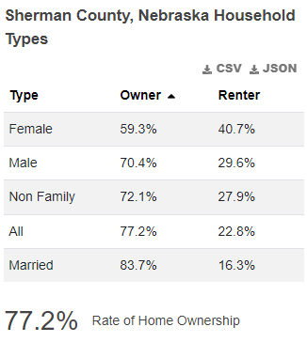
Valley County:

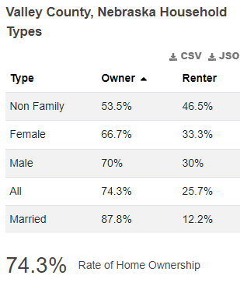
Wheeler County:
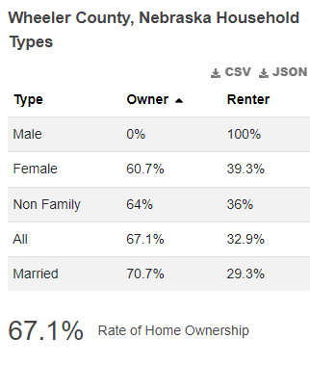
Within the CNCAP service area there were 68,681 total housing units, 49,405 owner occupied. In 2019 there were 82,092 total housing units and 50,626 were owner occupied.
https://worldpopulationreview.com/us-counties/ne/wheeler-county-population
Within the CNCAP programs, during the 2021 year the housing status was:
- 34% owned
- 49% rented
- 2% other permanent housing
- 9% homeless
- 2% unknown/not reported
- 2% other
Cost
The 2015-2019 American Community Survey shows that 27.68% of homeowners with mortgages nationwide pay 30% or more of their income on housing costs. 20.98% of owners with mortgages and 10.74% of owners without mortgages spend 30% or more of their income on housing costs within the CNCAP service area. 30% or more of income spent on housing costs is considered a “housing-cost burden”.
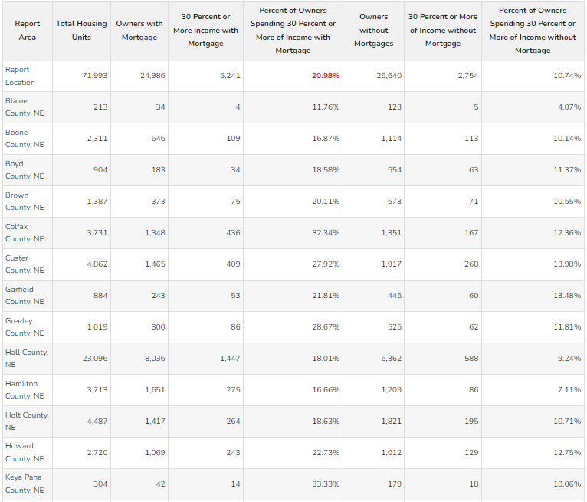
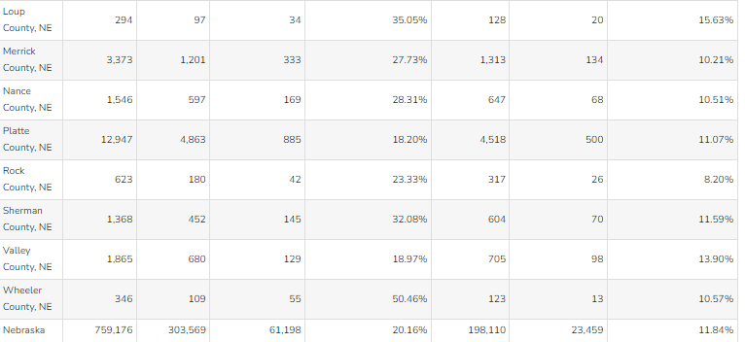
THE ACS survey shows that 46% of occupied units paying rent nationwide pay 30% or more of their income on housing costs. For the CNCAP service area, 32.66% of occupied units paying rent have a housing cost burden.
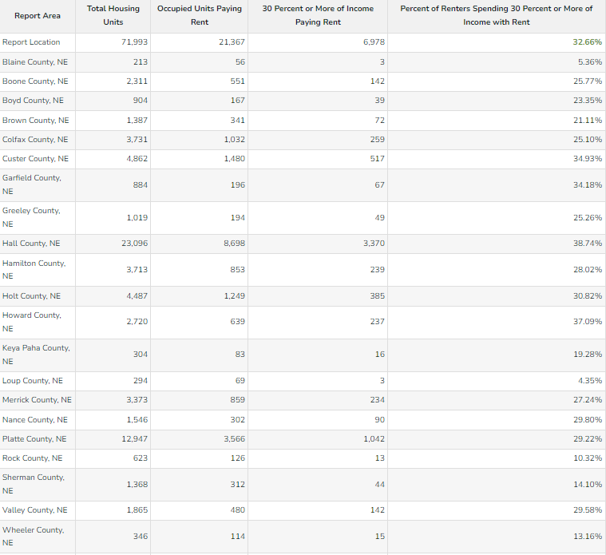

Cost of homes per county:
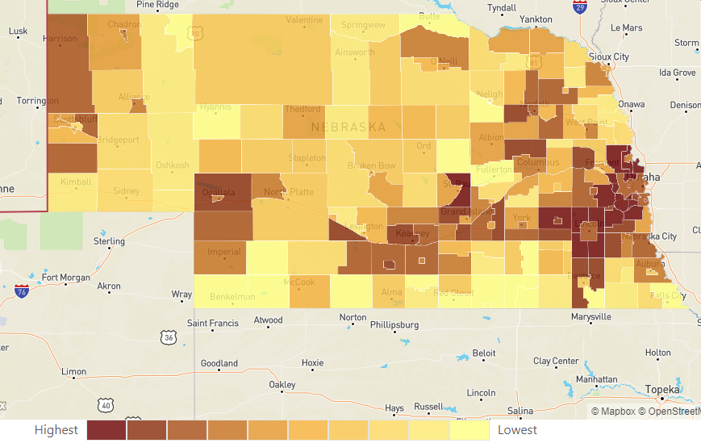
Real Estate Appreciation and Housing Market Trends:
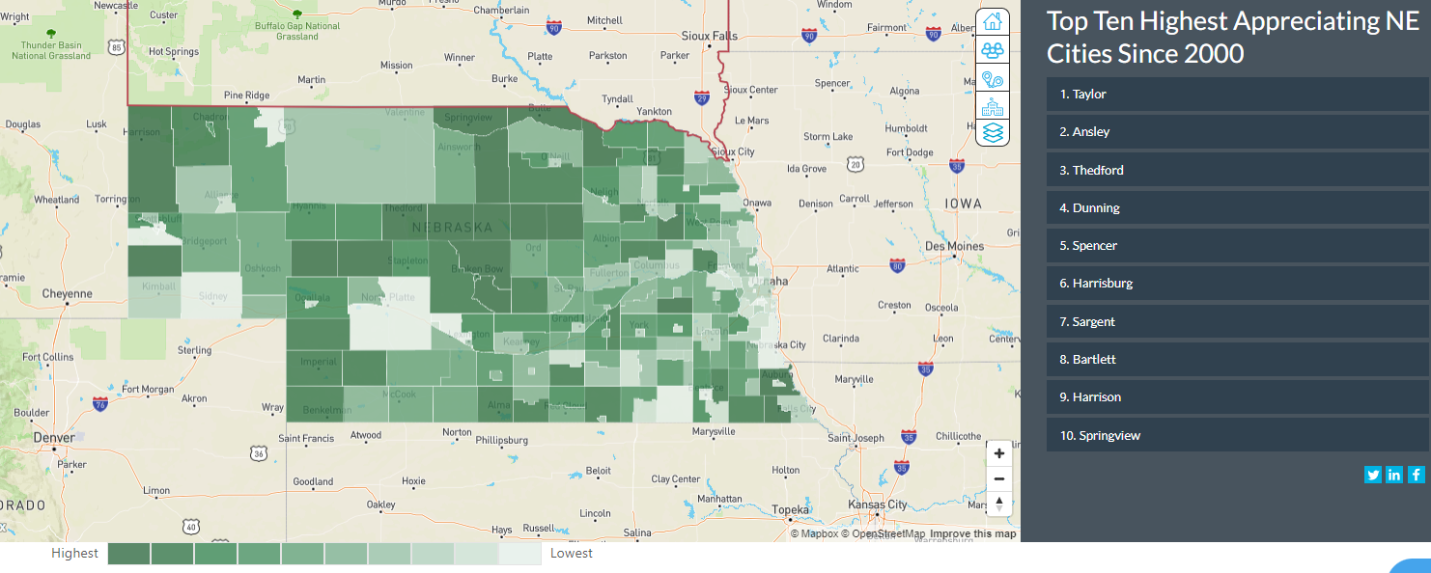
https://www.neighborhoodscout.com/ne/demographics
Taylor, Ansley, Dunning, Spencer, Sargent, Bartlett and Springview are listed in the top ten highest appreciating Nebraska Cities. These are part of Loup, Custer, Blaine, Boyd, Wheeler and Keya Paha counties. When there is a high demand and low supply, commonly referred to as a seller’s market, home-value appreciation increases. 7 of the highest appreciating cities in Nebraska, are within the CNCAP service area.
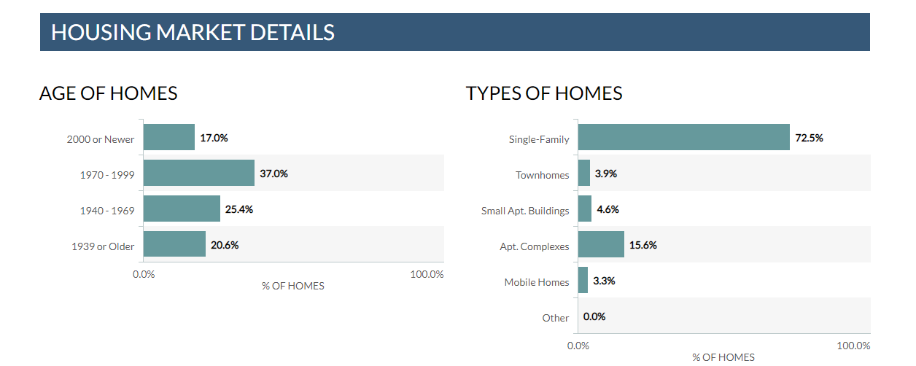

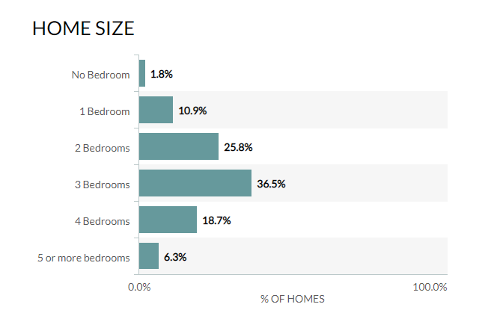
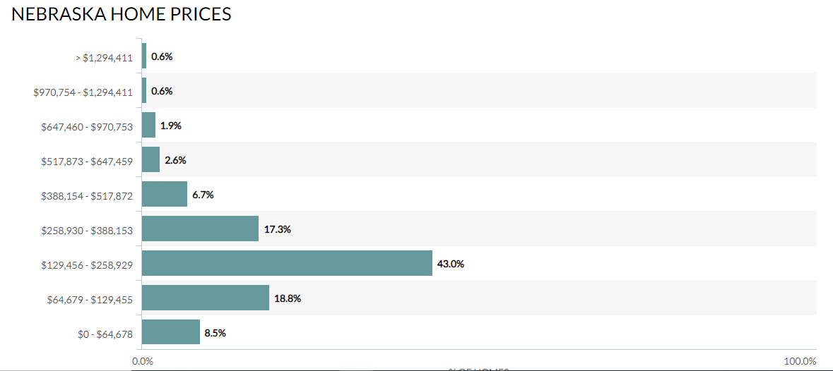
Housing Age
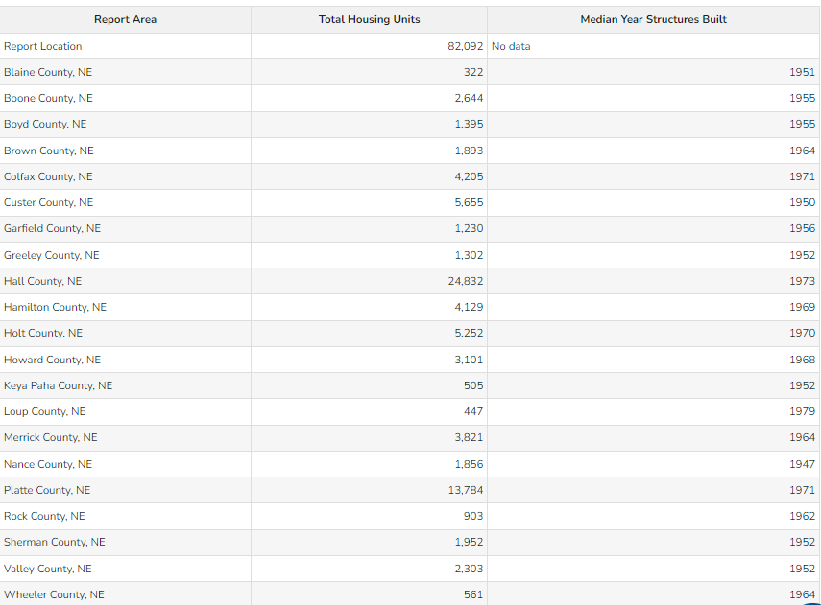
All housing units by age:
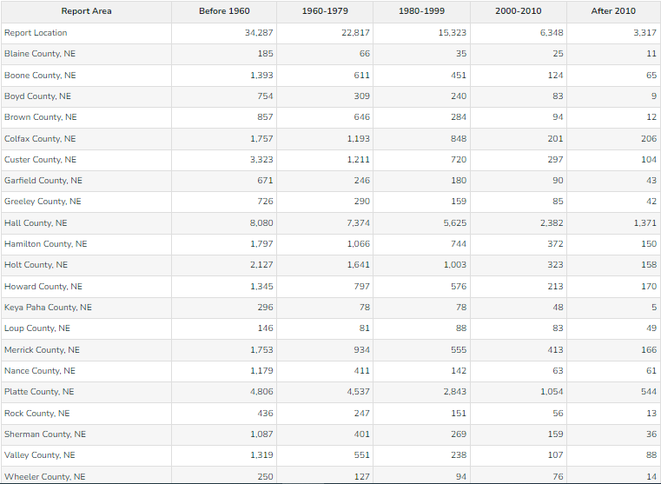
Overcrowding:
An overcrowded home is defined as one where the number of occupants is greater than the number of total rooms. In overcrowded homes, it is not uncommon for people to double up or triple up in the available bedrooms or for people to convert a living room or kitchen into a sleeping space. The number of children experiencing overcrowding in homes is high and has an emotional impact on children. According to Governing, stagnant incomes and rapidly rising prices in many cities have made it harder for middle-class residents to afford a mortgage. It’s even difficult for tenants to find a place they can afford to rent. Across the nation, 14% of all children live in overcrowded homes. “The home is a place many children go every night, and especially young children spend even more time at home.” stated Dr. Claudia Solari in an article written by the Governing. These children affected by overcrowding homes lag behind their peers in educational performance and are more prone to withdrawal and fighting in school Solari also stated. Parents report the children are in poorer health than those who do not live in overcrowded housing. Every additional person per room in a crowded home erases 1.5 years of a parent’s education achievement and, in turn, hinders the future learning outcomes for their children. A parent who earned a high school degree but raises her children in an overcrowded home transfers the same benefit as a parent who dropped out of high school half way through the 10th grade. “having an additional person in a room is like taking away $30,000 in family income,” says Solari. For comparison, household income is used to indicate a child’s trajectory. Researchs has shown the exposure to toxic stress has an impact on every indicator of quality of life.
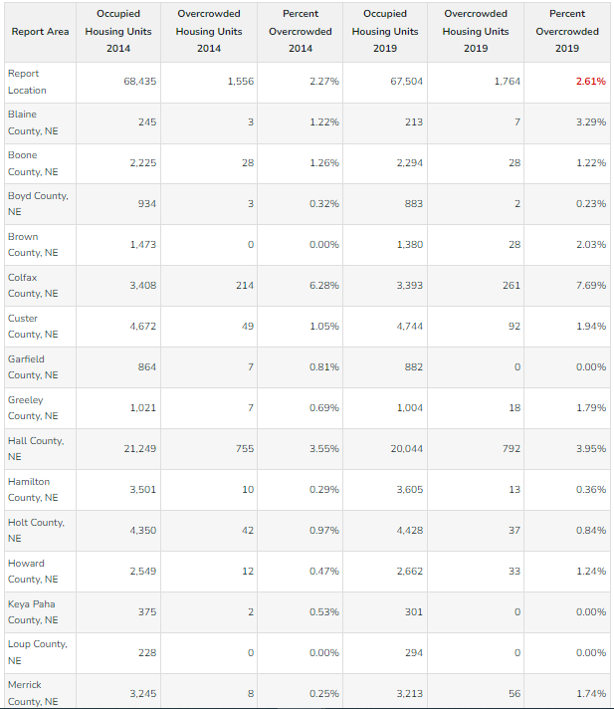
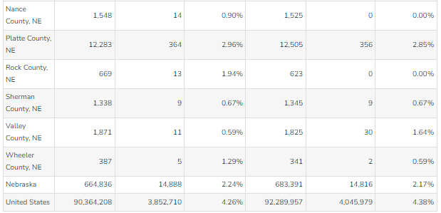
https://www.governing.com/archive/gov-children-overcrowding-housing-cities-lc.html
https://cap.engagementnetwork.org

Substandard Housing
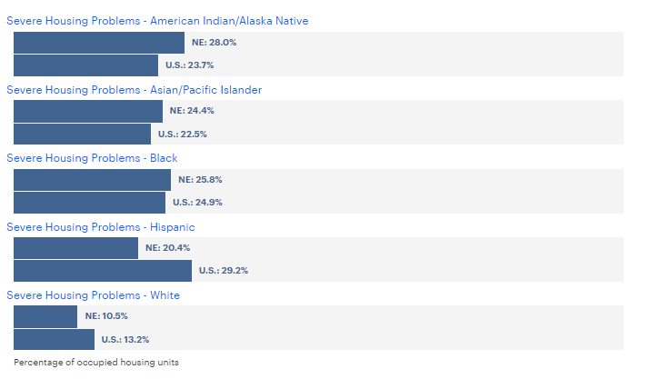
https://www.americashealthrankings.org/explore/annual/measure/severe_housing_problems/state/NE
Substandard housing is defined as any condition which exists to an extent that it endangers the life, limb, property, safety or welfare of the occupants or general public. Examples of substandard housing include:
- Inadequate sanitation
- Lack of water
- Lack of heating
- Inappropriate ventilation
- The presence of insects or vermin
- Structural hazards
- Faulty weather protection
- Fire hazards
This reports the number of owner and renter occupied housing units with at least one of the following conditions: lacking complete plumbing facilities, lacking complete kitchen facilities, 2 or more occupants per room, selected monthly owner costs as a percentage of household income greater than 30%, and gross rent as a percentage of household income greater than 30%.
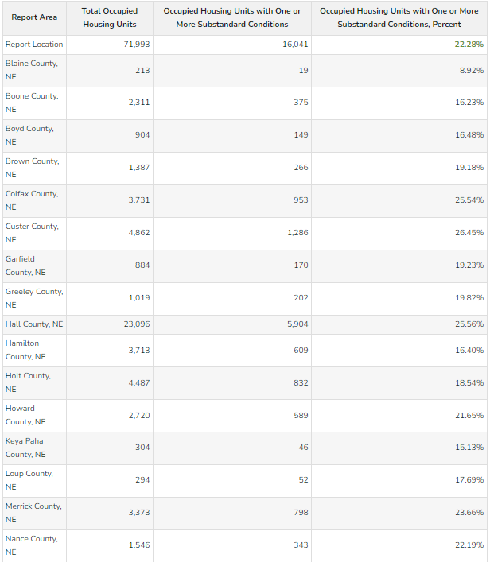
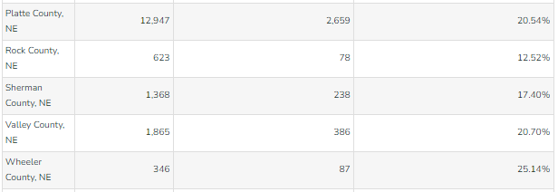
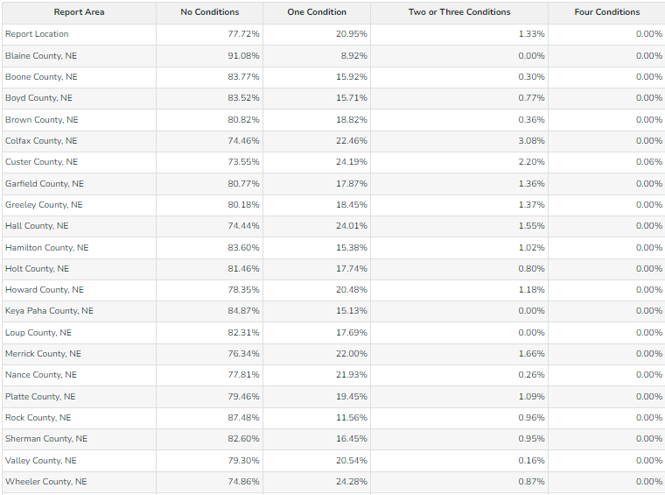
Severe problems:
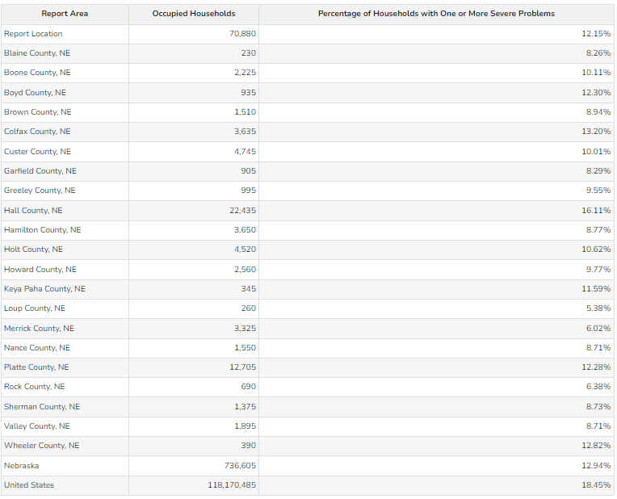
The weatherization program installed 10 new furnaces, 14 water heaters, and 4 refrigerators in the CNCAP service area during the year of 2021. Weatherization met the needs of 50 households and 54 benefactors, 22 handicapped and 29 elderly, 45 home owners and 5 renters.
Farm Land Values
2021
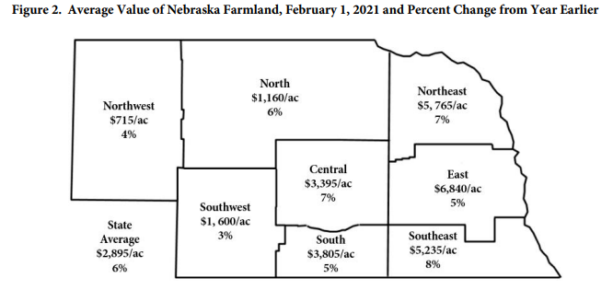
2020
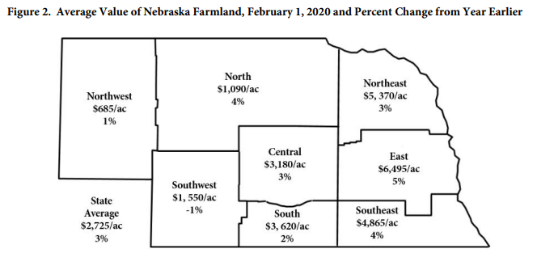
2019
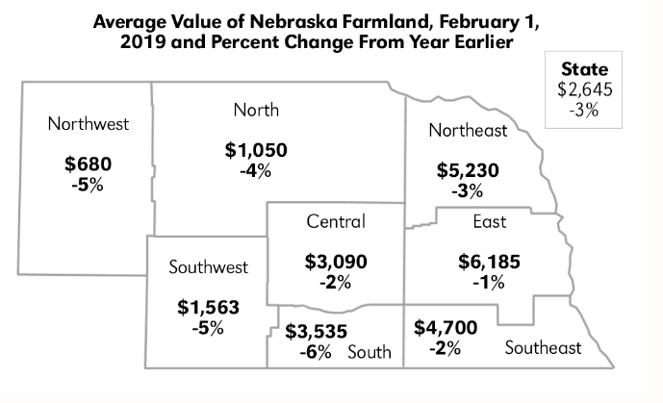

The statewide all-land average for the year was $2,895 per acre which is a $170 per acre increase from the year prior. In 2019 the state average was $2,645 per acre. Panel members reported during the year of 2021, that current crop prices, interest rate levels, and purchases for farm expansion as the economic forces guiding the market value of land higher. In addition, non-farmer investor interest in the land purchases and federal farm program payment were ranked as positive forces.
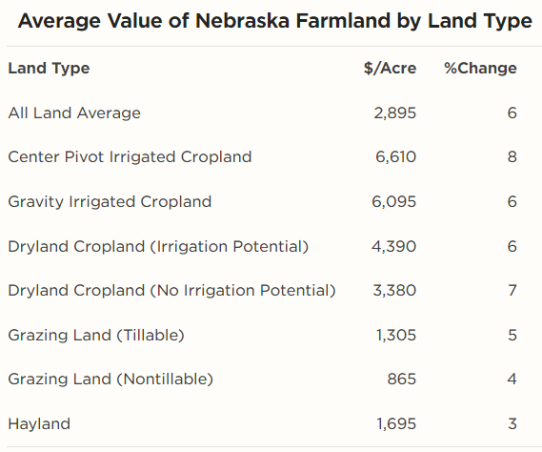
https://cap.unl.edu/documents/2021-NE-Farm-Real-Estate-Report-final.pdf
Homelessness
Across the state of Nebraska, there are about 2,404 people experiencing homelessness on any given night, as reported by Continuums of Care to the U.S. Department of Housing and Urban Development.
- 202 were family households
- 153 were veterans
- 149 were unaccompanied young adults (aged 18-24)
- 463 Were individuals experiencing chronic homelessness.

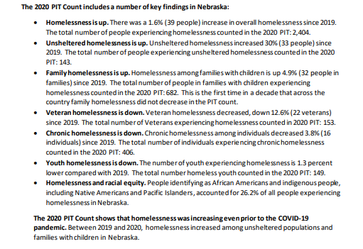
In Nebraska, the state’s homeless population grew by 1.6% from 2019. Homelessness is on the rise in the United States. Of the 2,404 homeless people counted, 446 reported chronic substance abuse. COVID continues to impact homelessness across the state of Nebraska due to increase in necessary expenses such as groceries and fuel, all while jobs still have not bounced back from the pandemic. These impact the people who are experiencing homelessness and poverty.
Some homeless people of Grand Island shared their stories of homelessness with NTV News. A Somalian refugee, Abdikarin Ali, who came to the U.S. in 1995 seeking refuge in the American Dream, was laid off from JBS without explanation and became homeless as he was barely making ends meet when living paycheck to paycheck. “In the United States, I never thought I was going to walk night-time not knowing what I’m doing, digging in the trash that was not my dream,” Ali said in the interview. Due to his living conditions, he lost connection with his 12 children and claimed that being homeless is like being alive, but not really living. Another person, Agom Arou from Sudan lost her house and custody of her children, stating “after those things got taken away, for six months straight I’ve been crying.” Many of these homeless people dig through the trash looking for things they can sell, hoping to make $10-20 a day in order to buy something to drink. Many of these people sleep in alleys between apartments, abandoned cars, and during the cold nights they sleep in abandoned houses. Crossroads Mission Avenue Executive Director Daniel Buller, states that homelessness keeps increasing each year. They used to be serving a few people in Grand Island, and in just two years it has increased to 200. Abdikarin Ali said that “people think because we are homeless, we harm people, we are bad people, and no, we are good people, human beings, we have dreams and goals, just like everybody.” Arou added, “I am part of this America.”
All within the same week, news stories shared a homeless Grand Island man was arrested for breaking into a home through a window. Sayid Mohamed was barricaded inside of the empty apartment at 3 o’clock in the morning. Grand Island police said he was under the influence of drugs. Another man was found dead in an apartment as part of an apparent homicide. The man was last known to be homeless. A Grand Island woman came home to another woman sitting on her couch, wearing her clothes. The 35 year old homeless woman had gone through her drawers and consumed her alcohol and food.

According to the Columbus Telegram, “Columbus Rescue Mission relocating to more spacious location”, the shelter has run out of space and the need for more floors, rooms and better access to food, shelter and guidance has become imminent.

Thrives is a program offered by CNCAP that stands for Traditional Housing for Rural Independence, Viability and Economic Stability. It assists homeless individuals in obtaining safe and suiltable permanent housing. Participants receive intensive case management to enhance their skills for self-sufficiency and secure and maintain permanent housing. This program is available in all 21 counties and Cherry county. During the year of 2021, THRIVES assisted 93 households and 117 benefactors. It saved $63,729.00 in debt from 20 households and 68 benefactors. It saved $111,548 in 52 households and 152 benefactors.

The HART Program offered by CNCAP stands for Homes, Advocacy, and Referrals for Totality. It provides rent/utility assistance to individuals and families in crisis. This program is available in all 21 counties plus Cherry county. During the year of 2021, HART helped 29 homes and 25 benefactors. It saved debt of $1,775.00 in 3 homes and 9 benefactors. It accumulated $6,631.00 in savings for 10 houses and 23 benefactors.

Extreme poverty is the strongest predictor of homelessness in families. These families are often forced to choose between housing and other necessities for their survival. Homeless single mothers often have histories of violent victimization with over one third having post-traumatic stress disorder and over half experiencing major depression while homeless. A then 41% develop dependency on alcohol and drugs and are often in poor physical health. Maternal depression and parental substance abuse has a series of negative outcomes for children.

https://omaha.com/news/local/nebraska-sees-1-6-increase-in-individuals-experiencing-homelessness
https://nebraska.tv/news/local/special-report-struggling-with-homelessness-in-the-tri-cities-abdikarin-ali-agom-arou-daniel-buller
https://columbustelegram.com/news/local/columbus-rescue-mission-relocating-to-more-spacious-location
https://www.ksnblocal4.com/2022/02/15/man-arrested-after-breaking-into-grand-island-apartment/

Project Connect is an annual day of services for people that are homeless or near homeless. It is held in Grand Island and provides a day of free services ranging from haircuts, dental services, vaccinations, foot care, legal services, as well as signing up and creating awareness of housing, SNAP and other services. They receive food for the day and everything is free for anyone that attends. This event is hosted by Hope Harbor and Multicultural Coalition. Project Connect began as a national movement based in San Francisco. By bringing all of these services together into the same day, homeless or near homeless benefit by not having to take days off from work, which they often cannot afford. There were nearly 200 people who volunteered, often coming back the next year because of the community members they never knew were struggling. “We have a very high poverty level in Nebraska. A lot of people are struggling now, partly because of the coronavirus, but also because of the wage situation, especially in a lot of rural areas,” says Shelly Witt, Nebraska Health and Human Services support specialist. https://theindependent.com
Central Nebraska Community Action Partnership, along with other service agencies, conducts a Point-In-Time survey of homeless on a specific day each year. In 2021, the PIT was conducted on January 26th to reflect the number of homeless in the state. Along with that, a housing inventory is collected to determine the number of beds available. “Beds” may be determined by emergency and transitional shelter availability, as well as slots available through housing programs. 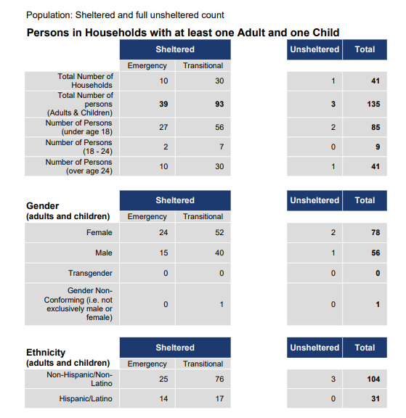

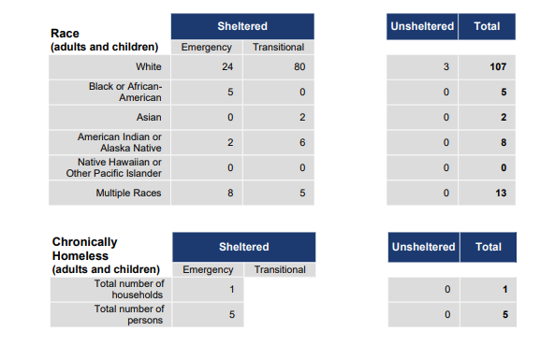
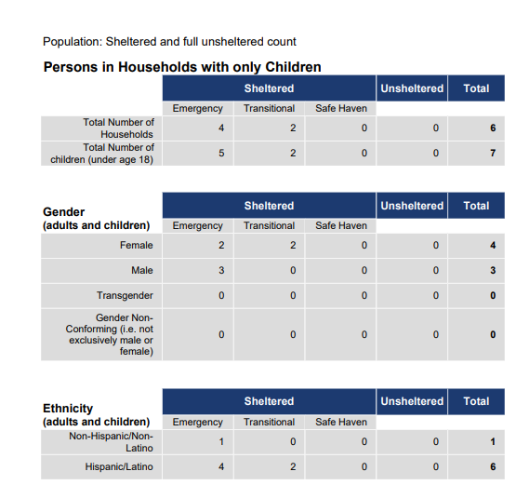
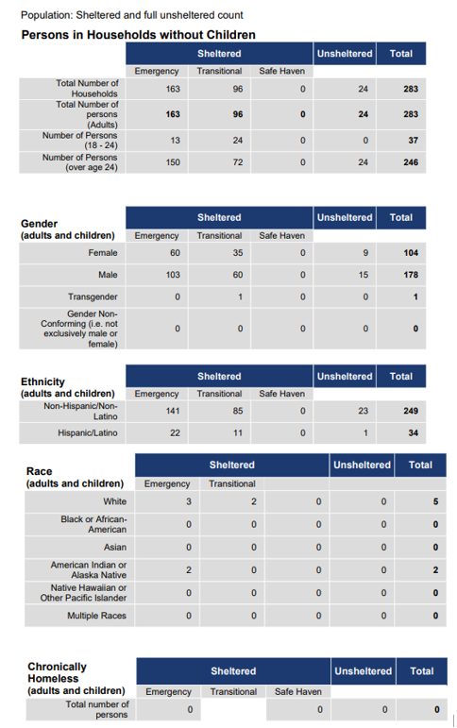
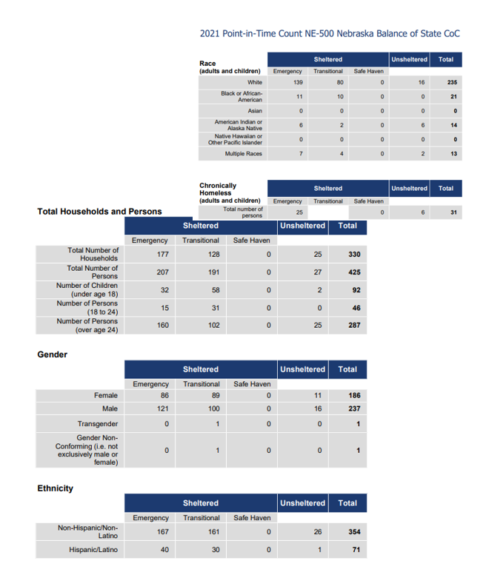
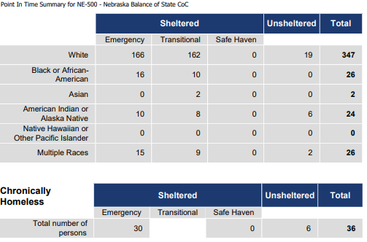
Rural vs Urban

One of Nebraska’s biggest challenges is the divergence in population trends between Nebraska’s urban and rural areas. Three counties in Nebraska make up 56% of the state’s population. Only 24 of Nebraska’s 93 counties grew in their population over the past decade. There is a need for economic policies to strive to promote opportunity throughout the state. Politics must accommodate both urban and rural interests.
While research done by Ernie Goss of Creighton University has shown an increase in rural economy, Nebraska’s rural economy is still down 3,400 nonfarm jobs compared to pre-COVID levels. The increase has no doubt been due to the improved financial conditions of crop producers. Great prices and oilseed prices are surging, bringing greater returns for Nebraska’s crop producers. But while big farmers are thriving, rural non-farm families are suffering from a lack of opportunity in rural small towns.

When it comes to optimism about the people of Nebraska’s current situations, optimism about the future is high. However, in rural areas, it did show a decrease from the previous year. Their urban counterparts showed that they are more optimistic about their current situation and the future. 52% of rural Nebraskans believed that they are now better off than they were five years ago. This is down from 53% the previous year. According to polls done on both rural and metro Nebraskans, metro residents are more likely than rural residents to say they are better off compared to five years ago and that they will be better off 10 years from now. 6 out of 10 metro residents believe they are better off now than five year ago, compared to the 52% of rural respondents. 55% of metro residents believe they will be better off in a decade, while 47% of rural respondents agree with this assessment.
Rural residents are more likely than metro residents more commonly feel like they are powerless to control their own lives. 32% of rural residents believe that they are powerless to their own lives compared to the previous year when only 26% of rural residents felt that way. 23% of metro residents felt that way.
Steve Schulz, a professor of supply chain management at University of Nebraska Omaha said that powerlessness is often attributed to the inability to manage or control personal or social outcomes. Rural residents were more likely than metro residents to report that the pandemic affected their financial health. Lack of control over financial health may have led to increased powerlessness among rural residents.
In comparison of 23 variables that can affect well-being, such as family and financial security in retirement, satisfaction levels were the same between metro and rural areas. Metro respondents did however claim they were more likely than their rural counterparts to be satisfied with many financial variables including their ability to afford their residence, ability to build assets and wealth, general quality of life, general standard of living, housing, job opportunities, education, health and current income level. Rural respondents were more likely to be satisfied with clean air and their religion/spirituality.
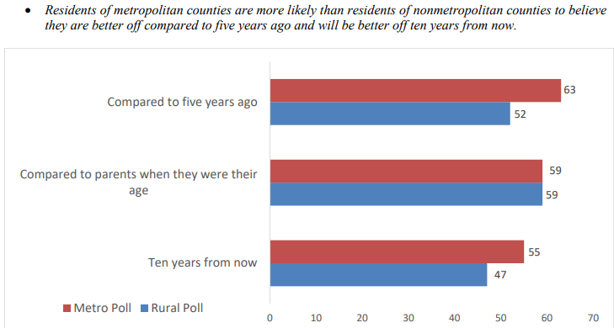
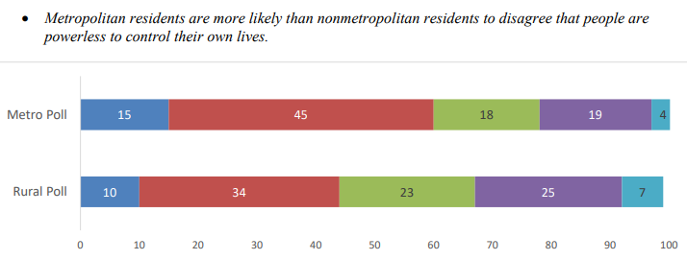
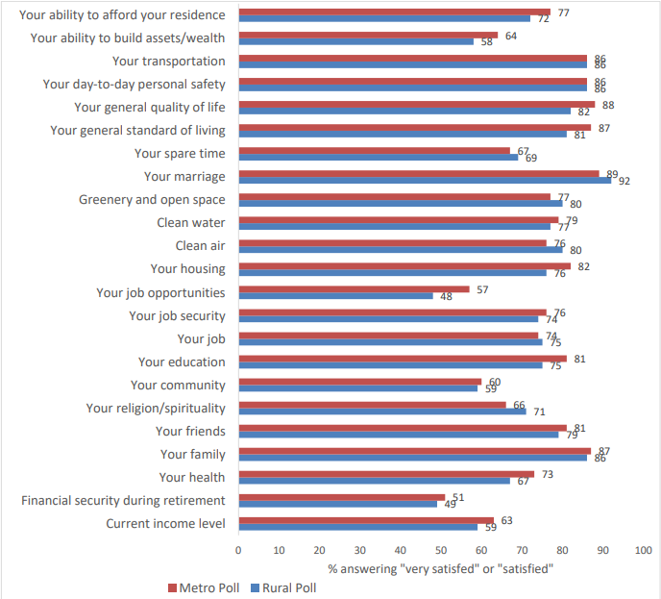

https://omaha.com/opinion/editorial/editorial-nebraska-achieves-strong-population-growth-must-promote-urban-rural-reconciliation
https://www.nefb.org/05/10/2021/optimism-in-rural-america/
https://ruralpoll.unl.edu/pdf/wellbeingresearchbrief.pdf

Community Satisfaction

The effects of the COVID pandemic have lingered into the end of 2021, leaving lasting affects on CNCAP communities that we still experience today. Having increased poverty, substance abuse, mental health issues and decreased social activities within communities has been felt across the board. Given the challenges, CNCAP wanted to know how their community members feel about their community and whether they are satisfied with the services provided. CNCAP collected feedback through surveys with community-based organizations, faith-based organizations, private sector, and educational institutions, low-income clients and the Board of Directors.

Community Surveys

CNCAP collected feedback on existing needs in area communities. Community stakeholders including businesses, public schools, faith-based organizations and other non-profit organizations were asked which of the following were serious challenges within their community. 92% of stakeholders within the CNCAP service area said that housing was a greatest need within their community. 92% also said that childcare was a greatest need within the service area. This is compared to the previous year, when 88% said that housing was a greatest need and childcare was only 41%. The top needs for the prior year according to the community stakeholders was housing 88%, and Healthcare Services and Transportation Services both at 59% seeing it as a greatest need.
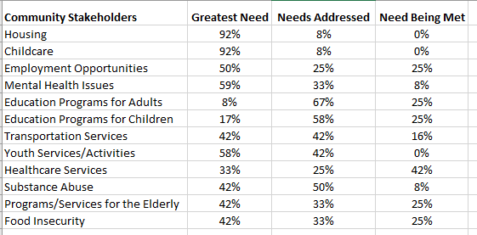

Any other needs you feel are important but were not listed in the previous section:
- Places and funding to help with rent
Please share any thoughts you may have on how the issues could be addressed:
- Larry Harbour has great ideas utilizing modular units that he has shared with me
- Daycare is needed in Burwell that needs to be looked into. Also, an after school program would be a great need for the community.
- Community Coalition to address prioritized needs.
Additional comments?
- CNCAP has always been good about helping with assistance when it comes to housing for our drug court participants.
- Housing is one of the biggest obstacles. If there is housing it is so expensive for those we work with in Domestic Violence.

Of the low-income clients that were surveyed, 92% said that housing was a serious challenge within the CNCAP service area. 54% said that childcare was a serious challenge. This is only a little bit less than the community stakeholder surveys, with housing and childcare being the two biggest issues among both. In the previous year, Housing and Mental Health were the top two greatest needs among the low-income clients. 62% believed that housing was a greatest need and 56% believed that mental health issues and transportation services were a greatest need. There has been a noticeable increase in low-income clients who believe that housing is a serious challenge within the service area. Childcare also increased from 41% to 58% in just one year. Mental health has remained nearly the same as the previous year 56% to 53% and it is still one of the greater needs as of the current year.
When asked to list the top 3 most important needs within the community, 92% placed housing in the top 3 and 43% placed childcare in the top 3. 36% placed mental health in the top 3 challenges within the area.

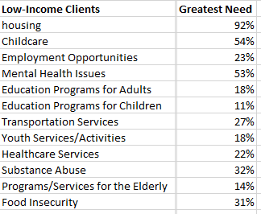

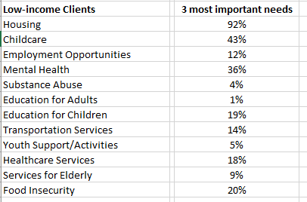

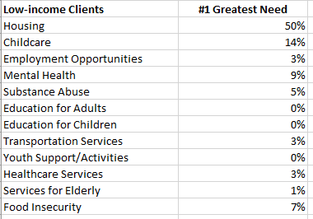

Any other needs that you feel are important but not listed above?
- Medical assistance
- Youth activities
- Programs for challenged kids with ADHD
- Car repairs help
- More family centers
- Dental services—specifically ones that accept Medicaid
- Community involvement for children
- Overnight childcare
- Child abuse & child sexual abuse

Please share any thoughts you may have on how the issue(s) could be addressed?
- Law enforcement needs to do more about substance abuse.
- College classes and more daycare centers
- Overnight childcare for jobs
- Transportation for adults that runs 7 days a week. Better transportation/bus routes for schools
- Public forum/jobs to keep the younger crowd from moving away
- Better investigation and prosecution
- Make housing cheaper, more education and mental health
- Rent is too high
- I haven’t thought about it too much so I’m not sure.
- There needs to be more daycares that accept state and more than 2 open with availability/housing has their own rules and regulations which needs to be revised and lowered for those of us barely getting by.
- New to the area
- More daycares
- Building affordable housing
- I believe more people need to talk to the community more to see the needs needed and how they can be met
- I feel like mental health is an issue that is not talked to enough and not affordable for normal income people let alone low income. Maybe if every therapist could do 2 days a month of a low fee for people that need it.
- Housing is terrible there just isn’t enough affordable housing not enough resources for any all comes down to money
- Need more pet friendly-affordable housing options and more things for kids to do. Not sure how either could be resolved.
- Get back together on the law for food stamps
- Make housing more affordable
- More community based funding
- Services within Ainsworth instead of reaching out to other communities far away
- Fix unlivable house in area
- Pantrys allow people to get help with food more often than one time. Add more food
- Build or fix up buildings for cheaper rentals
- Offer more places for substance abuse and open up more groups/add more places for food pantries. Get more housing.
- Help with gas to get to jobs and other places
- Unsure exactly how to address this but I do believe that people could lower the cost of their rent on places
- More options for dentists that accept Medicaid/affordable healthcare
- Better communication and get more resources
- More government help for childcare add more daycares for all day hours
- Get doctors to take their time on kids
- Not sure
- Being able to provide resources to meet the challenges
- Affordable housing
- Sometimes it is hard to find out what is available out there to help. People feel stuck because they don’t know where to go for help, or think getting help is not in their reach.

Do you have any additional comments?
- Affordable housing is very hard for someone working full time at a decent wage
- You guys are awesome and I am definitely grateful for everything
- Resources for adult education and help with studying for exams
- The price of rent and availability. It seems really high and there isn’t much for rent. I need a 3 bedroom house and they are going for $1200 and up. If it is that there would be nothing left for daily needs ,food, daycare and what not.
- Rent increases while wage increases don’t happen. People who work full time still have difficulty affording rent
- Resources should be easier to find when it comes to housing, the lack of affordable housing makes people feel stuck and can’t get out of a bad situation. Columbus needs more options for affordable housing.
- All of these things need to be normalized. If more people were educated about “hush hush” topics-childcare for special needs children, mental health and eating disorders- all areas would improve

The Board of Directors found substance abuse and childcare to be the greatest need within the service area. 53% felt like childcare and substance abuse were the greatest need. 47% found that housing was a greatest need. While the same challenges are ranked at the top among the stakeholders, clients and Board of Directors, the numbers do vary. From 47% of the Board seeing housing as a greatest need, to 92% of community stakeholders. In the previous year, education programs for children was the greatest need within the service area, along with education programs for adults. 43% of the Board members found education programs for adults and children. Only 21% of the Board members found childcare to be a greatest need in the previous year. The same for mental health. There has been a significant increase in those two over the year.

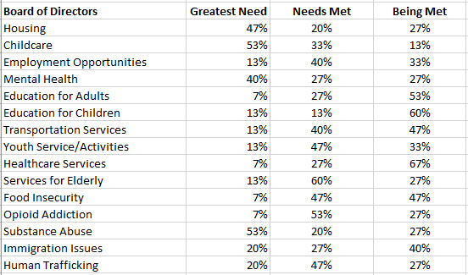

Weatherization

Thank you for all you have done for us. We are already enjoying not having extra drafts in the house at night! The kids are looking forward to opening their windows for fresh air this summer. Thanks again. –This is a thank you written in December of 2021 after the weatherization program assisted in weatherizing their home.
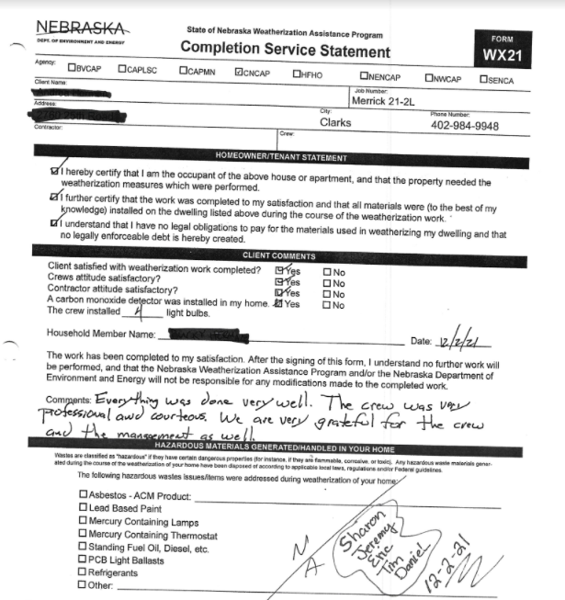

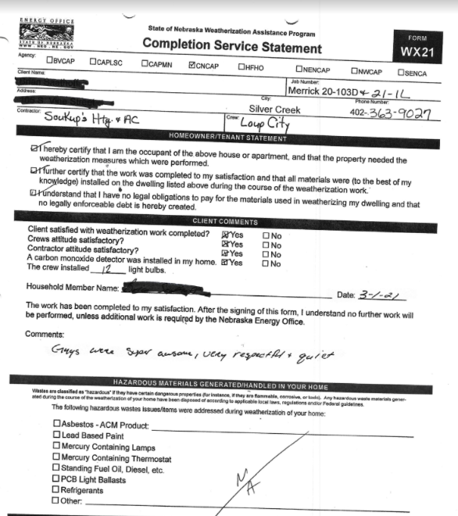

Client surveys from Family Outreach Department Programs 2021

- How long have you been in the program?
2 Less than 1 month
14 1 to 6 months
15 7 to 12 months
4 13 months to 1 ½ years
5 More than 1 ½ years

- What services do you receive from this agency or program?
27 case management services
0 substance abuse services
28 rent/utilities assistance
1 assisting accessing benefits (SSI)
14 food/nutrition assistance
1 vocational rehab
3 mental health
7 medical
0 HIV
18 security deposits (rent/utilities)
0 income tax assistance
6 employment
4 education
6 transportation
10 life skills
6 parenting

2a. Are your service needs being met in this program? (check one)

34 always
4 most of the time
1 some of the time
1 never

3. Overall how satisfied are you with the assistance you have received from this agency or program?

35 very satisfied
4 somewhat satisfied
0 somewhat dissatisfied
1 very dissatisfied

4. Has assistance from this agency helped you to maintain your housing or improve your housing situation?

36 very much
3 somewhat
0 a little
1 rarely/never

5. Has this program been helpful in maintaining or increasing your income (employment assistance, benefit support)?

28 very much
6 somewhat
2 a little
4 never

6. Overall did Staff:

Treat you with dignity and respect
39 Always 0 Most of the time 1 Sometimes 0 Rarely/never

Seem to understand your situation and needs
36 Always 3 Most of the time 0 Sometimes 1 Rarely/never

Do a good job of explaining program requirements
34 Always 5 Most of the time 0 Sometimes 1 Rarely/never

7. Overall was Staff
Responsive in a timely manner
34 Always 4 Most of the time 2 Sometimes 0 Rarely/never

Sensitive to your ethnic and cultural background
36 Always 3 Most of the time 0 Sometimes 0 Rarely/never

Able to communicate with you in a language you can understand
37 Always 3 Most of the time 0 Sometimes 0 Rarely/never

Knowledgeable about available services
36 Always 3 Most of the time 1 Sometimes 0 Rarely/never

Treat your personal information confidentially
38 Always 2 Most of the time 0 Sometimes 0 Rarely/never

8. Do you feel that you can make decisions about what happens to you in this program?
32 Always 5 Most of the time 1 Sometimes 1 Rarely/never

9. Have you had the chance to give input into how the program is run (for example: consumer advisory board or tenants’ council, grievance procedure, suggestion boxes, consumer involvement in agency/board membership)?
17 Yes 21 No

10. Do you feel safe in this program/facility?
37 Always 1 Most of the time 1 Sometimes 0 Rarely/never

11. Is this program’s facility clean and well maintained?
30 Always 2 Most of the time 0 Sometimes 0 Rarely/never 7 N/A

12. When you have a problem or complaint, is a staff person available to help you?
33 Always 4 Most of the time 1 Sometimes 0 Rarely/never

13. Has the quality of your life improved since you entered this facility or program?
33 Greatly 6 Somewhat 0 Stayed the same 1 Gotten worse
Please explain:
- I am able to deal with personal issues/problems without having to worry constantly about how I’m going to pay bills, keep a roof over my head.
- I make better choices and I feel I am better with my money
- Keeping up with all my bills and making sure to stay on track with things.
- I do not stress over my bills.
- I didn’t have anywhere to really go and they helped me get a place of my own.
- Helped get apartment
- Financial stress reduced
- Danie went above and beyond to help me with my apartment.
- I have reduced my debt and went from being homeless to being able to have my son back and be self-sufficient.
- When I started out in your, very grateful for program, you were going through employment issues Danie, Stepped into a mess and was absolutely amazing I’m beyond grateful for her and THRIVES
- Paid deposit & rent
- Got house
- House
- Housing, diapers
- They are trying to find me a place I can afford
- Help me catch up
- We have a home and can start to heal
- I’m still in a hotel but coronavirus and lack of income haven’t helped
- I still cannot afford to maintain and keep my home. I am terrified about what is going to happen to me.

14. This is what I like about the program/facility…
- Dani is extremely nice and helpful. If I have a problem she does everything she can to help, uses all resources, knowledge.
- Very understanding and help with anything I need I feel safe.
- The people I worked with are very nice and understanding and help give me the respect of things.
- All of it
- The staff is wonderful
- The people
- Can’t think of anything. I guess allowed me to stay in my home for the moment—I don’t know about next month or the following month
- The program has made my life easier and more relaxed.
- The support that Danie gave me week to week and she was able to come to me.
- Very good
- I feel like I am not being judged by my situation in any way which makes it easier for me to communicate
- The ability to help me in the capacity that it does. Never made me feel guilty for asking for help.
- Very helpful and nice
- They go out of their way to help you!
- I’m getting my confidence back
- I like that the program was there to help
- The caseworker call and check on us and help out if she can.
- Everyone was so welcoming and I feel seen
- They are very friendly and helpful

15. This is what I wish were different about the program/facility…

- Would be more up front about what you will do and how much things are going to negatively impact me
- I have a hard time focusing on the things I need to be doing and need reminders often. I need to be able to call someone if I’m going to be late for meeting or need to reschedule or just have a problem
- I am not sure of anything right now
- Open Friday
- Nothing
- Nothing, I am happy.
- Keep program the same
- The meetings are one thing I would change. I didn’t mind the once a month but the every two weeks I didn’t like I had to move around work schedules or be late for work just to go to a meeting. That cut into my paycheck which isn’t beneficial to me.
- Honestly I haven’t had any problems so for me it’s nothing.

Any other comments?
- Terry is very nice and she helped us get where we are and she even follow up after and keep in touch
- Awesome people, everything
- Cassie has been a great help getting me back on track
- We greatly appreciate everything you have done for us. Without you we would be homeless.
- My case worker is very helpful. Knowledgeable, polite, considerate and respectful of my situation.
- Danie did an outstanding job helping me become a productive member of my community again.
- Thank you
- Again I am terrified what is going to happen I need long term resolution. My quality of life at my age has pretty much dissipated to nothing. After January I face homelessness and even now I face starvation.

WIC Survey Results

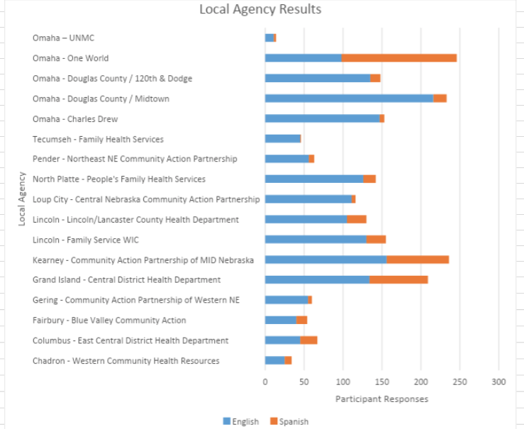

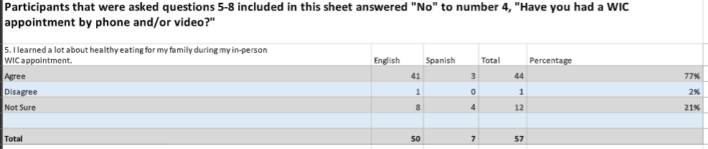
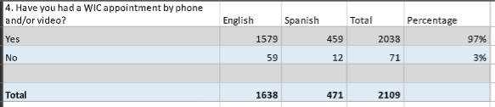
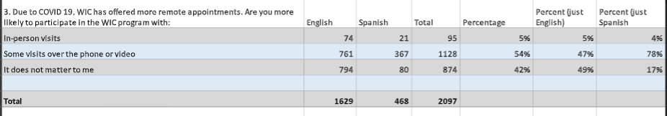
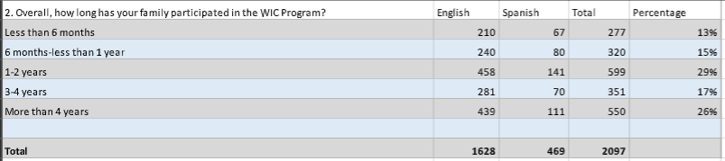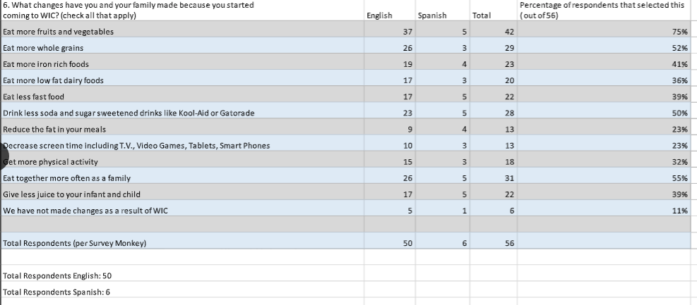

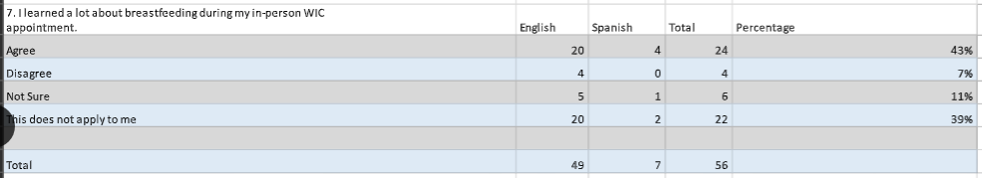

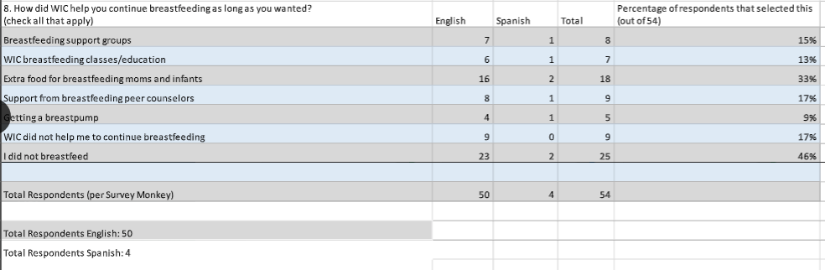
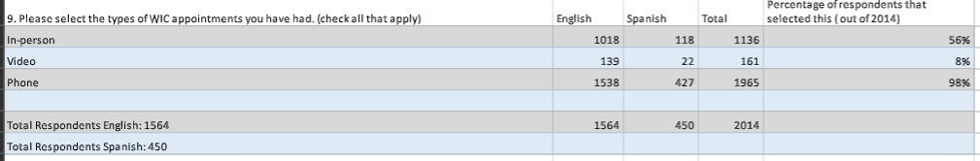
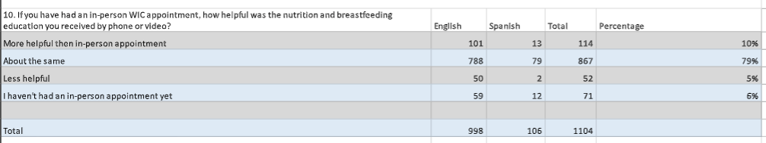
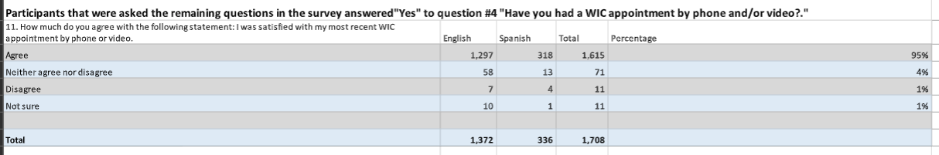
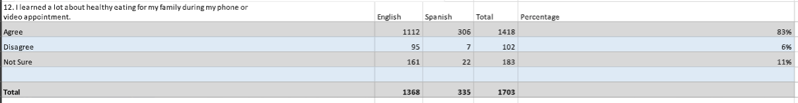
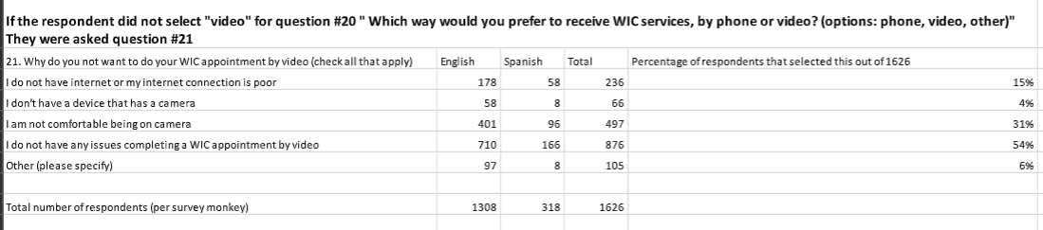
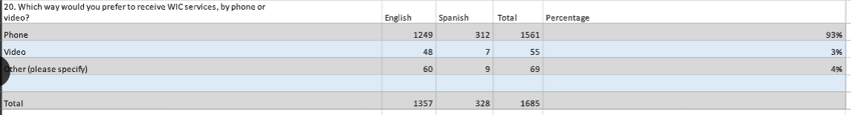
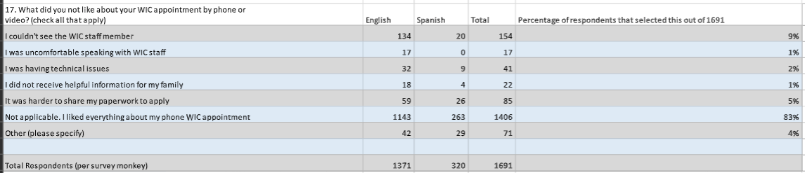
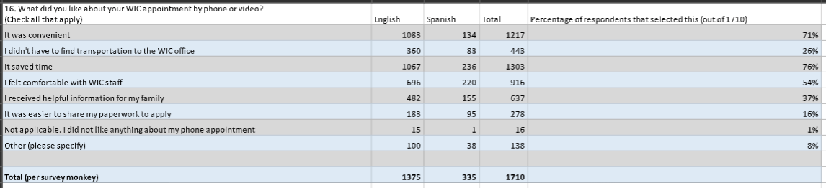

2021-2022 Parent Survey Responses

Why did you choose this ECP Program?
- To get my child ready for Kindergarten
- Other siblings were in the program
- The only preschool open locally
- I also know the program is excellent
- Wanted our son to socialize with others.
.
- My child needed consistently and a preschool setting for learning
- To help educate my child for kindergarten
- Only program available in our district.
- Our child was ready to start school and learn.
- To help grow our child’s knowledge
- To give my child time away from mom and to prepare for Kindergarten
- It is a great program with many supports.
  - It’s an opportunity for my child to learn early
  - Because it is an excellent program for the children’s education
  - My son has a problem speaking so I thought this program could help him
  - They reached out to me first when I was in high school
  - Many opportunities for the children
  - People and staff are wonderful
  - So my child can learn to interact and learn with other children
  - My other children loved it
  - It is a free program that helps with my child’s development
  - They heard great things about the Center Based program
  - I felt like it was a safe place and the staff members were friendly
  - I was in the program when I was little and enjoyed it. I knew how good the program was and wanted to enroll my daughter in it.
  - I heard so many good things about it helps me a lot with daycare for my son.
  - To strengthen my daughters education
  - Heard good things about the program
  - I was a head Start kid
  - Because I have been in the program and I liked it very much. Staff really help
  - The learning
  - Financially helpful and very educational for my child
  - Quality of program
  - Older son did very well in the program
  - It was recommended by another parent in the program
  - So my kids could interact with other kids. We were also involved in the Sixpence program
  - Wanted my kids to have 2 years of preschool experience
  - I have always heard good things about the program
  - Convenient
  - This program is a social emotional learning program which is the best practice for academic success.
  - It is the only preschool in our community and is very cost effective
  - It was the only option available
  - Affordable and my other children have been through the program
  - For Learning
  - Because it was recommended
  - The teacher is good with the kids
  - So my son could socialize with other children and get ready for Kindergarten.
  - Because they give good teaching
  - Excellent service and very good program
  - For the quality

Would you recommend this program to other parents?
- Yes, My daughter has learned so much
- Yes, teachers are great. Good balance of social time and learning.
- If there was another option I would consider that. The program has declined since our older children last attended preschool.
- Yes, our child finds it fun and loves to play and learn.
- Yes, any learning opportunity is a positive
- Yes, my son loves going to school.
- Yes I have no complaints.
- Yes, It’s excellent. The staff have helped my son with issues he was delayed in.
- Yes, everyone is very nice and they take very well care of kids.

- Yes, My child has grown so much this past year and a half. Knows numbers, letters and making actual conversation.
- Yes, Both my children oved going to this preschool. Great teachers and great learning program.
- Yes, it has been great for all of my 3 kids
- Yes, my child enjoys it.
- Yes, I am very happy with the program
- Yes, I believe staff want to help my child learn and grow.
- Yes, My son loves coming to school. Teachers are very helpful.
- Yes, my child is developing academically and socially
- Yes, the staff works well with the children. My child always comes home with a smile and is excited to tell me about her day.
  - Yes, it is a good program for early childhood to learn
  - Yes, because it helps a lot with the learning of our kids.
  - Yes, My son has been in the program for a little more than a month and is already talking better.
  - Yes because my child comes back happy
  - Yes, it is good for infants and toddlers to learn and be around others at an early age.
  - Yes, my child has improved mentally and physically
  - Yes, I love it.
  - Yes, They support my child a lot
  - My son feels happy being in the program
  - Yes, it is a safe and educated place that cares not only for the child, but they help the whole family.
  - Yes, because they take good care of the children and they give supplies to you
  - Yes, I’ve actually recommended this program to 2 different families already
  - Yes, because the program is beneficial to parents who cna’t afford to pay babysitters. It’s also a good education for kids.
  - Yes, amazing educational program
  - Yes I will because I have been involved in the program and I know how the kids enjoy coming and learning.
  - Yes, I think it is good for child development
  - A great program for parents
  - Yes, staff does an excellent job in teaching all children appropriate content and curriculum for that age group.
  - Yes, older son is excelling in Kindergarten
  - yes, my kids are always excited to learn new things
  - Yes, because how much this program has helped my family
  - Yes, kids have grown and learned so much
  - Yes, very much. The program is very educational through fun methods of learning that my child is always excited about.
  - Yes the staff is organized, calm and professional. The teachers are supportive and interact with students exceptionally well with warmth and expert teaching level skills
  - Yes, our child has blossomed there. The teachers are patient and caring and always create fun and interesting lessons.
  - Yes, great structered learning
  - Yes, because they are good at teaching kids
  - Yes, it is very good. We like how they are with the kids, they are nice and charismatic.
  - Yes, it’s an excellent program to prepare the kids for Kindergarten.
  - Give good attention and very good program
  - Yes, my son learned a lot
  - Yes they are good with child care
  - Yes, because I feel that this program would help a lot of people

How has CNCAP helped you navigate through the Covid pandemic?
- Staying open for social interaction
- Very well
- Feel that the issues of masks can be difficult at times.
- Staff always keep us updated on the latest requirements.
- Staff have kept us up to date with all the latest guidelines
- Getting the Farmers to Families last year
- They haven’t
- Only enforcing masks when absolutely needed.
- Taking safety precautions
- Give us referrals when we need them and also assistance.
- The staff have communicated with us if there was a positive case.
- Extra Communication
- We were given sanitizers and other sanitary products to protect our family
- Gave us a lot of free
  - By giving us monthly supplies and the daily temperature checks

  - Given us papers and talked to us about it.
  - How to be cautious and understanding
  - Home care packages
  - They kept us updated on the changes and gave care packages.
  - A parent got it and staff made sure there were activities for my child.
  - They try to help as much as they can
  - They have provided us with care packages. It was very helpful when we would receive the cleaning supplies and paper goods.
  - They protected our kids by making them wear masks
  - They have helped out a lot by supplying us anything we need for our child.
  - They notify us if anything major is going on.
  - Finding us resources to make ends meet
  - Gave us resources to us when we were home alot
  - I talked to them about possibility of help with housing
  - They have given us a lot of information
  - Financial and community resources and support
  - Continued to stay focused on my child’s education in a safe manner
    - Cleaning supplies came at the perfect time
  - They always provide information and resources
  - They were very understanding and rescheduled P/T conferences when our family had COVID
  - It gave us things for the house
  - They always follow the protection rules like wearing a mask.
  - Everything good
  - They always follow the protection rules like wearing a mask
  - With commodities and hygiene
  - Help us get soap, wipes and gel
  - It has helped a lot with indications to prevent the pandemic
  - It has helped me keep moving forward

How has Covid-19 pandemic impacted your family?
- The kids lives have been changed by missing experiences due to COVID
- Made family gatherings difficult
- We don’t go out as much
- We live our lives no differently
- Added stress and anxiety for our work
- My kids had COVID
- Less travel and less weekend activities
- My family and I got sick
- Husband job shut down for a while. Our family experienced COVID
- Kind of rough
- Not being able to spend time with extended family
- It has impacted us very little.
- Mentally, financially and stress related
- Not a lot
- It is bad the cost of everything is going up
  - Too much
  - Haven’t been able to go to the parks as much
  - It has not
  - We are getting through it the best we can
  - some members of the family has gotten sick
  - It was hard missing work
  - They sometimes would suspend my work
  - Nobody in my family has gotten COVID
  - We were a family who like going out to have fun but since the pandemic. We’ve changed to doing fun activities inside so we aren’t around many people.
  - There are certain places we can’t go to or also they have rules.
  - Work income was low
  - Hard to get out and do activities
  - Stress with getting bills paid
  - It changed a lot of people interactions
  - Not a lot
  - Besides a couple health issues, we have grown closer as a family.
  - It hasn’t
  - We don’t go many places like we did before COVID
  - We limit the large public gatherings
  - We haven’t been impacted too much. We have adjusted to the changes. Some members of our family had COVID.
  - Job changes, financial changes, school and social changes. My job was at high risk for COVID. Caused increase due to my girls have asthma.
  - Both parents have had it but the children did not.
  - Lots of extra stress from having to make a lot of big decisions on what is safe or not. We had to miss a lot of work due to daycare being closed.
  - We try to live life as normal
  - It has not affected us. Everything is good at home
  - We were without work for some days
  - There was the fear of getting it.
  - Good
  - Did not affect
  - No it has not affected us much we live a healthy life.

Resources

AAA
https://gasprices.aaa.com/?state=NE

America’s Health Rankings
https://www.americashealthrankings.org

American Psychological Association
https://www.apa.org

AP News
https://apnews.com/article/nebraska-census-2020-e9e6443240098a3ff831e865b8b31993

Boyd County
About Boyd County (ne.gov)

Broadstreet
https://www.broadstreet.io/board

Buffett Institute
https://buffettinstitute.nebraska.edu/-/media/beci/docs/2021-market-rate-survey-report-final-spreads.pdf?la=en

Bureau of Labor
Local Area Unemployment Statistics Home Page (bls.gov)

Business & Learning Resources
https://www.blr.com/HR-Employment/Discrimination/Disabilities-ADA-in-Nebraska

Center for Disease Control
Disability & Health U.S. State Profile Data: Nebraska | CDC

Childcare Center
Nebraska Child Care and Daycare Centers | All Counties in Nebraska (childcarecenter.us)

City of Broken Bow
https://cdn.cityofbrokenbow.org/uploads/2020/03/Broken_Bow_Housing_Study_DRAFT.pdf

Columbus Telegram
https://columbustelegram.com

Community Action Partnership
https://cap.engagementnetwork.org/assessment-tools

Cornnation
https://www.cornnation.com/2018/7/1/17479652/nebraska-county-countdown-62-greeley-county

Council for a Strong America
https://www.strongnation.org/articles/1453-early-childhood-programs-scarcity-undermines-nebraskas-rural-communities

County Health Rankings & Roadmaps
https://www.countyhealthrankings.org/app/nebraska/2021/downloads

Department of Labor
https://dol.nebraska.gov/webdocs/Resources/Trends/August%202021/Trends%20August%202021.pdf
DHHS
2021 Market Rate Survey Report.pdf (ne.gov)

eReference Desk
Brown County, Nebraska: History and Information (ereferencedesk.com)

Federal Reserve Bank of Kansas City
Remote Work a Challenge and Opportunity for Nebraska - Federal Reserve Bank of Kansas City (kansascityfed.org)

Feeding America
https://www.feedingamerica.org

First Five Nebraska
Report (firstfivenebraska.org)

Fox Nebraska
https://foxnebraska.com/

Governing
Children May Suffer Worst Effects of Housing Crunch (governing.com)

Hall County
About Hall County, Nebraska (hallcountyne.gov)

Hays Post
https://hayspost.com/posts/a4436d12-8920-454e-979f-00e36ce8893d
Human Trafficking Hotline
https://humantraffickinghotline.org/es/state/nebraska

Hud
https://www.huduser.gov/portal/datasets/fmr/fmrs/fy2021_code/2021summary.odn

Junk Jaunt
https://junkjaunt.com/sherman-county-ne/

Kearney Hub
https://kearneyhub.com/news/local/crime-and-courts/aurora-man-charged-with-felony-sex-trafficking-in-buffalo-county
KETV
https://www.ketv.com/article/amazon-presidents-day-sales/38953388

KFF
https://www.kff.org/statedata/election-state-fact-sheets/nebraska/

Kiddle
https://kids.kiddle.co/Valley_County,_Nebraska

KSNB
GI police arrest unconscious man in running car (ksnblocal4.com)
Pursuit involving child leads to Grand Island man’s arrest (1011now.com)

Lincoln Journal Star
https://journalstar.com/news

Live Stories
https://www.livestories.com/statistics/nebraska/mental-health-overview

Mental Health America
Spotlight 2021 - COVID-19 and Mental Health.pdf (mhanational.org)

NAMI
https://www.nami.org/

Nebraska Association of County Officials
https://nacone.org

Nebraska Attorney General’s Office
https://ago.nebraska.gov/sites/ago.nebraska.gov/files

Nebraska Children
https://www.nebraskachildren.org/

Nebraska Crime Commission
2019 Domestic Assault and Arrest by County_0.pdf (nebraska.gov)

Nebraska Department of Education
https://www.education.ne.gov/federalprograms/title-vii-b/

Nebraska Legislature
food_insecurity_2020.pdf (nebraskalegislature.gov)

Nebraska Public Media
https://nebraskapublicmedia.org/en/news/news-articles/why-nebraska-hospitals-are-paying-2-to-3-times-more-for-traveling-nurses/

Nebraska TV News
https://nebraska.tv/news/local/nursing-shortage-at-crisis-levels-in-nebraska
UNMC health care report shows rural communities need more health care professionals | KHGI (nebraska.tv)

Neighborhood Scout
https://www.neighborhoodscout.com/ne/crime

News Now Omaha
News (3newsnow.com)

Niche
https://www.niche.com/places-to-live/search/counties-with-the-lowest-cost-of-living/s/nebraska/?page=4

Only in Your State
The Cost Of Living In Nebraska Is Lower Than In Many Other States (onlyinyourstate.com)

Omaha World Harold
https://omaha.com/news/local/nebraska-sees-1-6-increase-in-individuals-experiencing-homelessness

Policy Advice
https://policyadvice.net/insurance/insights/how-many-uninsured-americans/

Poverty USA
Maps & Data (povertyusa.org)

Procare Solutions
Child Care Costs by State 2020 - Procare Solutions (procaresoftware.com)

Rural Health Information Hub
https://www.ruralhealthinfo.org/states/nebraska

Safewise
https://www.safewise.com/blog/safest-cities-nebraska/

Stacker
https://stacker.com/nebraska/counties-highest-rate-food-insecure-children-nebraska

University of Nebraska-Lincoln
When Will Rural Nebraskans Retire and What Will They Do (unl.edu)
https://news.unl.edu/newsrooms/today/article/polls-pandemic-affected-nebraskans-mental-health-finances-consumerism/
https://cap.unl.edu/documents/2021-NE-Farm-Real-Estate-Report-final.pdf

University of Nebraska-Omaha
https://www.unomaha.edu

UNMC
https://www.unmc.edu/news.cfm?match=26318

United States Interagency Council on Homelessness
Homeless in Nebraska Statistics 2019. Homeless Estimation by State | US Interagency Council on Homelessness (usich.gov)

U.S. Department of Justice
https://www.justice.gov/file/1440486/download

U.S. Department of Agriculture
https://www.ers.usda.gov/topics/food-nutrition-assistance/food-security-in-the-u-s/measurement/

U.S. News
https://www.usnews.com/education

Voices for Children
https://voicesforchildren.com/wp-content/uploads/2021/02/County-Fact-Sheets-All.pdf

WOWT
https://www.wowt.com/2021/12/10/columbus-woman-sentenced-conspiracy-methamphetamine-distribution/

